Economic Development Committee Staff:
Alex Paulenoff, Counsel
Nadia Johnson, Policy Analyst

Transportation Committee Staff:
Jonathan Masserano, Senior Policy Analyst
Emily Rooney, Policy Analyst

Waterfronts Committee Staff:
Kristoffer Sartori, Counsel
Patrick Mulvihill, Senior Policy Analyst

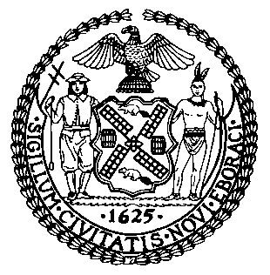

THE COUNCIL OF THE CITY OF NEW YORK

BRIEFING PAPER OF THE HUMAN SERVICES

AND INFRASTRUCTURE DIVISIONS
Jeff Baker, Legislative Director

COMMITTEE ON ECONOMIC DEVELOPEMT

Hon. Daniel R. Garodnick, Chair

COMMITTEE ON TRANSPORTATION

Hon. Ydanis Rodriguez, Chair

COMMITTEE ON WATERFRONTS

Hon. Deborah Rose, Chair

October 19, 2017

Oversight - The Economic Impact of NYC Ferry and the New Ferry Transport Routes

INTRODUCTION

On October 19, 2017, the Committee on Economic Development, chaired by Council Member Daniel R. Garodnick, the Committee on Transportation, chaired by Council Member Ydanis Rodriguez, and the Committee on Waterfronts, chaired by Council Member Deborah Rose, will hold a joint oversight hearing entitled “The Economic Impact of NYC Ferry and the New Ferry Transport Routes.” The Committee expects to hear testimony from New York City Economic Development Corporation (“NYCEDC”) and other interested stakeholders.

BACKGROUND
Prior to the construction of bridges and tunnels connecting the five boroughs, ferry service was crucial to connecting and transporting New Yorkers. In more recent decades ferry services more often complement other forms of transportation, relieving growing vehicular and mass transit congestion. Moreover, ferry service has played a crucial role in transporting New Yorkers during emergencies, including in the aftermath of Superstorm Sandy.
Today, ferry service in New York City is provided by both public and private entities. Since 1905, the City has operated the Staten Island Ferry between Staten Island and Lower Manhattan. According to the New York City Department of Transportation (“DOT”) over 23 million passengers utilize the Staten Island Ferry annually. In addition to this City-operated ferry service, a host of private companies have long operated ferry service between New York and New Jersey along the Hudson River.
The Council held oversight hearings on the state of ferry service in New York City in 2012, 2013 and 2015. At the 2012 hearing, the NYCEDC highlighted the significant role played by the Council in launching the East River Ferry service. According to one witness at that hearing, the inauguration of the East River Ferry played a role in boosting “local economic development, increasing real estate values and increasing access to the waterfront neighborhoods along the East River.”
2011 Citywide Ferry Study
In 2011, the City released its first ever comprehensive ferry service study. The ferry study was a culmination of proposals put forth by the City Council and the Bloomberg Administration to increase and expand ferry service throughout the City. In the 2011 report, NYCEDC, in conjunction with NYHaborWay, surveyed 43 different locations throughout New York City for possible ferry service. The study, which received technical assistance from DOT, examined the market demand and potential ridership from sites throughout the City, identified possible future service corridors, analyzed the potential for recreational ferry services, reviewed possible funding sources, and investigated the issue of governance.
The 43 sites selected for ferry commuter analysis were based on materials from prior reports, meetings between NYCEDC staff and elected officials, and information gathered from a series of public meetings held by NYCEDC in 2009, which asked City residents to suggest sites to be analyzed. However, of those sites, only 17 were equipped with an existing ferry landing. Because the study only focused on the operating and subsidy costs associated with ferry services, not examined in the study were the capital costs necessary to build the dock and barge infrastructure at any one particular site, which could run into the millions of dollars.
East River Ferry
Begun as a pilot in 2011, the East River Ferry served seven stops in Manhattan, Brooklyn, and Queens, with limited seasonal service to Governors Island. Widely considered a success, it met its three-year ridership goal in just 14 months and served over 1.2 million riders in 2014. Average weekday ridership was 3,257 in 2013. NY Waterway operated the service under contract with NYCEDC.
From 2011 – 2015 the East River Ferry experienced seasonal variations in ridership; in the summer months weekend trips, dominated by recreational users, outstripped weekday trips, while in the winter months commuter-heavy weekday trips outpaced weekend trips. Ridership in both categories declined during the colder months and rose during the summer. Fares of $4.00 covered 64% of the operating cost, requiring a $2.22 per passenger trip subsidy to make up the difference – which amounted to over $2.5 million per year. A comparison of operating subsidies for various transportation modes in New York as of 2013 can be found in Appendix A. As a result of the success of its pilot phase, the East River Ferry contract was extended through 2019.
Citywide Ferry Study 2013
Building off of the first Citywide Ferry Study and the initial results of the East River Ferry program, EDC conducted an updated and expanded study, the Citywide Ferry Study 2013 (“CFS2013”). CFS2013 found that East River Ferry service had contributed to a rise in property values near ferry stops (by as much as 8 percent for properties within 1/8 of a mile of stops in Brooklyn and Queens) and contributed to over 600,000 square feet of additional residential and commercial building space in areas near ferry landings. The study concluded that significant potential ridership generated by fast-growing areas of the Brooklyn and Queens waterfront had the potential to support expanded service with only “modest” public subsidy, while more distant locations, while providing accessibility benefits to those communities, would generate higher operating costs requiring greater public subsidy in order to maintain comparable fare rates.
In all, CFS2013 examined 50 potential ferry landing sites and identified the six most promising new routes, including service to LaGuardia Airport. The study concluded that an expanded ferry network at a lower uniform fare (in the $3 range) could be revenue-neutral while generating significantly increased ridership. It also strongly recommended identifying and pursing appropriate “value capture” funding methods to support any increased ferry service.
Planning NYC Ferry
On February 3, 2015, Mayor Bill de Blasio announced plans to create a citywide ferry system with fares equivalent to the subway and bus fare. The stated aims of the new service include connecting residents of neighborhoods with limited transportation service to opportunities throughout the City, spurring development in newly-accessible places (specifically in the outer boroughs), and increasing the resiliency of the City’s transportation network. Like the East River Ferry, a private ferry operator would provide the new service with oversight by NYCEDC. In addition to the existing East River Ferry routes, NYCEDC planned five new routes as part of NYC Ferry: the Astoria, South Brooklyn, and Rockaway routes began operating in 2017, and the Soundview and Lower East Side routes are to begin service in 2018. NYCEDC expects the complete ferry system to provide 4.6 million rides per year when fully operational.
In March 2016, Mayor de Blasio announced a six-year contract with Hornblower, Inc. (“Hornblower”) to run the new NYC Ferry service, including the existing East River Ferry routes. NYCEDC stated that the cost of constructing or renovating the 12 ferry landings necessary for the new service was covered by $55 million in City capital funds. Construction began in 2016 on 19 ferries at two shipyards and employing some 200 builders. NYCEDC stated that each vessel would include the following:
- Capacity for 150 passengers along with space for bikes, strollers and wheelchairs.
- Compliance with ADA and Local Law 68/2005 accessibility requirements.
- Boats are 85 feet long, offering passengers more space than more traditional ferries.
- Ferries are primarily built out of aluminum, which is safe, [lightweight] and increases fuel efficiency.
- Use of ultra-efficient engines to reduce emissions.
- Innovative hull design to limit wake and maximize fuel efficiency.
- Wi-Fi available throughout the vessel.
- Heated decks that increase each vessel’s resiliency and durability, especially during the cold, snowy winter months.

NYC FERRY LAUNCH IN 2017
The new citywide ferry network, NYC Ferry, launched on May 1, 2017. The first two routes were the new Rockaway line, with three stops from Rockaway in Queens to Pier 11/Wall Street in Manhattan (“Pier 11”), and the East River line with six stops from East 34th Street in Manhattan to Pier 11, with stops in Queens and Brooklyn along the way. The fare is $2.75 per ride, the same cost as a ride on an MTA subway or bus. The city is providing $30 million in operating support per year, which is expected to result in a per-trip subsidy of $6.60.
The South Brooklyn line launched on June 1, 2017 with five stops from Bay Ridge to Pier 11, and the fourth route with four stops from Astoria in Queens to Pier 11 launched on August 29, 2017. The routes for Soundview and the Lower East Side are planned to launch in the summer 2018 and NYCEDC has also announced that it has formally committed to exploring expansion of the service to Coney Island and Canarsie.
On July 26, 2017, the city announced NYC Ferry had already served 1 million customers. This milestone came nearly a month before the city had projected reaching the million-rider mark. Additionally, on August 25th the NYCEDC reported the results from a new rider survey that gave NYC Ferry a 93% approval rate, with 66% surveyed rating the new ferry system the highest option. The survey also found that 87% of riders surveyed lived in New York City, suggesting that the ridership was primarily commuters.
While the new citywide ferry system has generally been well-received, the rollout has not been without its challenges. Some riders complained of up to two hour delays, being turned away completely from riding the ferry due to high demand, and that only four boats had been allotted to the East River line. One passenger wrote that people were "waiting in 90 degree weather in direct sun for nearly an hour (many children, too) after scheduled arrival, only to tell them the boat is full and won't be accepting passengers." In response to complaints of overcrowding due to high demand, Hornblower said they were working with NYCEDC to address these issues. In May, Mayor de Blasio acknowledged that additional and higher-capacity boats would likely be needed. NYCEDC and Hornblower have leased additional ferries from New York Waterway to meet unexpectedly high demand. This included chartering two additional boats with a capacity of 400 riders to help with large weekend ridership in the summer season, at a cost of about $60,000 per weekend in the summer and $485,000 overall. They have also increased an order of new boats from 19 to 20, and increased the capacity on three of these boats from 149 to 250.
As the NYC Ferry fleet expands, companies involved with building the boats have faced challenges. The company Kamcor, brought on by Hornblower to provide welders and other workers to build the ferries, says it has yet to be fully paid for its work on the project. Horizon Shipbuilding, which produced 10 of the ferries at its yard in Alabama, is now facing bankruptcy. Hornblower has shifted its order for additional boats from Horizon to Metal Shark, a shipyard in Louisiana. Hornblower sued Horizon and an insurance company in September 2017 for failure to finish the contract. Hornblower also contends that Horizon is responsible for the money owed to Kamcor, while Horizon asserted that while they were paid $2.6 million per ferry, Hornblower paid Metal Shark about $3 million per boat.
Finally, there have also been complaints from seniors regarding reduced fares. NYC Ferry does provide an application for seniors and people with disabilities to receive a Reduced-Fare 30-Day Pass. However, seniors have expressed concern that the senior discount is only for a 30-day pass and requires completing and submitting an application, then waiting weeks for processing. Many seniors only need to ride the NYC Ferry intermittently and thus may not want to pay for a 30-day pass. NYC Ferry does not offer senior discounts on single rides, which differs from the MTA policy that allows seniors to purchase discounted fares of $1.35 per ride on the buses and subways.

CONCLUSION
At this hearing, the Committees look forward to learning more about NYCEDC’s plans for meeting the high demand for the ferries and the associated costs to the city. The Committees also seeks more details on which communities across the City will see benefits of the new service in both the immediate and long-term future.
Appendix A – Transit Fares and Subsidies per Passenger Trip (as of 2013)

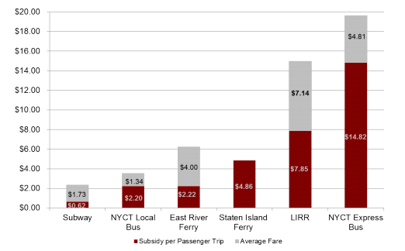
Source: CFS2013
Appendix B – NYC Ferry Routes
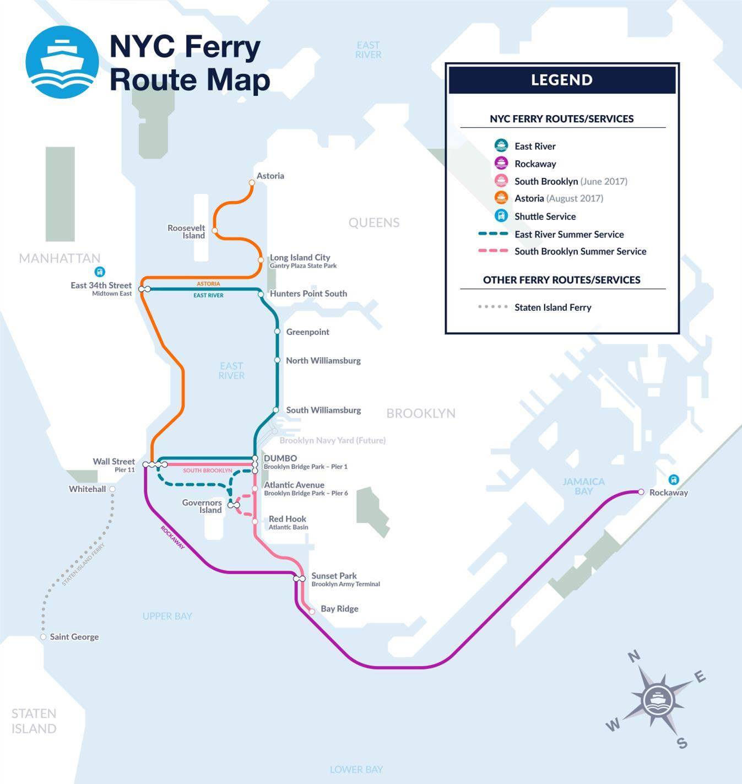
Source: https://www.nycedc.com/project/nycferry

Patrick McCandless, Understanding the Challenges of Regional Ferry Service in New York City 11 (2010), available at http://wagner.nyu.edu/files/faculty/publications/RCWP_McCandless.pdf.
Id. at 11-12.
Metropolitan Waterfront Alliance, Maximizing Ferries in New York City’s Emergency Management Planning (Apr. 2013), available at http://waterfrontalliance.org/wp-content/uploads/2015/07/Waterfront_Platform_Ferries_04_2013.pdf.
N.Y.C. Department of Transportation, Staten Island Ferry, http://www.nyc.gov/html/dot/html/ferrybus/staten-island-ferry.shtml (last accessed October 12, 2017).
N.Y.C. Department of Transportation, Ferry Information, http://www.nyc.gov/html/dot/html/ferrybus/ferintro.shtml (last accessed October 12, 2017).
Testimony of Ronald Lewis, President and CEO of Metropolitan Waterfront Alliance, April 25, 2012.
The NYHarborWay is an initiative of NYC & Company, New York City’s official marketing, tourism, and partnership organization. The NYHarborWay is intended to establish nine harbor destinations as must-see sites for residents and visitors.
NYC Economic Development Corporation and NYHarborWays, Comprehensive Citywide Ferry Study (Mar. 2012), available at http://www.appleseedinc.com/reports/ComprehensiveCitywideFerryStudy_2011-03-15.pdf.
Id.
NYC Economic Development Corporation, East River Ferry Service, http://www.nycedc.com/project/east-river-ferry-service (last accessed Sept. 17, 2015).
NYC Economic Development Corporation, Citywide Ferry Study 2013 Final Report (Feb. 2015), available at https://www.nycedc.com/resource/citywide-ferry-study-2013
NYC Economic Development Corporation, supra note 11 at 13-14.
Id. at 12.
NYC Economic Development Corporation, Letter to Transportation Committee Chair Ydanis Rodriguez, Jun. 24, 2015, on file with staff.
NYC Economic Development Corporation, Citywide Ferry Study 2013 Final Report (Feb. 2015), available at https://www.nycedc.com/resource/citywide-ferry-study-2013. A preliminary version of the Citywide Ferry Study was issued in 2013, with the final report issued in 2015. Information in this report is based on the final 2015 report unless otherwise noted.
NYC Economic Development Corporation, supra note 11, at 5.
Id.
Id. at 70.
Id. at 71.
See Appendix B for a map of the planned routes.
NYC Economic Development Corporation, NYC Ferry Project Highlights, available at https://www.nycedc.com/project/nycferry (last accessed October 12, 2017)
WNYC, New York City Awards New Ferry Contract (March 17, 2016), available at http://www.wnyc.org/story/new-york-city-plans-new-ferry-service-queens-brooklyn-2017/
NYC Economic Development Corporation, supra note 15.
NYC Economic Development Corporation, Mayor De Blasio, NYCEDC And Hornblower Announce Citywide Ferry Boat Construction Officially Underway (September 22, 2016), available at https://www.nycedc.com/press-release/mayor-de-blasio-nycedc-and-hornblower-announce-citywide-ferry-boat-construction
Id.
NYC Mayor's Office, All Aboard: Mayor de Blasio Launches NYC Ferry (May 1, 2017), available at http://www1.nyc.gov/office-of-the-mayor/news/277-17/all-aboard-mayor-de-blasio-launches-nyc-ferry#/0
Simone Wilson, NYC's Huge New Ferry Network: Route Maps, Schedules, Fares, Opening Dates And More, New York City Patch (April 18, 2017), available at https://patch.com/new-york/new-york-city/nycs-huge-new-ferry-network-route-maps-schedules-fares-opening-dates-more
NYC Mayor's Office, All Aboard: Mayor de Blasio Launches NYC Ferry (May 1, 2017), available at http://www1.nyc.gov/office-of-the-mayor/news/277-17/all-aboard-mayor-de-blasio-launches-nyc-ferry#/0
NYC Mayor's Office, Mayor de Blasio Announces NYC Ferry Rockaway Route Launching May 1st, One Month Ahead of Schedule (Apr 27, 2017), available at http://www1.nyc.gov/office-of-the-mayor/news/212-17/mayor-de-blasio-nyc-ferry-rockaway-route-launching-may-1st-one-month-ahead-schedule#/0
Jeanmarie Evelly, SEE IT: NYC Ferry Service Launches New Astoria Route, DNA Info (August 29, 2017), available at https://www.dnainfo.com/new-york/20170829/astoria/nyc-ferry-astoria-route-launch-aug-29
Tanay Warerkar, NYC Ferry has had 1 million riders since launch, Curbed New York (July 26, 2017), available at https://ny.curbed.com/2017/7/26/16034396/nyc-ferry-1-million-riders-astoria-launch
Id.
NYC Economic Development Corporation, NYC Ferry Receives 93% Approval in New Rider Survey (August 25, 2017), available at https://www.nycedc.com/press-release/nyc-ferry-receives-93-approval-new-rider-survey
Id.
Nikki M. Mascali, NYC Ferry addresses customer complaints, Metro US (June 12, 2017), available at https://www.metro.us/news/local-news/new-york/nyc-ferry-addresses-customer-complaints
Id.
Id.
Katie Honan, NYC Ferry Service Could Get Bigger Boats to Meet Demand, Mayor Says, DNA Info (May 31, 2017), available at https://www.dnainfo.com/new-york/20170531/red-hook/nyc-ferry-boats-red-hook-bay-ridge-rockaway-route
Kirk More, NYC Ferry will get bigger boats, Workboat (June 15, 2017), available at https://www.workboat.com/news/passenger-vessels/nyc-ferry-will-get-bigger-boats/
J. David Goodman and Patrick McGeehan, NYC Ferry, More Popular Than Expected, Scrambles to Meet Demand, N.Y. Times (June 15, 2017) available at https://www.nytimes.com/2017/06/15/nyregion/nyc-ferry-more-popular-than-expected-scrambles-to-meet-demand.html
Id.
Patrick McGeehan, New York’s Ferries Have Left Some of Their Builders High and Dry, N.Y. Times (October 5, 2017), available at https://www.nytimes.com/2017/10/05/nyregion/new-york-city-ferry-builders-finances.html?_r=0
Id.
Id.
NYC Ferry, Application for NYC Ferry Reduced-Fare Ticketing Program for Senior Citizens, available at https://www.ferry.nyc/wp-content/uploads/2017/04/Reduced-Fare-Program-Application-Senior-Citizens-NYC-FERRY-2.pdf
Crain's New York, Senior citizen asks: Where's our ferry discount? (June 27, 2017), available at http://www.crainsnewyork.com/article/20170627/OPINION/170629924/senior-citizen-asks-wheres-our-ferry-discount
Id.

