THE COUNCIL OF THE CITY OF NEW YORK
RESOLUTION NO. 598

Resolution approving the decision of the City Planning Commission on Application No. N 180212 ZRQ (L.U. No. 247), for an amendment of the Zoning Resolution of the City of New York, modifying Appendix F for the purpose of establishing a Mandatory Inclusionary Housing Area, Borough of Queens, Community District 1.

By Council Members Salamanca and Moya

WHEREAS, the City Planning Commission filed with the Council on September 28, 2018 its decision dated September 26, 2018 (the "Decision"), pursuant to Section 201 of the New York City Charter, regarding an application submitted by the Ravi Management, LLC, for an amendment of the text of the Zoning Resolution of the City of New York, modifying Appendix F for the purpose of establishing a Mandatory Inclusionary Housing Area, which in conjunction with the related action, would facilitate the development of a new eight-story mixed-use building with approximately 74 dwelling units, including 22 permanently affordable units, and ground floor retail space at 11-14 35th Avenue, in the Ravenswood neighborhood of Queens, Community District 1, (Application No. N 180212 ZRQ), Community District 1, Borough of Queens (the "Application");

WHEREAS, the Application is related to application C 180211 ZMQ (Pre. L.U. No. 246), a Zoning Map amendment to change an R5 zoning district to an R6A/C1-3 district;

WHEREAS, the Decision is subject to review and action by the Council pursuant to Section 197-d(b)(1) of the City Charter;
WHEREAS, upon due notice, the Council held a public hearing on the Decision and Application on October 3, 2018;

WHEREAS, the Council has considered the land use implications and other policy issues relating to the Decision and Application; and

WHEREAS, the Council has considered the relevant environmental issues, including the negative declaration issued May 7, 2018 (CEQR No. 18DCP079Q), which includes an (E) designation to avoid the potential for significant adverse impacts related to hazardous materials, air quality and noise and an (E) designation requirements related to hazardous materials would apply to development sites Block 331, Lots 27, 38, and 50 (Projected Development Sites 1, 2, 3) (E-480) (the “Negative Declaration”).

RESOLVED:

The Council finds that the action described herein will have no significant impact on the environment as set forth in the Negative Declaration.

Pursuant to Section 200 of the City Charter and on the basis of the Decision and Application, and based on the environmental determination and consideration described in the report, N 180212 ZRQ, incorporated by reference herein, the Council approves the Decision of the City Planning Commission.

Matter underlined is new, to be added;
Matter struck out is to be deleted;
Matter within # # is defined in Section 12-10;
*** indicates where unchanged text appears in the Zoning Resolution.

APPENDIX F

Inclusionary Housing Designated Areas and Mandatory Inclusionary Housing Areas

* * *

Queens

* * *

Queens Community District 1

* * *

Map 4 – [date of adoption]

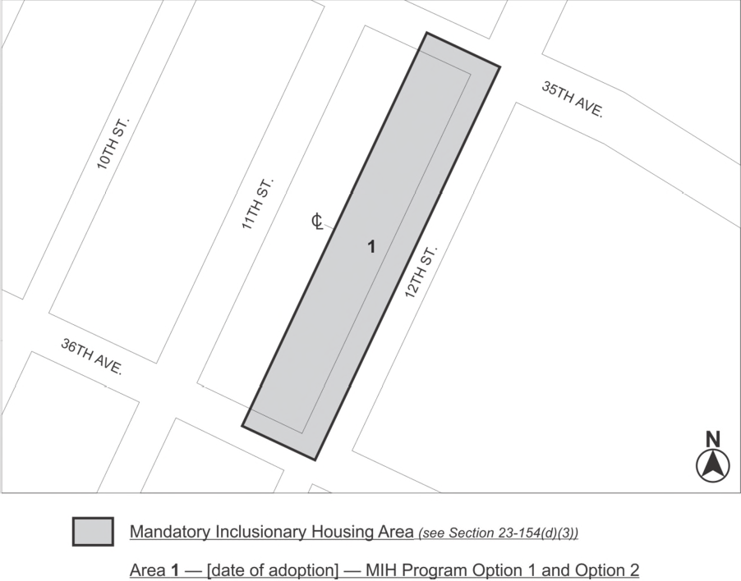

Portion of Community District 1, Queens
* * *

Adopted.

Office of the City Clerk, }
The City of New York, } ss.:

I hereby certify that the foregoing is a true copy of a Resolution passed by The Council of The City of New York on October 31, 2018, on file in this office.

.....……......................................... City Clerk, Clerk of The Council

