General Welfare Committee Staff
Sahar Moazami, Legislative Counsel
Nina Rosenberg, Policy Analyst
Julia Haramis, Finance Unit Head
Phariha Rahman, Finance Analyst
Elisabeth Childers-Garcia, Finance Analyst



THE COUNCIL OF THE CITY OF NEW YORK

briefing paper OF
The Legislative Division
Andrea Vazquez, Director
Smita Deshmukh, Deputy Director, Human Services

COMMITTEE ON GENERAL WELFARE
Hon. Diana Ayala, Chair

January 27, 2025

Oversight: Administration of the CityFHEPS program

- INTRODUCTION
On January 27, 2025, the Committee on General Welfare, chaired by Deputy Speaker Diana Ayala, will hold an oversight hearing titled “Administration of the CityFHEPS program.” Those invited to testify include representatives from the New York City (“NYC” or “City”) Department of Social Services (“DSS”), other interested stakeholders, and members of the public.
- BACKGROUND
  - History of CityFHEPS
In 2004, the Bloomberg Administration introduced Housing Stability Plus, a city-funded, time-limited rental subsidy program for individuals and families at risk of or experiencing homelessness. Housing Stability Plus was a five-year rental subsidy administered by the Department for Homeless Services (DHS) that included work requirements and a voucher that declined in value by 20 percent each year. The Bloomberg Administration replaced the program in 2007 with Advantage, a two-year subsidy. The Advantage program offered subsidies for people in shelters if they worked 20 hours a week or more and then was expanded to incorporate additional populations. In 2011, the State pulled funding for Advantage and the City subsequently ended the program. Around 8,500 families returned to DHS shelters following the end of Advantage. In 2014 and 2015, the de Blasio Administration re-instituted City rental assistance vouchers for homeless households and those at risk of homelessness, including Living in Communities (LINC); City Family Eviction Prevention Supplement and City Family Exit Plan Supplement (CityFEPS) programs; and Special Exit and Prevention Supplement (SEPS) for single adults and adult families. On October 29, 2018, the de Blasio Administration consolidated the LINC, SEPS, and CityFEPS rental assistance programs into the City Fighting Homelessness and Eviction Prevention Supplement (CityFHEPS) program.
  - Current CityFHEPS program
CityFHEPS is administered by DSS and provides a rental supplement to eligible low-income households to assist them with paying their monthly rent. In recent years, several changes have been made to the eligibility criteria for qualifying for a CityFHEPS voucher both via rules changes and via local laws, which are currently pending in litigation. These rule changes and litigation notwithstanding, it is important to note that current rules require that a household have an open cash assistance case to be eligible to receive a voucher.
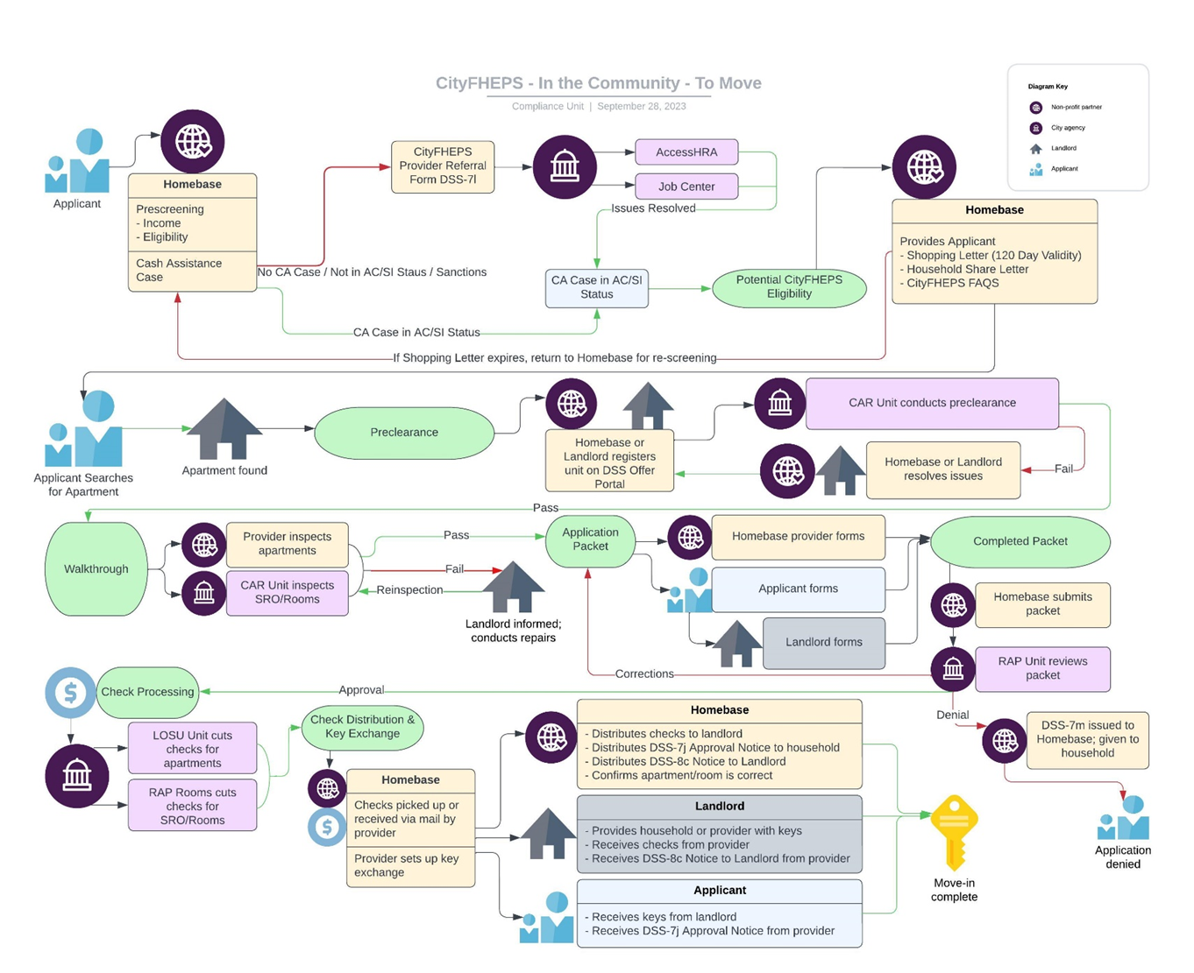
Households already in shelters can work with a housing specialist or case manager to assess eligibility and begin the application process, while households at risk of homelessness can seek assistance at a Homebase location. Homebase provides New Yorkers experiencing housing instability in the community with various homeless prevention, as well as aftercare services to families and individuals exiting NYC DHS shelter to permanent housing. Homebase providers are contracted by DSS and include Services for the UnderServed (S:US), Riseboro Community Partnership, CAMBA, Catholic Charities, Bronxworks and Help USA. Eligible households who need to move to a new apartment will be issued a shopping letter after their eligibility is confirmed during a preliminary eligibility screening. The shopping letter includes the highest amount of rent CityFHEPS will allow for household size and apartment type and the documentation property owners or brokers will need to provide and is valid for 120 days. Shopping letters are generated by the Client Assistance and Rehousing Enterprise System (CARES) case management system, based on data matching with the Welfare Management System (WMS), a state-managed portal and system of record for Supplemental Nutrition Assistance Program (SNAP), Cash Assistance (CA), Temporary Assistance for Needy Families (TANF), and other New York City and State benefits. CARES is currently only accessible to DSS employees. Once households have found a potential housing option, they can submit their full application for the CityFHEPS voucher. Before final voucher approval and move-in, all units must pass an assessment of safety and habitability. Households are required to reside in the CityFHEPS unit for which they were approved unless they receive approval from the Commissioner to move. The below diagram details the full CityFHEPS process for voucher seekers in the community.
According to DSS, individuals “will know that [they] might be eligible for CityFHEPS” when they receive the "DSS Letters”, the “Shopping Letter” and “Household Share Letter,” from their caseworker. The DSS letters allow the individual to look for housing and, once found, apply for a voucher. DSS will also determine eligibility and ensure the housing qualifies for the program. CityFHEPS can be used to rent an apartment anywhere within New York State, or a single room in an apartment of SRO within the five boroughs. Payment standards vary based on household composition and apartment size and are the maximum number of bedrooms HRA will subsidize. The following table illustrates the maximum rent amounts HRA will pay based on the number of bedrooms and utilities that are included in the rent as of December 2023.
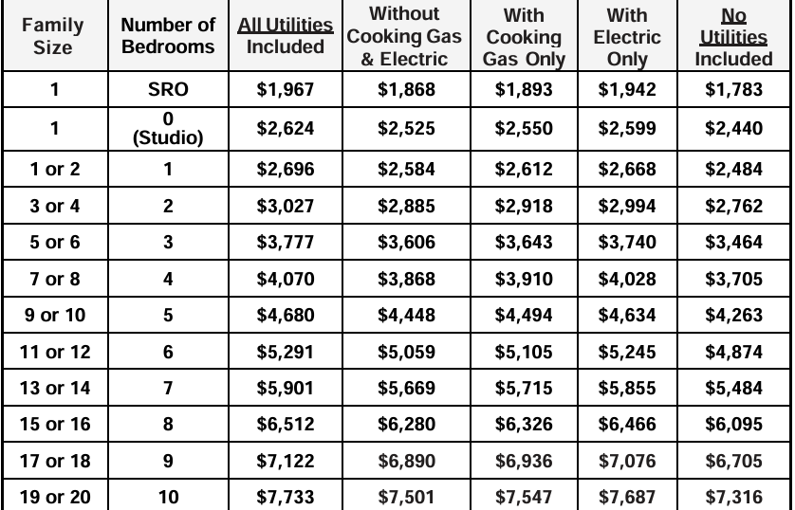
Source: NYC Department of Social Services

CityFHEPS voucher subsidies must be renewed, or recertified, annually, and DSS states that it will send renewal applications to clients five months before the current subsidy expires. In order to renew the subsidy, voucher holders must confirm that they are still living in their approved apartment and send information about their household size and income. DSS provides an initial and final deadline for renewal applications and applications received after the final deadline will result in termination of the subsidy; however, DSS may be able to renew a subsidy that has been terminated if there is good cause reason for the late application. Voucher holders are able to renewal annually for up to five years, after which they can no longer receive a voucher unless they have a good cause reason to need a renewal, or if their household includes someone who is 60 years old or older or who received federal disability benefits. The five-year limit is inclusive of any voucher holders who may have gotten payments from an old rental assistance program.

- ADMINISTRATIVE ISSUES WITH CITYFHEPS

  - Administrative Delays and Internal Controls

Advocates have long highlighted administrative issues with the CityFHEPS program, including those that cause processing and payment delays, and incorrect eligibility assessments. According to the Fiscal 2024 Mayor’ Management Report (MMR), though an average of about 73% of single adults and families with children who exited shelter did so with a subsidy, entrances into the shelter system in Fiscal Year (FY) 2024 were almost three times that of exits.
Women in Need (WIN) identified that delays from three weeks to "indefinitely” at various checkpoints in the CityFHEPS process, including delays in crosschecking apartments for preclearance; cutting and mailing checks to landlords; and finalizing applications to move, which are wholly rejected for small and easily corrected issues like a misspelling or incorrect date. These delays affect the voucher program’s efficacy in preventing homelessness, as well as the ability of individuals and families in shelters to exit to permanent housing.
New York State Comptroller Thomas DiNapoli’s office undertook an audit of CityFHEPS between 2019 and 2023 and identified major issues related to poor oversight and management. Some problems included families becoming “lost” in the case management system due to being incorrectly labelled as having exited shelter, and units remaining vacant after being identified as having safety and habitability issues by contractors but never being subsequently inspected by DSS to verify this status. Units can fail inspections for seemingly small issues, such as a missing screw, which can result in the added delays to the process and in some cases, require property owners to need to issue a new lease.
The Comptroller recommended establishing better internal controls and monitoring systems to ensure the timeliness of the CityFHEPS process, from initial eligibility review to cutting checks for property owners.
  - Lack of Accessibility and Responsiveness
The CityFHEPS voucher process can be extremely complicated and it can be difficult for clients to access support; the MMR included information that the average wait time to speak with a customer service agent at DHS has increased year on year since FY 2020, reaching an all-time high of 106 minutes in FY 2024. Multiple caseworkers may be assigned to clients throughout the process, creating additional difficulties for clients in tracking their case status. Advocates have stated that the recertification process can be burdensome, and voucher holders have previously reported that delays in processing their recertification, including due to DSS failing to send them notices about their renewal deadlines, left them facing evictions. In other cases, voucher holders have reported that HRA failed to pay their subsidy to the landlord, or else paid the subsidy late, leading to tenants being taken to housing court over unpaid rent.
For low-income older New Yorkers, referrals to Adult Protective Services (APS) is one of the only ways of obtaining a CityFHEPS voucher, however reporting from The Gothamist in November 2024 found that four out of five older adult New Yorkers referred to Adult Protective Services were denied services. Clients can only receive support from the agency if there is evidence of physical or mental impairments, which affect their ability to care for themselves, and Gothamist reported that many clients who have a clear need were found ineligible by APS, and thus unable to access a housing voucher or other supports.
  - Source of Income Discrimination

Source of Income (SOI) discrimination refers to “the illegal practice by landlords, owners, and real estate brokers of refusing to rent to current or prospective tenants seeking to pay for housing with housing assistance vouchers, subsidies, or other forms of public assistance.” According to the New York State Division of Human Rights, all vouchers and subsidies are covered as lawful sources of income, and housing providers are engaging in SOI discrimination if they refuse to rent, delay review of applications, do not reply to applicants, or undertake other actions that create barriers to housing for voucher holding tenants. The New York City Council passed legislation in 2020, LL 115 of 2020, which requires DSS to provide written information about SOI protections to CityFHEPS applicants along with their Shopping Letter. Despite the safeguards put in place to protect New Yorkers from illegal discrimination, this still occurs and in August 2024 the Community Service Society (CSS) released a study of denial tactics used by housing providers and property owners engaging in SOI discrimination. The report found that tactics differed for voucher holders with locally-backed CityFHEPS and FHEPS vouchers as opposed to those with federally backed Section 8 vouchers; notably, those with locally-backed vouchers were more likely to report being spoken to in a rude manner by brokers and property owners. Additionally, CSS reported that CityFHEPS and FHEPS recipients encountered property owners who claimed to only accept Section 8 vouchers; property brokers and owners have shared that they prefer Section 8 incentives and are wary of accepting locally-backed vouchers due to payment delays and other administrative issues.

- BUDGET AND VOUCHER UTILIZATION DATA FOR HRA’S RENTAL ASSISTANCE PROGRAMS
For the past several fiscal years, actual spending on rental assistance programs has been considerably higher than the baseline budget at the time of budget adoption. In the Fiscal 2025 Preliminary Budget Response, the Council called on the Administration to increase HRA’s baseline budget for rental assistance to a level that more accurately reflects the full need. In the Fiscal 2025 Executive Plan, $12.6 million was added in Fiscal 2024, $614.9 million in Fiscal 2025, and $540.3 million was baselined in Fiscal 2026 and in the outyears. Notably, HRA has stated on numerous occasions that the rental assistance budget is continually monitored and that additional funding is added to the budget throughout the fiscal year based on the level of actual expenditures.
As of the November 2024 Plan, HRA’s Fiscal 2025 budget for all rental assistance programs totaled $817.1 million, with $787.5 million budgeted for CityFHEPS. Actual expenditures through November 2024 totaled $490.4 million, with $475.7 million for CityFHEPS. The November 2024 Plan added $114.9 million for CityFHEPS in Fiscal 2025 only to meet the level of demand in the program. As of the November 2024 Plan, the budget for rental assistance programs in Fiscal 2026 and the outyears drops to approximately $629 million, with $534.3 million budgeted for CityFHEPS. For Fiscal 2025, the breakdown of budgeted funding and actual expenditures through November 2024, by rental assistance program, is listed in the succeeding table. Notably, funding is currently budgeted for predecessor rental assistance programs that have ended and HRA plans to transfer it to CityFHEPS in a future financial plan.

HRA's Rental Assistance Budget
Rental Assistance Program | FY25 Budget * | FY25 Actual Expenditures (November 2024)
LINC I | $6,149 | $0
LINC II | $573,862 | $112,023
LINC III | $0 | $0
LINC IV | $0 | $0
LINC V | $0 | $0
LINC VI | $116,610 | $10,925
CFEPS | $361,298 | $78,373
FHEPS B | $11,299,663 | $11,023,472
SEPS | $490,846 | $174,264
SOTA | $3,500,000 | $1,841,162
CITYFHEPS | $687,901,155 | $377,605,148
Rental Assistance ARP | $91,266,800 | $91,266,800
Project Based Rental Assistance | $8,344,540 | $6,808,538
SHARE | $13,273,906 | $1,500,000
TOTAL | $817,134,829 | $490,420,704
*Budget modifications will be made to reallocate funds from predecessor programs to CityFHEPS.
Source: HRA and FMS
The following table illustrates the number of households and individuals who have used rental assistance programs to exit shelter or who were at risk of eviction but were able to remain in their existing housing with assistance. Rental assistance programs in Fiscal 2022 assisted 9,646 households or 20,968 individuals, programs in Fiscal 2023 assisted 12,053 households or 26,603 individuals, and programs in Fiscal 2024 assisted 15,169 households or 32,890 individuals. Through September 2024, programs in Fiscal 2025 assisted 3,949 households or 8,663 individuals. For all years listed in the table, the majority of household exits were with CityFHEPS – 77 percent in Fiscal 2022, 78 percent in Fiscal 2023, 88 percent in Fiscal 2024, and 88 percent through September 2024 in Fiscal 2025.
Shelter Exits and Community Placements
 | FY22 |  | FY23 |  | FY24 |  | FY25  (through Sept)
 | H | I | H | I | H | I | H | I
NYCHA | 736 | 2237 | 671 | 2,056 | 538 | 1634.3 | 238 | 731.6
Section 8 | 485 | 926 | 493 | 953.5 | 528 | 1089.2 | 109 | 227.2
SEPS | 0 | 0 | 0 | 0 | 0 | 0 | 0 | 0
HOME TBRA | 1 | 3 | 0 | 0 | 0 | 0 | 0 | 0
421a (non-SOTA + non-CFHEPS) | 8 | 11.3 | 1 | 1 | 1 | 1 | 0 | 0
NYCHA - HRA | 22 | 68 | 4 | 12 | 16 | 50 | 5 | 16
SOTA | 257 | 643 | 210 | 525 | 221 | 553 | 62 | 155
FHEPS A (DHS Shelter) | 11 | 34 | 8 | 25 | 8 | 24.8 | 7 | 21.7
FHEPS B (Shelter + Community) | 193 | 598 | 150 | 465 | 180 | 558.0 | 54 | 167.4
CityFHEPS (Shelter + Community) | 7,466 | 15,176 | 9,413 | 19,936 | 13,402 | 28,420 | 3,465 | 7,330
Emergency Housing Voucher (EHV) | 467 | 1,270 | 1103 | 2629.4 | 275 | 559.8 | 9 | 14.3
TOTAL | 9,646 | 20,968 | 12,053 | 26,603 | 15,169 | 32,890 | 3,949 | 8,663
H = Households, I = Individuals
Source: HRA

- CONCLUSION

The CityFHEPS program is one of New York City’s most important housing voucher programs. The Committee is looking forward to learning more from the Administration about the challenges it faces in implementing the program, updates and changes it has made recently and plans to make in the future to improve efficiency, and how the Council and Administration can continue to collaborate to ensure all New Yorkers can become, and remain, housed.

Coalition for the Homeless, The Bloomberg Administration’s Flawed Homeless Rental Assistance Plan: A Misguided Plan with Opportunities for Effective Change, (Nov. 2004), available at https://www.coalitionforthehomeless.org/wp-content/uploads/2014/06/Briefing-cityrentplan-11-2004.pdf.
Id.
Joe Lamport, A New Program to Fight Homelessness, The Gotham Gazette, (May 30, 2007), available at https:// www.gothamgazette.com/housing/3574-a-new-program-to-fight-homelessness.
Id.
Peter Nasaw and Thomas J. Main, De Blasio and Homelessness: A New Progressive Mayor Wrestles with an Old Social Problem, The Gotham Gazette, (May 1, 2017), available at http://www.gothamgazette.com/opinion/6902-deblasio-and-homelessness-a-new-progressive-mayor-wrestles-with-an-old-social-problem.
R.C.N.Y. Title 68 Chapter 7 LINC Programs
R.C.N.Y. Title 68 Chapter 8 CITYFEPS Programs; SEPS Program
Id.
Joe Anuta, Launch Date Set for Consolidated Rent-Voucher Program, Crain’s, (Oct. 2, 2018), available at https://www.crainsnewyork.com/real-estate/launch-date-set-consolidated-rent-voucher-program.
New York City Human Resources Administration. “CityFHEPS” (n.d.). Available at: https://www.nyc.gov/site/hra/help/cityfheps.page
On November 14, 2022, the Adams administration announced reforms for the CityFHEPS program including reducing the monthly contribution by CityFHEPS tenants who move into single-room occupancy units from 30 percent of their income to a maximum of $50 per month; covering the cost of apartment application fees; increasing HRA staff presence in Housing Court to ensure eligible clients get quick access to financial assistance that will allow them to stay in their homes; and creating consistency across CityFHEPS, Emergency Housing Vouchers (EHV), and the Special one-Time Assistance (SOTA) programs. (“Mayor Adams Takes Major Steps to Help New Yorkers Access High-Quality Housing More Quickly, Move From Streets to Permanent Homes.” (November 14, 2022), available at https://www.nyc.gov/office-of-the-mayor/news/835-22/mayor-adams-takes-major-steps-help-new-yorkers-access-high-quality-housing-more-quickly-move#/0). In June 2023, the Adams Administration also eliminated the rule that New Yorkers in shelter can only be eligible for CityFHEPS after a 90-day shelter stay. NYC Office of the Mayor ( “Mayor Adams Ends 90-Day Rule for all Populations, Expands Eligibility to City-Funded Rental Assistance for all New Yorkers in Shelter” (June 16, 2023), available at https://www.nyc.gov/office-of-the-mayor/news/427-23/mayor-adams-ends-90-day-rule-all-populations-expands-eligibility-city-funded-rental#/0.)
In May 2023, the Council passed four pieces of legislation aimed at expanding access to the CityFHEPS program by altering its existing eligibility requirements. Following the passage of these bills, they were sent to the Mayor who subsequently decided to veto the bills. In July 2023, the Council exercised its right to override the mayoral veto by once again passing the legislation by a supermajority of the Council. Although the Council enacted the bills according to the existing procedural rules, when the bills went into effect in January 2024 the City announced publicly that it would not implement the laws. After confirming that DSS would not implement the laws, a group of petitioners represented by the Legal Aid Society filed suit against the city to force implementation. In February 2024, the Council filed a motion with the court to become an intervening petitioner in the existing case filed by the Legal Aid Society. On August 1, 2024, the state judge presiding over the case held that the Council has no legal authority to expand the CityFHEPS rental assistance program as the Council is field preempted by the State Social Services law from legislating in the area of social services. On October 1, 2024, the Council and the Legal Aid Society filed an appeal asking the Appellate Division – First Department to overrule the Supreme Court ruling.
Section 10-03 of title 68 of the rules of the city of New York.
NYC 311, CityFHEPS Rental Assistance. (n.d.). Available at:https://portal.311.nyc.gov/article/?kanumber=KA-03172
NYC HRA, Homebase (n.d). Available at: https://www.nyc.gov/site/hra/help/homebase.page
Id.
NYC Department of Social Services, CityFHEPS Frequently Asked Questions. (Dec, 2023) Available at: https://www.nyc.gov/assets/hra/downloads/pdf/cityfheps-documents/DSS-7n-(E).pdf
Id.
Office of the New York State Comptroller, New York City Department of Social Services Administration of the CityFHEPS Program for Department of Homeless Services Shelter Residents (Oct 2024). Available at: https://www.osc.ny.gov/files/state-agencies/audits/pdf/sga-2025-23n1.pdf
Id.
Id.
68 NYCRR § 10-08
Id.
For voucher seekers in shelter, the CityFHEPS pathway may include additional steps, such as DHS CARES matching.
Id.
Id.
Mayor Eric Adams announced in September 2023 that cityFHEPS voucher holders could use vouchers on housing outside of the five boroughs; prior, CityFHEPS vouchers could only be used in New York City
Id.
Id.
NYC Department of Social Services, DSS CITYFHEPS Payment Standards. Available at https://www1.nyc.gov/assets/hra/downloads/pdf/cityfheps-documents/DSS-8r-E.pdf
NYC Department of Social Services. “CityFHEPS Renewal Frequently Asked Questions”. (2021.) Available at: https://www.nyc.gov/assets/hra/downloads/pdf/cityfheps-documents/CityFHEPS-Renewal-English-Renewal-FAQ.pdf
Id.
Id.
Id.
Id.
Women In Need. “CityFHEPS Roadblocks to Housing”. (n.d.). Available at: https://winnyc.org/wp-content/uploads/2023/04/CityFHEPS_ROADBLOCKS_v1.pdf
”Subsidized exits” include CityFHEPS placements as well as other voucher programs
Mayor’s Office of Operations, Mayor’s Management Report, Department of Homeless Services (Sept 2024). Available at: https://www.nyc.gov/assets/operations/downloads/pdf/mmr2024/MMR-2024-Cover.pdf
Id.
City Limits. “Administrative Obstacles Jam Up Moving Process for NYC Shelter Residents.” (January 31, 2022). Available at: https://citylimits.org/2022/01/31/administrative-obstacles-jam-up-moving-process-for-nyc-shelter-residents/
Office of the New York State Comptroller. “Administration of the CityFHEPS Program for Department of Homeless Services Shelter Residents.” (October 30, 2024). Available at: https://www.osc.ny.gov/state-agencies/audits/2024/10/30/administration-cityfheps-program-department-homeless-services-shelter-residents
Id.
Kahn, Rachel. The City. “How to Find Housing With a Voucher in New York City.” (November 11, 2024). Available at https://www.thecity.nyc/2024/11/11/housing-voucher-discrimination-cityfheps/#h-step-4-inspection-and-your-cityfheps-package-nbsp
Office of the New York State Comptroller. “Administration of the CityFHEPS Program for Department of Homeless Services Shelter Residents.” (October 30, 2024). Available at: https://www.osc.ny.gov/state-agencies/audits/2024/10/30/administration-cityfheps-program-department-homeless-services-shelter-residents
Mayor’s Office of Operations, Mayor’s Management Report, Department of Homeless Services (Sept 2024). Available at: https://www.nyc.gov/assets/operations/downloads/pdf/mmr2024/MMR-2024-Cover.pdf
Win and REBNY, Housing More New Yorkers: Systemic issues afflicting voucher programs and an overview of the simple policy proposals that can solve them. (May 2023). Available at: https://winnyc.org/wp-content/uploads/2024/05/Win-REBNY-Voucher-Report.pdf
Zaveri, Mihir. The New York Times. “Program That Fights Homelessness Is Mired in Dysfunction, Advocates Say.” (April 5, 2023). Available at: https://www.nytimes.com/2023/04/05/nyregion/ny-housing-voucher-program-problems.html
Duddridge, Natalie. CBS News. Harlem tenants facing eviction after city's rental assistant program did not make payments. (February 10, 2023). Available at: https://www.cbsnews.com/newyork/news/harlem-tenants-facing-eviction-after-citys-rental-assistant-program-did-not-make-payments/
Brand, David. Gothamist. “New Yorkers in need of housing aid are finding little luck with the city's last resort” (November 4, 2024). Available at: https://gothamist.com/news/new-yorkers-in-need-of-housing-aid-are-finding-little-luck-with-the-citys-last-resort
Id.
NYC Commission on Human Rights. “Source of Income Discrimination” (n.d.) available at: https://www.nyc.gov/site/cchr/media/source-of-income.page
NYS Division of Human Rights. “Guidance on Protections from Source of Income Discrimination in Housing Under The New York State Human Rights Law.” (2020). Available at: https://dhr.ny.gov/system/files/documents/2022/05/nysdhr-soi-guidance-2020.pdf
LL 115 of 2020
Community Service Society. “Denial Tactics”. (August 2024). Available at: https://smhttp-ssl-58547.nexcesscdn.net/nycss/images/uploads/pubs/Denial_Tactics_Report_V5.pdf
Id.
Id.
Fiscal 2025 Preliminary Budget Response, City Council. April 2024. https://council.nyc.gov/budget/wp-content/uploads/sites/54/2024/06/Fiscal-2025-Preliminary-Budget-Response.pdf.
Fiscal 2025 Executive Plan Report, City Council. May 2024. https://council.nyc.gov/budget/wp-content/uploads/sites/54/2024/05/HRA-.pdf.
The budget breakdown for rental assistance programs was provided to the Council by HRA via an email communication on December 11, 2024.
On record with the New York City Council Finance Division, as retrieved from the City’s Financial Management System (FMS).
On record with the New York City Council Finance Division, as retrieved from the City’s Financial Management System (FMS). The funding budgeted for Project Based Rental Assistance and Rental Assistance American Rescue Plan is included in the budget for CityFHEPS, as provided to the Council by HRA via email communication.
The reason for additional funding included for CityFHEPS in the November 2024 Plan was provided to the Council by HRA via an email communication on December 25, 2024.
On record with the New York City Council Finance Division retrieved from the City’s Financial Management System (FMS).
The budget breakdown for rental assistance programs was provided to the Council by HRA via an email communication on December 11, 2024.
The breakdown of rental assistance program utilization was provided to the Council by HRA via an email communication on December 11, 2024.

