THE COUNCIL OF THE CITY OF NEW YORK
RESOLUTION NO. 1579

Resolution approving with modifications the decision of the City Planning Commission on Application No. N 180497 ZRK, for an amendment of the text of the Zoning Resolution (Preconsidered L.U. No. 719).

By Council Members Salamanca and Moya

WHEREAS, 1600/20 Realty Corp., filed an application pursuant to Sections 197-c and 201 of the New York City Charter, for an amendment of the text of the Zoning Resolution of the City of New York, modifying Appendix F for the purpose of establishing a Mandatory Inclusionary Housing Area utilizing Options 1 and 2, which in conjunction with the related action would facilitate the construction of a mixed-use building containing a total of approximately 85 residential dwelling units and 10,000 square feet of ground floor commercial space at 1620 Cortelyou Road in the Ditmas Park neighborhood of Brooklyn, Community District 14 (Application No. N 180497 ZRK) (the “Application”);

WHEREAS, the City Planning Commission filed with the Council on January 22, 2021, its decision dated January 20, 2021 (the “Decision”), on the Application;

WHEREAS, the Application is related to application C 180496 ZMK (Pre. L.U. No. 718), a zoning map amendment to change an R6A/C2-4 zoning district to an R7D/C2-4 district;

WHEREAS, the Decision is subject to review and action by the Council pursuant to Section 197-d of the City Charter;

WHEREAS, upon due notice, the Council held a public hearing on the Decision and Application on January 26, 2021;

WHEREAS, the Council has considered the land use implications and other policy issues relating to the Decision and Application; and

WHEREAS, the Council has considered the relevant environmental issues, including the negative declaration issued March 2, 2020 (CEQR No. 20DCP101K), which include an (E) designation to avoid the potential for significant adverse impacts related to hazardous materials and noise (E-564) (the “Negative Declaration”).
RESOLVED:

The Council finds that the action described herein will have no significant impact on the environment as set forth in the (E) Designation (E-564) and Negative Declaration.

Pursuant to Sections 197-d and 200 of the City Charter and on the basis of the Decision and Application, and based on the environmental determination and consideration described in the report, N 180497 ZRK, incorporated by reference herein, and the record before the Council, the Council approves the Decision of the City Planning Commission with the following modifications:

Matter underlined is new, to be added;
Matter struck out is to be deleted;
Matter double struck out is old, deleted by the City Council
Matter double-underlined is new, added by the City Council
Matter within # # is defined in Section 12-10;
* * * indicates where unchanged text appears in the Zoning Resolution.

* * *

APPENDIX F
Inclusionary Housing Designated Areas and Mandatory Inclusionary Housing Areas

* * *

BROOKLYN

* * *

Brooklyn Community District 14

* * *

Map 6 – [date of adoption]

[PROPOSED]

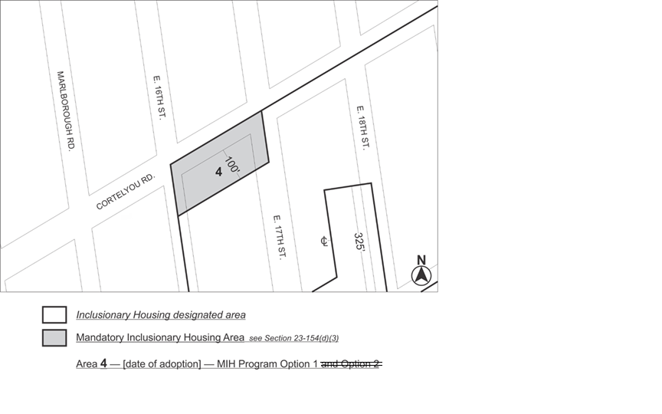

Portion of Community District 14, Brooklyn

* * *

Adopted.

Office of the City Clerk, }
The City of New York, } ss.:

I hereby certify that the foregoing is a true copy of a Resolution passed by The Council of The City of New York on March 18, 2021, on file in this office.

.....................................................
City Clerk, Clerk of The Council

