THE COUNCIL OF THE CITY OF NEW YORK
RESOLUTION NO. 1040

Resolution approving with modifications the decision of the City Planning Commission on Application No. N 250152 ZRM, for an amendment of the text of the Zoning Resolution (L.U. No. 340).

By Council Members Salamanca and Riley
WHEREAS, Lenox Hill Hospital filed an application pursuant to Section 201 of the New York City Charter, for an amendment of the text of the Zoning Resolution of the City of New York, amending Article VI, Chapter 6 (Special Regulations Applying Around Mass Transit Stations), Article VII, Chapter 4 (Special Permits by the City Planning Commission), Article IX, Chapter 2 (Special Park Improvement District), and APPENDIX F for the purpose of establishing a Mandatory Inclusionary Housing area, which in conjunction with the related actions would facilitate the redevelopment and enlargement of Lenox Hill Hospital, located at 100 East 77th Street (Block 1411, Lots 1 and 113), in the Lenox Hill neighborhood of Manhattan, Community District 8 (ULURP No. N 250152 ZRM), (the “Application”);
WHEREAS, the City Planning Commission filed with the Council on July 14, 2025, its decision dated July 2, 2025 (the “Decision”) on the Application;
WHEREAS, the Application is related to applications C 250151 ZMM (L.U. No. 339), a zoning map amendment to change an R8B district to a C1-8 district and a C1-8X district to a C1-9 district; and C 250153 ZSM (L.U. No. 341), a zoning special permit to facilitate a floor area increase of up to 20 percent for non-profit hospital use, allow such floor area bonus to be used in conjunction with a transit improvement bonus, and permit modifications of applicable bulk regulations;
WHEREAS, the Decision is subject to review and action by the Council pursuant to Section 197-d of the City Charter;
WHEREAS, upon due notice, the Council held a public hearing on the Decision and Application on July 16, 2025;
WHEREAS, the Council has considered the land use implications and other policy issues relating to the Decision and Application; and
WHEREAS, the Council has considered the relevant environmental issues, including the Positive Declaration issued January 30th, 2023 (CEQR No. 23DCP079M) and a Final Environmental Impact Statement (FEIS) for which a Notice of Completion was issued on June 20, 2025, in which significant adverse impacts related to hazardous materials, air quality and noise would be avoided through the placement of (E) designation (E-777) on the project sites as specified in Chapters 8, 11, and 13, respectively of the FEIS. The application, as analyzed in the FEIS, contained Project Components Related to the Environment (PCREs), which are set forth in Chapter 16 “Construction.” To ensure the implementation of the PCREs, the applicant would enter into a Restrictive Declaration at the time of the approval of land use-related actions and prior to the issuance of any permits; and in addition, the proposed project as analyzed in the FEIS identified significant adverse impacts with respect to shadows and construction (noise) in which the identified significant adverse impacts and proposed mitigation measures under the proposed actions are summarized in Chapter 18, “Mitigation,” of the FEIS. The significant adverse impacts that would not be fully mitigated are summarized in Chapter 19, “Unavoidable Adverse Impacts,” of the FEIS. To ensure the implementation of the mitigation measures identified in the FEIS, the mitigation measures are included in the Restrictive Declaration. The Council has also considered the Technical Memorandum dated [_____, 2025] (the “Technical Memorandum”).
RESOLVED:
Having considered the FEIS with respect to the Decision and Application, the Council finds that:
- The FEIS meets the requirements of 6 N.Y.C.R.R. Part 617;
- The environmental impacts disclosed in the FEIS were evaluated in relation to the social, economic, and other considerations associated with the action that is set forth in the Decision;
- Consistent with social, economic, and other essential considerations, from among the reasonable alternatives provided in the application, the actions are those which minimize or avoid adverse environmental impacts to the maximum extent practicable; and
- The adverse environmental impacts revealed in the FEIS will be minimized or avoided to the maximum extent practicable by incorporating as conditions to the approval, pursuant to the restrictive declaration dated June 30, 2025, those project components related to the environment and mitigation measures that were identified as practicable.
The Decision, together with the FEIS issued June 20, 2025, constitute the written statement of facts, and of social, economic and other factors and standards that form the basis of this determination, pursuant to 6 N.Y.C.R.R. §617.11(d);
Pursuant to Sections 197-d and 201 of the City Charter and on the basis of the Decision and Application, and based on the environmental determination and consideration described in the report, N 250152 ZRM, and the Technical Memorandum, incorporated by reference herein, and the record before the Council, the Council approves the Decision of the City Planning Commission, with the following modifications.
Matter underlined is new, to be added;
Matter struck out is to be deleted;
Matter double-underlined is new, added by the City Council;
Matter double struck out is old, deleted by the City Council;
Matter within # # is defined in Section 12-10;
* * * indicates where unchanged text appears in the Zoning Resolution.

ARTICLE VI
SPECIAL REGULATIONS APPLICABLE TO CERTAIN AREAS

* * *

Chapter 6
Special Regulations Applying Around Mass Transit Stations

* * *

66-50
SPECIAL APPROVALS

* * *

66-51
Additional Floor Area for Mass Transit Station Improvements

* * *

66-513
Additional rules and limitations, conditions, findings, and requirements

Any authorization or special permit application pursuant to the provisions of Section 66-511 (Additional floor area for mass transit station improvements by authorization) or Section 66-512 (Additional floor area for mass transit station improvements by special permit), respectively, shall be subject to the following provisions.

(a) Additional rules and limitations on bonus #floor area#

The following rules and limitations on bonus #floor area# shall apply in addition to the provisions set forth in Sections 66-511 and 66-512:

(1) Where a #zoning lot# contains multiple #uses# with different #floor area ratios#, the bonus may be applied to any individual #use#, and the total of all #floor area ratios# shall not exceed 20 percent of the greatest #floor area ratio# permitted on the #zoning lot#;

(2) The #floor area# bonus may be used in combination with other #floor area# bonuses, provided that the maximum #floor area ratio# permitted through the combination of bonuses does not exceed 20 percent of the maximum #floor area ratio# otherwise permitted on the #zoning lot#. However, such 20 percent limitation shall not apply:

(i) where explicitly stated otherwise in a Special Purpose District; or

(ii) where explicitly stated otherwise in a special permit of the City Planning Commission; and

(3) For #MIH developments# or #UAP developments#, the requirements of Article II, Chapter 7 (Additional Regulations and Administration in Residence Districts) shall not apply to the bonus #floor area# granted under the provisions of this Section.

For the purposes of applying this paragraph to applications seeking an authorization pursuant to Section 66-511 (Additional floor area for mass transit station improvements by authorization), notwithstanding the above allowances, in no event shall the amount of bonus #floor area# exceed 200,000 square feet.

(b) Conditions

* * *

ARTICLE VII
ADMINISTRATION

* * *

Chapter 4
Special Permits by the City Planning Commission

* * *

74-90
ADDITIONAL PERMITS

* * *

74-904
Non-profit or voluntary hospitals in R9 or R10 Districts and certain Commercial Districts

For a #zoning lot# occupying an entire #block# located in an R9 or an R10 District, or in #commercial districts# mapped within, or with a #residential equivalent# of an R9 or an R10 District, partially within the #Special Park Improvement District#, and containing a non-profit or voluntary hospital and related facilities, as listed in Use Group III(B), the City Planning Commission may, by special permit, allow the modifications set forth in paragraph (a) of this Section, provided the conditions set forth in paragraph (b) and findings set forth in paragraph (c) are met.

(a) The Commission may allow an increase in the maximum #community facility# #floor area ratio# by up to a maximum of 20 percent. A #floor area# bonus pursuant to this Section may be used in combination with a #floor area# bonus permitted pursuant to Section 66-51 (Additional Floor Area for Mass Transit Station Improvements), and the combination of such bonuses may exceed 20 percent of the maximum #floor area ratio# otherwise permitted.

In connection with such #floor area# bonus, the Commission may allow modifications to applicable #bulk# regulations.

(b) In order to grant a special permit pursuant to this Section, the following conditions shall be met:

(1) a minimum #floor area# of 75 95 percent of any #development# or #enlargement# on such #zoning lot# will be allocated to such hospital #use#;

(2) the bonus #floor area# allowed pursuant to this Section shall be exclusively allocated to such hospital #use#; and

(3) the amount of #floor area# to be located on the portion of such #zoning lot# within the #Special Park Improvement District# shall not exceed a #floor area ratio# of 10.0.

(c) In order to grant a special permit pursuant to this Section, the Commission shall find that:

(1) the public benefit derived from such proposed hospital #development# or #enlargement# merits the additional #floor area# being granted pursuant to this special permit;

(2) where #bulk# modifications are utilized, such modifications will provide a more satisfactory physical relationship to existing hospital #buildings or other structures# on the #zoning lot#, and facilitate a more efficient and integrated site plan; and

(3) where #bulk# modifications are utilized, the distribution of #bulk# on the #zoning lot# will result in a satisfactory site plan and urban design relationships of #buildings or other structures# to adjacent #streets# and the surrounding area.

The Commission may prescribe appropriate conditions and safeguards to minimize adverse effects on the character of the surrounding area.

74-91
Modification of Public Plazas
* * *
ARTICLE IX
SPECIAL PURPOSE DISTRICTS
* * *
Chapter 2
Special Park Improvement District
* * *
92-20
SPECIAL BULK REGULATIONS
* * *
92-21
Special Floor Area Regulations

The underlying #floor area# regulations shall apply except as modified in this Section.

For #developments# or #enlargements# on #qualifying transit improvement sites#, a #floor area# bonus for #mass transit station# improvements may be granted by the City Planning Commission pursuant to the provisions of Section 66-51 (Additional Floor Area for Mass Transit Station Improvements). For the purposes of this paragraph, defined terms additionally include those in Section 66-11 (Definitions). In addition, a #floor area# bonus may be granted by the Commission pursuant to the provisions of Section 74-904 (Non-profit or voluntary hospitals in R9 or R10 Districts and certain Commercial Districts). No other #floor area# bonuses shall be permitted.

* * *
APPENDIX F
Mandatory Inclusionary Housing Areas and former Inclusionary Housing Designated Areas
MANHATTAN
* * *
Manhattan Community District 8
* * *
Map 3 – [date of adoption]
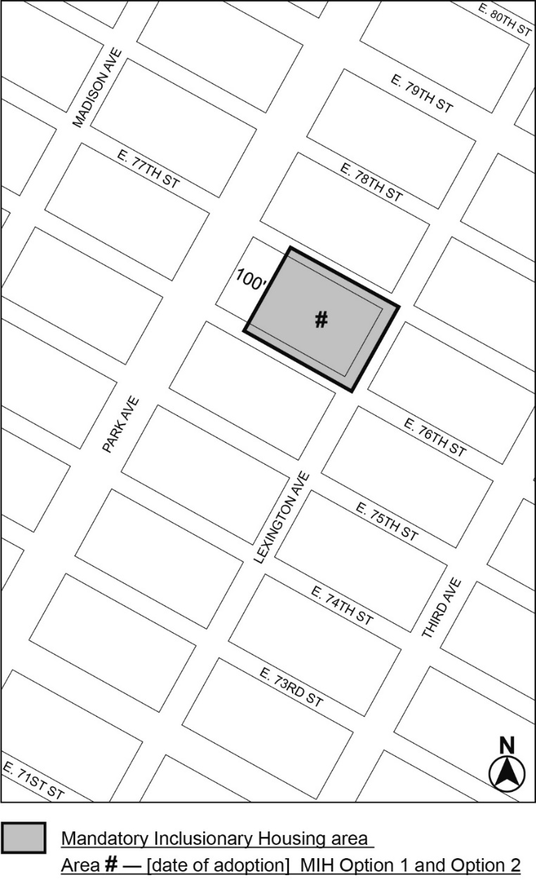
Portion of Community District 8, Manhattan
* * *
Adopted.
Office of the City Clerk,}
The City of New York,} ss.:
I hereby certify that the foregoing is a true copy of a Resolution passed by The Council of The City of New York on _________, 2025, on file in this office.

.....................................................
City Clerk, Clerk of The Council

