THE COUNCIL OF THE CITY OF NEW YORK
RESOLUTION NO. 539

Resolution approving the decision of the City Planning Commission on Application No. N 220307 ZRX, for an amendment of the text of the Zoning Resolution (Pre. L.U. No. 173).

By Council Members Salamanca and Riley

WHEREAS, M521 Tremont LLC, filed an application pursuant to Section 201 of the New York City Charter, for an amendment of the Zoning Resolution of the City of New York, modifying APPENDIX F for the purpose of establishing a Mandatory Inclusionary Housing area, which in conjunction with the related action would facilitate the construction of a 14-story mixed use development containing 205 dwelling units, along with a cellar, ground floor commercial and residential space, community facility space, outdoor terraces, and parking, at 521 East Tremont Avenue in the East Tremont neighborhood of Bronx, Community District 6 (ULURP No. N 220307 ZRX) (the “Application”);

WHEREAS, the City Planning Commission filed with the Council on February 3, 2023, its decision dated February 1, 2023 (the “Decision”), on the Application;

WHEREAS, the Application is related to application C 220306 ZMX (L.U. No. 172), a zoning map amendment to change C4-5X, M1-4/R7A, and R6A zoning districts to a C4-4D zoning district;

WHEREAS, the Decision is subject to review and action by the Council pursuant to Section 197-d of the City Charter;

WHEREAS, upon due notice, the Council held a public hearing on the Decision and Application on February 8, 2023;

WHEREAS, the Council has considered the land use implications and other policy issues relating to the Decision and Application; and

WHEREAS, the Council has considered the relevant environmental issues, including the Negative Declaration issued September 16, 2022 (CEQR No. 22DCP123X), which include an (E) designation to avoid the potential for significant adverse impacts related to hazardous materials and noise impacts (E-687) (the “Negative Declaration”).

RESOLVED:

The Council finds that the action described herein will have no significant impact on the environment as set forth in the Negative Declaration.

Pursuant to Sections 197-d and 200 of the City Charter and on the basis of the Decision and Application, and based on the environmental determination and consideration described in the report, N 220307 ZRX, incorporated by reference herein, and the record before the Council, the Council approves the Decision of the City Planning Commission.

Matter underlined is new, to be added;
Matter struck out is to be deleted;
Matter within # # is defined in Section 12-10;
* * * indicates where unchanged text appears in the Zoning Resolution

* * *

APPENDIX F
Inclusionary Housing Designated Areas and Mandatory Inclusionary Housing Areas

* * *

THE BRONX

* * *

The Bronx Community District 6

* * *

Map 3 – [date of adoption]

[PROPOSED MAP]

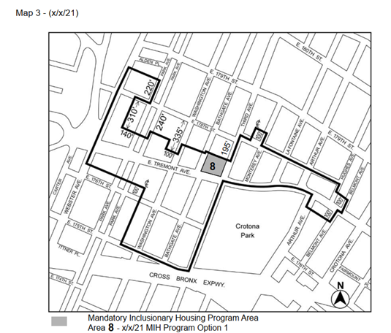

* * *

Adopted.

Office of the City Clerk, }
The City of New York, } ss.:

I hereby certify that the foregoing is a true copy of a Resolution passed by The Council of The City of New York on __________, 2023, on file in this office.

.....................................................
City Clerk, Clerk of The Council

