THE COUNCIL OF THE CITY OF NEW YORK
RESOLUTION NO. 736

Resolution approving the decision of the City Planning Commission on Application No. N 230002 ZRK, for an amendment of the text of the Zoning Resolution (L.U. No. 242).

By Council Members Salamanca and Riley

WHEREAS, 7120 New Utrecht, LLC, filed an application pursuant to Section 201 of the New York City Charter, for an amendment of the text of the Zoning Resolution of the City of New York, modifying APPENDIX F for the purpose of establishing a Mandatory Inclusionary Housing area, which in conjunction with the related action would facilitate the development of a nine-story, 85,034-square-foot mixed-use building containing 100 dwelling units, approximately 30 of which would be permanently income-restricted, 11,651 square feet of commercial floor area at 7120 New Utrecht Avenue in the Bensonhurst neighborhood of Brooklyn, Community District 11 (ULURP No. N 230002 ZRK), (the “Application”);

WHEREAS, the City Planning Commission filed with the Council on June 20, 2023, its decision dated June 7, 2023 (the “Decision”) on the Application;

WHEREAS, the Application is related to application C 230001 ZMK (L.U. No. 241), a zoning map amendment to change an R5/C2-2 zoning district to a C4-4L zoning district;

WHEREAS, the Decision is subject to review and action by the Council pursuant to Section 197-d of the City Charter;

WHEREAS, upon due notice, the Council held a public hearing on the Decision and Application on June 28, 2023;

WHEREAS, the Council has considered the land use implications and other policy issues relating to the Decision and Application; and

WHEREAS, the Council has considered the relevant environmental issues, including the Negative Declaration issued January 30th, 2023 (CEQR No. 23DCP002K) (the “Negative Declaration”).

RESOLVED:

The Council finds that the action described herein will have no significant impact on the environment as set forth in the Negative Declaration.

Pursuant to Sections 197-d and 200 of the City Charter and on the basis of the Decision and Application, and based on the environmental determination and consideration described in the report, N 230002 ZRK, incorporated by reference herein, and the record before the Council, the Council approves the Decision of the City Planning Commission.

Matter underlined is new, to be added;
Matter struck out is to be deleted;
Matter within # # is defined in Section 12-10;
* * * indicates where unchanged text appears in the Zoning Resolution

* * *
APPENDIX F
Inclusionary Housing Designated Areas and Mandatory Inclusionary Housing Areas
* * *
BROOKLYN
* * *
Brooklyn Community District 11
* * *

Map 3 – [date of adoption]

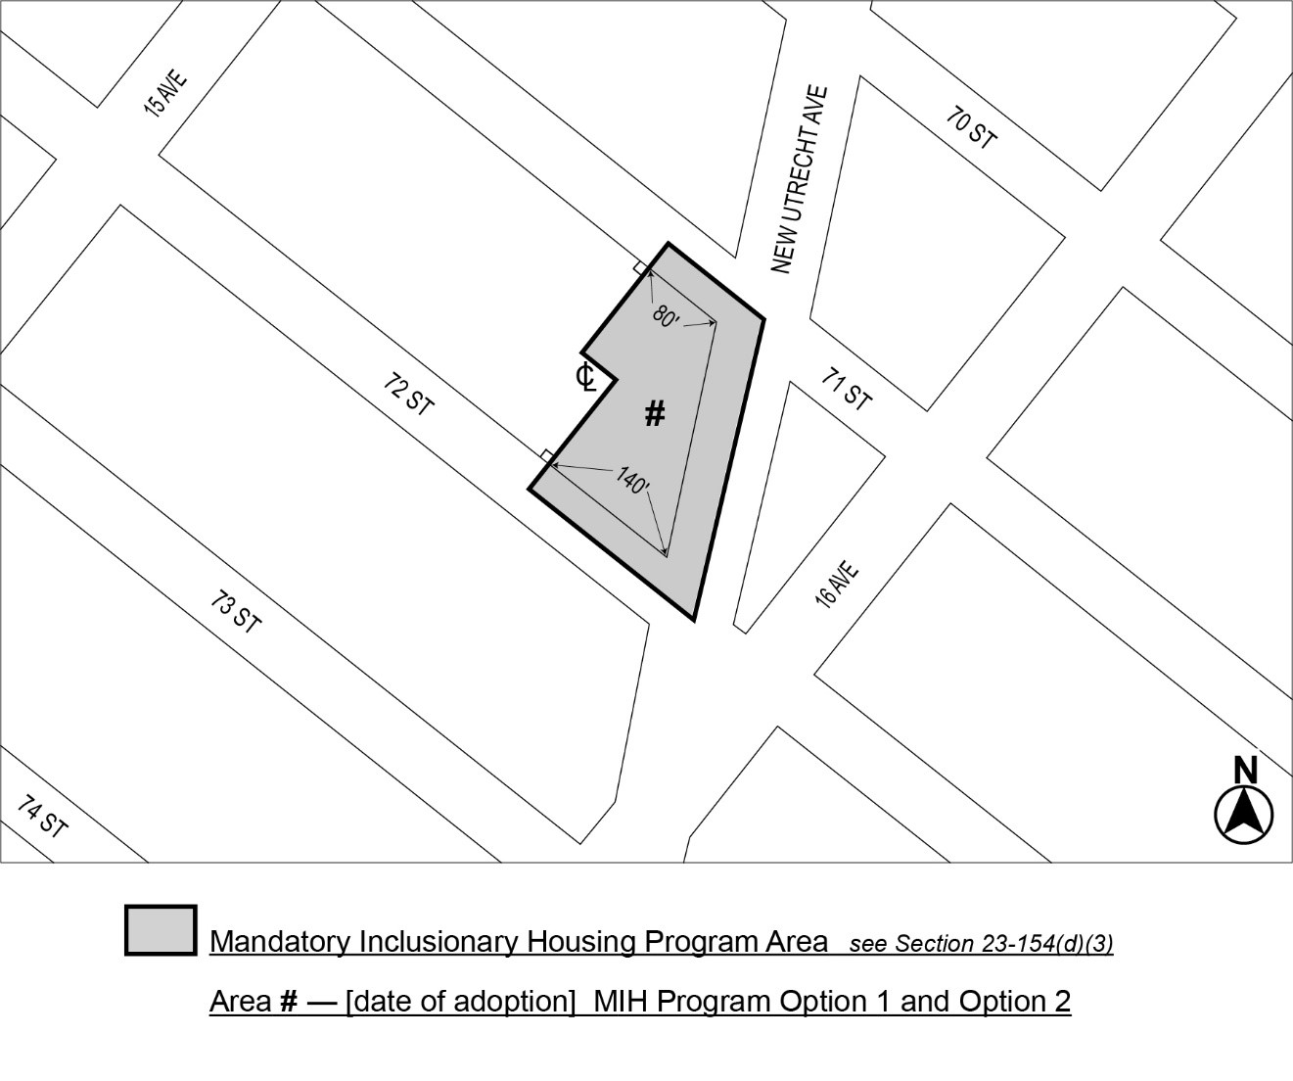

Portion of Community District 11, Brooklyn
* * *
Adopted.
Office of the City Clerk,}
The City of New York,} ss.:

I hereby certify that the foregoing is a true copy of a Resolution passed by The Council of The City of New York on _________, 2023, on file in this office.

.....................................................
City Clerk, Clerk of The Council

