Committee on Public Safety:
Daniel Ades, Senior Legislative Counsel
Maxwell Kampfner-Williams, Legislative Counsel
Casie Addison, Senior Policy Analyst

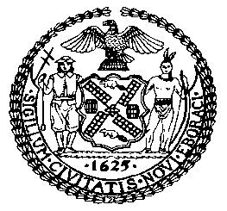

THE COUNCIL OF THE CITY OF NEW YORK
BRIEFING PAPER AND COMMITTEE REPORT OF THE
GOVERNMENTAL AFFAIRS DIVISION
Jeffrey Baker, Legislative Director
Brian Crow, Deputy Director, Justice Division

COMMITTEE ON PUBLIC SAFETY
Hon. Donovan Richards, Chair

January 22, 2019

Oversight: Preventing Hate Crimes in NYC

PROPOSED INT. NO. 1234-A By Council Members Levine, Cumbo, Deutsch, Richards, Constantinides, Koslowitz, Chin, Treyger, Maisel, Levin and Rosenthal

TITLE: A Local Law to amend the New York city charter, in relation to creating an office for the prevention of hate crimes

NEW YORK CITY CHARTER: Adds new section 20-F

PROPOSED INT. NO. 1261-A By Council Members Deutsch, Richards, Levine, Vallone, Eugene, Menchaca, Moya, Ampry-Samuel, Cabrera, Gibson, Levin, Lancman and Rodriguez

TITLE: A Local Law to amend the New York city charter, in relation to requiring educational outreach within the office of prevention of hate crimes.

NEW YORK CITY CHARTER: Amends section 20-F

- INTRODUCTION
On January 22, 2019, the Committee on Public Safety, chaired by Donovan Richards, will vote on Proposed Introduction Number 1234-A (Prop. Int. 1234-A) and Proposed Introduction Number 1261-A (Prop. Int. 1261-A). The Committee previously heard these bills on November 19, 2018. Representatives of the New York Police Department (NYPD) and various advocates, stakeholders, and members of the public testified at that hearing.
- NYPD’S HATE CRIME TASK FORCE
The NYPD’s Hate Crime Task Force, formally known as the Bias Incident Investigative Unit, is a dedicated citywide team of investigators who are responsible for investigating all hate crimes and related incidents. The Unit is part of the Special Victims Division. Patrol Officers responding to the scene of crimes that may be the result of bias refer these cases to the Hate Crime Task Force. According to the Patrol Guide, the Commanding Officer of the Task Force then determines how an investigation of the incident should proceed. The investigation may be conducted wholly by the Task Force or precinct detectives or may be a joint investigation between the two. Pursuant to the guidelines in the Patrol Guide, officers investigating incidents of bias should include personal contact with the victims of the alleged bias incident. Investigators must make a determination of whether the incident was in fact bias motivated and issue a report within 10 days. Throughout this process, reports on the progress of the bias incident investigation are recorded on the following forms: Complaint Follow Up (PD313-081), Complaint Report (PD313-152), Complaint Report Worksheet (PD313-152A), and Unusual Occurrence Report (PD370-152).
The Hate Crime Task Force is also required to compile reports on bias related incidents and use this data to conduct analyses designed to assist the Department and the City in coordinating an appropriate response to these incidents.
- RECENT HATE CRIME TRENDS
Several reports have shown a spike in hate crimes both nationally and locally. According to the Federal Bureau of Investigation’s (FBI) Uniform Crime Reporting Program, the number of hate crime incidents reported in 2017 increased by 17% from the year prior. The Uniform Crime Reporting Program’s Hate Crime Statistics report is comprised of incidents reported to the federal government by law enforcement agencies. In 2017, law enforcement agencies reported 7,175 hate crimes incidents compared to 6,121 in 2016. The 2017 incidents encompassed 8,437 total offenses and involved 8,825 victims. While the total number of reported hate crimes grew, so did the number of law enforcement agencies reporting hate crime data. According to the FBI, nearly 1,000 law enforcement agencies contributed information related to hate crimes that had `not the year before. The FBI has reported an increase in hate crimes consistently for the past 3 years, with a 5% increase between 2015 and 2016.
Of the 8,828 victims of hate crimes in 2017, 59.65% were targeted based on their race/ethnicity, 20.6% were victimized because of bias against religion, and 15.8% were targeted because of bias against their perceived sexuality. Of the 5,060 victims of racial bias hate crimes, nearly 50% were victims of anti-Black or African American bias. Similarly, of the 1,749 victims of anti-religious hate crimes, 58.1% were victims of crimes motivated by anti-Jewish bias.
The NYPD is required to report hate crime complaints and arrests pursuant to Local Law 130 of 2016. These data show that local trends mirror those at the national level. In 2017, 325 hate crimes were reported to the NYPD, of which 135 arrests were made, a slight decrease from 333 reported hate crimes in 2016. Of reported hate crimes in 2017, 46.46% were motivated by anti-Jewish bias. The number of anti-Jewish hate crime complaints is consistently much higher than all other bias motivations.
The following charts are based on NYPD data that is posted online. It is crucial to note that these statistics reflect the number of complaints made to the NYPD rather than the number of hate crimes that actually occurred. In addition, there are some discrepancies between the quarterly reports and the annual totals that may suggest the quarterly data contains duplicate entries or incidents that were incorrectly tabulated as hate crimes and later corrected.

Complaints
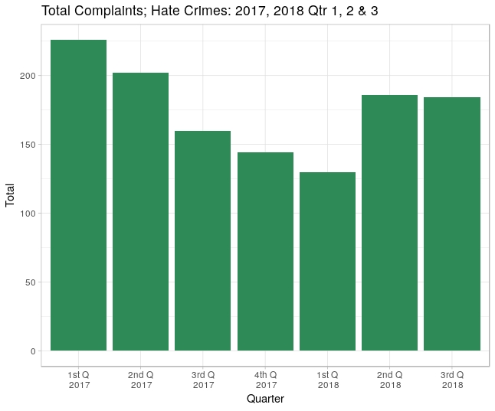
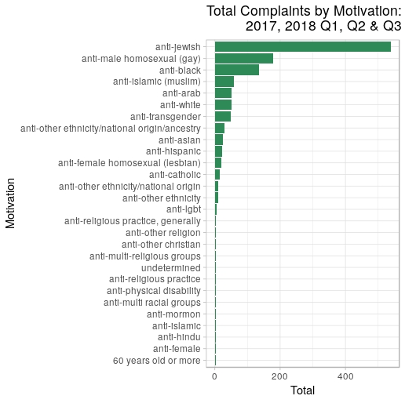

Arrests
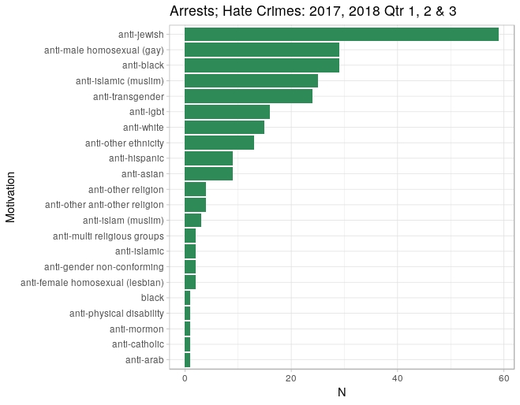
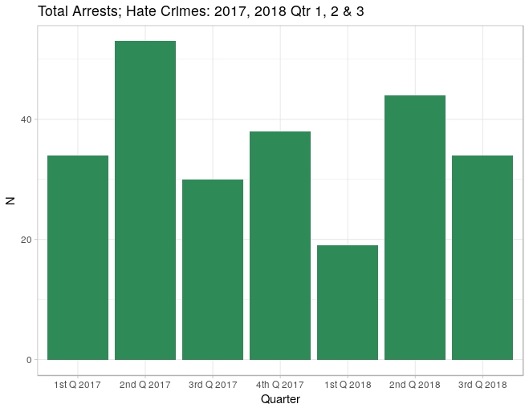

- RECENT NOTABLE INCIDENTS IN NEW YORK CITY
The rise in hate crimes in New York City has had particular effects on certain communities, leading to growing fears and concerns about safety, specifically in the years following the 2016 presidential election. Anti-Jewish hate crimes and sentiments have made up a significant proportion of reported crimes in the City, accounting for nearly half of reported crimes so far this year. According to the New York Times, there have been four times as many crimes motivated by bias against Jews as compared to crimes motivated by bias against Black/African Americans.
Several notable anti-Jewish hate crimes and sentiments have occurred around the City. In one month last year, within a few days, a graffiti swastika along with “KKK” was found on a police/fire call box on the Upper West Side in Manhattan, and two Orthodox Jewish men were attacked on the street in a Hasidic Jewish neighborhood in Brooklyn. Days before Halloween, last year, swastikas appeared at a popular trick-or-treating area in Brooklyn Heights. In early November of 2018, a get-out-the-vote event was cancelled at a Brooklyn synagogue after anti-Semitic graffiti was discovered on the temple’s walls, just days following the mass shooting at a synagogue in Pittsburgh. Other anti-Semitic hate crimes were reported that same weekend, as surveillance footage showed a group of teenagers throwing a metal pipe through a window during a service at the Congregation Aveni Aish Volkin in Bedford Stuyvesant, Brooklyn.
While anti-Jewish bias hate crimes represent a large share of reported crimes in the City, crimes against protected identities are generally on the rise. On October 31, 2018 the African Burial Ground Monument, which contain 15,000 remains of enslaved persons in Lower Manhattan, was defaced with racist slurs, as a vandal wrote “Kill N-ggers” on a plaque. In early November, Ann Marie Washington, a black woman was punched and stabbed on a subway platform in Brooklyn, while her assailant yelled expletives at her. In September of last year, two gay men were attacked in Brooklyn after leaving a bar in Williamsburg. According to the police department the assailant uttered anti-gay slurs before injuring both men, rendering them unconscious.
In October, the Metropolitan Republican Club in Manhattan hosted Gavin McInnes, the founder of the ‘Proud Boys’, a right-wing organization with ties to white supremacist groups, leading to a series of brawls and arrests. The event highlighted the ongoing conflict of identifying the harmful nature of hate speech and holding those accountable while protecting the right to free speech.

- ANALYSIS OF PROP. INT. NO. 1234-A
This bill would require the mayor to establish an office for the prevention of hate crimes. The office would be headed by a coordinator, whose duties would include: advising and assisting the mayor in the planning and implementation of a coordinated response to hate crimes among the agencies involved in the prevention, awareness, investigation, prosecution and impact on communities of hate crimes; reviewing the budget requests of all agencies for programs related to hate crimes; reporting on the activities of the office, the areas in the city that are vulnerable to hate crimes, the security concerns of neighborhoods, schools, and houses of worship, the efficacy of available resources for victims of hate crimes, and statistics on hate crime complaints within the city; studying the effectiveness of safety plans and resources available for victims in vulnerable communities; and serving as a liaison for the city with providers of victim services.
This bill would take effect 9 months after it became law.

- AMENDMENTS TO PROP. INT. NO. 1234-A
Prop. Int. 1234-A has been amended since it was heard as Preconsidered Int. No. 1234. The bill now allows the NYPD to not diclose information that is confidential or would compromise safety. In addition, for security purposes, the bill no longer requires an assessment of institutional security concerns to be published online.

- ANALYSIS OF PROP. INT. NO. 1261-A
This bill would add to the duties of the office of hate crimes by requiring it to establish a division of educational outreach on the impact and effects of hate crimes, including measures to achieve greater tolerance and understanding, and coordination with relevant city agencies, interfaith organizations, community groups, and civil rights groups. The office would also be required to report on the populations which the division of educational outreach addressed, the types of programs created or provided by the division, and any other outreach, education, and prevention efforts made by the division.
This bill would take effect on the same day as Prop. Int. No. 1234-A.

- AMENDMENTS TO PROP. INT. NO. 1261-A
Prop. Int. 1261-A has had no substantive amendments since it was heard as Preconsidered Int. No. 1261.

Proposed Int. No. 1234-A

By Council Members Levine, Cumbo, Deutsch, Richards, Constantinides, Koslowitz, Chin, Treyger, Maisel, Levin and Rosenthal

A LOCAL LAW

To amend the New York city charter, in relation to creating an office for the prevention of hate crimes

Be it enacted by the Council as follows:

Section 1. Chapter 1 of the New York city charter is amended by adding a new section 20-g to read as follows:
§ 20-g Office for the prevention of hate crimes. a. The mayor shall establish an office for the prevention of hate crimes. Such office may be established within any office of the mayor or as a separate office or within any other office of the mayor or within any department the head of which is appointed by the mayor. Such office shall be headed by a coordinator who shall be appointed by the mayor or the head of such department. For the purposes of this section only, “coordinator” shall mean the coordinator of the office for the prevention of hate crimes.
b. Powers and duties. The coordinator shall have the power and the duty to:
1. Advise and assist the mayor in planning and implementing for coordination and cooperation among agencies under the jurisdiction of the mayor that are involved in prevention, awareness, investigation and prosecution, and impact on communities of hate crimes.
2. Create and implement a coordinated system for the city’s response to hate crimes. Such system shall, in conjunction with the New York city commission on human rights’ bias response teams, the police department, and any relevant agency or office, coordinate responses to hate crime allegations.
3. Review the budget requests of all agencies for programs related to hate crimes, and recommend to the mayor budget priorities among such.
4. Prepare and submit to the mayor and the council and post on the city’s website by January 30 of each year an annual report of the activities of the office, regarding the prevalence of hate crimes during the previous calendar year and the availability of services to address the impact of these crimes. Such report shall include but need not be limited to the following information: (i) identification of areas or populations within the city that are particularly vulnerable to hate crimes, (ii) identification and assessment of the efficacy of counseling and resources for victims of hate crimes, making recommendations for improvements of the same, and (iii) collation of city, state and federal statistics on hate crime complaints and prosecutions within the city, including incidents by offense, bias motivation, and demographic characteristics such as age and gender of offenders.
5. Study the effectiveness of, and make recommendations with respect to, the expansion of safety plans for neighborhoods and institutions that are particularly vulnerable to hate crimes, and the resources available for victims. This paragraph shall not require the disclosure of material that would reveal non-routine investigative techniques or confidential information or where disclosure could compromise the safety of the public or police officers or could otherwise compromise law enforcement investigations or operations.
6. Serve as liaison for the city with providers of victim services, community groups, and other relevant nongovernmental entities and assist in the coordination among such entities on reporting and responding to allegations of hate crimes, to ensure that city residents have access to relevant services after hate crime events.
7. Perform other duties as the mayor may assign.
§2. This local law takes effect nine months after it becomes law.
LS # 3942
MKW
1/15/19

Proposed Int. No. 1261-A

By Council Members Deutsch, Richards, Levine, Vallone, Eugene, Menchaca, Moya, Ampry-Samuel, Cabrera, Gibson, Levin, Lancman and Rodriguez

A LOCAL LAW

To amend the New York city charter, in relation to requiring educational outreach within the office of prevention of hate crimes

Be it enacted by the Council as follows:

Section 1. Paragraph 4 of subdivision b of section 20-g of the New York city charter, as added by a local law for the year 2019 amending the New York city charter, relating to creating the office for the prevention of hate crimes, as proposed in introduction number 1234 for the year 2018, is amended to read as follows:
4. Prepare and submit to the mayor and the council and post on the city’s website by January 30 of each year an annual report of the activities of the office, regarding the prevalence of hate crimes during the previous calendar year and the availability of services to address the impact of these crimes. Such report shall include but need not be limited to the following information: (i) identification of areas or populations within the city that are particularly vulnerable to hate crimes, (ii) identification and assessment of the efficacy of counseling and resources for victims of hate crimes, making recommendations for improvements of the same, [and] (iii) collation of city, state and federal statistics on hate crime complaints and prosecutions within the city, including incidents by offense, bias motivation, and demographic characteristics such as age and gender of offenders, (iv) the populations to which the division of educational outreach addressed, (v) the types of programs created or provided by the division of educational outreach and the names of the providers of such programs, and (vi) any other outreach, education, and prevention efforts made by the division of educational outreach.
§ 2. Section 20-g of the New York city charter, as added by a local law for the year 2019 amending the New York city charter, relating to creating the office for the prevention of hate crimes, as proposed in introduction number 1234 for the year 2018, is amended by adding a new subdivision c to read as follows:
c. The coordinator shall establish a division of educational outreach. The division shall have the power and the duty to:
1. Ensure, by such means as necessary, including coordination with relevant city agencies and interfaith organizations, community groups, and human rights and civil rights groups, the provision of effective outreach and education on the impact and effects of hate crimes, including measures necessary to achieve greater tolerance and understanding, and including the use of law enforcement where appropriate.
2. Create a K-12 curriculum addressing issues related to hate crimes, in consultation with the department of education.
3. Perform other duties as the mayor may assign.
§ 3. This local law takes effect on the same date as a local law for the year 2019 amending the New York city charter, relating to creating the office for the prevention of hate crimes, as proposed in introduction number 1234 for the year 2018, takes effect.

LS # 8664
MKW
1/15/19

The Official Website of the New York City Police Department “Hate Crimes/Bias Incidents” available at https://www1.nyc.gov/site/nypd/services/law-enforcement/hate-crimes.page
The Official Website of the New York City Police Department “Hate Crimes/Bias Incident” available at https://www1.nyc.gov/site/nypd/services/law-enforcement/hate-crimes.page
See NYPD Patrol Guide “Bias Motivated Incidents” Section: Complaints Procedure No. 207-10 available at https://www1.nyc.gov/assets/ccrb/downloads/pdf/investigations_pdf/pg207-10-bias-motivated-incidents.pdf
See NYPD Patrol Guide “Bias Motivated Incidents” Section: Complaints Procedure No. 207-10 available at https://www1.nyc.gov/assets/ccrb/downloads/pdf/investigations_pdf/pg207-10-bias-motivated-incidents.pdf
See NYPD Patrol Guide “Bias Motivated Incidents” Section: Complaints Procedure No. 207-10 available at https://www1.nyc.gov/assets/ccrb/downloads/pdf/investigations_pdf/pg207-10-bias-motivated-incidents.pdf
See NYPD Patrol Guide “Bias Motivated Incidents” Section: Complaints Procedure No. 207-10 available at https://www1.nyc.gov/assets/ccrb/downloads/pdf/investigations_pdf/pg207-10-bias-motivated-incidents.pdf
See NYPD Patrol Guide “Bias Motivated Incidents” Section: Complaints Procedure No. 207-10 available at https://www1.nyc.gov/assets/ccrb/downloads/pdf/investigations_pdf/pg207-10-bias-motivated-incidents.pdf
See NYPD Patrol Guide “Bias Motivated Incidents” Section: Complaints Procedure No. 207-10 available at https://www.fbi.gov/news/pressrel/press-releases/fbi-releases-2017-hate-crime-statistics
See NYPD Patrol Guide “Bias Motivated Incidents” Section: Complaints Procedure No. 207-10 available at https://www.fbi.gov/news/pressrel/press-releases/fbi-releases-2017-hate-crime-statistics
“FBI Releases 2017 Hate Crime Statistics” Federal Bureau of Investigations November 13, 2018 available at https://www.fbi.gov/news/pressrel/press-releases/fbi-releases-2017-hate-crime-statistics
See “2017 Hate Crime Statistics – Victim Data” Federal Bureau of Investigations available at https://ucr.fbi.gov/hate-crime/2017/topic-pages/victims
See NYPD Patrol Guide “Bias Motivated Incidents” Section: Complaints Procedure No. 207-10 available at https://www.fbi.gov/news/stories/2017-hate-crime-statistics-released-111318
See NYPD Patrol Guide “Bias Motivated Incidents” Section: Complaints Procedure No. 207-10 available at https://ucr.fbi.gov/hate-crime/2017/topic-pages/victims
See NYPD Patrol Guide “Bias Motivated Incidents” Section: Complaints Procedure No. 207-10 available at https://ucr.fbi.gov/hate-crime/2017/topic-pages/victims
The Official Website of the New York City Police Department “Hate Crimes Reports” https://www1.nyc.gov/site/nypd/stats/reports-analysis/hate-crimes.page
Weiss, Murray “Hate Crimes Jump 30 Percent in 2016, NYPD Stats Show” DNA Info New York November 16, 2016 available at https://www.dnainfo.com/new-york/20161116/civic-center/nypd-hate-crime-statistics-2016-2015/
Bellafante, Ginia “Is It Safe to Be Jewish in New York” New York Times October 31, 2018 available at https://www.nytimes.com/2018/10/31/nyregion/jewish-bias-safety-nyc.html
Bellafante, Ginia “Is It Safe to Be Jewish in New York” New York Times October 31, 2018 available at https://www.nytimes.com/2018/10/31/nyregion/jewish-bias-safety-nyc.html
Rashbaum, William and Winston, Ali “Ilana Glazer Event at Synagogue Is Canceled After Anti-Semitic Graffiti Is Found” New York Times November 2, 2018 available at https://www.nytimes.com/2018/11/02/nyregion/broad-city-jewish-synagogue-anti-semitism.html?rref=collection%2Fsectioncollection%2Fnyregion&action=click&contentCollection=nyregion&region=rank&module=inline&version=highlights&contentPlacement=2&pgtype=sectionfront
Roberston, Campball “11 Killed in Synagogue Massacre; Supsect Charged With 29 Counts” New York Times October 27, 2018 available at https://www.nytimes.com/2018/10/27/us/active-shooter-pittsburgh-synagogue-shooting.html?module=inline
Offenhartz, Jake “De Blasio, Cuomo Accused of Indifference After Racist Graffiti Discovered At African Burial Ground Monument” Gothamist November 5, 2018 available at http://gothamist.com/2018/11/05/african_burial_ground_monument.php
Watkins, Ali “Racist Slur Defaces African Burial Ground Monument in Lower Manhattan” New York Times November 2, 2018 available at https://www.nytimes.com/2018/11/02/nyregion/african-burial-ground-monument-racial-slur.html
Whaley, Natelege “The Stabbing of Ann Marie Washington Should Call Attention to Hate Crimes in Public Spaces” Mic November 13, 2018 available at https://mic.com/articles/192427/the-stabbing-of-ann-marie-washington-should-call-attention-to-rising-hate-crimes-in-public-spaces#.pYK7BVIy3
Fitzsimmons, Tim “Police hunt for suspect in alleged anti-gay attack in Brooklyn” NBC News September 24, 2018 available at https://www.nbcnews.com/feature/nbc-out/police-hunt-suspect-alleged-anti-gay-attack-brooklyn-n912681
Goldmacher, Shane “Fight Breaks Out Near Republican Club After Visit by Gavin McInnes, Police Say” New York Times October 12, 2018 available at https://www.nytimes.com/2018/10/12/nyregion/gavin-mcinnes-republican-club-vandalized.html?module=inline

