THE COUNCIL OF THE CITY OF NEW YORK
RESOLUTION NO. 1480

Resolution approving modifications the decision of the City Planning Commission on Application No. N 160222 ZRK, for an amendment of the Zoning Resolution of the City of New York, modifying Appendix F (Inclusionary Housing Designated Areas) and a related section in Article XII, Chapter 3 (Special Mixed Use District) to apply Inclusionary Housing regulations in Community District 3, Borough of Brooklyn (L.U. No. 590).

By Council Members Greenfield and Richards

WHEREAS, the City Planning Commission filed with the Council on March 10, 2017 its decision dated March 8, 2017 (the "Decision"), pursuant to Section 201 of the New York City Charter, regarding an application submitted by Riverside Developers USA, Inc. for an amendment of the text of the Zoning Resolution of the City of New York, modifying Appendix F (Inclusionary Housing Designated Areas) and a related section in Article XII, Chapter 3 (Special Mixed Use District) to apply Inclusionary Housing regulations in Brooklyn Community District 3. This action, along with the related amendment to the Zoning Map would facilitate the development of two new buildings in the Bedford-Stuyvesant neighborhood of Brooklyn, (Application No. N 160222 ZRK), Community District 3, Borough of Brooklyn (the "Application");

WHEREAS, the Application is related to application C 160221 ZMK (L.U. No. 589), an amendment to the Zoning Map changing an M1-2 zoning district on portions of two blocks to an R7A/C2-4 district and an M1-2/R6A (MX-4) district;

WHEREAS, the Decision is subject to review and action by the Council pursuant to Section 197-d(b)(1) of the City Charter;
WHEREAS, upon due notice, the Council held a public hearing on the Decision and Application on March 28, 2017;

WHEREAS, the Council has considered the land use implications and other policy issues relating to the Decision and Application; and

WHEREAS, the Council has considered the relevant environmental issues, including the negative declaration issued October 4, 2016 (CEQR No. 16DCP121K), which includes (E) designations to avoid the potential for significant adverse impacts related to hazardous materials, air quality, and noise (E-395) (the “Negative Declaration”);

RESOLVED:

The Council finds that the action described herein will have no significant impact on the environment as set forth in the Negative Declaration.

Pursuant to Sections 197-d and 200 of the City Charter and on the basis of the Decision and Application, and based on the environmental determination and consideration described in the report, N 160222 ZRK, incorporated by reference herein, the Council approves the Decision with the following modifications:

Matter underlined is new, to be added;
Matter struck out is to be deleted;
Matter within # # is defined in Section 12-10;
Matter in double strikeout is old, deleted by the City Council;
Matter in double-underline is new, added by the City Council;
* * * indicates where unchanged text appears in the Zoning Resolution

Article XII - Special Purpose Districts

Chapter 3
Special Mixed Use District

* * *

123-63
Maximum Floor Area Ratio and Lot Coverage Requirements for Zoning Lots Containing Only Residential Buildings in R6, R7, R8 and R9 Districts

* * *
However, in #Inclusionary Housing designated areas# and #Mandatory Inclusionary Housing areas#, as listed in the table in this Section, the maximum permitted #floor area ratio# shall be as set forth in Section 23-154 (Inclusionary Housing). The locations of such districts are specified in APPENDIX F of this Resolution.

#Special Mixed Use District# | Designated #Residence District#
MX 2 - Community District 2  Brooklyn | R7A R8A
MX 4 - Community District 3  Brooklyn | R6A
MX 8 - Community District 1  Brooklyn | R6 R6A R6B R7A

* * *

APPENDIX F
Inclusionary Housing Designated Areas and Mandatory Inclusionary Housing Areas

* * *

BROOKLYN

* * *

Brooklyn Community District 3

In the R6A, R7A, and R7D Districts within the areas shown on the following Maps 1, 2, 3, 4, and 5:

* * *

Map 3 – [date of adoption]

[PROPOSED MAP]

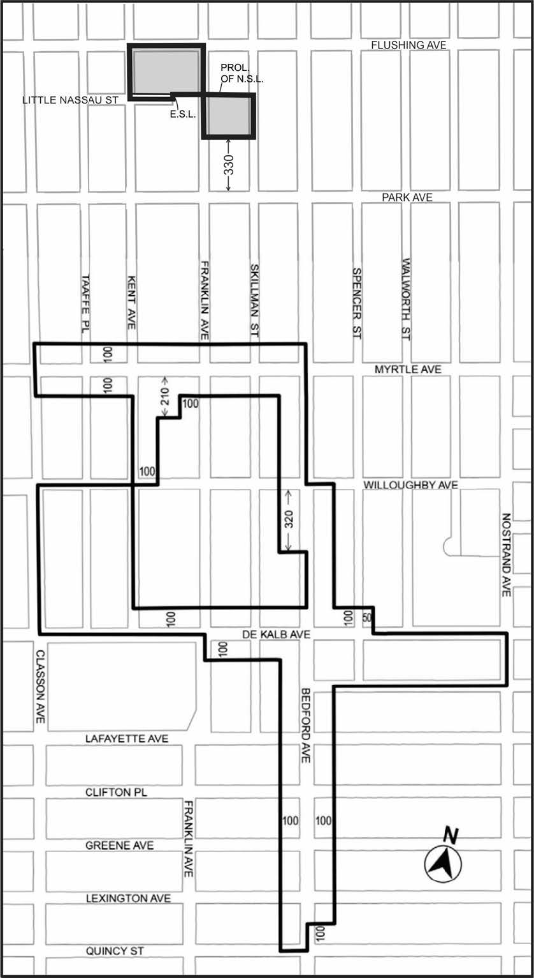
1
2

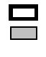
Inclusionary Housing Designated Area
Mandatory Inclusionary Housing area see Section 23-154(d)(3)

Area 1 (date of adoption) ─ MIH Program Option 1, Option 2 and Workforce Option
Area 2 (date of adoption) ─ MIH Program Option 1 and Option 2

Portion of Community District 3, Brooklyn
* * *

Adopted.

Office of the City Clerk, }
The City of New York, } ss.:

I hereby certify that the foregoing is a true copy of a Resolution passed by The Council of The City of New York on May 10, 2017, on file in this office.

.....…….........................................
City Clerk, Clerk of The Council

