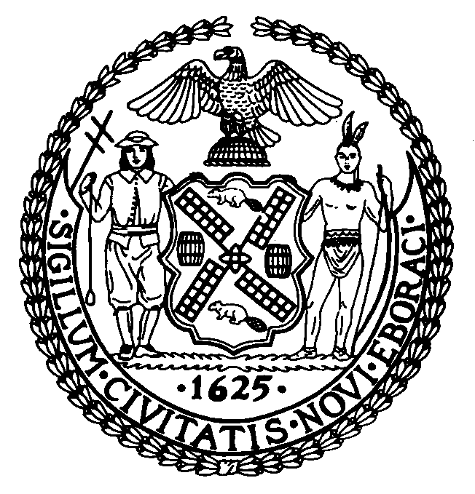 | The Council of the City of New York  Finance Division  Preston Niblack, Director  Fiscal Impact Statement  Intro. No: 940  Committee: Economic Development
Title: A Local Law to amend the administrative code of the city of New York, in relation to the boundaries of the Chinatown/Lower East Side empire zone | Sponsors: White, Jr. and Comrie (by the request of the Mayor)
Summary of Legislation: This legislation would authorize New York City to submit an application to the Commissioner of the New York State Department of Economic Development to revise the boundaries of the Manhattan’s Chinatown/Lower East Side Empire Zone (the “Empire Zone”) to include the East River Science Park.

Effective Date: This local law would take effect immediately.

Fiscal Year In Which Full Fiscal Impact Anticipated: 2009

Fiscal Impact Statement:

 | Effective FY09 | FY Succeeding  Effective FY10 | Full Fiscal  Impact FY09
Revenues | $0 | $0 | $0
Expenditures | $0 | $0 | $0
Net | $0 | $0 | $0

Impact on Revenues: There would be no impact on revenues by the enactment of this legislation.

Impact on Expenditures: There would be no impact on expenditures by the enactment of this legislation. The State, not the City, will bear the costs.

Source of Funds To Cover Estimated Costs: Not applicable

Source of Information: City Council Finance Division

Estimate Prepared By: Ralph P. Hernandez, Legislative Financial Analyst
Jonathan Rosenberg, Deputy Director
City Council Finance Division

History: Introduced by Council on February 26, 2009 and referred to the Committee on Economic Development as Int. 940. Hearing held by Committee on June 4, 2009 as Int. 940. To be considered by Committee on June 9, 2009 as Int. 940.

