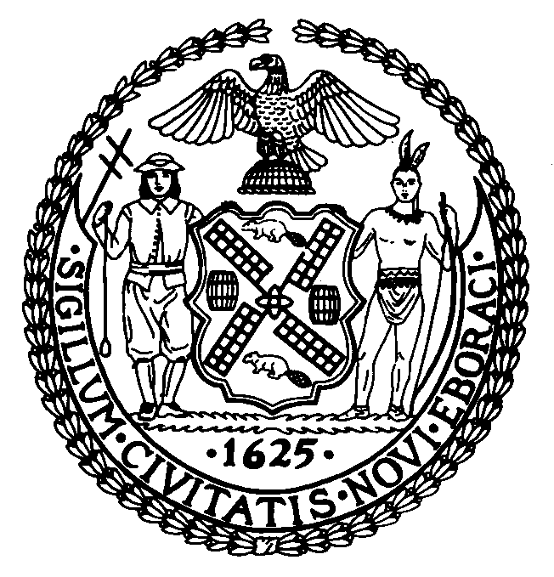

The Council of the City of New York

Finance Division
Preston Niblack, Director
Fiscal Impact Statement

Intro. No: 500

Committee: Parks and Recreation

Title: A Local Law in relation to the naming of six thoroughfares and public places.

Sponsor: By Council Members Avella and Palm

Summary of Legislation: The proposed law would rename, through the posting of additional signs, the following six thoroughfares and public places: Hillside Avenue, Borough of Queens; Douglas Road, Borough of Queens; Little Neck Road, Borough of Queens; Cherry Street, Borough of Queens; Willow Street, Borough of Queens; Boulevard, Borough of Queens; and to amend the official map of the city of New York accordingly.

New Name | Present Name | Limits
Hillside Avenue | 38th Road | Between Douglaston Parkway and Douglas Road
Douglas Road | Douglas Road/ Marinette Street | Between Hillside Avenue and West Drive
Little Neck Road | 38th Drive | Between Circle Road and Cherry Street
Cherry Street | 39th Avenue | Between Douglaston Parkway and Little Neck Road
Willow Street | 40th Avenue | Between Douglaston Parkway and Circle Road
Boulevard | 141st Street | Between the intersection of Center Drive and Point Crescent to the intersection of 141st Street and Boulevard

Effective Date: This local law would take effect immediately upon its enactment into law.

Fiscal Year IN, WHICH Full Fiscal Impact Anticipated: Fiscal 2009

Fiscal Impact Statement:
 | Effective FY09 | FY Succeeding  Effective FY10 | Full Fiscal  Impact FY09
Revenues (+) | $0 | $0 | $0
Expenditures (-) | ($5,996) | $0 | ($5,996)
Net | ($5,996) | $0 | ($5,996)

Impact on Revenues: There would be no impact on revenues resulting from the enactment of this legislation.

Impact on Expenditures: This legislation would require approximately 54 signs at a cost of $74 each and an additional $2,000 for the installation of these signs. The total cost of enacting this legislation would be approximately $ 5,996.

Source of Funds To Cover Estimated Costs: General Fund

Source of Information: City Council Finance Division

Estimate Prepared By: Latonia McKinney, Assistant Director
Chima Obichere, Legislative Financial Analyst

History: This legislation was introduced by Council and referred to the Committee on Parks and Recreation on February 1, 2007. Hearing held and laid over by the Committee on October 20, 2008. The Committee on Parks and Recreation will reconsider this legislation on October 23, 2008.

Fiscal Impact Schedule

New Name | Number of Signs | Cost | Installation (street signs only) | Total Cost
Hillside Avenue | 14 | 1,036 | 500 | 1,536
Douglas Road | 8 | 592 | 250 | 842
Little Neck Road | 4 | 296 | 250 | 546
Cherry Street | 10 | 740 | 250 | 990
Willow Street | 6 | 444 | 250 | 694
Boulevard | 12 | 888 | 500 | 1,388
TOTAL | 54 | $3,996 | $2,000 | $5,996

