THE COUNCIL OF THE CITY OF NEW YORK
RESOLUTION NO. 790

Resolution approving with modifications the decision of the City Planning Commission on Application No. N 240281 ZRK, for an amendment of the text of the Zoning Resolution (L.U. No. 213).

By Council Members Salamanca and Riley
WHEREAS, Arrow Linen Supply Co. Inc., filed an application pursuant to Section 201 of the New York City Charter, for an amendment of the text of the Zoning Resolution of the City of New York, modifying APPENDIX F for the purpose of establishing a Mandatory Inclusionary Housing area, which in conjunction with the related action would facilitate the development of two new 13-story buildings, totaling approximately 248,000 square feet, with approximately 244 dwelling units of which 61 would be permanently income-restricted pursuant to Mandatory Inclusionary Housing, located in Windsor Terrace, Brooklyn, Community District 7 (ULURP No. N 240281 ZRK), (the “Application”);
WHEREAS, the City Planning Commission filed with the Council on December 30, 2024, its decision dated December 16, 2024 (the “Decision”) on the Application;
WHEREAS, the Application is related to application C 240280 ZMK (L.U. No. 212), a zoning map amendment to rezone part of an R5B District to an R7-1 District;
WHEREAS, the Decision is subject to review and action by the Council pursuant to Section 197-d of the City Charter;
WHEREAS, upon due notice, the Council held a public hearing on the Decision and Application on January 9, 2025;
WHEREAS, the Council has considered the land use implications and other policy issues relating to the Decision and Application; and
WHEREAS, the Council has considered the relevant environmental issues, including the Negative Declaration issued on June 24, 2024 (CEQR No. 24DCP028K), which includes an (E) designation to avoid the potential for significant adverse impacts related to hazardous materials and air quality (E-759) (the “Negative Declaration”).
RESOLVED:
The Council finds that the action described herein will have no significant impact on the environment as set forth in the (E) Designation (E-759) and Negative Declaration.
Pursuant to Sections 197-d and 200 of the City Charter and on the basis of the Decision and Application, and based on the environmental determination and consideration described in the report, N 240281 ZRK, incorporated by reference herein, and the record before the Council, the Council approves the Decision of the City Planning Commission, with the following modifications.
Matter underlined is new, to be added;
Matter struck out is to be deleted;
Matter double struck out is old, deleted by the City Council;
Matter double-underlined is new, added by the City Council;
Matter within # # is defined in Section 12-10;
* * * indicates where unchanged text appears in the Zoning Resolution.

* * *
APPENDIX F
Inclusionary Housing Designated Areas and Mandatory Inclusionary Housing Areas

* * *
BROOKLYN

* * *
Brooklyn Community District 7

* * *
Map 4 — [date of adoption]

[PROPOSED MAP]
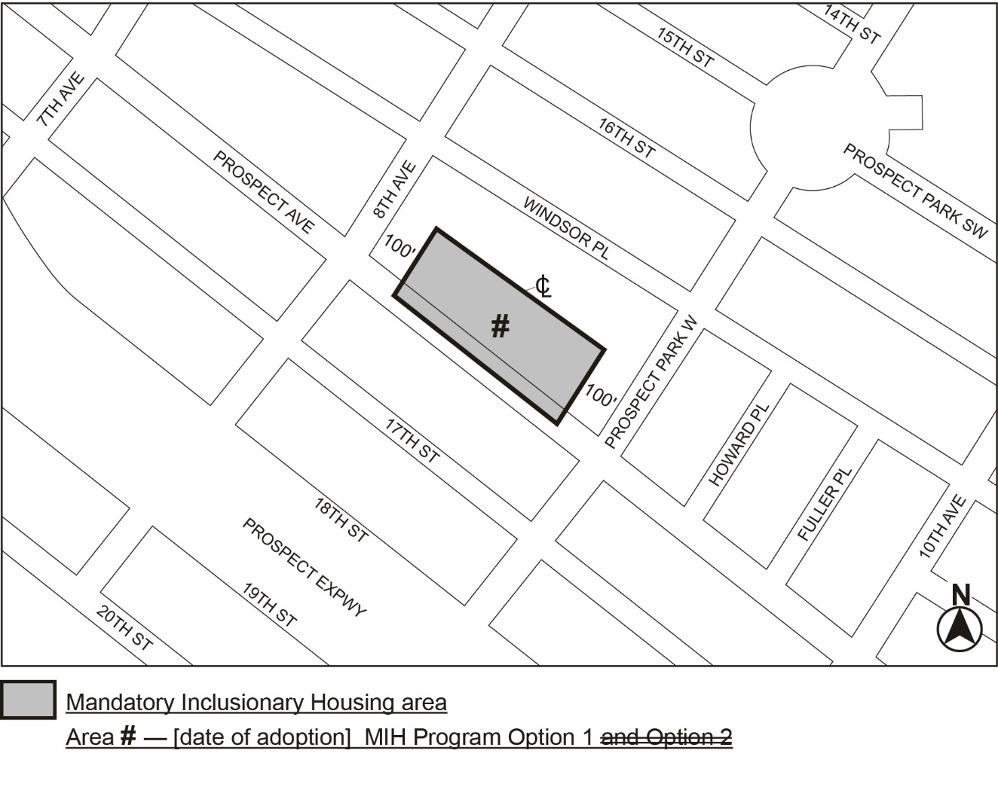
Portion of Community District 7, Brooklyn

* * *

Adopted.

Office of the City Clerk,}
The City of New York,} ss.:

I hereby certify that the foregoing is a true copy of a Resolution passed by The Council of The City of New York on _________, 2025, on file in this office.

.....................................................
City Clerk, Clerk of The Council

