THE COUNCIL OF THE CITY OF NEW YORK
RESOLUTION NO. 1893

Resolution approving with modifications the decision of the City Planning Commission on Application No. N 210165 ZRQ, for an amendment of the text of the Zoning Resolution (L.U. No. 926).

By Council Members Salamanca and Moya

WHEREAS, 10316 Van Wyck Exp LLC, filed an application pursuant to Section 201 of the New York City Charter, for an amendment of the Zoning Resolution of the City of New York, modifying APPENDIX F for the purpose of establishing a Mandatory Inclusionary Housing area, which in conjunction with the related action would facilitate the development of a four-story mixed-use building with 18 dwelling units at 103-16 Van Wyck Expressway in the South Ozone Park neighborhood of Queens, Community District 10 (Application No. N 210165 ZRQ) (the “Application”);

WHEREAS, the City Planning Commission filed with the Council on November 5, 2021, its decision dated November 3, 2021 (the “Decision”), on the Application;

WHEREAS, the Application is related to application C 210164 ZMQ (L.U. No. 925), a zoning map amendment to change an R3A zoning district to an R6B/C2-3 zoning district;

WHEREAS, the Decision is subject to review and action by the Council pursuant to Section 197-d of the City Charter;

WHEREAS, upon due notice, the Council held a public hearing on the Decision and Application on November 18, 2021;

WHEREAS, the Council has considered the land use implications and other policy issues relating to the Decision and Application; and

WHEREAS, the Council has considered the relevant environmental issues, including the Negative Declaration issued July 26, 2021 (CEQR No. 20DCP161Q) which includes an (E) designation related to hazardous materials and noise to avoid the potential for significant adverse impacts (the “E” Designation (E-600));

RESOLVED:

The Council finds that the action described herein will have no significant impact on the environment.

Pursuant to Sections 197-d and 200 of the City Charter and on the basis of the Decision and Application, and based on the environmental determination and consideration described in the report, N 210165 ZRQ, incorporated by reference herein, and the record before the Council, the Council approves the Decision of the City Planning Commission with the following modifications:

Matter underlined is new, to be added;
Matter struck out is to be deleted;
Matter double underlined is a modification made by City Council, to be added;
Matter double struck out is to be deleted by City Council
Matter within # # is defined in Section 12-10;
* * * indicates where unchanged text appears in the Zoning Resolution
*** indicates where unchanged text appears in the Zoning Resolution
*** indicates where unchanged text appears in the Zoning Resolution.

* * *

APPENDIX F
Inclusionary Housing Designated Areas and Mandatory Inclusionary Housing Areas
* * *
Queens
* * *
Queens Community District 10
* * *
Map # – [date of adoption]

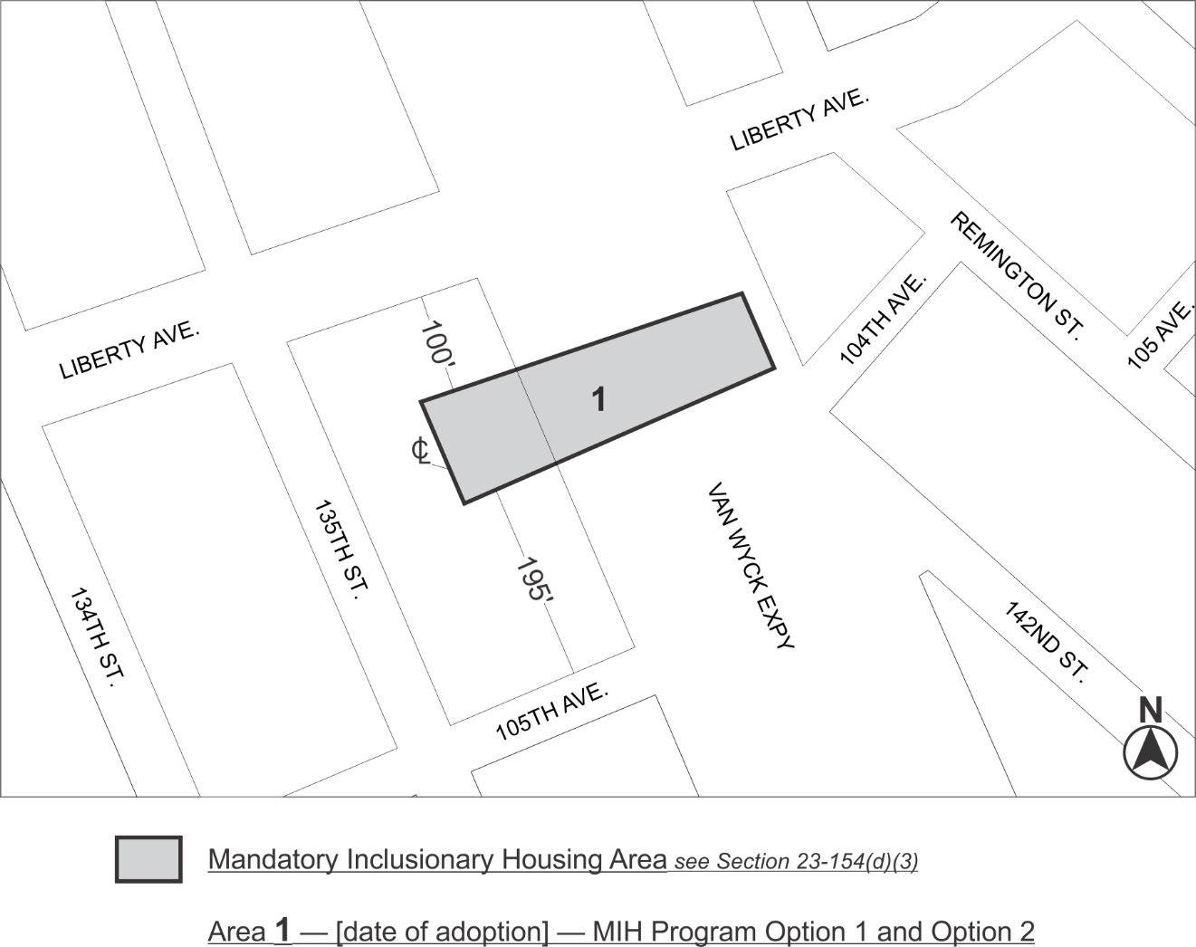
Area 1 – [date of adoption] – MIH Program 1 and Option 2
Portion of Community District 10, Queens

* * *

Adopted.

Office of the City Clerk, }
The City of New York, } ss.:

I hereby certify that the foregoing is a true copy of a Resolution passed by The Council of The City of New York on _________, 2021, on file in this office.

.....................................................
City Clerk, Clerk of The Council

