Staff: Committee on Finance
Kathleen Ahn, Counsel
Michael Twomey, Assistant Counsel



THE NEW YORK CITY COUNCIL
TANISHA EDWARDS, ESQ., CHIEF FINANCIAL OFFICER AND DEPUTY CHIEF OF STAFF TO THE SPEAKER

RICHARD LEE, DIRECTOR, FINANCE DIVISION

COMMITTEE ON FINANCE
HON. JUSTIN BRANNAN, CHAIR

October 19, 2023

RES. NO. 807 By Council Member Brannan

TITLE: Resolution concerning an amendment to the district plan of the Westchester Square business improvement district that provides for a change in the method of assessment upon which the district charge is based, and setting the date, time and place for the public hearing of the local law authorizing such change.

RES. NO. 808 By Council Member Brannan

TITLE: Resolution concerning the increase in the annual expenditure for four business improvement districts and the setting of the date, time and place for the hearing of the local law increasing the annual expenditure for such districts.

- INTRODUCTION
The Committee on Finance, chaired by Council Member Justin Brannan, will vote on Resolutions 807 and 808, which set a date, time, and place for a public hearing to consider local laws that would amend the assessment method of the Westchester Square Business Improvement District (“BID”), and would increase the annual expenditures of four (4) BIDs as of July 1, 2024, respectively. The resolutions set November 15, 2023 at 10:00 am in the City Council Committee Room, 2nd Floor, City Hall, Manhattan as the date, time, and place for the hearing.
The resolutions also direct that all notices required under the BID Law be properly given by the Department of Business Services and the District Management Association of the respective BIDs, and will list the amounts of the proposed increase in assessments, where applicable.
BIDs, which are specifically established areas, use the City's property tax collection mechanism to approve a special tax assessment with which to fund additional services that would enhance such areas and improve local business. The additional services are normally in the areas of security, sanitation, physical/capital improvements (lighting, landscaping, sidewalks, etc.), seasonal activities (Christmas lighting) and related business services (marketing and advertising). The BID demarcates the areas in which services will be enhanced and also establishes the mechanism for the assessment needed to generate the required budget.
- Resolution 807
The current method of assessment for the Westchester Square BID is based on the length of each property’s longer frontage with an additional $300 fee for corner properties and properties with above ground commercial uses. Under the proposed amendment, the method of assessment would change by deriving assessments from each property’s linear frontage along the main retail, commercial, or professional side of the property and by increasing the fee for corner properties and properties with above ground commercial uses to $500. Wholly residential properties will remain assessed at $1 annually, while government and not-for-profit owned properties devoted in whole to public or not-for-profit usages will remain exempt from assessment.
This amended method of assessment would allow for a more equitable assessment, as properties would now be assessed based on the length of their commercial frontage, rather than the longest linear frontage of their property overall. The change is designed such that 65 lots would see an increase in their assessment while 17 lots would see a decrease, with the median assessment amount in the BID decreasing 14 percent ($4,520.91 to $3,850.68).
Resolution 808
These increases, which have been requested by the BIDs and approved by the respective District Management Associations, would result in a higher assessment on all properties currently subject to the BIDs’ assessments as a result of the increase in the assessment rate.
Pursuant to §§ 25-410(b) and 25-416 of the Administrative Code, the BIDs may obtain an increase in its budget (i.e. the total amount allowed to be expended annually by the BIDs for improvements, services, maintenance, and operation) by means of the adoption of a local law amending the BID’s district plan. Such a local law may be adopted by the City Council after a determination that it is in the public interest to authorize such an increase in the maximum annual amount and that the tax and debt limits prescribed in § 25-412 of the Administrative Code will not be exceeded. Notice of the public hearing to consider such a local law must be published in at least one newspaper having general circulation in the district specifying the time when, and the place where, the hearing will be held and stating the increase proposed in the maximum amount to be expended annually.
Accordingly, the resolution also directs the District Management Associations of each of the BIDs to publish in a newspaper of general circulation in each district, not less than ten (10) days prior to the public hearing, a notice stating the time and place of the public hearing and setting forth the increase in the amount to be expended annually in each of the BIDs.
The following BIDs have requested increases to their budgets, as indicated below:

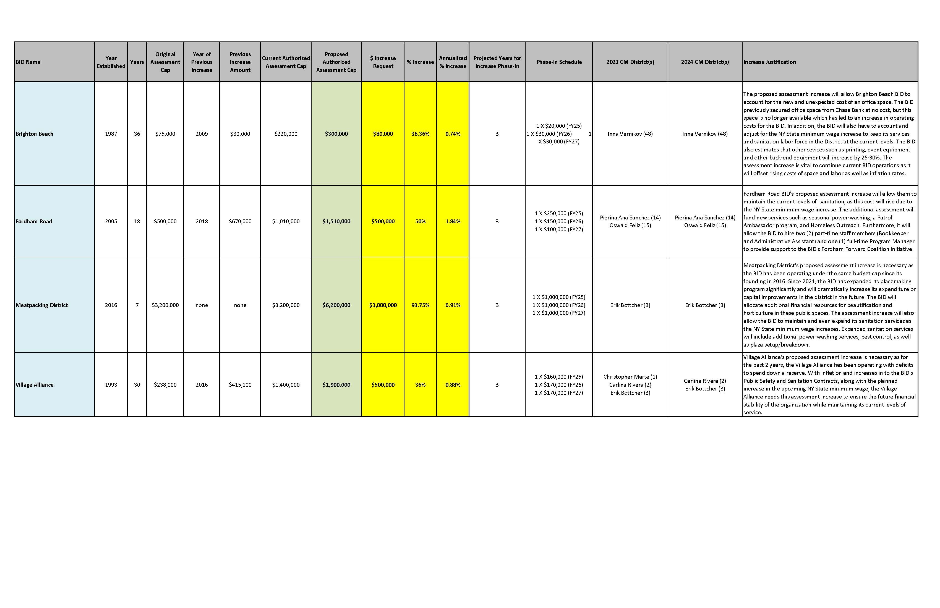
Res. No. 807

Resolution concerning an amendment to the district plan of the Westchester Square business improvement district that provides for a change in the method of assessment upon which the district charge is based, and setting the date, time and place for the public hearing of the local law authorizing such change.

By Council Member Brannan

WHEREAS, pursuant to chapter 4 of title 25 of the Administrative Code of the City of New York (the "BID Law"), the City established the Westchester Square Business Improvement District (the “District”) in the Borough of the Bronx; and

WHEREAS, pursuant to Local Law No. 82 for the year 1990, the City Council assumed responsibility for adopting legislation relating to Business Improvement Districts; and

WHEREAS, pursuant to Section 25-410(b) of the BID Law, an amendment to the District Plan that provides for any change in the method of assessment upon which the district charge is based may be adopted by local law, provided that the City Council determines, after a public hearing, that it is in the public interest to authorize such change and that the tax and debt limits prescribed in Section 25-412 of the BID Law will not be exceeded by such change; and

WHEREAS, the District wishes to amend the District Plan in order to provide for a change in the method of assessment upon which the district charge is based; and

WHEREAS, pursuant to Section 25-410(b) of the BID Law, the City Council is required to give notice of the public hearing by publication of a notice in at least one newspaper having general circulation in the district specifying the time when and the place where the hearing will be held; now, therefore, be it

Resolved, that the Council of the City of New York, pursuant to Section 25-410(b) of the BID Law, hereby directs that:

- November 15, 2023 is the date and the City Council Committee Meeting Room, 2nd floor, City Hall, is the place and 10:00 am is the time for a public hearing (the "Public Hearing") to hear all persons interested in the legislation that would authorize a change in the method of assessment upon which the district charge in the Westchester Square Business Improvement District is based; and

(ii) On behalf of the City Council and pursuant to Section 25-410(b) of the BID Law, the District Management Association of the Westchester Square Business Improvement District is hereby authorized to publish in a newspaper of general circulation in the district, not less than ten (10) days prior to the Public Hearing, a notice stating the time and place of the Public Hearing.
Res. No. 808

Resolution concerning the increase in the annual expenditure for four business improvement districts and the setting of the date, time and place for the hearing of the local law increasing the annual expenditure for such districts.

By Council Member Brannan

WHEREAS, pursuant to Chapter 4 of Title 25 of the Administrative Code of the City of New York or the predecessor of such Chapter (the "BID Law"), the City established the Village Alliance, Brighton Beach, Fordham Road, and Meatpacking Area Business Improvement Districts in the City of New York; and

WHEREAS, pursuant to Local Law No. 82 for the year 1990, the City Council assumed responsibility for adopting legislation relating to Business Improvement Districts; and

WHEREAS, pursuant to Section 25-410(b) of the BID Law, an increase in the amount to be expended annually may be adopted by local law, provided that the City Council determines, after a public hearing, that it is in the public interest to authorize the increase and that the tax and debt limits prescribed in Section 25-412 of the BID Law will not be exceeded; and

WHEREAS, the four Business Improvement Districts wish to increase the amount to be expended annually beginning on July 1, 2024 as follows: the Village Alliance Business Improvement District, $1,900,000; and the Brighton Beach Business Improvement District, $300,000; and the Fordham Road Business Improvement District, $1,510,000; and the Meatpacking Area Business Improvement District, $6,200,000; and

WHEREAS, pursuant to Section 25-410(b) of the BID Law, the City Council is required to give notice of the public hearing by publication of a notice in at least one newspaper having general circulation in the districts specifying the time when and the place where the hearing will be held and stating the proposed amount to be expended annually; now, therefore, be it

RESOLVED, that the Council of the City of New York, pursuant to Section 25-410(b) of the BID Law, hereby directs that:

(i) November 15, 2023 is the date and the City Council Committee Room, 2nd Floor, City Hall is the place and 10:00 AM is the time for a public hearing (the “Public Hearing”) to hear all persons interested in the legislation that would increase the amount to be expended annually in the four Business Improvement Districts; and

(ii) on behalf of the City Council and pursuant to Section 25-410(b) of the BID Law, the District Management Associations of the Village Alliance, Brighton Beach, Fordham Road, and Meatpacking Area Business Improvement Districts are hereby authorized to publish in a newspaper of general circulation in each district, not less than ten (10) days prior to the Public Hearing, a notice stating the time and place of the Public Hearing and setting forth the proposed increase in the amount to be expended annually in each of the four Business Improvement Districts.

