Committee Staff
Jeffrey Campagna
Senior Counsel & Parliamentarian

THE COUNCIL OF THE CITY OF NEW YORK
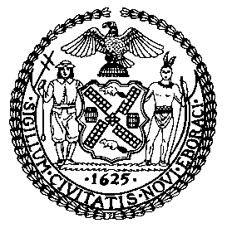

OFFICE OF THE GENERAL COUNSEL
Jason A. Otaño, General Counsel

COMMITTEE REPORT OF THE
COMMITTEE ON RULES, PRIVILEGES AND ELECTIONS

October 9, 2025

250 Broadway, 8th Floor
New York, NY

Preconsidered Res. No. 1099: By The Committee on Rules, Privileges and Elections

Title: Resolution pursuant to Rule 7.00 making changes to the chairs and membership of certain committees of the Council.

Preconsidered Res. No. 1099

Resolution pursuant to Rule 7.00 making changes to the chairs and membership of certain committees of the Council.

By The Committee on Rules, Privileges and Elections

Pursuant to Rule 7.00 of the Rules of the Council, the chairs and membership of certain committees of the Council are changed as specified below:

CIVIL SERVICE AND LABOR
Frank Morano

CONSUMER AND WORKER PROTECTION
[Julie Won]

Cultural Affairs, Libraries, and International Intergroup OrGANIZATIONS
Erik Bottcher (Chair)

FIRE AND EMERGENCY MANAGEMENT
Simcha Felder

GOVERNMENT OPERATIONS, STATE & FEDERAL LEGISLATION
[Vickie Paladino]
Frank Morano

HEALTH
Justin Brannan
Simcha Felder

HOSPITALS
Gale Brewer

LAND USE
Diana Ayala
Joann Ariola

MENTAL HEALTH, DISABILILTIES, AND ADDDICTION
[Kristy Marmorato]

OVERSIGHT & INVESTIGATIONS
Simcha Felder
Frank Morano

PUBLIC SAFETY
[Joann Ariola]

RULES, PRIVILEGES & ELECTIONS
Joann Ariola

SANITATION AND SOLID WASTE MANAGEMENT
Simcha Felder
Frank Morano

VETERANS
Simcha Felder

