THE COUNCIL OF THE CITY OF NEW YORK
RESOLUTION NO. 602

Resolution approving the decision of the City Planning Commission on Application No. N 180266 ZRQ (L.U. No. 236), for an amendment of the Zoning Resolution of the City of New York, modifying Appendix F for the purpose of establishing a Mandatory Inclusionary Housing Area, Community District 2, Borough of Queens.

By Council Members Salamanca and Moya

WHEREAS, the City Planning Commission filed with the Council on September 17, 2018 its decision dated September 5, 2018 (the "Decision"), pursuant to Section 201 of the New York City Charter, regarding an application submitted by 69-02 Queens Boulevard Woodside, LLC, for an amendment of the text of the Zoning Resolution of the City of New York, modifying Appendix F for the purpose of establishing a Mandatory Inclusionary Housing Area, which in conjunction with the related actions would facilitate development of two new, mixed residential and commercial buildings with a total of 561 dwelling units, 169 of which would be permanently affordable, in the Woodside neighborhood in Queens, Community District 2, (Application No. N 180266 ZRQ) (the "Application");

WHEREAS, the Application is related to applications C 180265 ZMQ (L.U. No. 235), a zoning Map amendment to change an M1-1 district to an R7X/C2-3 district and C 180267 ZSQ (L.U. No. 237), a special permit to modify height and setback regulations for a large-scale general development (LSGD) (ZR Section 74-743);

WHEREAS, the Decision is subject to review and action by the Council pursuant to Section 197-d(b)(1) of the City Charter;
WHEREAS, upon due notice, the Council held a public hearing on the Decision and Application on October 3, 2018;

WHEREAS, the Council has considered the land use implications and other policy issues relating to the Decision and Application; and

WHEREAS, the Council has considered the relevant environmental issues, including the Revised Negative Declaration issued September 5, 2018 (CEQR No. 18DCP132Q), which includes an (E) designation to avoid the potential for significant adverse impacts related to hazardous materials, air quality, and noise on the development site (Block 2432, Lots 9, 21, 41, 44, and 50) (E-472) which supersedes the Negative Declaration issued April 9, 2018 and a previously-assigned (E) designation for hazardous materials, air quality, and noise placed on Lots 9 and 21 as part of the Maspeth-Woodside Rezoning (E-163) (CEQR No. 06DCP065Q) (the “E Designation (E-472)” and “Revised Negative Declaration”) and Technical Memorandum dated October 30, 2018_(“Technical Memorandum”).

RESOLVED:

The Council finds that the action described herein will have no significant impact on the environment as set forth in the (E) Designation (E-472) and Revised Negative Declaration and Technical Memorandum.

Pursuant to Section 200 of the City Charter and on the basis of the Decision and Application, and based on the environmental determination and consideration described in the report, N 180266 ZRQ, incorporated by reference herein, the Council approves the Decision of the City Planning Commission.

Matter underlined is new, to be added;
Matter struck out is to be deleted;
Matter within # # is defined in Section 12-10;
*** indicates where unchanged text appears in the Zoning Resolution.

* * *

APPENDIX F
Inclusionary Housing Designated Areas and Mandatory Inclusionary Housing Areas

* * *
QUEENS

* * *

Queens Community District 2

* * *

Map 4 – [date of adoption]

[PROPOSED MAP]

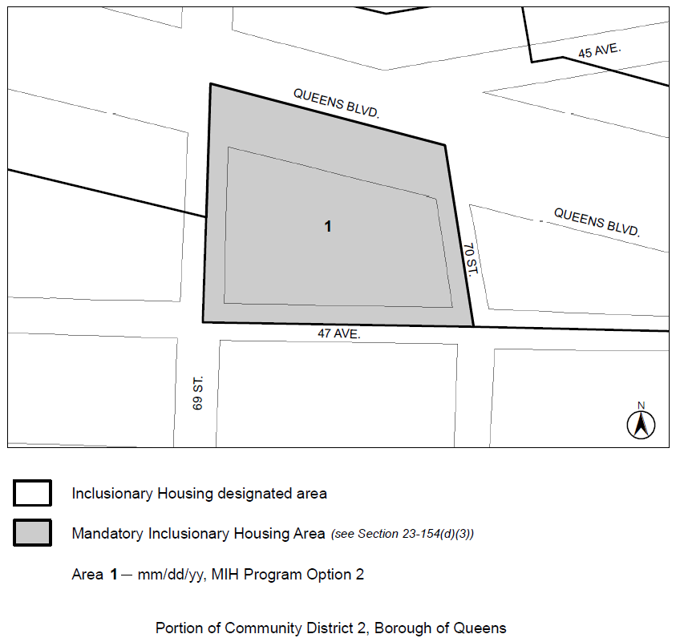

* * *

Adopted.

Office of the City Clerk, }
The City of New York, } ss.:

I hereby certify that the foregoing is a true copy of a Resolution passed by The

Council of The City of New York on October 31, 2018, on file in this office.

.....……......................................... City Clerk, Clerk of The Council

