Committee on Criminal Justice
Jeremy Whiteman, Legislative Counsel
Natalie Meltzer, Legislative Policy Analyst
Casey Lajszky, Financial Analyst
Melissa Nuñez, Senior Data Scientist
Rachel Avram, Data Scientist



THE COUNCIL OF THE CITY OF NEW YORK

COMMITTEE REPORT AND BRIEFING PAPER OF THE Governmental AFFAIRS Division
Andrea Vazquez, Legislative Director
Rachel Cordero, Deputy Director, Governmental Affairs Division

COMMITTEE ON CRIMINAL JUSTICE
Hon. Sandy Nurse, Chair

October 31, 2024

Oversight – Preventing and Addressing Sexual Assault and Harassment in City Jails

INT. NO. 792 By Council Members Rivera, Cabán, Abreu, Ossé, Avilés, Restler, Won, Williams, Ayala, Hudson, Narcisse, Schulman and The Speaker (Council Member Adams)

TITLE A Local Law to amend the administrative code of the city of New York, in relation to requiring the department of correction to use an electronic case management system to track investigations of sexual abuse

ADMINISTRATIVE CODE Amends section 9-156

INT. NO. 830 By Council Members Louis, Nurse, Riley, Restler and The Speaker (Council Member Adams)

TITLE A Local Law to amend the administrative code of the city of New York, in relation to requiring the commissioner of correction to develop a comprehensive training program for investigation of sexual crimes

ADMINISTRATIVE CODE Adds section 9-156.1

- Introduction
On October 31, 2024 the Committee on Criminal Justice, chaired by Council Member Sandy Nurse, will hold an oversight hearing on preventing and addressing sexual assault and harassment in City jails. The committee will also hear Introduction Number 792 (Int. No. 792), in relation to requiring the department of correction to use an electronic case management system to track investigations of sexual abuse, and Introduction Number 830 (Int. No. 830), in relation to requiring the commissioner of the department of correction to develop a comprehensive training program for investigation of sexual crimes. Those expected to testify include representatives from the Department of Correction (DOC, the Department), Correctional Health Services (CHS), the Department of Investigation (DOI), legal services providers, social services providers, and other interested stakeholders.
- Background
Sexual assault, a form of sexual abuse, is generally defined as subjecting another person to sexual contact, including rape, without the latter’s consent. Sexual harassment is generally defined as repeated and unwelcome sexual advances, requests for sexual favors, or verbal comments, gestures, or actions of a sexual nature. Sexual assault and harassment are serious, pervasive issues with dire consequences both inside and outside correctional facilities, but jails and prisons present a unique context for such abuse to occur. The insular environment, restrictions on incarcerated individuals’ movement, and the inherent power structures in correctional facilities contribute to increased opportunities for sexual violence perpetrated by both people in custody and correctional staff.
  - PREA and the Sexual Abuse and Harassment Minimum Standards
The Prison Rape Elimination Act (PREA), enacted in 2003, was the first federal law designed to deter sexual assault and harassment of incarcerated individuals. PREA “provide[s] for the analysis of the incidence and effects of prison rape in Federal, State, and local institutions and to provide information, resources, recommendations and funding to protect individuals from prison rape.” PREA also created the National Prison Rape Elimination Commission and charged it with drafting standards for eliminating prison rape; the Department of Justice published the PREA Standards in the Federal Register on June 20, 2012, and they became effective August 20, 2012.
Sexual abuse, as defined in the PREA Standards, includes sexual abuse of an individual in custody by another person in custody, a staff member, contractor, or volunteer. In order for a sexual act between individuals in custody to be considered sexual abuse, the victim must not consent, be coerced into such act by overt or implied threats of violence, be unable to consent or refuse such contact. Any sexual contact—or any attempt, threat, or request by a staff member, contractor, or volunteer to engage in such contact—between a person in custody and a jail staff member, with or without consent, is considered sexual abuse.
PREA standards identify sexual harassment as including repeated and unwelcome sexual advances, requests for sexual favors, or verbal comments, gestures, or actions of a derogatory or offensive sexual nature by one inmate, detainee, or resident directed toward another; or repeated verbal comments or gestures of a sexual nature to an inmate, detainee, or resident by a staff member, contractor, or volunteer, including demeaning references to gender, sexually suggestive or derogatory comments about body or clothing, or obscene language or gestures.
In 2016, the Board of Correction (BOC) implemented National Sexual Abuse and Harassment Minimum Standards, which are equivalent to those set nationally by PREA. Some requirements of these rules include services to ensure that victims of sexual abuse receive proper treatment to overcome emotional and physical trauma, a 90-day deadline to complete all investigations, and expanded training on working with transgender or intersex individuals. The rules also require specific reporting to the BOC regarding populations most affected by sexual harassment and abuse in jails, including by age, gender and sexual orientation.
  - DOC’s Directive on the Elimination of Sexual Abuse and Sexual Harassment
In response to the PREA Standards and BOC sexual abuse and harassment minimum standards, DOC promulgated Directive 5011, “Elimination of Sexual Abuse and Sexual Harassment,” which establishes the Department’s policies and procedures for preventing, detecting, reporting and responding to incidents of sexual abuse and harassment against people in custody.
Reporting Sexual Abuse
Pursuant to Directive 5011, people in custody and DOC staff can report allegations of sexual assault and harassment through multiple channels including DOI, 311, the DOC grievance process, and a dedicated DOC PREA hotline that is posted in jail housing areas, court holding pens and corridors. Incarcerated individuals may report incidents of sexual abuse, sexual harassment and retaliation to any staff including chaplains, medical and mental health staff, volunteers and administrators, and DOC staff are instructed to promptly document any verbal reports. Staff who receive any information, from any source, regarding sexual abuse or harassment or who observe such incidents are required to verbally report the incident to their immediate supervisor and submit a written report to the Tour Commander who, in turn, is instructed to submit the report to the Warden or highest-ranking official on duty and staff responsible for coordinating PREA compliance.
Investigating Allegations
The responsibility for tracking and resolving person in custody-on-person in custody allegations of sexual misconduct rests with DOC’s Special Investigations Unit (SIU). Upon receiving an allegation, SIU is tasked with conducting a preliminary investigation within 72 hours of a complaint’s submission to determine if the complaint is PREA-reportable, i.e., if the act described meets the PREA Standards’ definitions of sexual abuse and sexual harassment. Allegations that are PREA-reportable receive a full investigation.
The Department of Investigation (DOI) conducts investigations of alleged sexual misconduct that involve staff-on-incarcerated individuals as well as allegations that involve alleged rape. If such allegations are made, DOI will wither commence a preliminary investigation or refer it back to SIU to conduct a preliminary investigation. DOI considers a number factors when deciding whether to open a preliminary investigation, including: “(1) whether information, including the alleged victim’s or subject’s identity and a time and place of occurrence, is provided; (2) whether the alleged abuser has been the subject of similar allegations previously; (3) whether physical contact is alleged; and (4) DOI’s investigative resources.” As of 2019, DOI had approximately 40 investigators assigned to DOC, including some DOC Correction Officers and Captains assigned to DOI.
DOC’s directive mandates that SIU and DOI staff conducting a criminal investigation; “gather and preserve direct and circumstantial evidence including any available physical DNA evidence, photographs, and any available electronic monitoring data; use recording devices to interview alleged victims, suspected perpetrators, and witnesses; and review prior complaints and reports of sexual abuse involving the suspected perpetrator.” When the allegation involves sexual abuse, the directive provides that SIU shall only use investigators who have received specialized training.
Following an investigation, an allegation of sexual abuse or sexual harassment is considered “substantiated” if it is determined to have occurred based on a preponderance of evidence. Allegations are considered “unsubstantiated” when the investigation produced insufficient evidence to prove that the event occurred. Allegations are “unfounded” if they are proven false. All substantiated allegations are to be referred to the District Attorney’s office for criminal prosecution.
Protecting Vulnerable Populations and Alleged Victims
DOC’s Directive 5011 establishes multiple mechanisms to protect individuals at risk of sexual abuse as well as those who have made allegations of sexual assault and harassment.
Within 72 hours of admission to DOC custody, incarcerated individuals are screened for “potential vulnerability to sexual abuse or harassment, or tendencies to act out through sexually aggressive behavior.” Any person assessed as being at risk of victimization shall not be housed with an inmate assessed as having a history of sexual assault or as “presenting a risk to vulnerable inmates.”
Research shows that some groups of people experience disproportionate rates of sexual violence in correctional facilities, including survivors of prior sexual violence, people with mental illness, and LGBTQ+ people. Individuals in custody who are determined to be at high risk for sexual victimization or who report sexual victimization are supposed to be assessed by the Operations Security Intelligence Unit (OSIU) for placement purposes. OSIU may not place people in custody in involuntary segregated housing unless an assessment of all available alternatives has been made and a determination has been made that there is no available alternative means of separation from likely predators. If OSIU cannot conduct such an assessment immediately, OSIU may hold the incarcerated individual in involuntary segregated housing for up to 24 hours while completing the assessment, and must continue to provide them with access to programs, privileges, education, and work opportunities. If the individual is placed in involuntary segregated housing, OSIU’s documentation must include: “the basis for the concern for the inmate’s safety, the reason why no alternatives are available, and the contents of a review, offered every thirty (30) days, to determine if there is a continuing need for separation.”
When a DOC staff member has been accused of sexual abuse, they may be placed on administrative leave pending the outcome of an investigation, in “appropriate circumstances and with the Deputy Commissioner of ID or his/her designee’s approval.” If they are not placed on administrative leave, a staff member accused of sexual abuse and harassment should not be assigned to work in any area where they are likely to come into contact with the complainant pending the outcome of the investigation, and they are prohibited from making contact with the alleged victim “other than as allowable in the performance of official duties and assignment.” The Warden may transfer the complainant, any witnesses, or a third-party informant to a comparable housing unit, to another facility, or make other appropriate housing accommodations to ensure their safety.
Incident Review
At the conclusion of each investigation that was determined to be substantiated or unsubstantiated, a facility “Sexual Abuse Incident Review Team” made up of upper management is directed to complete an incident review. As part of that process the team is instructed to:
- “Consider whether changes in policy or practice are needed to improve the prevention, detection, or response to sexual abuse incidents similar to the alleged incident;
- Consider whether race, ethnicity, gender identity, sexual orientation, gang affiliation, perceived status, or other group dynamics in the facility played a role;
- Consider whether physical barriers in the facility contributed to the incident or could enable abuse;
- Evaluate what staffing levels were at the time of incident and whether staffing levels need to be changed in light of the alleged incident;
- Consider whether more or different video monitoring is needed;
- Prepare a report of its findings, including any recommendations for improvement and submit such report to the facility Warden, PREA Coordinator, and PCM;
- Implement the recommendations for improvement or document its reasons for not doing so.”
  - Prevalence of Sexual Assault and Harassment in City Jails
In general, sexual assaults are severely underreported compared to other crimes: two-thirds of rapes and sexual assaults go unreported to law enforcement. Many victims of sexual violence do not report the crimes to the police because they fear retaliation or believe law enforcement would not do anything to help. These dynamics are worse in correctional institutions. Indeed, at a November 9, 2021 BOC meeting, a witness testified that her nonprofit organization, Freedom Agenda, heard from people incarcerated in RMSC that they did not report incidents of sexual assaults because they feared retaliation from the officers who had “total control” over them.
Despite the known underreporting of sexual violence, the prevalence of sexual abuse at Rikers Island is well documented. In 2012, a U.S. Department of Justice report found that two facilities on Rikers—the Rose M. Singer Center (RMSC) and Otis Bantum Correctional Center (OBCC)—had among the highest rates of staff sexual misconduct in the country. The same report found that RMSC, the facility at Rikers where women are incarcerated, had among the highest rates in the country of sexual victimization perpetrated by people in custody against other people in custody. Under the Adult Survivors Act, a state law that opened a one-year window for sexual assault survivors to file claims outside of the statute of limitations, formerly incarcerated individuals filed 719 civil lawsuits against the City and DOC alleging abuse at RMSC spanning from 1976 to 2023.
BOC’s National Sexual Abuse and Harassment Minimum Standards and Local Law require DOC to submit multiple reports on allegations and investigations of sexual abuse and harassment made by people in custody. Pursuant to both reports, the number of PREA-reportable allegations in City jails has decreased in recent years. However, since July 2022, the share of allegations categorized as sexual abuse or assault has surpassed those categorized as sexual harassment. DOC’s Minimum Standards reports indicate that the number of allegations decreased from 500 in 2018 to 180 in 2023. The Anna M. Kross Center (300), RMSC (204), and George R. Vierno Center (115) had the highest number of PREA-reportable cases between 2018 and 2023.
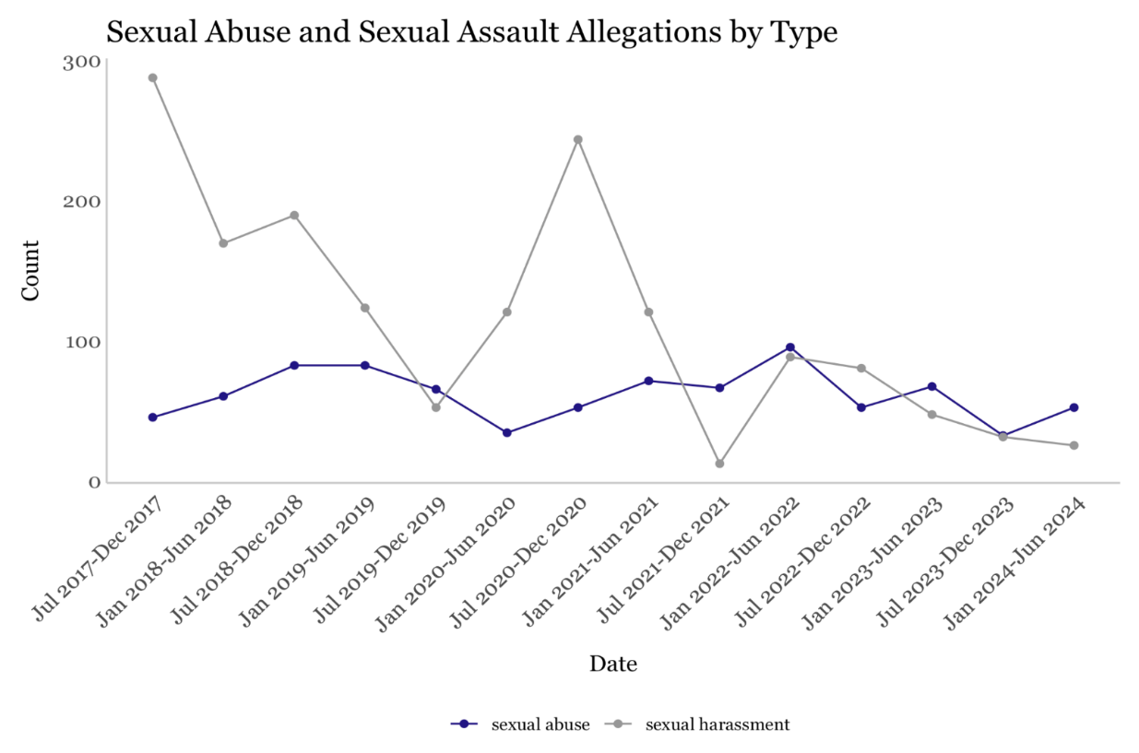
- Issues and Concerns
  - Inadequate Investigations
Independent reports have documented that DOC has historically failed to adequately address the problem of sexual abuse in its facilities. A federally-funded report from The Moss Group, a Washington, D.C.-based criminal justice consulting firm, detailed systemic problems in DOC’s handling of sexual abuse and harassment. The report, which was leaked to the media in 2015, found that DOC had not been properly handling incidents of sexual abuse, revealing emergency hotlines that did not work, confidential complaints that were not treated as such, and incomplete investigations of complaints of sexual abuse and harassment. A 2016 report from Timothy P. Ryan, a long-time correctional professional, concluded that the City’s practices showed “a callous disregard” and “deliberate indifference by the City to the sexual safety and well-being of the female detainees” at RMSC.
In September 2018, BOC published an audit of DOC’s investigations into allegations by people in custody of sexual abuse or harassment that found “significant gaps in the Department’s investigations of sexual abuse and sexual harassment in the City’s jails, including missing supervisory approval of investigations, key interviews not completed, and insufficient explanations as to why crime scenes were not established.” In April 2019, the Board published a supplementary audit of DOC’s handling of sexual assault and sexual harassment reports, noting “significant deficiencies” in the DOC’s process for reviewing allegations of sexual abuse and harassment and an “urgent need for reform.” The Board expressed concern that “interviews are not always carried out with alleged victims and alleged perpetrators” and that “when interviews are conducted, they are not always in private and confidential locations.”
  - Low Substantiation Rates
There are very low substantiation rates for those allegations deemed PREA-reportable by SIU. Since 2015, just one half of one percent of the PREA-reportable sexual abuse allegations people in custody reported against correction staff were deemed “substantiated,” representing seven of nearly 1,500 allegations. For allegations of sexual abuse people in custody reported against other people in custody, the substantiation rate was 3.4 percent in 2023. The DOC substantiation rates fall far below the national average of 6 percent.
In BOC’s 2019 audit of the sexual abuse incident review reports, investigators adequately described how they reached their conclusions regarding what was and was not substantiated in only 30 percent of the cases reviewed. In the remainder of cases, “there was a lack of specific information about which precise elements of the allegation had been verified or disproved. In at least two cases that the Board reviewed, there were key pieces of evidence that were referenced in testimonial or other evidence that were not adequately examined and assessed as part of the investigator’s reasoning.”
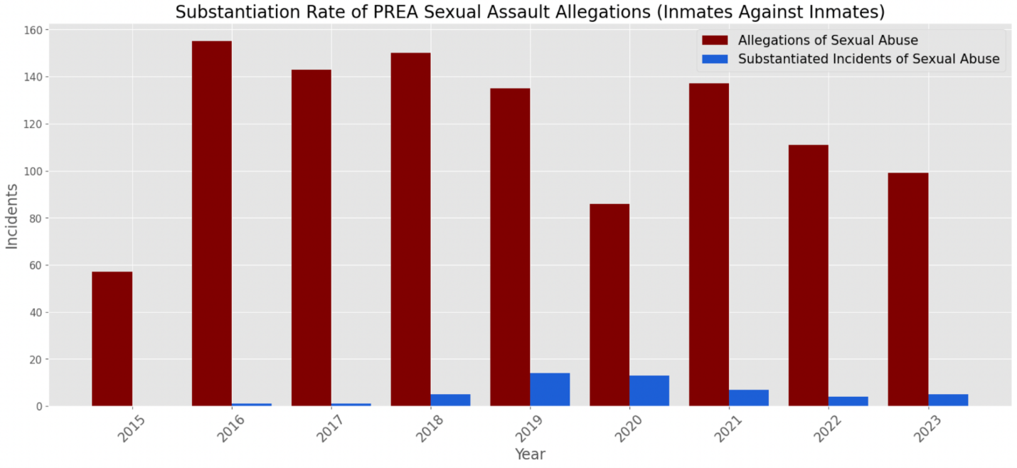
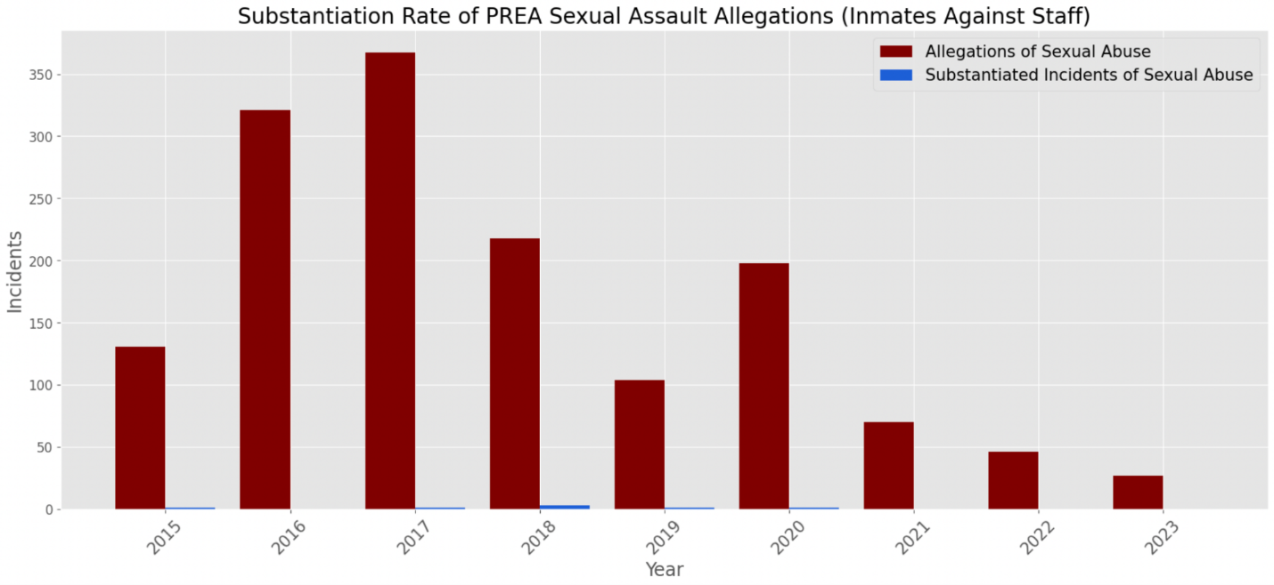
  - Duration of Investigations Increasing
Pursuant to the PREA Standards and sexual abuse and harassment minimum standards, investigations into sexual abuse in DOC custody must be completed within 90 days. Following the BOC 2019 audit of the Department’s investigations into sexual abuse allegations, DOC managed to substantially reduce the number of investigations taking over 90 days in 2020 and 2021. However, the number and share of investigations taking over 90 days increased again in 2022 and 2023.
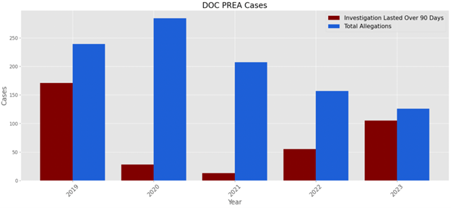
- Potential Undercounting of Allegations
There is concern the Department might be undercounting or missing allegations of sexual abuse made by people in custody. Sexual abuse and harassment is consistently one of the most frequent subjects of grievances filed by incarcerated individuals, and 1,440 grievances related to sexual abuse and harassment were submitted to DOC in 2023. However, the Department reported just 126 PREA-reportable allegations. In April 2024, the Department acknowledged that it missed 14 grievances filed by people in custody in the second half of 2023 which should have received further review; six of those allegations were serious enough to warrant a full investigation under PREA.
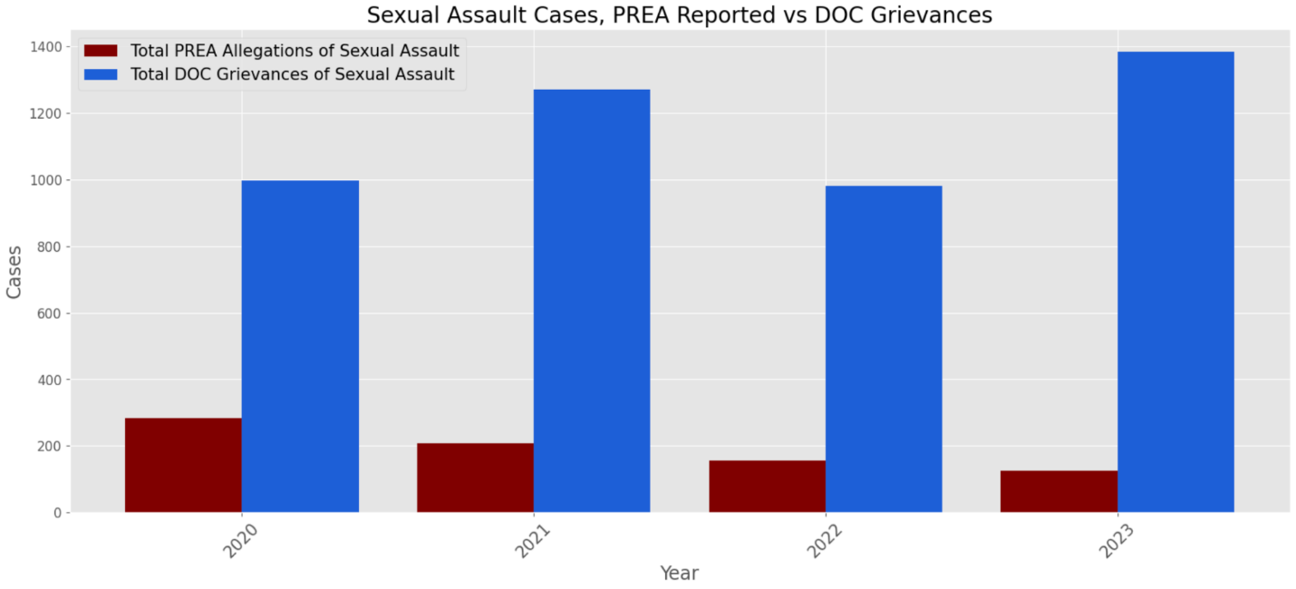
In addition, as mentioned above, there are substantial discrepancies between DOC’s reports on sexual abuse and harassment submitted pursuant to BOC minimum standards and Local Law. This suggests there may be allegations missing from several reports.
- Retaliation
According to DOC, the “PREA Facility Compliance Unit conducts monthly Retaliation Monitoring for those who have submitted sexual abuse complaints.” In addition, DOC’s Directive 5011 provides that alleged victims are to receive multiple protection measures “to include housing changes, staff removal, and emotional support services.” However, in his investigation of RMSC’s efforts to prevent and address sexual abuse of people in custody, correctional expert Ryan concluded that the City “does not take appropriate measures to protect inmates from retaliation for reporting sexual misconduct” and does not “take appropriate measures to investigate claims of retaliation.”
- Special Populations
As mentioned above, some groups are at higher risk of experiencing sexual violence in correctional facilities, including women, survivors of prior sexual violence and LGBTQ+ people. Even as the overall number of PREA-reportable allegations has decreased across DOC facilities, the number of cases at RMSC has more than doubled from 25 in 2018 to 62 in 2023. RMSC houses women at Rikers Island and also includes the Special Considerations Unit, a housing a housing area designated for transgender, gender non-conforming, nonbinary and intersex individuals.
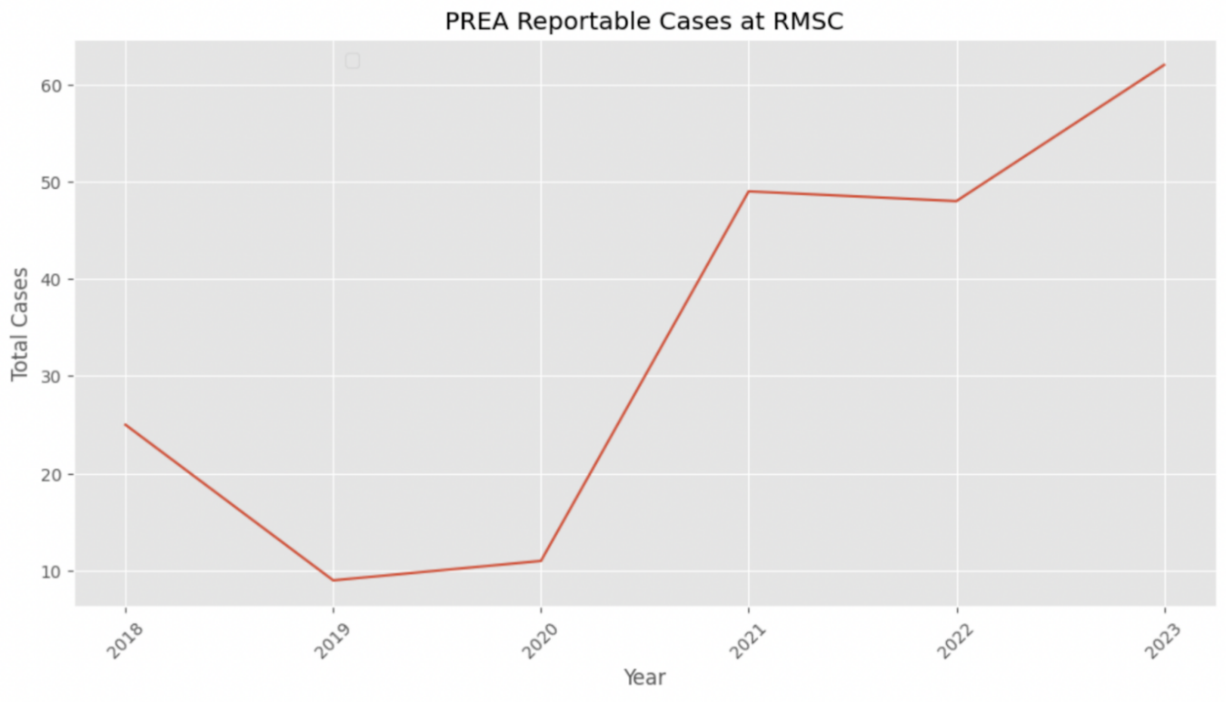

  - Poor Hiring and Training Practices
Oversight bodies and independent experts have consistently flagged deficiencies in staff vetting, training and oversight around sexual abuse investigations. Two DOI reports published in 2015 and 2018 found that DOC’s Applicant Investigation Unit was consistently failing to identify red flags that should have precluded the department from hiring certain officers. In one egregious example, the Department had hired a candidate who had previously left his employment within the State prison system after he had an inappropriate relationship with a person in custody. Independent expert Ryan concluded that correction officers, medical staff, investigators, and supervisors are not properly trained to follow DOC directives and national correctional practices concerning staff-on-inmate sexual abuse. BOC in 2019 recommended that the Department should re-train investigative staff to record complete and comprehensive information in relation to every stage of their investigation, and that the Department must ensure that supervisory investigative staff are adequately trained and resourced to appropriately oversee PREA investigations.
- LEGISLATIVE ANALYSIS
  - Int. No. 792
Int. No, 792 would require DOC to track all information regarding sexual abuse and harassment cases in an electronic case management system. It would take effect immediately.
  - Int. No. 830
Int. No. 830 would require DOC to develop a comprehensive training program for investigations of sexual crimes. All investigators would be required to complete this newly designed training in order to enhance their understanding specific needs of victims of sexual crimes and develop new skills. The Department of Correction would be required to submit annual reports on the training program, including its components, the number of investigators who participated in the training, and the experts consulted in developing the training.
These legislative requirements would be effective 180 days after this bill becomes law, however, implementation measures may be taken before the effective date.
- CONCLUSION
The Committee looks forward to discussing how DOC implements its directive to prevent sexual assault and harassment in City jails and how they seek to improve their training, investigations, and procedures to achieve a safer, more humane jail for both those in custody and those who work there. The Committee also looks forward to hearing from DOI regarding its efforts to address staff sexual misconduct in City jails.

Int. No. 792

By Council Members Rivera, Cabán, Abreu, Ossé, Avilés, Restler, Won, Williams, Ayala, Hudson, Narcisse, Schulman and The Speaker (Council Member Adams)

A Local Law to amend the administrative code of the city of New York, in relation to requiring the department of correction to use an electronic case management system to track investigations of sexual abuse

Be it enacted by the Council as follows:

Section 1. Section 9-156 of the administrative code of the city of New York, as added by local law number 21 for the year 2019, is amended by adding a new subdivision i to read as follows:
i. The department shall collect, manage, and store all information required pursuant to this section electronically.
§ 2. This local law takes effect immediately.

Int. No. 830

By Council Members Louis, Nurse, Riley, Restler and The Speaker (Council Member Adams)

A Local Law to amend the administrative code of the city of New York, in relation to requiring the commissioner of correction to develop a comprehensive training program for investigation of sexual crimes

Be it enacted by the Council as follows:
Section 1. Chapter 1 of title 9 of the administrative code of the city of New York is amended by adding a new section 9-156.1 to read as follows:
§ 9-156.1 Sexual crimes investigation training. a. Definitions. For the purposes of this section, the term “sexual crime” means any offense specified in article 130 of the penal law.
b. Sexual crimes investigation training program. The commissioner, after considering information from outside experts, shall develop and implement a victim-centered sexual crimes investigation training program designed to develop skills related to the investigation of sexual crimes and the specific needs of victims of sexual crimes. The curriculum shall include nationally recognized best practices and factors contributing to the complexity of sexual crimes investigations, including the depth of victimization, the negative social consequences for victims of sexual crimes, the trauma and neurobiological damage inflicted by sexual crimes, the complexity of victim management, the falsity or partially truthful disclosure of complaints, the large unreported rate of sexual crimes and any other training deemed relevant to sexual crimes cases by the commissioner. Such program shall include the following training components: the Forensic Experiential Trauma Interview method, specialized investigative training for sexual crimes cases in confinement settings, Sexual Assault Forensic Examiner training, victim advocate based training and any other training courses currently offered by the department relating to the investigation of sexual crimes and any other training deemed relevant to sexual assault cases by the commissioner, except that the commissioner may eliminate a training component or replace a training component with an alternative component in order to provide comprehensive victim-centered training. Such program shall include a proficiency examination or demonstration for each training component and shall be of a length that the commissioner determines is sufficient to allow investigators to develop proficiency in utilizing such skills.
c. Training requirement. All newly assigned department investigators shall complete the sexual crimes investigation training program defined in subdivision b of this section and shall be required to demonstrate proficiency in subject matters covered by such program before engaging with victims of sexual crimes; however, such investigators may engage with victims before completing such program if such engagement is under the supervision of an experienced investigator or supervisor, or in circumstances where no experienced investigator or supervisor is available. Any department employees assigned as investigators as of the effective date of the local law that added this section must demonstrate proficiency in subject matters covered by such program within one year of such date, and any department employees assigned as investigators after such effective date must demonstrate such proficiency within one year of assignment.
d. Training report. No later than January 30, 2023, and every January 30 thereafter, the commissioner shall post on the department’s website a report setting forth the training components of the sexual crimes investigation training program defined in subdivision b of this section, including the instructors, purpose, length and format of each training component, the specific reasons for eliminating or replacing any training component, and the number of department investigators during the previous calendar year that: (i) participated in such program, (ii) failed to demonstrate proficiency required pursuant to subdivision c of this section on their first attempt, disaggregated by subject matter, and (iii) successfully demonstrated proficiency on all subject matters required pursuant to subdivision c of this section. Such report shall also include any experts consulted pursuant to subdivision b of this section in developing such training.
§ 2. This local law takes effect 180 days after it becomes law, except that the commissioner of correction shall take such measures as are necessary for the implementation of this local law, including the promulgation of rules, before such date.

The term sexual assault is used in this hearing, but refers to both assault and abuse, adopting the same meaning set forth in section 115.6 of title 38 of the code of federal regulations, or any successor regulation.
National Prison Rape Elimination Commission Report, June 2009, available at: https://www.prearesourcecenter.org/sites/default/files/library/NPREC-Final-Report.PDF
Viktoria Kristiansson and Charlene Whitman-Barr, “Identifying, Investigating, and Prosecuting Witness Intimidation in Cases of Sexual Abuse in Confinement,” AEquitas, Issue 26, September 2015, available at: https://www.prearesourcecenter.org/sites/default/files/library/strategiesinbrief-witnessintimidation.pdf
Prison rape, or jail rape, is rape occurring in prison; the term is typically used to refer to rape of incarcerated individuals by other incarcerated individuals as well as by staff.
The United States Department of Justice, The Department Releases Final Rule to Prevent Detect and Respond to Prison Rape, May 17, 2012, available at https://www.justice.gov/opa/pr/justice-department-releases-final-rule-prevent-detect-and-respond-prison-rape
PUBLIC LAW 108–79
National PREA Resource Center, “About the Prison Rape Elimination Act,” available at: https://www.prearesourcecenter.org/about/prison-rape-elimination-act
28 CFR Part 115 § 115.6
Id.
Id.
Id.
NYC Board of Correction, “Sexual Abuse and Sexual Harassment Standards,” available at: https://www.nyc.gov/site/boc/jail-regulations/sexual-abuse-harassment-standards.page
Id.
40 RRNY § 5-40
NYC Department of Correction, “Directive 5011” 5/2/2016 amended 5/31/2019, available at: https://www.nyc.gov/assets/doc/downloads/directives/5011R-A-Elimination_Sexual_Assault_Sexual_Harassment.pdf
Id at 22.
Id at 22.
Id at 25.
New York City Department of Correction, “Semi-Annual Sexual Abuse & Harassment Report, July 1, 2023 – December 31, 2023,” available at: https://www.nyc.gov/assets/doc/downloads/pdf/REVISED%20LL21%20Jul%20to%20Dec%202023.pdf.
Id.
Id.
NYC Department of Correction, “Directive 5011” 5/2/2016 amended 5/31/2019, at 33, available at: https://www.nyc.gov/assets/doc/downloads/directives/5011R-A-Elimination_Sexual_Assault_Sexual_Harassment.pdf
NYC Department of Investigation, “Written Testimony of Commissioner Margaret Garnett Submitted to the Board of Correction,” April 23, 2019, available at: https://www.nyc.gov/assets/doi/Testimony/DOICommGarnettWrittenTestimonyforBOCHearing_42319.pdf
Id.
Id.
NYC Department of Correction, “Directive 5011” 5/2/2016 amended 5/31/2019, at 34, available at: https://www.nyc.gov/assets/doc/downloads/directives/5011R-A-Elimination_Sexual_Assault_Sexual_Harassment.pdf
Id.
NYC Department of Correction, “NYC Board of Correction Minimum Standard 5-40 Assessment Report,” August 2024, available at: https://www.nyc.gov/assets/doc/downloads/pdf/FINAL_Bi-Annual_5-40_Report_August_2024.pdf
Id.
Id.
NYC Department of Correction, “Directive 5011” 5/2/2016 amended 5/31/2019, at 40, available at: https://www.nyc.gov/assets/doc/downloads/directives/5011R-A-Elimination_Sexual_Assault_Sexual_Harassment.pdf
Id at 16.
Id.
Just Detention International, “Sexual Abuse in Detention: The Most Vulnerable Inmates,” October 2018, available at: https://justdetention.org/wp-content/uploads/2019/07/Fact-sheet-Sexual-Abuse-in-Detention-The-Most-Vulnerable-Inmates.pdf
Id at 21.
Id.
Id.
Id.
NYC Department of Correction, “Directive 5011” 5/2/2016 amended 5/31/2019, at 36, available at: https://www.nyc.gov/assets/doc/downloads/directives/5011R-A-Elimination_Sexual_Assault_Sexual_Harassment.pdf
Id.
Id.
Id at 38.
Id.
Rachel E. Morgan and Jennifer L. Truman, “Criminal Victimization, 2019,” U.S. Department of Justice Office of Justice Programs Bur Bureau of Justice Statistics eau of Justice Statistics, September 2020, available at: https://bjs.ojp.gov/content/pub/pdf/cv19.pdf
RAINN, “The Criminal Justice System: Statistics,” https://rainn.org/statistics/criminal-justice-system
2021-11-09 - NYC Board of Correction Public Meeting, https://www.youtube.com/watch?v=u9eLrq59eAc&t=9195s.
U.S. Department of Justice, “Sexual Victimization In Prisons And Jails Reported By Inmates, 2011–12,” Office Of Justice Programs, Bureau Of Justice Statistics, 2013, available at: https://bjs.ojp.gov/content/pub/pdf/svpjri1112.pdf
Id.
Jessy Edwards and Samantha Max, “Late-night sex assaults. Invasive searches. The 700+ women alleging abuse at Rikers,” Gothamist, March 26, 2024, available at: https://gothamist.com/news/late-night-sex-assaults-invasive-searches-the-700-women-alleging-abuse-at-rikers
See NYCRR § 5-40; NYC Administrative Code § 9-130; NYC Administrative Code § 9-156
New York City Department of Correction, “Bi-Annual BOC Sexual Abuse and Sexual Harassment Reports,” available at: https://www.nyc.gov/site/doc/about/harassment-reports.page
Id.
This Report was summarized by the Associated Press. See e.g., Michelle Mark and Associated Press, REPORT: New York's biggest jail has a huge problem with sexual abuse, June 21, 2016, available at https://www.businessinsider.com/ap-apnewsbreak-report-assails-nyc-jails-sex-abuse-response-2016-6.
Miranda Katz, “Report: Rikers Still A Relatively Safe Haven for Rapists,” Gothamist, June 21, 2018, available at http://gothamist.com/2016/06/21/rikers_sex_abuse.php.
Report of Timothy P. Ryan dated November 3, 2016, Jane Doe 1 and Jane Doe 2 v. The City of New York and Benny Santiago, 1:15-cv-03849-AKH, (S.D.N.Y. 2016), available at: https://www.nyc.gov/assets/boc/downloads/pdf/letter_to_board_of_correction_5_10_2019.pdf
New York City Board of Correction, “Audit Report on the New York City Department of Correction’s Sexual Assault and Sexual Harassment (PREA) Closing Reports,” September 2018, available at: PREA_ClosingReports_FINAL_09.24.18_update.pdf (nyc.gov)
New York City Board of Correction, “Supplementary Audit Report on the New York City Department of Correction’s Sexual Assault and Sexual Harassment (PREA) Closing Reports,” April 2019, available at: 2019.04.22 - FINAL_Supplementary BOC PREA Investigations Audit.pdf (nyc.gov)
Id.
New York City Department of Correction, “Annual Report on Sexual Abuse Allegations and Incidents,” available at: https://www.nyc.gov/site/doc/about/incidents-reports.page
Id.
Emily D. Buehler and Shelby Kottke-Weaver, “Sexual Victimization Reported by Adult Correctional Authorities, 2019–2020 – Statistical Tables,” U.S. Department of Justice, Office of Justice Programs, Bureau of Justice Statistics, July 2024, available at: https://bjs.ojp.gov/document/svraca1920st.pdf
New York City Board of Correction, “Supplementary Audit Report on the New York City Department of Correction’s Sexual Assault and Sexual Harassment (PREA) Closing Reports,” April 2019, available at: 2019.04.22 - FINAL_Supplementary BOC PREA Investigations Audit.pdf (nyc.gov)
Id at 22.
NYCRR § 5-30
Matt Katz, “Sexual abuse investigations at Rikers languish under Adams,” Gothamist, September 20, 2024, available at: https://gothamist.com/news/sexual-abuse-investigations-at-rikers-languish-under-adams
New York City Department of Correction, “Bi-Annual City Council Sexual Abuse and Sexual Harassment Report” and “Annual Report on Sexual Abuse Allegations and Incidents”
New York City Department of Correction, “Quarterly Grievance Reports,” available at: https://www.nyc.gov/site/doc/about/grievance-reports.page
New York City Department of Correction, “Annual Report on Sexual Abuse Allegations and Incidents Calendar Year 2023,” available at: https://www.nyc.gov/assets/doc/downloads/pdf/Sexual_Abuse_Incidents_CY2023.pdf
New York City Department of Correction, “Semi-Annual Sexual Abuse & Harassment Report, Bi-Annual Comparison Report, July 1, 2023 – December 31, 2023,” available at: https://www.nyc.gov/assets/doc/downloads/pdf/FINAL%20LL21%20Jul%20to%20Dec%202023.pdf
New York City Department of Correction, “Semi-Annual Sexual Abuse & Harassment Report Bi-Annual Comparison Report July 1, 2023 – December 31, 2023,” available at: https://www.nyc.gov/assets/doc/downloads/pdf/FINAL%20LL21%20Jul%20to%20Dec%202023.pdf
NYC Department of Correction, “Directive 5011” 5/2/2016 amended 5/31/2019, at 41, available at: https://www.nyc.gov/assets/doc/downloads/directives/5011R-A-Elimination_Sexual_Assault_Sexual_Harassment.pdf
Report of Timothy P. Ryan dated November 3, 2016, Jane Doe 1 and Jane Doe 2 v. The City of New York and Benny Santiago, 1:15-cv-03849-AKH, (S.D.N.Y. 2016), available at: https://www.nyc.gov/assets/boc/downloads/pdf/letter_to_board_of_correction_5_10_2019.pdf
Just Detention International, “Sexual Abuse in Detention: The Most Vulnerable Inmates,” October 2018, available at: https://justdetention.org/wp-content/uploads/2019/07/Fact-sheet-Sexual-Abuse-in-Detention-The-Most-Vulnerable-Inmates.pdf
New York City Department of Correction, “Semi-Annual Sexual Abuse & Harassment Reports”
New York City Department of Correction, “Quarterly Report on TGNBI Individuals in Custody”
New York City Department of Investigation, “New York City Department of Investigation Report on the Recruiting and Hiring Process for New York City Correction Officers,” January 2015, available at: https://www.nyc.gov/assets/doi/reports/pdf/2015/2015-01-25-Pr01rikers_aiu.pdf; New York City Department of Investigation, “Persistent Problems in the Hiring of City Correction Officers,” May 2018, available at: https://www.nyc.gov/assets/doi/reports/pdf/2018/May/22DOCAIU_%20report_50318.pdf
Id.
Report of Timothy P. Ryan dated November 3, 2016, Jane Doe 1 and Jane Doe 2 v. The City of New York and Benny Santiago, 1:15-cv-03849-AKH, (S.D.N.Y. 2016), available at: https://www.nyc.gov/assets/boc/downloads/pdf/letter_to_board_of_correction_5_10_2019.pdf
New York City Board of Correction, “Supplementary Audit Report on the New York City Department of Correction’s Sexual Assault and Sexual Harassment (PREA) Closing Reports,” April 2019, available at: 2019.04.22 - FINAL_Supplementary BOC PREA Investigations Audit.pdf (nyc.gov)

