Land Use Committee Staff:
Rebecca Crimmins, Policy Analyst
Chelsea Kelley, Project Manager

Economic Development Committee Staff:
Alex R. Paulenoff, Legislative Counsel
Nadia Johnson, Policy Analyst
Aliya Ali, Finance Analyst



THE COUNCIL OF THE CITY OF NEW YORK

COMMITTEE REPORT OF THE GOVERNMENTAL AFFAIRS

AND LAND USE DIVISIONS
Jeffrey Baker, Legislative Director
Raju Mann, Land Use Director
Rachel Cordero, Deputy Director, Governmental Affairs

COMMITTEE ON ECONOMIC DEVELOPMENT
Hon. Paul A. Vallone, Chairperson

SUB-COMMITTEE ON ZONING AND FRANCHISING
Hon. Francisco Moya, Chairperson

June 21, 2018

Oversight - REFRESH: Assessing the zoning and financial incentives of the Food Retail Expansion to Support Health program
- Introduction
On June 21, 2018, the Committee on Economic Development, chaired by Council Member Paul A. Vallone, and the Sub-Committee on Zoning and Franchising, chaired by Council Member Francisco Moya, will hold a joint oversight hearing entitled, “REFRESH: Assessing the zoning and financial incentives of the Food Retail Expansion to Support Health program.” At this hearing, the Committee and Sub-Committee will consider assessments of the FRESH program and feedback on proposals for reform. The Committee and Sub-Committee seek to hear testimony from the New York City Economic Development Corporation (“NYCEDC”), the Department of City Planning (“DCP”), the Mayor’s Office of Food Policy, FRESH incentive recipients and applicants, food justice advocates and interested members of the public.

- Background
Studies have shown that full-service grocery stores that are affordable and accessible are essential to developing and sustaining healthy neighborhoods. Evidence also suggests that access to fresh foods and vegetables, in particular, is often lacking in communities with high rates of obesity and diabetes. These also tend to be low-income communities with fewer full-service grocery stores. While it is difficult to pinpoint and address all of the reasons why access to healthy foods is lacking in certain communities, it is clear that full-service grocery stores that offer affordable fresh foods deliver an essential public benefit.
Supermarkets are an important contributor to determining whether or not a community has sufficient and equitable access to fresh, healthy food. In 2008, the New York City Department of City Planning (DCP), released “Going to Market: New York City's Neighborhood Grocery Store and Supermarket Shortage”, an interagency report which highlighted the lack of full-line grocery stores in many low- and moderate-income neighborhoods throughout the city. In conjunction, the City Council established the New York City Food Policy Task Force to study food access issues, evaluate existing programs to encourage healthy eating, and make policy recommendations and changes. A major outcome of these collective efforts was the 2009 creation of the Food Retail Expansion to Support Health (FRESH) program, aimed to address limited full-service supermarket options in low-income neighborhoods with high rates of diet related diseases.
The creation of FRESH was an interagency effort between the New York City Economic Development Corporation (NYCEDC), the DCP, the New York City Department of Mental Health and Hygiene (DOHMH), and the Office of the Deputy Mayor for Health and Human Services, and has historically been a partnership between the Council and the Administration. The FRESH program has two major components to promote the creation and retention of neighborhood grocery stores in underserved communities:
- Zoning incentives for developers of FRESH food stores in certain Mixed Residential, Commercial, and Light Manufacturing districts throughout Northern Manhattan, the South Bronx, Central Brooklyn, and Queens
- Financial incentives administered by EDC via the New York City Industrial Development Agency (NYCIDA) for grocery store operators in eligible areas throughout the city
There are separate application processes for the zoning and financial incentives. Sometimes the incentives work together if the geographical areas for the two benefits coincide, but not always. The zoning incentives are for new developments, and the financial incentives can be used to create new or preserve existing supermarkets. In order to receive the zoning incentives, the developer must apply for certification as a FRESH food store to the Chairperson of the City Planning Commission (“CPC”). This requires the submittal of site plans and a lease or commitment by a participating grocer before the additional floor area is approved. Financial incentives come in the form of real estate tax reductions, sales tax exemptions, and mortgage recording tax deferrals and are approved by the NYCIDA on a discretionary basis.
In the years that followed the creation of FRESH, more grocery stores faced new pressures due to rising real estate values and commercial rent increases. With these challenges in mind, the City Council established the FRESH Task Force (“Task Force”), which was first convened in Spring 2016 and led by Council Member Donovan Richards with participation from the City Council’s Legislation, Finance, and Land Use divisions.
The Task Force met with representatives from City Hall, EDC, DCP, and the Mayor’s Office of Food Policy, as well as several advocacy groups, to discuss a variety of potential solutions that would address issues faced by supermarket operators in different real estate markets. A few of the ideas discussed include expanding the geographies for the zoning and financial incentives of the FRESH program, considering commercial overlays on NYCHA property to allow construction of supermarkets, and programmatic offerings such as the expansion of fresh food box programs and an SBS helpdesk for supermarket operators.
Additionally, in June 2017 the Administration shared data with the Council highlighting neighborhoods where DCP thought an expansion of the FRESH zoning boundaries could be appropriate. The analysis focused on geographies where there is an overlap of low supermarket square footage, high poverty rates and low access and consumption of fresh produce. The Administration noted that the fresh produce data is by United Hospital Fund (UHF) district, of which there are only 34 in the City, which do not necessarily align closely with the 59 community districts.
Since the FRESH program was put into effect in 2009, 31 grocery stores have taken advantage of one or both incentives:
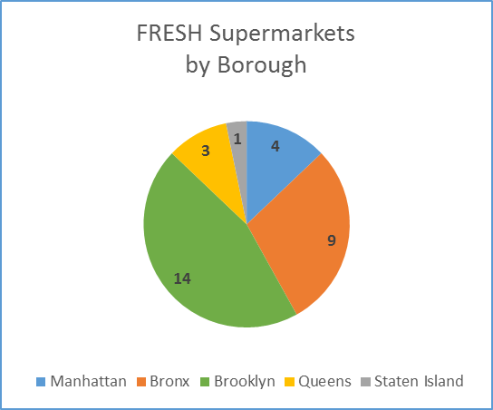
- 15 of the projects are complete with open stores, while 16 stores have been approved for FRESH benefits with development and construction in progress. Additionally, one store received the zoning bonus but could not secure a grocer upon opening. In this case, DCP worked with the developer so they could compensate for the extra floor area in some other way.
- Of the 31 stores, 21 stores were in locations eligible to take both the zoning and financial incentives. Ten of those 21 stores took only the financial incentives and two of the 21 stores only took the zoning incentive. Additionally, eight of those 21 stores have taken the zoning bonus and they may take the NYCIDA financial incentives closer to opening.

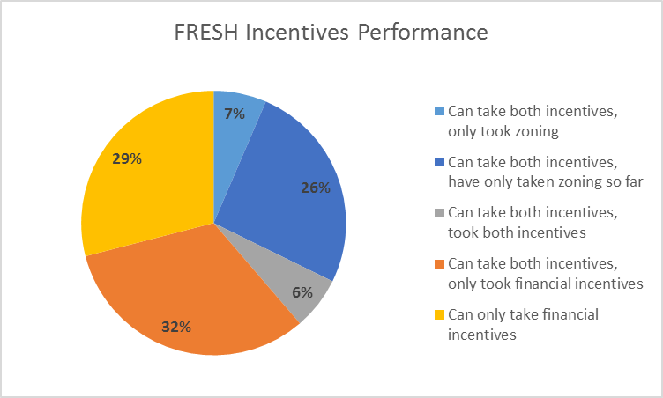

- Of the 15 stores that are open, one store has taken both the zoning and financial incentives, while 12 have taken only the financial incentives and two only took the zoning bonus.
- Of the 31 stores, 12 stores were previously grocery stores and 19 projects appear to have no prior use as a grocery store.
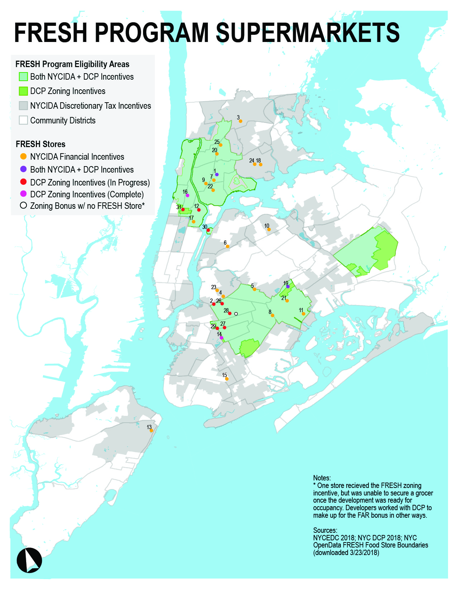

- FRESH Zoning Incentive Program
The FRESH program offers a number of key zoning incentives:
- Floor Area - one additional square foot of floor area in a mixed use building for every square foot provided for a FRESH food store, up to a maximum bonus of 20,000 square feet.
- Reduction in Required Parking: Depending on the location and size of the grocery store, waivers for parking allow for smaller development sites to accommodate a supermarket.
- Larger FRESH stores in M1 zones – M1 zones have a size restriction on supermarkets but FRESH supermarkets are allowed to occupy a larger area, up to 30,000 square feet.
In order to receive the zoning bonus, the development must be located within a FRESH area and meet the requirements of a FRESH food store, which is certified by the Chairperson of the CPC. There are several requirements, which include a portion of floor area dedicated to certain grocery items, standards for signage, and window design standards.
Prior to the creation of the FRESH food zoning text, the DCP created a Supermarket Needs Index (“SNI”) using GIS and geospatial analysis in order to determine which areas the zoning bonus would be mapped. The SNI is comprised of a variety of criteria, which were selected to reflect both the health status of local populations and the economic and geographic barriers they face in acquiring fresh food. When created in 2008, the SNI found that three million New Yorkers were living in areas that were identified as high need based on the following indicators:
- Obesity and diabetes – NYC Department of Health and Mental Hygiene - Health Surveys are compiled for the 59 Community Districts, data is from NYC DOHMH community health survey
- Consumption of fresh fruits and vegetables – NYC Department of Health and Mental Hygiene - Health Surveys are compiled for the 59 Community Districts, data from NYC DOHMH community health survey
- Share of fresh food retailers to all food retailers – Bureau of Labor Statistics
- Car ownership – US Census
- Supermarkets database – New York State Department of Agriculture and Markets - Lists licensed stores across New York City including supermarkets
- Population density – US Census
- CDBG eligibility – NYC Department of City Planning
- Geographic shapefiles – NYC Department of City Planning

The geospatial method used to generate the SNI was complex and compiled with data that came in the form of many incongruent geographies, which compromised the strength of the index in its ability to pinpoint areas most in need of fresh food. The methodology of the SNI was modified in 2011 and was updated to reflect more recent data. However, the FRESH program boundaries have not been changed since 2009, aside from the expansion in South Jamaica as part of that neighborhood rezoning in 2011.

- FRESH Financial Incentive Program
The FRESH Financial Incentive Program is administered by the New York City Industrial Development Agency (“NYCIDA”) and offers the following benefits to eligible grocery stores:
- Real Estate Tax Reductions
- Sales Tax Exemptions
- Mortgage Recording Tax Deferrals

The NYCIDA is tasked with encouraging economic development throughout the five boroughs, assisting in the retention of existing jobs, and creating and attracting new job opportunities. The Uniform Tax Exemption Policy (“UTEP”) of the NYCIDA is the authorizing document guiding financial assistance for proposed projects that will create or retain permanent, private-sector jobs.
UTEP outlines the requirements for consideration for the FRESH tax incentives but the ultimate allocation of financial assistance is a discretionary act on the part of the NYCIDA board. In making the discretionary decision, staff and the board consider a long list of variables including financial feasibility of the project, the environmental impact of the project, the amount of private-sector investment to be generated by the proposed project, and public support for, or opposition to, the proposed project.
The NYCIDA board has 15 members who are appointed by the Borough Presidents and the Mayor. The Council has no appointee to the Board. The NYCIDA is staffed by EDC staff members, but is a separate authority and does not need approval from EDC to make discretionary decisions. The tax benefits typically include full or partial reductions in the real property tax, mortgage recording tax and sales tax on store-related construction materials. The tax benefits typically go to the supermarket operator and can last for up to 25 years.
In 2017, there were changes made to the UTEP and the FRESH benefits. The NYCIDA amended the UTEP text to standardize requirements for FRESH financial incentives and the addition of this language means that projects will no longer be negotiated on a one-off basis.
To qualify for FRESH financial incentives, a project must meet the following requirements:
- Recipient is a grocery store operator constructing a new or renovating an existing retail space or a developer building a space that will be leased to a grocery store operator
- The grocery store must be a minimum of 5,000 square feet of retail space with at least 500 square feet reserved for fresh produce
- The store must be located in an area eligible to participate in the FRESH program
- The project can receive a maximum benefit term of 25 years
- The project will be exempted from City real property taxes
- The IDA can exempt the project from paying the City and State mortgage recording taxes

- Current Challenges and Draft Proposals for FRESH Reform
Incentivizing the creation of grocery stores by lowering the costs of owning, developing, and renovating retail spaces to accommodate their expansion in underserved communities, is worthwhile. The FRESH program aims to do just that, and while it currently only applies in a limited geography of New York City, there are ways to improve the program’s performance.
In conversations with developers and supermarket operators that have utilized or sought to take advantage of the FRESH financial and/or zoning incentives, the following issues have arisen:
- Onerous application process for obtaining both the zoning bonus and financial incentives
- The zoning bonus and financial incentive is not sufficient as an incentive
- Prohibitively large application fees for the financial incentives
- Many operators would prefer to take the ICAP due to the easier application process, even though it’s a shorter benefit period (15 year tax incentive versus up to 25 years under FRESH)
- Banks feel apprehensive to lend on projects with the zoning bonus due to the threat of holding up a temporary certificate of occupancy (TCO) on the residential units due to the supermarket being slow to open
- The glazing requirements in the zoning bonus need to be updated to match with recent building code requirements related to energy efficiency
The possible reforms to FRESH zoning are a first step in improving access to fresh, healthy foods in low and moderate-income neighborhoods, but should not be the only efforts made. The single most important change would be to increase federal SNAP benefits. Other reforms and programming that encourage healthier eating habits are important, as studies have shown that eating habits and health indicators such as body mass index (BMI) did not necessarily improve just because a supermarket opens nearby (a peer reviewed study was conducted in Pittsburgh). Other types of programs could include technical assistance for supermarket providers to navigate the DCP/EDC approvals process, which could be housed at SBS.

The following are preliminary proposals the Council is seeking feedback on to reform the FRESH program:

- Expand the list of neighborhoods that are eligible to receive the FRESH zoning bonus to more closely align with the areas of highest need where the financial incentive is mapped. Potential areas for expansion include parts or all of the following community districts:
Manhattan:
- Portions of CD3 (CMs Rivera, Chin)
- Portions of CD7 (Levine, Rosenthal)
Bronx:
- Portions of CD9 (CMs Salamanca, Gjonaj, Diaz Sr.)
- Portions of CD12 (CMs Cohen, King, Torres)
- Portions of CD10 (King, Gjonaj)
Brooklyn:
- Portions of CD7 (CMs Menchaca and Lander)
- Portions of CD13 (CMs Treyger and Deutsch)
- Portions of CD12 (CMs Yeger, Lander, Menchaca)
Queens:
- Portions of CD1 (CMs Constantinides, Van Bramer)
- Portions of CD4 (CMs Moya, Koo, Lancman)
- Portions of CD14 (CM Richards)
Staten Island:
- Portions of CD1 (CMs Rose, Matteo)

- Identify opportunities for supermarkets on NYCHA-owned land where there is a scarcity of grocery stores. Currently, many campuses are zoned strictly for residential uses which are districts that prohibit grocery stores. In order to allow the construction of FRESH supermarkets on NYCHA property, an exemption to the residential zoning district rules on land controlled by NYCHA could be created exclusively for FRESH grocery stores.
- Explore reductions in parking that would encourage additional FRESH zoning benefits.
- Ease glazing requirements to work better with recent changes to the building codes concerning energy efficiency.
- Consider a larger zoning bonus for projects that include a FRESH supermarket and are 100% affordable housing.
- Potentially deepen the financial incentive in higher-need neighborhoods where the existing benefits have not worked to deliver grocery stores.
- Simplify the application process for both financial and zoning incentives to make it less cumbersome for developers who would like to use the program and provide a FRESH grocery store.
  - Explore reductions to EDC’s fees for the NYCIDA incentive (application fee and fee for outside counsel).
  - Reassess the application process for the DCP zoning bonus and potentially reduce any unnecessary steps in order to streamline the process.

- Increase the visibility of the FRESH incentive by including the program on HPD term sheets as a potential benefit.
- Improve oversight and transparency so the public can benefit from understanding the efficacy of the FRESH program.

- Conclusion
Council Members constantly hear from residents who lack access to fresh, affordable food and from supermarket operators struggling with rising costs, and at the same time, are wondering how the city’s zoning and financial incentives can better address these issues. At this hearing, the Council is evaluating the areas that could benefit most from an expansion of the FRESH zoning incentives. Additionally, the Council is eager to learn more from the experiences of developers and supermarket operators about ways to improve the application process for the zoning and financial incentives. Finally, the Council is interested in hearing feedback from the Administration, related industries, and food justice advocates on the draft proposals included in this report to identify approaches to updating and strengthening the program.
- Appendix
Below is a table showing how the different indicators were weighted in the original development of the SNI.
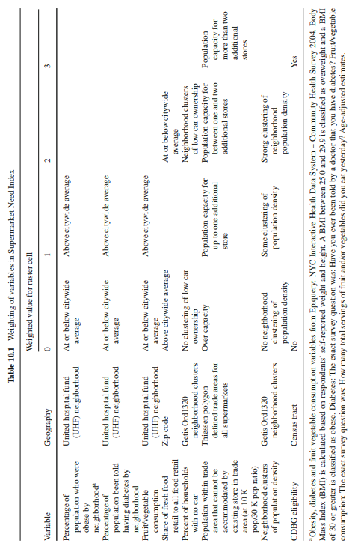

FRESH Grocery Stores to Date

# | Grocery | Size (sf) | Address | Borough | Status | Incentives taken | Incentives Allowed
1 | Associated Supermarket | 17000 | 3470 Third Avenue | Bronx | Project Complete & Store Open | NYCIDA Financial, DCP Zoning | Zoning and discretionary tax incentives
2 | Bedford Market | 18394 | 744 Bedford Avenue | Brooklyn | In Progress | DCP Zoning | Zoning and discretionary tax incentives
3 | Fine Fare - East Gun Hill Road LLC | 17000 | 801 E Gun Hill Road | Bronx | In Progress | NYCIDA Financial | Discretionary tax incentives
4 | Food Bazaar, Williamsburg/Bushwick | 60000 | 21 Manhattan Avenue | Brooklyn | Project Complete & Store Open | NYCIDA Financial | Discretionary tax incentives
5 | Food Bazaar – Bushwick | 56000 | 17-59 Ridgewood Place | Brooklyn | In Progress | NYCIDA Financial | Zoning and discretionary tax incentives
6 | Bogopa LIC - Food Bazaar | 50000 | 42-02 Northern Boulevard | Queens | Project Complete & Store Open | NYCIDA Financial | Discretionary tax incentives
7 | Bogopa 163 - Food Bazaar | 30000 | 445 E 163rd Street | Bronx | Project Complete & Store Open | NYCIDA Financial | Zoning and discretionary tax incentives
8 | Food Bazaar, Brownsville | 45000 | 417 Junius Street | Brooklyn | In Progress | NYCIDA Financial | Zoning and discretionary tax incentives
9 | Food Bazaar, Grand Concourse | 55000 | 238 E 161st Street | Bronx | Project Complete & Store Open | NYCIDA Financial | Zoning and discretionary tax incentives
10 | Food Bazaar, Jackson Heights | 18000 | 34-20 Junction Boulevard | Queens | Project Complete & Store Open | NYCIDA Financial | Discretionary tax incentives
11 | Gateway Shoprite | 90000 | 590 Gateway Drive | Brooklyn | Project Complete & Store Open | NYCIDA Financial | Zoning and discretionary tax incentives
12 | Super Fi Emporium | 11976 | 2211 Third Avenue | Manhattan | In Progress | NYCIDA Financial, DCP Zoning | Zoning and discretionary tax incentives
13 | Key Food Supermarket | 9000 | 300 Sand Lane | Staten Island | Project Complete & Store Open | NYCIDA Financial | Discretionary tax incentives
14 | Lincoln Park Partners | 11970 | 31 Lincoln Road | Brooklyn | Project Complete & Store Open | DCP Zoning | Zoning and discretionary tax incentives
15 | Moisha's Discount Supermarket | 15000 | 305-325 Avenue M | Brooklyn | Project Complete & Store Open | NYCIDA Financial | Discretionary tax incentives (looks right outside the boundary)
16 | Key Food - Strivers Plaza | 7688 | 2630 Frederick Douglass Boulevard | Manhattan | Project Complete & Store Open | DCP Zoning | Zoning and discretionary tax incentives
17 | Super Fi - Reyco Supermarket | 7500 | 1635 Lexington Avenue | Manhattan | Project Complete & Store Open | NYCIDA Financial | Zoning and discretionary tax incentives
18 | Village Super Market Inc. dba Nick & Perry Markets | 29418 | 1998 Bruckner Boulevard/861 Pugsley Avenue | Bronx | In Progress | NYCIDA Financial | Discretionary tax incentives
19 | Western Beef Retail, Inc - Cypress Hills | 16000 | 814 Jamaica Avenue | Brooklyn | In Progress | NYCIDA Financial, DCP Zoning | Zoning incentives
20 | Western Beef Supermarket | 35000 | 2050 Webster Avenue | Bronx | Project Complete & Store Open | NYCIDA Financial | Zoning and discretionary tax incentives
21 | Cypress Pitkin Berriman | 10696 | 2501 Pitkin Avenue | Brooklyn | In Progress | NYCIDA Financial | Zoning and discretionary tax incentives
22 | 149 Street Food Corp - Fine Fare | 14600 | 459 E 149th Street | Bronx | Project Complete & Store Open | NYCIDA Financial | Zoning and discretionary tax incentives
23 | Tapps Supermarket | 19900 | 575 Grand Street | Brooklyn | In Progress | NYCIDA Financial | Discretionary tax incentives
24 | Western Beef - Bruckner | 40840 | 1851 Bruckner Boulevard | Bronx | Project Complete & Store Open | NYCIDA Financial | Discretionary tax incentives
25 | Western Beef Retail, Inc - Belmont | 18505 | 4720 Third Avenue | Bronx | In Progress | NYCIDA Financial | Zoning and discretionary tax incentives
26 | 859 Myrtle Avenue FRESH | 20000 | 859 Myrtle Avenue | Brooklyn | In Progress | DCP Zoning | Zoning and discretionary tax incentives
27 | 1535 Bedford Ave FRESH | 7030 | 1535 Bedford Avenue | Brooklyn | In Progress | DCP Zoning | Zoning and discretionary tax incentives
28 | 410 Tompkins Avenue FRESH | 6200 | 410 Tompkins Avenue | Brooklyn | In Progress | DCP Zoning | Zoning and discretionary tax incentives
29 | 805 Washington Ave BK | 7730 | 805 Washington Ave | Brooklyn | In Progress | DCP Zoning | Zoning and discretionary tax incentives
30 | Halletts Point | 21750 | 26-01 1 Street | Queens | In Progress | DCP Zoning | Zoning and discretionary tax incentives
31 | ST. NICHOLAS FRESH | 24990 | 223 St. Nicholas Avenue | Manhattan | In Progress | DCP Zoning | Zoning and discretionary tax incentives

Smith, L., Goranson, C., Bryon, J., Kerker, B., & Nonas, C. (2011). Developing a Supermarket Need Index. Geospatial Analysis of Environmental Health, 205-221. doi:10.1007/978-94-007-0329-2_10
Access to Healthy Foods (Issue brief). (2010, January). Retrieved June 6, 2018, from Policy Link website: http://www.policylink.org/sites/default/files/access-to-healthy-food_0.pdf
NYC Department of City Planning, "Going to Market: New York City's Neighborhood Grocery Store and Supermarket Shortage" (April 2008), https://www1.nyc.gov/assets/planning/download/pdf/plans/supermarket/supermarket.pdf
NYCEDC, "Food Retail Expansion to Support Health (FRESH)" https://www.nycedc.com/program/food-retail-expansion-support-health-fresh
NYC Mayor's Office of Food Policy, "Food Metrics Report 2017," (2017) at 28, http://www1.nyc.gov/assets/foodpolicy/downloads/pdf/2017-Food-Metrics-Report-Corrected.pdf
NYC Department of City Planning, "FRESH Food Stores," https://www1.nyc.gov/site/planning/zoning/districts-tools/fresh-food-stores.page
See id.
NYCEDC, "Food Retail Expansion to Support Health (FRESH)" https://www.nycedc.com/program/food-retail-expansion-support-health-fresh
Data from NYC EDC and NYC DCP 2018
No stores have filed an application to remove a FRESH certification or authorization. This requires either CPC chair approval and demonstration of a good faith effort to lease the space to a qualifying supermarket. While DCP has had discussions with one approved project (27 Albany Street), they have not filed any application to remove the requirements. DCP will continue to work with them to address the issue.
NYC Department of City Planning, "FRESH Food Stores," https://www1.nyc.gov/site/planning/zoning/districts-tools/fresh-food-stores.page
See id.
See id.
L. Smith et al., Developing a Supermarket Need Index, from J.A. Maantay, S. McLafferty (eds.), Geospatial Analysis of Environmental Health, Geotechnologies and the Environment 4, DOI 10.1007/978-94-007-0329-2 _10, Springer Science+Business Media B.V. 2011, page 203.
L. Smith et al., Developing a Supermarket Need Index, from J.A. Maantay, S. McLafferty (eds.), Geospatial Analysis of Environmental Health, Geotechnologies and the Environment 4, DOI 10.1007/978-94-007-0329-2 _10, Springer Science+Business Media B.V. 2011, page 208.
New York City Mayor’s Office of Food Policy and the Mayor’s Office of Long Term Planning and Sustainability, 2013 New York City Food Metrics Report, 2013, pages 16-17.
NYCEDC, "Food Retail Expansion to Support Health (FRESH)" https://www.nycedc.com/program/food-retail-expansion-support-health-fresh
NYCEDC, "New York City Industrial Development Agency," https://www.nycedc.com/nycida
NYC Industrial Development Agency, "Amendment and Restatment of New York City Development Agency Uniform Tax Exemption Policy," (June 13, 2017), https://www.nycedc.com/sites/default/files/filemanager/NYCIDA/Governance_and_Policies/NYCIDA_UNIFORM_TAX_EXEMPTION_POLICY/NYCIDA_Uniform_Tax_Exemption_Policy_Final.pdf
See id at B-1 to B-3
NYCEDC, "NYCIDA Board of Directors," https://www.nycedc.com/nycida/board-directors
NYC Industrial Development Agency, "Amendment and Restatment of New York City Development Agency Uniform Tax Exemption Policy," (June 13, 2017) at B-1 to B-3, https://www.nycedc.com/sites/default/files/filemanager/NYCIDA/Governance_and_Policies/NYCIDA_UNIFORM_TAX_EXEMPTION_POLICY/NYCIDA_Uniform_Tax_Exemption_Policy_Final.pdf
See id.
See id.
Dubowitz,T., Ghosh-Dastidar, M.,Cohen D.A., et al. (2015) Changes in Diet after Introduction of a Full Service Supermarket in a Food Desert. National Institutes of Health. https://www.ncbi.nlm.nih.gov/pmc/articles/PMC4977027/
L. Smith et al., Developing a Supermarket Need Index, from J.A. Maantay, S. McLafferty (eds.), Geospatial Analysis of Environmental Health, Geotechnologies and the Environment 4, DOI 10.1007/978-94-007-0329-2 _10, Springer Science+Business Media B.V. 2011, page 213.
Data from NYC EDC and NYC DCP 2018

