THE COUNCIL OF THE CITY OF NEW YORK
RESOLUTION NO. 210

Resolution approving the decision of the City Planning Commission on Application No. N 210300 ZRK, for an amendment of the text of the Zoning Resolution (Preconsidered L.U. No. 51).

By Council Members Salamanca and Riley

WHEREAS, Zucker Enterprises, LLC, filed an application pursuant to Section 201 of the New York City Charter, for an amendment of the text of the Zoning Resolution of the City of New York, modifying APPENDIX F for the purpose of establishing a Mandatory Inclusionary Housing Area, which in conjunction with the related action would facilitate the construction of a new mixed-use development containing 74 dwelling units, 19 of which would be affordable under the Mandatory Inclusionary Housing (MIH) Program, as well as approximately 25,000 square feet of commercial floor area throughout the first three stories of the building, located at 840 Lorimer Street (Block 2679, Lot 43) in the Greenpoint neighborhood of Community District 1, Brooklyn (ULURP No. N 210300 ZRK) (the “Application”);

WHEREAS, the City Planning Commission filed with the Council on April 15, 2022, its decision dated April 13, 2022 (the “Decision”), on the Application;

WHEREAS, the Application is related to application C 210299 ZMK (Pre. L.U. No. 50), a zoning map amendment to change M1-2/R6A (MX-8) and R6A/C2-4 zoning districts to a C4-5D zoning district;

WHEREAS, the Decision is subject to review and action by the Council pursuant to Section 197-d of the City Charter;

WHEREAS, upon due notice, the Council held a public hearing on the Decision and Application on April 26, 2022;

WHEREAS, the Council has considered the land use implications and other policy issues relating to the Decision and Application; and

WHEREAS, the Council has considered the relevant environmental issues, including the Negative Declaration issued November 29th, 2021 (CEQR No. 21DCP078K) which includes an (E) designation to avoid the potential for significant adverse impacts related to hazardous materials, air quality, and noise impacts (E-650) (the “Negative Declaration”).

RESOLVED:

The Council finds that the action described herein will have no significant impact on the environment as set forth in the (E) Designation (E-650) and Negative Declaration.

Pursuant to Sections 197-d and 200 of the City Charter and on the basis of the Decision and Application, and based on the environmental determination and consideration described in the report, N 210300 ZRK, incorporated by reference herein, and the record before the Council, the Council approves the Decision of the City Planning Commission.

Matter underlined is new, to be added;
Matter struck out is to be deleted;
Matter within # # is defined in Section 12-10;
* * * indicates where unchanged text appears in the Zoning Resolution

APPENDIX F
Inclusionary Housing Designated Areas and Mandatory Inclusionary Housing Areas

* * *

BROOKLYN

Brooklyn Community District 1

* * *

Map 2 – [date of adoption]

[EXISTING]
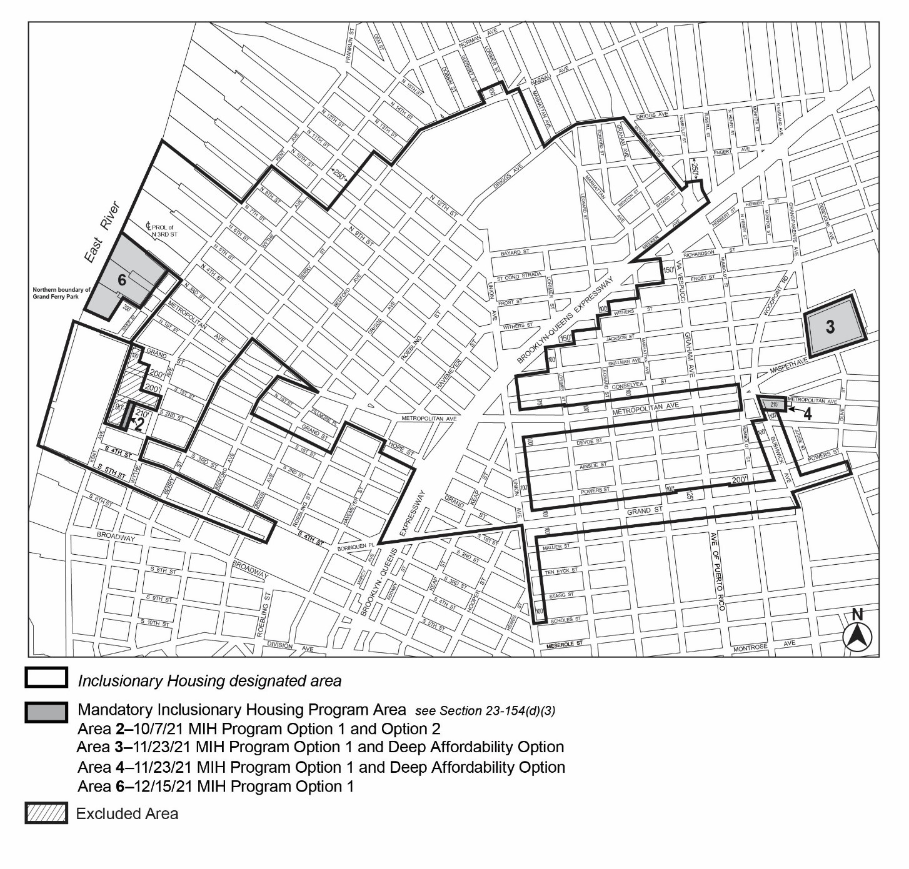

[PROPOSED]
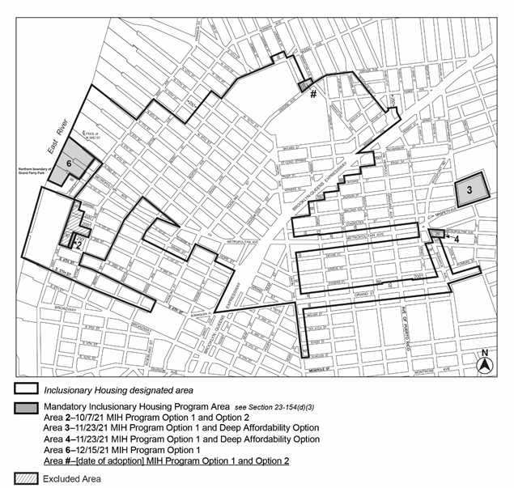

Portion of Community District 1, Brooklyn
* * *

Adopted.

Office of the City Clerk, }
The City of New York, } ss.:

I hereby certify that the foregoing is a true copy of a Resolution passed by The Council of The City of New York on __________, 2022, on file in this office.

.....................................................
City Clerk, Clerk of The Council

