THE COUNCIL OF THE CITY OF NEW YORK
RESOLUTION NO. 1895

Resolution approving with modifications the decision of the City Planning Commission on Application No. N 220063 ZRK, for an amendment of the text of the Zoning Resolution (Preconsidered L.U. No. 930).

By Council Members Salamanca and Moya

WHEREAS, River Street Partners, LLC, filed an application pursuant to Section 201 of the New York City Charter, for an amendment of the text of the Zoning Resolution of the City of New York, modifying Article VII, Chapter 4 (Special Permits by the City Planning Commission) for the purpose of modifying Large-scale General Development provisions, and modifying APPENDIX F, for the purpose of establishing a Mandatory Inclusionary Housing area, which in conjunction with the related actions would facilitate the construction of an approximately 1.16 million-square-foot mixed-use large-scale general development (LSGD) containing approximately 1,050 residential units, 30,000 square feet of community facility uses, 79,000 square feet of commercial space, and 2.9 acres of open space located at 105 River Street in the Williamsburg neighborhood of Brooklyn, Community District 1 (ULURP No. N 220063 ZRK), (the “Application”);

WHEREAS, the City Planning Commission filed with the Council on November 17, 2021, its decision dated November 17, 2021 (the "Decision") on the Application;

WHEREAS, the Application is related to applications C 220062 ZMK (Pre. L.U. No. 929), a zoning map amendment to (a) rezone an M3-1 zoning district to a C6-2 zoning district; and (b) rezone an M3-1 zoning district to a M1-4 zoning district; C 220061 MLK (L.U. No. 932), a landfill action to add approximately 6,320 square feet to create open area as part of the waterfront public space; C 220064 ZSK (L.U. No. 933), a special permit pursuant to ZR Section 74-74 to establish a LSGD, allow reconstructed piers to retain floor area, and modify bulk regulations; N 220065 ZAK (L.U. No. 934), an authorization pursuant to ZR Section 62-822(a) to modify regulations pertaining to the locations and dimensions of required waterfront public access areas; C 220070 ZSK (L.U. No. 935), a special permit pursuant to ZR Section 74-533 to reduce the parking requirements for accessory group parking facilities in a Transit Zone; and C 210425 MMK (L.U. No. 936), city map change to eliminate, discontinue, close, and dispose of a segment of Metropolitan Avenue to the west of River Street and a portion of North First Street west of River Street;

WHEREAS, the Decision is subject to review and action by the Council pursuant to Section 197-d of the City Charter;

WHEREAS, upon due notice, the Council held a public hearing on the Decision and Application on November 18, 2021;

WHEREAS, the Council has considered the land use implications and other policy issues relating to the Decision and Application; and

WHEREAS, the Council has considered the relevant environmental issues, including the Positive Declaration issued March 22nd, 2021 (CEQR No. 21DCP157K) and a Final Environmental Impact Statement (FEIS) for which a Notice of Completion was issued on November 5, 2021, in which significant adverse impacts related to hazardous materials, air quality, and noise would be avoided through the placement of (E) designations (E-636) on the project sites. To ensure the implementation of the PCREs, the applicant will enter into a Restrictive Declaration at the time of the approval of land use-related actions and prior to issuance of any permits. The proposed project as analyzed in the FEIS identified significant adverse impacts with respect to transportation (pedestrians, street user safety) and construction (noise) and to ensure the implementation of the mitigation measures identified in the FEIS, they are included in the Restrictive Declaration.

RESOLVED:

Having considered the FEIS with respect to the Decision and Application, the Council finds that:

- The FEIS meets the requirements of 6 N.Y.C.R.R. Part 617;

- The environmental impacts disclosed in the FEIS were evaluated in relation to the social, economic, and other considerations associated with the action[s] that are set forth in this report; and

- Consistent with social, economic and other essential considerations from among the reasonable alternatives available, the action is one which avoids or minimizes adverse environmental impacts to the maximum extent practicable; and

- The adverse environmental impacts identified in the FEIS will be minimized or avoided to the maximum extent practicable by incorporating as conditions to the approval, pursuant to the restrictive declaration dated November 15, 2021, those project components related to the environment and mitigation measures that were identified as practicable.

The Decision, together with the FEIS constitute the written statement of facts, and of social, economic and other factors and standards that form the basis of this determination, pursuant to 6 N.Y.C.R.R. §617.11(d).

Pursuant to Sections 197-d and 200 of the City Charter and on the basis of the Decision and Application, and based on the environmental determination and consideration described in the report, N 220063 ZRK, incorporated by reference herein, and the record before the Council, the Council approves the Decision of the City Planning Commission with the following modifications:

Matter underlined is new, to be added;
Matter struck out is to be deleted;
Matter within # # is defined in Section 12-10;
* * * indicates where unchanged text appears in the Zoning Resolution.
Matter double struck out is old, deleted by the City Council;
Matter double-underlined is new, added by the City Council

ARTICLE VII
ADMINISTRATION

Chapter 4
Special Permits by the City Planning Commission

74-74
Large-scale General Development

* * *

74-742
Ownership

* * *

A special permit may be applied for and granted under the provisions of Section 74-74, even though such #large-scale general development# does not meet the ownership requirements set forth elsewhere in this Section, when the site of such #large-scale general development# is:

* * *

(d) partially under State or City ownership, or may include a tract of land under private ownership that is located within the bed of 26th Avenue between 1st Street and the bulkhead line within the Hallets Point Peninsula, in the area bounded by 8th Street and Vernon Boulevard on the east, the East River on the west and south, and the north side of 26th Avenue on the north, in Community District 1 in the Borough of Queens, provided that the exception to the ownership requirements set forth herein shall apply only to:

(1) tracts of land in State or City ownership; or

(2) a tract of land in private ownership located within the bed of 26th Avenue, between 1st Street and the bulkhead line; or

(e) within Manhattan Community District 2, where the City Planning Commission has approved a special permit under Section 74-74 for a #large-scale general development# located partially within a C2-7 District, and a portion of such #large-scale general development# is subsequently mapped as a park and transferred to City ownership, then the consent or authorization of any owner or party in interest to:

* * *

(2) property other than the #public park# shall not be required for any application for a modification to the special permit or associated restrictive declaration relating only to the #public park#.; or

(f) partially under State or City ownership, and is located within the boundaries of Community District 1 in the Borough of Brooklyn, on a #waterfront zoning lot# located within a C6-2 District that is mapped within a #Mandatory Inclusionary Housing area#, provided that the exception to the ownership requirements set forth herein shall apply only to such tracts of land in State or City ownership.

* * *

74-743
Special provisions for bulk modification

(a) For a #large-scale general development#, the City Planning Commission may permit:

* * *

(11) wholly within a C1-9 District entirely within the boundaries of Community District 8 in Manhattan, for a predominantly #community facility development#, a #floor area# bonus not to exceed 20 percent of the maximum #floor area ratio# permitted by the underlying district regulations where, in connection with such #development#, an improvement to a #public park# located within the same Community District and within a one mile radius of the proposed #development# is provided in accordance with the provisions of this Section.

* * *

(ii) Prior to a determination as to whether to grant the special permit, the City Planning Commission shall have received from the Commissioner of Parks and Recreation:

* * *

(b) a letter that shall include:

* * *

(ii) a statement that the funding to be provided by the applicant, in combination with any other available funding, is adequate for completion of the necessary infrastructure, landscape and other work necessary to complete the #public park# improvement; or

(12) within the boundaries of Community District 1 in the Borough of Queens, in the area generally north of 30th Road and west of 8th Street, within the Hallets Point Peninsula, the #floor area# distribution from a #zoning lot# containing existing public housing #buildings#, provided that upon approval of a #large-scale general development# there exists unused #floor area# on a separate parcel of land with existing light industrial #buildings# in an amount equivalent to, or in excess of, the #floor area# approved for distribution and further provided:

* * *

(ii) the existing light industrial #buildings# on the separate parcel of land are demolished.; or

(13) within the boundaries of Community District 1 in the Borough of Brooklyn, on a #waterfront zoning lot# located within a C6-2 District that is mapped within a #Mandatory Inclusionary Housing area#, portions of the land, #piers# or #platforms# projecting seaward of the bulkhead line and existing on [date of adoption] may be replaced or reconstructed with #new piers# or #new platforms#, as follows:

(i) any such existing land projecting seaward of the bulkhead line may be replaced or reconstructed with #new platforms# and such #new platforms# may be included as part of the #upland lot#. In no event shall the #lot area# generated by such #new platforms# exceed the #lot area# of the land projecting seaward of the bulkhead line, as it existed on [date of adoption]; and

- any other such #new piers# or #new platforms# may be considered #lot area# for the purposes of determining allowable #floor area# or number of #dwelling units#, or to satisfy any other #bulk# regulations, in accordance with the provisions of paragraphs (b) and (c) of Section 62-31 (Bulk Computations on Waterfront Zoning Lots). In no event shall the #floor area# generated by such #new piers# or #new platforms# exceed the #floor area# generated by #piers# or #platforms# projecting seaward of the bulkhead line, as they existed on [date of adoption]; and

(ii)(iii) any #new piers# or #new platforms# that are subject to the provisions of this paragraph (a)(13) need not meet the requirements of Sections 62-242 (Uses on new piers and platforms), 62-54 (Requirements for Public Access on Piers), or 62-63 (Design Requirements for Public Access on Piers and Floating Structures), inclusive.

(b) In order to grant a special permit pursuant to this Section for any #large-scale general development#, the Commission shall find that:

* * *

(10) a declaration with regard to ownership requirements in paragraph (b) of the #large-scale general development# definition in Section 12-10 (DEFINITIONS) has been filed with the Commission; and

(11) where the Commission permits #floor area# distribution from a #zoning lot# containing existing light industrial #buildings# to be demolished in accordance with the provisions of paragraph (a)(12) of this Section, such #floor area# distribution shall contribute to better site planning of the #waterfront public access area# and shall facilitate the #development# of affordable housing units within a #large-scale general development#.; and

(12) where #new piers# or #new platforms# are constructed, replaced or reconstructed in accordance with the provisions of paragraph (a)(13) of this Section, such #new piers# and #new platforms# are an integral part of such #large-scale general development#, result in a superior site plan and form an appropriate relationship with adjacent #waterfront public access areas# and #shorelines#, and provide significant public access to or within the #seaward lot# portion of the #waterfront zoning lot#.

Within Manhattan Community District 2, within the former Washington Square Southeast Urban Renewal Area, where the Commission has approved a #large-scale general development# and a #lot line# of such #large-scale general development# coincides with the boundary of a mapped #public park#, such #lot line# shall be considered to be a #street line# of a #wide street# for the purposes of applying all #use# and #bulk# regulations of this Resolution.

* * *

APPENDIX F

Inclusionary Housing Designated Areas and Mandatory Inclusionary Housing Areas

* * *

BROOKLYN

* * *

Brooklyn Community District 1

* * *

Map 2 - [date of adoption]

[EXISTING MAP]

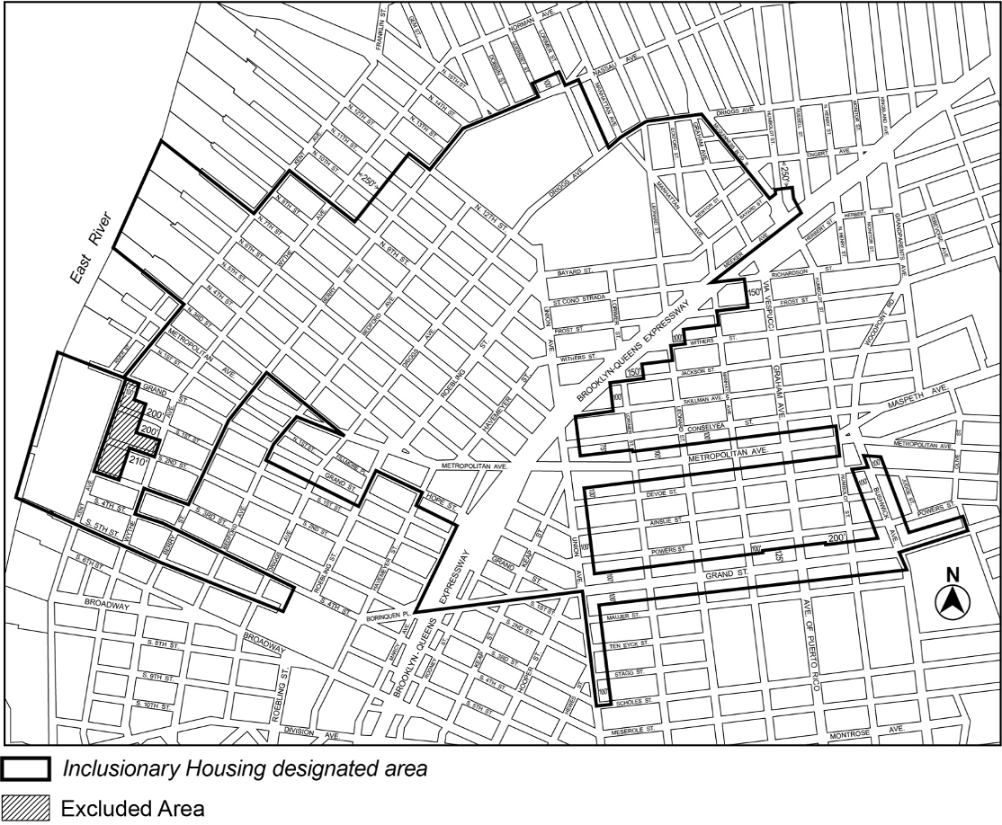

[PROPOSED MAP]

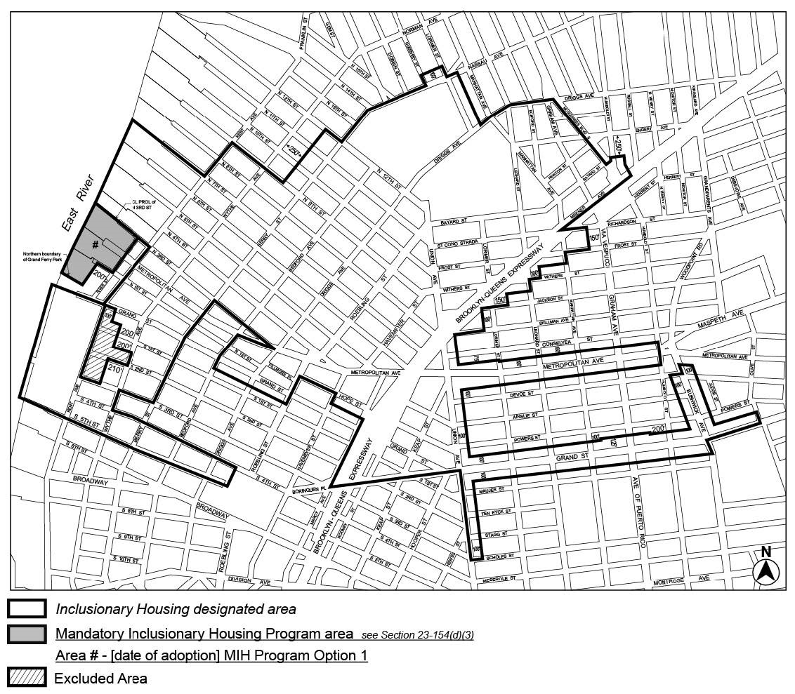

Portion of Community District 1, Brooklyn

* * *

Adopted.

Office of the City Clerk, }
The City of New York, } ss.:

I hereby certify that the foregoing is a true copy of a Resolution passed by The Council of The City of New York on ____________, 2021, on file in this office.

.....................................................
City Clerk, Clerk of The Council

