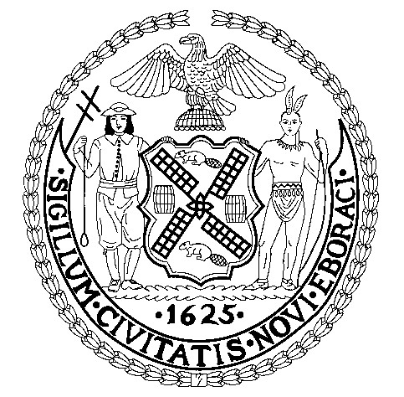

Negative Declaration

CEQR Number: 08CCO008X Date Issued: July 17, 2008

NAME: Bronx Westchester Tempering, Inc. Empire Zone Regionally Significant Project

LOCATION: Bronx, Manhattan

SEQR CLASSIFICATION: The project is classified as an Unlisted action pursuant to 6 NYCRR, Part 617.2(ak).

Description

The proposed action requests the approval by enactment of a local law of the designation of Bronx Westchester Tempering, Inc., a manufacturer in an Industrial Business Zone (IBZ), as a Regionally Significant Project. The Empire Zones program is a certification program through which businesses that make investments in a geographically designated area are made eligible for a variety of New York State tax credits and other benefits

The proposed action would create and retain upwards of 60 new jobs over the next five years in the local community, and Bronx Westchester Tempering, Inc. would invest approximately $4 million in the project, including minor interior renovations, installation of a new electric-powered HVAC system, and the purchase and installation of an energy efficient, electric-generated glass tempering furnace that is roughly twice as energy efficient as conventional furnaces.

Statement of No Significant Effect

Pursuant to Title 62 of the Rules of the City of New York Section 5-03(d), the Office of the Mayor and the New York City Council are designated as co-lead agencies for enactment of local laws and make the following determination. The proposed action would have no significant effect on the quality of the environment.

CEQR Number: 08CCO008X July 17, 2008

Supporting Statements

The above determination is based on an Environmental Assessment Statement (EAS) dated May 2008, and incorporated by reference herein. The EAS finds that:

- The project as proposed would not have significant adverse impacts on land use or the character of the surrounding community.

- The project as proposed would not result in significant adverse traffic, noise or air quality impacts.

- The project as proposed would not result in significant adverse impacts on cultural resources.

- The project as proposed will not result in any impacts from environmental hazards to humans or the natural environment.

- No other significant effects upon the environment that would require an
Environmental Impact Statement are foreseeable.

This Negative Declaration has been prepared in accordance with Article 8 of the New York State Environmental Conservation Law (SEQRA).

_____________________________________ ________________
Robert R. Kulikowski, Ph.D. Date
Assistant to the Mayor

______________________________________ __________________
Jeffrey Haberman Date
Deputy Director of the Infrastructure Division
New York City Council

cc: Andrew Schwartz
Leslie Ramos
Douglas Rice

