THE COUNCIL OF THE CITY OF NEW YORK
RESOLUTION NO. 454

Resolution approving with modifications the decision of the City Planning Commission on Application No. N 180097 ZRK, for an amendment of the Zoning Resolution of the City of New York, for the purpose of eliminating a portion of an Inclusionary Housing designated area to establish a Mandatory Inclusionary Housing area, and to extend the Special Downtown Brooklyn District, modifying Article X, Chapter 1, and related Sections, Community District 2, Borough of Brooklyn (L.U. No. 109).

By Council Members Salamanca and Moya

WHEREAS, the City Planning Commission filed with the Council on May 16, 2018 its decision dated May 9, 2018 (the "Decision"), pursuant to Section 201 of the New York City Charter, regarding an application submitted by South Portland, LLC, for an amendment of the text of the Zoning Resolution of the City of New York, for the purpose of eliminating a portion of an Inclusionary Housing designated area to establish a Mandatory Inclusionary Housing area, and to extend the Special Downtown Brooklyn District, modifying Article X, Chapter 1, and related Sections, which in conjunction with the related action would facilitate a new, approximately 85,900-square-foot mixed residential development with community facility space at 142-150 South Portland Avenue in the Fort Greene neighborhood of Brooklyn Community District 2, (Application No. N 180097 ZRK), Community District 2, Borough of Brooklyn (the "Application");

WHEREAS, the City Planning Commission’s Decision modified the Application, declining to extend the Special Downtown Brooklyn District;

WHEREAS, the Application is related to application C 180096 ZMK (L.U. No. 108), as modified, Zoning map amendment to change an R7A district to an R8A district and to an R8A/C2-4 district and 20185361 HAK (L.U. No. 110), a real property tax exemption;

WHEREAS, the Decision is subject to review and action by the Council pursuant to Section 197-d(b)(1) of the City Charter;
WHEREAS, upon due notice, the Council held a public hearing on the Decision and Application on May 30, 2018;

WHEREAS, the Council has considered the land use implications and other policy issues relating to the Decision and Application; and

WHEREAS, the Council has considered the relevant environmental issues, including the negative declaration issued January 2, 2018 (CEQR No. 18DCP044K), which include (E) designations to avoid potential significant adverse impacts related to hazardous materials and air quality which would be assigned to sites within the Rezoning Area (Block 2003, Lots 19, 29, 30, 31, 32, 33, 34, and 37) (E-460) (the “Negative Declaration”).

RESOLVED:

The Council finds that the action described herein will have no significant impact on the environment as set forth in the Negative Declaration.

Pursuant to Section 200 of the City Charter and on the basis of the Decision and Application, and based on the environmental determination and consideration described in the report, N 180097 ZRK, incorporated by reference herein, the Council approves the Decision of the City Planning Commission with the following modifications:

Matter underlined is new, to be added;
Matter struck out is to be deleted;
Matter within # # is defined in Section 12-10;
Matter double struck out is old, deleted by the City Council;
Matter double-underlined is new, added by the City Council;
* * * indicates where unchanged text appears in the Zoning Resolution.

* * *

APPENDIX F

Inclusionary Housing Designated Areas and Mandatory Inclusionary Housing Areas

* * *

BROOKLYN

* * *

Brooklyn Community District 2

* * *

Map 4 - [date of adoption]
[PROPOSED MAP]

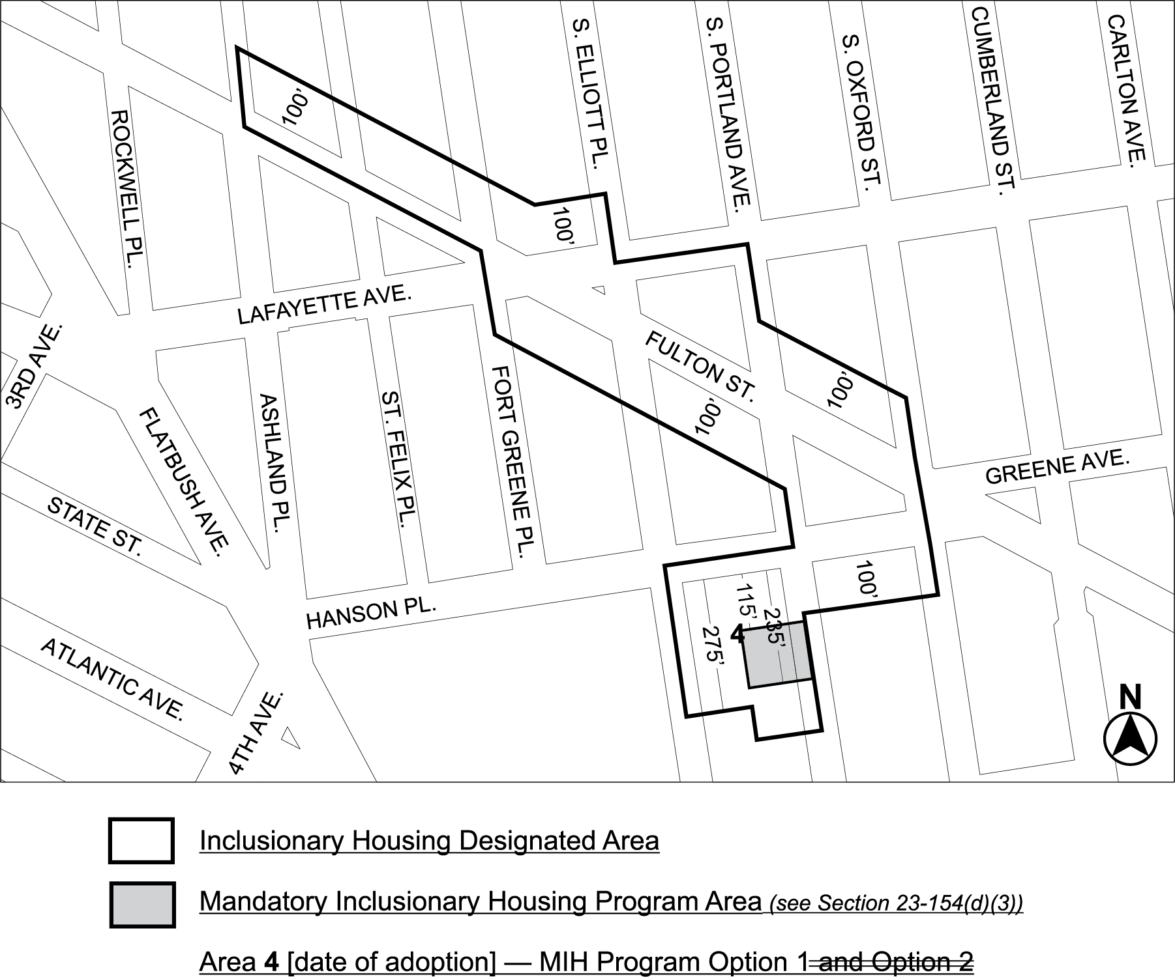

Portion of Community District 2, BROOKLYN

* * *

Adopted.

Office of the City Clerk, }
The City of New York, } ss.:

I hereby certify that the foregoing is a true copy of a Resolution passed by The Council of The City of New York on June 28, 2018, on file in this office.

.....……......................................... City Clerk, Clerk of The Council

