Committee on Contracts Staff
Alex R. Paulenoff, Senior Counsel
Alex Yablon, Legislative Policy Analyst
Florentine Kabore, Financial Analyst

Committee on Oversight and Investigations Staff
Nicole Catá, Legislative Counsel
Alex Yablon, Legislative Policy Analyst
Owen Kotowski, Financial Policy Analyst

Oversight and Investigations Division Staff
Zachary Meher, Lead Investigator
Kevin Frick, Investigative Counsel
Katie Sinise, Investigator



THE COUNCIL OF THE CITY OF NEW YORK

BRIEFING PAPER OF THE GOVERNMENTAL AFFAIRS AND OVERSIGHT & INVESTIGATIONS DIVISIONS
Andrea Vazquez, Legislative Director

Rachel Cordero, Deputy Director, Governmental Affairs Division

Aaron Mendelsohn, Director, Oversight & Investigations Division

Meagan Powers, Deputy Director, Oversight & Investigations Division

COMMITTEE ON CONTRACTS

Hon. Julie Won, Chair

COMMITTEE ON OVERSIGHT & INVESTIGATIONS
Hon. Gale A. Brewer, Chair

September 21, 2023
Oversight: Revisiting City Contracts Serving Asylum Seekers in New York City

- INTRODUCTION
On September 21, 2023, the Committee on Contracts, chaired by Council Member Julie Won, and the Committee on Oversight and Investigations, chaired by Council Member Gale Brewer, will conduct a joint oversight hearing to revisit the City’s contracts serving asylum seekers, which have been scrutinized in previous hearings. Those invited to testify include representatives from several City agencies, including the Department of Social Services (DSS), Housing Preservation & Development (HPD), New York City Emergency Management (NYCEM), NYC Health + Hospitals (H+H), and the Mayor’s Office of Contract Services (MOCS), the New York City Comptroller, immigration and housing advocates, and other interested stakeholders.
- BACKGROUND

  - Asylum and Asylum-Seekers
People fleeing persecution have the right to seek asylum. This fundamental right is guaranteed by the 1951 United Nations Convention relating to the Status of Refugees and implemented in the 1967 United Nations Protocol relating to the Status of Refugees. The United States (U.S.) codified refugee protection and the procedures for asylum in the Refugee Act of 1980, made part of the Immigration and Nationality Act (INA). Responsibility for the implementation and enforcement of most U.S. immigration law, including asylum and refugee law, is shared between the U.S. Department of Homeland Security (U.S. DHS) and the U.S. Department of Justice’s (DOJ) Executive Office for Immigration Review (EOIR). Within U.S. DHS, U.S. Citizenship and Immigration Services (USCIS) adjudicates applicants for immigration benefits; Customs and Border Protection (CBP) inspects and admits non-citizens into the U.S.; and Immigration and Customs Enforcement (ICE) investigates immigration violations, as well as detains and removes violators of immigration law. EOIR conducts removal proceedings and adjudicates appeals of decisions in removal proceedings. Individuals who seek asylum may encounter any and all of these agencies during the asylum process. If an individual is applying for asylum affirmatively, their application is adjudicated by USCIS. If an individual is applying for asylum defensively, their asylum application is transferred to the EOIR immigration court upon the filing of a Notice to Appear (NTA).
To qualify for asylum, an applicant must be physically present in the U.S. Asylum may be granted to an applicant who can establish past persecution or a “well-founded fear” of future persecution in their home country on account of race, religion, nationality, membership in a particular social group, or political opinion. Asylum is discretionary; additionally, certain bars apply that could make an applicant ineligible for asylum, such as prior fraudulent asylum claims. Upon a grant of asylum, an asylee has the right to: (1) travel and return to the U.S. with asylum status; (2) remain indefinitely in the U.S.; (3) work; and (4) after one year, apply to adjust their status to lawful permanent resident (LPR). An asylee’s spouse and unmarried children, under the age of 21, can also obtain asylee status with the asylee or follow the asylee to join them in the U.S.
Asylees and individuals who apply for asylum have often experienced unimaginable atrocities. Many have had family members killed in conflict or been separated from their parents or children due to violence or chaos. They may have been arrested, jailed, beaten, raped, tortured, threatened with death, or otherwise persecuted because of their political or religious beliefs, or their race, nationality, or other fundamental aspects of their identity. Currently, more than 797,526 U.S. asylum applications are pending. While current U.S. asylum policies are less restrictive than in the previous federal administration, asylum applicants who come to the U.S. seeking refuge are met with extraordinary barriers at the state and local levels that may put their safety and wellness at grave risk. New York and other sanctuary cities have become targets of efforts by cities and states along the U.S./Mexico border to curb the appetite for granting asylum in the U.S.

  - Asylum Seekers in New York
    - Historic Trends
While the complete population of asylum-seeking New Yorkers is difficult to quantify, the Transactional Records Access Clearinghouse (TRAC) at Syracuse University has reported data collected through Freedom of Information Act requests (FOIA). Since 2001, EOIR has made 150,885 asylum determinations in NYS, granting asylum in 99,465 cases. Notably, the majority of asylum seekers in NYS since 2001 have never been detained (77 percent). However, recent data from the Trump years shows that this trend changed, with defensive asylum cases making up 9 out of 10 asylum decisions, nationally.
NYS has historically reviewed a disproportionate number of asylum cases, compared to states across the U.S. In 2019, NYS’s EOIR courts decided over 20 percent of all completed defensive asylum cases. While immigration judges—DOJ employees within EOIR—are making more asylum decisions per year, and the number of asylum grantees more than doubled from Fiscal Year 2014 to Fiscal Year 2019, the denial rate has increased sharply: nationally, two-thirds of applicants were denied in 2019 as compared to half in 2014. Additionally, by compiling case-by-case EOIR court records, TRAC found NYS, which has historically had one of the highest acceptance rates in the nation, has also seen a rise in denial rates: 37 percent in Fiscal Year 2019 as compared to 16 percent in fiscal year 2015. Asylum-seeking New Yorkers will face further hardship as EOIR’s case backlog in NYS surpasses 193,000 cases— necessitating more resources from local legal, social service, and New York City (NYC or City) agencies.
    - Current Asylum Policy: Status of Migrants and Asylum Seekers in NYC
In early June 2022, reports began circulating that the governors of Arizona and Texas were busing asylum seekers to Washington D.C. Shortly thereafter, on July 19, 2022, NYC Mayor Eric Adams expressed concerns about the increase in the number of asylum seekers in the City. On October 7, 2022, Mayor Adams declared a state of emergency in anticipation of the “highest recorded shelter census record” as recently arrived migrants and asylum seekers were being moved to NYC shelters. The number of migrants and asylum seekers arriving in the City continued to exceed expectations. The Mayor’s Office of Immigrant Affairs (MOIA) revealed that between August 5, 2022, and August 7, 2022, 68 asylum seekers had arrived to NYC onboard a bus from Texas. According to the Adams Administration, by early November at least 23,800 asylum seekers had arrived in NYC. Notably, this influx of arrivals tapered off after the Biden Administration reintroduced Title 42 – detailed below – in October 2022 and the Mayor of El Paso, Texas suspended its busing program.
Title 42 was originally introduced in March 2020 by the Center for Disease Control (CDC). This provision gives the U.S. Customs and Border Protection authority to expel individuals seeking asylum if the CDC Director believes the asylum seekers could bring communicable diseases of a serious nature, such as coronavirus, to the U.S. Although the Biden Administration terminated Title 42 in April 2022, it was reintroduced in October 2022 and led to the expulsion of over 6,000 Venezuelans. As of November 15, the U.S. District Court for the District of Columbia invalidated Title 42 as “arbitrary and capricious,” in violation of the Administrative Procedures Act, enjoining Title 42 effective mid-December 2022.. While many experts and government bodies projected that “between 9,000 and 14,000 migrants may attempt to cross the U.S. southern border a day” once the invalidation order took effect, no such surge materialized. In May 2023, the Biden Administration chose to end Title 42. In New York City, there has been a multi-agency effort to support the newly arrived asylum seekers. The resources and services available for asylum seekers as well as gaps in these areas are outlined below, by City agency.
- AGENCY-SPECIFIC SERVICES, RESOURCES and ChallengeS for New Arrivals
  - Department Of Social Services
In NYS, every person has the right to shelter. In NYC, the right to shelter is provided through the NYC Department of Homeless Services (DHS), which operates shelters for individuals, families with minor children, and families of related adults. In a 2022 statement, Mayor Adams addressed the City’s obligation to provide shelter to these individuals and called for federal resources to support these efforts. Specifically, the Mayor acknowledged that,
By law, asylum seekers have a right to be in the United States while they seek humanitarian protection. In New York City, we are responsible for the provision of services and infrastructure for newly arrived asylum seekers and currently residing populations alike.

He claimed that at the time, 2,800 people had entered the NYC shelter system and required services.
In August 2022, reports emerged about families sleeping on the floors of intake offices, in violation of the City’s right-to-shelter law, as the Adams Administration indicated that the number of asylum seekers in the shelter system had risen to 4,900. As buses continued to arrive at the Port Authority Bus Terminal (PABT), agencies and non-profit organizations coordinated efforts to provide necessary services to the new arrivals. Representatives from the City’s Fire Department provided medical assistance and the City made attorneys available to aid the asylum seekers. At the time, advocates expressed concerns regarding the provision of shelter and basic supplies, including food, diapers, and medical aid. Aid workers from local organizations provided some necessities including shoes and toiletries.
As Mayor Adams called for federal assistance to help NYC “fulfill its legal obligation to provide housing to those in need,” advocates noted existing local challenges to timely shelter placement, include staffing issues and a complex application process that often results in placement delays for all New Yorkers seeking shelter. Additionally, for all New Yorkers seeking shelter on public assistance, once applicants have been approved, some landlords refuse to take their housing vouchers, which, in turn, keeps shelters full. Finally, establishing new housing options for this group of people often elicits opposition from the community.
On August 1, 2022, then-DSS Commissioner Gary Jenkins announced a Declaration of Emergency for Asylee Services and Shelter, enabling the City to move quickly to procure additional service providers and create an Asylum Seeker Service Referral Center to assist asylum seekers in securing housing and other social services. Following widespread reports about families that were left unhoused, sleeping in intake offices, on August 9, 2022, the Council’s Committee on General Welfare held an oversight hearing on “Long-standing NYC Shelter Intake Issues and the Recent Increase in Asylum Seekers.” At that hearing, Commissioner Jenkins confirmed asylum seekers have a right to shelter and temporary housing services are available to all, regardless of their immigration status. Commissioner Jenkins also testified that approximately 100 people were applying at intake sites per day and that the Adams Administration was working with federal and state partners to access financial resources to address this emergency.
Prior to the hearing, the Mayor announced a declaration of emergency for asylee services and shelter. At the hearing, Commissioner Jenkins claimed that the Mayor’s emergency declaration allows the City to more efficiently procure and for providers to deliver services before contracts are signed. The Commissioner also noted that, according to the Mayor, the City must find new locations for emergency temporary housing.
The DHS shelter census significantly increased during calendar year 2022 and 2023, largely due to the influx of asylum seekers that began in spring 2022. On February 11, 2022, the shelter census was at its lowest point in 2022 with 45,054 individuals. By September 14, 2023, the shelter census reached 84,080 individuals. That is a difference of 39,026 individuals, or 86.6%, between the 2022 low and high today.
As part of its effort to alleviate the strain on the shelter system, the Adams Administration opened Humanitarian Emergency Response and Relief Centers (HERRCs), under the purview of H+H operating these facilities, to provide intake services and temporary shelter to asylum seekers as they arrive in NYC.
  - Mayor’s Office of Immigrant Affairs
On September 30, 2022, MOIA Commissioner Manuel Castro testified before the Council’s Committee on Immigration acknowledging the Adams Administration was caught off-guard by the buses arriving at PABT as well as the number of passengers on those buses, as they had not received any communications from Texas or Arizona. He stated that MOIA was speaking with legal service providers, community groups, and asylum seekers to better understand the situation and effectively respond to their needs. Commissioner Castro asserted that MOIA was working to provide in-language services to the asylum seekers arriving New York, including free legal advice and health services through NYC Care.
In response to the influx of migrants, on August 25, 2022, MOIA unveiled the Asylum Seeker Resource Navigation Center. MOIA contracted Catholic Charities to operate the Navigation Center out of a Red Cross owned location in Manhattan. MOIA has since opened 11 such centers across all five boroughs. The Navigation Centers’ purpose is to “connect asylum seekers with counseling, school enrollment, child services, health care, and immigration legal services.” The announcement about the Center detailed the resources that would be available to asylum seekers by appointment as well as emphasizing the partnership with community-based organizations (CBOs) to work with more asylum seekers. The Navigation Centers are in addition to pre-established DHS intake centers that exist throughout NYC for any person regardless of immigration status.
The process to access these services begins with scheduling an appointment through the intake centers or CBOs with a trained case manager to identify the asylum seekers needs, and connect them with services, resources and information. However, eligibility to access the services and referrals include providing paperwork by ICE demonstrating that they entered the U.S. Southwest Border on or after January 1, 2022, currently live in NYC, and have made an appointment with the Center.
On December 1, 2022, the Adams Administration and MOIA announced the opening of additional satellite Navigation Centers with services provided by various CBOs. However, this announcement and subsequent conversations with legal services providers did not indicate such centers would include legal services.
With the numbers of newly arrived migrants entering NYC reaching more than 23,000, the primary Navigation Center has struggled to adequately serve these individuals. Catholic Charities’ testimony from the hearing on September 30, 2022, shared that the “demand for individualized legal services quickly outweighs the capacity available.” Other legal service providers staffing the Navigation Center, such as Immigrant Justice Corps, shared a similar perspective noting the time-consuming and complex nature of asylum cases and the need for longer-term support. To address these concerns, on September 15, 2022, MOIA submitted a Request for Proposal (RFP) for five million dollars to extend the work of the Navigation Center, for “light touch legal services for up to 100 individuals a day through the end of fiscal year 2024.”
CBOs, like Make the Road New York, testified that this RFP will not provide adequate financial support for these services as the RFP “amounts to roughly $100 per individual case.” Further exacerbating the situation, a recent report contended that the U.S. DHS has been encouraging migrants to travel to New York City, and providing often incorrect information about where to receive services. Catholic Charities reported families are confused about where to go and how to get there, and emphasized “crucial paperwork” such as documents containing information about court dates have been misdirected, thereby putting the migrants at risk of deportation. Recent articles have reported asylum seekers lining up outside of 26 Federal Plaza to access appointments and check-ins with ICE as early as 2:00 AM only to miss the cutoff for permission into the building, due to its 500-person daily limit.
Newly arrived migrants and asylum seekers must obtain work authorizations to gain employment in the City. In efforts to expand the work opportunities available to the new arrivals, the Council supported the Mayor’s request that USCIS expedite processing times for their employment authorization applications. This authorization, along with an IDNYC, allows new immigrants an opportunity to obtain gainful employment in the City. Yet, there are still outstanding questions on whether the authorizations are being prioritized and new arrivals can obtain employment. A recent report of an asylum seeker in a City shelter who committed suicide noted the lack of in-language services and her inability to obtain employment as factors that contributed to her isolation and mental state.
Before applying for work permits, asylum seekers must wait at least 150 days after receiving confirmation that their I-589 asylum application was received. After 180 days, and if the applicant has received work authorization documents, the individual is able to access employment. However, the delays in accessing ICE appointments, the notices and court dates being sent to the wrong address, the limited legal services available, and the backlog of court cases contributes to the delay in these processes. In addition, for asylum seekers interested in working demolition or constructions jobs, fulfilling the OSHA certification process through 40 hours of training comes with another barrier. The few classes that provide this training for free are inundated and the price to pay for training out of pocket range from 400 to 650 dollars.

  - New York City Emergency Management
According to its website, NYCEM helps New Yorkers before, during, and after emergencies through preparedness, education and response. The agency is responsible for coordinating citywide emergency planning, and response for all types and scales of emergencies.
According to NYCEM’s Strategic Plan, NYCEM has 6 goals that include: (i) optimizing citywide preparedness and outreach efforts to ready all New Yorkers for emergencies; (ii) enhancing the City’s response, recovery, and mitigation operations to include new and growing threats, capabilities, and City entities; (iii) fostering a diverse, inclusive, and equitable agency to better support the communities NYCEM serves; (iv) prioritizing a people centered culture to develop and retain the next generation of emergency managers in New York City; (v) leveraging the latest technologies from the public and private sector to inform and make critical decisions; and (vi) promoting emergency management thought-leadership and innovation to solve complex problems.
At the September 30, 2022, Immigration Committee hearing, Zach Iscol, Commissioner of NYCEM, testified regarding the coordinating role NYCEM was called on to respond to the surge in asylum seekers.
Commissioner Iscol indicated that, in general, NYCEM helps New Yorkers before, during and after emergencies through preparedness, education and response. The agency, he explained, is staffed by more than 200 professionals, with diverse backgrounds and areas of expertise, including individuals detailed from other City agencies, and is responsible for coordinating citywide emergency planning and response for all types and sizes of emergencies. According to the Commissioner, as the coordinating agency for the City of New York, NYCEM functions as a general facilitator when it comes to emergency response: ensuring that resources are available for its sister agencies to complete their core competencies and serving New Yorkers in what can be their worst days, with compassion and cultural competency.
Commissioner Iscol testified that the influx of asylum seekers was a challenging task and a great example of collaboration among City agencies. He indicated NYCEM was continuing to coordinate between the incoming buses of asylum seekers and provide logistical support to the operations of the Asylum Seeker Resource Navigation Center. He explained the Navigation Center was intended to streamline city and non-profit services into a one-stop-shop, serving as a central place for newly arrived asylum seekers to receive free and confidential help accessing important services and resources to help them integrate and thrive in New York City.
The Commissioner further testified that NYCEM was coordinating with City agency partners at the Welcome Center located at the PABT where those arriving could receive light medical care, water, PPE and COVID testing; and where FDNY EMS was located in the event someone needed emergency treatment. He added that individuals could receive information for shelter in the event they do not have friends, family or a sponsor.
NYCEM was, at that time, coordinating the opening of HERRCs, the first of which was being built out at Orchard Beach in the Bronx, and was expected to open the following week to serve adult migrants. The Commissioner testified the City intended to move forward with the Orchard Beach HERCC despite criticism from the Council and many others such as lack of transportation, being located in an area prone to flooding with poor drainage, and cold weather ensuing, among others. However, flood concerns ultimately required the relocation of this center to Randall’s Island.
The Commissioner explained these centers would be operated by NYCEM and H+H, completely outside of the DHS shelter system and would become the first touchpoint for arriving asylum seekers by immediately offering shelter, food, medical care, casework services, and a range of settlement options including through connections to family and friends inside and outside of New York City, in addition to, if needed, direct referrals to alternative emergency supports or city shelters. He added that, all spaces will be safe, secure, climate controlled and built to withstand weather year-round. The Commissioner also testified that NYCEM had an emergency contract to provide wraparound services such as food and water, clothes, care products, and other human service needs.
The Commissioner related that NYCEM would continue to work with partner agencies, as well as contracted partners and providers, to provide comprehensive on-site services and referrals. He said the City did not know when the influx of asylum seekers would end or slow down, but that the City is here for the duration, and it is not only our responsibility as a city to help asylum seekers adjust and regain their livelihoods, but it is an important investment in the future of New York. On November 10, 2022, the Adam’s Administration announced the closing of Randall’s Island with plans to redirect newly arrived asylum seekers to HERRC hotels.
As of October 31, 2022, the NYC Independent Budget Office (IBO) estimated that more than 15,400 asylum seekers resided in DHS operated facilities, and an additional estimated 2,100 asylum seekers and migrants resided in HERRCs. As of August 7, 2023, the total number of asylum seekers and migrants in NYC surpassed at least 57,000.
Although homeless asylum seekers are located throughout the DHS shelter system, the majority of the 2022 population increase from the Southwest U.S. border reside in 14 HERRC along with additional housing at 180 different sites across NYC. To provide the total asylum seeker population in NYC access to the shelter system and HERRCs, the IBO estimated the total annual cost associated for only the expenses for the facilities, providing meals, security, and management is $487,380,000. However, being under the jurisdiction of NYCEM and H+H, HERRCs currently function outside the requirements and regulations of the DHS shelter system and it is unclear whether individuals are being quickly moved from HERRCs into shelters. It is also unclear what additional services these HERRCs provide asylum seekers at the locations aside from medical care and potentially clothing. At the hearing, the Commissioner unequivocally testified that these HERRCs are not subject to the standards in place pursuant to the Callahan consent decree. Such statements indicated that these HERRCs create a parallel shelter system for migrants and asylum seekers, leaving them without protections available to those in the DHS shelter system.
In May 2023, Mayor Adams issued Emergency Executive Order 402 suspending rules established pursuant to the decree requiring families to be placed in private rooms with bathrooms and kitchens, and not in congregate settings. After the issuance of Emergency Executive Order 402, the City began housing asylum seekers in emergency respite centers. These centers are handled by NYCEM and are designed to house asylum seekers short-term until longer term housing is available. As of the end of August 2023, NYCEM was operating sixteen respite centers. Respite centers are located in a variety of facilities such as recreation centers, gyms, schools, churches, and office buildings, and offer less services and resources than HERRCs.
Since June 7, OID has toured multiple respite centers and noted areas of concern across several of them. On those tours, OID directly observed or were made aware of water leaks and other forms of structural disrepair, including inadequate or faulty plumbing or electricity that needs frequent servicing. Many locations lacked essential amenities such as air conditioning or hot water. The adequacy of shower and hygiene facilities was questionable in some centers—for example, when OID toured a respite center located at 354 Stockton Street in Brooklyn on July 19, 2023, they learned that there were only 6 functioning bathroom stalls available and were no showers on site for the more than 300 residents. Instead, residents were directed to utilize showers at public pools, where they were often turned away because they did not meet Parks Department’s requirements. Accessibility posed another challenge, with several sites not being conveniently located near public transit. Overcrowding was evident in some centers’ sleeping areas, compromising the privacy of residents.
The rapid pace of new site openings has also frustrated several local elected officials, who were often given little to no notice of respite centers in their districts. For example, it was reported that Council Member Avilés received just 24 hours’ notice before the Sunset Park respite center opened in her district. NYCEM has also not been transparent about its plans. In the early summer NYCEM was reportedly considering placing limits on shelter stays as short as 30 days for adult migrants, which could lead to migrants sleeping on streets. NYCEM did not communicate these plans to the public or the Council.
As of the end of August 2023, NYCEM was operating sixteen respite centers. Over the course of several tours of respite centers, OID has noted several areas of concern across multiple respite centers. They observed or were made aware of water leaks and other forms of structural disrepair, including inadequate or faulty plumbing or electricity that needs frequent servicing. Many locations lacked essential amenities such as air conditioning or hot water. Moreover, the adequacy of shower and hygiene facilities was questionable in some centers. Accessibility posed another challenge, with several sites not being conveniently located near public transit. Overcrowding was evident in sleeping areas of some centers, compromising the privacy of residents. Additionally, OID has received various concerns from community members regarding these facilities posing challenging conditions for the surrounding community, because of lack of adequate services and resources provided at the sites.
  - Mayor’s Office of Contract Services
The Mayor’s Office of Contract Services (MOCS) administers contracts on behalf of City agencies. MOCS is responsible for “overseeing the New York City procurement process and leading reform initiatives to improve it.” Contracting agencies themselves are responsible for the content of such contracts, as well as the specifics of the procurement of goods, services and managing those agreements with their vendors.
There are several steps agencies and vendors must undergo before a contract can be finalized, depending on the method used. The Procurement Policy Board (PPB) issues rules and guidelines to “simplify, clarify, and modernize the law” governing the City’s procurement process and the different methods of purchasing goods and services that must be followed. MOCS and the PPB work to ensure that “City procurement officers are responsible for protecting against waste, fraud, corruption, and abuse, as well as ensuring fair competitive access.”
On August 1, 2022, Mayor Adams issued a statement indicating, in part,
To fulfill our city’s legal and moral mandate to provide quality shelter to anyone experiencing homelessness, and to ensure we are providing appropriate services to asylum seekers, we are immediately issuing an emergency procurement declaration to rapidly procure additional shelter and services to serve these individuals and families.
It is unclear what efforts MOCS has made to inform agencies regarding the impact this declaration has in expediting their contracts required to meet the needs of the influx of migrants, but the Council is interested in understanding the role MOCS has played to ensure this declaration has had the greatest possible impact and is using its offices and knowledge across agencies to fulfill their individual and the City’s collective obligations. Regarding the HERRCs, MOCS’s role is—as it is for all City agency contracts—to partner with contracting agencies and vendors “to identify…areas for reform to reduce administrative burdens, achieve responsible use of tax-payer dollars, and to assure high quality service.”
Each Fiscal Year (FY), MOCS releases its Citywide Procurement Indicators Report, which identifies how City agencies spend their money. The report for FY 2023 is not yet available. In the FY 2022 report, MOCS indicated that NYCEM spent $473,105,400 on 282 contracts, with the vast majority (nearly $460 million) on three large contracts. These contracts were for vendors to provide COVID-19 vaccinations.
In August 2022, DSS issued an emergency procurement order for contractors to assist the increasing number of asylum seekers who were entering the shelter system. The DSS Commissioner indicated that their existing providers did not provide the comprehensive and specific assessments needed to conduct intake and referrals. At the time, the Mayor stated they were seeking additional shelter and services for the incoming migrants and asylum seekers.
  - NYC Health + Hospitals
Approximately one week after the announcement of the Asylum Seeker Resource Navigation Center, Mayor Adams announced that the City would open HERRCs. NYC Health + Hospitals was tasked alongside NYCEM to operate the HERRCS. As mentioned above, the first of these HERRCs was to be located at Orchard Beach in the Bronx and would provide shelter, food, medical care, casework services, settlement options and direct referrals to alternative emergency supports. This announcement was met with widespread concern from advocates and elected officials. In addition to the previously mentioned concerns around weather, flooding, and limited access to transportation, questions were raised about whether the proposed HERRCs would conform to requirements under the right-to-shelter law in NYC, and whether families would also be housed in congregate settings. Due to flooding, the Orchard Beach HERRC was eventually deactivated, and the Randall’s Island location was built instead. However, in early November, the Randall’s Island location was torn down and migrants were sent to hotel-based HERRCs throughout the city. H+H continues to operate the HERRCs, in collaboration with NYCEM.
Other than a cursory health evaluation at the border, many migrants are being bussed to NYC without adequate medical care. According to MOIA’s Asylum Seeker Resource Navigation Center, all newly arrived asylum seekers can work with a case manager to identify their needs and connect them to healthcare services, resources, and information, as well as health insurance enrollment. All immigrants and asylum seekers can access medical care in NYC, regardless of immigration status or ability to pay, primarily through NYC H+H. To immediately assist incoming asylum seekers, the H+H Ambulatory Care and Populations Health teams have set up on-site services at PABT that provide COVID-19 testing and treatment on-site along with other required medical care. At H+H facilities, children can receive a full physical and immunization series. The Navigation Centers serve as a one-stop information center for social, medical, and legal services, where H+H’s “mini clinics” provide medications, resources and assistance to apply for health plans to eligible adults.
  - Department of Health and Mental Hygiene
In August 2022, the Adams Administration announced Project Open Arms, a multi-agency effort to provide children and families seeking asylum with the necessary services and support necessary to succeed in NYC public schools. As part of this cross-agency team, DOHMH is helping link families to Federally Qualified Health Centers (FQHCs) and health centers not just for immunizations, but also for on-going pediatric care.
On September 9, 2022, DOHMH Commissioner Vasan sent a “Dear Colleague” letter to health and mental health providers throughout the city on how they can best serve those who have recently arrived from the U.S.-Mexico border. He outlined various health concerns to be cognizant of and provided guidance on how to address them, which includes screening all newly arrived asylum seekers for insurance eligibility and connecting them to NYC Well, DOHMH’s confidential helpline staffed by trained counselors who can provide referrals to care in over 200 languages.
At the November 7, 2022, joint oversight hearing on the present challenges of COVID-19 in NYC, held by the Committee on Health, Committee on Hospitals, and Subcommittee on COVID-19 Recovery and Resiliency, Commissioner Vasan testified that DOHMH has been providing 24/7 medical services to asylum seekers at all temporary shelters. An array of vaccinations—including the vaccine for Tuberculosis and other communicable diseases—is also being provided at these centers as well as at the Navigation Center in Hell’s Kitchen, at the FQHCs, and other H+H sites. This includes the COVID-19 vaccination and boosters. Regarding routine childhood vaccinations, Commissioner Vasan stated that there is a specific shelter dedicated to newly arrived families which offers routine immunizations to children who will be entering the city‘s public school system. Such vaccinations are also available at the Navigation Centers and via appointments at FQHCs and H+H sites. Further, DOHMH has prioritized providing routine primary care to all newly arrived asylum seekers by connecting them to primary care providers at FQHCs and H+H outpatient sites. In terms of COVID-19 testing and treatment, the Commissioner testified that all temporary shelter sites have isolation areas set up and provide direct access to COVID-19 care and treatment.
  - Department of Education
For many asylum seekers that are arriving with families, their priorities include educating their children who may require intensive support. In mid-August 2022, a month before the first day of school, as mentioned above, the Adams Administration announced Project Open Arms (POA), a “comprehensive plan” to support all new-arrival students and ensure they “have access to critical academic, social-emotional, and language-based supports needed to be successful” in NYC public schools. The plan largely relies on interagency collaboration and work with CBOs, and emphasizes additional supports for students in temporary housing (STH). Specific strategies and action items of POA are listed under the following categories, indicated by italicized text.
Under the Inter-Agency Collaboration category, POA identifies plans for Department of Education (DOE) to collaborate with DYCD to prioritize after school enrollment for new-arrival students; liaising with MOIA and City-funded CBOs to host legal clinics and public resources presentations at schools; and “back to school” webinar presentations by the DOE STH team for DHS and Human Resources Administration (HRA) family shelter provider partners. Additionally, POA notes DHS and the DOE STH team consult with MOIA and relevant CBOs to identify areas for support (e.g., clothing, food, shelter, jobs, English language lessons, access to benefits, etc.).
Under the Enrollment Process category, POA notes that DHS provides daily updates to the DOE STH team on new shelter locations so that Regional Managers may deploy personnel to meet with families and assist with enrollment. POA also notes the placement of an enrollment staff member at the Asylum Seeker Resource Navigation Center (Monday through Friday from 9:00 AM to 5:00 PM), to provide enrollment support, in addition to similar stations and support at other Family Welcome Center sites based on need. Lastly, POA notes students are being provided with backpacks and supplies upon enrollment, and families are being linked to FQHCs and health centers for immunizations and on-going pediatric care.
Under the subcategory of Transportation, POA notes the DOE Office of Pupil Transportation (OPT) is prioritizing routing for all STH (STH in grades K-6 are eligible for busing), and that the DOE STH and OPT teams are working with DHS to monitor shelter provider support in arranging transportation, including the provision of a MetroCard for a parent/guardian to take children to and from school in the meantime. Under the subcategory of Finance/Budget, POA reveals the DOE STH team has provided superintendents and schools with information related to Title I STH, which can be used to support the academic and immediate needs of the new-arrival families. POA also notes that schools may apply for budget appeals as they take in additional students and require additional resources, and school registers are consistently monitored through the October 31 snapshot date so that additional funding may be released to schools early if needed. Additionally, human resources directors are working with principals to ensure bilingual/dual language/English as a New Language (ENL) teachers are certified and licensed, and the DOE Office of Language Access (OLA) will reach out to school Language Access Coordinators with an update once school allocation memoranda for translation and interpretation services are available.
Under Language Access and Support, POA notes the DOE STH team and the DOE Office of Multilingual Learners (MLLs) are collaborating to ensure new-arrival families are being supported with the enrollment process in their native languages. Meanwhile, there are meetings between the DOE Office of MLLs and superintendents to share instructional material, policy guides and resources to support family engagement; and DOE OLA is providing free written translations and connecting schools and central offices with free over-the-phone interpretation services as needed, in addition to on-site and remote interpretation services. Lastly, there is at least one Language Access Coordinator at each school, as well as a Field Language Access Coordinator within DOE OLA.
Under Academic and Extracurricular Programming and Support, POA notes that DOE leadership is working in concert to provide support in the selection, creation, and utilization of culturally and linguistically responsive curricular and instructional resources, as well as implementing assessment practices to gather baseline data on proficiency. Meanwhile, DOE is offering professional support related to language and specialized instruction for diverse learners with trauma-informed pedagogy, and creating an array of before- and after-school activities across all grade levels. Additionally, DOE plans to monitor progress through check-in meetings, focus groups, and surveys with superintendents and principals; place new-arrival students in the appropriate grade level; and continue advertising resources in a Principal’s Digest.
Under Social-Emotional Support/Mental Health, POA notes there are two counselors available to help walk families through the enrollment process at each Family Welcome Center; DOE is utilizing the Devereux Student Strengths Assessment (DESSA) social-emotional screener to help identify social-emotional strengths and area of need; and that schools are encouraged to closely monitor new-arrival students’ attendance.
Under Support from Community Providers/CBOs, POA identifies DOE collaborating with United Way of NYC; working closely with Community School Lead CBOs, including Make the Road NY, Comprehensive Youth Development, El Puente, United Community Schools, the Coalition for Hispanic Families, the Bushwick Community Partnership, and the Elmhurst Community Partnership.
DOE does not track the immigration status of students. However, DOE does collect housing status information at enrollment, and is utilizing the number of newly-enrolled STH as a proxy for students from migrant families. According to DOE, as of December 15, 2022, 9,793 STH have enrolled in public schools since July 2, 2022. According to the Comptroller’s update report on the 2023-2024 DOE budget, this school year began with approximately 19,000 child asylum seekers enrolled in New York City’s public schools.
Additionally, some new-arrival students enrolled in publicly-funded, privately-run charter schools, and are not included in DOE’s count of new-arrival student enrollment in public schools. VOICE, a K-8 charter school in Long Island City, Queens, for example, enrolled an estimated 70 new-arrival students, whose families were referred to the school by other families or received recommendations from local shelters and social service organizations.
On October 31, 2022, DOE published School Allocation Memorandum No. 65 (“SAM 65” or “Memorandum”) issuing $12 million for schools experiencing an influx of STH identified by POA as requiring additional resources. Accordingly, DOE schools that have enrolled six or more STH since July 2, 2022 will receive $2,000 per student. This funding is being allocated in addition to the Fair Student Funding (FSF) these schools should receive as a result of higher student enrollment at the midyear adjustment based on the register numbers finalized on October 31, 2022.
The SAM 65 provides supplemental funding to provide additional curricular and instructional support for multilingual learners. According to the Memorandum, the funds will enable schools to support the following priorities: (1) ensuring language access and support; (2) providing academic and extracurricular programming; (3) creating supportive classrooms and schools; and (4) continuous coordination with community providers and CBOs. As such, “necessary and reasonable expenditures/purchases” in the following categories are allowed: Per Session, Per diem substitute, Prep period coverage, Sixth period shortage, Supplies – General, Non-Contractual Services, Parental Involvement, Printing Services – Contractual, Office Temp Services – Contractual, Educational Consultants, Other Administrative Consultants, and Instructional Curriculum & Staff Development. Funding will be placed in school budgets in the allocation category “Project Open Arms” and, per the Memorandum, SAM 65 will be updated as needs are identified throughout the school year.
  - HOUSING PRESERVATION AND DEVELOPMENT
Housing Preservation and Development has been charged with quickly establishing hotel-based shelter sites for migrants, including the flagship facility at the Roosevelt Hotel near Grand Central Station. As part of this effort, HPD is the agency responsible for the largest single contract related to the arrival of asylum seekers over the last year, a May 2023 agreement worth $432 million with the firm Rapid Reliable Testing NY LLC, also known as DocGo, to provide various services at HPD managed sites across the city, including its main Manhattan hotel intake center. DocGo and HPD operate 24 shelters across the city, and the company runs 13 more shelters elsewhere in New York State. Until 2022, DocGo had primarily provided COVID testing and vaccination services.
A comptroller’s review of the contract with DocGo found numerous abnormalities, which led the office to refuse to register the agreement. As Comptroller Lander explained in a September 6, 2023 letter to HPD Commissioner Carrión, the DocGo contract presented the following problems:
- Insufficient detail to explain costs for specific services and justify the $432 million contract value.
- Inconclusive reasoning for selecting the vendor and contradictory statements about the vendor’s fiscal ability to provide contracted services. The company provided no evidence it had experience with the kinds of services required by the HPD contract, such as logistics, social services or legal services. Additionally, the company affirmed that it had the resources to quickly arrange housing and services, but also asked for an unusual $4 million cash advance to meet the contract’s obligations(despite being a large publicly traded company that presumably has access to credit to fund ongoing operations).
- Insufficient information about whether the company had paid a lien, or full disclosure of corporate organization. Past d/b/a names such as Ambulnz, Inc. were not disclosed.
- Inadequate information on subcontractors. State investigations found DocGo had hired unregistered security subcontractors at sites in Erie and Albany counties.
In addition to the issues raised by the Comptroller, law enforcement and state authorities raised concerns about DocGo. Buffalo police were investigating whether DocGo tampered with witnesses in two sexual assault cases involving a DocGo site. In August, state attorney general Letitia James announced she was investigating allegations that the company gave inaccurate information to migrants about healthcare and work eligibility, and its security subcontractors threatened migrants. An investigation by the New York Times alleged that DocGo was giving migrants “dubious work eligibility and residency letters on what appeared to be a fake letterhead,” had lost crucial mail related to asylum cases, and was bussing them from New York City to localities upstate without communicating needs upon arrival.
Finally, DocGo’s CEO Anthony Capone resigned in mid-September after it was revealed he had falsely claimed to have received a graduate degree in computer science from a university he never attended.
- OVERVIEW OF EMERGENCY PROCUREMENT PROCEDURES
New York City’s emergency procurement procedures have their roots in the 1989 Charter revision, which established Section 315 of the City Charter formalizing the emergency procurement process. Emergency procurements enable city agencies to rapidly obtain necessary goods, services, or construction in urgent situations where following standard competitive procurement procedures could perpetuate an “unforeseen danger to life, safety, property or a necessary service.” Section 315 of the City Charter only allows agencies to make emergency procurements when such an emergency requires immediate action.
Similarly, Section 3-06 of the Procurement Policy Board (“PPB”) Rules permits emergency procurements only in situations that constitute an “immediate and serious need” arising from an emergency that cannot be met by standard procurement methods. The PPB Rules prohibit the intentional misuse of emergency procurements to avoid competitive bidding where there is adequate time to do so, and allow for “competition as is possible and practicable.” Therefore, while emergency procurements do not require standard competitive bidding procedures, contracting agencies must still seek competition to the greatest extent possible.
The PPB rules further require an agency to obtain prior approval of both the City Comptroller and Corporation Counsel in order to proceed with an emergency procurement. Following an emergency procurement, the contracting agency must then provide written notice to the City Comptroller and Corporation Counsel at the earliest practicable time, and to the Council within fifteen days of the contract award, detailing the basis for the emergency and the selection of the contractor.
Emergency procurements carry risks of inefficiency and overspending if not properly monitored, however, they provide city agencies with crucial flexibility to respond urgently to a variety of threats and unexpected situations. Clear justification for an emergency procurement, transparent reporting from contracting agencies, and regular oversight by the City Comptroller and the Council are essential to preventing misuse while maintaining the City’s ability to respond effectively to an emergency.
- ANALYSIS OF MIGRANT-RELATED CONTRACTING AND SPENDING

With Mayor Adams’s forecasting an anticipated 12 billion dollar cost burden to the city due to the asylum seeker crisis, the Council is focused on understanding how the Administration is spending those funds. While the administrative responsibilities for managing this crisis fall on several city agencies, the direct services for asylum seekers are provided by a complex network of for-profit and non-profit private vendors and their sub-vendors. These vendors are mainly contracted through emergency procurement, discussed previously, which absolves the administration from having to abide by traditional procurement rules, and thus necessitates greater scrutiny to ensure that public dollars are not wasted.
OID reviewed and analyzed contracts and publicly available spending data related to the asylum-seeker crisis to better understand, and map out the network of non-profit service providers, agencies and for-profit companies receiving public dollars, and how those dollars are being spent. Below is a breakdown of OID’s analysis and findings, first for agencies’ contracts and second, for their spending under those contracts.

  - agency contracts providing services to asylum seekers
    - Contract Breakdown by Award Type
OID found that of the 196 contracts reviewed related to asylum-seeker spending, 125 of them were awarded through emergency procurement. Only 3 contracts of the 196 were procured through a competitive sealed bid or proposal.
Figure 1- This chart shows the breakdown of the 196 contracts reviewed by OID by procurement method
As the crisis deepens and more funds are allocated to agencies to provide services to migrants, the city should consider contracting through competitive methods as soon as feasible to ensure the highest return on investment for contracted services. As illustrated in Figure 2, these 125 emergency-procured contracts represent nearly two billion dollars of contract value, a significant portion of the total contracting value associated with asylum seeker contracts.

    - Contracts Value Analysis
OID found that multiple vendors had contracts in excess of 100 million dollars, showing that a significant percentage of contracting dollars are being allocated to a limited number of high-dollar contracts. Certain contracts may have an artificially high ceiling set to ensure services can be
Figure 2- This chart shows the total contracted dollar value for all OID-reviewed contracts procured by each procurement method
procured rapidly without additional approvals or applications, without the expectation that the full contract value will be spent; nevertheless, it is concerning to see such high-dollar contracts issued to multiple for-profit entities, who have an inherent fiduciary incentive to maximize their profits (and hence, their drawdown on such a contract).
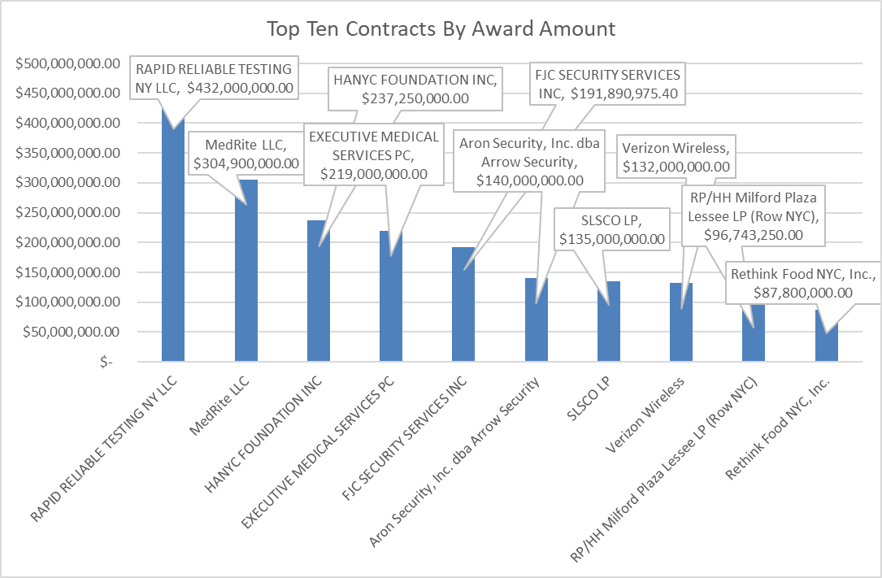
As of July 31, 2023, OID found that the highest dollar value contract was with Rapid Reliable Testing LLC. (also known as DocGo), who held a one year $432,000,000 dollar contract with HPD for the provision of hotel sites, services at those sites, and transportation services for migrants. As stated above, DocGo is currently the subject of a New York State Attorney General investigation and the New York City Comptroller has declined to register the contract for a multitude of serious and concerning reasons. Figure 3 shows the remaining nine contracts making up the top ten contracts by dollar value.
Figure 3 - Top ten contracts by award amount as of July 31, 2023

    - Contracting Value- By Agency
The Administration has tapped into resources from various city agencies to address the asylum-seeker crisis. Considering the array of agencies engaged and the intricate distribution of emergency 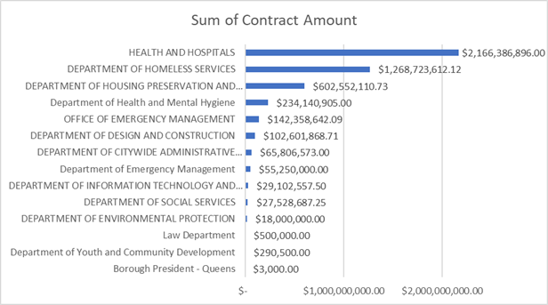budgetary funds, OID delved into how contracting dollars were allocated among these city agencies.
Figure 4- Total Contracting Dollar Value by Agency - Including Health and Hospitals Corporation
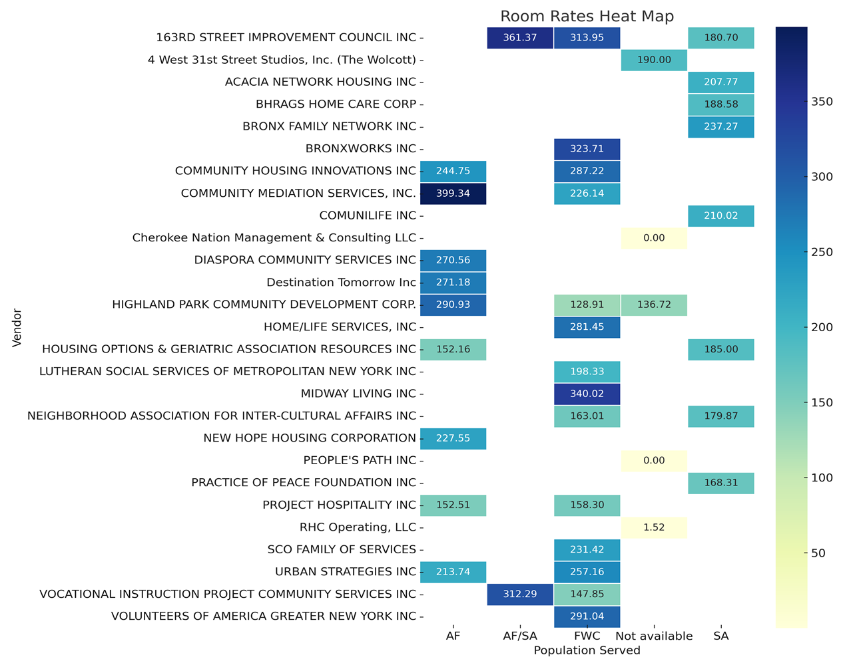
Using data sourced from Checkbook NYC, OID identified HHC as the leading agency in terms of allocated contract dollars, with a commitment nearing $2.2 billion. It should be noted that HHC, being a city-run not-for-profit corporation, is not subject to the standard procurement oversight and processes, like comptroller review and registration. In this context, OID emphasizes that, of agencies normally subject to those rules, DSS has procured the most dollars of contract work. To date, DSS has awarded with contracts worth nearly $1 billion related to this crisis. Figure 4 illustrates the cumulative value of contracts managed by each agency concerning the asylum-seeker situation. As evidenced by the graph, a substantial portion of the contracting funds is channeled through an agency that operates with less transparency and is exempt from customary oversight.
Figure 5- Room Rates by Vendor and Population Type (“AF” = adult families; “SA” = single adult; “FWC” = families with children)
    - Room Rates through DSS-Contracted Providers
As depicted in Figure 4, the Department of Homeless Services stands out as the second-largest contract holder, operating under the supervision of DSS. The bulk of these contracts involve partnerships with non-profit organizations to lease and oversee shelter locations for migrants across the city. These venues vary widely, from congregate shelters to hotels that have been adapted to accommodate asylum-seeking families.
With close to a billion dollars allocated for DSS-contracted shelter providers, OID reviewed the nightly costs associated with different vendors. Figure 5 underscores the significant variation in per-person room rates across different contracted locations. Some shelters would be expected to cost more—because they offer greater privacy or more comfortable accommodations; provide additional services to children or other high-need populations; or because the property’s preexisting value is simply higher. But OID's analysis revealed such a stark lack of consistency in per-person rates among providers that it suggests that the City is not effectively exerting its bargaining power.
    - COVID Emergency Vendors compared to Asylum-Seeker Crisis Vendors
The rapid pace at which the Administration procured services for the asylum-seeker crisis led OID to examine the overlap between vendors contracted for asylum-seeker services and those that worked during the COVID emergency. OID aimed to determine whether the City awarded many emergency contracts to pre-existing vendors from a prior emergency, instead of potentially seeking new companies better suited to address the distinct needs of this very different crisis. Interestingly, OID found that nearly 40% of vendors providing asylum-seeker services had also provided services during the COVID emergency. On its own, this fact does not indicate that the vendors are not suited to provide the currently needed services. However, it is notable that several overlapping COVID-crisis vendors provided drastically different services then, compared to their current work serving asylum seekers.
    - Contract Amendments

In addition to the awarding of 125 contracts through emergency procurement, the Administration has begun amending many of those same emergency contracts to extend the contract term for years into the future. This practice technically circumvents procurement procedures a second time, missing another opportunity for the City to control costs through competitive bidding. As of September 12, 2023, at least 19 contract amendments, originally procured through emergency procurement, were currently listed as “in progress” on MOCS’s database, PASSport Public. Figure 6 displays the top 10 contract amendments by dollar value for asylum seeker-related contracts in progress on September 12, 2023.
Figure 6- Top 10 Contract Amendments by Dollar Value
Contracts procured using emergency procedures rarely last longer than one year. However, as shown above, nearly every pending contract amendment extends the contract end date through until 2026, without going through the traditional—and more transparent—procurement process. Given these extended time periods, each contract’s maximum spend has climbed and the ceiling for spending under each contract has climbed. For example, HANYC’s $237 million dollar contract—already one of the City’s largest for the asylum seeker crisis—has an amended contract amount of $1.365 billion dollars, making it the City’s largest asylum seeker contract and over three times the total amount of DocGo’s $432 million dollar contract.
  - Agency Expenditures providing services for asylum seekers
City contracts procuring services related to the asylum seekers have notably high contract amounts—the ceiling for the maximum that can be spent under a contract. To track agency spending, OID used Checkbook NYC to search budget codes specific to asylum seeker spending, enabling the Division to track spending across contracts and agencies, current to mid-September 2023.
    - Spending by Contract
OID found that seven of the City’s ten top contracts by spending totals are contracted with DHS. Again, HANYC stands out as a particularly high level of spending, with NYCEM’s contract with SLSCO, coming in second. Noticeably absent from this analysis is NYC Health and Hospital’s spending pursuant to its contracts as that data is not reported to the Comptroller’s Office. HHC’s spending can be tracked to a degree due to the lump sum payments from the city to HHC, but a vendor or contract breakdown is not reported publicly. Figure 7 highlights the top ten vendors by total spend, as of September 15, 2023.
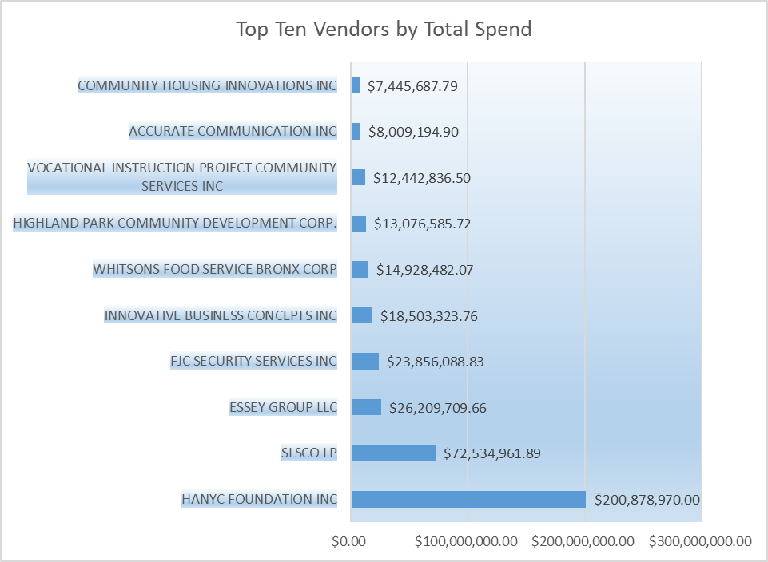
Figure 7- Top Ten Vendors by Total Spend
    - Spending By Agency
As highlighted previously, many City agencies are involved in this asylum-seeker crisis, and each is contracting for millions of dollars’ worth of services. OID has conducted spending analysis to determine which agencies are spending the most relating to this crisis. It is important to note that when contrasting the agency spend chart in Figure 8 with the total contract value graph by each agency in Figure 4, it becomes evident that not all agencies with contracts have made payments on them.
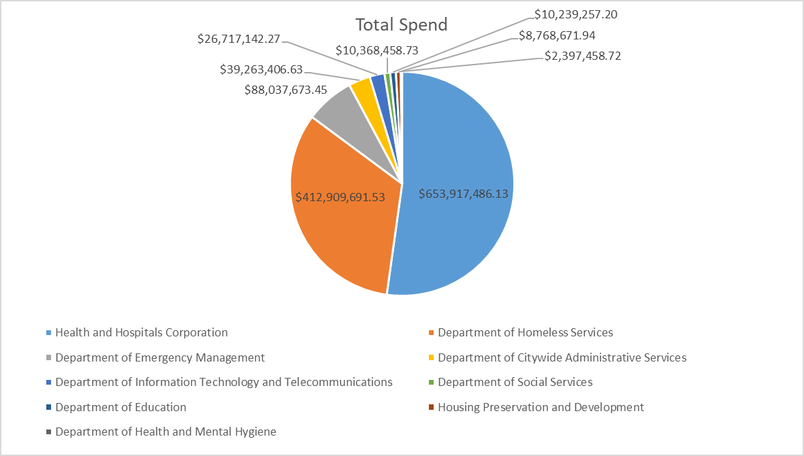
Figure 8 shows that HHC operates the majority of the city's HERRCs and, according to NYC Checkbook data, has the most significant expenditure. Yet, due to HHC's corporate form, its spending details are less transparent than those of other agencies. The expenditures are presented as aggregate payments from the City to HHC, lacking specifics on vendors or individual contracts.
Figure 8- Total Spend by Agency

    - Spending by Category
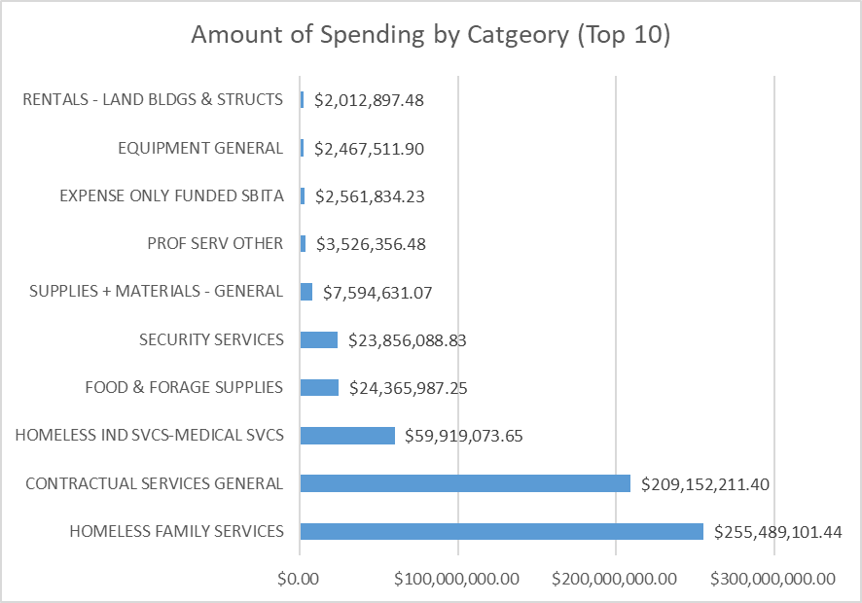
OID also analyzed agency expenditures by category to gain insights into the allocation of contracting dollars. Excluding payments to HHC, the city's principal spending area is 'Homeless Family Services' via DHS and DSS. Another significant category is 'Contractual Services General.' This broad category covers a range of expenses, from staffing (from vendors like Essey Group LLC, SLSCO LP) and office supplies (Dependable Office Supplies Inc., among other vendors) to tech services (provided by firms such as MTX B2B Solutions LLC, Innovative Business Concepts Inc, and Mason Technologies Inc.).
Figure 9- Amount of spend by category (top 10 categories)
- UTILIZATION OF SERVICES

The Administration purports to provide a number of services to asylum seekers in the City’s care including health insurance enrollment, healthcare services, mental health counseling, school enrollment and child services, immigration legal services, municipal identification (IDNYC) enrollment, English as a Second Language (ESL) classes, and job training classes. Following a request for specific data related to these services, the Administration could only provide limited information as to the number of asylum seekers served.
In respect to healthcare services for asylum seekers, the Administration indicated that 12,629 individuals had been enrolled in Metroplus insurance and 9,727 were still active as of August 2023 at sites designated to serve recent arrivals. They could not provide data on health insurance enrollment for other health plans. The Administration further stated that the HERRCs and Arrival Center had provided services for 71,041 total medical encounters, with 36,866 total vaccines provided. They were unable to provide data regarding the number of migrants who have received mental health support at the Navigation Center or the Application Assistance Center.
The Administration was also unable to provide specific numbers for enrollment in childcare services. There was limited data produced for 3-K and Pre-K School Day programs, with the Administration providing what appeared to be general data for enrolment in such programs for all individuals in DHS shelters, rather than asylum seeker specific data.
As for legal services provided to asylum seekers, the Administration indicated that a limited number of newly arrived migrants received immigration-related legal services in fiscal year 2023, per MOIA: 4,702 participated in legal information & orientation sessions at the Asylum Seeker Resource Navigation Center; 500 received information, orientation, and individualized screenings through the Asylum Seeker Legal Assistance Network; 150 received application assistance, advice, and counsel, and/or full representation from the Asylum Seeker Legal Assistance Network; and over 350 received individual screenings and legal assistance through the Haitian Response Initiative.
Finally, in relation to English as a Second Language (ESL) and job training classes, the Administration, again, provided limited asylum seeker-specific information. 509 asylum seekers enrolled in the ESL classes at the 5 HERRC sites. And, 211 asylum seekers received OSHA Construction Training classes through community-based organizations.
- CONCLUSION
No one doubts that Administration officials and their frontline staff have worked diligently, under difficult circumstances, to shelter and provide services to asylum seekers. But, the contracts’ high spending maximums and the Administration’s frequent use of emergency procurement—sometimes followed by multiyear renewals—warrant greater-than-normal scrutiny. The Council recognizes its role and continues to engage in rigorous oversight that protects City resources. The Committees look forward to more detailed answers on this subject from the Administration and advocates engaged in this work.

Pro Bono Asylum Representation Manual: An Overview of Asylum Law & Procedure, The Advocates for Human Rights (2009). Available at https://www.theadvocatesforhumanrights.org/res/byid/7538.
Id.
Id.
Id.
Id.
Applying for asylum affirmatively means a person has come to the U.S. and has not been placed in removal proceedings by U.S. DHS.
Pro Bono Asylum Representation Manual, supra note 1.
Applying for asylum defensively means a person was arrested by ICE or CBP and placed in removal proceedings.
Pro Bono Asylum Representation Manual, supra note 1.
Id. at 2 n.1 (“Adjudication of refugee status takes place outside U.S. borders and is handled by the U.S. Refugee Program (USRP). Individuals approved as refugees are then resettled to the U.S. and enter the country with refugee status. They do not go through an asylum adjudication in the U.S.”).
Id.
Id.
Id.
Id.
Fact Sheet: The Basics of U.S. Asylum Law, Human Rights First. Available at https://www.humanrightsfirst.org/wp-content/uploads/pdf/HRF_Fact_Sheet-The_Basics_of_US_Asylum_Law.pdf.
Id.
Number of Service-wide Forms by Quarter, Form Status, and Processing Time, U.S. Citizenship and Immigration Services. Available at https://www.uscis.gov/sites/default/files/document/data/Quarterly_All_Forms_FY2023_Q2.pdf
Id.
See Immigration Law: Sanctuary Cities, Franklin County Law Library, available at https://fclawlib.libguides.com/immigrationlaw/sanctuary (“There’s no official legal definition for sanctuary city and what it means varies significantly from place to place. Generally speaking, local law enforcement in sanctuary cities or counties don’t ask or report the immigration status of people they come into contact with. A sanctuary jurisdiction typically refuses requests from federal immigration authorities to detain undocumented immigrants apprehended for low-level offenses. A sanctuary city would also refuse to have its local law enforcement "deputized" as federal immigration agents.”)
Dey, Sneha, Gabriel Poblete, and Greg B. Smith, How Gov. Greg Abbott Texas-Sized a Crisis for NYC Mayor Eric Adams. The City. (Aug. 12, 2022) Available at https://www.thecity.nyc/immigration/2022/8/12/23302379/greg-abbott-eric-adams-asylum-crisis.
About TRAC, TRAC Immigration. Available at http://foiaproject.org/about/about-trac/.
Asylum Decisions APP, TRAC Immigration. Available at https://trac.syr.edu/phptools/immigration/asylum/.
Id.
Asylum Grant Rates Climb Under Biden. TRAC Immigration. Available at https://trac.syr.edu/immigration/reports/667/.
Asylum Decisions Vary Widely Across Judges and Courts – Latest Results, TRAC Immigration. Available at https://trac.syr.edu/immigration/reports/590/.
Record Number of Asylum Cases in FY 2019, TRAC Immigration. Available at https://trac.syr.edu/immigration/reports/588/.
Beth Fertig, Why It’s Harder to Win Asylum, Even in New York, WNYC (May 15, 2019). Available at https://www.pri.org/stories/2019-05-15/why-its-harder-win-asylum-even-new-york. See also Asylum Grant Rates Climb Under Biden supra note 24.
Id.
New York State Immigration Court Backlog Tool in FY 2023, TRAC Immigration. Available at https://trac.syr.edu/phptools/immigration/court_backlog/.
Patteson, Callie. Arizona, Texas sent 79 Buses of Migrants to DC Since mid-April. NY Post (June 15, 2022). Available at https://nypost.com/2022/06/15/arizona-texas-sent-79-buses-of-migrants-to-dc-since-april/.
Mayor Adams Calls for Federal Resources to Assist with Arriving Asylum Seekers. Office of the Mayor. (July 19, 2022) Available at https://www1.nyc.gov/office-of-the-mayor/news/520-22/mayor-adams-calls-federal-resources-assist-arriving-asylum-seekers.
As City Anticipates Surpassing Highest Recorded Shelter Census, Mayor Adams Declares Asylum Seeker State of Emergency, Calls for Urgent Aid From Federal, State Governments. Office of the Mayor. (Oct. 7, 2022). Available at https://www.nyc.gov/office-of-the-mayor/news/728-22/as-city-anticipates-surpassing-highest-recorded-shelter-census-mayor-adams-declares-asylum-seeker#/0.
Brown, N., Beech, S., Chang, E. and Elassar. A. At Least 68 migrants arrived in NYC over the weekend on buses sent by Texas Gov. Abbott. CNN. (Aug. 8, 2022) Available at https://www.cnn.com/2022/08/07/us/new-ork-migrants-buses-texas/index.html.
Mayor Adams Announces Placement of Humanitarian Emergency Response and Relief Center to Assist Single Adult Men Seeking Asylum, City Will Demobilize Randall's Island Relief Center. Office of the Mayor. (Nov. 10, 2022). Available at https://www.nyc.gov/office-of-the-mayor/news/827-22/mayor-adams-placement-humanitarian-emergency-response-relief-center-assist.
Offenhartz, Jake and Arya Sundaram. Number of migrant buses arriving to NYC drops following Biden’s new border policy. Gothamist. (Oct. 21, 2022). Available at https://gothamist.com/news/number-of-migrant-buses-arriving-to-nyc-drops-following-bidens-new-border-policy.
Gramlich, John. Key facts about Title 42, the pandemic policy that has reshaped immigration enforcement at U.S.-Mexico border. PEW RESEARCH (April 27, 2022). Available at https://www.pewresearch.org/fact-tank/2022/04/27/key-facts-about-title-42-the-pandemic-policy-that-has-reshaped-immigration-enforcement-at-u-s-mexico-border/.
Id.
Shoicet, Catherine E. What is Title 42, and what happens now that a federal judge has blocked it? CNN. (November 16, 2022). Available at https://www.cnn.com/2022/11/16/politics/title-42-blocked-whats-next-explainer-cec.
Jordan, Miriam and Eileen Sullivan. Judge Invalidates Rule Allowing Migrant Expulsions on Border. New York Times (Nov. 15, 2022). Available at https://www.nytimes.com/2022/11/15/us/immigration-title-42-judge.html#:~:text=The%20pandemic%2Dera%20health%20order,allowed%20to%20pursue%20asylum%20claims.
Id.
Alvarez, Priscilla. Biden administration projecting daily migrant border crossings could double when Trump-era policy ends. CNN. (Nov. 30, 2022). Available at https://www.cnn.com/2022/11/30/politics/migrant-border-crossings-could-double.
Ainsley, Julia and Martinez, Didi. The number of migrants crossing the border has hit its lowest point since Biden hit office. Here are four reasons there was no post-Title 42 surge. NBC News. (June 2, 2023). Available at https://www.nbcnews.com/politics/immigration/four-reasons-there-was-no-post-title-42-migrant-border-surge-rcna87325
The Callahan Legacy: Callahan v. Carey and the Legal Right to Shelter. Coalition for the Homeless. Available at https://www.coalitionforthehomeless.org/our-programs/advocacy/legal-victories/the-callahan-legacy-callahan-v-carey-and-the-legal-right-to-shelter/ (last visited Nov. 18, 2022); see Callahan v. Carey, (New York Cnty Sup. Ct., Index #42582/79) (a consent decree entered into by city and state officials recorded the state's obligation to provide food, shelter, supervision and security to homeless to all homeless men applying, and set standards for shelters and emergency hotel accommodations for which the homeless were issued vouchers, including capacity limits, staff to resident ratios, and specifications regarding beds, bathroom facilities, and additional services, such as mail, telephone, laundry, and secure storage, and also required the city to report regularly on the state of the shelters to the plaintiffs' attorneys), see also Eldredge v. Koch, 469 N.Y.S.2d 744 (1st Dep’t 1983) (the Callahan consent decree of 1981 extends to include homeless women in NYC having the right to access shelter), see also McCain v. Koch, 70 N.Y.2d 109 (1987) (the right to shelter homeless families in NYC, improve conditions in shelter facilities, and the prohibits the City from forcing homeless children and families from sleeping in intake offices).
Memorandum. City of New York Independent Budget Office. (Nov.13, 2022) Available at https://www.ibo.nyc.ny.us/iboreports/ibo-asylum-seeker-letter-and-memo-november2022.pdf at 1.
As City Anticipates Surpassing Highest Recorded Shelter Census, Mayor Adams Declares Asylum Seeker State of Emergency, Calls for Urgent Aid From Federal, State Governments, supra note 32.
Id.
Id.
Newman, Andy and Raúl Vilchis. A Migrant Wave Tests New York City’s Identity as the World’s Sanctuary. New York Times. (Aug. 20, 2022) Available at https://www.nytimes.com/2022/08/20/nyregion/nyc-migrants-texas.html.
Kaufman Geballe, Isa and Samantha Beech. 140 migrants welcomed in NYC from Texas in largest single-day arrival Sunday, officials say. CNN. (Aug. 21, 2022) Available at https://www.cnn.com/2022/08/21/us/texas-migrants-new-york-buses/index.html; Guidos, Rhina, New York Catholic agency calls out ‘chaotic’ dispersal of asylum-seekers. Crux. (July 27, 2022) Available at https://cruxnow.com/church-in-the-usa/2022/07/new-york-catholic-agency-calls-out-chaotic-dispersal-of-asylum-seekers.
Id.
Newman, Andy and Raúl Vilchis, supra note 48.
Kaufman Geballe, Isa and Samantha Beech, supra note 49.
Mays, Jeffery C. (2022). Adams Blames Migrants for Shelter Woes. Critics Say That’s Too Simple. The New York Times. (July 25, 2022) Available at https://www.nytimes.com/2022/07/25/nyregion/asylum-migrant-homeless-nyc.html.
Id.
Id.
Declaration of Emergency for Asylee Services and Shelter. NYC Department of Social Services. (July 29, 2022) Available at https://www1.nyc.gov/assets/home/downloads/pdf/press-releases/2022/Asylum-Seeker-Services-Shelter-Emergency-Deck.pdf.
Dorn, Sara. In stunning admission, NYC Officials Say They Left Migrant Families Stranded Without Shelter. The City. (July 21, 2022) Available at https://www.cityandstateny.com/politics/2022/07/stunning-admission-nyc-officials-say-they-left-migrant-families-stranded-without-shelter/374811/.
Testimony before the Committee on General Welfare (Aug. 9, 2022) available at https://legistar.council.nyc.gov/LegislationDetail.aspx?ID=5741789&GUID=FBB364A1-F3F2-4C7C-946A-A378DAC85BBA&Options=&Search=
Id.
Id.
Id.
Id.
Id.
See DHS Daily Report. NYC Open Data. Available at https://data.cityofnewyork.us/Social-Services/DHS-Daily-Report/k46n-sa2m (last visited September 20, 2023).
See id.
Id.
Id.
Memorandum. City of New York Independent Budget Office. Supra note 44; see also https://www.nyc.gov/office-of-the-mayor/news/695-22/mayor-adams-humanitarian-emergency-response-relief-centers-further-support-asylum.
Dey, Sneha, Gabriel Poblete, and Greg B. Smith, supra note 20.
Testimony before the Committee on General Welfare, supra note 58.
Id.
Mayor Adams, NYCEM, MOIA Open Resource Navigation Center to Support Newly Arrived Individuals and Families Seeking Asylum. Office of the Mayor. (Sept. 15, 2022). Available at https://www.nyc.gov/office-of-the-mayor/news/667-22/mayor-adams-nycem-moia-open-resource-navigation-center-support-newly-arrived-individuals-and#/0.
Mayor’s Office of Immigrant Affairs. Asylum Seeker Resources. https://www.nyc.gov/site/immigrants/help/asylum-seekers/asylum-seeker-resources.page
Memorandum. City of New York Independent Budget Office, supra note 44.
Mayor Adams, NYCEM, MOIA Open Resource Navigation Center to Support Newly Arrived Individuals and Families Seeking Asylum, supra note 72.
NYC Asylum Seeker Response. Accessing Homeless Services. Mayor’s Office of Immigrant Affairs. Available at https://www.nyc.gov/site/immigrants/help/asylum-seekers/asylum-seekers-help.page (last visited November 18, 2022).
Id.
Id.
Mayor Adams Announces Opening of Satellite Asylum Seeker Resource Navigation Sites to Support Newly Arriving Asylum Seekers. Office of the Mayor. (Nov. 30, 2022) Available at https://www.nyc.gov/office-of-the-mayor/news/874-22/mayor-adams-opening-satellite-asylum-seeker-resource-navigation-sites-support-newly.
Testimony before the Committee on Immigration (Sept. 30, 2022) available at https://legistar.council.nyc.gov/LegislationDetail.aspx?ID=5844023&GUID=7DDF58E1-CEFA-4503-A35E-BE9A4B4BE8AB&Options=&Search=
Id.
Memorandum. City of New York Independent Budget Office, supra note 44.
Testimony before the Committee on Immigration, supra note 80.
Russo, Melissa. NYC Doesn’t Know Why Migrants Being Dropped in City With Inaccurate Docs. NBC New York. (July 31, 2022) Available at https://www.nbcnewyork.com/investigations/nyc-doesnt-no-why-migrants-are-being-dropped-in-city-with-inaccurate-docs/3801091/.
Id.
Feldman, Eric. Families spend hours in the cold waiting for ICE appointments. (November 22, 2022). NY1. Available at https://www.ny1.com/nyc/all-boroughs/politics/2022/11/23/families-spend-hours-in-the-cold-waiting-for-ice-appointments.
Hogan, Bernadette. Council Leaders Back Mayor Adams’ Push to Put Migrants to Work in NYC. NY Post. (Sept. 14, 2022) Available at https://nypost.com/2022/09/14/city-council-leaders-back-mayor-adams-push-to-put-migrants-to-work-in-nyc/.
Poblete, Gabriel. Next Stop for Asylum Seekers Newly Arrived in New York: Get IDNYC Card. The City. (Aug. 8, 2022) Available at https://www.thecity.nyc/2022/8/8/23297454/asylum-seekers-nyc-id-card-library.
Mcdonnell Nieto Del Rio, Giulia and Rommel H. Ojeda. A Family Separated by Borders Reels From a Tragedy at a Queens Shelter. Documented NY. (Sept. 21, 2022) Available at https://documentedny.com/2022/09/21/queens-asylum-seeker-suicide-mother-migrant-nyc/; Gonella, Catalina. ‘Solitude’: Residents Struggling to Connect at Queens Shelter Where Woman Committed Suicide. Gothamist. (Sept. 20, 2022) Available at https://gothamist.com/news/solitude-residents-struggling-to-connect-at-queens-shelter-where-woman-committed-suicide.
U.S. Citizen and Immigration Services. USCIS Stopped Applying June 2020 Rules Pursuant to Court Order in Asylumworks v. Mayorkas. Available at https://www.uscis.gov/archive/uscis-stopped-applying-june-2020-rules-pursuant-to-court-order-in-asylumworks-v-mayorkas. (Accessed Nov. 2022).
Poblete, Gabriel. Asylum-Seekers Who Came Months Ago Still Say they Lack Housing, Legal Help Due to Immigration Status. THE CITY. (Sept. 30, 2022) Available at https://www.thecity.nyc/2022/9/30/23381145/asylum-migrants-nyc-housing-jobs-lawyers.
Irizarry Aponte, Claudia and Tanaz Meghjani. Migrant Job-Seekers Face Long Waits for Required Construction Safety Course. THE CITY. (Nov. 14, 2022). Available at https://www.thecity.nyc/work/2022/11/14/23458300/osha-30-construction-safety-training-immigrants.
NYCEM Agency History. NYC Emergency Management. Available at https://www.nyc.gov/assets/em/downloads/pdf/agency_history.pdf. (Accessed Nov. 2022)
NYCEM Strategic Plan. NYC Emergency Management. Available at https://nyc-oem.maps.arcgis.com/apps/Cascade/index.html?appid=72522e0db548473b9f4fce4d030a976b. (Accessed Nov. 2022)
Testimony before the Committee on Immigration, supra note 80.
Id.
Id.
Id.
Hoogensen, Finn and Henry Rosoff. NYC to move migrant center from Orchard Beach to Randall’s Island. PIX11. (Oct. 3, 2022). Available at https://pix11.com/news/local-news/nyc-to-move-migrant-center-from-orchard-beach-to-randalls-island/#:~:text=NYC%20to%20move%20migrant%20center%20from%20Orchard%20Beach%20to%20Randall's%20Island,-by%3A%20Finn%20Hoogensen&text=ORCHARD%20BEACH%2C%20the%20Bronx%20(PIX11,flooding%20concerns%20in%20Orchard%20Beach.
Testimony before the Committee on Immigration, supra note 80.
Id.
Id.
Id.
Offenhartz, Jake and Arya Sundaram, supra note 35.
Memorandum. City of New York Independent Budget Office, supra note 44.
Mayor Adams Announces Placement of new Humanitarian Emergency Response and Relief Center. August 7, 2023. Available at https://www.nyc.gov/office-of-the-mayor/news/577-23/mayor-adams-placement-new-humanitarian-emergency-response-relief-center
Mayor Adams Announces Asylum Application Help Center has Helped Submit 1,300 Asylum Applications in a Matter of Weeks, Announces Higher Education Partnership for Fall Semester. August 2, 2023. Available at https://www.nyc.gov/office-of-the-mayor/news/561-23/mayor-adams-asylum-application-help-center-has-helped-submit-1-300-asylum
Memorandum. City of New York Independent Budget Office, supra note 44.
Mayor Adams Announces Humanitarian Emergency Response and Relief Centers to Further Support Asylum Seekers Entering NYC. Office of the Mayor. (Sept. 22, 2022). Available at https://www.nyc.gov/office-of-the-mayor/news/695-22/mayor-adams-humanitarian-emergency-response-relief-centers-further-support-asylum.
Robinson, Eric. New Short Term Relief Center Opens for Migrants on Randall’s Island, Spectrum News NY 1, (Oct. 19, 2022) https://www.ny1.com/nyc/all-boroughs/politics/2022/10/20/new-short-term-relief-center-opens-for-migrants-on-randall-s-island.
Testimony before the Committee on Immigration, supra note 80.
Notably, the Adams Administration also testified that asylum seekers and migrants may stay in these HERRCs for longer periods of time than the initially posited 24 to 96 hours. See Id.
NYC Mayor’s Office. Emergency Executive Order 402. (May 10, 2023). Available at https://www.nyc.gov/office-of-the-mayor/news/402-003/emergency-executive-order-402.
Yu, Janice. Migrants sent to respite centers in NYC; Hochul says SUNY campuses being considered. ABC 7. (May 25, 2023). Available at https://abc7ny.com/asylum-seekers-housing-nyc-suny-migrants/13297632/
Asylum Seekers Terms and Conditions Report, August 2023 (on file with Council), available at https://council.nyc.gov/budget/wp-content/uploads/sites/54/2023/09/Asylum-Seekers-Report-August-2023-1.pdf
Hogan, Gwynne and Haidee Chu. Adams Admin Races to Open Seventh Migrant ‘Respite Center’ as It Challenges Right to Shelter. The City. (May 24, 2023). Available at https://www.thecity.nyc/2023/5/24/23736745/respite-centers-eric-adams-migrants
See Bahar Ostadan, Gothamist, “New Migrant Respite Center in Sunset Park Draws Opposition From First-Generation Immigrants,” Aug. 6, 2023, available at https://gothamist.com/news/new-migrant-respite-center-in-sunset-park-draws-opposition-from-first-generation-immigrants.
Gwynne Hogan & Haidee Chu, The City, “Admin Races to Open Seventh Migrant ‘Respite Center’ as It Challenges Right to Shelter,” May 24, 2023, available at https://www.thecity.nyc/2023/5/24/23736745/respite-centers-eric-adams-migrants.
See id.
Citywide Procurement Indicators: Fiscal Year 2022. Mayor’s Office of Contract Services (2022) at 2, available at https://www.nyc.gov/assets/mocs/downloads/pdf/Indicators/Indicators_Report_FY_2022.pdf.
Id.
See Procurement Policy Board Rules. Mayor’s Office of Contract Services. Available at https://www1.nyc.gov/assets/mocs/downloads/pdf/ppb/UPDATE%20PPB%20RULES_FINAL_Effective%20November%202018%20Accepted%20TC.PDF
Citywide Procurement Indicators: Fiscal Year 2022, supra note 120.
Mayor Adams Announces Emergency Procurement Declaration to Rapidly Procure Shelter, Services for Asylum Seekers. Office of the Mayor. (Aug. 1, 2022). Available at https://www.nyc.gov/office-of-the-mayor/news/558-22/mayor-adams-emergency-procurement-declaration-rapidly-procure-shelter-services-for.
Citywide Procurement Indicators: Fiscal Year 2022, supra note 120 at 4.
Id. at 90.
Checkbook NYC: Department Of Emergency Management Active Expense Contracts. New York City Comptroller. Available at https://www.checkbooknyc.com/contracts_landing/status/A/yeartype/B/year/123/agency/67
Dorn, Sara. As New York City seeks contractors to aid asylum seekers, advocates decry continued mismanagement at shelters. City and State New York. (Aug. 1, 2022). Available at https://www.cityandstateny.com/policy/2022/08/new-york-city-seeks-contractors-aid-asylum-seekers-advocates-decry-continued-mismanagement-shelters/375220/
Id.
Id.
Song Beer, Isabel and Dean Moses. NYC To Provide Humanitarian Emergency Response for Asylum Seekers. AMNY. (Sept. 22, 2022) Available at https://www.amny.com/services/adams-humanitarian-response-asylum-seekers/.
Mayor Adams Announces Humanitarian Emergency Response and Relief Centers to Further Support Asylum Seekers Entering NYC, supra note 109.
Id.
Donaldson, Sahalie. Overwhelmed With Migrant Arrivals, NYC Has Planned Tent Shelter To Be Built In A Bronx Flood Zone. City and State New York. (Sept. 23, 2022) Available at https://www.cityandstateny.com/policy/2022/09/overwhelmed-migrant-arrivals-nyc-has-planned-tent-shelter-be-built-bronx-flood-zone/377614/.
Id; Advocates have asserted that congregate settings are hazardous. Congregate settings allow for the easy spread of airborne disease, such as COVID-19, along with the potential for violence due to interpersonal tensions. These settings do not afford families the privacy they require. See Simone, Jacquelyn. State of the Homeless 2022: New York at a Crossroads. Coalition for the Homeless. (March 2022) Available at https://www.coalitionforthehomeless.org/state-of-the-homeless-2022/.
Hoogensen, Finn and Henry Rosoff. NYC to move migrant center from Orchard Beach to Randall’s Island. PIX11. (Oct. 3, 2022). Available at https://pix11.com/news/local-news/nyc-to-move-migrant-center-from-orchard-beach-to-randalls-island/#:~:text=NYC%20to%20move%20migrant%20center%20from%20Orchard%20Beach%20to%20Randall's%20Island,-by%3A%20Finn%20Hoogensen&text=ORCHARD%20BEACH%2C%20the%20Bronx%20(PIX11,flooding%20concerns%20in%20Orchard%20Beach.
Offenhartz, Jake and Arya Sundaram, supra note 35.
Stark-Miller, Ethan. Mayor Adams opens 8 new resource centers for asylum seekers backed by $2.1M grant. AMNY. (Nov. 30, 2022). Available at https://www.amny.com/politics/mayor-adams-opens-8-new-resource-centers-for-asylum-seekers-backed-by-2-1m-grant/; See generally NYCEM supra page 18-20.
Commissioner Ashwin Vasan, Dear Colleague, NYC Health. (Sept. 9, 2022) Available at https://www1.nyc.gov/assets/doh/downloads/pdf/about/dear-colleague-migrants.pdf.
NYC Asylum Seeker Response, NYC Mayor’s Office of Immigrant Affairs. (last updated Oct. 14, 2022), https://www.nyc.gov/site/immigrants/help/asylum-seekers/asylum-seekers-help.page.
Id.
Report to the Board of Directors. NYC Health + Hospitals. (Sept. 29, 2022), https://www.nychealthandhospitals.org/report-to-the-board-of-directors-sep-2022/.
Id.
Adams Administration Announces 'Project Open Arms,' Comprehensive Support Plan to Meet Educational Needs of Families Seeking Asylum. Office of the Mayor. (Aug. 19, 2022) Available at https://www.nyc.gov/office-of-the-mayor/news/607-22/adams-administration-project-open-arms-comprehensive-support-plan-meet-educational.
Open Arms: Families Seeking Asylum: Comprehensive Support Plan. City of New York. (Aug. 2022), available at https://www1.nyc.gov/assets/home/downloads/pdf/press-releases/2022/OpenArms-Families-Seeking-Asylum.pdf.
Commissioner Ashwin Vasan, Dear Colleague, NYC Health (Sept. 9, 2022), https://www1.nyc.gov/assets/doh/downloads/pdf/about/dear-colleague-migrants.pdf.
Id.
Testimony before the Committees on Health, Hospitals, and Sub-Committee on COVID-19 Recovery & Resiliency. (Nov. 7, 2022) Available at https://legistar.council.nyc.gov/MeetingDetail.aspx?ID=1018094&GUID=2B8992F5-27B8-4E02-9A30-D08193F07FD5&Options=info%7C&Search=.
Id.
Id.
Id.
Id.
Id.
Poblete, Gabriel and Reema Amin. Budget Cuts, Asylum Seekers, COVID Changes: NYC’s First Day of School Brings Joy and Jitters. The City. (Sept. 8, 2022) Available at https://www.thecity.nyc/2022/9/8/23343783/first-day-school-asylum-covid-budget.
Adams Administration Announces 'Project Open Arms,' Comprehensive Support Plan to Meet Educational Needs of Families Seeking Asylum, supra note 144.
Open Arms: Families Seeking Asylum: Comprehensive Support Plan, supra note 145.
Id.
Id.
Id. at 2-3.
Id. at 3.
Note, per DOE Chancellor’s Regulation A-780, students in temporary housing are excluded from immunization requirements as part of their right to immediate enrollment. See Regulation of the Chancellor: Students in Temporary Housing. Dept. of Ed. (Apr. 18, 2019) Available at https://www.schools.nyc.gov/docs/default-source/default-document-library/a-780-4-18-19-final-combined-remediated-wcag2-0.
Open Arms: Families Seeking Asylum: Comprehensive Support Plan, supra note 145.
Id. at 3-4.
Id. at 4.
Id.
Id. 4-5.
Id. at 5.
Id.
Id.
Id.
Id. at 6.
Id.
Id. at 6-7.
Id. at 7-8.
NYC Public Schools Admissions Guide , Dept. of Ed. (2022) Available at https://www.schools.nyc.gov/docs/default-source/default-document-library/2022-nyc-public-schools-admissions-guide---accessible at 8.
Students from Families Seeking Asylum: Update on the City’s Responses. Office of NYC Comptroller. (Nov. 9, 2022) Available at https://comptroller.nyc.gov/wp-content/uploads/documents/Students-from-Families-Seeking-Asylum.pdf at 2.
Email from Melissa Aviles-Ramos, Senior Executive Director, Program Implementation, Office of the First Deputy Chancellor, NYC Public Schools/NYCDOE to Education Committee staff (Dec. 15, 2022).
Office of Comptroller Brad Lander. 2023-2024 School Budget Update. Available at https://comptroller.nyc.gov/wp-content/uploads/2023/09/School-Budget-Spotlight-0923.pdf
Michael Elsen-Rooney, Asylum-Seeking Students Reshape Charter School in Queens. The City. (Nov. 28, 2022) Available at https://www.thecity.nyc/2022/11/28/23483063/asylum-seeking-students-reshape-voice-charter-school.
Id.
School Allocation Memorandum No. 65, FY 2023. Dept of Ed. (Oct 31, 2022; revised Nov. 9, 2022) Available at https://www.nycenet.edu/offices/finance_schools/budget/DSBPO/allocationmemo/fy22_23/fy23_docs/fy2023_sam065.htm.
Id.
Students from Families Seeking Asylum: Update on the City’s Responses, supra note 176.
School Allocation Memorandum No. 65, FY 2023, supra note 181.
Id.
Id.
Id.
Comptroller Brad Lander, Letter to HPD Commissioner Alfonso Carrion on Return of Rapid Reliable Testing NY LLC Contract #20248801671. September 6, 2023. Available at https://comptroller.nyc.gov/reports/letter-on-return-of-rapid-reliable-testing-ny-llc-contract-20248801671/
Kelly Mena, “City comptroller to conduct ‘real-time’ audit of embattled migrant service provider DocGo,” NY1.com, available at https://ny1.com/nyc/all-boroughs/politics/2023/09/18/city-comptroller-to-conduct--real-time--audit-of-embattled-migrant-service-provider-docgo.
Jay Root. DocGo Used Unregistered Guards at Migrant Hotels, N.Y. Officials Charge. New York Times. September 1, 2023. Available at https://www.nytimes.com/2023/09/01/nyregion/docgo-migrants-security-licenses.html
Jay Root. A New York City Migrant Contractor Faces Scrutiny In Sexual Assault Cases. New York Times. August 20, 2023. Available at https://www.nytimes.com/2023/08/20/nyregion/docgo-migrant-sexual-assaults.html
Jay Root. NY Attorney General Will Investigate DocGo, A Troubled Migrant Contractor. New York Times. August 21, 2023. Available at https://www.nytimes.com/2023/08/21/nyregion/nyc-migrants-docgo-investigation.html
Jay Root. New York City Had A Migrant Crisis. It Hired A Covid Expert to Help. New York Times. July 30, 2023. Available at https://www.nytimes.com/2023/07/30/nyregion/migrants-albany-docgo.html
Joshua Solomon. DocGo CEO resigns following report he lied about college degree. Albany Times-Union. September 15, 2023. Available at https://www.timesunion.com/state/article/docgo-ceo-falsely-told-investors-earned-graduate-18368860.php
See 1989 New York City Charter Revision Commission, "Final Report of the New York City Charter Revision Commission," (Jan 1989) at 24-25 available at https://www.nyc.gov/assets/charter/downloads/pdf/1989_final_post-election_report.pdf.
N.Y.C. Charter § 315.
See id.
N.Y.C. Procurement Policy Bd. Rules § 3-06(a).
N.Y.C. Procurement Policy Bd. Rules § 3-06(d).
See id.
N.Y.C. Procurement Policy Bd. Rules § 3-06(c)(2).
N.Y.C. Procurement Policy Bd. Rules § 3-06(c)(3); see also N.Y.C. Charter § 315.
Office of the Mayor of the City of New York, Press Release, “As City Nears Arrival of 100,000 Asylum Seekers Since Last Spring, Mayor Adams Lays out Updated Costs if State and Federal Governments do not Take Swift Action” August 9, 2023 available at https://www.nyc.gov/office-of-the-mayor/news/583-23/as-city-nears-arrival-100-000-asylum-seekers-since-last-spring-mayor-adams-lays-out-updated#/0
https://cbs6albany.com/news/local/new-york-state-attorney-general-launches-investigation-into-docgo-over-alleged-mistreatment-of-asylum-seekers-migrant-healthcare-plans-employment-opportunities-super-8-evictions The investigation was launched following a series of complaints that migrants have allegedly been misled and mistreated by the company while being moved upstate under a $432 million uncompetitive contract from the city. The AG’s office is looking into ineligible enrollment of healthcare plans, and allegations that the company gave inaccurate information to migrants on employment opportunities, "made “explicit or implicit threats,” and took “other actions that may jeopardize migrants’ ability to obtain asylum”
https://comptroller.nyc.gov/reports/letter-on-return-of-rapid-reliable-testing-ny-llc-contract-20248801671/ The Comptroller cited 4 primary reasons for his refusal to register the contract:. 1. Insufficient budget detail to justify over $432 million in contract value; 2. Inconclusive reasoning as to the selection of the vendor and contradictory statements about their fiscal ability to provide contracted services; 3. Inadequate vendor responsibility determination, contract oversight and subsequent questions about proper service delivery; 4. Inadequate information regarding the selection of subcontractors
NYC Passport, as of September 12, 2023.
See, e.g., NYC311 – Asylum Seeker Resource Navigation Center, https://portal.311.nyc.gov/article/?kanumber=KA-03502.
September 18, 2023 Response from Administration.
Id.
Id.
Id. (“As of late August, there were 4,500 children age eligible for 3-K and Pre-K in the DHS shelter. Of those, 78% have received an offer for 3-K and Pre-K. NYCPS public school staff, local schools, CBOs, and Head Starts continue to contact the families of those children to let them know about the offers. Last school year, there were about 5,000 new admits to NYCPS 3-K and Pre-K programs that were students in temporary housing (shelter, doubled up, hotel, etc.”).
Id.

