THE COUNCIL OF THE CITY OF NEW YORK
RESOLUTION NO. 507

Resolution approving with modifications the decision of the City Planning Commission on Application No. N 170381 ZRM (L.U. No. 148), for an amendment of the Zoning Resolution of the City of New York, modifying Appendix F for the purpose of establishing a Mandatory Inclusionary Housing area, Community District 6, Borough of Manhattan.

By Council Members Salamanca and Moya

WHEREAS, the City Planning Commission filed with the Council on June 25, 2018 its decision dated June 25, 2018 (the "Decision"), pursuant to Section 201 of the New York City Charter, regarding an application submitted by 33rd Street Acquisition, LLC, for an amendment of the text of the Zoning Resolution of the City of New York, modifying Appendix F for the purpose of establishing a Mandatory Inclusionary Housing area, which in conjunction with the related action, to facilitate the development of a mixed‐use building at 339‐345 East 33rd Street in the Kips Bay neighborhood of Community District 6 in Manhattan (Application No. N 170381 ZRM), Community District 6, Borough of Manhattan (the "Application");

WHEREAS, the Application is related to application C 170380 ZMM (L.U. No. 147), a Zoning map amendment to change from an existing R8A district to a C1-9A district;

WHEREAS, the Decision is subject to review and action by the Council pursuant to Section 197-d(b)(1) of the City Charter;
WHEREAS, upon due notice, the Council held a public hearing on the Decision and Application on July 17, 2018;

WHEREAS, the Council has considered the land use implications and other policy issues relating to the Decision and Application; and

WHEREAS, the Council has considered the relevant environmental issues, including the negative declaration (CEQR No. 17DCP203M) issued on January 2, 2018, which included an (E) designation to avoid the potential for significant adverse impacts related to hazardous materials, air quality and noise (E-458) (the “Negative Declaration”).

RESOLVED:

The Council finds that the action described herein will have no significant impact on the environment as set forth in the Negative Declaration.

Pursuant to Section 200 of the City Charter and on the basis of the Decision and Application, and based on the environmental determination and consideration described in the report, N 170381 ZRM, incorporated by reference herein, the Council approves the Decision of the City Planning Commission with the following modifications:

Matter underlined is new, to be added;
Matter struck out is to be deleted;
Matter within # # is defined in Section 12-10;
Matter in double strikeout is deleted by the City Council;
Matter in double-underline is added by the City Council.
* * * indicates where unchanged text appears in the Zoning Resolution.

* * *

APPENDIX F

Inclusionary Housing Designated Areas and Mandatory Inclusionary Housing Areas

* * *

MANHATTAN

* * *

Manhattan Community District 6

* * *

Map 2 – [date of adoption]
[PROPOSED MAP]

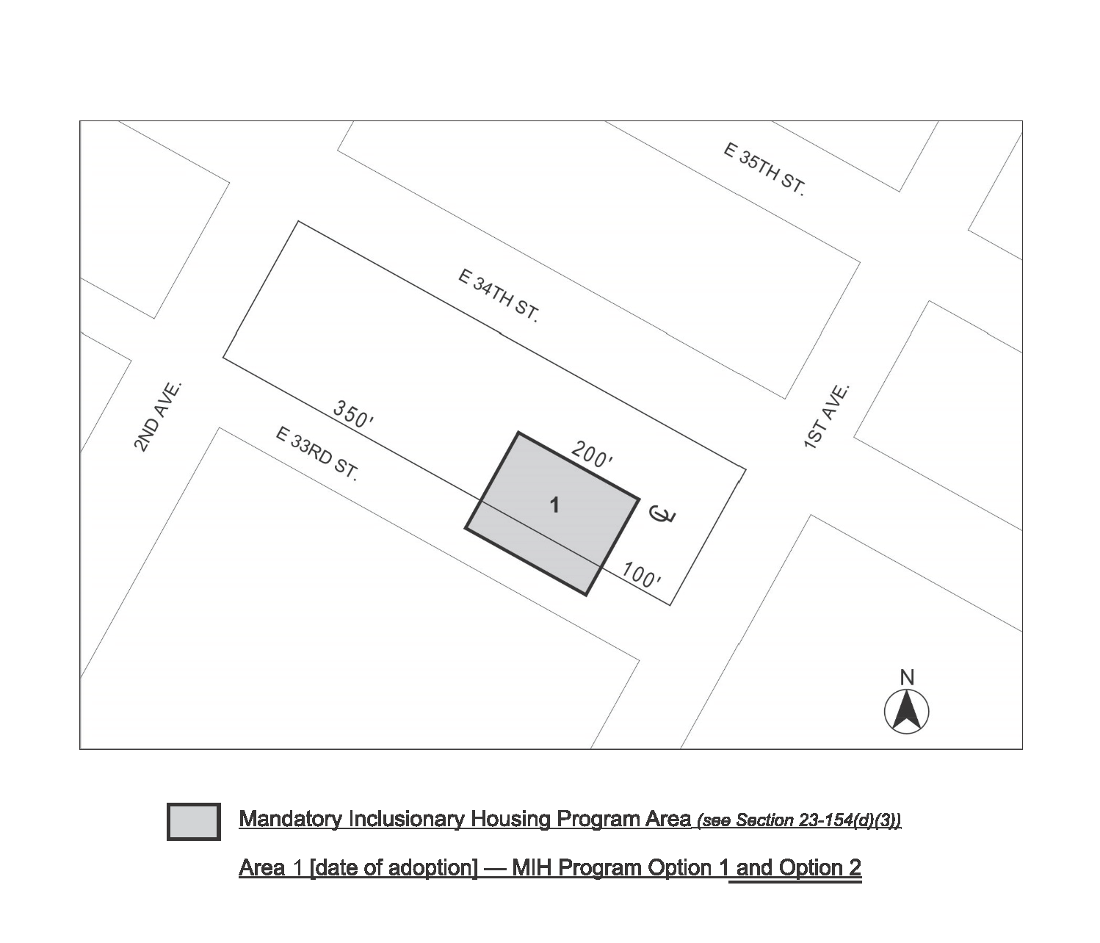

Portion of Community District 6, Manhattan

* * *

Adopted.

Office of the City Clerk, }
The City of New York, } ss.:

I hereby certify that the foregoing is a true copy of a Resolution passed by The Council of The City of New York on August 8, 2018, on file in this office.

.....……......................................... City Clerk, Clerk of The Council

