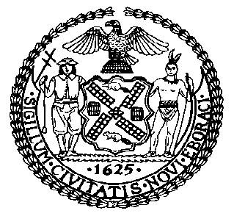 | The Council of the City of New York  Finance Division  Latonia McKinney, Director  Fiscal Impact Statement  Proposed Intro. No: 289-A  Committee: Housing and Buildings
Title: A Local Law to amend the administrative code of the city of New York, in relation to the provision of housing applications in multiple languages by the department of housing preservation and development | Sponsors: Council Members Cumbo, Williams, Deutsch, Chin, Cornegy, Eugene, Gibson, Koo, Levine, Reynoso, Rose, Treyger, Menchaca, Rosenthal, Rodriguez, Lander, Levin, Vallone
Summary of Legislation: Proposed Intro. 289-A would require the Department of Housing Preservation and Development (“HPD”) to make application forms available in all multiple languages, including: English; Arabic; Chinese; Haitian Creole; Korean; Russian, Spanish; and any other languages chosen by HPD. The legislation also would require HPD to provide a notice to applicants that application forms are available in additional languages, and to post such notice in HPD offices and online.

Effective Date: This local law takes effect 120 days after it becomes law, except that HPD may take any actions necessary, including the promulgation of rules, before such effective date.
Fiscal Year In Which Full Fiscal Impact Anticipated: Fiscal 2018
Fiscal Impact Statement:

 | Effective FY17 | FY Succeeding Effective FY18 | Full Fiscal Impact FY18
Revenues | $0 | $0 | $0
Expenditures | $0 | $0 | $0
Net | $0 | $0 | $0

Impact on Revenues: It is estimated that there would be no impact on revenues resulting from the enactment of this legislation.
Impact on Expenditures: It is anticipated that there would be no impact on expenditures resulting from the enactment of this legislation because HPD would use existing resources to implement the provisions of this proposed bill.
Source of Funds To Cover Estimated Costs: Not applicable.

Source of Information: New York City Council Finance Division

Estimate Prepared by: Sarah Gastelum, Senior Legislative Financial Analyst

Estimated Reviewed by: Chima Obichere, Unit Head
Regina Poreda Ryan, Deputy Director
Eric Bernstein, Counsel

Legislative History: This legislation was introduced to the full Council on April 29, 2014 as Intro. No. 289 and was referred to the Committee on Housing and Buildings. A hearing was held by the Committee on Housing and Buildings on October 29, 2014 and the bill was laid over. The legislation was subsequently amended, and the amended version, Proposed Intro. 289-A, will be considered by the Committee on Housing and Buildings on February 14, 2017. Following a successful Committee vote, the bill will be submitted to the full Council for a vote on February 15, 2017.

Date Prepared: December 12, 2016

