Public Housing Committee Staff
Connor Mealey, Counsel
Jose Conde, Senior Policy Analyst
Charles Kim, Policy Analyst
Dan Kroop, Senior Financial Analyst
Nicholas Montalbano, Senior Data Scientist
Christopher Zawora, Data Scientist



THE NEW YORK CITY COUNCIL

BRIEFING PAPER OF THE INFRASTRUCTURE DIVISION
Andrea Vazquez, Legislative Director
Bradley Reid, Deputy Director, Infrastructure

COMMITTEE ON PUBLIC HOUSING
Hon. Alexa Avilés, Chair

September 22, 2023

Oversight: $78.34 Billion:
NYCHA’s Physical Needs Assessment
INTRODUCTION
On September 22, 2023, the Committee on Public Housing, chaired by Council Member Alexa Avilés, will hold an oversight hearing titled “$78.34 Billion: NYCHA’s Physical Needs Assessment.” At the hearing, the Committee expects to hear testimony from the New York City Housing Authority (“NYCHA”) on the results of the 2023 Physical Needs Assessment (“PNA”), which estimated that there are $78.3 billion in 20-year physical needs across the NYCHA portfolio. Witnesses invited to testify include NYCHA residents, the New York City Central Labor Council, various unions, workforce development organizations, and other interested parties.
BACKGROUND ON NYCHA AND PUBLIC HOUSING
Former New York City Mayor Fiorello La Guardia created NYCHA in 1934 to replace dilapidated tenements using funds from The New Deal, three years before the Housing Act of 1937 established public housing nationwide. NYCHA originally served two purposes: (1) to provide low-cost housing for middle-class, working families temporarily unemployed because of the Great Depression and (2) to bolster the lagging economy by creating jobs for the building trades. Later, NYCHA’s purpose evolved into providing safe, decent housing for families with the lowest incomes.
As of April 2023, NYCHA has 335 developments, and 177,569 units home to 360,970 authorized residents in their the conventional public housing program (“Section 9”) and the Permanent Affordability Commitment Together program (“PACT”), which is NYCHA’s implementation of the federal Rental Assistance Demonstration (“RAD”) program. NYCHA also provides housing to 167,135 residents through the Housing Choice Voucher program created by the United States Housing and Community Development Act of 1978 (“Section 8”). Beginning with Nostrand Houses in late 2023, NYCHA developments will also begin to vote on whether to remain in conventional public housing, move to the PACT program, or join the newly created New York City Public Housing Preservation Trust (“the Trust”). Joining the Trust would keep the developments under NYCHA management while moving the developments to Project Based Section 8 funding. All these changes are taking place while NYCHA is under a federal monitor which was imposed by a U.S. district court judge after several federal court cases, including one brought by the United States Department of Justice alleging “that NYCHA has routinely failed to comply with lead-based paint safety regulations, had failed to provide decent, safe, and sanitary housing, including with respect to the provision of heat and elevators and the control and treatment of mold and pests; and had repeatedly misled the United States Department of Housing and Urban Development (“HUD”) through false statements and deceptive practices.” The Agreement resulting from the lawsuit has led to substantial management changes as well as increased funding from the City.
WHAT IS A PHYSICAL NEEDS ASSESSMENT?
A Physical Needs Assessment is a systematic review of all of the major physical components of a property, used to develop a long-term plan for addressing the costs of replacement of the components as they wear out.” NYCHA conducts a PNA every five years to assess the physical condition of NYCHA’s properties across their portfolio. These PNAs record various data points that characterize the conditions of NYCHA’s portfolio via individual components of the buildings. These components are divided into broad categories that HUD calls “disciplines” including (1) Apartment, which includes interior items like bathrooms, kitchens, and doors; (2) Architectural, which includes building exteriors and common areas like roofs, windows, and entrances and exits; (3) Mechanical, which includes building systems like boilers, elevators, and gas lines; (4) Site, which includes items like playgrounds, landscaping, and sidewalks; and (5) Electrical, which includes electrical upgrades like fire alarms, security cameras, indoor and outdoor lighting, and more. Because PNAs provide valuable data that evaluates the viability of real estate, they also serve as important documentation for various real estate management operations, including the development of maintenance plans, grant support applications, and many property-focused financial transactions. NYCHA’s PNAs are crucial to the proper oversight and management of investment into NYCHA’s building portfolio. This is particularly true given the aging building stock at NYCHA: more than 70 percent of buildings were built before 1969. NYCHA’s PNAs from 2006, 2011, and 2017 also give historical data on NYCHA’s building portfolio, providing invaluable context for the issues currently facing NYCHA buildings.

PAST NYCHA PNAs SHOWED EXTENSIVE UNFUNDED NEEDS
The deterioration of NYCHA properties is not a new problem, and past PNAs have shown the effects of decades of disinvestment in NYCHA buildings. In 2006, NYCHA’s PNA found a five-year capital need of $6.9 billion, along with a need of an additional $25 billion over the next 15 years to maintain the current housing stock in a “state of good repair.” However, according to its 2011 Comprehensive Annual Financial Report (“CAFR”), NYCHA’s federal capital subsidies for 2006-2010 amounted to just $1.6 billion, only 23 percent of the identified $6.9 billion need. NYCHA stated it invested about $2 billion between 2006 and 2010, leaving approximately $5.5 billion in unmet need through the end of 2010, and anticipated additional investment of $1.5 billion for an estimated $9 billion capital need for 2011 to 2015. At the time. NYCHA stated that in the absence of securing more funding, there would be $13 billion in deferred capital investments by 2015.
The 2011 PNA reported the total five-year capital need had grown to $16.5 billion, and the total 20-year need was nearly $30 billion. In May 2015, NYCHA released a development plan titled “NextGeneration NYCHA” which pointed out that since 2011, NYCHA had invested about $1.5 billion in HUD monies for renovation and rehabilitation, reducing the $16.5 billion capital need to $15 billion in 2011 dollars. However, despite this investment, NYCHA found that what would be considered $15 billion in unmet capital need in 2011 was now evaluated to be $16.9 billion in 2015 after accounting for an assumed construction cost escalation of three percent per year. A general breakdown of the costs was included, and showed that Apartment Interiors and Building Exteriors made up the majority of the unmet capital need. NYCHA’s 2017 PNA is the precursor to the most recently released 2023 PNA, and established a methodology that was a departure from the methods used to conduct the 2011 and 2006 PNAs. NYCHA spent about $23 million over a five-year contract period to have two engineering firms, STV and AECOM, conduct the 2017 PNA. Both firms inspected all 325 developments that were managed by NYCHA at the time, surveying buildings, common areas, facilities, and grounds in 2017 before finalizing and releasing their findings in 2018. The 2017 PNA estimated a capital need of $31.8 billion for the five-year period from 2017 to 2022, with an additional $13.4 billion in capital need projected from years 6 through 20. The 2017 PNA mentioned that part of the increased cost came from inflation, meaning more 2017 dollars would be needed to pay for the same units of work as would 2006 or 2011 dollars, but this only accounted for part of the growth in need. The report also clarified that other factors contributing to the increase included unmet needs identified in the 2011 PNA carrying forward into the 2017 PNA, as well as 2011 being a year in which a “post-Great Recession” marketplace saw contractors pricing work competitively, thereby deflating costs that year. NYCHA estimated that inflation and the aforementioned market conditions accounted for about 65 percent, or $9.8 billion, of the roughly $15 billion increase in cost from the 2011 PNA to the 2017 PNA, while deterioration accounted for the remaining 35 percent, around $5.2 billion, in increased cost. The projected and estimated capital need identified in the 2017 PNA, at $31.8 billion over a five-year period, was nearly double the $16.5 billion amount identified in the 2011 PNA and almost quintuple the $6.9 billion amount identified in the 2006 PNA. Importantly, this ballooning cost reflected NYCHA’s aging portfolio and the increasing costs of maintenance and repairs that were predicted in the 2011 and 2006 PNAs. Since the 2017 PNA, about $3.8 billion of the identified need has been addressed through completed Capital Projects. However, NYCHA’s newest PNA, conducted in 2022 and released in 2023, has revealed a dramatically increased capital need over the next five- and 20-year periods.
MORE NEED, LESS NYCHA
The 2023 PNA again found a stark increase in the need across NYCHA properties even as the number of properties under NYCHA’s direct responsibility has lessened. As stated above, the total capital need for NYCHA’s entire portfolio as found by the 2023 PNA is $78.3 billion; while the short-term, or five-year, capital need was calculated to be $60.32 billion. The 2023 five-year need reflects a dramatic rise in costs, almost twice the $31.8 billion identified in 2017. This increase is not unexpected given the lack of resources NYCHA has faced, but an examination of the underlying data and change in data collection process between the 2017 and 2023 PNAs raise several questions.
Although there has been a large increase in overall need over the last several PNAs, the growth in immediate need has outpaced the overall increase. Short-term needs account for 77 percent of the total need in the 2023 PNA. This represents an increase from 55.4 percent in 2011 and 70 percent in 2017. The jump is all the more alarming when considering the fact that it covers a comparatively smaller portfolio of developments: NYCHA’s 2023 portfolio consists of 264 developments, compared to 325 developments managed by NYCHA in 2017. This is due to the conversion of developments to the PACT program and the removal of the need associated with those developments from NYCHA’s books. The increased costs of 2023 result from several factors according to the 2023 PNA, including increased construction costs and inflation, reevaluated unit costs within NYCHA’s portfolio, and a broader scope of evaluation that included additional areas like decarbonization and façade repair. Even with the smaller universe of buildings, the need increased dramatically.
As to be expected, the size and age of developments are connected to the amount of need at any individual development. Older developments, particularly those built before the 1970s, largely have higher needs. This is seen below in Figure 1, which shows the pre-1970s buildings with a much wider spread of need, while showing those built after 1970 having relatively less need. There are some variations in both pre-1970s buildings and post-1970s buildings. For instance, Vladeck II and First Houses, both pre-1970s buildings, have relatively low needs when considering their age, while Morrisania Air Rights and Samuel, both post-1970s buildings, having higher needs than other more recently built developments.
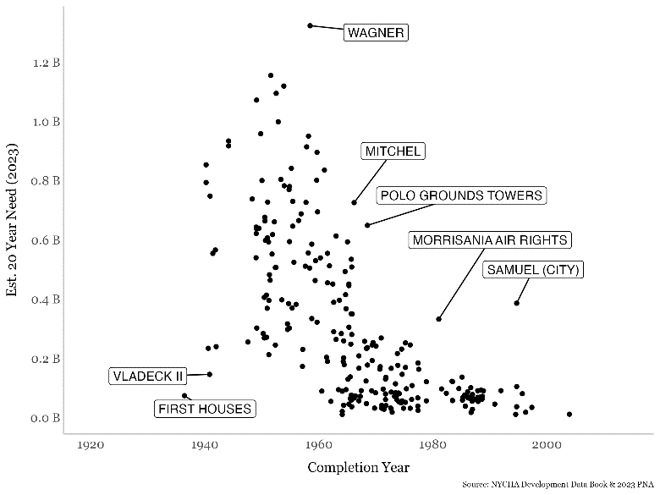
Fig 1: This is a scatterplot chart with the y-axis labeled “Est. 20 Year Need (2023)”, with markers ascending from the bottom labeled “0.0 B” to “1.2 B” at the top, and the x-axis labeled “Completion Year”, with the leftmost marker listed as “1920” and the rightmost marker listed as “2000”. The scatterplot is generally clustered in the middle of the chart, and has some dots that have labels attached to them to denote particular outlier NYCHA developments, such as “Vladeck II” and “Polo Grounds Towers”, with a total of seven dots labeled.
There is also a clear relationship between the size of the developments and the amount of need. As seen in Figure 2 below, the need rises with the size of the development. There are some outliers in this overall pattern, with the Whitman, Marcy, and Wager developments showing higher need when compared to other similarly sized developments. One noticeable outlier on the lower end is Morrisania Air Rights, which has lower need compared to similarly sized developments.
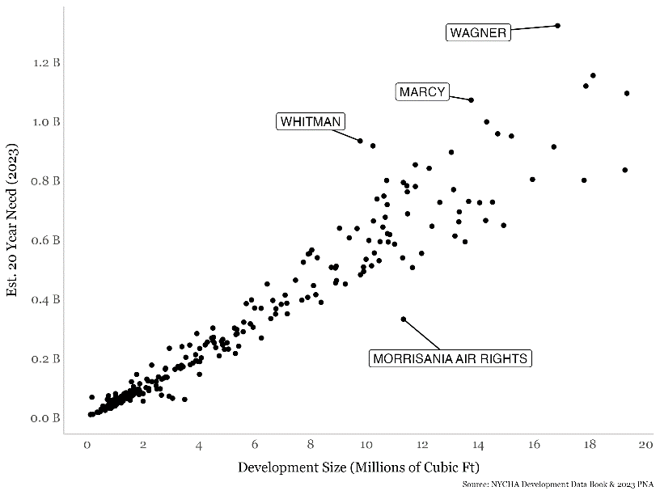
Fig 2: This is a scatterplot chart with the y-axis labeled “Est. 20 Year Need (2023)”, with markers ascending from the bottom labeled “0.0 B” to “1.2 B” at the top, and the x-axis labeled “Development Size (Millions of Cubic Ft)”, with the leftmost marker listed as “0” and the rightmost marker listed as “20”. The scatterplot is grouped in a fashion that shows a diagonally ascending trend, starting as a cluster in the bottom left of the chart and spreading out as the data points move towards the top right of the chart. This chart as four dots labeled to denote outlier NYCHA developments.
NEW METHODOLOGY PRESENTS NEW QUESTIONS
Although NYCHA used the same firms as the 2017 PNA, the methodology they used changed dramatically. In 2017, all 325 developments were inspected, while in 2023, the PNA was based on a review of a sample of 30 “representative” developments. These physical inspections took place between July 2022 and October 2022, and data collection involved assessing the current conditions of real estate to determine whether a component would need replacement or rehabilitation, along with a suggested timeframe of rehabilitation efforts based on current and projected deterioration, noted deficiencies, and the urgency of an asset needing attention. After all the data was collected, it was analyzed using deterioration curves to incrementally age all assets in NYCHA’s portfolio from their 2017 condition to their 2023 condition, forming a basis for calculating the portfolio’s capital needs. The resulting total capital needs cost calculation was organized into short-term needs and mid-term needs, with short-term needs entailing conditions requiring immediate action to be addressed within twelve months and within five years, and mid-term needs entailing conditions requiring rehabilitative actions between six and 20 years beyond 2023.
Although sampling and using modeling is a widely acceptable statistical tool, it raises questions as to whether the results are tailored to the needs of each particular development. One area of need within the 2023 PNA that showed a possible example of less than tailored results is elevators. Elevator replacement has been a specific focus of NYCHA since the imposition of the federal monitor. As shown in the chart below (Fig. 3), the estimated 20-year elevator needs for the vast majority of developments saw almost identical growth of approximately 80 percent from 2017 to 2023. Only a handful of developments saw their needs grow at a lower rate, and only one development, Highbridge Gardens, saw its elevator needs decrease. The two developments which were the outliers were two of the 30 that were individually inspected. As elevators were a specific focus of the federal monitor’s agreement, as well as an area that NYCHA has put significant resources into correcting, it may be possible that the nearly uniform growth was a result of sampling, rather than a tailored inspection of the particular needs at each development. Put another way, either the increased funding for elevators resulted in no decrease in growth in need compared to elevators that did not have that same funding, or the sampling and modeling for this element was not sufficiently tailored as to show any decrease in those developments where work was done.

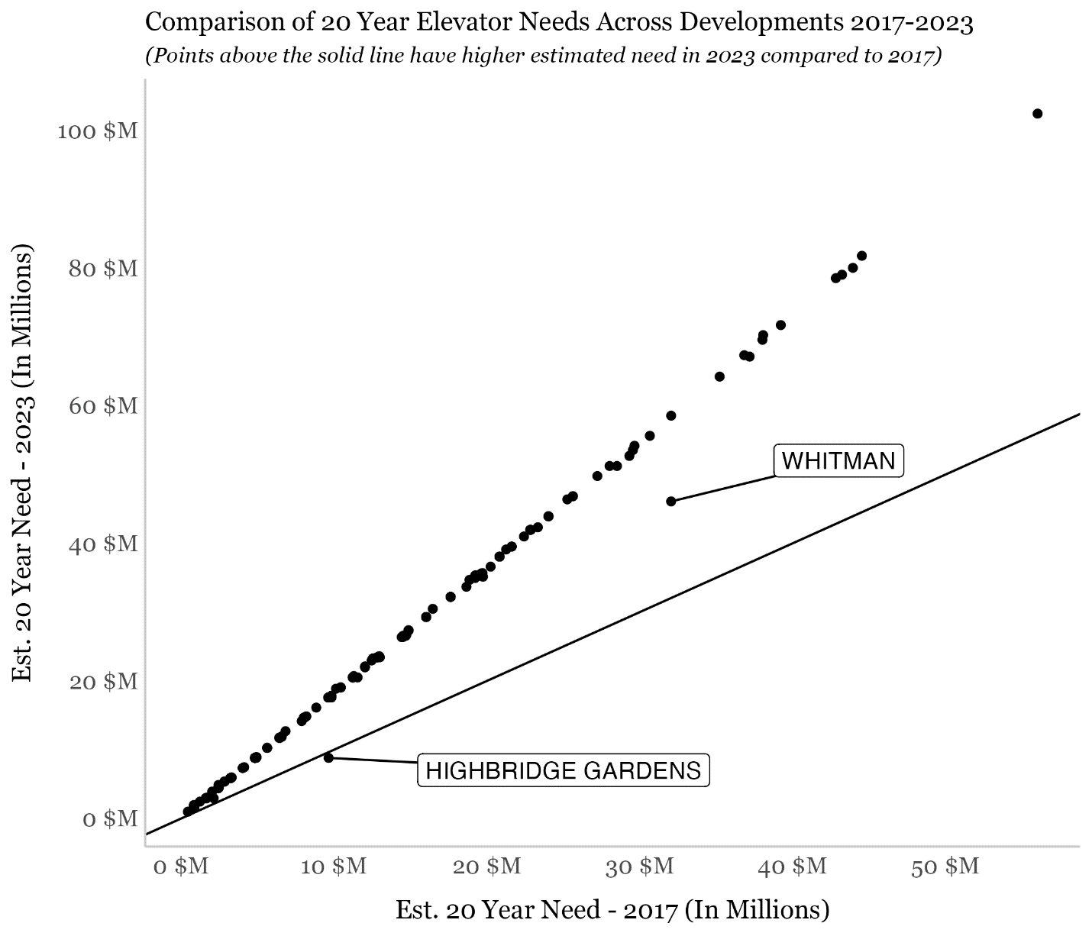
Fig 3: This is a scatterplot chart with the y-axis labeled “Est. 20 Year Need (2023)”, with markers ascending from the bottom labeled “0 $M” to “100 $M” at the top, and the x-axis labeled “Est. 20 Year Need – 2017 (In Millions)”, with the leftmost marker listed as “0 $M” and the rightmost marker listed as “50 $M”. There is a solid black line that shows what no growth in need would be in the elevators between the 2017 and 2023. The scatterplot is grouped in a fashion that shows a diagonally ascending trend except for two outlier developments labeled “Highbridge Gardens” and “Whitman.”

The 2023 PNA reported that conditions identified as short-term need were typically linked to life safety, structural, security, and leak-related observations, along with inoperable elevators. By far, NYCHA’s greatest short-term needs across its portfolio were found in its apartments, as issues related to items including bathrooms, floors, kitchens, and doors made up $25.13 billion, or 41.66%, of the 2023 PNA’s $60.32 billion short-term costs. The second largest need was heating systems, including decarbonization technologies for space heat and domestic hot water, representing $7.53 billion, or about 12.48%, of the 2023 short-term capital needs. The third largest needs were architectural systems and subsystems (including windows, roofs, main doors, stairs/ramps), at $6.67 billion, or about 11.06%; this was followed by mechanical systems and subsystems like steam piping and boiler systems, at $4.61 billion, or about 7.65%; and conveying (elevators), at $3.21 billion, or about 5.33% of NYCHA’s total short-term needs burden.
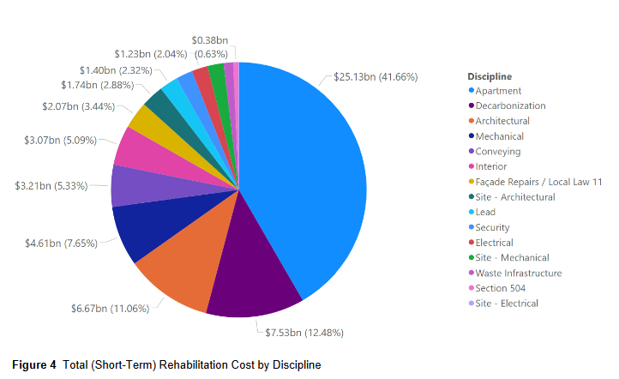
Fig. 4: A multi-colored pie chart with differently sized slices indicating a portion of the total short-term costs identified in NYCHA’s 2023 Physical Needs Assessment, with each slice marked with a price in billions of dollars and each price followed by a parenthesized percentage denoting the labeled price’s percent amount of the total cost. To the right is a legend titled “Discipline” which indicates the category that each pie slice’s color represents.

For the $18.02 billion in mid-term needs across NYCHA’s portfolio, the largest contributors were mechanical systems ($6 billion), apartments ($2.96 billion), and interior items like common area bathrooms and kitchens, roll down gates, and stairs ($2.52 billion).
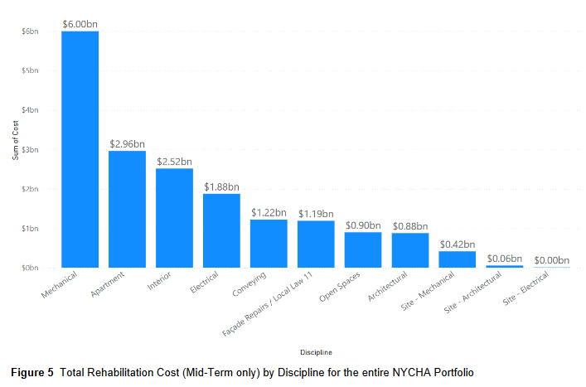
Fig. 5: This is a descending bar graph with the largest amount starting on the left side; the x-axis is labeled “Discipline” to indicate the categories that make up the largest contributing costs for the mid-term capital needs identified in the 2023 NYCHA Physical Needs Assessment, and the y-axis is labeled “Sum of Cost” to indicate the amount that each category entails, in billions of dollars.

CHARTING A WAY FORWARD
The 2023 PNA shows a continued dire and immediate need for serious capital repairs across NYCHA’s portfolio. Looking forward in the 2023 PNA, NYCHA assumes that about $38 of the $78 billion 20-year need would be addressed through three methods. First, there are $4.9 billion worth of capital projects which are either currently under construction or are budgeted and planned as of the PNA’s publication. Second, there are $10.5 billion worth of needs at developments currently in the PACT pipeline which NYCHA assumes will be addressed by the private developers in the PACT process. Finally, NYCHA assumes that $22.6 billion of needs will be addressed through future PACT conversions as well as developments anticipated to be renovated through the Public Housing Preservation Trust. While these methods represent almost half of the 20-year PNA need, this still leaves over $40 billion in needs with no designated funding source. In the last Capital Plan published by NYCHA in December 2022, there are $8.6 billion of planned commitments between 2023 and 2027. It is unclear from the PNA what amount of these commitments were captured in the $4.9 billion referenced above. Even with the current commitments, there remains an enormous amount of need.
The growth in overall and short-term needs also raises questions about how the PNA is used within NYCHA’s capital planning. In the sections of the 2017 and 2023 PNA where the authors lay out “The Challenge Ahead”, the authors list the same challenges and almost identical suggestions for the path forward. Since the 2017 PNA, NYCHA has undergone extensive changes and while clearly the massive disinvestment cannot be fixed in a five year span, it is unclear from the 2023 PNA what the effect of the changes has been in the capital planning at NYCHA. Lastly, as pointed out, NYCHA no longer includes the PACT developments in the PNA process. For developments already converted and for the developments that may be converted in the future, NYCHA counts that need as no longer under NYCHA’s responsibility. It is unclear what other review or inspections have taken place either in the midst of or following conversion to ensure that the needs of those developments have been adequately addressed.
CONCLUSION
The 2023 PNA again shows that NYCHA residents are living with, and will continue to live with the impact of decades of disinvestment. The Committee on Public Housing is interested to learn the details of the 2023 PNA process and results, to understand the rapid growth in costs, and how NYCHA is using this data to inform and improve its ongoing capital planning.

Luis Ferre-Sadurni, The Rise and Fall of New York Public Housing: An Oral History, The New York Times, Jun. 25, 2018, available at https://www.nytimes.com/interactive/2018/06/25/nyregion/new-york-city-public-housing-history.html.
Housing Act of 1937, last accessed on Jan. 25, 2023, available at https://www.gpo.gov/fdsys/pkg/USCODE-2009-title42/pdf/USCODE-2009-title42-chap8.pdf.
Peter Marcuse, The Beginnings of Public Housing in New York, Journal of Urban History 12(4) at 353-54 (1986); J.A. Stoloff, A Brief History of Public Housing, Paper presented at August 14 meeting of the American Sociological Association, at 3 (2004).
Marcuse, 354; Stoloff, 1; see also Judith D. Feins, et al., Revised Methods of Providing Federal Funds for Public Housing Agencies, United States Department of Housing and Urban Development, at 9 (1994).
See NYCHA Fact Sheet, last accessed on Jun. 7, 2023, available at https://www.nyc.gov/assets/nycha/downloads/pdf/NYCHA-Fact-Sheet-2023.pdf.
Id.
NYCHA, Public Housing Preservation Trust, New York City Housing Authority, available at https://www.nyc.gov/site/nycha/about/public-housing-preservation-trust.page.
Agreement between United States Department of Housing and Urban Development, the New York City Housing Authority, and New York City, Jan. 31, 2019, available at https://nychamonitor.com/wp-content/uploads/2019/03/Final-Executed-NYCHA-Agreement.pdf.
Id.
HUD, PNA Implementation: Frequently Asked Questions, U.S. Department of Housing and Urban Development, 2014, available at https://www.hud.gov/sites/documents/7_2014_GPNA_FAQS.PDF.
Since 2015 Congress has prohibited HUD from requiring Public Housing Associations to conduct PNAs, although NYCHA still undertakes the exercise. HUD, Physical Needs Assessment of Public Housing, U.S. Department of Housing and Urban Development, available at https://www.hud.gov/program_offices/public_indian_housing/programs/ph/capfund/physicalassessment; NYCHA, Transparency & Reports, New York City Housing Authority, available at https://www.nyc.gov/site/nycha/about/reports.page.
NYCHA, Modernizing NYCHA Properties, New York City Housing Authority, available at https://www.nyc.gov/site/nycha/about/modernizing-properties.page/#capneeded; Office of Public and Indian Housing, Physical Needs Assessment Report, U.S. Department of Housing and Urban Development, 2015, available at https://www.hud.gov/sites/documents/2015PNA_CR_FINAL.PDF.
Peter O’Hanlon and Stirling Edward Moore, PNA Technical Report: Physical Needs Assessment, New York City Housing Authority Physical Needs assessment 2023 Joint Venture, 2023, available at https://www.nyc.gov/assets/nycha/downloads/pdf/2023-PNA-Report-Physical-Needs-Assessment-NYCHA.pdf.
Id; STV AECOM PNA – A Joint Venture, Final Report: Physical Needs Assessment 2017, New York City Housing Authority, Mar. 25, 2018, available at https://www.nyc.gov/assets/nycha/downloads/pdf/PNA%202017.pdf and 2011 PNA Technical Report: Physical Needs Assessment, 2011, available at https://www.nyc.gov/assets/nycha/downloads/pdf/transparency-pna-2011.pdf.
Sean Campion, NYCHA Capital: What You Need to Know, Citizens Budget Commission New York, Dec. 2017, available at https://cbcny.org/sites/default/files/media/files/REPORT_NYCHA_Capital_12062017_1.pdf; NYCHA, Comprehensive Annual Financial Report for the Year Ended December 31st, 2011, New York City Housing Authority, available at https://www.nyc.gov/assets/nycha/downloads/pdf/CAFR_2011.pdf.
Id; Citizens Budget Commission, NYCHA Capital: What You Need to Know, Citizens Budget Commission New York, Dec. 20, 2017, available at https://cbcny.org/research/nycha-capital#2012-2016-capital-plan; https://www.nyc.gov/assets/nycha/downloads/pdf/CAFR_2011.pdf.
NYCHA, PlanNYCHA: A Roadmap for Preservation, New York City Housing Authority, Dec. 2011, available at https://www.scribd.com/document/119655816/PlanNYCHA-A-Roadmap-for-Preservation#.
Id.
Id.
NYCHA, 2011 Physical Needs Assessment (PNA) Summary, New York City Housing Authority, available at https://www.nyc.gov/assets/nycha/downloads/pdf/transparency-pna-2011.pdf; NYCHA, NextGeneration NYCHA, New York City Housing Authority, May 2015, available at https://www.nyc.gov/assets/nycha/downloads/pdf/nextgen-nycha-web.pdf.
Id.
See NYCHA, Board Meeting Minutes, January 27, 2016, New York City Housing Authority, available at https://www1.nyc.gov/assets/nycha/downloads/pdf/board_meeting_minutes_01272016.pdf.
See STV AECOM PNA – A Joint Venture, Final Report: Physical Needs Assessment 2017, New York City Housing Authority, Mar. 25, 2018, available at https://www1.nyc.gov/assets/nycha/downloads/pdf/PNA%202017.pdf.
Id.
Id.
Id.
Id.
STV AECOM PNA – A Joint Venture, Final Report: Physical Needs Assessment 2017, New York City Housing Authority, Mar. 25, 2018, available at https://www.nyc.gov/assets/nycha/downloads/pdf/PNA%202017.pdf.
Peter O’Hanlon and Stirling Edward Moore, PNA Technical Report: Physical Needs Assessment, New York City Housing Authority Physical Needs assessment 2023 Joint Venture, 2023, available at https://www.nyc.gov/assets/nycha/downloads/pdf/2023-PNA-Report-Physical-Needs-Assessment-NYCHA.pdf.
Id.
The total number $78 billion is more than the reported 2017, 2011, and 2016’s five-year capital needs combined ($31.8, $16.5, and $6.9 billion, respectively). Id; See STV AECOM PNA – A Joint Venture, Final Report: Physical Needs Assessment 2017, New York City Housing Authority, Mar. 25, 2018, available at https://www.nyc.gov/assets/nycha/downloads/pdf/PNA%202017.pdf; NYCHA, PlanNYCHA: A Roadmap for Preservation, New York City Housing Authority, Dec. 2011, available at https://www.scribd.com/document/119655816/PlanNYCHA-A-Roadmap-for-Preservation#.
Id.
Peter O’Hanlon and Stirling Edward Moore, PNA Technical Report: Physical Needs Assessment, New York City Housing Authority Physical Needs assessment 2023 Joint Venture, 2023, available at https://www.nyc.gov/assets/nycha/downloads/pdf/2023-PNA-Report-Physical-Needs-Assessment-NYCHA.pdf.
Id.
Id.
Id; NYCHA Performance Tracking and Analytics Department, NYCHA Development Data Book 2023, New York City Housing Authority, available at https://www.nyc.gov/assets/nycha/downloads/pdf/pdb2023.pdf.
Id.
Id.
Id.
Id.
Id.
Id.
NYCHA Federal Monitor, Elevator Service Report, May 18, 2023, Office of the NYCHA Federal Monitor, available at https://nychamonitor.com/wp-content/uploads/2023/05/Monitor-Elevator-Report-5.18.pdf.
Analysis from NYC Council Data Team, based on Peter O’Hanlon and Stirling Edward Moore, PNA Technical Report: Physical Needs Assessment, New York City Housing Authority Physical Needs assessment 2023 Joint Venture, 2023, available at https://www.nyc.gov/assets/nycha/downloads/pdf/2023-PNA-Report-Physical-Needs-Assessment-NYCHA.pdf and STV AECOM PNA – A Joint Venture, Final Report: Physical Needs Assessment 2017, New York City Housing Authority, Mar. 25, 2018, available at https://www.nyc.gov/assets/nycha/downloads/pdf/PNA%202017.pdf.
Peter O’Hanlon and Stirling Edward Moore, PNA Technical Report: Physical Needs Assessment, New York City Housing Authority Physical Needs assessment 2023 Joint Venture, 2023, available at https://www.nyc.gov/assets/nycha/downloads/pdf/2023-PNA-Report-Physical-Needs-Assessment-NYCHA.pdf.
Id.
Id.
Id.
Id.
Id.
Id.
Id.
Id.
Id.
Id.
Id.
The paragraphs in the 2017 and 2023 PNA “The Challenge Ahead” sections match up word for word in certain parts. Whether the authors were suggesting NYCHA had not followed their suggested approach from 2017 is unclear.

