Governmental Operations Committee Staff
Brad J. Reid, Senior Counsel
Elizabeth Kronk, Legislative Policy Analyst
Emily Forgione, Legislative Policy Analyst
Zachary Harris, Finance Analyst

Technology Committee Staff
Irene Byhovsky, Counsel
Patrick Mulvihill, Senior Legislative Policy Analyst
Sebastian Bacchi, Finance Analyst



THE COUNCIL

COMMITTEE REPORT OF THE GOVERNMENTAL AFFAIRS Division and the Infrastructure Division
Jeffrey Baker, Legislative Director
Rachel Cordero, Deputy Director, Governmental Affairs
Terzah Nasser, Deputy Director, Infrastructure

COMMITTEE ON GOVERNMENTAL OPERATIONS
Hon. Fernando Cabrera, Chair

COMMITTEE ON TECHNOLOGY
Hon. Peter Koo, Chair

January 17, 2018

Oversight: 311 Customer Experience and Operations

Int. No. 188-2018: By Council Member Matteo, Brannan, Holden, Yeger and Gjonaj

Title: A Local Law to amend the administrative code of the city of New York, in relation to procedures to be adopted by the 311 call center for responding to certain repeat anonymous complaints against the same property

Administrative Code: Section 23-304

Int. No. 1328-2019: By Council Member Menchaca

Title: A Local Law to amend the administrative code of the city of New York, in relation to the identification of languages spoken by callers to the 311 customer service center

Administrative Code: Section 23-304

Introduction
On January 17, 2019, the Committee on Governmental Operations, chaired by Council Member Fernando Cabrera, jointly with the Committee on Technology, chaired by Council Member Peter Koo, will hold an oversight hearing on ‘311 Customer Experience and Operations.’ In addition, the Committee on Governmental Operations will hold a first hearing on two bills: Int. 188-2018 (Matteo), in relation to procedures to be adopted by the 311 call center for responding to certain repeat anonymous complaints against the same property, and Int. 1328-2019 (Menchaca), in relation to the identification of languages spoken by callers to the 311 customer service center. The committees expect to receive testimony from the Department of Information Technology and Telecommunications (“DoITT”), the 311 Customer Service Center (“311”), advocates, and members of the public related to the above topics.
This is the first of a two-part hearing on the 311 system. The second hearing will be focused on agency responsiveness to 311 service requests.

Background
311
The 311 Customer Service Center (“311”) was first launched in 2003 as a call center, built on technology from 2002. Since then it has evolved to provide services through text messages, a mobile application, social media and a website. Prior to its establishment by former Mayor Michael Bloomberg, the City relied on approximately 40 agency help lines and a general Mayoral phone line, almost all of which have been folded into the 311 call center. It now registers tens of millions of customer contacts each year – with over 42 million in FY18. Only about half of those contacts originated by telephone, while the rest mostly originated through the website, text messaging, and the mobile application.
People can access 311 via phone (by dialing 3-1-1 within the City and 212-NEW-YORK from anywhere in the world), a nyc.gov 311 Online web portal, Facebook, Twitter, sending a text message to 311-NYC (311-692) or via a 311 smartphone application for iPhone and Android. The 311Online website and the mobile app can also be used to look up the status of an individual request, by service number, after it has been reported. However, only the mobile app can track multiple service requests at one time for a customer, and then only if those requests were submitted through the mobile app. Neither the website nor the telephone system allows for similar tracking. A customer contact with 311 generally generates either a service request, when the customer is seeking a City agency to take an action, or an informational request, when the customer has a question regarding a City service. There are datasets for both types of requests on the Open Data Portal.
The system has worked, but there are concerns that its old and inflexible technology makes it difficult to incorporate new features or services. One area where 311 could improve, but is hindered by its outdated technology, is its user interface. Currently, the system is organized by service request, not by customer, so, except to a limited degree with the mobile app, New Yorkers cannot sign in and view all the service requests they have made in one convenient place. 311 has expressed a desire to change the interface to make it more customer-oriented, but the outdated technology has made that change too difficult to implement on any platform other than the mobile application.
With that in mind, 311 and DoITT released an RFS in April of 2015 to develop a new backend to their system. IBM won the contract and committee staff have been told that they are currently in the testing phase, with an anticipated completion in 2019. Once completed, the new 311 system is expected to be more flexible and customer oriented, as described above. It is also anticipated to be more stable, even under a high volume of requests.
In Fiscal Year 2018, the 311 Customer Service Center received more than 42 million inquiries, 20.6 million of which were from telephone, 19.3 million from 311 Online, 1.8 million from the mobile application and 254,000 from text messaging. Overall, there was a seven percent increase in contacts since FY 2017. 311 also continues to increase its social media presence with 24/7 live agents on Twitter supporting a following of 300,000 people. The peak use of the system has been during emergency events such as the blizzard in 2010 or Hurricane Sandy in 2012.
The 311 mobile app does not seem to have especially high adoption numbers in comparison to the volume of contacts received through the telephone or online. In 2012, then Mayor Bloomberg attempted to use the mobile app to report a condition he observed, only to find it non-functional and lacking a desired complaint category. Although the app has undergone improvements and redesigns since then, there still seems to be a limited number of complaint categories compared to 311 Online. This may lead users to intentionally mis-categorize a complaint to most closely approximate the condition they are observing, or to abandon their attempt at a complaint altogether. Additionally, while the app utilizes a dashboard that allows users to sign in and track all of their mobile app complaints from one location without having to type in cumbersome service request numbers, they cannot track complaints made through phone or internet via the mobile app. This stands in stark contrast to the 311 mobile apps used by cities such as Boston, where users can even view recent service requests made by other users in real-time. Outside of NYC’s mobile app, there is no tracking dashboard of any type available for tracking an individual’s service requests.
311 usage for all platforms (by phone, online, text and app contacts) for the last six fiscal years is visible on the below graph:
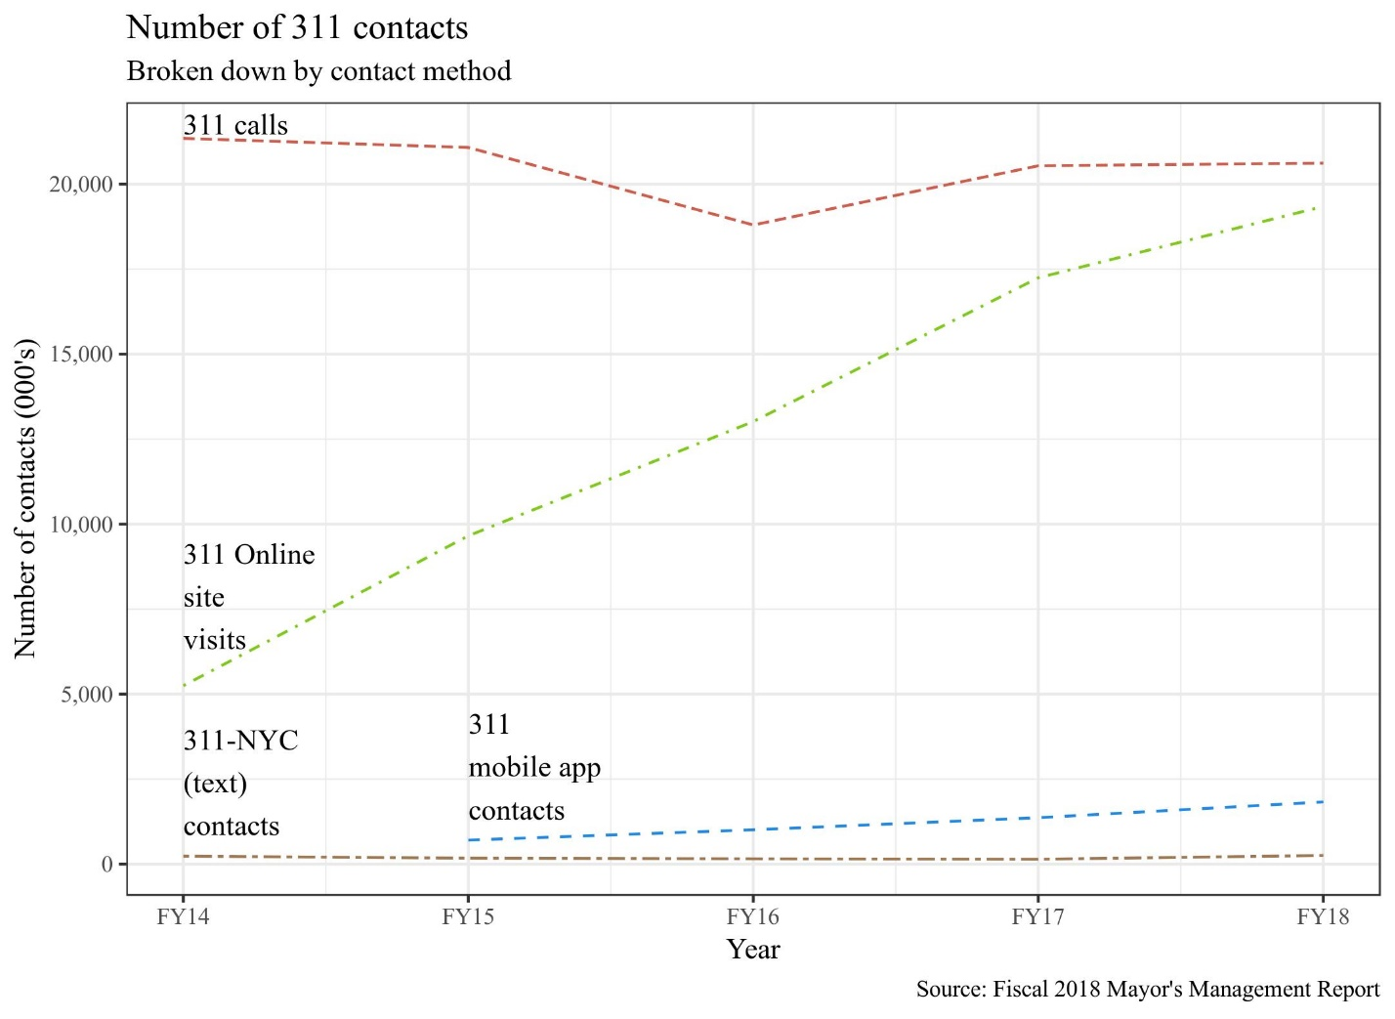
RFP and IBM Contract

On December 31, 2013, in an attempt to revamp the City’s 311 system, then-Mayor Bloomberg approved a $10 million contract with a Montreal-based company CGI. CGI is a global information technology consulting, systems integration, outsourcing and solutions company founded in 1976. However, New York City Comptroller Scott Stringer did not approve the contract due to concerns about the planning and scope of the project, as well as costs. Ultimately, the Comptroller’s Office stated that the contract needed to be rebid.
In April 2015, DoITT released a request for systems (RFS) integration services entitled, “311 Customer Service Management System Replacement and Re-Architecture Project”, to gather ideas from companies to upgrade the entire 311 system since its launch in 2003. The request solicited a systems integrator with extensive contact center experience to assist with the replacement and re-architecture of 311’s incident-oriented Customer Service Management System (CSMS) with a more customer-centric, cost effective and extensible system.
The intention of the RFS is to create a new platform where users could create 311 accounts that allow users to track requests and also receive updates on complaints. In addition, the City wants to simplify the service request process with a mobile accessible interface making it feasible to track requests through third-party channels with an Application Programming Interface.
The City awarded IBM with a $24 million contract in February 2017 to install networks and systems. The term of the contract was from March 1, 2017 until August 31, 2019. IBM’s Watson will support a new customer-management system that will be constructed for multiple communications channels, such as social media and text messaging. Watson is a high-tech computing system with high machine-learning capability that can speed up and enhance the process of providing answers to residents and visitors regarding city services and responding to complaints. The system can search through billions of records 311 has kept throughout its existence and figure out the most effective way to answer a question or complaint.
During the 18-month implementation, some key elements of the proposed timeline include three agile releases of the prototype in which after each release, there will be a user acceptance testing (Agile UAT) in order to keep the City and its users engaged and familiar with the system so that early feedback by users would be provided. As a part of the implementation process, IBM will provide education and training to existing and new City employees. In addition, there will be a “Full System Testing” period for approximately two months, which will include a system test and performance test and twelve months of solution support.

Anonymous Complaints as Harassment

While 311 usually functions as a way for New Yorkers to request agencies to address legitimate complaints, there is concern that it occasionally has been used as a tool for harassment, whereby a caller makes repeated, anonymous, unsubstantiated complaints against a private property. This abuse of 311 is not only detrimental to the subject of the anonymous complaints, but a drain on City resources that could be used to respond to valid complaints. Between 2006 and 2014, the Staten Island Borough President’s district office recorded over 50 reports of 311 harassment, including one homeowner who was the subject of nine anonymous complaints about various conditions in and around his home in 2013, five of which were made over just two days, and seven of which were deemed baseless upon inspection. Local elected officials believed these repeated anonymous calls were the result of neighbor-versus-neighbor disputes. The issue is not just limited to Staten Island. In 2017, a Bronx homeowner reported that he had received 68 summonses for conditions in and around his home over the past two years, all arising from anonymous calls to 311. Local State Assembly Member Michael Benedetto said that 66 of the 68 complaints were dismissed. That case also appeared to be a case of neighbor-versus-neighbor disputes.
There has also been reported 311 harassment against businesses. In 2012, D’Amico, a coffee and specialty food store in Carroll Gardens, Brooklyn, was the subject of repeated anonymous complaints over the smell of roasting coffee beans coming from their shop. The caller then began calling the Fire Department, which could have diverted important City resources away from responding to true emergencies.

Language Access

311 provides telephonic interpretation and translation services in over 200 languages. It informs callers of the availability of interpretation services through its call pickup recording, and then transfers them to a telephonic interpreter if they choose. Its recording offers pre-recorded announcements about City services in Spanish, Mandarin, Russian, Cantonese, Korean, and Haitian Creole. According to 311’s Language Access Plan, published in 2018, 94 percent of limited English proficient (“LEP”) callers request interpretation services in Spanish, Mandarin, Russian, or Cantonese, with the other 6 percent requesting other languages. Of the approximately 20 million calls received in 2017, 639,521 calls, or approximately three percent, required interpretation services. 311’s telephonic interpretation vendor, Language Line, provided assistance in 93 different languages.
311 operators are trained on how to interface with a caller who does not speak English, and how to handle a call when they are unable to readily identify a caller’s language. The 2018 Language Access Plan states that when operators are unable to identify a caller’s language, they “will connect with Language Line and request to speak with someone who is skilled in language identification.” Despite this training, there have been reports that 311 operators do not always appropriately identify the language a caller is speaking, which results in a caller being denied the opportunity to make a request to receive or get information about a City service. At a City Council hearing in October, advocates, including the Asian American Federation, the New York Immigration Coalition, and India Home, testified that they knew of incidents where LEP New Yorkers were unable to lodge a 311 complaint because they could not access the appropriate interpreter for the language that they spoke.
Committee staff recently tested 311’s language access procedures and found that while non-English speakers eventually reached an appropriate Language Line interpreter, the process was slow and prone to human error. Committee staff observed that the automated system by which callers may select one of six pre-recorded languages does not appear to communicate with 311’s human operator system. When a caller has selected one of the six non-English languages and has a question requiring a human operator, the call is transferred to an operator who answers in English and does not appear to know that the caller previously selected a non-English language. When a caller is speaking a language other than the six pre-recorded languages, the call is also transferred to a human operator, who answers in English and then attempts to identify the language the caller needs. In both cases, a 311 operator first has to make a best guess of the caller’s language and then transfer the caller to a Language Line interpreter. If the 311 operator guesses incorrectly, or cannot understand the caller’s language, it is up to Language Line staff to figure out the correct language and eventually connect the caller to the appropriate interpreter. The process takes time, and only the most determined callers are likely to remain on the line before getting frustrated and disconnecting.
311’s reliance on human operators to identify spoken languages opens the possibility that New Yorkers could be denied assistance because they cannot make the complaint in the language they speak. It also underestimates the true need for language services in the City, because callers likely hang up when they cannot connect with someone who speaks their language.

Legislative Analysis

Int. No. 188-2018

Int. No. 188-2018 would require 311 to document, but not refer to an agency, any non-emergency anonymous complaint made against a property classified as harassed. A harassed property under this bill would be defined as a private property that, within a six month period, is the sole subject of three or more anonymous complaints that an agency cannot substantiate despite reasonable efforts, or an agency substantiates the complaint, but the condition or circumstance is not illegal. The designation of a property as harassed would last for three months from the date of the third complaint.

Int. No. 1328-2019
Int. No. 1328-2019 would require 311 to implement a protocol for identifying the language spoken by a telephone caller to 311. The protocol must include the use of automated language recognition software to assist in the identification of the language possibly spoken by the caller. The bill would require 311 to examine every call that disconnects during the process of identifying the caller’s language without having completed the process, determine the cause of the disconnection, and implement remedies to address the problem where appropriate. DoITT would be required to submit a report to the Council and post on its website a summary of these instances and remedies on an annual basis.

Int. No. 188

By Council Member Matteo, Brannan, Holden, Yeger and Gjonaj

A LOCAL LAW

To amend the administrative code of the city of New York, in relation to procedures to be adopted by the 311 call center for responding to certain repeat anonymous complaints against the same property

Be it enacted by the Council as follows:
Section 1. The administrative code of the city of New York is amended by adding a new section 23-304 to read as follows:
§ 23-304 Repeated anonymous unfounded complaints. a. The 311 customer service center, upon receipt of any non-emergency anonymous complaint relating solely to a property classified as harassed, shall document such call but shall not refer such call to any agency.
b. For the purposes of this section:
1. a property shall be classified as “harassed”: (i) if it is a privately-owned property that, within a six month period, is the sole subject of three or more anonymous complaints made to the 311 customer service center and referred to an agency; and (ii) such agency is unable to substantiate the condition or circumstance complained of, despite reasonable efforts; or (iii) such agency substantiates such condition or circumstance, but the condition or circumstance is not a violation of any applicable law. Such classification shall last for three months from the date of the third such complaint; and
2. “anonymous complaint” means a complaint made to the 311 customer service center where the complaining individual does not give his or her name and address, whether or not such information is requested.
§ 2. This local law takes effect 180 days after it becomes law.

DSS
LS 598
LS 152/Int 92/2014
12/28/17

Int. No. 1328
By Council Member Menchaca

A LOCAL LAW

To amend the administrative code of the city of New York, in relation to the identification of languages spoken by callers to the 311 customer service center

Be it enacted by the Council as follows:

Section 1. Chapter 3 of title 23 of the administrative code of the city of New York is amended to add a new section 23-304 to read as follows:
§ 23-304 Identification of spoken language. a. The 311 customer service center shall implement a protocol for identifying the language spoken by a telephone caller to the 311 customer service center.
b. Such protocol shall include the use of automated language recognition software to assist in the identification, either for an automated message system or for the call taker, of the language possibly spoken by the caller.
c. The 311 customer service center shall examine every call that disconnects during the process of identifying the caller’s language without having completed such process, determine the cause of such disconnection, and implement remedies for such disconnections where appropriate to ensure that callers to the 311 system in any language are properly addressed. By January 30 of each year, the department of information technology and telecommunications shall submit to the council and post on its website a report summarizing such causes and remedies.
§ 2. This local law takes effect 1 year after it becomes law.

BJR
LS 8859
1/2/19 11:12 AM

‘311 Customer Service Center: More Calls and a Growing Budget’, IBO Fiscal Brief, April 2008, p. 1-2, found at: http://www.ibo.nyc.ny.us/iboreports/311Apr08.pdf
2018 Mayor’s Management Report, p. 134.
Id.
FY 2018 Mayor’s Management Report, p. 134, found at: https://www1.nyc.gov/assets/operations/downloads/pdf/mmr2018/2018_mmr.pdf
Id.
Id.
‘Mayor Bloomberg Commemorates Ten Years Of Nyc311, The Nation's Largest And Most Comprehensive 311 Service,’ Mayor’s Office Press Release, March 11, 2013, found at: http://www1.nyc.gov/office-of-the-mayor/news/089-13/mayor-bloomberg-commemorates-ten-years-nyc311-nation-s-largest-most-comprehensive-311
In FY18, there were 1.8 million inquiries placed via the mobile app, compared to 20.6 million and 19.3 million via phone and online, respectively. See supra note 4.
Gonzalez, Juan, ‘Free iPhone app designed for citizen complaints a dud, fumes Bloomberg’, NY Daily News, April 16, 2012, http://www.nydailynews.com/new-york/smartphone-app-designed-citizen-complaints-dud-angers-mayor-bloomberg-article-1.1062174
Citizens Connect, http://www.cityofboston.gov/DoIT/apps/citizensconnect.asp; ‘Updating 311’, Innovation and the City, Center for an Urban Future, found at: https://nycfuture.org/pdf/Innovation-and-the-City.pdf
Karni, Annie, “Bloomberg Gave 311 Contract Worth $10M to Company Behind Obamacare Rollout,” New York Daily News, January 25, 2014, found at: http://www.nydailynews.com/news/politics/exclusive-bloomberg-gave-311-contract-worth-10m-cgi-article-1.1590916
Karni, Annie, “Co. That Botched HealthCare.gov Loses $10 Million New York City Contract,” New York Daily News, February 5, 2014, found at: http://www.nydailynews.com/new-york/healthcare-gov-loses-10m-nyc-contract-article-1.1602569
Id.
Flamm, Matthew, “City’s 311 Hotline is Getting Some Help of Its Own,” Crain’s New York Business, April 30, 2015, found at: https://www.crainsnewyork.com/article/20150430/TECHNOLOGY/150429832/city-s-311-hotline-is-getting-some-help-of-its-own.
See, The City of New York Department of Information Technology and Telecommunications Request for Systems Integration Services for 311 Customer Service Management System Replacement and Re-Architecture Project, April 28, 2015, found at: https://www1.nyc.gov/assets/doitt/downloads/pdf/311-rfs.pdf
Neubauer, Miranda, “City Seeks New 311 Framework,” Politico New York, May 11, 2015, found at: https://www.politico.com/states/new-york/city-hall/story/2015/05/city-seeks-new-311-framework-089425
Id.
See, Task Order Number 1426-001A, NYC 311 CSMS Replacement and Re-Architecture for Department of Information Technology and Telecommunications, found at: https://www.scribd.com/document/342938208/NTP-and-NYC-311-IBM-Task-Order-1426-001A-signed-Redacted-v2?secret_password=RtVgjUFEdELXT1pukn65
Flamm, Matthew, “IBM’s Watson Will Soon Answer Your 311 Calls,” Crain’s New York Business, January 11, 2017.
Flamm, Matthew, “City’s 311 Hotline is Getting Some Help of Its Own,” Crain’s New York Business, April 30, 2015.
Id.
See, Task Order Number 1426-001A, NYC 311 CSMS Replacement and Re-Architecture for Department of Information Technology and Telecommunications, found at: https://www.scribd.com/document/342938208/NTP-and-NYC-311-IBM-Task-Order-1426-001A-signed-Redacted-v2?secret_password=RtVgjUFEdELXT1pukn65
Id.
‘New City Council bill targets 311 ‘harassment,’ Metro, March 20, 2014, found at: https://www.metro.us/local/new-york-city-looks-to-end-harassment-via-311-complaint-hotline/tmWncs---b47PDHLFQBMqs
Id.
‘Bronx Man Claims Neighbor Is Using 311 Complaint Hotline to Harass Him,’ CBS Local News, August 10, 2017, found at: https://newyork.cbslocal.com/2017/08/10/311-complaint-harassment/
Id.
Id.
‘D’Amico To Anonymous 311 Caller In New Message: Stop Calling DEP And Fire Department,’ Pardon Me For Asking, April 20, 2012, found at: https://pardonmeforasking.blogspot.com/2012/04/damico-to-anonymous-311-caller-in-new.html
Id.
New York City 311 Customer Service Center Language Access Plan (May 22, 2018), found at: https://www1.nyc.gov/assets/doitt/downloads/pdf/311-Language-Access-Plan.pdf.
Id.
Id.
Id.
Id.
Id.
Id.
Id.
Testimony before the Governmental Operations Committee, New York City Council, October 25, 2018, found at: https://legistar.council.nyc.gov/LegislationDetail.aspx?ID=3698345&GUID=D53B67F7-5F3F-47C5-B753-EC74797E5072&Options=&Search=

