Staff: Committee on Technology
Irene Byhovsky, Legislative Counsel
Charles Kim, Legislative Policy Analyst
Florentine Kabore, Finance Analyst
Nicholas Montalbano, Data Analyst
James Wu, Data Analyst



THE COUNCIL

BRIEFING PAPER OF THE

INFRASTRUCTURE DIVISION
Andrea Vazquez, Legislative Director
Bradley Reid, Deputy Director

COMMITTEE ON TECHNOLOGY
Hon. Jennifer Gutiérrez, Chairperson

May 3, 2022

Oversight: LinkNYC

- Introduction
On May 3, 2022, the Committee on Technology, chaired by Council Member Jennifer Gutiérrez will hold an oversight hearing on Link NYC. The Committee expects to receive testimony from representatives of the Office of Technology and Innovation also known as the Department of Information Technology and Telecommunications (“DoITT”), the Link NYC franchisee, and other interested members of the public.
- Background
- Original Franchise Agreement with CityBridge
In April of 2014, DoITT released a request for proposal (“RFP”) for replacing public payphones with public communications structure that called for free calling to 311, 911 and free 24/7 public Wi-Fi. In exchange, the winning bidder would receive advertising revenue from advertisements placed on the structures. At least sixty organizations, including Time Warner, Cisco, the Metropolitan Transit Authority, and Verizon, expressed interest in the RFP. Ultimately, CityBridge LLC (“CityBridge”) was awarded the franchise. CityBridge is a consortium of experts in technology, advertising, connectivity and user experience, including Qualcomm, Civiq Smartscapes; as well as Intersection, a company made through the purchase and merger of Control Group and Titan by Sidewalk Labs. Sidewalk Labs is an urban innovation company that was previously under Google’s parent company Alphabet and has since been folded into Google.
According to the franchise agreement signed in 2014, a total of 7,500 LinkNYC kiosks were to be installed across the five boroughs by 2022. LinkNYC kiosks allow a user to maintain a free Wi-Fi network connection while moving through the City in covered areas; provide the ability to access city services, maps and directions from a LinkNYC tablet; make free phone calls to anywhere in the U.S.; contact 911 in the event of an emergency; and charge devices through a USB outlet. All of these services exist at no extra cost to taxpayers.
By July 2020, 3,153 LinkNYC structures were supposed to be installed; however, as of April 29, 2022, only 2,182 structures were installed, with just 1,855 of those installed kiosks live and functional. Of those, 1,169 kiosks are in Manhattan, 252 are in Brooklyn, 252 are in Queens, 148 are in the Bronx, and 34 are in Staten Island.
- Amended Agreement with CityBridge
In March 2018, CityBridge stopped paying their franchise fees. In July 2021, DOITT amended the original franchise agreement to recoup some of the lost funds. Pursuant to the amended agreement, the LinkNYC kiosks will have a new design which allow mobile telecom franchisees to leverage kiosks to build out 5G networks, and a new payment structure, according to which CityBridge paid $25 million of its debt and will continue to pay $3 million yearly over 7 years. In late 2021, the City received limited approval from the Public Design Commission for its new 5G LinkNYC kiosk upgrade designs, allowing the 5G design to be rolled out in commercial and industrial districts, but not residential.
The new structures will be 32 feet tall, more than three times taller than the original LinkNYC kiosk design. The new kiosks will still have a 911 button, USB ports charge devices, a tablet, calling capabilities, the same 55-inch advertising displays, and continue to provide free Wi-Fi throughout the city.
Under the new agreement CityBridge will install 4,000 total kiosks by 2025, which is 3,500 less than the initial franchise agreement. 90% of new kiosks will be located above 96th Street in Manhattan and in the Bronx, Brooklyn, Queens and Staten Island. 739 kiosks will also be installed in 13 “equity” areas, which were chosen by City officials based on substantial foot traffic, low median incomes, and a lack of broadband options for households. The areas include Hunts Point and Longwood in The Bronx; Bushwick, Brownsville and Ocean Hill in Brooklyn; Inwood and Washington Heights in Manhattan; Rockaway, Jamaica and Hollis in Queens; and Port Richmond, St. George and Stapleton in Staten Island.
- LinkNYC Data and Statistics
LinkNYC is the subject of multiple datasets on NYC’s Open Data portal, which include usage data, permit data, and the installation status of kiosks.
- Usage Data
The following graph Fig. 1 shows the average length of a LinkNYC Wi-Fi session, in minutes, over the years 2020, 2021, and 2022.
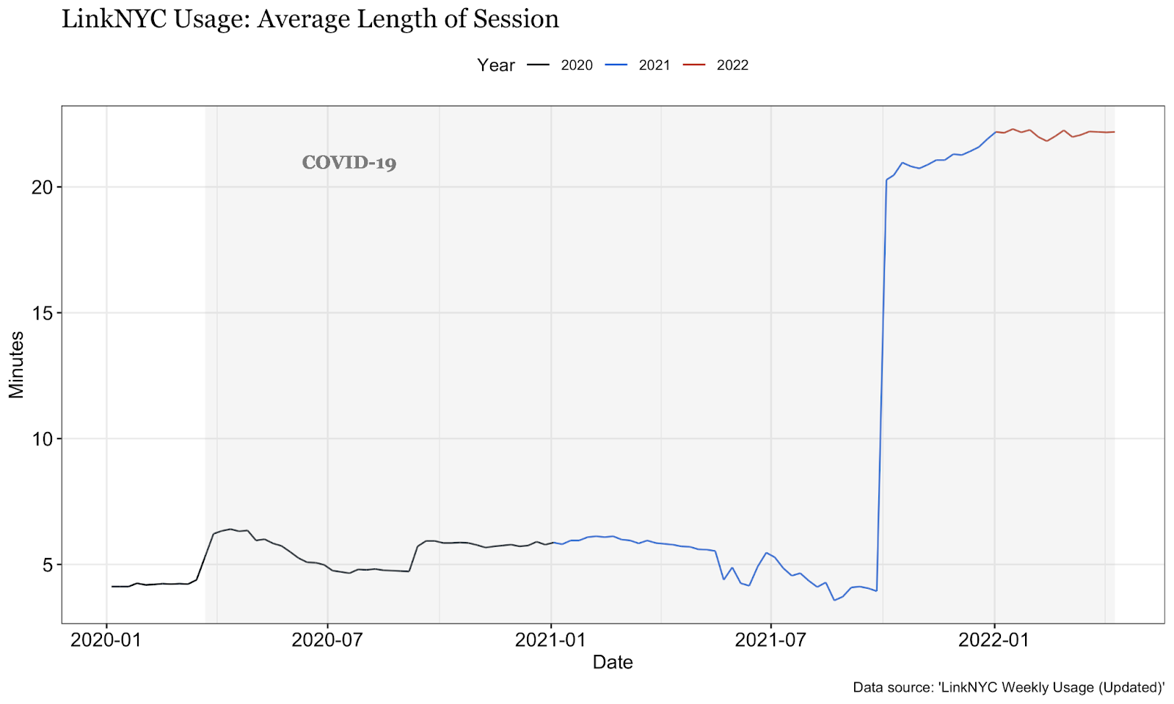
Fig. 1
Usage data uploaded to the LinkNYC weekly and historical usage datasets have some inconsistencies but nonetheless display definitive trends. There is an average length of session time, or how long someone was connected to LinkNYC Wi-Fi, of 4-6 minutes. Then, on October 4, 2021, the reported data shows an extreme spike where average length of session times go from 4-6 minutes to over 20 minutes of session times. This higher average length continues throughout the rest of 2021 and into 2022.
Fig. 2 shows the weekly number of unique devices connected to LinkNYC Wi-Fi, in hundreds of thousands, from 2020 to 2022.
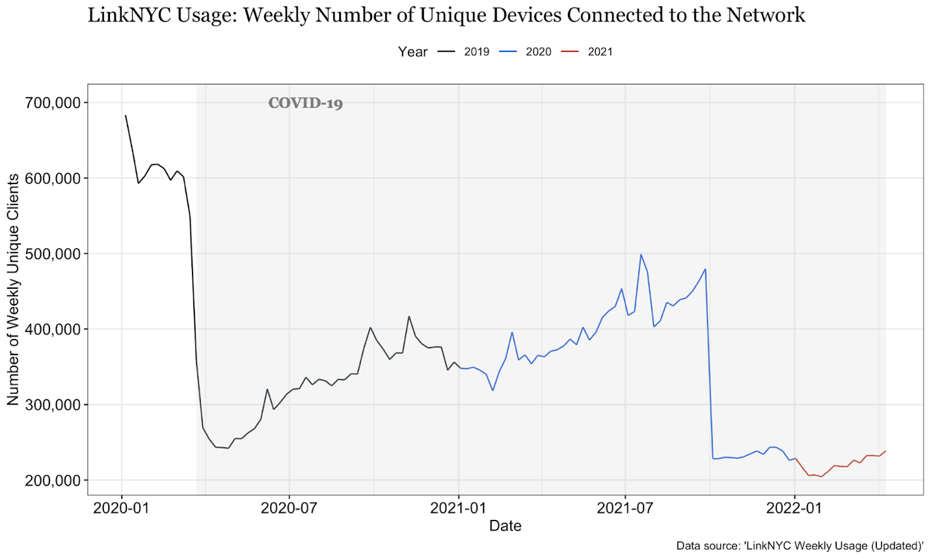
Fig. 2
The number of unique devices connected to LinkNYC Wi-Fi indicates a general idea on how many people were utilizing LinkNYC Wi-Fi per month. When the pandemic hit New York City, the number of unique devices connected to LinkNYC Wi-Fi dropped from around 600,000 to just around 250,000 per month. From there, the number of unique connected devices steadily increased throughout 2020 and 2021 before dropping drastically on October 4, 2021.
Fig. 3 shows the weekly number of times any device connected to a LinkNYC Wi-Fi network from 2020 to 2022.
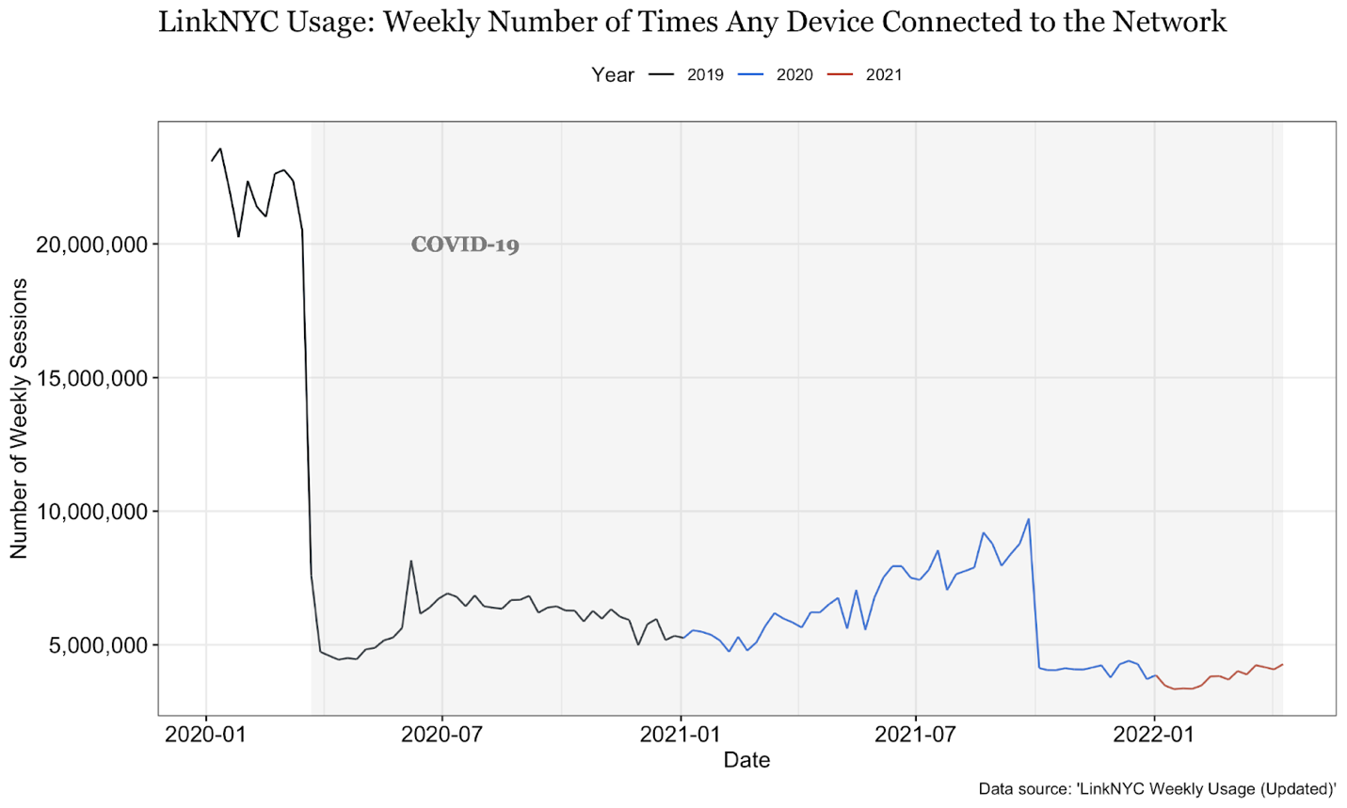
Fig. 3
In this dataset we see the number of times any device connected to a LinkNYC Wi-Fi network. Notably, usage in this dataset saw a dramatic decline upon the advent of the COVID-19 pandemic, from 20 million sessions to 5 million sessions; as well as a spike on June 7, 2020, during the George Floyd protests.

- Permit Data
Fig. 4 shows the number of LinkNYC Permit Applications disaggregated by borough.
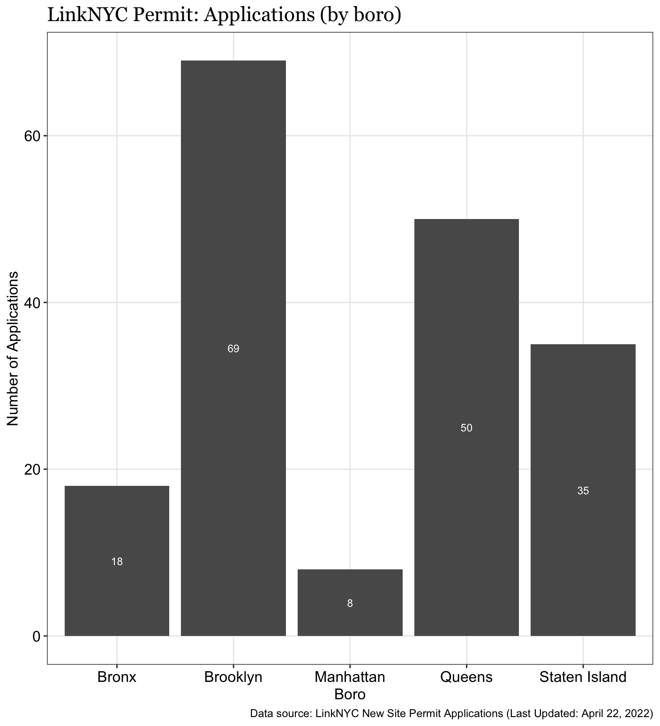
Fig. 4
As of April 22, 2022, most new permit applications are for locations in Brooklyn (69), Queens (50), and Staten Island (35), with 18 in the Bronx and 8 in Manhattan. Further, the Manhattan locations are in Washington Heights South and Marble Hill-Inwood; in other words, north of 96th Street, which is consistent with the terms of the amended agreement.
- Installation Status of Kiosks
Fig. 5 is a table that lists the number of installed LinkNYC kiosks in each borough, as well as their status, accumulating in a total number per 10,000 residents.
Table: LinkNYC Kiosk Status
Borough | Live | Installed | Ready for Activation | Removal Pending | Repair Pending | TOTAL (per 10,000 residents)
Bronx | 148 | 7 | 11 | 0 | 6 | 172 (1.21)
Brooklyn | 252 | 3 | 1 | 1 | 37 | 294 (1.14)
Manhattan | 1169 | 10 | 3 | 4 | 221 | 1407 (8.64)
Queens | 252 | 4 | 0 | 1 | 17 | 274 (1.21)
Staten Island | 34 | 0 | 0 | 0 | 0 | 34 (0.72)
Fig. 5
As of April 29, 2022, the vast majority of live LinkNYC kiosks are in Manhattan (1169), followed by Brooklyn (252), Queens (252), the Bronx (148), and Staten Island (34).
- LinkNYC Benefits
LinkNYC has had multiple benefits since the first kiosks became active in 2016. The primary benefit has been access to free high-speed internet, with peak usage in 2019 seeing more than 6 million users who had collectively used around 8.6 terabytes of data. According to CityBridge company Interception, LinkNYC also facilitated around 600,000 phone calls per month, and the tablets have been used to search for social services, engage with NYC311, and find locations in the preinstalled Maps application.
Beyond emergency and social services, LinkNYC’s agreement and amendment with the City provides for 25% of kiosk advertisements to be given to the City, which are used to encourage civic engagement, display public service announcements; as well as highlight City-sponsored events and cultural projects like showcasing historical photos of NYC. However, despite these clear benefits, there are still concerns and issues with LinkNYC.
- LinkNYC Past and Current Concerns
- Privacy and Data Tracking
Despite the LinkNYC benefits of free internet access and device charging, many New Yorkers expressed concerns over possible information sharing. Privacy groups have also raised concerns regarding the vast amounts of data about New York City residents that is collected, stored, and shared; the lack of transparency; and the ability of kiosk technology to track an individual's movements.
In order to use LinkNYC’s free internet service, a person needs to first register by providing an email address. According to the LinkNYC privacy policy dated May 17, 2017, CityBridge also collects “technical information” which includes anonymized MAC addresses, IP addresses, device identifiers, and information deemed necessary to facilitate Wi-Fi service delivery. This information is kept for 60 days, except for MAC addresses, which are stored for one year if a user never opts in to use LinkNYC again. However, if a user’s devices are set to remember and join Wi-Fi networks, LinkNYC kiosks will connect with the user even as they are passing by.
There are several privacy-related concerns that were raised by the public, such as the City allowing LinkNYC to collect data for advertising purposes without oversight. Further, digital data security concerns were not addressed by the RFP, and were only briefly mentioned in the initial franchise agreement, according to which “the franchisee retains ownership rights in all data created in the course of providing the Wi-Fi Services to the extent that such data doesn’t include Personally Identifiable Information.”
CityBridge categorizes device identifiers, MAC addresses and IP addresses as Technical Information rather than Personal Information. However, these device identifiers, even when anonymized, still provide identifying information about a person as they are connecting their personal devices. For example, knowing that a device has been in multiple locations, along with the history of the websites it has visited, could provide enough information for someone to figure out an individual’s routines and can ultimately identify a person through matching datasets.
In fact, based on their privacy policy, CityBridge claims to supplement anonymized Technical Information with information collected by third parties, which include advertising partners and “other providers that help [them] understand [their] users.” Mr. Dan Doctoroff, the founder and CEO of Sidewalk Labs explained that having access to anonymized browsing data actually enables them to proximally target ads, and that they can track users through beacons and location data, claiming to “[replicate] the digital experience in physical space.” Therefore, the kiosks can allegedly use the data they collect to create location-specific targeted advertising.
Another concern is related to security breaches and unwanted surveillance of users and passersby, as entities like the New York Civil Liberties Union (“NYCLU”) has argued the volume of information gathered creates massive databases which present attractive opportunities for hackers and law enforcement as well as risk of abuse and unauthorized access. Even the existence of municipal wireless networks presents a tempting target for hackers. In addition to collecting and retaining some data about users’ interactions with the kiosks, the LinkNYC kiosks also collect information from sensors and video cameras that reportedly capture a 360-degree view of surrounding streets and sidewalks. According to the CityBridge privacy policy, the structure “may include two cameras camera mounted on each side of the Link above the ad panels”, while tablets also contain built-in cameras that could be used for video calls in the future. However, the privacy policy states that video captured by any camera will not be kept longer than seven days, unless the footage is necessary to investigate an incident. The policy further states that the data collected by the cameras will not be disclosed except in select circumstances such as to protect kiosks from vandalism or when they are served a subpoena by law enforcement. The policy further states that facial recognition technology will never be used for any reason, nor will cameras track user movement throughout the city.
In addition to cameras, each kiosk has 30 sensors. The privacy policy states that these sensors collect information about the environment surrounding the structures like temperature, pressure, and ambient noise, but do not collect data from or about users; however, the policy does not clarify the data retention period and use of the data collected from these sensors.
- Inaccessibility
There have also been reports that the kiosks are not sufficiently accessible to the vision-impaired. Issues raised include not adding braille on the keypad and failing to include audio functions. These concerns led the National Federation of the Blind to a file a lawsuit calling on the City and CityBridge to stop the installation of any new kiosks until additional accessibility features are added to kiosks which have already been installed. Now, according to the LinkNYC website, LinkNYC kiosks are built to ADA standards, with features including hearing loop and controls marked with braille, an ‘Accessibility’ tile on tablet home screens for more specific functions, and settings that allow for color inversion, zoom, and volume control.
- Improper Use
There have been reports of individuals using the kiosks as ‘personal spaces’ for themselves, where in some instances, people would be seen using drugs, drinking around the kiosks, and also watching pornography. Further, kiosks along Eighth Avenue in Manhattan were considered eyesores to residents because of their design and the brightness of their advertisements. Residents and business owners have also complained that the kiosks have caused the streets to become more cluttered and have also become areas where homeless persons gather, deterring others from using the kiosks.
As a result of people using the kiosks for personal use and in some cases, committing lewd acts, on September 14, 2016, LinkNYC announced that they would be removing web browsing on all the kiosks while they work on potential solutions to alleviate crowding and personal use issues, such as possibly enforcing time limits on usage. In addition, LinkNYC dimmed the light on the kiosk displays and limited their maximum volume at night in response to community feedback and suggestions. The kiosks continue to provide the public with free phone calls, maps, device charging and access to 911.
- Rollout Inequity
Despite the LinkNYC program’s potential to provide internet, its initial uneven buildout limited the program’s ability to bridge the digital divide. The buildout of LinkNYC kiosks has historically come under scrutiny due to the concentration of kiosks in comparatively wealthier districts in Manhattan while other boroughs were left with barely any kiosks by comparison. As such, equity was prioritized in the amended agreements, which placed specific location-based requirements on where new LinkNYC kiosks would be built, focusing on neighborhoods that had not received LinkNYC buildouts in the past. As previously mentioned, 90% of new kiosks will be installed in the outer boroughs and above 96th street in Manhattan as part of the amended agreement with CityBridge.
- Conclusion
The Committee looks forward to receiving testimony from the Administration, franchisees, advocacy groups, academia, and other interested members of the public on the status of the LinkNYC program in New York City and how they foresee overcoming challenges with the program, as well as how this network can be leveraged and improved for the betterment of the City and its residents.

See Testimony of Stanley Shor, Assistant Commissioner of Franchise Administration before the Technology Committee, New York City Council, November 15, 2016.
Sam Gustin, Google May Turn 7,000 New York City Payphones into WiFi Hotspots, MOTHERBOARD, July 22, 2014, 2:04 PM, https://motherboard.vice.com/en_us/article/3dkvqk/google-may-turn-7000-new-york-city-payphones-into-wifi-hotspots.
See Testimony of Stanley Shor, Assistant Commissioner of Franchise Administration before the Technology Committee, New York City Council, November 15, 2016.
CityBridge, LinkNYC, CityBridge, 2022, https://link.nyc.
This world leader in Wi-Fi, 3G, and 4G technologies will help ensure LinkNYC supports the latest technology, especially as it relates to wireless connectivity. Qualcomm Quick Charge enabled USB charging ports, allowing Quick Charge 2.0 enabled devices to charge up to 75% faster than conventional charging, https://www.qualcomm.com/media/documents/files/linknyc-infographic.pdf.
CIVIQ Smartscapes Specializing in the design and manufacturing of interactive communications solutions that withstand rugged environments, CIVIQ will design, engineer, and manufacture the Links to create durable, robust, and reliable structures, https://www.qualcomm.com/media/documents/files/linknyc-infographic.pdf.
Titan and Control group combine under one united company —Intersection. Titan oversees LinkNYC’s operations and manages the advertising media program. Control Group is a tech, strategy and user experience design firm responsible for delivering concept to production UX, http://www.isralink.org.il/en/citybridge-linknyc/; Intersection is a technology and media company that’s dedicated to improving the urban experience. The company creates new products and services and invests in the most engaging media platforms that enable cities, businesses and communities to drive engagement, innovation and revenue, https://www.qualcomm.com/media/documents/files/linknyc-infographic.pdf.
Jillian D’Onfro, Google is funding a plan to bring free Wi-Fi to NYC, Insider, Jun 23, 2015, https://www.businessinsider.com/google-sidewalk-labs-acquires-titan-outdoor-and-control-group-2015-6.
Ava Kofman, Are New York’s Free LinkNYC Internet Kiosks Tracking Your Movements?, The Intercept, Sep 8, 2018, https://theintercept.com/2018/09/08/linknyc-free-wifi-kiosks/; Nick Pinto, Google Is Transforming NYC’s Payphones Into a ‘Personalized Propaganda Engine’, The Village Voice, Jul 6, 2016, https://www.villagevoice.com/2016/07/06/google-is-transforming-nycs-payphones-into-a-personalized-propaganda-engine/.
Kim Lyons, Sidewalk Labs will be folded into Google as CEO steps down for health reasons, The Verge, Dec 16, 2021, https://www.theverge.com/2021/12/16/22840028/sidewalk-labs-google-doctoroff-health-toronto-quayside.
DoITT, Franchise Agreement, The City of New York, Dec 10, 2014, https://www1.nyc.gov/assets/doitt/downloads/pdf/Franchise-Agreement-for-Public-Communications-Structures-(REVISED-FINAL-12-10-2014).pdf; DoITT, Public Communications Structure Franchise Agreement Attachment SRV (Services), The City of New York, Dec 10, 2014, https://www1.nyc.gov/assets/doitt/downloads/pdf/Attachment-SRV-Services-(REVISED-FINAL-12-10-2014).pdf.
Id.
Amit Chowhdry, Pay Phones in NYC to be Replaced With up to 10,000 Free Wi-Fi Kiosks Next Year, Forbes, Nov 19, 2014, http://www.forbes.com/sites/amitchowdhry/2014/11/19/linknyc-free-wifi/#24d3bd647028.
DoITT, LinkNYC Kiosk Status, NYC OpenData, last accessed Apr 29, 2022, https://data.cityofnewyork.us/City-Government/LinkNYC-Kiosk-Status/n6c5-95xh.
Id.
Ryan Deffenbaugh, Hard reset: It’s Plan B for LinkNYC, Crain’s New York Business, Aug 30, 2021, https://www.crainsnewyork.com/technology/linknyc-plans-reboot; Gabriel Sandoval, Big Tech Pays to Supersize LinkNYC and Revive Broken Promise to Bridge Digital Divide, The City, Apr 27, 2022, https://www.thecity.nyc/2022/4/27/23045122/link5g-free-wifi-tech-linknyc.
Id.
Id; DoITT, Amendment No. 3 to the Franchise Agreement, The City of New York, Dec 10, 2014, https://www1.nyc.gov/assets/doitt/downloads/pdf/franchise-agreements/citybridge-fcrc-proposed-amendment-052721.pdf.
Kiosk Industry, LinkNYC 5G Design “Limited” Approval Passes (except for Residential), Kiosk Industry, Dec 13, 2021, https://kioskindustry.org/linknyc-5g-design-doesnt-get-approval/.
Gabriel Sandoval and Joshua McWhirter, Big Tech Pays to Supersize LinkNYC and Revive Broken Promise to Bridge Digital Divide, The City, Apr 27, 2022, https://www.thecity.nyc/2022/4/27/23045122/link5g-free-wifi-tech-linknyc.
Id.
Id.
Id.
Id.
Id; DoITT, CityBridge, and ZenFi Networks, LinkNYC Link5G Design Proposal, DoITT, Oct 18, 2021, https://www1.nyc.gov/assets/designcommission/downloads/pdf/10-18-2021-pres-DoITT-p-Link-5G.pdf#page=11.
DoITT, LinkNYC Weekly Usage (Updated), NYC OpenData, last accessed Apr 29, 2022, https://data.cityofnewyork.us/City-Government/LinkNYC-Weekly-Usage-Updated-/nxmt-wszr.
Id.
Id.
DoITT, LinkNYC New Site Permit Applications, NYC OpenData, last accessed Apr 29, 2022, https://data.cityofnewyork.us/Social-Services/LinkNYC-New-Site-Permit-Applications/xp25-gxux.
DoITT, LinkNYC Kiosk Status, NYC OpenData, last accessed Apr 29, 2022, https://data.cityofnewyork.us/City-Government/LinkNYC-Kiosk-Status/n6c5-95xh.
Kyle Wiggers, LinkNYC’s 6 million users have used 8.6 terabytes of data, VentureBeat, Mar 28, 2019, https://venturebeat.com/2019/03/28/linknycs-6-million-users-have-downloaded-8-6-terabytes-of-data/.
Id.
DoITT, Franchise Agreement, The City of New York, Dec 10, 2014, https://www1.nyc.gov/assets/doitt/downloads/pdf/Franchise-Agreement-for-Public-Communications-Structures-(REVISED-FINAL-12-10-2014).pdf; DoITT, Public Communications Structure Franchise Agreement Attachment SRV (Services), The City of New York, Dec 10, 2014, https://www1.nyc.gov/assets/doitt/downloads/pdf/Attachment-SRV-Services-(REVISED-FINAL-12-10-2014).pdf; DoITT, Amendment No. 3 to the Franchise Agreement, The City of New York, Dec 10, 2014, https://www1.nyc.gov/assets/doitt/downloads/pdf/franchise-agreements/citybridge-fcrc-proposed-amendment-052721.pdf; DoITT, LinkNYC, DoITT, the Museum of the City of New York and Urban Archive Launch Historic NYC: Photography from NYC History Displayed on Links Across the City, The City of New York, https://www1.nyc.gov/site/doitt/about/press-releases/linknyc-doitt-museum-historic-nyc.page.
One person told a reporter that “she did not feel comfortable using the Wi-Fi or connecting her phone to the USB outlet. ‘For some reason, I don't trust it,’ she said. ‘They're trying to get everyone's information.”’ Patrick McGeehan, New Yorkers Greet the Arrival of Wi-Fi Kiosks with Panic, Skepticism and Relief, N.Y. TIMES (July 26, 2016), https://www.nytimes.com/2016/07/27/nyregion/link-nyc-wi-fi-kiosks.html; Another person “said his primary concern was ‘having to give them information,’ not that he was certain who ‘they’ were.” Id. But see id. (describing others who said the kiosks provided access to people who otherwise couldn't afford to get online).
The American Civil Liberties Union, Electronic Frontier Foundation, ReThink LinkNYC and others.
CityBridge, How do I get free Wi-Fi?, https://www.link.nyc/how-to-connect.html. iOS users also have the option of choosing the LinkNYC private network, which requires a separate profile installation and the device passcode
CityBridge, LinkNYC Privacy Policy, CityBridge, last updated March 17, 2017, https://www.link.nyc/privacy-policy.html.
Id.
Brandon A. Brooks, Alexis Schrubbe, The Need for A Digitally Inclusive Smart City Governance Framework, 85 UMKC L. Rev. 943, 949 (2017).
Ira S. Rubinstein & Bilyana Petkova, Governing Privacy in the Datafied City, 47 Fordham Urb. L.J. 755, 801 (2020).
DoITT, Franchise Agreement, The City of New York, Dec 10, 2014, https://www1.nyc.gov/assets/doitt/downloads/pdf/Franchise-Agreement-for-Public-Communications-Structures-(REVISED-FINAL-12-10-2014).pdf.
Ava Kofman, Are New York’s Free LinkNYC Internet Kiosks Tracking Your Movements?, The Intercept, Sep 8, 2018, https://theintercept.com/2018/09/08/linknyc-free-wifi-kiosks/.
Id; See Latanya Sweeney, Policy and Law: Identifiability of de-identified data, http://latanyasweeney.org/work/identifiability.html.
Id.
Nick Pinto, Google Is Transforming NYC’s Payphones Into a ‘Personalized Propaganda Engine’, The Village Voice, Jul 6, 2016, https://www.villagevoice.com/2016/07/06/google-is-transforming-nycs-payphones-into-a-personalized-propaganda-engine/.
According to May 2017 privacy policy, “[CityBridge does] not collect information about your precise location. However, “[CityBridge knows] where we provide WiFi services, so when you use the Services we can determine your general location,” CityBridge, LinkNYC Privacy Policy, CityBridge, last updated March 17, 2017, https://www.link.nyc/privacy-policy.html..
Ira S. Rubinstein & Bilyana Petkova, Governing Privacy in the Datafied City, 47 Fordham Urb. L.J. 755, 803 (2020) (citing City's Public Wi-Fi Raises Privacy Concerns, N.Y. C.L. UNION, Mar 16, 2016, http://www.nyclu.org/news/citys-public-wi-fi-raises-privacy-concerns).
Eric Hornbeck, "We Know Not Where We Go": Protecting Digital Privacy in New York City's Municipal Wi-Fi Network, 45 Fordham Urb. L.J. 699, 712–13 (2018).
Shahid Buttar and Amul Kalia, LinkNYC Improves Privacy Policy, Yet Problems Remain, Electronic Frontier Foundation, Oct 4, 2017, https://www.eff.org/deeplinks/2017/09/linknyc-improves-privacy-policy-yet-problems-remain; Ira S. Rubinstein & Bilyana Petkova, Governing Privacy in the Datafied City, 47 Fordham Urb. L.J. 755, 802–03 (2020) (internal citations are omitted).
CityBridge, LinkNYC Privacy Policy, CityBridge, last updated March 17, 2017, https://www.link.nyc/privacy-policy.html.
Id.
Id.
Id.
Ashley Carman, How secure are New York City's new Wi-Fi hubs?, The Verge, Jan 20, 2016, https://www.theverge.com/2016/1/20/10773014/linknyc-public-wifi-access-security-citybridge.
CityBridge, LinkNYC Privacy Policy, CityBridge, last updated March 17, 2017, https://www.link.nyc/privacy-policy.html.
Shaye Weaver, City's LinkNYC Kiosks Discriminate Against the Blind, Lawsuit Says, DNA Info, Aug. 1, 2016, https://www.dnainfo.com/new-york/20160801/upper-east-side/linknyc-kiosks-exclude-blind-lawsuit-against-city-says.
Id.
CityBridge, Are Link kiosks ADA-accessible?, CityBridge, 2022, https://www.link.nyc/faq.html#accessibility
Jen Kirby, City is Turning Off Web Browing on Its Wi-Fi Kiosks After Complaints Over Squatters and Porn Watchers, New York Mag, Sep. 14, 2016, http://nymag.com/daily/intelligencer/2016/09/complaints-force-linknyc-to-turn-off-web-browsing.html; Zolan Kanno-Youngs, New York City’s Wi-Fi Plan Faces Delays, Criticism, The Wall Street Journal, Jul 22, 2016, http://www.wsj.com/articles/new-york-citys-wi-fi-plan-faces-delays-criticism-1469234058.
Id.
Id.
Office of the New York State Comptroller, DiNapoli Examines Faltering LinkNYC Program, The State of New York, Jul 30, 2021, https://www.osc.state.ny.us/press/releases/2021/07/dinapoli-examines-faltering-linknyc-program.
Id.
Id.
Ryan Deffenbaugh, Hard reset: It’s Plan B for LinkNYC, Crain’s New York Business, Aug 30, 2021, https://www.crainsnewyork.com/technology/linknyc-plans-reboot; Gabriel Sandoval and Joshua McWhirter, Big Tech Pays to Supersize LinkNYC and Revive Broken Promise to Bridge Digital Divide, The City, Apr 27, 2022, https://www.thecity.nyc/2022/4/27/23045122/link5g-free-wifi-tech-linknyc.

