Governmental Operations, State and Federal Legislation Committee Staff
Jayasri Ganapathy, Senior Legislative Counsel
Erica Cohen, Policy Analyst
Hector German, Economist

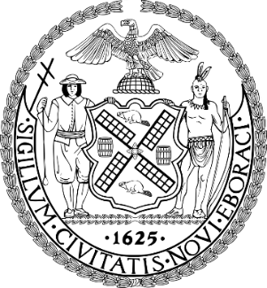
The Council Of The City Of New York

Committee Report of the Governmental Affairs Division
Andrea Vazquez, Director
Rachel Cordero, Deputy Director, Governmental Affairs

Committee on Governmental Operations, State & Federal Legislation
Hon. Lincoln Restler, Chair

June 11, 2025

 | By Council Member Restler
SLR #11: | S.4824-A (Jackson)  A.1847-A (Pheffer Amato)
TITLE: | AN ACT to amend the general municipal law, in relation to disabilities of members of the uniformed force of sanitation departments in certain cities

- BACKGROUND
On June 11, 2025, the Committee on Governmental Operations, State and Federal Legislation, chaired by Council Member Lincoln Restler, held a vote on Preconsidered SLR 11, State Legislation Resolution requesting the New York State Legislature to pass bills introduced by Senator Jackson, S.4824-A, and Assembly Member Pheffer Amato, A.1847-A, “AN ACT to amend the general municipal law, in relation to disabilities of members of the uniformed force of sanitation departments in certain cities.” Preconsidered SLR 11 passed with 9 votes in the affirmative, 0 votes in the negative, and 0 abstentions.
- PROPOSED STATE LEGISLATION
This legislation would establish a rebuttable presumption that leptospirosis that results in disability or death of a member of the uniformed force of a paid sanitation department was incurred in the performance or discharge of duty.
- FISCAL IMPLICATIONS
See Council Finance Division fiscal impact statement.
- EFFECTIVE DATE
This bill takes effect immediately.
Preconsidered State Legislation Resolution No. 11

State Legislation Resolution requesting the New York State Legislature to pass bills introduced by Senator Jackson, S.4824-A, and Assembly Member Pheffer Amato, A.1847-A, “AN ACT to amend the general municipal law, in relation to disabilities of members of the uniformed force of sanitation departments in certain cities”.

By Council Member Restler

Whereas, Bills have been introduced in the New York State Legislature by Senator Jackson, S.4824-A, and Assembly Member Pheffer Amato, A.1847-A, “AN ACT to amend the general municipal law, in relation to disabilities of members of the uniformed force of sanitation departments in certain cities” and

Whereas, The enactment of the above State Legislation requires the concurrence of the Council of the City of New York as the local legislative body; now, therefore, be it

Resolved, That the Council of the City of New York, in accordance with the provisions of Section 2 of Article 9 of the Constitution of the State of New York, does hereby request the New York State Legislature to enact into law the aforesaid pending bills.

JG
06/04/25 3:30 PM

