THE COUNCIL OF THE CITY OF NEW YORK
RESOLUTION NO. 843

Resolution approving with modifications the decision of the City Planning Commission on Application No. N 180448 ZRQ, for an amendment of the text of the Zoning Resolution (L.U. No. 361).

By Council Members Salamanca and Moya

WHEREAS, the City Planning Commission filed with the Council on February 15, 2019 its decision dated January 30, 2019 (the "Decision"), on the application submitted by Auberge Grand Central, LLC, pursuant to Section 201 of the New York City Charter, for an amendment of the text of the Zoning Resolution of the City of New York, modifying Appendix F for the purpose of establishing a Mandatory Inclusionary Housing area on the project area Options 1, 2, and 4 (Workforce Option), which in conjunction with the related action would facilitate the reuse and enlargement of the former Parkway Hospital building for residential and community facility uses and the development of a new residential building in the Forest Hills neighborhood of Queens, Community District 6, (Application No. N 180448 ZRQ), (the "Application");

WHEREAS, the Application is related to application C 180447 ZMQ (L.U. No. 360), a zoning map amendment changing property from an R1-2A district to an R7A district and an R7X district;

WHEREAS, the Decision is subject to review and action by the Council pursuant to Section 197-d(b)(1) of the City Charter;
WHEREAS, upon due notice, the Council held a public hearing on the Decision and Application on March 6, 2019;

WHEREAS, the Council has considered the land use implications and other policy issues relating to the Decision and Application; and

WHEREAS, the Council has considered the relevant environmental issues, including the negative declaration issued September 24th, 2018 (CEQR No. 18DCP021Q), which includes an (E) designation to avoid the potential for significant adverse impacts related to hazardous materials, air quality, and noise (E-502) (the “Negative Declaration”).

RESOLVED:

The Council finds that the action described herein will have no significant impact on the environment as set forth in the (E) Designation (E-502) and Negative Declaration.

Pursuant to Sections 197-d and 200 of the City Charter and on the basis of the Decision and Application, and based on the environmental determination and consideration described in the report, N180448 ZRQ, incorporated by reference herein, and the record before the Council, the Council approves the Decision of the City Planning Commission with the following modifications:

Matter underlined is new, to be added;
Matter struck out is to be deleted;
Matter within # # is defined in Section 12-10;
Matter double struck out is old, deleted by the City Council;
Matter double-underlined is new, added by the City Council
* * * indicates where unchanged text appears in the Zoning Resolution.

APPENDIX F

Inclusionary Housing Designated Areas and Mandatory Inclusionary Housing Areas

* * *
QUEENS

* * *

Queens Community District 6

Map 1 – (date of adoption)

[PROPOSED MAP]

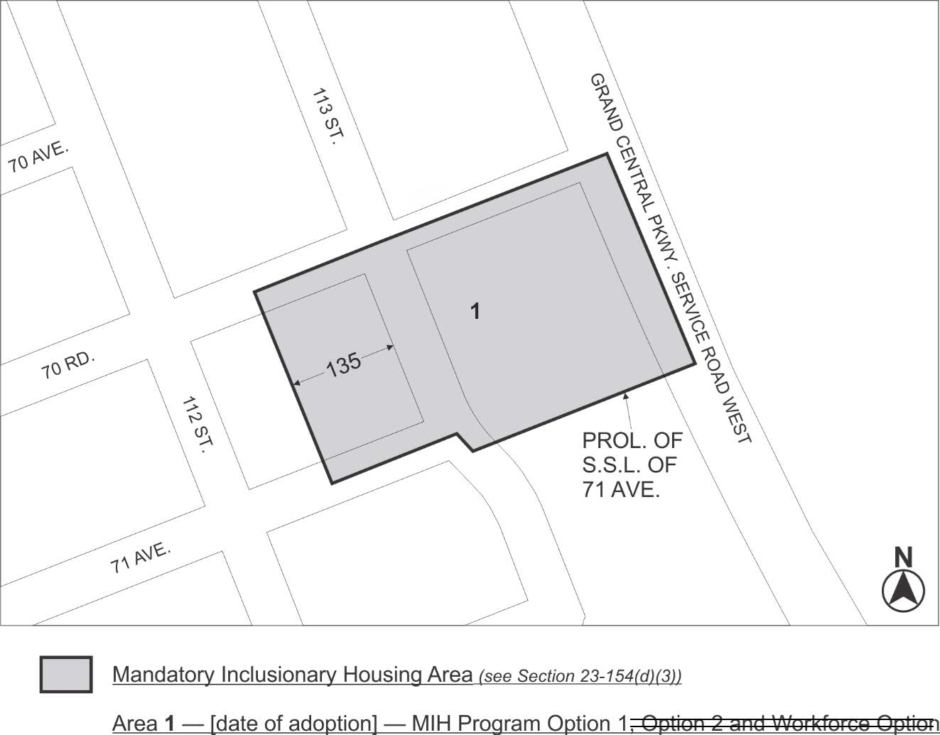

Portion of Community District 6, Queens

* * *

Adopted.

Office of the City Clerk, }
The City of New York, } ss.:

I hereby certify that the foregoing is a true copy of a Resolution passed by The Council of The City of New York on April 9, 2019, on file in this office.

.....……......................................... City Clerk, Clerk of The Council

