Committee Staff:
James DiGiovanni, Counsel
Kris Sartori, Legislative Attorney
Agatha Mavropoulos, Legislative Analyst
Emily Rooney, Policy Analyst
Rick Arbelo, Policy Analyst
Chima Obichere, Finance Analyst
John Basile, Finance Analyst



THE COUNCIL OF THE CITY OF NEW YORK

COMMITTEE REPORT OF THE INFRASTRUCTURE DIVISION
Jeffrey Baker, Legislative Director

COMMITTEE ON TRANSPORTATION

Hon. Ydanis Rodriquez, Chair

August 15, 2018

Oversight – Speed Cameras

INT. NO. 322: By Council Members Rodriguez, Constantinides and The Speaker (Council Member Johnson)
TITLE: A Local Law to amend the administrative code of the city of New York, in relation to a street design checklist
ADMINISTRATIVE CODE: Adds §19-182.2 to Subchapter 1 of Chapter 1 of Title 19
INT. NO. 971: By Council Members Lander, Torres, Reynoso, Richards, Menchaca, Adams, Levin, Van Bramer, Gibson, Treyger, Rosenthal, Powers, Brannan, Ayala, Rodriguez, Rivera, Ampry-Samuel, Holden, Koslowitz, Constantinides, and Chin
TITLE: A Local Law to amend the administrative code of the city of New York, in relation to dangerous driving
ADMINISTRATIVE CODE: Adds §19-199.1 to Subchapter 3 of Chapter 1 of Title 19
INT. NO. 972: By Council Members Lander, Torres, Reynoso, Richards, Menchaca, Adams, Levin, Van Bramer, Gibson, Treyger, Rosenthal, Powers, Brannan, Ayala, Rodriguez, Rivera, Ampry-Samuel, Koslowitz, Constantinides, Gjonaj, and Chin
TITLE: A Local Law to amend the administrative code of the city of New York, in relation to requiring a study of dangerous driving
ADMINISTRATIVE CODE: Adds §19-199.2 to Subchapter 3 of Chapter 1 of Title 19
INT. NO. 1061: By Council Members Gjonaj, Holden, Menchaca, Cohen, Yeger, Ulrich, Brannan, Chin, Richards, Lancman and Rose
TITLE: A Local Law to amend the administrative code of the city of New York, in relation to installing radar speed display signs in school zones
ADMINISTRATIVE CODE: Adds §19-177.1 to Subchapter 3 of Chapter 1 of Title 19
RES. NO. 268: By Council Members Ampry-Samuel, Brannan, Constantinides, and Chin
TITLE: Resolution calling upon the New York State Legislature to pass, and the Governor to sign, (1) S.6046/A.7798, which would authorize the expanded use of speed cameras in New York City, (2) legislation that would provide for the escalation of penalties and consequences for multiple violations issued by red light and speed cameras and (3) legislation that would require physicians to report medical conditions or incidents that indicate a driver is at high risk of suddenly losing consciousness or vehicle control
INTRODUCTION
On August 15, 2018, the Committee on Transportation, chaired by Council Member Ydanis Rodriguez, will hold a hearing on speed cameras and on Int. No. 322, a Local Law in relation to a street design checklist, Int. No. 971, a Local Law in relation to dangerous driving, Int. No. 972, a Local Law in relation to requiring a study of dangerous driving, Int. No. 1061, a Local Law in relation to installing radar speed display signs in school zones, and Res. No. 268, a Resolution calling upon the New York State Legislature to pass, and the Governor to sign, (1) S.6046/A.7798, which would authorize the expanded use of speed cameras in New York City, (2) legislation that would provide for the escalation of penalties and consequences for multiple violations issued by red light and speed cameras and (3) legislation that would require physicians to report medical conditions or incidents that indicate a driver is at high risk of suddenly losing consciousness or vehicle control. The Committee expects to hear testimony from representatives of the Department of Transportation and the New York Police Department, as well as other interested stakeholders and advocates.
BACKGROUND
Speed Cameras
In 2013, the state of New York passed a law that permitted New York City to install 20 photo speed violation monitoring systems (“speed cameras”) in school zones. Speed cameras are devices that measure an oncoming vehicle’s speed. If the vehicle is traveling above the speed limit, the camera will photograph the vehicle at different points of the road, proving that the vehicle is moving too fast. The penalty for a speed camera violation was a $50 fine to the owner of the vehicle. In 2014, the state of New York passed a law amending this provision to permit 140 speed cameras, effective until July 25, 2018.
These cameras have proven to be one of the most effective means of promoting pedestrian safety. The daily rate of violations issued for excessive speeding in school speed zones has declined by over 60 percent, from 104 during the first month the cameras were fully operational to 35 in the program’s 18th month. There has been a decline in crashes, injuries, and fatalities of motor vehicle occupants, pedestrians, and cyclists in areas where the speed cameras were used. Most significantly, the number of pedestrian fatalities dropped 55%:
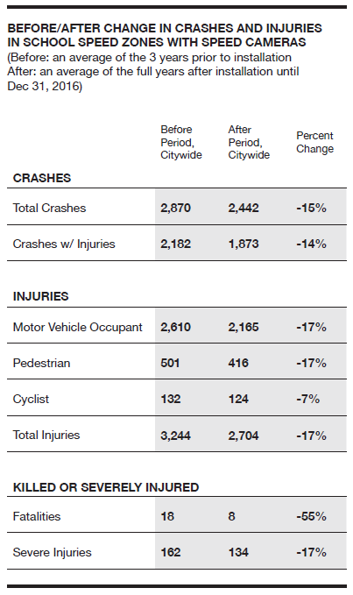
Despite the high efficacy and public support of the speed camera program, the New York State Legislature has not renewed New York City’s authority to operate these speed cameras. As per state law, the program that authorized 120 of the 140 cameras sunsetted on July 25, 2018. The program that authorized the remaining 20 cameras is set to sunset on August 30, 2018. Although the cameras are still fully operational and can capture images of vehicles speeding in school zones, there are no enforcement mechanisms behind the program because of the sunset provisions. Unless the New York State Legislature acts to renew the program, students’ safety will be at-risk once the new school year begins on September 5th.
Penalties for Speed Camera and Red Light Violations
Red Light Camera Enforcement
Under New York State law, the penalty for any violation by a red light or speed camera is limited to $50, and issued to a vehicle, based on the license number of the vehicle that the camera captures, regardless of the number of prior violations or how many miles per hour (“MPH”) above the speed limit that vehicle was traveling. For a speed camera violation, the vehicle must have been traveling at least 10 MPH above the posted school speed limit. The DMV may not use red light or speed camera violations to assess points to a driver’s license and insurers may not use such violations to set rates.
Other Then Red Light Camera Enforcement
On the other hand, when a police officer stops a driver for speeding and issues a moving traffic violation directly to the driver, there is an entirely different penalty scheme than the violations issued for red light or speed camera infractions. In those situations, when a vehicle exceeds the applicable speed limit by less than 10 MPH, the driver may be fined between $45 and $150. Such driver may also receive three driver penalty points. When a vehicle exceeds the applicable speed limit by more than 10 MPH but less than 30 MPH, the driver may be fined between $90 and $300 and is subject to 15 days of imprisonment. Such driver may also receive four to six driver penalty points. When a vehicle exceeds the applicable speed limit by more than 30 MPH, the driver may be fined between $180 and $600, and is subject to 30 days of imprisonment. Such driver may also receive eight to eleven driver penalty points. In New York State, a driver’s license is suspended after the accumulation of 11 points in 18 months.
Further, if a vehicle is traveling at a speed greater than what is considered “reasonable and prudent under the conditions”—even if within the speed limit—the driver could be stopped by a police officer, fined an amount between $45 and $150 and is subject to 15 days imprisonment. Fines increase if a driver is convicted of more than one speeding violation in 18 months. A driver’s license is revoked after three convictions in 18 months. Fines may vary for speeding in school zones or restricted highways. Fines are also doubled in work zones.
Other Traffic Control and Pedestrian Safety Measures
Speed Humps and Speed Bumps
Speed humps or speed bumps are a raised area on the street that are installed to cause vehicles to slow down as they approach. The city installed 390 speeds bumps in 2017, which is double the pace that were installed in the pre-Vision Zero years. According to the Federal Highway Administration, people often gripe about the inconvenience of having to slow down for speed bumps, humps or other raised pavements but indicate that their effectiveness at slowing traffic cannot be disputed. Due to their effectiveness, these traffic calming devices are sometimes referred to as “Silent Policemen.”
School Crossing Guards
School Crossing Guards (“SCG’s”) are part-time employees of the New York City Police Department (“NYPD”) tasked with helping children safely cross busy intersections on their way to and from school, and controlling traffic flow around schools in the morning, at lunch time and at the end of the school day. There are currently 2,638 SCG’s budgeted positions in the NYPD but there are only 2,517. As part of Vision Zero, the city was supposed to hire an additional 100 full-time School Crossing Guard supervisors and 200 additional part-time School Crossing Guards over the course of four fiscal years. However, according to some reports the NYPD was having difficulty filling these positions and in some precincts almost half of the budgeted positions were vacant.
Radar Speed Display Signs
A radar speed display sign is a device that measures the speed of an oncoming vehicle using a radar and then displays the speed to the driver of the oncoming vehicle in LED lights. These devices are often coupled with a speed limit sign to draw a speeding driver’s attention to the fact that they are breaking the speed limit. These devices can be stationary or mobile. Many of these devices are also solar powered. Some examples of radar speed display signs include:
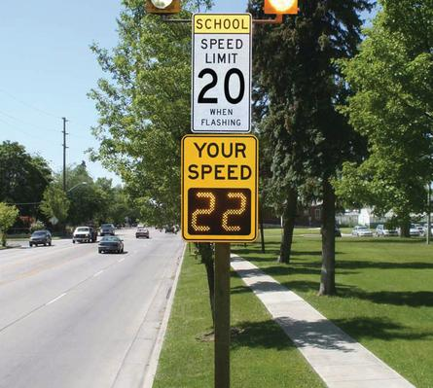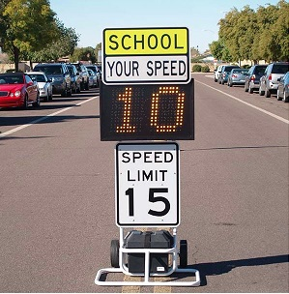
Stationary radar speed display sign Mobile radar speed display sign

Radar speed display signs have been proven effective at lowering drivers’ speed in school zones. One study showed a speed reduction between 1.5 and 5 mph in school zones in Santa Barbara, California, as well as a reduction in the percent of driver’s speeding in a school zone in South Korea, from 26.5% prior to installation, to 9.9% two weeks after installation, to 5.5% 12 months after installation. According to a 2012 report published by Morgan State University, radar speed display signs are effective for a short distance and are best utilized at critical points, such as an area where the probability of crashes is high or safety is very important (such as a school zone). When a radar speed display sign is combined with another speed control device, its effectiveness increases.
Street Design
Traditionally, streets have always been designed with the primary goal of creating efficiency for vehicles. There are a variety of street design elements that New York City incorporates into the arrangement of our streets that safeguard pedestrians and cyclists.
ADA Accessibility
Utilizing sidewalks that are ADA accessible provides safer streets for pedestrians with disabilities. Some examples include:
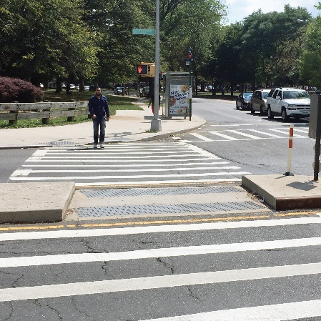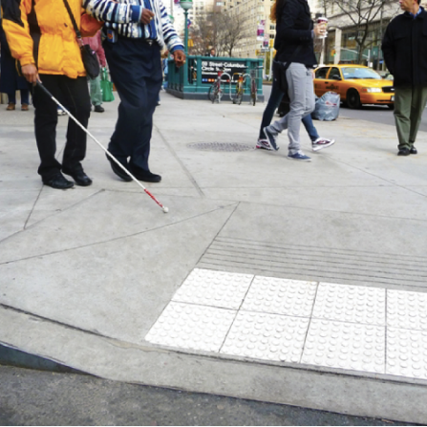
ADA accessible crosswalk on Claremont ADA accessible crosswalk in Columbus
Parkway & Crotona Avenue, Bronx Circle, Manhattan

Public Amenities
Public amenities such as wayfinding, benches, bus stops and shelters, make the streets more pedestrian-friendly and help promote public transportation over single-occupancy vehicles. Greenery and bioswales help manage flooding by absorbing rainwater that the City’s sewer system cannot handle. Some examples of public amenities include:
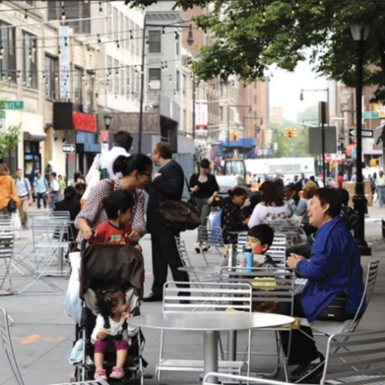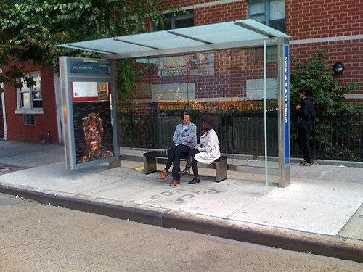
Willoughby Pedestrian Plaza, Brooklyn Bus shelter at Avenue A & 11th Street, Manhattan

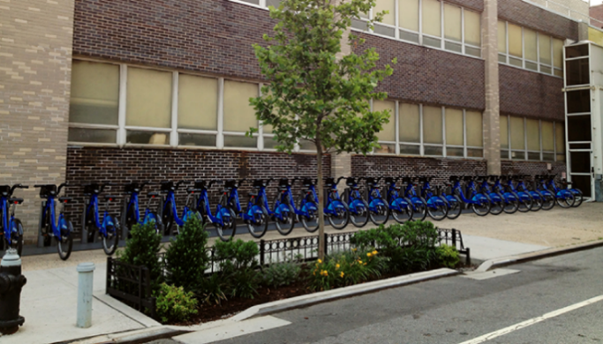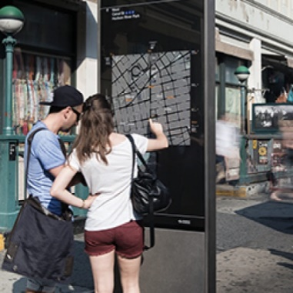
Bioswale on Dean Street, Brooklyn Wayfinding on Canal Street, Manhattan

Protected Bicycle Lanes
Protected bicycle lanes are paths for cyclists that are separated from the roadway by an open space or physical barrier. Some physical barriers include a line of parked cars or a line of poles. Examples include:
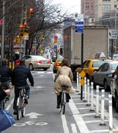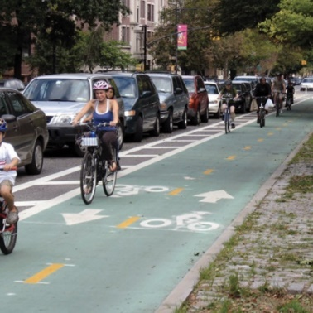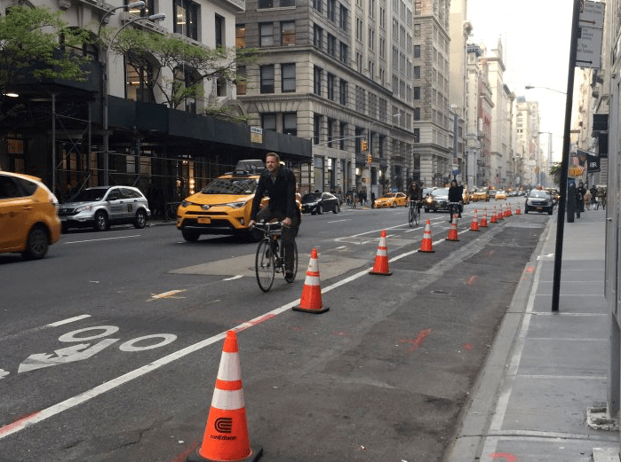
Pole barriers in Chelsea, Parked cars as barrier on Prospect Unprotected bicycle lane on Fifth Avenue,
Manhattan Park West, Brooklyn Manhattan

Dedicated Mass Transit Facilities
Dedicated mass transit facilities prioritize mass transit and encourage the public to use public transit over single-occupancy vehicles. Dedicated bus lanes are lanes in which only buses are permitted to drive during certain specified hours of the day. This helps buses move more efficiently through traffic. Bus bulbs are widened sidewalks to meet an offset bus lane. Bus bulbs allow buses to travel straight into and out of the bus stop without pulling over. These stops also have a high curb wherever possible making it easier and faster for all passengers to get on and off the bus. Example of a bus bulb:
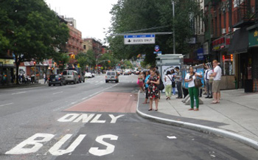
Bus bulb in New York City

Dedicated Unloading Zones
Dedicated unloading zones reduce double-parking. Double-parking reduces visibility and stalls traffic.

Narrow Vehicle Lanes
Narrowing the width of each traffic lane to 10 feet causes vehicles to slow down. Here is an example of narrowed vehicle lanes on Columbus Avenue in Manhattan:
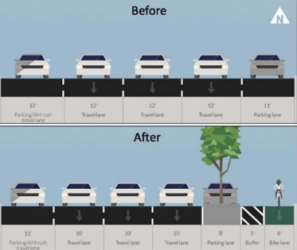
Pedestrian Safety Islands
A pedestrian safety island is a raised area located at a crosswalk that serves as pedestrian refuge separating traffic lanes or directions. These devices allow pedestrians to safely wait for the light to change before proceeding to cross the street. Here are some examples of pedestrian safety islands:
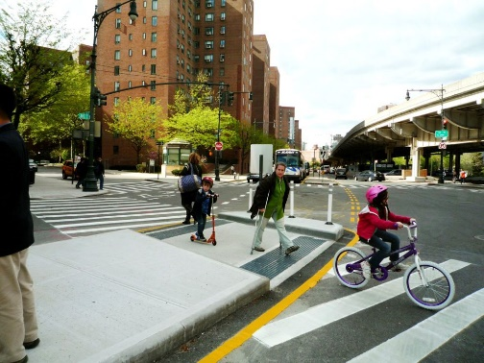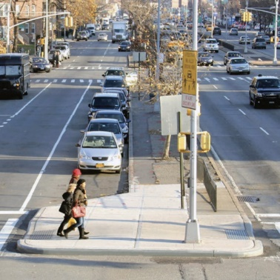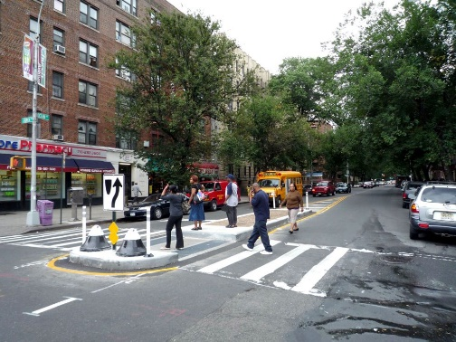
Avenue C and 18th Street, Manhattan Queens Boulevard, Queens Ocean Avenue and Church Street, Brooklyn

Signal-Protected Pedestrian Crossing
A signal-protected pedestrian crossing gives pedestrians the ability to cross the street when no vehicles have the right of way. This allows pedestrians to safely cross, as well as reduce vehicles attempting fast turns before pedestrians enter the cross walk. Some examples include:
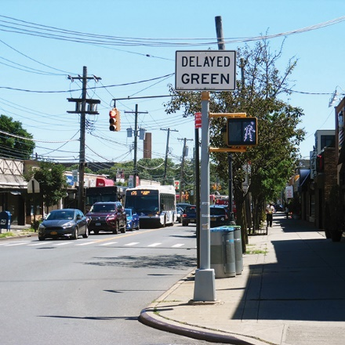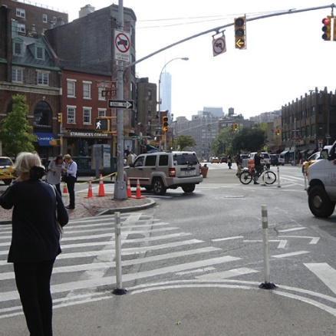
New Dorp Lane and Clawson Street, Staten Island West 4th Street and 7th Avenue, Manhattan

Signal Retiming
Signal retiming is the coordination of traffic signals to ensure that vehicles are not driving above the speed limit, as well as aid in reducing traffic congestion.
Wide Sidewalk
Wide sidewalks are sidewalks that are at least eight feet wide. Wide sidewalks promote walking and reduce speeding by narrowing traffic lanes. Some examples of wide sidewalks include:
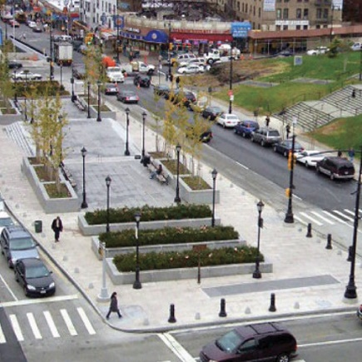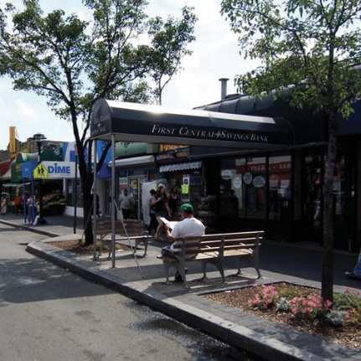
Lou Gehrig Plaza, Bronx 46th Street, Queens

Medical Conditions that Affect a Driver’s Ability to Operate a Motor Vehicle
The New York Department of Motor Vehicles requires all drivers applying for a license or renewing a license to disclose any medical conditions that “causes unconsciousness or unawareness such as convulsive disorder, epilepsy, fainting or dizzy spells, or heart ailment.” Any applicant for a driver’s licenses that has such medical condition is required to have their treating physician, physician assistant, or nurse practitioner submit a form detailing their medical opinion on whether the applicant is suited to be driving. This disclosure requirement only applies to the driver. A physician does not have a duty to disclose such information to the Department of Motor Vehicles.
On March 5, 2018, a driver suffered a seizure and ran a red light in Park Slope and killed a one-year-old boy and a four-year-old girl, as well as injuring several adults. The driver had a history of seizures and had been advised by her doctor to stop driving due to her failing health. On October 31, 2015, an epileptic driver suffered a seizure while driving on Morris Park Avenue in the Bronx. The car jumped onto the curb and crashed into trick-or-treaters, killing a ten-year-old girl, and two adults, as well as seriously injuring other pedestrians. The driver had been diagnosed with epilepsy over 20 years ago and had not been taking his prescribed medication for the past few days leading up the crash. On March 20, 2015, a cab driver suffered a seizure while driving on a Grand Concourse service road. The driver killed a man and a five-year-old girl as well as injured two others. The driver was aware that he suffered from epilepsy but failed to disclose this to the Taxi & Limousine Commission. The driver had not been taking the anti-seizure medication they had been prescribed.
ANALYSIS
The proposed introductions and resolution are aimed at addressing the safety of pedestrians in New York City. While this past year has been the safest year on record for pedestrians with the lowest rate of fatalities and serious injuries, there were still 101 pedestrian fatalities in 2017 in New York City. Additionally, the New York State Legislature failed to renew New York City’s authority to implement speed cameras in school speed zones. Since the State Legislature has yet to reauthorize New York City to utilize these highly-effective speed cameras, the Council wants to explore all options to make our streets safer for all.
ANALYSIS OF INT. NO. 322

Section one of Int. No. 322 would add new section 19-182.2 to subchapter 1 of chapter 1 of title 19 of the Code. This new section requires the Commissioner of the Department of Transportation to develop a checklist of street design elements to be used for the design of arterial streets. Arterial streets are streets that have a high capacity. The checklist will include ADA accessibility, public amenities, protected bicycle lanes, dedicated mass transit facilities, dedicated unloading zones, narrow vehicle lanes, pedestrian safety islands, signal-protected pedestrian crossings, signal retiming, wide sidewalks, and any other appropriate street design elements. Beginning June 30, 2018, the Department of Transportation must post on its website a checklist along with a list of all arterial street design projects subject to this checklist review. The Department of Transportation will also post on its website street design elements being implemented at each arterial street design project, and street design elements that are not being implemented, and an explanation as to why a street design element was not implemented. The Department of Transportation must keep these posts up to date during the project but may remove the post once the arterial street design project is complete.
Section two would provide that the local law takes effect immediately.

ANALYSIS OF INT. NO. 971

Section one of Int. No. 971 would add a new section 19-199.1 to subchapter 3 of chapter 1 of title 19 of the Code. After a motor vehicle has been documented for traffic violations by red light cameras or speed cameras at least five times within a 12-month period, the owner will be required to complete a traffic safety program and pay the fees for such program. The program will be developed by the Department of Transportation. If the owner fails to complete a traffic safety program, the vehicle will be subject to impoundment and will be released when the owner completes the traffic safety program and pays the program and impoundment fees. Fees may be paid in installments. Within one year of the effective date of this law, the Department of Transportation must create rules and regulations to designate which vehicles are covered by this law, based on the findings of the Department of Transportation’s dangerous driving study, conducted pursuant to 19-199.2.
Section two would provide that this local law takes effect 180 days after it becomes law.

ANALYSIS OF INT. NO. 972

Section one of Int. No. 972 would add a new section 19-199.2 to subchapter 3 of chapter 1 of title 19 of the Code. This would require the Department of Transportation, the New York Police Department, and any other agency deemed appropriate by the mayor, to conduct a study of dangerous driving, specifically what behaviors contribute to dangerous driving. The Department of Transportation will analyze hit-and-run police reports, convictions for traffic-related violations or crimes, crash reports attributing dangerous conduct to the driver, driving activity of vehicles registered to people with suspended or revoked licenses, and, to the extent feasible, motor vehicle insurance information. After one year, the Office of Operations would submit this report, as well as its recommendations for reducing dangerous driving, to the Council and post the report on its website. Each year after, the Office of Operations would issue a report on what actions were taken by any agency and whether dangerous driving increased or decreased.
Section two of the bill would require that the local law takes effect immediately.
ANALYSIS OF INT. NO. 1061
Section one of Int. No. 1061 would add a new section 19-177.1 to subchapter 3 of chapter 1 of title 19 of the Code. This section requires that the Department of Transportation install at least one radar speed display sign adjacent to every school with at least 250 students, grades pre-k to 12. The Department of Transportation must install the radar speed display boards as soon as possible but by no later than October 31, 2018.
Section two of the bill would provide that the local law takes effect immediately.
ANALYSIS OF RES. NO. 268
Res. No. 268 calls on the New York State Legislature to pass, and the Governor to sign, S.6046/A.7798, introduced by Assembly Member Deborah Glick and State Senator Jose Peralta. The law would immediately authorize New York City to continue the use of speed cameras in school speed zones and increase the number of speed cameras to 290.
The resolution also calls on the New York State Legislature to pass and the Governor to sign additional legislation that would increase the penalties and consequences for multiple violations issued by red light cameras and speed cameras.
Lastly, the resolution calls on the New York State Legislature to pass and the Governor to sign additional legislation that would require physicians to report medical conditions or incidents that indicate a driver is at high risk of suddenly losing consciousness or control of a vehicle.

Int. No. 322

By Council Member Rodriguez, Constantinides and The Speaker (Council Member Johnson)

A Local Law to amend the administrative code of the city of New York, in relation to a street design checklist

Be it enacted by the Council as follows:

Section 1. Subchapter 1 of chapter 1 of title 19 of the administrative code of the city of New York is amended by adding a new section 19-182.2 to read as follows:
§ 19-182.2 Street design checklist. a. As used in this section, the following terms have the following meanings:
ADA. The term “ADA” the Americans with Disabilities Act, title 42 of the United States code section 12101 et seq., and any regulations promulgated thereunder, as such act and regulations may be amended.
ADA accessibility. The term “ADA accessibility” means compliance with the Americans with Disabilities Act pursuant to part 36 of title 28 of the code of federal regulations and any subsequent provisions.
Arterial street design. The term “arterial street design” means street design for high-capacity streets under the jurisdiction of the department serving as the principal network of through-traffic flow.
Class 1 protected bicycle lane. The term “class 1 protected bicycle lane” means a path intended for the use of bicycles that is physically separated from motorized vehicle traffic by an open space or barrier and either within the roadway or within an independent right-of-way.
Narrow vehicle lane. The term “narrow vehicle lane” means a vehicular lane that is no more than 10 feet wide.
Pedestrian safety island. The term “pedestrian safety island” means a raised area located at a crosswalk that serves as pedestrian refuge separating traffic lanes or directions.
Signal-protected pedestrian crossing. The term “signal-protected pedestrian crossing” means any pedestrian crossing that allows pedestrians an exclusive interval in which to cross.
Signal retiming. The term “signal retiming” means the retiming of a traffic signal for a 25 mile per hour speed limit.
Wide sidewalk. The term “wide sidewalk” means a sidewalk that is at least eight feet wide.
b. Notwithstanding any inconsistent provision of law or rule, the commissioner shall develop a checklist of street design elements that enhance safety that the department shall consider for all arterial street design projects. Such checklist shall include but need not be limited to the following elements: (i) ADA accessibility; (ii) amenities, such as benches, bioswales, bus stop shelters, greenery and wayfinding; (iii) class 1 protected bicycle lanes; (iv) dedicated mass transit facilities, such as bus lanes; (v) dedicated unloading zones; (vi) narrow vehicle lanes; (vii) pedestrian safety islands (viii) signal-protected pedestrian crossings; (ix) signal retiming; and (x) wide sidewalks.
c. No later than June 30, 2018, the department shall post such checklist and shall post a list of arterial street design projects subject to such checklist on the department’s official website. For each arterial street design project subject to such checklist, the department shall state which street design elements have been applied, and if an element has not been applied, a specific reason for not applying such element. The department shall update such postings as necessary, and may remove a project from the list after such project has been completed.
§ 2. This local law takes effect immediately.
FM/ACK
LS #3127
1/11/2018 2:02pm

Int. No. 971

By Council Members Lander, Torres, Reynoso, Richards, Menchaca, Adams, Levin, Van Bramer, Gibson, Treyger, Rosenthal, Powers, Brannan, Ayala, Rodriguez, Rivera, Ampry-Samuel, Holden, Koslowitz, Constantinides, and Chin

A Local Law to amend the administrative code of the city of New York, in relation to dangerous driving

Be it enacted by the Council as follows:

Section 1. Subchapter 3 of chapter 1 of title 19 of the administrative code of the city of New York is amended by adding a new section 19-199.1 to read as follows:
§ 19-199.1 Dangerous Driving. a. Definitions. For the purposes of this section, the following terms have the following meanings:
Camera violation. The term “camera violation” means, on or after the date this section becomes law, the failure of an operator to comply with traffic-control indications pursuant to section 1111-a of the vehicle and traffic law and section 19-210 of the administrative code, or the failure of an operator to comply with certain posted maximum speed limits pursuant to section 1180-b of the vehicle and traffic law and section 39-21 of title 19 of the rules of the city of New York, other than any such violation that occurred in a time period during which the vehicle was reported to the police department as having been stolen.
Covered vehicle. The term “covered vehicle” means any motor vehicle, other than a rental vehicle as defined in section 137-a of the vehicle and traffic law, that has been documented by a photo violation monitoring device for a camera violation at least five times within a 12-month period or any motor vehicle determined by the department to be a covered vehicle pursuant to subdivision h.
Traffic safety program. The term “traffic safety program” means a traffic safety program approved by the department.
b. The department shall notify, by certified mail, the owner of a motor vehicle after the vehicle's fourth documentation for a camera violation in a 12-month period that such owner shall be required to complete a traffic safety program after the fifth camera violation or such vehicle will be subject to impoundment and informing such owner of the opportunity to complete such traffic safety program voluntarily prior to the fifth camera violation.
c. The department shall notify, by certified mail, the owner of any covered vehicle that such owner is required to complete a traffic safety program and that such covered vehicle shall be subject to impoundment if the owner does not register for such traffic safety program within 10 days or complete such traffic safety program within 30 days following receipt of such notice.
d. Any individual who completes a traffic safety program pursuant to this section shall be required to pay the fees for such traffic safety program. The department shall provide the option to pay such fees in installments.
e. Following completion of a traffic safety program and payment of fees for such traffic safety program, any camera violation that occurred prior to the completion of such traffic safety program shall not be taken into account for purposes of this section.
f. Any covered vehicle owned by a person who fails to complete a traffic safety program in accordance with subdivision c of this section shall be subject to impoundment by the department.
g. Any covered vehicle impounded pursuant to this section shall not be released until the owner of the covered vehicle completes a traffic safety program and pays the fees for the traffic safety program and all applicable towing and storage fees.
h. One year following the effective date of this section, the department shall promulgate rules and regulations designating vehicles as covered vehicles for the purposes of this section based on the indicators of dangerous driving identified by the study conducted pursuant to section 19-199.2.
§ 2. This local law takes effect 180 days after it becomes law.
NB
LS #6159
6/1/2018

Int. No. 972

By Council Members Lander, Torres, Reynoso, Richards, Menchaca, Adams, Levin, Van Bramer, Gibson, Treyger, Rosenthal, Powers, Brannan, Ayala, Rodriguez, Rivera, Ampry-Samuel, Koslowitz, Constantinides, Gjonaj, and Chin

A Local Law to amend the administrative code of the city of New York, in relation to requiring a study of dangerous driving

Be it enacted by the Council as follows:

Section 1. Subchapter 3 of chapter 1 of title 19 of the administrative code of the city of New York is amended by adding a new section 19-199.2 to read as follows:
§ 19-199.2 Study of dangerous driving. The office of operations, in collaboration with the department, the police department and any other appropriate agencies identified by the mayor, shall conduct a study of driving behavior to identify specific behaviors indicating a pattern of dangerous driving associated with traffic crashes, injuries and fatalities. As part of such study the department shall analyze data including, but not limited to: hit-and-run police reports; convictions for traffic-related violations or crimes, including convictions pursuant to section 1212 of the vehicle and traffic law and section 19-190; MV104AN crash reports attributing dangerous conduct to the driver; driving activity of vehicles registered to people with suspended or revoked licenses; and, to the extent feasible, motor vehicle insurance information. Within one year of the effective date of this section, the office of operations shall submit to the council and post on its official website a report on the indicators of dangerous driving identified by such study and the office of operations’ recommendations for reducing dangerous driving. Each year thereafter, the office of operations shall submit to the council and post on its official website a report on any interventions undertaken by any agency with respect to dangerous driving and any increases or decreases in patterns of dangerous driving in the prior year.
§ 2. This local law takes effect immediately.

NB
LS #7115
5/30/2018

Int. No. 1061

By Council Members Gjonaj, Holden, Menchaca, Cohen, Yeger, Ulrich, Brannan, Chin, Richards, Lancman and Rose

A Local Law to amend the administrative code of the city of New York, in relation to installing radar speed display signs in school zones

Be it enacted by the Council as follows:

Section 1. Subchapter 3 of chapter 1 of title 19 of the administrative code of the city of New York is amended by adding a new section 19-177.1 to read as follows:
§19-177.1 Installation of radar speed display signs. a. Definitions. For the purposes of this section, the following terms have the following meaning:
Radar speed display sign. The term “radar speed display sign” means a traffic control device that uses a radar to determine an oncoming vehicle’s speed and then displays the speed as the vehicle approaches.
School. The term “school” means any buildings, grounds, facilities, property, or portion thereof in which educational instruction is provided to at least 250 students at or below the twelfth grade level.
b. Installation of radar speed display signs around schools. As soon as practicable and by no later than October 31, 2018, the commissioner shall install radar speed display signs so that there is at least one radar speed display sign adjacent to every school in the city.
§2. This local law takes effect immediately.

AM/MN
LS #7644
07/27/18

Res. No. 268

Resolution calling upon the New York State Legislature to pass, and the Governor to sign, (1) S.6046/A.7798, which would authorize the expanded use of speed cameras in New York City, (2) legislation that would provide for the escalation of penalties and consequences for multiple violations issued by red light and speed cameras and (3) legislation that would require physicians to report medical conditions or incidents that indicate a driver is at high risk of suddenly losing consciousness or vehicle control

By Council Member Ampry-Samuel, Brannan, Constantinides and Chin

Whereas, According to the Vision Zero Year Four Report, in 2017, 214 people, including 101 pedestrians, were killed in traffic crashes in New York City; and
Whereas, Many of these crashes could be prevented by stronger state laws; and
Whereas, As one recent tragic example, on March 5, 2018, four-year-old Abigail Blumenstein and one-year-old Joshua Lew were killed in a crash in Park Slope, Brooklyn, by a driver who ran a red light, who claimed to have suffered a seizure at the time of the crash and whose car already had been issued four violations by red light cameras and four violations by speed cameras, with no serious consequences; and
Whereas, In order to ensure the safety of all pedestrians and road users, it is necessary that the New York State Legislature make a number of changes to New York State law, some of which have already been proposed in pending bills and others of which must still be introduced; and
Whereas, To begin with the first proposal, under New York State’s Vehicle and Traffic Law (VTL), speed cameras may only be installed in school zones and may only be used during, and one hour before and after, the school day and during, or 30 minutes before and after, student activities at the school; and
Whereas, The VTL currently authorizes the use of speed cameras in only 140 out of more than 2,300 school zones in New York City and limits the definition of school zones to only those streets abutting a school building, exit or entrance; and
Whereas, At the locations and times they are authorized to be used, speed cameras have been shown to reduce speeding in school zones by 63%; and
Whereas, A.7798, introduced by Assembly Member Deborah Glick and pending in the New York State Assembly, and companion bill S.6046, introduced by State Senator Jose Peralta and pending in the New York State Senate, seek to amend the VTL by authorizing the installation of speed cameras in an additional 150 school zones and by more broadly defining school zones to include streets within a quarter mile of schools; and
Whereas, The passage of A.7798 and companion bill S.6046 would therefore take one important step toward improving safety throughout the city; and
Whereas, A second major obstacle to eliminating traffic fatalities on New York City streets is the lenient penalty scheme for violations issued by a red light or speed camera mandated by New York State law; and
Whereas, Under the VTL, the penalty for any violation issued to a vehicle by a red light or speed camera is limited to $50, regardless of the number of prior violations, the DMV may not use such violations to assess points to a driver’s license and insurers may not use such violations to set rates; and
Whereas, This penalty structure is insufficient, because it is too low to serve as an effective deterrent and may not be used to identify and deter dangerous drivers; and
Whereas, Therefore, the State should provide for the escalation of penalties and consequences for multiple violations issued by red light or speed cameras such that for the third violation it would impose a penalty of $150, for the fourth violation a penalty of $250, for the fifth violation a penalty of $300 and information sent to the car’s insurer and for the sixth violation a penalty of $350 and suspension of the car’s registration; and
Whereas, A third serious problem is that drivers can lose control of their vehicles due to medical conditions, leading to serious injury or death; and
Whereas, In addition to the Park Slope crash, in recent years such incidents include, on March 20, 2015, two pedestrians killed in Grand Concourse by a taxi driver who had stopped taking his epilepsy medication, on October 31, 2015, three pedestrians killed in Morris Park by a driver who was epileptic and not taking his prescribed medication and on January 9, 2017, a pedestrian killed in East Flatbush by a driver whose leg allegedly stiffened and became locked on the gas pedal due to a medical condition; and
Whereas, Identifying drivers who have medical conditions with a high risk of interfering with their ability to drive safely would help protect city residents; now, therefore, be it
Resolved, That the Council of the City of New York calls upon the New York State Legislature to pass, and the Governor to sign, (1) S.6046/A.7798, which would authorize the expanded use of speed cameras in New York City, (2) legislation that would provide for the escalation of penalties and consequences for multiple violations issued by red light and speed cameras and (3) legislation that would require physicians to report medical conditions or incidents that indicate a driver is at high risk of suddenly losing consciousness or vehicle control.

LS #6166, 6167, 6168
3/28/18
NB

L.2013, c. 189, § 10.
Automated Speed Enforcement Program Report: 2014-2017, at 7. Department of Transportation, www.nyc.gov/html/dot/downloads/pdf/speed-camera-report-june2018.pdf.
L.2014, c. 43, § 11.
Automated Speed Enforcement Program Report: 2014-2017, at 12. Department of Transportation, www.nyc.gov/html/dot/downloads/pdf/speed-camera-report-june2018.pdf.
Id. at 11.
Id. at 11.
Wang, Vivian. “A Screeching Stop for Speed Cameras in New York City School Zones.” The New York Times, 25 July 2018, www.nytimes.com/2018/07/25/nyregion/speed-cameras-nyc-schools.html.
N.Y. Veh. & Traf. Law § 1111-a(e); N.Y. Veh. & Traf. Law § 1180-b(e).
N.Y. Veh. & Traf. Law § 1180-b(b).
N.Y. Veh. & Traf. Law § 1111-a(f); N.Y. Veh. & Traf. Law § 1180-b(f).
https://dmv.ny.gov/brochure/traffic-violations-bureau
“Speeding and Speed Limits.” Governor’s Traffic Safety Committee. http://www.safeny.ny.gov/spee-ndx.htm#strategy.
“Automated Speed Enforcement Program Report: 2014-2017, at 4. Department of Transportation, www.nyc.gov/html/dot/downloads/pdf/speed-camera-report-june2018.pdf.
FHWA Course on Bicycle and Pedestrian Transportation. Lesson 11, Traffic Calming, p.5. Federal Highway Administration. https://safety.fhwa.dot.gov/ped_bike/univcourse/pdf/swless11.pdf
Id.
See NYPD – School Crossing Guards, available at http://www.nyc.gov/html/nypd/html/careers/school_crossing_guard.shtml (last accessed 8/10/2018).
Testimony of Vincent Grippo, Deputy Commissioner of Management and Budget, N.Y.P.D., during the FY ‘19 Executive Budget Hearing of the Committee on Finance Jointly with the Committee on Public Safety, Committee on Justice System and the Committee on Housing & Buildings, May 14, 2018.
School Crossing Guards in Short Supply, by Michael Garofalo. http://www.ourtownny.com/local-news/20180327/school-crossing-guards-in-short-supply
Veneziano, David, et al. Effective Deployment of Radar Speed Signs. 2010, pp. 4–5, Effective Deployment of Radar Speed Signs. https://safety.fhwa.dot.gov/speedmgt/ref_mats/fhwasa1304/resources2/37%20-%20Effective%20Deployment%20of%20Radar%20Speed%20Signs.pdf.
Jeihani, Mansoureh, et al. Evaluating the Effectiveness of Dynamic Speed Display Signs. Morgan State University, 2012, https://safety.fhwa.dot.gov/speedmgt/ref_mats/fhwasa1304/resources2/28%20-%20Evaluating%20the%20Effectiveness%20of%20Dynamic%20Speed%20Display%20Signs.pdf.
“Driver License Restrictions for Medical Conditions.” New York Department of Motor Vehicles, 30 May 2018, dmv.ny.gov/driver-license/license-restrictions-medical-conditions.
Physicians Statement for Medical Review Unit Form. New York Department of Motor Vehicles. https://dmv.ny.gov/forms/mv80u1.pdf.
Poggio, Marco, et al. “Woman Faces 10 Charges in Park Slope Crash That Killed Two Kids, Was Told by Doctors to Stop Driving.” New York Daily News, 4 May 2018, www.nydailynews.com/new-york/nyc-crime/driver-killed-2-kids-park-slope-indicted-manslaughter-article-1.3969318.
Kochman, Ben. “Driver in Deadly 2015 Trick-or-Treater Crash Will Face Manslaughter Charges over Neglected Epilepsy Med.” New York Daily News, 19 Oct. 2016, www.nydailynews.com/new-york/nyc-crime/driver-deadly-trick-or-treater-crash-face-manslaughter-rap-article-1.2836868.
Whitford, Emma. “Epileptic Cab Driver Charged With Manslaughter Months After Killing Two People At Bus Stop.” Gothamist, 19 Oct. 2015, gothamist.com/2015/10/19/cab_bronx_manslaughter.php.
Vision Zero: Year Four Report. March 2018, at 5
Id. at 14.
Wang, Vivian. “A Screeching Stop for Speed Cameras in New York City School Zones.” New York Times. July 25, 2018. https://www.nytimes.com/2018/07/25/nyregion/speed-cameras-nyc-schools.html.

