THE COUNCIL OF THE CITY OF NEW YORK
RESOLUTION NO. 1055

Resolution approving the decision of the City Planning Commission on Application No.
N 240279 ZRX, for an amendment of the text of the Zoning Resolution (L.U. No. 350).

By Council Members Salamanca and Riley

WHEREAS, Riverdale Garage Corp., filed an application pursuant to Section 201 of the New York City Charter, for an amendment of the text of the Zoning Resolution of the City of New York, modifying APPENDIX F for the purpose of establishing a Mandatory Inclusionary Housing area, which in conjunction with the related action would facilitate the development of a residential building with a Mandatory Inclusionary Housing (MIH) requirement, located at 5602-5604 Broadway (Block 3267, Lots 90 and 91), in the Kingsbridge neighborhood of the Bronx, Community District 8 (ULURP No. N 240279 ZRX), (the “Application”);

WHEREAS, the City Planning Commission filed with the Council on August 8, 2025, its decision dated July 16, 2025 (the "Decision") on the Application;

WHEREAS, the Application is related to application C 240278 ZMX (L.U. No. 349), a zoning map amendment to change an M1-1 zoning district to R7-3/C2-3;

WHEREAS, the Decision is subject to review and action by the Council pursuant to Section 197-d of the City Charter;

WHEREAS, upon due notice, the Council held a public hearing on the Decision and Application on August 20, 2025;

WHEREAS, the Council has considered the land use implications and other policy issues relating to the Decision and Application; and

WHEREAS, the Council has considered the relevant environmental issues, including the Negative Declaration issued on April 23, 2025 (CEQR No. 24DCP106X), which includes an (E) designation to avoid the potential for significant adverse impacts related to hazardous materials, air quality, and noise (E-843) (the “Negative Declaration”).

RESOLVED:

The Council finds that the action described herein will have no significant impact on the environment as set forth in the (E) Designation (E-843) and Negative Declaration.

Pursuant to Sections 197-d and 201 of the City Charter and on the basis of the Decision and Application, and based on the environmental determination and consideration described in the report, N 240279 ZRX, incorporated by reference herein, and the record before the Council, the Council approves the Decision of the City Planning Commission.

Matter underlined is new, to be added;
Matter struck out is to be deleted;
Matter within # # is defined in Section 12-10;
* * * indicates where unchanged text appears in the Zoning Resolution

* * *

APPENDIX F
Inclusionary Housing Designated Areas and Mandatory Inclusionary Housing Areas

* * *

THE BRONX

* * *

Bronx Community District 8

* * *

Map 1 [date of adoption]

[PROPOSED MAP]
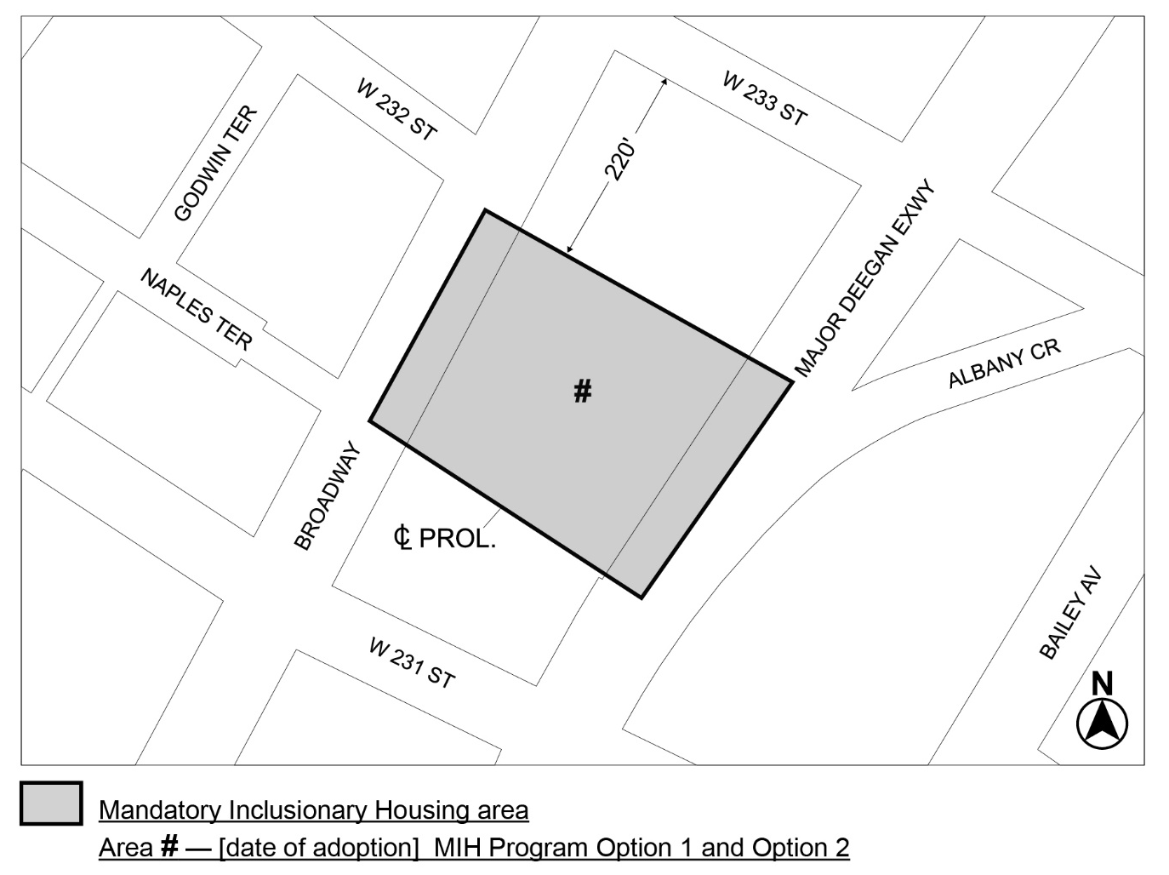

Portion of Community District 8, The Bronx

* * *
Adopted.

Office of the City Clerk,}
The City of New York,} ss.:

I hereby certify that the foregoing is a true copy of a Resolution passed by The Council of The City of New York on _________, 2025, on file in this office.

.....................................................
City Clerk, Clerk of The Council

