Committee on Immigration
Harbani Ahuja, Legislative Counsel
Elizabeth Kronk, Senior Policy Analyst
Florentine Kabore, Financial Analyst

Committee on Aging
Nuzhat Chowdhury, Legislative Counsel
Kalima Johnson, Senior Policy Analyst
Daniel Kroop, Senior Financial Analyst



THE COUNCIL OF THE CITY OF NEW YORK

BRIEFING PAPER OF THE JUSTICE AND HUMAN SERVICES DIVISIONS
Jeffrey Baker, Legislative Director
Brian Crow, Deputy Director for the Justice Division
Andrea Vazquez, Deputy Director for the Human Services Division

COMMITTEE ON IMMIGRATION

Hon. Carlos Menchaca, Chair

COMMITTEE ON AGING

Hon. Margaret Chin, Chair

February 10, 2021

OVERSIGHT: OLDER ADULT IMMIGRANT POPULATION

- INTRODUCTION
On February 10, 2021, the Committee on Immigration, chaired by Council Member Carlos Menchaca and the Committee on Aging, chaired by Council Member Margaret Chin, will conduct a joint oversight hearing on New York City’s older adult immigrant population, their unique needs, and the programs that serve them. The Committees expect to receive testimony from the Mayor’s Office of Immigrant Affairs (‘MOIA’) and the Department for the Aging (‘DFTA’), along with social service providers, advocates of older adult programs, and other interested parties.
- BACKGROUND
Older Adult Immigrants in New York City
Of the 3.1 million immigrants who call New York City home, 19.3 percent are age 65 or older, making older adults a larger proportion of the foreign-born population than the U.S.-born population. Twenty-seven percent of older immigrant New Yorkers are naturalized citizens, while 13.4 percent are green card holders or other statuses, and 1.9 percent are undocumented. As a group, naturalized citizens are more likely to have lived in the U.S. 20 years or more than those immigrants that have not sought naturalization.
According to the Center for Urban Future, the older adult population, or individuals aged 65 and older, is the fastest growing segment of the New York State population. Over the last ten years, the older adult population has grown by 26 percent to 3.2 million, while the number of older immigrants statewide has grown at nearly double the rate of U.S.-born older adults. At the same time, the number of older adult immigrants living in poverty within the City rose by 11 percent, even as the overall poverty rate for this age group fell by 2 percent between 2007 and 2017. This indicates that the older immigrant population has particularly faced increasing levels of poverty.
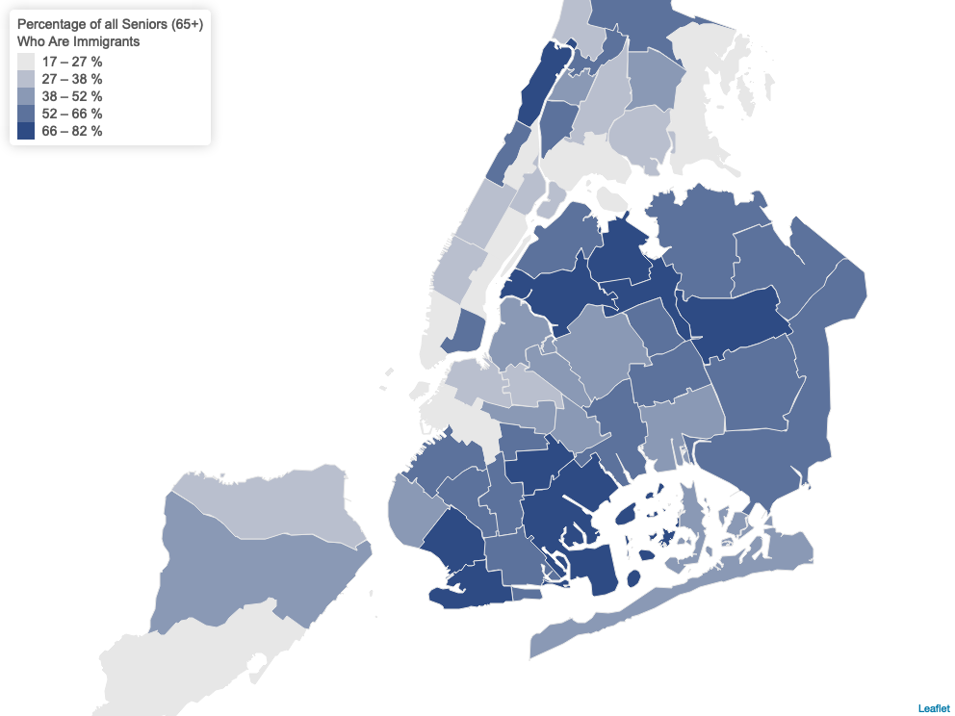
The older immigrant population has grown 42 percent over the past decade. In 2019, the Center for Urban Future reported that it expected that immigrants would make up the majority of the senior population in New York City by 2020. While all boroughs have seen growth in their older immigrant adult populations in the last 10 years, Brooklyn has the highest proportion (58 percent) of older adult immigrants. The Bronx, on the other hand, is experiencing the second-fastest growth rate in this population in the state: 67 percent growth, compared to just 5 percent growth in the number of U.S.-born older adults. According to reports, the fastest-growing older adult populations in the city hail from the Dominican Republic, Mexico, and China.
Unique Challenges faced by Immigrant Older Adults
To older individuals, who are often unable to work due to health, mobility issues, and other age-related ailments, becoming older in New York poses several unique challenges. Although New York is continuously ranked as one of the most expensive states to live in and the cost in New York City is particularly high, older adults often lack sufficient income or family support to keep pace with the rising cost of living. As a result, New York’s increasing older adult population has also led to the growth in the number of older adults living in poverty. Among this population, older non-white adults tend to be particularly impacted by poverty. U.S.-born Latinx New Yorkers above the age of 65 and Asian American older adults, for example, have higher rates of poverty than the statewide average of 20 percent.
New York City has the second highest rate of poverty for older adults in New York State. While Brooklyn was the only New York City borough where the number of older adults living in poverty decreased in the past decade (by 2 percent), the county still represents the largest number of older adults living in poverty in New York State, with 80,595 older adults living in poverty. The number of older adults living in poverty in all other New York City boroughs has increased in the past decade, with Queens increasing by 10 percent, Staten Island by 15 percent, Manhattan by 16 percent, and the Bronx by 36 percent.
Within the older adult population, older adult immigrants are 50 percent more likely to live in poverty. According to the Center for an Urban Future, immigrant older adults in New York City have a median income of only $9,900, compared to $18,300 for native-born older adults. This population also tends to receive significantly less than their native-born counterparts from wages, Social Security, private retirement accounts, and other income sources. For example, the average immigrant in New York City who is between the ages of 55 and 64 earns less than the average native-born resident in the same age range. Many immigrants also do not meet the eligibility requirements for federal benefits such as Social Security, Supplemental Security Income (SSI), Temporary Assistance for Needy Families (TANF), Medicare, and Medicaid (except emergency Medicaid), often because they have not worked in the United States long enough or because they work or have worked “off the books.” Furthermore, lower educational attainment among immigrants in general, and particularly older adult immigrants, contributes to their higher poverty rates. Even among older adult immigrants who achieved high levels of education in their home countries, many find that their degrees and experiences are unfortunately worth little in the United States and require additional training or licensure. For older adult immigrants, these factors compound difficulties they generally face in being able to sufficiently provide for themselves and afford the cost of living in the city.
Older immigrants also face additional barriers to accessing essential services, such as their inability to communicate with service providers in their own language. Fifty-seven percent of older adult immigrants in New York City identify as Limited English Proficient (LEP), and approximately 37 percent of older adult immigrants live in households that are linguistically isolated, meaning that no one over the age of 14 can speak English very well. Seniors in such households are among the most vulnerable because they are more likely to be socially isolated and less likely to find appropriate interpretation for important information. Furthermore, for many immigrants, family is the first and most central source of support and care, and there are negative associations with government services their nations of origin or reluctance in seeking government aid. These challenges often make it difficult to reach and engage older adult immigrants.
Additional issues facing older adult immigrants include lack of affordable housing, food insecurity, access to transportation, and medical care. In 2017, the number of homeless people in the city age 65 or older doubled to over 2,000, while the rate of empty apartments paying $800 or less was just 1.1 percent. Unfortunately, there are not enough affordable housing units for all older adults in need, as housing vouchers issued to help seniors pay their rent are not accepted everywhere. Furthermore, even though one in ten older adult New Yorkers face food insecurity in New York City, and one in four are nutritionally at-risk, older adult immigrants often fail to enroll in SNAP; this is reportedly due to stigma, cultural competency, language barriers, and fears related to immigration status. While many older adult immigrants enjoy hot, fresh meals served at DFTA senior centers and through delivery programs, many of these programs and institutions fail to obtain culturally specific foods or fresh produce that older immigrants can cook at home. For those older adult immigrants who are undocumented, these challenges are often further exacerbated, as they are frequently among the poorest and also the least eligible for assistance, as undocumented individuals are not eligible for federal assistance programs such as SNAP, housing vouchers, or public housing.
COVID-19 and the Older Immigrant Population
In March 2020, the rapid spread of the SARS-CoV-2 virus, which led to the global pandemic of COVID-19, required New York City to restrict in-person gatherings. Older New Yorkers were disproportionately impacted by the virus, with 70 percent of early cases affecting this population as of April 1, 2020. The pandemic continued to put a spotlight on older adults—who are the most vulnerable to the virus—as data showed that people aged 65 to 74 were 90 times more likely to suffer from COVID-19 related deaths, and people over 65 made up eight out of ten COVID-19 deaths.
To help control the spread of the virus, the City shut down physical operation of Department for the Aging senior centers in March 2020 and switched congregate meal operations to home delivered meals. The consequences of the pandemic and the switch in service has impacted the older adult population even as the city has entered phased re-opening: older adults have been disproportionately affected by food insecurity and social isolation and the disruption of their daily lives has been exacerbated by the extended closures to in-person resources such as senior centers, libraries, settlement houses, as well as the restricted re-opening of restaurants and houses of worship.
At the height of the pandemic, communicating basic information about the virus in New York City was difficult, especially for those who have limited English proficiency and were cut off from their families due to social distancing guidance. Furthermore, the digital divide made accessing information more difficult and led to severe social isolation, as 50 percent of older New Yorkers live alone and 42 percent do not have broadband Internet access. Food insecurity was also exacerbated during the pandemic, as senior centers and food pantries closed and meal delivery to older adults became a key concern. Since March, Citymeals, which many older adults rely on for food, delivered 2.5 million meals to homebound New York older adults—an increase of 64 percent over the prior year. According to a study done by FoodBank NYC, prior to the pandemic, one in 10 older New Yorkers was food insecure, but that number has now soared to one in five.
As older adults are the population most vulnerable to the disease, ensuring their safety and health during the pandemic is paramount, as is ensuring that they have access to proper nutrition, technology to remain socially engaged, telehealth care, and critical information available in their languages.
- SERVICES FOR OLDER IMMIGRANT NEW YORKERS
In New York City, DFTA is responsible for administering federal, state, and city funding to address service needs for older residents above the age of 60. The agency oversees case management services, in home services, and home delivered meals to eligible older adults. DFTA also funds and oversees nearly 250 senior centers and dozens of affiliated sites through partnerships with community based organizations (CBOs) and provides services to protect older adults from crime and abuse. Other services supported by the agency include but are not limited to: naturally occurring retirement communities (NORCs), housing support, senior employment, support for care givers, and mental health services.
While DFTA’s mandate covers all older adults within the city, a large portion of DFTA’s clients are immigrants. To this end, DFTA has previously worked with MOIA to help address needs in this population. According to an April 2017 joint letter to older New Yorkers from MOIA and DFTA, for example, DFTA and its contractors are committed to protecting older adults’ confidential information, including their immigration status, consistent with law and DFTA's policies. Staff are also prohibited from asking older adults who are visiting a senior center or seeking services about their immigration status, except to access their eligibility for benefits. Seniors can decline to share this information; however, if they choose to share information pertaining to their immigration status to apply for certain benefits, the information may be shared with other City contractors, City agencies, and the state or federal government to complete their application.
The Senior Centers for Immigrant Populations Initiative
DFTA oversees over 250 senior centers that support older adults. The City Council’s senior services initiatives provide critical support for core DFTA operations and senior services, as well as funding for specific senior populations, including immigrants. Over the past four fiscal years, the Council’s share of DFTA’s total budget has remained at approximately eight to nine percent.
In particular, the Council’s citywide senior services initiative portfolio totals $24.8 million in Fiscal 2021, a decrease of $3.6 million when compared to $28.5 million in Fiscal 2020. Discretionary funds designated by the Speaker and Council Members add $8.3 million at DFTA in Fiscal 2021, for a total of $33.2 million in Fiscal 2021.
The Senior Centers for Immigrant Populations initiative was first funded in Fiscal 2016. The funding, initially $1 million, was to support culturally-competent and linguistically accessible senior centers that predominantly serve immigrant seniors. Funding for this initiative was increased to $1.5 million in Fiscal 2017 and has remained at that level through Fiscal 2021.
From Fiscal 2018, the initiative has been standardized, meaning it provides equal funding of $150,000 to ten senior centers that do not have a baselined DFTA contract, but serve predominantly immigrant populations. Five of these centers are in Brooklyn, four are in Queens, and one is in Manhattan. Particular ethnic senior populations served include: Chinese, Korean, Indian, Bangladeshi, Latino, and Indo-Caribbean.
The following Senior Centers for Immigrant Populations providers were selected in Fiscal 2021 to receive funding from this Council initiative:
- Brooklyn Chinese-American Association, Inc.
- Chinese American Planning Council, Inc.
- Council of Peoples Organization, Inc.
- Homecrest Community Services, Inc.
- India Home, Inc.
- Korean American Senior Citizens Society of Greater New York, Inc.
- Salvation Army, The
- South Asian Council for Social Services
- Vision Urbana, Inc.
- Young Women's Christian Association of Queens
Naturally Occurring Retirement Communities (NORCs)
NORC programs are one of the most vital City services designed to allow older residents, including immigrant seniors, to age-in-place in their homes and communities in a healthy, independent manner. These naturally occurring retirement communities are specific geographic areas that contain a large proportion of older adults through no specific planning or design. Communities can evolve into NORCs in a number of ways—through the aging in place of long-time residents, through the departure of large portions of younger residents, and through the migration of older adults into the community. Once a community has been designated a NORC, that community can receive local and state funding to provide special and relevant services to serve that unique population. DFTA funds dozens of NORCs where residents can access health and social services in their community, including case-management assistance, help with benefits and entitlements, health and wellness activities, fitness classes, educational activities, outings, and volunteer opportunities.
For immigrant seniors, NORCs can provide an important sense of community. The nature of NORCs allows immigrant older adults to age in place close to other older adults who speak the same language or share cultures or cultural similarities; this can, at a minimum, help combat the high costs of social isolation. Further, culturally competent neighborhood NORCs can also empower their immigrant senior communities by coordinating specific services that are unique to those communities. However, while NORCs can provide an important sense of community to immigrant seniors, the City’s current NORCs leave much of the immigrant senior population unaccounted for. The Center for Urban Future has reported that the majority of NORCs are located in high-density moderate-income or public housing developments, where immigrants are less likely to live. The lower-density areas of the city where older immigrants tend to reside, and which are fast growing in this specific population, do not meet current city NORC requirements. In 2016, for example, the Center for Urban Future testified that there is only one NORC in Flushing and Whitestone, despite the fact that the surrounding neighborhood has gained almost 10,000 more immigrant seniors since the year 2000. Similarly, although the North Shore of Staten Island has a growing senior population from Liberia and other African countries, there are no NORCs in that area at all. This lack of accounting may leave older immigrants at a disadvantage: although older immigrants may live in neighborhoods that are now growing in that population, without a NORC designation, those communities will not receive appropriate funds to help develop services and programs to better serve their needs. There are currently 38 DFTA funded NORCs in New York City. The following chart shows the number of immigrant seniors living in an area in the city, overlaid by NORCs in that community.
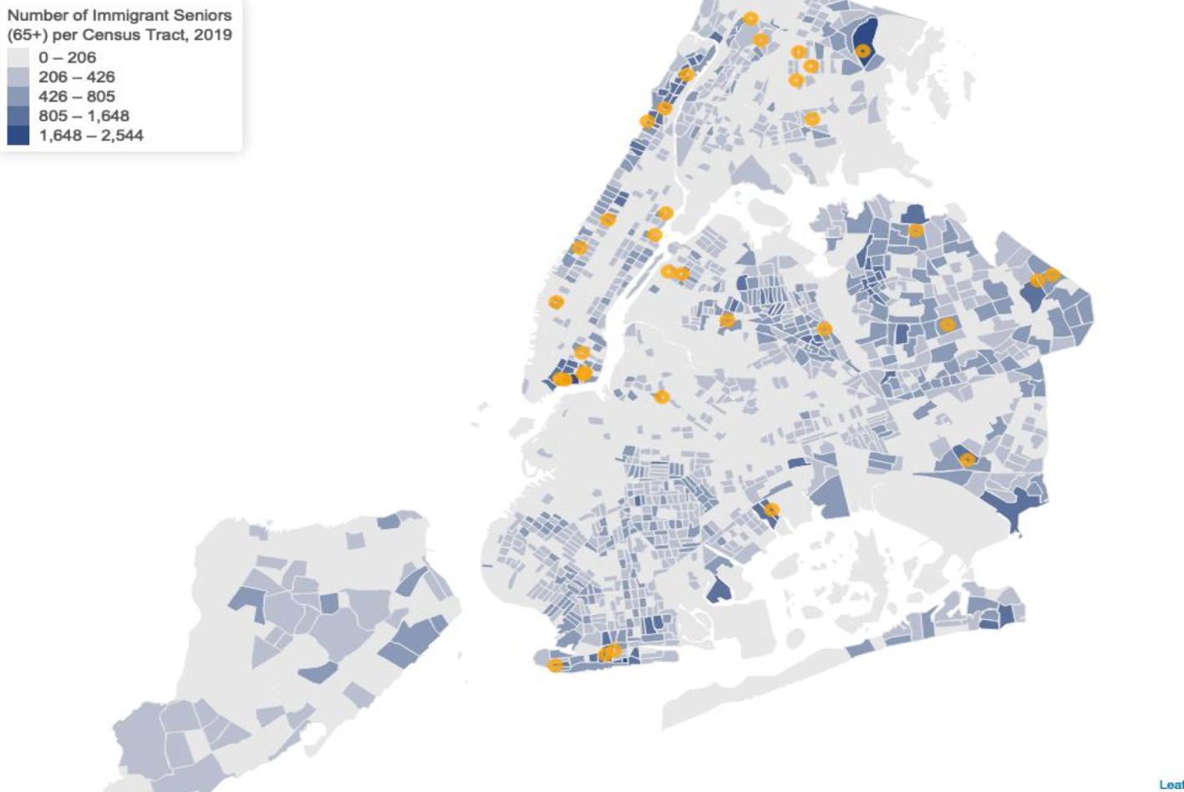

Issues, Concerns, and Recommendations
In January of 2020, the Center for Urban Future issued a paper focused on expanding and improving services for the City’s rapidly growing older adult population. Among the Center’s general recommendations included areas of improvement that would also help better serve the older immigrant population. For example, one recommendation is that the City launch a major initiative to reduce poverty among older New Yorkers and that, specifically, any such plan should include specific actions to support older immigrants. The specific and separate emphasis on addressing such needs among older immigrants is important in this case as older immigrants tend to have disproportionately higher rates of poverty than their non-immigrant counterparts.
Another recommendation from the Center is for the City to ensure that the City’s older adult services reflect the diversity of the older adult population. Part of this recommendation is demanding more cultural diversity on the part of senior center providers—such as requiring applicants of DFTA’s Request for Proposals (RFP) to demonstrate that their services are accessible to immigrant populations in their areas and giving providers more flexibility to partner with organizations that have the cultural and linguistic competencies to serve immigrant populations. Another component is for the City itself to take more initiative to pilot new programs that serve different pockets of the older adult population, such as older immigrants.
The Center also released a paper in April 2020 with recommendations on how to support older adults specifically during the COVID-19 pandemic. Once more, although the Center offers various recommendations on how to serve all older adults, there are certain recommendations aimed at addressing the needs of older immigrants in particular. For example, the paper suggests that the City expand access to technology and increase technological training in older adults, but especially among older immigrants and those with limited English proficiency. This group is in particular need of training and attention as they not only have the same digital literacy needs as non-immigrant older adults, but specific needs such as translating bills and translating health guidance as well. Related, the Center suggests that the City provide information on senior services in multiple languages through local media so as to better connect older immigrant adults, “who likely have higher rates of limited English proficiency, and may lack connections to neighborhood senior centers,” to City health and vaccination services and initiatives.
- CONCLUSION
As New York City faces the realities and needs of a quickly growing older adult population, it is important that the City to only offer resources and programs to serve seniors generally, but to invest in and create culturally competent and diverse resources, services, and programs that address the situations that immigrant seniors face.
At this hearing, the Committees intend to discuss the process of identifying and serving the unique needs of older immigrant adults in New York City with MOIA and DFTA. The Committees seek to hear more about how DFTA and MOIA are serving this population, both as separate agencies and collaboratively, including what unique services and programs are being offered to older immigrants, what they are doing to prepare for and better serve the rapidly growing older immigrant population, and how both agencies are reaching out to older immigrants during the current pandemic.
Further, this hearing is meant to amplify the voices of advocates, senior service providers, and members from the older immigrant community about the challenges that they have been facing during the pandemic, how the City has reached out to their communities, if at all, and how the City can better connect older immigrants to City services, programs, and resources.

New York City Mayor’s Office of Immigrant Affairs, Annual Report (Calendar year 2019), (March 2020), https://www1.nyc.gov/assets/immigrants/downloads/pdf/MOIA-Annual-Report-for-2019.pdf.
Id.
Id.
Christian González-Rivera, et al., New York’s Older Adult Population is Booming Statewide, Center for Urban Future (Feb. 2019), https://nycfuture.org/research/new-yorks-older-adult-population-is-booming-statewide.
Id.
Id.
Id.
Marlene Peralta, What Aging Means for Immigrant New Yorkers, City Limits, Jul. 30, 2019, https://citylimits.org/2019/07/30/what-aging-means-for-immigrant-new-yorkers/.
Christian González-Rivera, supra note 4.
Marlene Peralta, supra note 8.
Id.
Id.
Hillary Hoffower & Libertina Brandt, 13 mind-blowing facts that show just how expensive New York City really is, Business Insider, Nov. 15, 2019, https://www.businessinsider.com/how-expensive-is-new-york-city-mind-blowing-facts-2019-6.
Marlene Peralta, supra note 8.
Christian González-Rivera, supra note 4.
Id.
Id.
Id.
Id.
Marlene Peralta, supra note 8.
Christian González-Rivera, Older Immigrants in New York City, Federal Reserve Bank of Boston, May 28, 2014, https://www.bostonfed.org/publications/communities-and-banking/2014/summer/older-immigrants-in-new-york-city.aspx.
Id.
This age range is significant because people at or nearing the end of their careers, when they can expect to have their highest earned income. Id.
Id.
Id.
Id.
Id.
U.S. Census Bureau, 2019 American Community Survey 1-Year Public Use Microdata Sample, https://www.census.gov/programs-surveys/acs/microdata.html.
Christian González-Rivera, supra note 21.
Id.
Id.
Marlene Peralta, supra note 8.
Marlene Peralta, supra note 8.
Marlene Peralta, supra note 8.
Nutrition and Aging: Improving Food Accessibility for NYC’s Seniors, Hunter College New York City Food Policy Center, May 7, 2019, https://www.nycfoodpolicy.org/nutrition-and-aging-improving-food-accessibility-for-nycs-seniors/.
Id.
Marlene Peralta, supra note 8.
Erin Garnett, et al., Supporting Older Adults Through Coronavirus: Ideas from Experts and Leaders Across NYC, Center for Urban Future (Apr. 2020), https://nycfuture.org/research/supporting-older-adults-through-coronavirus.
Cynthia McFadden, et al., Hidden hunger: Elderly hunger is on the rise during Covid, NBC News, Jan. 17, 2021, https://www.nbcnews.com/news/us-news/hidden-hunger-elderly-hunger-rise-during-covid-n1254415
See Yoav Gonen and Christine Chung, Food Czar To Oversee Meal Delivery for Elderly After Early Stumbles, The City, Apr. 15, 2020, https://www.thecity.nyc/life/2020/4/15/21247114/food-czar-to-oversee-meal-delivery-for-elderly-after-early-stumbles.
Erin Garnett, et al., supra note 38.
Coronavirus intensifies existing issues for older immigrants, American Heart Association News, Apr. 28, 2020, https://www.heart.org/en/news/2020/04/28/coronavirus-intensifies-existing-issues-for-older-immigrants.
Elana Kieffer, Beyond Age, Race & Income: Sociodemographic Factors to Track During COVID-19, National Council on Aging, May 22, 2020, https://www.ncoa.org/blog/beyond-age-race-income-sociodemographic-factors-to-track-during-covid-19/.
Kate Kirker, 40 Suggestions to Help Especially Vulnerable Seniors During Coronavirus Crisis: Report, Gotham Gazette, Apr. 17, 2020, https://www.gothamgazette.com/city/9320-suggestions-to-help-especially-vulnerable-seniors-during-coronavirus-crisis-new-york; Chelsia Rose Marcius, 'A panic for food’: How the COVID-19 pandemic has impacted NYC’s hungry, New York Daily News, Oct. 4, 2020, https://www.nydailynews.com/new-york/ny-covid-nyc-hungry-need-food-20201005-74ukp32w4fcihckkusciu7t6fq-story.html.
Id.
Id.
Erin Garnett, et al., supra note 38.
NYC Department for the Aging, Find Services, https://www1.nyc.gov/site/dfta/index.page.
NYC Department for the Aging, Senior Centers, https://www1.nyc.gov/site/dfta/services/senior-centers.page.
NYC Department for the Aging, COVID-19 Resources, https://www1.nyc.gov/site/dfta/services/covid-19-resources.page
NYC Department for the Aging, Letter to Older New York Immigrants, (Apr. 2017) https://www1.nyc.gov/site/dfta/about/letter-to-older-new-york-immigrants.page.
Id.
Id.
Id.
NYC Department for the Aging, supra note 49.
On File with Council Finance.
On File with Council Finance.
On File with Council Finance.
On File with Council Finance.
On File with Council Finance.
On File with Council Finance.
On File with Council Finance.
On File with Council Finance.
On File with Council Finance.
The City Council of the City of New York Fiscal Year 2021, Adopted Expense Budget, Adjustment Summary/Schedule C (Jun. 30, 2020), https://council.nyc.gov/budget/wp-content/uploads/sites/54/2020/06/Fiscal-2021-Schedule-C-Cover-REPORT-Final.pdf.
NYC Department for the Aging, Naturally Occurring Retirement Communities, https://www1.nyc.gov/site/dfta/services/naturally-occurring-retirement-communities.page.
Id.
Id.
See, e.g., Funding Opportunities for New Naturally Occurring Retirement Communities, LeadingAge New York, https://www.leadingageny.org/providers/home-and-community-based-services/community-based-services/funding-opportunities-for-new-naturally-occurring-retirement-communities/.
NYC Department for the Aging, supra note 66.
Emily Dugdale, The Fight to “Age-in-Place” in New York, Medium, Nov. 29, 2016, available at https://medium.com/@eedugdale/the-fight-to-age-in-place-in-new-york-51c1b2b8d854.
Christian Gonzalez-Rivera, Testimony: 3 ways to Support NYC’s Aging Immigrants, Center for Urban Future, Mar. 2016, https://nycfuture.org/pdf/3-ways-to-support-nycs-aging-immigrants.
Emily Dugdale, supra note 71.
Id.
Christian Gonzalez-Rivera, supra note 72.
Id.
NYC Open Data, Department of the Aging NORC Contracted Providers, https://data.cityofnewyork.us/Social-Services/Department-for-the-Aging-DFTA-NORC-Contracted-Prov/kwxj-h5ji.
Christian Gonzalez-Rivera, Age of Opportunity: A Blueprint for Expanding & Improving Services for New York’s Rapidly Growing Older Adult Population, Center for an Urban Future, Jan. 2020, available at https://nycfuture.org/pdf/Age_of_Opportunity_-_Policy_Recommendations.pdf.
Id.
Id.
Id.
Erin Garnett, et al., supra note 38.
Id.
Id.

