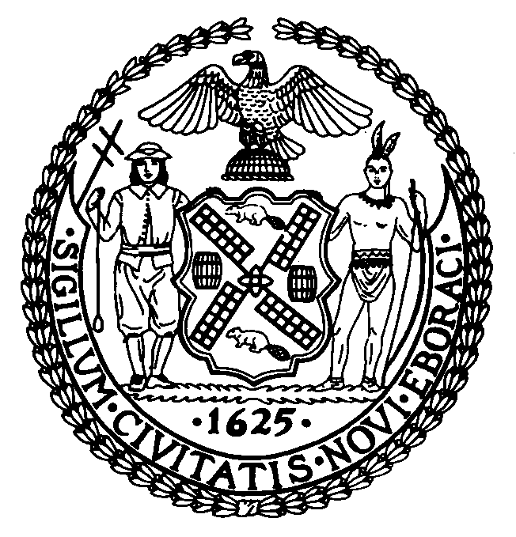 | The Council of the City of New York  Finance Division  Preston Niblack, Director  Fiscal Impact Statement  Pre-considered Intro.  Committee: Finance
Title: A Local Law to amend the administrative code of the city of New York, in relation to the collection of the commercial motor vehicle tax for medallion taxicabs. | Sponsors: Council Members Recchia Jr. and Vacca (by request of the Mayor)
Summary of Legislation: The proposed legislation would amend section 11-808 of the administrative code of the city of New York, by adding a new subdivision e, authorizing the Taxi and Limousine Commission (TLC) to promulgate a rule requiring the payment of the commercial motor vehicle tax (CMVT) as a condition precedent to the licensing, or renewals of the licenses, of the medallion taxicabs.

In addition, the bill would amend subdivisions a, b, c, d, e, f, h, j, k, m, and n of section 11-809.2 of the administrative code of the city of New York, as added by local law 73 for the year 2011, to return to the Department of Finance (DOF) the authority to collect the CMVT for medallion taxicabs and narrow the scope of the application of section 11-809.2 to non-medallion for-hire vehicles referred to as “designated licensed vehicles”.

Lastly, the bill would limit TLC’s obligation to refund payment of the CMVT for a period of more than one year to designated licensed vehicles whose license has been terminated for reasons other than revocation and amend subdivision e of section 19-504 of the administrative code of the city of New York to condition the renewal of a license issued by the TLC, or by the Police Department on compliance with both section 11-808 and section 11-809.2.

Effective Date: This legislation would take effect immediately after its enactment into law and if it shall have become a law after June 1, 2012, it shall be retroactive to and deemed to have been in full force and effect as of June 1, 2012.

Fiscal Year In Which Full Fiscal Impact Anticipated: Fiscal 2013

Fiscal Impact Statement:
 | Effective FY12 | FY Succeeding  Effective FY13 | Full Fiscal  Impact FY13
Revenues | $0 | $0 | $0
Expenditures | $0 | $0 | $0
Net | $0 | $0 | $0

Impact on Revenues: Under this bill, CMVT will continue to be collected except that the authority to collect from medallion taxicabs would be returned to DOF from TLC. As such, it is estimated that there would be no impact on revenues resulting from the enactment of this legislation.

Impact on Expenditures: There would be no impact on expenditures resulting from the enactment of this legislation.
Source of Funds To Cover Estimated Costs: N/A

Source of Information: City Council Finance Division
Mayor’s Office of Legislative Affairs

Estimate Prepared By: Nathan Toth, Deputy Director
Chima Obichere, Unit Head

History: This legislation will be considered and voted on as a pre-considered intro by the Committee on Finance on June 13, 2012.

