Staff: Committee on Sanitation & Solid Waste Management
Jessica Steinberg Albin, Acting Senior Legislative Counsel
Ricky Chawla, Policy Analyst
Jonathan Seltzer, Senior Finance Analyst



The New York City Council
Andrea Vazquez, Legislative Director

Committee Report of the Infrastructure Division
Brad Reid, Deputy Director

Committee on Sanitation & Solid Waste Management
Hon. Sandy Nurse, Chair

March 4, 2022

Oversight: Clean Streets and Expanding Vital Sanitation Service

Preconsidered Res. No. 55: By The Speaker (Council Member Adams) and Council Member Nurse

Title: A Resolution calling upon Governor Kathy Hochul and the New York State Legislature to establish an Extended Producer Responsibility system for packaging and printed paper.

- Introduction

On March 4, 2022 the Committee on Sanitation and Solid Waste Management (the “Committee”), chaired by Council Member Sandy Nurse, will hold a hearing on clean streets and expanding vital sanitation services in New York City. The Committee will also hear Preconsidered Res. No. ____ a Resolution calling upon Governor Kathy Hochul and the New York State Legislature to establish an Extended Producer Responsibility system for packaging and printed paper. The Committee expects to receive testimony from representatives of the New York City Department of Sanitation (“DSNY”), environmental advocates and interested members of the public.

II. Background
Sidewalk Cleanliness
Unlawful dumping of household and business waste in and around corner litter baskets is an ongoing challenge to maintaining clean and sanitary sidewalks and streets. It is illegal for any person to deposit household or commercial refuse or liquid wastes in a public litter basket. Local Law 135 of 2018 increased the civil and criminal penalties for unlawful dumping, prohibited improper disposal of household and commercial waste on sidewalks and streets, and allowed DSNY to use identifying information to locate the violator. Still, corner litter baskets overflowing with household and commercial waste continues to exacerbate the City’s litter challenges. On occasion, DSNY has removed litter baskets subject to unlawful dumping in an attempt to curb the behavior.
DSNY had also received more than 1,300 requests for surveillance of areas of suspected illegal dumping as of September 15, 2021. Residents in some neighborhoods have created voluntary litter cleanup operations. In neighborhoods around Brooklyn, including Fort Greene, Bushwick, and Bay Ridge, volunteer cleanup groups have formed and organize clean up days to help address overflowing garbage cans and littered sidewalks, streets and parks. Residents have said that the state of cleanliness on the streets is not due to lack of neighborly efforts, but to the City not doing its part. Some also note that for a City still facing a global pandemic, having filthy streets and garbage piling up does not further efforts to create sanitary conditions.
In April 2021, then Mayor Bill de Blasio announced as part of his Recovery for All Plan, the creation of the City Cleanup Corps (“CCC”), a jobs program aimed to “make New York City the cleanest, greenest city in the United States.” The goal of the program was to hire up to 10,000 workers across 10 City agencies to clean and beautify public spaces, neighborhoods, parks, and green spaces. This work was to include graffiti removal, pressure washing sidewalks, designing public murals, and tending to and maintaining community gardens and Open Streets. The CCC is being funded with federal stimulus money, and hiring for the initiative began in April 2021. As of December 29, 2021, the City claimed the CCC has collected 1,000,000 bags of garbage around the City, and hand swept 70,000 City blocks.
Alternate Side Parking
A main way the City works to keep streets clean is through alternate side parking (“ASP”) regulations that mandate that cars are moved from each side of the street to allow for street cleaning. The DSNY works with the Department of Transportation (“DOT”) and New York Police Department (“NYPD”) to enforce ASP street cleaning rules. According to DOT, some street cleaning rules have a three-hour limit on designated days of the week, but these times vary throughout the City.
At the start of the COVID-19 pandemic in March 2020, ASP rules were initially suspended, resumed for a week in May 2020, and later resumed with regularity in August 2020, with some changes. Residential streets are only being cleaned once per week. If a street is normally cleaned twice per week, it will only be cleaned on the later of the two days on the street sign. Currently, these ASP reform regulations remain in place until further notice.
Due to ASP reductions, cars have remained parked on streets for longer periods of time and the street sweepers have not been able to thoroughly clean the streets. This may be a contributing factor to the increase in litter being reported throughout the City, which has seen significant increases in 311 complaints for dirty street conditions and missed garbage collections between 2020 and the present. Further, during flash flood conditions like those experienced on September 1, 2021 during Tropical Storm Ida, significant amounts of litter floated with stormwater and swiftly clogged catch basins, exacerbating flooding issues in some neighborhoods. DSNY noted that mechanical brooms were used to help clean catch basins, but also encouraged people who live nearby to volunteer to keep their local catch basins clear of litter.

Figure 1:
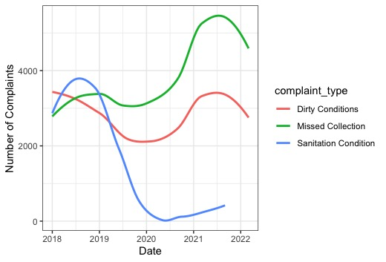
Graph showing an increase in dirty conditions complaints from approximately 2,000 complaints at the beginning of 2020 to nearly 5,000 complaints in the second half of 2021(red line), and missed collection complaints increasing from approximately 3,000 at the beginning of 2020 to approximately 6,000 at the beginning of 2022 (green line), and a decline in sanitation condition complaints (blue line) over the same period. *Data sourced from NYC open data portal as of 2/24/22

Citywide Organics Collection
The City has for decades provided citywide curbside collection service for refuse and MGP (commingled metal, glass, plastic recycling) and paper recyclables. DSNY’s 2017 Waste Characterization Study identifies organics as the biggest area of opportunity for the City to divert waste from landfill. Thus, a robust, citywide organics program is an imperative tool for advancing the City’s commitment to Zero Waste. The City has, in the past, implemented both curbside and non-curbside programs to divert organics from landfill. In October 2013, the New York City Council passed Local Law 77 of 2013 (“LL77”), which required the DSNY Commissioner to establish a voluntary residential organic waste curbside collection pilot program and a school organic waste collection pilot program. In 2015, the OneNYC plan committed the City to implement a residential organics program that would serve all New Yorkers by the end of 2018, and in 2019 the OneNYC 2050 plan committed the City to establishing mandatory organics recycling citywide. However, neither commitment has been met.
In May 2018, DSNY announced during a City Council Executive Budget hearing that the City was temporarily halting the residential organic waste curbside collection program’s expansion. At the time, DSNY continued to service areas already receiving curbside organics collection, despite low participation rates." In communities that were receiving organics collection service, only 10.6% of the organic waste produced was being sorted into the organics bins. The remaining 89% of organic waste was still being discarded as refuse waste and then sent to landfills. In addition to halting citywide expansion, some communities that were receiving twice a week curbside collection were reduced to once a week as of July 30, 2018.
The program’s participation rates did not make it cost effective. In order to fill trucks, either participation rates needed to increase or longer truck routes would be required, which would conflict with hours stipulated in collective bargaining agreements. More drivers or overtime pay would have increased the budget of a program that had low participation rates.
On March 12, 2020, then Mayor de Blasio issued a state of emergency in response to the COVID-19 pandemic. In 2020, some City resources were diverted to aid the relief efforts and Fiscal Year 2021 (FY2021) budget gaps, and priorities shifted substantially. The residences serviced by the pilot curbside organics collection program had their collection halted on May 4, 2020 and were told there were no plans to resume service until at least June 30, 2022. Food scrap drop-off sites were also temporarily suspended due to COVID-19 related budgetary constraints, with some sites reinstated after a FY2021 partial restoration of funding.
In 2021, a limited version of the curbside collection program was reinstituted. Community Board districts that had previously received the service were eligible if they registered and if enough demand existed to justify restarting collection. Further, as of February 2022, about 50% of public schools in New York City have also been enrolled in the curbside organics collection program, with composting material, recycling, and trash collected each day school is in session. DSNY also maintains a map of Drop-Off Composting locations throughout the five boroughs, showing the highest concentration of drop off sites in lower Manhattan and Astoria, and fewer drop off sites in the Bronx, Brooklyn, Staten Island, and western Queens. In February of 2022, Mayor Eric Adams announced as part of his first spending plan, the intention to halt a planned expansion of the curbside organics collection program, citing the cost of the program and limited public participation, though DSNY has committed to continuing organics collection for the approximately 100,000 households and buildings enrolled in the program.
Citywide Rat Complaints
Rats are known vectors for a number of communicable diseases that can be passed to humans, including E. coli, leptospirosis, and hantavirus. Additionally, exposure to rat infestations can contribute to negative mental health outcomes, property damage, food spoilage, and the risk of physical injury due to rodent bites. Monitoring for the presence of COVID-19 DNA in NYC wastewater has uncovered a number of cryptic lineages of the virus that are hypothesized to be circulating in the City’s rat population, while analysis of the Omicron variant of COVID-19 suggests that changes in the virus’ spike protein may have been caused by jumping from humans to rodents (mice), and back to humans.
COVID-19 related budget cuts in the early days of the pandemic led to a reduction in sanitation services such as trash pick-ups. Such cuts overlapped with an increase in outdoor dining, and other shifting patterns of human behavior, resulting in an exploding rat population citywide and many displaced rats seeking new territories (see also fig. 2). This has led to a significant increase in rat sighting complaints filed with 311 in 2021, compared to the three years prior.
Figure 2:
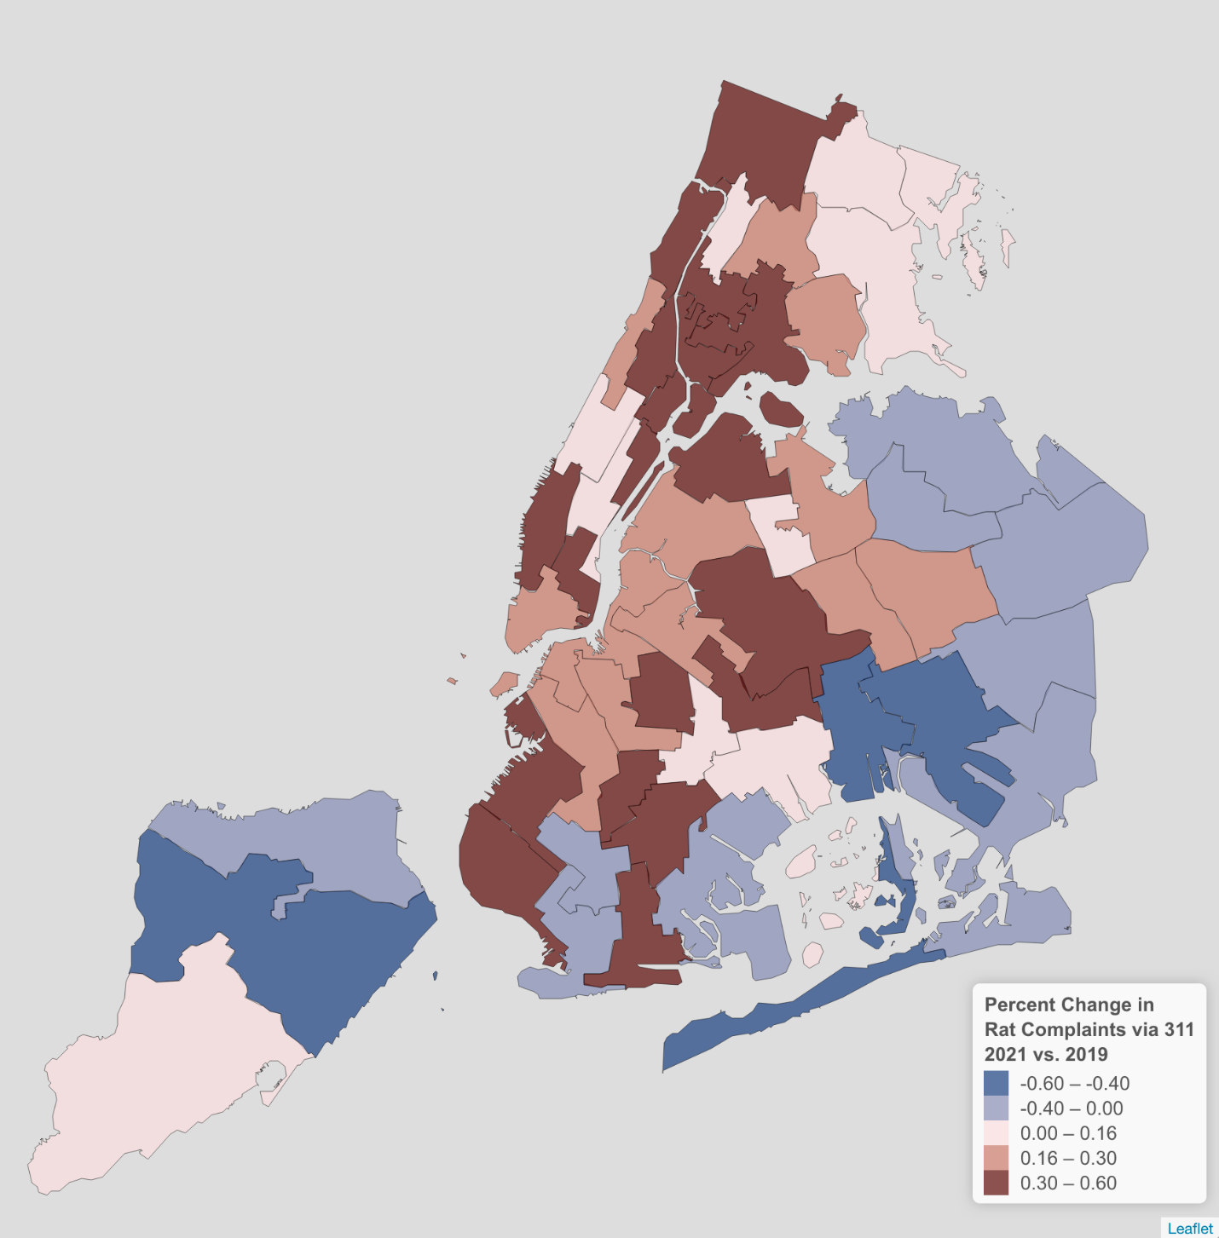
Fig. 2: Map of New York City showing the percentage of change in rat complaints via 311 between 2019 and 2021. Some neighborhoods in South Brooklyn, Eastern Queens, and the northern half of Staten Island show a decline in complaints, while neighborhoods across Manhattan, the Bronx, and Western Queens show varying levels of increase. Data sourced from NYC open data portal as of 2/24/22
Figure 3:
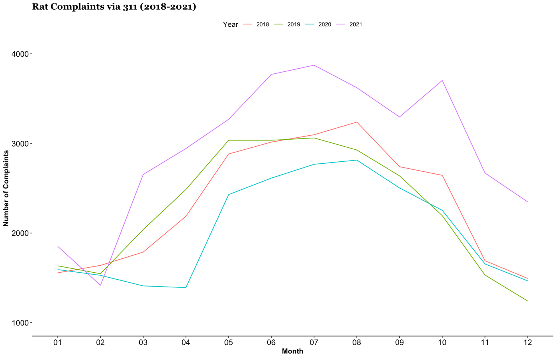
Fig. 3: Line graph showing number of rat complaints per month from 2018 to 2021. Lines for 2018 (orange) and 2019 (green) showing a similar trajectory, while 2020 (blue) shows a relative decline in complaints, and 2021 (purple) showing a higher volume of complaints for every month other than the period from January to February. Data sourced from NYC open data portal as of 2/24/22

Save-As-You-Throw
In 2015, the Administration of then-Mayor Bill de Blasio committed to send zero waste to landfill by 2030, as part of the City’s OneNYC: The Plan for a Strong and Just City. To measure progress towards the “Zero Waste” goal, the de Blasio Administration committed to track waste reduction and waste diversion from landfills, and to set a target of reducing the amount of waste disposed by 90% by 2030 from a 2005 baseline. One of the eight initiatives developed to reach Zero Waste was to develop an equitable blueprint for a Save-As-You-Throw program to reduce waste. In 2018, DSNY awarded Resource Recycling Systems, a Michigan-based company, a $1 million, three-year contract to study Save-As-You-Throw and determine whether such a program could be implemented in the City. However, the contractor did not complete the study.
Save-As-You-Throw programs provide an incentive for residents to divert more of their waste from landfill through recycling, composting and other methods. A financial incentive would be provided to those who divert more of their waste, i.e., by recycling or composting more of their household waste, residents would receive a financial incentive such as a rebate or credit based on the amount of waste diverted. Sometimes this incentive is provided as a reduction in a general fee for residential waste collection, a service for which the City currently does not charge.
E-Waste Collection
In January 2015, a New York State law banning the disposal of electronic waste took effect, barring the City from collecting these materials as refuse. Disposing of e-waste improperly can lead to a $100 fine. DSNY’s ecycleNYC program allows apartment buildings with ten or more units to sign up for collection with DSNY. Currently, buildings already part of the ecycleNYC program can make pick-up appointments with DSNY, while buildings interested in enrolling can submit applications. DSNY also launched a pilot program that provided curbside collection of e-waste for disposal in certain neighborhoods. This pilot first launched in Staten Island, and expanded to areas of Brooklyn, Queens, and the Bronx in 2017, 2018 and 2019. Due to the COVID-19 pandemic, the e-waste curbside collection pilot program was suspended, though as of September 2021, DSNY has resumed limited curbside e-waste collection by appointment for Staten Island residents.
Although e-waste contributes less than one percent of the total waste stream, electronic waste contains many toxic materials, including mercury, cadmium, lead, and other heavy metals. Recycling electronic waste not only keeps these toxins from polluting the air, soil, and water, it also reduces energy and water use associated with manufacturing new materials. Additionally, when improperly disposed of, lithium ion batteries like those often found in electronic devices can also create fire and explosion hazards, like a 2018 incident where an improperly disposed of lithium ion battery caused a five alarm fire at a recycling facility in Jamaica, Queens, and a 2017 incident where a battery caused an explosion in the back of a New York City garbage truck. According to Tom Outerbridge, General Manager at the Sims Municipal Recycling Facility (the “Facility”) in Brooklyn, the Facility experienced roughly 100 fire and smoldering incidents in 2021, a trend some attribute to budget cuts affecting the curbside e-waste recycling program. In December 2021, a fire on a barge in the East River that required 60 fire fighters to put out and sent four individuals to the hospital for smoke inhalation, was attributed to an exploding lithium ion battery.

III. Conclusion
At this hearing, the Committee would like to hear, from DSNY, updates on their efforts to keep New York City sidewalks and streets clean. The Committee is interested in understanding how changes to ASP rules have impacted the presence of litter in the City’s streets and sidewalks, whether the City still plans to meet previously established zero waste commitments given the recent budget cuts affecting the expansion of the curbside organics collection program, and whether vital sanitation services that were cut due to COVID-19 related budget concerns will be reinstated.

Preconsidered Res. No.

Resolution calling upon Governor Kathy Hochul and the New York State Legislature to establish an Extended Producer Responsibility system for packaging and printed paper
By The Speaker (Council Member Adams) and Council Member Nurse
Whereas, printed paper and packaging, which includes plastic, steel, aluminum, glass containers, boxboard, cardboard, cartons, newsprint and magazines, constitutes approximately 40 percent of the materials by weight managed by municipalities and solid waste authorities in New York State; and
Whereas, local municipal governments in New York State are required to fund the management of discarded consumer packaging and printed paper and to take responsibility for achieving waste diversion goals; and
Whereas, the value of recyclable materials does not cover the cost to collect, sort, process, and market these items, causing recycling system ratepayers to pay millions of dollars annually to manage their recycling programs while the State loses an estimated 860,000 tons of potentially recyclable materials to trash each year; and
Whereas, such costs to New York City and recycling system ratepayers in 2021 are estimated at over hundreds of millions; and
Whereas, the State’s current recycling system places unreasonable burdens on local governments to collect, manage, and market recyclable materials, when it is the consumer brand owners who have control over which materials are placed on the market; and
Whereas, costs paid by citizens and local governments to manage packaging and printed paper are, in effect, subsidies to producers that enable and encourage producers to design packaging and printed paper materials without regard to end-of-life management; and
Whereas, producers have little incentive to design packaging or printed paper to minimize waste, reduce toxicity, or maximize recyclability, creating a supply chain disconnect with environmentally sound, end-of-life management of these consumer materials; and
Whereas, Extended Producer Responsibility (“EPR”) is an environmental policy approach in which producers (brand owners and importers) accept responsibility for the management of post-consumer products and packaging so those who produce these materials help bear the costs of recycling; and
Whereas, EPR programs for packaging and printed paper have existed for up to 30 years in all European Union member states, across Canada, and other parts of the world, achieving recycling rates for packaging and printed papers upwards of 70 percent; and
Whereas, enacting EPR for packaging and printed paper could significantly increase recycling rates for residential materials, reduce consumer confusion and contamination in recycling streams, create green sector jobs, provide millions of dollars in savings for local governments and taxpayers, and lower greenhouse gas emissions by over 2.3 million metric tons annually; and
Whereas, New York State Governor Kathy Hochul has proposed a 2022-23 Executive Budget that includes Part RR, which would establish an EPR system for consumer packaging and printed paper and require producers to reimburse municipalities for recycling the packaging and printed paper they introduce into the marketplace; and
Whereas, Governor Hochul’s proposal would incentivize producers to reduce packaging waste, make it easier to recycle the material they generate, invest in modernizing local recycling infrastructure across New York State, ensure that all New Yorkers have access to recycling and upgrade recycling infrastructure to achieve higher recycling rates, and provide clear, consistent consumer education, resulting in less confusion for residents and minimizing contamination in the recycling stream.
Whereas, Senate Bill S1185 seeks to establish an extended producer responsibility act requiring covered materials and product producers to develop and implement strategies to promote recycling, reuse and recovery of packaging and paper products; and
Whereas, EPR can work in tandem with and supplement New York State’s Returnable Container Act; and
Whereas, Making producers responsible for ensuring their materials are reused or recycled responsibly will incentivize them to design for reduction, recyclability, and reduced toxicity; now, therefore be it
Resolved, that the Council of the City of New York calls upon Governor Kathy Hochul and the New York State Legislature to establish an Extended Producer Responsibility system for packaging and printed paper; and
BE IT FURTHER RESOLVED, that the Council of the City of New York shall forward copies of this resolution to Governor Kathy Hochul, the New York State Legislature, and all others deemed necessary and proper.

NRC
LS# 8022
3/03/22

NYC Administrative Code section 16-120 (e) (f)
Local Law 135 of 2018, https://legistar.council.nyc.gov/LegislationDetail.aspx?ID=3363746&GUID=D9B2BB3B-4AA0-450C-B1DC-40B3B2581131&Options=ID|Text|
Winnie Hu, "Harlem’s Trash Bins Were Overflowing. So the City Took 223 Away" New York Times (August 19, 2018), https://www.nytimes.com/2018/08/19/nyregion/harlem-litter-baskets-sanitation-department-nyc.html
Christina Fan, "New Initiatives Will Crack Down On Illegal Dumping, Garbage Problems In Queens" CBS2 New York (September 15, 2021), https://newyork.cbslocal.com/2021/09/15/queens-illegal-dumping-garbage-piles/
Miranda Levingston, "Neighbors Are Tackling the Trash Amidst COVID-19 Budget Cuts" BK Reader (August 31, 2020), https://www.bkreader.com/2020/08/31/neighborhoods-tackling-litter/
Id.
Id.
NYC Office of the Mayor. "Recovery for All of Us: New York City Launches New Deal-Inspired City Cleanup Corps" (April 6, 2021), https://www1.nyc.gov/office-of-the-mayor/news/246-21/recovery-all-us-new-york-city-launches-new-deal-inspired-city-cleanup-corps.
Id.
Id.
Id.
Data obtained from City Clean Up Corps social media account. https://www.instagram.com/p/CYFN5jSNQIl/?utm_medium=copy_link
N.Y.C DOT, Motorists and Parking: Alternate Side Parking, http://www.nyc.gov/html/dot/html/motorist/alternate-side-parking.shtml
Sanders, Anna “NYC alternate-side parking suspended through April 28 for coronavirus” (April 13, 2020) https://www.nydailynews.com/coronavirus/ny-coronavirus-alternate-side-parking-nyc-suspended-20200413-57bqabfhl5fhtkepzx3j37jx74-story.html
NYC 311 “Alternate Side Parking and Street Cleaning” https://portal.311.nyc.gov/article/?kanumber=KA-01011
See Fig. 1
Clayton Guse, "NYC street sweeping remains halved, despite Ida flooding drains clogged with trash" New York Daily News (September 5, 2021), https://www.nydailynews.com/new-york/ny-alternate-side-parking-drain-basin-flood-hurricane-ida-20210905-vn5wveblxzbydm2lv2wj37nnim-story.html
Julian Roberts Grmela, “How do we prevent damage and flooding in Bushwick like what happened during Ida?” Bushwick Daily (September 28, 2021) https://bushwickdaily.com/community/how-do-we-prevent-flooding-and-damage-in-bushwick-like-what-happened-during-ida/
Id at 20
New York City Local Law 77 of 2013, available at http://legistar.council.nyc.gov/LegislationDetail.aspx?ID=1450676&GUID=7743FA15-9A38-4854-8877-31C725522D90
One New York: The Plan for a Strong and Just City (April 2015) at 176, http://www.nyc.gov/html/onenyc/downloads/pdf/publications/OneNYC.pdf; OneNYC 2050 (April 2019) at 19, http://1w3f31pzvdm485dou3dppkcq.wpengine.netdna-cdn.com/wp-content/uploads/2020/01/OneNYC-2050-Full-Report-1.3.pdf.
DSNY Commissioner Kathryn Garcia, Testimony at Hearing on the FY 2019 Executive Budget (May 17, 2018), available in Hearing Testimony at http://legistar.council.nyc.gov/LegislationDetail.aspx?ID=3490250&GUID=5D437490-C1D4-42AF-9DF0-F845A74EB167&Options=&Search=
Id.
Farnoush Amiri, "NYC Pauses Expansion Of Ambitious Residential Composting Program" Gothamist (June 1, 2018), http://gothamist.com/2018/06/01/nyc_composting_sanitation.php
Id.
Pamela Wong, "Dept. Of Sanitation Will Reduce Organics Pickup In CB6 Neighborhoods" Bklyner (June 15, 2018), https://bklyner.com/dept-of-sanitation-will-reduce-organics-pickup-in-cb6-neighborhoods/
Danielle Muoio, "De Blasio's lofty organics goal stalled by lack of funding, participation" Politico (September 4, 2018), https://www.politico.com/states/new-york/albany/story/2018/09/03/de-blasios-lofty-organics-goal-stalled-by-lack-of-funding-participation-591124
Id.
City of New York Office of the Mayor, Executive Order 98 of 2020, (March 12, 2020), https://www1.nyc.gov/assets/home/downloads/pdf/executive-orders/2020/eeo-98.pdf.
City of New York, “Citywide Savings Program” https://www1.nyc.gov/assets/omb/downloads/pdf/csp11-20.pdf at 19
Id.
New York City Department of Sanitation, “Requests for Curbside Composting By Community Board” https://www1.nyc.gov/assets/dsny/site/services/food-scraps-and-yard-waste-page/bydistrict-curbsidecomposting (last accessed November 12, 2021)
New York City Department of Sanitation, “Schools with Curbside Composting.” https://www1.nyc.gov/assets/dsny/site/services/food-scraps-and-yard-waste-page/overview-organics-schools (last accessed November 12, 2021)
New York City Department of Sanitation, “Drop-Off Composting.” https://www1.nyc.gov/assets/dsny/site/services/food-scraps-and-yard-waste-page/nyc-food-scrap-drop-off-locations (last accessed November 12, 2021)
Jake Offenhartz, “Adams scraps expansion of organics recycling, despite campaign promise” Gothamist (February 17, 2022) https://gothamist.com/news/adams-scraps-expansion-organics-recycling-despite-campaign-promise
Cecilia A. Sánchez et al. Social and environmental correlates of rat complaints in Chicago. Journal of Urban Ecology, 1/10/21. https://par.nsf.gov/servlets/purl/10302042 (last accessed 2/28/22)
Id.
Davinda S. Smyth et al. Tracking cryptic SARS- CoV-2 lineages in NYC wastewater. Nature Communications. February 3, 2022. https://www.nature.com/articles/s41467-022-28246-3 (last accessed 2/28/22)
Changshuo Wei et al. Evidence for a mouse origin of the SARS-CoV-2 Omicron variant. Journal of Genetics and Genomics, December 2021. https://pubmed.ncbi.nlm.nih.gov/34954396/ (last accessed 2/28/22)
NYC Sanitation Announces Service Changes Related to COVID-19 Budget Cuts. https://www1.nyc.gov/assets/dsny/site/resources/press-releases/nyc-sanitation-announces-service-changes-related-to-covid-19-budget-cuts (4/17/2020)
Willy Blackmore. “New York City’s Rats are Doing Just Fine” Curbed (January 22, 2021) https://www.curbed.com/2021/01/covid-pandemic-rats-new-york-city.html
See Fig. 3
One New York: The Plan for a Strong and Just City (April 2015) at 176-87, available at http://www.nyc.gov/html/onenyc/downloads/pdf/publications/OneNYC.pdf.
One New York: The Plan for a Strong and Just City (April 2015) at 176-87, available at http://www.nyc.gov/html/onenyc/downloads/pdf/publications/OneNYC.pdf.
https://www.wastedive.com/news/update-dsny-awards-resource-recycling-systems-1m-contract-for-save-as-yo/437392/
"OneNYC: The Plan for a Strong and Just City" at 184, https://onenyc.cityofnewyork.us/wp-content/uploads/2018/04/OneNYC-1.pdf
New York City Department of Sanitation “Guidelines for Electronics Disposal” https://www1.nyc.gov/assets/dsny/site/services/electronics/overview-electronics-guidelines (last accessed on April 14, 2021)
New York City Department of Sanitation “Overview of ecycleNYC” https://www1.nyc.gov/assets/dsny/site/services/electronics/overview-electronics-ecycle (last accessed on April 14, 2021)
Id.
OneNYC Progress Report 2018 at 67, https://onenyc.cityofnewyork.us/wp-content/uploads/2018/05/OneNYC_Progress_2018.pdf; New York City Department of Sanitation, "2019 Annual Report" at 16 https://dsny.cityofnewyork.us/wp-content/uploads/2019/10/2019_Annual_Report_Final-1.pdf.
New York City Council, Department of Sanitation Fiscal 2021 Executive Budget Fact Sheet, (May 2020), available at https://legistar.council.nyc.gov/LegislationDetail.aspx?ID=4429900&GUID=99F493D9-E2E7-4EE1-AD34-5D7CC6334204&Options=&Search=
DSNY. Curbside E-Waste Collection Program to Resume on Staten Island (August 17, 2021) https://www1.nyc.gov/assets/dsny/site/resources/press-releases/curbside-e-waste-collection-program-to-resume-on-staten-island
"OneNYC: The Plan for a Strong and Just City" at 184, https://onenyc.cityofnewyork.us/wp-content/uploads/2018/04/OneNYC-1.pdf
Id.
Elizabeth Weise, Cell phones thrown in trash are exploding, causing 5 alarm fires in garbage trucks. USA Today (May 18, 2018) https://www.usatoday.com/story/tech/talkingtech/2018/05/18/cell-phones-lithium-ion-batteries-exploding-causing-trash-fires/619897002/
Danielle Muino Dunn, “How a floating trash fire in New York exposes a threat to national recycling efforts” PoliticoPro (February 14, 2022) https://www.politico.com/news/2022/02/21/fire-batteries-new-york-recycling-efforts-00008600
Id.

