Committee on Education staff: | Nadia Jean-François, Senior Legislative Counsel  Chloë Rivera, Senior Policy Analyst  Andrew Lane-Lawless, Senior Financial Analyst  Grace Amato, Financial Analyst
Committee on Civil & Human Rights staff:  Data Team staff: | Luciano Hamel, Legislative Counsel  Wiam Diouri, Senior Policy Analyst  Allie Stofer, Financial Analyst  Rose Martinez, Assistant Deputy Director  Erik Brown, Data Scientist  Anne Driscoll, Data Scientist

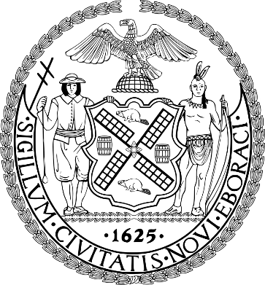

The Council of the City of New York

Committee Report of the Legislative Division
Andrea Vazquez, Director
Smita Deshmukh, Deputy Director, Human & Social Services
Rachel Cordero, Deputy Director, Governmental Affairs

Committee on Education
Hon. Rita Joseph, Chair

Committee on Civil & Human Rights
Hon. Dr. Nantasha Williams, Chair

June 18, 2025

Oversight: Advancing Diversity and Equity in NYC Public Schools

Introduction Number 142: | By Council Members Brooks-Powers, Joseph, Cabán, Louis, Abreu, Hanif, Farías, Brewer, Ung, Hudson, Gennaro, Restler, Williams, Ossé, Ayala, Krishnan, Hanks, Banks, Narcisse and the Public Advocate (Mr. Williams)
Title: | A Local Law to amend the administrative code of the city of New York, in relation to requiring the department of education to conduct a biannual study on student access to home internet and electronic devices
Administrative Code: | Amends Title 21-A by adding a new chapter
Introduction Number 955: | By Council Members Riley, Hanks, Restler, Brannan, Ossé, Banks, Williams, Narcisse and Louis
Title: | A Local Law to amend the administrative code of the city of New York, in relation to requiring annual reports on afterschool programs
Administrative Code: | Amends Title 21-A by adding a new chapter
Introduction Number 1002: | By Council Members Marmorato, Paladino, Ariola, Menin, Holden, Zhuang, Restler, Schulman, Narcisse, Hanks, Louis, Feliz, Hudson, Carr, Vernikov and Morano
Title: | A Local Law to amend the administrative code of the city of New York, in relation to requiring all schools to stock airway clearance devices, and to repeal section two of such local law upon the expiration thereof
Administrative Code: | Amends chapter 1 of Title 17
Resolution Number 718: | By Council Members Joseph, Stevens, Narcisse, Schulman, Louis, Ossé, Banks, Ayala, Brooks-Powers and Brewer
Title: | Resolution calling on the New York State Education Department to adopt oral health education for all elementary school students
Resolution Number 929: | By Council Members Brewer, Louis and Restler
Title: | Resolution calling on the New York State Legislature to pass, and the Governor to sign, A.5373/S.4735, known as the Protect Our Schools Act, in relation to protecting students, faculty and staff from civil arrest while attending or participating in school activities

- Introduction
On June 18, 2025, the Committee on Education, chaired by Council Member Rita Joseph, and the Committee on Civil & Human Rights, chaired by Council Member Nantasha Williams, will conduct a joint oversight hearing titled Advancing Diversity and Equity in NYC Public Schools. The Committees last held an oversight hearing on the topic, Segregation in NYC Schools, on May 1, 2019.
Additionally, the Committees will hear Introduction Number (Int. No.) 142, sponsored by Council Member Selvena Brooks-Powers, a Local Law to amend the administrative code of the city of New York, in relation to requiring the department of education to conduct a biannual study on student access to home internet and electronic devices; Int. No. 955, sponsored by Council Member Kevin Riley, a Local Law to amend the administrative code of the city of New York, in relation to requiring annual reports on afterschool programs; Int. No. 1002, sponsored by Council Member Kristy Marmorato, a Local Law to amend the administrative code of the city of New York, in relation to requiring all schools to stock airway clearance devices, and to repeal section two of such local law upon the expiration thereof; Resolution Number (Res. No.) 718, sponsored by Council Member Joseph, a Resolution calling on the New York State Education Department to adopt oral health education for all elementary school students; and Res. No. 929, sponsored by Council Member Gale Brewer, a Resolution calling on the New York State Legislature to pass, and the Governor to sign, A.5373/S.4735, known as the Protect Our Schools Act, in relation to protecting students, faculty and staff from civil arrest while attending or participating in school activities.
Witnesses invited to testify include representatives from the New York City (“NYC” or “City”) Department of Education (DOE) as well as students, parents/guardians, educators, unions, advocates, and other interested stakeholders.
- Background
New York City Public Schools
During the 2023-24 school year (SY), DOE schools served 912,064 students, making it the largest school district in the United States (U.S.). The student population is racially and ethnically diverse: 42.2% identify as Hispanic, 19.5% as Black, 18.7% as Asian, and 16.2% as white. Additionally, 16.3% of students are English Language Learners (ELLs), 21.6% are students with disabilities (SWDs), and approximately 73% are considered economically disadvantaged. Despite this diversity, significant segregation persists across the DOE system.
Brown v. Board of Education
In 1954, the U.S. Supreme Court delivered a unanimous ruling in Brown v. Board of Education of Topeka Kansas (“Brown”), declaring that racial segregation in public schools violated the Equal Protection Clause of the Fourteenth Amendment to the U.S. Constitution. This landmark ruling overturned the 1896 Plessy v. Ferguson decision, which had upheld the constitutionality of “separate but equal” facilities, and mandated the desegregation of schools across the U.S. While the ruling was a significant legal victory, 71 years later, the intent of Brown remains unfulfilled.
Many schools across the U.S. continue to experience de facto segregation due to circumstances like residential patterns and socioeconomic disparities. According to a 2022 report published by the U.S. Government Accountability Office, this remains true even as the public school student population grows more diverse. During the 2020-21 SY, more than a third of students (about 18.5 million) were enrolled in schools where 75% or more students were of a single race or ethnicity. This trend is even more acute in NYC.
Segregation within New York City Public Schools
According to the UCLA Civil Rights Project (CRP), NYC public schools have been ranked the most segregated schools for Black students in the U.S., and the second most segregated for Latinx students since 2014, when the CRP first began reporting on this data. The CRP also found that about 85% of Black students and 75% of Latinx students attend intensely segregated schools. In contrast, only 11% and 43% of white and Asian students do the same, respectively. Furthermore, 94% of NYC public school students attend predominantly non-white schools, a trend that has been increasing over the past 30 years.
Even within diverse areas of the City, there are issues with school populations reflecting that same diversity. For example, despite the diverse makeup of Manhattan’s District 3, of the district’s 40 schools, 16 schools have 35% or more Black students with an average of 4% white students. Similarly, of the 11 schools with over 35% white students, only an average of 8% of students are Black.
Segregation in the City is not limited to race; it is often closely linked to poverty, as seen in schools that are predominantly comprised of Black and Latinx students, three-fourths of whom come from low-income families. These schools face additional hurdles not often faced by schools in middle or upper class areas, such as neighborhood crime, parental joblessness, and inequity in access to resources at home, including food access, and untreated chronic health issues.
Impact of Segregation on NYC Public Schools
In 2022, the average score of fourth grade students in NYC was not significantly different than that of other students across the nation in the National Assessment for Educational Progress (NAEP) reading assessment. Nevertheless, disparities in student reading proficiency across different races present a cause for concern. In that same year, Black students in NYC had an average score that was 36 points lower than white students, and Latinx students had an average score that was 32 points lower than white students. Students who were eligible for the National School Lunch Program had an average score of 29 points lower than students who were not eligible.
Since then, these disparities have persisted or worsened within NYC. In 2024, Black students had an average score that was 31 points lower than white students in the same assessment, and Hispanic students had an average score that fell 38 points lower than white students. This is despite the fact that DOE spent an average of $31,717 per student in the 2023-2024 fiscal year, well above the national state average of $16,990 per student.
The 2025 NYU Steinhardt Research Alliance for New York City Schools report, Equity Indicators: High School Opportunities (“NYU Report”), finds that access to advanced coursework is unequally distributed across schools and students. The NYU report categorizes high schools into three tiers based on the number of advanced courses offered: high-, moderate-, and limited-opportunity schools. The analysis shows that Latinx students are the most likely to attend limited-opportunity schools (18%) and the least likely to attend high-opportunity schools (27%). Black students fare slightly better, with 14% attending limited-opportunity schools and 33% attending high-opportunity schools. In contrast, approximately 43% of white and Asian students attend high-opportunity schools.
Furthermore, even within high-opportunity schools, disparities persist. Black and Latinx students, as well as students from low-income neighborhoods, are significantly less likely to enroll in advanced coursework compared to their white and Asian peers. Students from the most affluent neighborhoods are almost twice as likely to attend high-opportunity schools (54%) as students from the poorest neighborhoods (28%). Just 6% of students from affluent neighborhoods attended limited-opportunity schools, compared to 20% of students from low-income neighborhoods. These findings suggest that disparities in access to advanced coursework are shaped not only by school offerings, but also by systemic barriers within schools that influence who enrolls in these opportunities.
NYC generally funds its schools equitably; schools serving low-income and Black and Hispanic students receive more funding per pupil than other schools. However, other forms of inequities persist. For instance, there is a large disparity between the funds raised by parent-teacher associations in wealthy zip codes when compared to higher poverty zip codes. Schools which are predominantly Black and Latinx have also historically had far less access to after-school sports, an issue which has garnered increased scrutiny in recent years.
One solution to these persistent demographic achievements gaps and inequities may be further school integration. Research has shown that attending diverse schools may have academic and psychological benefits for students. Some DOE schools have committed to policies of integrating diverse students into their accelerated programs. Research has also shown that integration was the most effective strategy in closing opportunity gaps between Black and white students during the height of desegregation efforts in the 1980s, and that students in the most diverse high schools within NYC were slightly more likely to graduate on time.
- Efforts to Desegregate DOE Schools
DOE Diversity Plan
In June 2017, the DOE released Equity and Excellence for All: Diversity in New York City Public Schools, a citywide school diversity plan which outlines the DOE’s approach to increase diversity in DOE schools. The plan includes a policy statement articulating the DOE’s commitment to school diversity and belief that all students benefit from diverse and inclusive classrooms. The plan also identifies the following three initial goals for making schools more diverse and inclusive:
- Increase the number of students in a “racially representative” school by 50,000 over the next five years;
- Decrease the number of “economically stratified” schools by 10% (150 schools) in the next five years; and
- Increase the number of “inclusive” schools that serve ELLs and SWDs.

The DOE defines a school as “racially representative” if Black and Latinx students together comprise between 50% and 90% of the school’s student population, given that Black and Latinx students make up approximately 70% of the citywide student population. Based on that definition, the DOE reported that 30.7% of schools were racially representative in 2017, when the plan was released.
The DOE considers a school “economically stratified” if its Economic Need Index is more than 10 percentage points higher or lower than the citywide average. A school can be classified as economically stratified if it has a higher concentration of either high-income or low-income students. Further, the DOE defines “inclusive schools” as those where a “significant, representative number” of ELLs and SWDs are “welcomed and served effectively.”
In addition to setting diversity goals, the plan included 12 proposals aimed at improving school diversity and equity. These proposals focused on reforming admissions practices to increase access for high-needs and underrepresented students; expanding diversity initiatives such as pilot programs and targeted funding; integrating diversity considerations into school planning and zoning decisions; and enhancing school climate and academic opportunities through discipline reform and access to rigorous coursework, including access to coursework in science, technology, engineering, and mathematics. The plan also emphasized streamlining the admissions process for families.
Finally, the DOE’s plan announced the formation of a School Diversity Advisory Group (SDAG), which includes a wide range of educational stakeholders to “tackle citywide policies and practices such as admissions and program planning.” The SDAG was tasked with evaluating the DOE’s initial diversity goals and policies, and with making recommendations to the Mayor and Chancellor on citywide practices and policies and the long-term governance structure for diversity work within DOE schools by June 2018.
The SDAG released its initial report, Making the Grade: The Path to Real Integration and Equity for NYC Public School Students, in February 2019, and a follow up report, Making the Grade II: New Programs for Better Schools, in August 2019. Together the reports present a comprehensive list of recommendations aimed at advancing school integration and equity. The first report discusses the DOE’s existing diversity plan and organizes its recommendations according to the framework developed by the youth-led organization IntegrateNYC, known as the “5Rs” of Real Integration: Race and Enrollment, Resources, Relationships, Restorative Justice and Practices, and Representation. The second report builds upon this foundation by outlining a roadmap for creating equitable, high-quality, and integrated schools, with additional recommendations focused on admissions screens, gifted and talented (G&T) programs, and the allocation of school resources. The DOE website includes a list of SDAG recommendations, indicating which have been adopted, are under review, or have not been adopted.
Diversity in Admissions Program
A key component of the DOE’s Diversity Plan is the expansion of the Diversity in Admissions pilot program. The program began with seven elementary schools in the 2016-17 SY, expanded to 76 schools by the 2017-18 SY, and as of the 2024-25 SY, includes over 100 schools. These schools give priority in their admissions processes to students who are low-income, ELLs or Emerging Multilingual Learners, are in the child welfare system, or live in temporary housing. Participating programs span 3-K, Pre-K, elementary, middle, and high schools, and include G&T programs and specialized high schools.
Screened Admissions Policy
Many DOE middle and high schools use selective admissions processes or “screens” to evaluate applicants based on factors such as test scores, grades, attendance, and other academic criteria. Prior to the COVID-19 pandemic, 196 middle schools utilized academic screens as part of their admissions policies. However, for the 2021-22 and 2022-23 SYs, the DOE paused the use of academic screens for middle school admissions because many of the selective admissions criteria were significantly disrupted or unavailable due to the pandemic. This temporary suspension led to an increase in the enrollment of low-income students and ELLs at the City’s most selective middle schools. According to the DOE, 48% of admissions offers for the 2021-22 SY were made to low-income students, an increase from 41% the previous school year, while 7% of offers went to ELLs, up from 3%.
In 2022, the DOE revised its policy to allow middle schools to reinstate academic screens based on a composite of students’ fourth-grade core course grades, rather than standardized test scores. Under this policy, the decision to reintroduce screened admissions was delegated to each community school district superintendent, who was instructed to consult with school leadership, staff, and parents to “determine if and where middle school screened programs should exist based on instructional and community needs.” Following this change, the number of middle schools using academic screens increased from 59 schools in the 2023-24 SY to 69 schools in the 2024-25 SY.
- New York City Council Legislation
In 2019, as part of a broader effort to promote diversity and integration in DOE schools, the City Council (Council) enacted a package of legislation comprising the following Local Laws (LLs):
- LL 208/2019, which created a specialized high school task force that would be charged with addressing the racial/ethnic student body inequities of the eight test-based specialized high schools;
- LL 223/2019, which requires the DOE to expand its current student demographic data reporting to the grade level to provide more granular data;
- LL 224/2019, which codified the mayoral SDAG;
- LL 225/2019, which mandated the establishment of district diversity working groups (DDWGs) in each community school district to develop local plans to improve diversity; and
- LL 226/2019, which requires the DOE to report on the diversity demographics of school staff in DOE schools.

- Issues & Concerns
Impact of School Zoning and Choice on School Segregation
A zoned school refers to a designated neighborhood public school for all students who live within that geographic area, also known as a “zone.” A zone’s boundaries are set by each school district’s Community Education Council (CEC), with the intention of offering convenience to families due to the typically close proximity of the zoned school to a student’s home.
Though a student and their family may opt to send the student to their respective zoned school, they are not required to do so due to NYC’s shift toward a school choice model in the 1990s. With respect to NYC, school choice refers to policies that allow families to select schools for their children beyond their designated zoned school. Other options may include a different public school within NYC, a school with screened admissions or an entrance exam policy, or a charter or private school, thereby allowing families and students to choose schools based on their own needs and desired educational opportunities.
While families may apply to any public school in the City regardless of where they live, the system can also create an overwhelming number of options for students and their families. Home to over 1,800 schools, including charter schools, there is seemingly no shortage of choice in NYC. This can create a lengthy and exhaustive choice process for families. Language barriers, varying degrees of education levels, and lack of access to resources, especially the technological kind, have long been established obstacles for parents and caregivers when it comes to understanding the City’s school system.
Citywide, there are more than 100 zoned middle schools, and most students attend their zoned middle school or a school within their community district. Therefore, elementary and, to an extent, middle school students living in a segregated community are highly likely to attend a segregated zoned school. In 2021, in an effort to increase diversity within schools, then-Mayor Bill de Blasio put forth a plan to end the practice of school zoning for NYC high schools. However, based on feedback from school communities, the decision was reevaluated by the de Blasio administration not long after it was publicly announced. The initial decision of ending zoned high schools was received with mixed feedback and some scrutiny, with some parents and communities claiming that that the priority given to geographically close students was helpful in increasing enrollment in certain neighborhood schools who may struggle if local students begin to attend school elsewhere due to greater access to out-of-zone schools. This, in effect, could also then force students who live in competitive districts to attend schools that are farther away, due to them losing geographical priority as a consideration in acceptance and enrollment. Parents on the Citywide Council for High School Students voted in favor of a resolution calling on the City to expand zoned schools and create a working group on how it can be done.
In September of 2024, Mayor Eric Adams and then-DOE Chancellor David Banks announced several updates to the public school application process, including removing district requirements for middle schools so families can apply citywide, permitting families to apply to an unlimited number of high schools, and leveraging technology to provide families with better information in making their application decisions. The implementation of these changes is intended to expand access and student choice, while aiding families through the complex public school application process. These updates came on the heels of engagement with relevant stakeholders, including parents, CEC representatives, the chancellor’s Parent Advisory Council, advocates, researchers, and school leadership and staff, as well as annual surveys with responses from over 5,000 families on the application process.

DOE Noncompliance with Local Laws 225
As noted in the previous section, LL 225 of 2019 mandated the establishment of DDWGs in each community school district to develop local plans to improve diversity. Currently, the DOE website includes limited information on DDWG-related activity. District 1 is noted as “working closely with the community on a plan to foster school diversity,” while Districts 3, 13, and 15 have launched or published plans to increase diversity. Additionally, District 26 has a website summarizing its ongoing work related to diversity and equity, and District 28 has a website outlining its diversity planning process.
At the January 25, 2023 Council Committee on Education hearing, DOE officials testified that “a lot of the work that was being done in furtherance of [LL 225] was interrupted by the pandemic, because it made outreach very difficult.” In a March 23, 2023 written response to a Council follow-up question regarding how many districts had established DDWGs to date, the DOE reiterated that “these plans were paused during the pandemic.” Despite acknowledging that the law required compliance by the end of 2024, the DOE has not made public any comprehensive update or timeline for implementing DDWGs across all 32 community school districts. This lack of transparency raises significant concerns about the DOE’s accountability in meeting its legal obligation to support diversity planning citywide.

DOE Implementation of the Class Size Law

The New York State (“NYS” or “State”)-mandated class size reduction law (“Class Size Law”) requires DOE schools to lower class sizes to no more than 20 students in grades kindergarten-3; 23 students in grades 4-8; and 25 students for high school academic classes through a phase-in process by the 2027-28 SY. According to the DOE, 54% of DOE schools currently do not meet these required thresholds.
A 2024 report from the NYC Comptroller’s Office highlights the financial and logistical challenges the City faces in implementing the law. While the School Construction Authority’s Fiscal Year 2025-2029 Proposed Five Year Capital Plan includes $4.13 billion in new capacity funding to support compliance with the law, the report notes that this amount is likely insufficient, given an estimated construction cost of $180,000 per seat. Additionally, with an average new school construction timeline of 2-4 years, physical expansion alone will not enable the City to meet the State’s mandate in the required timeframe. Given these constraints, the Comptroller’s Office recommends that the DOE explore solutions that better utilize existing school buildings, like school mergers and consolidation, which “must be rooted in equity and prioritize ‘real integration’ rather than inequity and gentrification.”
Additionally, the Class Size Working Group (“Working Group”), convened by the DOE Chancellor in 2023 to solicit input on implementing the law, recommends capping enrollment at overcrowded schools to comply with the law. The Working Group’s 2023 report notes that following public engagement sessions, some parents expressed that “limiting and balancing enrollment is not only the most cost effective way to implement the law, but would address various segregation and equity issues prevalent in the public school system.”
Despite these recommendations, DOE’s 2025-2026 Draft Class Size Reduction Plan—a final version of which is required to be submitted to the State by July 1, 2025 pursuant to the Class Size Law—does not address how equity, diversity and integration will factor into the implementation of the law. Given the significant demographic and geographic disparities that exist across the City’s public school system, stakeholders have raised concerns that, without intentional planning, efforts to reduce class sizes could inadvertently exacerbate school segregation.
- NYC Council Data Division School Diversity Analysis
To support the Council’s ongoing efforts to advance school diversity and equity, the Council’s Data Team analyzed 2023–2024 publicly available data on NYC elementary schools. The analysis examined how racial/ethnic and economic diversity correlate with student performance and explored whether changes to school zoning boundaries could serve as a tool to increase diversity in enrollment. Definitions of “diversity” varied depending on the specific analysis. A summary of key findings is provided below, with additional details and visualizations included in the Appendix.
Diversity & Academic Proficiency
The analysis found that schools with greater racial diversity tend to demonstrate higher proficiency rates in both Math and English Language Arts, though this reflects correlation rather than causation. Despite this trend, only 19% of elementary schools are considered racially diverse under the criteria used in the analysis. Among non-diverse schools, 63% serve a majority of Black and Latinx students. Patterns for economic diversity showed different trends: schools with a higher proportion of students not eligible for free or reduced-price lunch tended to perform better academically.
Diversity & Zoning
In examining the relationship between zoning and diversity, the analysis identified a number of schools where relatively small adjustments to zone boundaries could significantly impact a school’s demographic composition. Most of these schools fall between neighborhoods with differing racial and socioeconomic profiles, suggesting that rezoning could serve as a targeted and effective strategy for improving school-level diversity in specific areas of the city.
- Analysis of Legislation
Int. 142 – A Local Law to amend the administrative code of the city of New York, in relation to requiring the department of education to conduct a biannual study on student access to home internet and electronic devices
This bill would require the DOE to conduct a biannual survey, by school district, to collect data regarding students’ access to the Internet and electronic devices and how a lack of such access hinders students’ education. Additionally, the DOE would be required to include in the report recommendations on means to address students’ inability to access the Internet and electronic devices.
Int. 955 – A Local Law to amend the administrative code of the city of New York, in relation to requiring annual reports on afterschool programs
This bill would require the DOE, in consultation with the Department of Youth and Community Development, to provide annual reports on afterschool programs. Specifically, this bill would require reporting on location, available seats, enrollment, student demographic data, and attendance for each afterschool program offered in the previous school year.
Int. 1002 – A Local Law to amend the administrative code of the city of New York, in relation to requiring all schools to stock airway clearance devices, and to repeal section two of such local law upon the expiration thereof
This bill would require all NYC schools to stock airway clearance devices. Additionally, for each school year, this bill would require the DOE to report the number of airway clearance devices made available in each school building and the number of instances airway clearance devices were used during an emergency, disaggregated by school building. However, such reporting requirement would cease after 5 years.
- Conclusion
At this hearing, the Committees are interested in understanding the DOE’s efforts to address the issue of segregation throughout the City’s public school system, particularly for low-income students of color. This includes examining the timelines and creation of plans, advisory/working groups, and diversity initiatives as well as compliance with local laws. The Committees looks forward to continued engagement with the DOE and other stakeholders to identify strategies to fully desegregate public schools.

Appendix
This appendix summarizes methods and findings from a preliminary analysis of diversity in NYC elementary schools. The Council Data Team explored how diversity—measured through race/ethnicity and socioeconomic status—relates to student performance and how zoning changes could potentially increase diversity among eligible students. Data reflects the 2023–2024 school year and excludes schools in certain cases when comparing demographic groups with suppressed data (values fewer than five students).
Data Source: NYC Department of Education, Diversity Reports and U.S. Census Bureau, American Community Survey (ACS) 5-Year Estimates (2023)

1. How Does Diversity Impact Student Performance?
Methodology
The Council Data Team used school-level data to assess relationships between demographic composition and standardized test proficiency rates in Math and English Language Arts (ELA). Diversity was examined using:
- Socioeconomic status, measured by the percentage of students eligible for Free & Reduced-Price Lunch (FRPL).
- Racial/ethnic diversity, based on enrollment composition by race.
Metrics
- FRPL Rate: % of students eligible for FRPL.
- Racial Diversity Measure: 100 minus the % of the dominant group(s), where:
- A school is "diverse" if no one racial/ethnic group exceeds 50% and no two groups combined exceed 80%.
- Proficiency Rate: % of students achieving Level 3 or 4 on State Math and ELA tests.
- Achievement Gaps: Differences in average proficiency between FRPL and non-FRPL students.
Findings
Socioeconomic Status (FRPL) and Performance
- Overall, 67% of schools have 80% or more students eligible for FRPL.
- Significant Negative Trend: A 10-point increase in FRPL enrollment correlates with a 1-point decrease in proficiency (Math/ELA).
- Within-school gaps: In 90% of schools, FRPL students underperform compared to their non-FRPL peers.
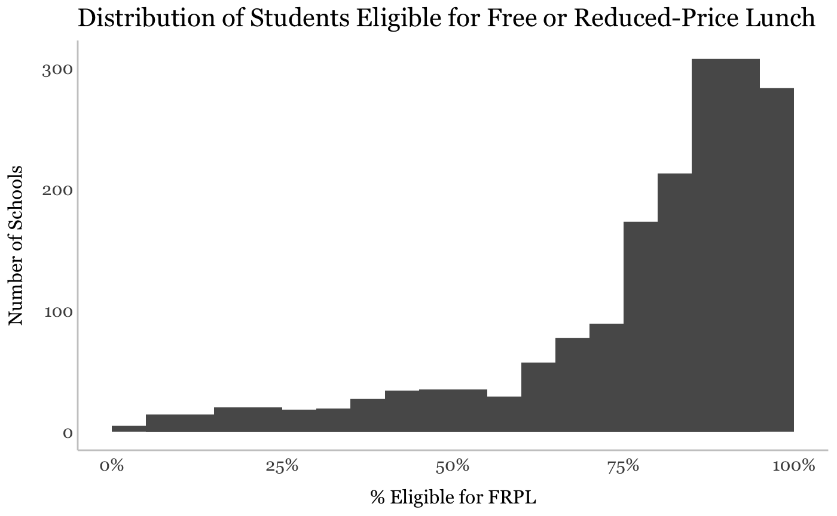
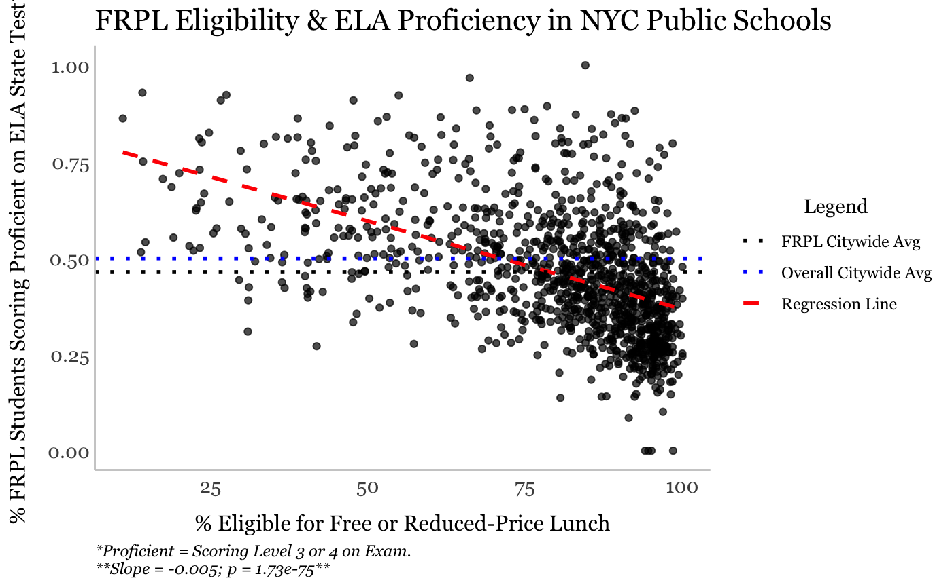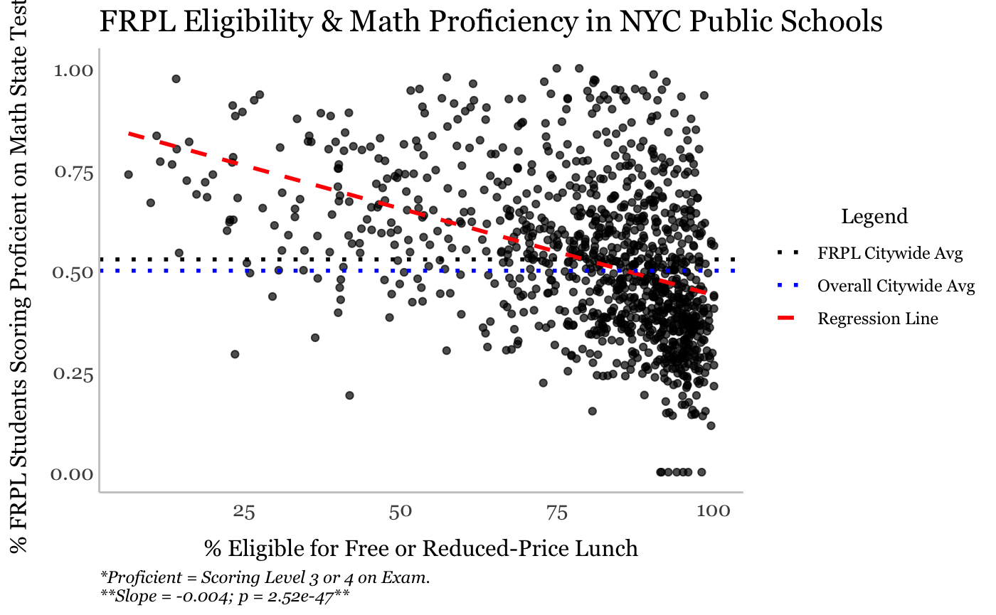

Racial/Ethnic Diversity and Performance
- Diversity Classification:
  - Only 19% of schools (120) meet the threshold for racial diversity using CCCNY’s metric (no group >50%; no two combined >80%).
  - Significant Positive Trend: A 10-point increase in diversity (as % of top dominant groups decreases) correlates with a 7-point increase in proficiency (Math/ELA).
  - 81% (510 schools) are not diverse:
    - 55% have a Hispanic majority.
    - 22% have a Black majority.
    - 13% have an Asian majority.
    - 11% have a White majority.
  - Dual-group majorities:
    - 63% (489 schools) are Black & Hispanic.
    - 21% (163) are Asian & Hispanic.
    - 9% (72) are Hispanic & White.
    - 5% (42) are Asian & White.
    - All other dual combinations are each <1%.
- Significant Trends for Racial Groups Alone:
  - Positive:
    - Asian +10 percentage points in enrollment → +4.4 points in Math proficiency.
    - White +10% → +4.7 points in Math proficiency.
    - Multiracial → +15 points in Math proficiency, likely influenced by smaller sample size.
  - Negative:
    - Black +10% → –2.9 points in Math proficiency.
    - Hispanic +10% → –3.9 points in Math proficiency.

Model Fit:
- Racial enrollment explains between 8% (Multi-Racial) – 21% (Hispanic and White) of variance in proficiency.
- Racial diversity index explains ~14% of proficiency variation.
- Schools with higher diversity tend to perform better, but many other factors are at play.

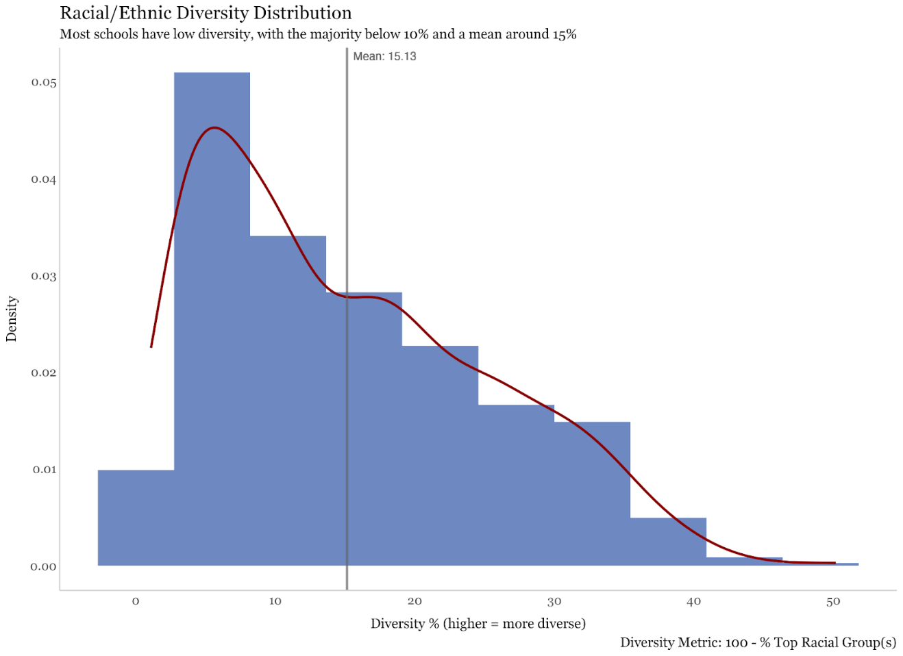
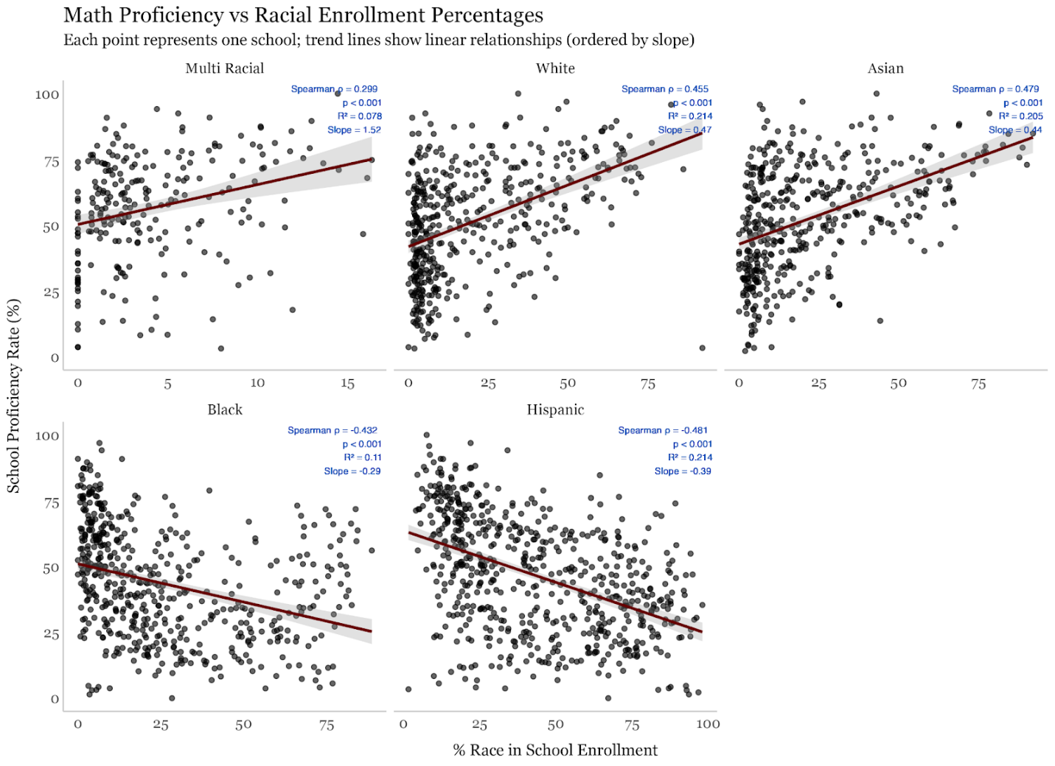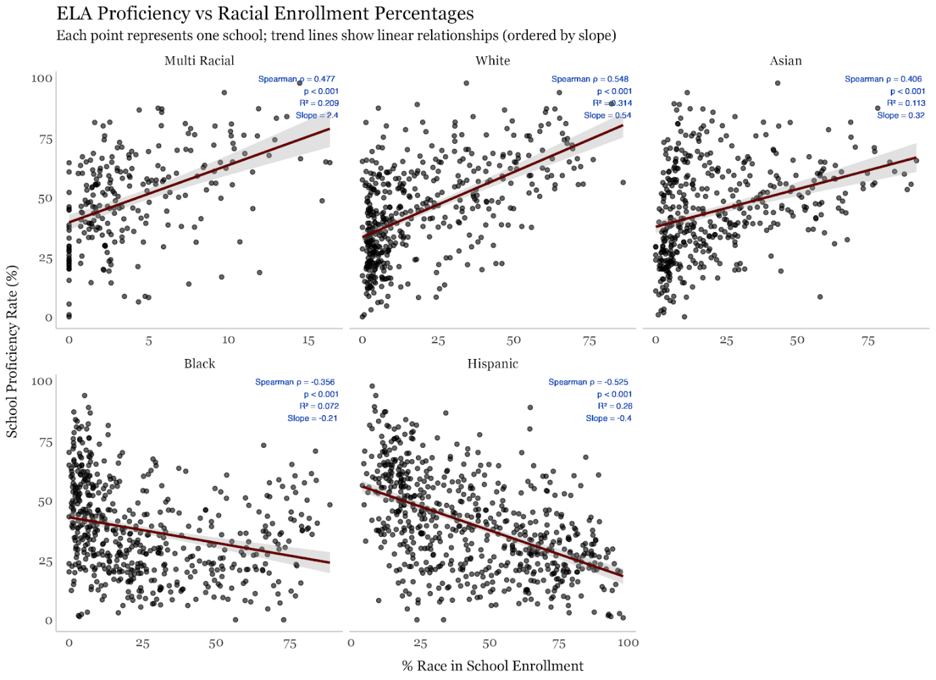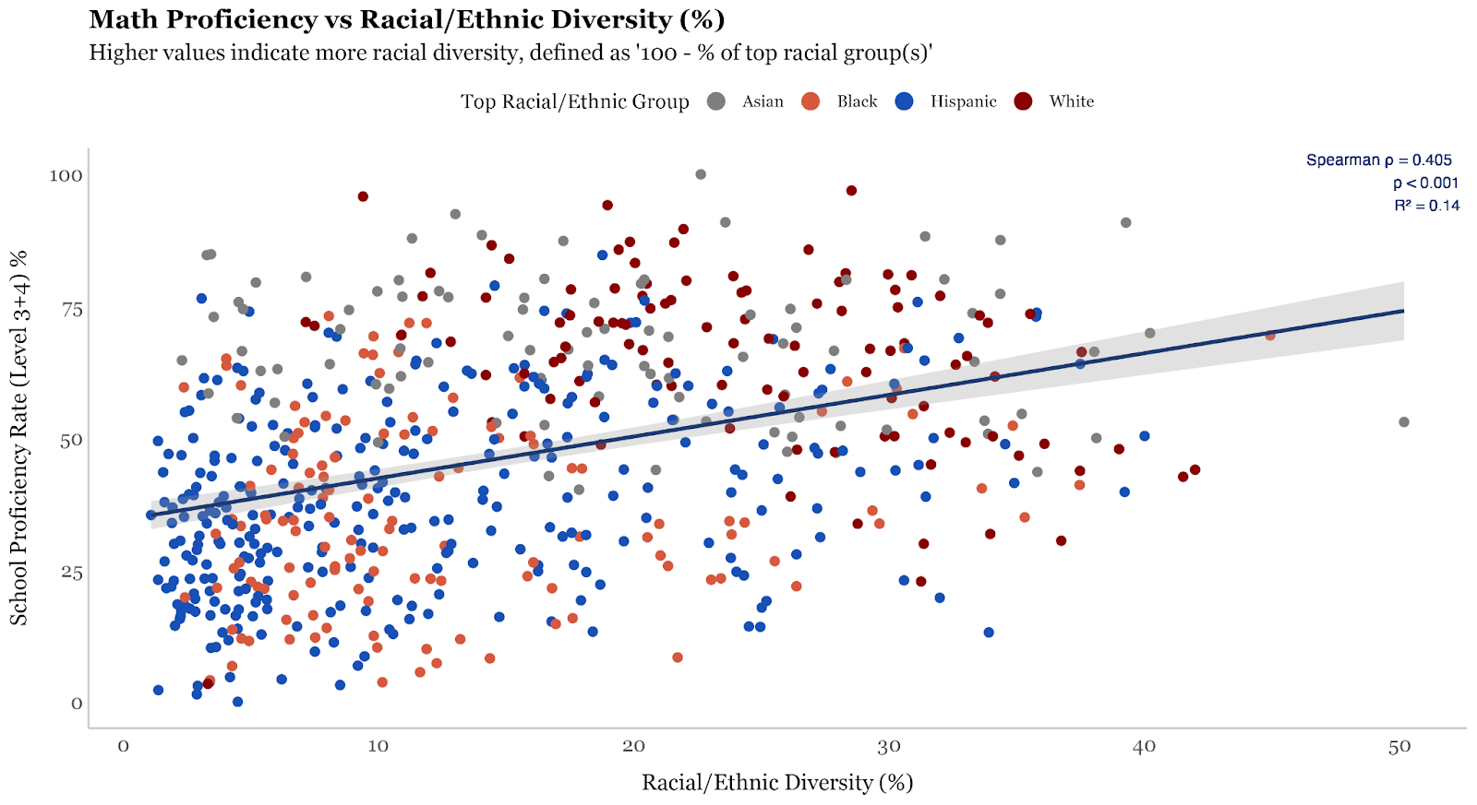
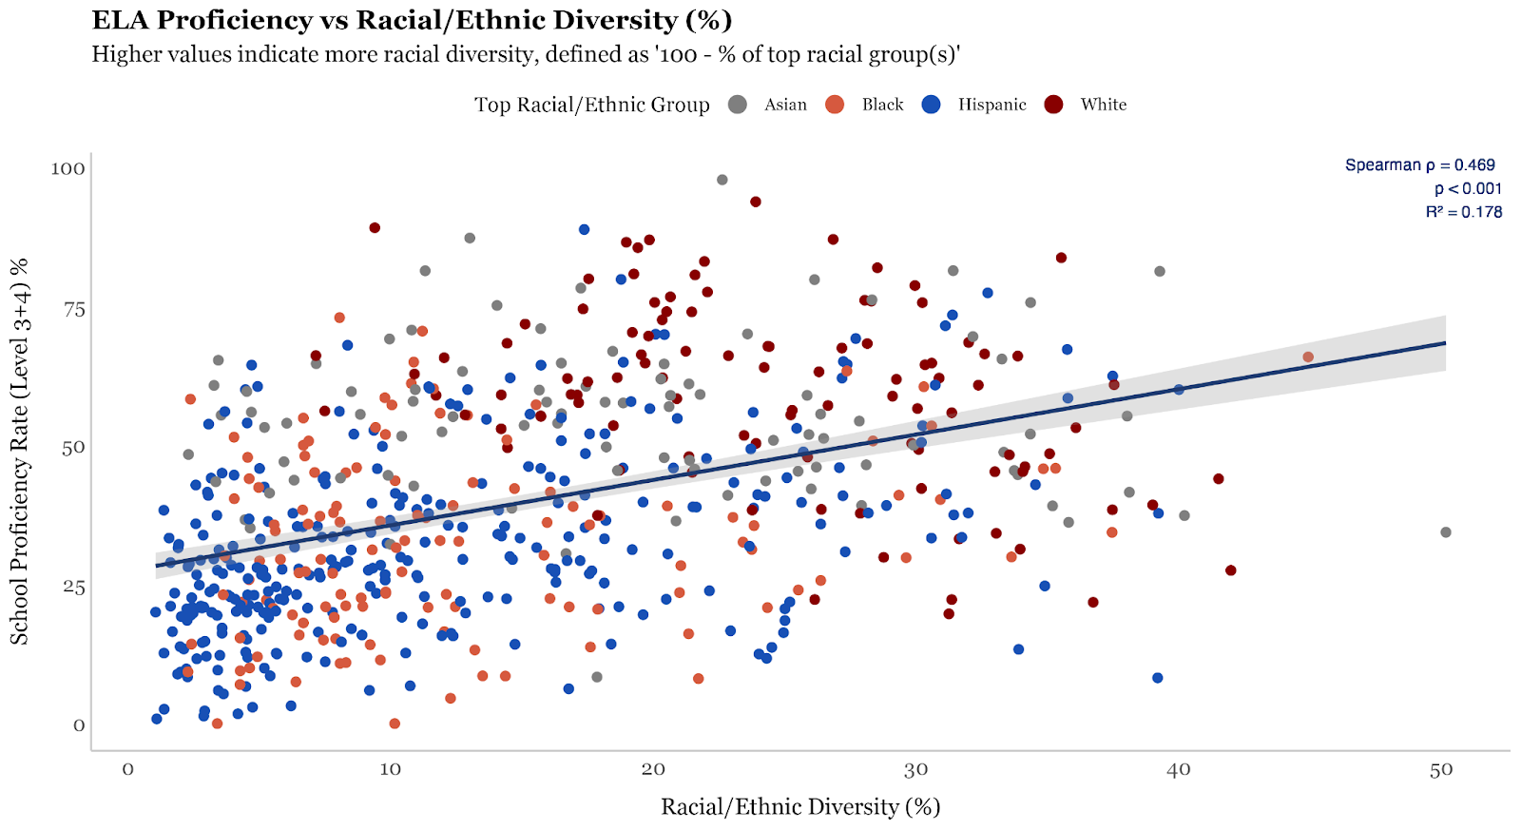
2. Can Zoning Changes Improve the Diversity of Eligibility?
Methodology
To explore how school zoning affects eligible student demographics, the Council Data Team developed a simulation to test alternative zoning configurations. The process involved:
- Generating randomized, capacity-constrained zones by:
  - Identifying each school’s census block.
  - Iteratively adding adjacent blocks until school capacity was met.
- Repeating simulations to create multiple plausible zones per school.
- Comparing demographic variability across simulated zones.
Metrics
- Racial Diversity: Calculated for each simulated zone using the Shannon-Weiner Diversity Index, a Census Bureau metric ranging from 0 (no diversity) to 1 (perfectly even distribution across groups).
- Variability Indicators:
  - Ratio Map: Highest vs. lowest simulated value for a metric (e.g., SNAP usage).
  - Difference Map: Percentage point difference between highest and lowest simulated values.
Findings
- Variation Exists: A number of schools showed high variability in diversity across simulated zones—suggesting zoning ca plays a significant role in shaping eligibility demographics.
- Geographic Pattern: Most variation occurred near neighborhood boundaries with distinct racial/ethnic compositions—places where redrawing zones could most impact diversity.
- Interpretation of Maps:
  - Lighter color indicates high variability suggesting high potential for zoning to influence eligible population diversity.
  - Darker color indicated low variability suggesting limited zoning flexibility due to surrounding demographic uniformity.
  - A ratio of 2 means one simulated zone had double the concentration of a demographic compared to another.
  - A difference of 0.2 means a 20-point difference in that metric across simulated zones.

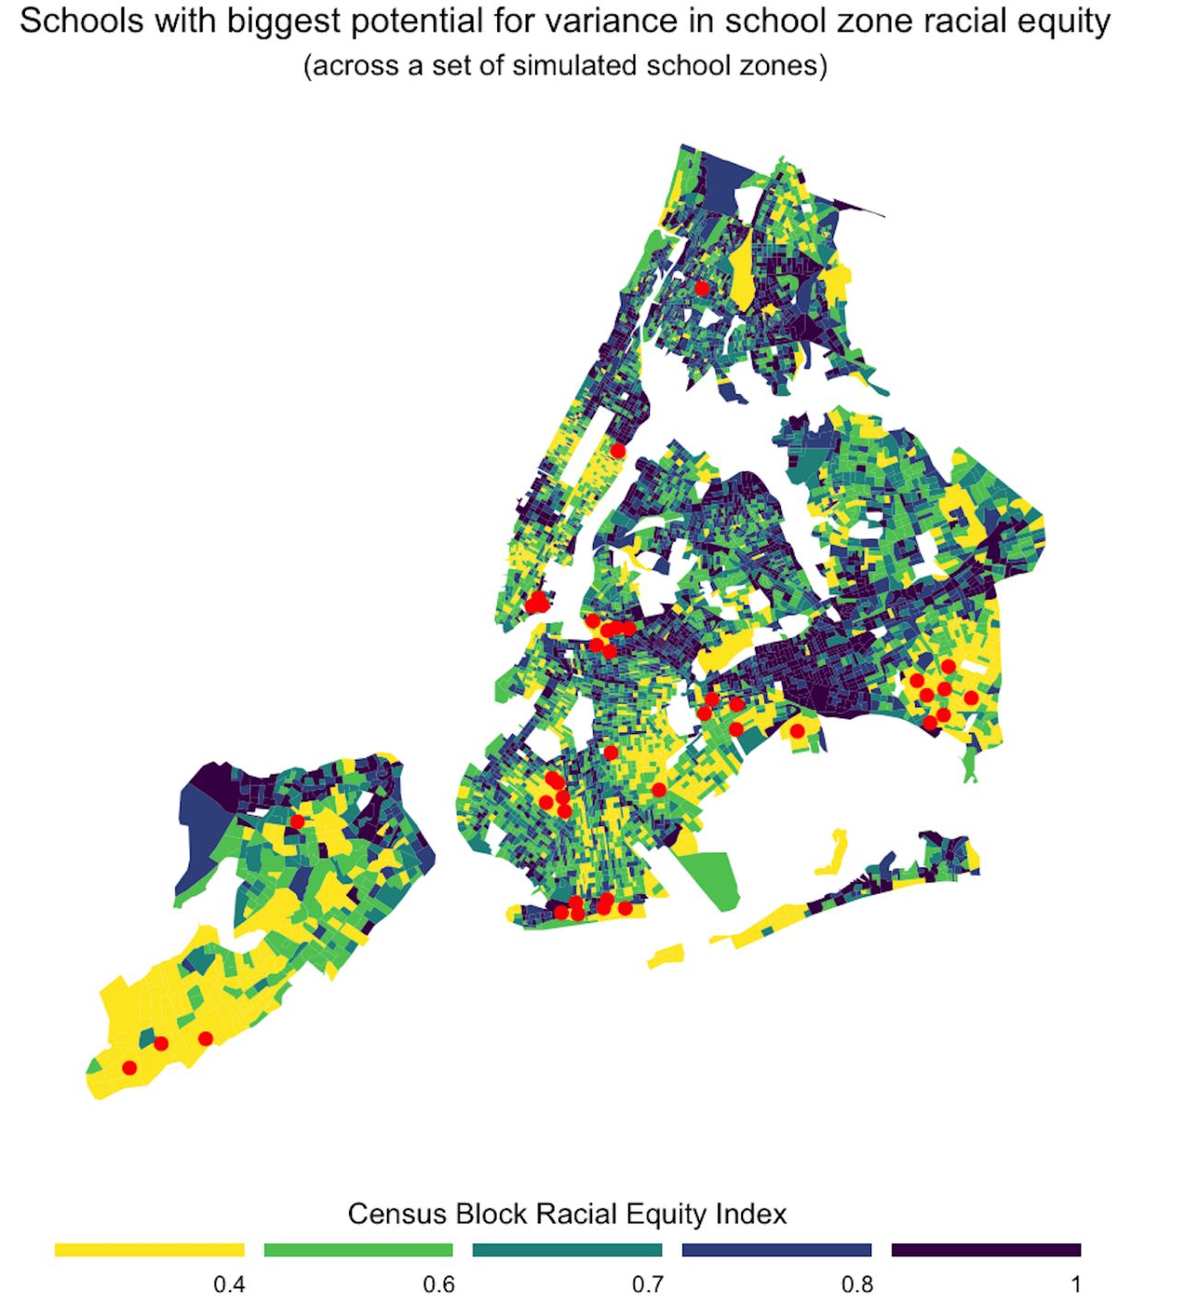
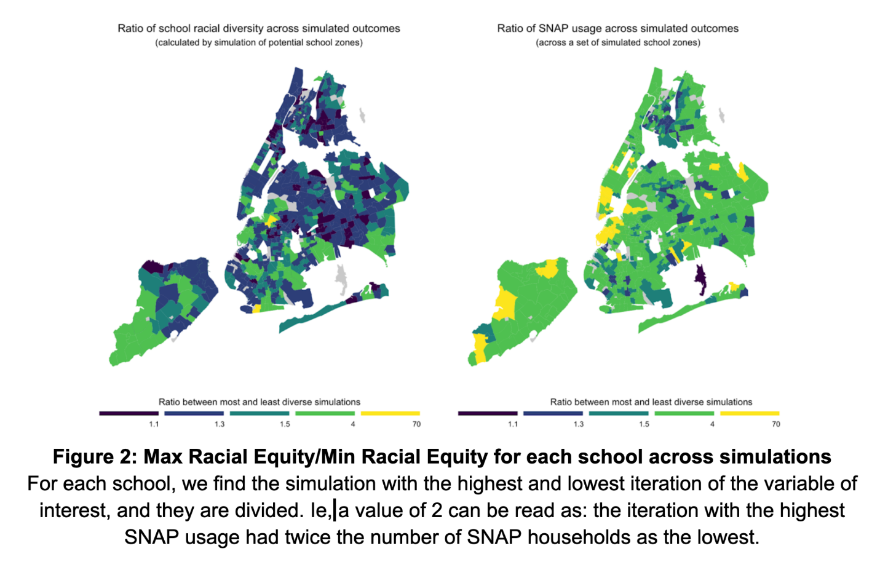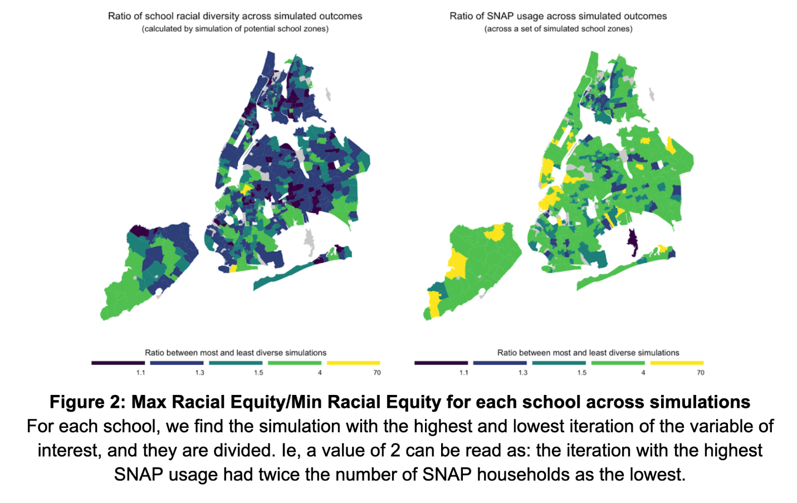

Int. No. 142

By Council Members Brooks-Powers, Joseph, Cabán, Louis, Abreu, Hanif, Farías, Brewer, Ung, Hudson, Gennaro, Restler, Williams, Ossé, Ayala, Krishnan, Hanks, Banks, Narcisse and the Public Advocate (Mr. Williams)

A Local Law to amend the administrative code of the city of New York, in relation to requiring the department of education to conduct a biannual study on student access to home internet and electronic devices

Be it enacted by the Council as follows:

Section 1. Title 21-A of the administrative code of the city of New York is amended adding a new chapter 30 to read as follows:
CHAPTER 30
STUDENT ACCESS TO HOME INTERNET AND ELECTRONIC DEVICES
§ 21-1001 Reporting on student access to home internet and electronic devices. a. Definitions. For the purposes of this section, the following terms have the following meanings:
Blended learning. The term “blended learning” means educational courses that occur through a combination of traditional, in-person classroom instruction and at-home instruction using electronic devices to connect students to teachers.
Electronic device. The term “electronic device” means a desktop computer, laptop, or tablet.
Remote learning. The term “remote learning” means educational courses that occur exclusively through at-home instruction using electronic devices to connect students to teachers.
b. Beginning on January 1, 2025, and every two years thereafter, the department shall submit to the speaker of the council and post conspicuously on the department’s website a report regarding student access to home internet and electronic devices. Information for the report may be procured through means deemed appropriate by the department, including but not limited to surveys sent to the parents or guardians of students. The report shall include, but not be limited to, the following information for each school district:
1. The total enrollment;
2. The number of students who do not have internet access at home;
3. The number of students who do not have access to at least one personal electronic device at home;
4. The number of students utilizing remote or blended learning;
5. The number of students issued a department-owned electronic device;
6. An estimate of the percentage of assignments that require home internet access or home electronic devices; and
7. Information regarding student academic performance, including but not limited to, an analysis of how student scores received on state examinations are affected by access to internet and electronic devices.
c. The department shall include in the report recommendations on reducing the digital divide among students, including but not limited to, identifying means of improving student access to home internet and electronic devices.
d. No information that is otherwise required to be reported pursuant to this section shall be reported in a manner that would violate any applicable provision of federal, state, or local law relating to the privacy of student information or that would interfere with law enforcement investigations or otherwise conflict with the interests of law enforcement.
§ 2. This local law takes effect immediately.

Session 13
LS #10183
1/22/2024

Session 12
APM
LS #10183
2/7/2023

Int. No. 955

By Council Members Riley, Hanks, Restler, Brannan, Ossé, Banks, Williams, Narcisse and Louis

A Local Law to amend the administrative code of the city of New York, in relation to requiring annual reports on afterschool programs

Be it enacted by the Council as follows:

Section 1. Title 21-A of the administrative code of the city of New York is amended by adding a new chapter 35 to read as follows:
CHAPTER 35
AFTERSCHOOL PROGRAM REPORTING
§ 21-1006 Annual afterschool program reporting. a. Definitions. For the purposes of this section, the term “afterschool program” means any program offered by the department or the department of youth and community development, or a provider under a contract with the department or department of youth and community development that provides supervised activities outside of school hours for students in grades kindergarten through 12.
b. Reporting. No later than 120 days after the effective date of the local law that added this section, and annually thereafter, the department, in consultation with the department of youth and community development, shall submit a report to the speaker of the council regarding all afterschool programs offered in the previous school year. The report shall include a table in which every row references a specific afterschool program that was offered in the previous school year. Each such row shall include the following information, set forth in separate columns:
1. The address where the afterschool program was located;
2. The community school district in which the afterschool was located;
3. The total available seats of the afterschool program;
4. The number of students enrolled in the afterschool program, in total and disaggregated by race, gender, and grade level; and
5. The average daily percentage of enrolled students in attendance at the afterschool program.
c. No information that is otherwise required to be reported pursuant to this section shall be reported in a manner that would violate any applicable provision of federal, state or local law relating to the privacy of student information. If a category contains between 1 and 5 students, or allows another category to be narrowed to between 1 and 5 students, the number shall be replaced with a symbol. A category that contains zero students shall be reported as zero, unless such reporting would violate any applicable provision of federal, state or local law relating to the privacy of student information.
§ 2. This local law takes effect immediately.

DPM
LS #13259/14938
5/15/2024 12:35 PM

Int. No. 1002

By Council Members Marmorato, Paladino, Ariola, Menin, Holden, Zhuang, Restler, Schulman, Narcisse, Hanks, Louis, Feliz, Hudson, Carr, Vernikov and Morano

A Local Law to amend the administrative code of the city of New York, in relation to requiring all schools to stock airway clearance devices, and to repeal section two of such local law upon the expiration thereof

Be it enacted by the Council as follows:

Section 1. Chapter 1 of title 17 of the administrative code of the city of New York is amended by adding a new section 17-199.26 to read as follows:
§ 17-199.26 Airway clearance devices in schools. a. Definitions. For purposes of this section, the following terms have the following meanings:
Airway clearance device. The term “airway clearance device” means a medical device registered as a class II acute upper airway obstruction device with the United States food and drug administration.
School building. The term “school building” means any building or facility in which there is a public school, private school, or charter school.
b. The department of education and each private school and charter school shall stock airway clearance devices in all school buildings under their respective control.
§ 2. Reporting on airway clearance devices. a. Definitions. For purposes of this section, the following terms have the following meanings:
Airway clearance device. The term “airway clearance device” means a medical device that has been registered as a class II acute upper airway obstruction device with the United States food and drug administration.
Chancellor. The term “chancellor” means the chancellor of the city school district of the city of New York.
School building. The term “school building” means any facility that is leased by the department or over which the department has care, custody, and control, in which there is a public school.
b. No later than November 30, 2025 and annually thereafter, the chancellor shall submit to the mayor and the speaker of the council a report that shall include, for the prior school year:
1. The number of airway clearance devices available for use in each school building; and
2. The number of instances that an airway clearance device was used during a choking emergency, disaggregated by school building.
§ 3. This local law takes effect 180 days after it becomes law and section two of this local law expires and is deemed repealed 5 years after it becomes law.

NJF
LS #16632/17373
7/24/2024 11:31 AM

Res. No. 718

Resolution calling on the New York State Education Department to adopt oral health education for all elementary school students.

By Council Members Joseph, Stevens, Narcisse, Schulman, Louis, Ossé, Banks, Ayala, Brooks-Powers and Brewer

Whereas, There is a systematic lack of cognizance regarding the importance of maintaining proper dental hygiene as robust oral health is related to maintaining overall physical health; and
Whereas, Dental cavities are the most common chronic disease in both children and adults according to the National Institute of Dental and Craniofacial Research; and
Whereas, Tooth decay and many oral diseases are preventable with proper brushing and flossing; and
Whereas, The New York State Department of Health recommends oral hygiene measures for babies from birth and brushing teeth should start as soon as the child’s first tooth comes in; and
Whereas, A child learning dental hygiene early can create the habit of regular brushing and flossing—promoting healthy oral hygiene from adolescence to adulthood; and
Whereas, According to the New York City Department of Health and Mental Hygiene, more than 33 percent of third-grade students have untreated tooth decay; and
Whereas, Failure to resolve tooth decay will only cause further health issues for the child growing up; and
Whereas, The American Dental Association recommends that children brush their teeth for at least two minutes a day twice a day and flossing should occur once a day; and
Whereas, Proper teaching of brushing and flossing behooves the child’s parents; and
Whereas, Not every student has the privilege to learn the intricacies of brushing and flossing; and
Whereas, According to the Centers for Disease Control and Prevention, children from low-income families are twice as likely to have cavities juxtaposed to children from wealthier households; and
Whereas, As oral hygiene should start as early as possible, elementary school-aged children are primed for oral health lessons; and
Whereas, The New York State Education Department governs the education curriculum in public schools; and
Whereas, the New York State Education Department should dictate that public schools in New York State teach oral health education to set students up for a lifetime of positive oral health; now, therefore, be it
Resolved, That the Council of the City of New York calls on the New York State Education Department to adopt oral health education for elementary school students.

LS # 18494
12/23/24
JEB

Res. No. 929

Resolution calling on the New York State Legislature to pass, and the Governor to sign, A.5373/S.4735, known as the Protect Our Schools Act, in relation to protecting students, faculty and staff from civil arrest while attending or participating in school activities

By Council Members Brewer, Louis and Restler

Whereas, On January 20, 2025, the Trump Administration rescinded a Biden-era memo called “Guidelines for Enforcement Actions in or Near Protected Areas”; and
Whereas, The Biden-era memo protected certain areas, including schools and places where children gather, from Immigration and Customs Enforcement (ICE) and Customs and Border Protection (CBP) activity; and
Whereas, Prior to this memo, standing guidance protecting certain, sensitive locations from immigration enforcement was issued by the Department of Homeland Security (DHS) to federal immigration authorities; and
Whereas, The Biden-era memo has since been replaced with guidance from the Trump Administration that directs federal immigration authorities to use “common sense” prior to conducting enforcement actions, but does not restrict them from conducting actions in any location; and
Whereas, In an article for Chalkbeat, immigration experts noted that it is unlikely that federal immigration authorities will conduct enforcement efforts in schools, however, because of the push by the Trump Administration to increase immigration arrests, advocates are doubtful that “common sense” will deter authorities from making arrests in previously protected locations; and
Whereas, According to reports in North Carolina and Illinois, since the memo was rescinded, ICE has conducted arrests of parents during school drop-offs; and
Whereas, The children witnessing the arrests of their parents or the students witnessing ICE conduct arrests can be traumatized, and the schools in these incidents offered counseling and social work support to their students; and
Whereas, Earlier this year in New Mexico, Border Patrol agents boarded a charter bus taking public school students to a swim competition to verify the legal status of the children on the bus; and
Whereas, Since the rescission of this memo, immigrant families have been scared to send their children to school and schools across the country are reportedly seeing drops in attendance of children in immigrant families; and
Whereas, Research has shown that increasing immigration enforcement negatively impacts student’s academic outcomes; and
Whereas, As seen anecdotally following the rescission of “Guidelines for Enforcement Actions in or Near Protected Areas” and further reinforced in research articles published by American Educational Research Association, immigration enforcement actions are correlated with chronic absenteeism and drops in school enrollment; and
Whereas, Reporting from KFF also connected increased immigration enforcement to negative physical and mental health outcomes among children in immigrant families; and
Whereas, According to the 2023 American Community Survey, across the United States there are roughly 9 million school age children that live in a household with at least one noncitizen adult vulnerable to federal immigration enforcement actions; and
Whereas, According to a 2019 report from the Vera Institute of Justice, in the New York Metro Area, there are 2 million children with at least one immigrant parent; and
Whereas, The same report noted that over 640,000 immigrants in New York are enrolled in pre-K through college or graduate school; and
Whereas, Between the summer of 2022 and September 2024, almost 40,000 migrant children were enrolled in New York City’s schools; and
Whereas, In New York City, school officials have reported a drop in attendance among migrant students; and
Whereas, With New York City school funding also dependent on class size, these drops in attendance due to the fear of interactions with immigration authorities could also lead to a decrease in a school’s funding; and
Whereas, Due to the significant number of immigrant children or children from immigrant families in New York City, in accordance with New York City Public Schools (NYCPS) policy, non-local law enforcement are not permitted to enter schools, except when required by law; and
Whereas, Non-local law enforcement must present valid judicial warrants, court orders, or subpoenas to enter a school or access information about an individual student, family member, or school employee; and
Whereas, NYCPS protocol limits communication between the non-local law enforcement officer and the school principal and provides a general process for principals that have been presented documentation which includes, getting the information of the officer, escalating the documentation to the Senior Field Counsel (SFC), and awaiting further instruction from the SFC; and
Whereas, Although some schools, like New York City Public Schools, have assured parents that their children will be safe in their care and have promised to protect the children in their schools, there is a push to codify and expand these protections; and
Whereas, A.5373 introduced by Assembly Member Catalina Cruz, pending in the New York State Assembly, and S.4735 introduced by Senator Luis R. Sepúlveda, pending in the New York State Senate, seek to amend the civil rights law and the education law, in relation to protecting students, faculty and staff from civil arrest while attending or participating in school activities; and
Whereas, A.5373/S.4735, also known as the Protect Our Schools Act, would codify NYCPS policy and protocols for staff, and students and their families while they are traveling to and from school, attending classes or school related activities, or participating in extracurricular or education programs on school grounds or affiliated with the school, such as after school programs; and
Whereas, Similar to the NYCPS protocols, the Protect Our Schools Act would prohibit immigration enforcement activities in public and charter school settings without a judicial warrant, restrict access to student records without a judicial order or subpoena, require the school’s superintendent and district attorney to assess the documentation provided by law enforcement prior to taking any action, mandate that parents or guardians are immediately notified if a student is the subject of enforcement actions, and require schools to establish and publicly post protocols; and
Whereas, Learning should be free of fear, and schools should be safe, nurturing, and educational spaces and without protections from immigration enforcement schools can become a place of terror for immigrant students or immigrant families; and
Whereas, All children, regardless of immigration status, are entitled to access to education and even more importantly students deserve peace and safety; and
Whereas, New York must ensure that schools remain a place of sanctuary, especially in light of the growing instability that many students may face because of the Trump Administration’s attacks on immigrants; now, therefore, be it
Resolved, That the Council of the City of New York calls on the New York State Legislature to pass, and the Governor to sign, A.5373/S.4735, known as the Protect Our Schools Act, in relation to protecting students, faculty and staff from civil arrest while attending or participating in school activities.

LS #19462
05/22/2025
RLB

NYC DOE, Demographic Snapshot 2023-24: Visual Guide (Jul. 2024), accessed via https://infohub.nyced.org/docs/default-source/default-document-library/23-24-demographic-snapshot-summary---july-2024---web.pdf.
Id.
Id.
National Archives, Milestone Documents: Brown v. Board of Education (1954), accessed via https://www.archives.gov/milestone-documents/brown-v-board-of-education.
Id.
Brenda Alvarez, “Revisiting Brown v. Board of Education – 70 Years Later,” neaToday (May 9, 2024), accessed via https://www.nea.org/nea-today/all-news-articles/revisiting-brown-v-board-education-70-years-later.
Id.
U.S. Government Accountability Office, K-12 Education: Student Population Has Significantly Diversified, but Many Schools Remain Divided Along Racial, Ethnic, and Economic Lines (Jun. 16, 2022), accessed via https://www.gao.gov/products/gao-22-104737.
Id.
UCLA Civil Rights Project, “UCLA Civil Rights Project Report Shows School Segregation in New York Remains Worst in Nation” (2021) accessed via https://www.civilrightsproject.ucla.edu/news/press-releases/2021-press-releases/report-shows-school-segregation-in-new-york-remains-worst-in-nation
Id.
Note: CRP’s reports have covered data from 2010 to 2018.
Supra note 10 at 25.
Id. at 2.
IntegrateNY, District Dashboard (n.d.), accessed via https://integrateny.org/district/.
EdTrust New York, “In New York City Public Schools, Brown v. Board remains…unfulfilled” (May 2024), accessed via https://newyork.edtrust.org/in-nyc-brown-v-board-remains-unfulfilled/.
Id.
Danielle Cohen, “NYC school segregation: A report card from the UCLA Civil Rights Project” the Civil Rights Project at the University of California Los Angeles. (June 2021), accessed via https://www.civilrightsproject.ucla.edu/research/k-12-education/integration-and-diversity/nyc-school-segregation-report-card-still-last-action-needed-now/NYC_6-09-final-for-post.pdf
Id.
The Nation’s Report Card, 2022 Reading Trial Urban District Snapshot Report: New York City Grade 4 Public Schools (n.d.), accessed via https://nces.ed.gov/nationsreportcard/subject/publications/dst2022/pdf/2023010XN4.pdf.
Id.
Note: Eligibility for the National School Lunch Program is a factor of household size and annual income. A family of 4 would be eligible for reduced priced meals with an annual salary of $59,478 and free meals with an annual salary of $41,795 in the 2025-2026 school year. See https://www.federalregister.gov/documents/2025/03/13/2025-03821/child-nutrition-programs-income-eligibility-guidelines#p-15.
Supra note 20.
Id.
NYC DOE, Funding Our Schools, (n.d.), accessed via https://www.schools.nyc.gov/about-us/funding/funding-our-schools.
National Education Association, Educator Pay Data 2025, (April 29, 2025), accessed via https://www.nea.org/resource-library/educator-pay-and-student-spending-how-does-your-state-rank.
The Research Alliance for New York City Schools, Equity Indicators: High School Opportunities, NYU Steinhardt (2025), accessed via https://steinhardt.nyu.edu/research-alliance/research/spotlight-nyc-schools/equity-indicators-high-school-opportunities.
Id.
Id.
Id.
Id.
Id.
Id.
Id.
Matthew M. Chingos, Ariella Meltzer & James Carter, “How Will Implementing Class Size Caps in New York City Affect Funding Equity? An Essay for the Learning Curve” Urban Institute (Nov. 30, 2023), accessed via https://www.urban.org/research/publication/how-will-implementing-class-size-caps-new-york-city-affect-funding-equity.
Reema Amin & Amy Zimmer, “Find Out How Much Your School’s PTA Raises (or Doesn’t)” Chalkbeat New York (Dec. 2, 2019), accessed via https://www.chalkbeat.org/newyork/2019/12/2/21113658/find-out-how-much-your-school-s-pta-raises-or-doesn-t/.
Michael Elsen-Rooney, “Students and Advocates Oppose Limits to School Sports Access” Chalkbeat New York (Apr. 17, 2024), accessed via https://www.chalkbeat.org/newyork/2024/04/17/students-and-advocates-oppose-limits-to-school-sports-access/.
Amanda Schmidt, Talia Gerstle & Clémence Idoux, “Reducing Segregation in New York City: Examining the Effects of Two District Policies on School Integration” Wm. T. Grant Found. (Nov. 11, 2024), accessed via https://wtgrantfoundation.org/reducing-segregation-in-new-york-city-examining-the-effects-of-two-district-policies-on-school-integration.
Kelly Field, “What Does a ‘Bright Kid’ Look Like? New York Expands Its Gifted Program,” The Christina Science Monitor (Jan. 16, 2024), accessed via https://www.csmonitor.com/USA/Education/2024/0103/What-does-a-bright-kid-look-like-New-York-expands-its-gifted-program.
Allison Roda, Ryan Coughlan, Paul Tractenberg & Deirdre Dougherty, “Making School Integration Work in New York City: A Long-Term Solution to the Enduring Problem of Segregation and Inequality” 48 Fordham Urban Law Journal 449, 455 (2021), accessed via https://ir.lawnet.fordham.edu/ulj/vol48/iss2/3/.
Supra note 10.
Christina Veiga, “The country’s largest school system – and one of the most segregated – just released its ‘school diversity’ plan. Here are the highlights” Chalkbeat New York (June 6, 2017), accessed via https://www.chalkbeat.org/newyork/2017/6/6/21102759/the-country-s-largest-school-system-and-one-of-the-most-segregated-just-released-its-school-diversit/.
NYC DOE, Equity and Excellence for All: Diversity in New York City Public Schools, 3 (n.d.), accessed via https://www.schools.nyc.gov/docs/default-source/default-document-library/diversity-in-new-york-city-public-schools-english.
Id at 4.
Id.
Id.
Id.
Id.
Id.
Id. at 6-13.
Id.
Id.
Id. at 4.
Id. at 5.
School Diversity Advisory Group, Making the Grade: The Path to Real Integration and Equity for NYC Public School Students (February 2019), accessed via https://docs.wixstatic.com/ugd/1c478c_4de7a85cae884c53a8d48750e0858172.pdf.
School Diversity Advisory Group, Making the Grade II: New Programs for Better Schools (August 2019), accessed via https://docs.steinhardt.nyu.edu/pdfs/metrocenter/atn293/sdag/Making-the-Grade-II.pdf?_ga=2.194158189.195514427.1748956694-528964780.1748623390.
Supra note 55.
Supra note 56.
NYC DOE, School Diversity Advisory Group Recommendations (n.d.), accessed via https://www.schools.nyc.gov/about-us/vision-and-mission/diversity-in-our-schools/school-diversity-advisory-group-recommendations#:~:text=Based%20on%20the%20SDAG's%20recommendation,goals)%20should%20consider%20all%20races.
NYC DOE, Equity and Excellence for All: Diversity in New York City Public Schools, 9 (n.d.), accessed via https://www.schools.nyc.gov/docs/default-source/default-document-library/diversity-in-new-york-city-public-schools-english.
Patrick Wall, “Here are the newly allowed diversity plans at seven city schools” Chalkbeat New York (November 20, 2015), accessed via https://www.chalkbeat.org/newyork/2015/11/20/21092446/here-are-the-newly-allowed-diversity-plans-at-seven-city-schools/.
Supra note 55.
NYC DOE, Diversity in Our Schools (n.d.), accessed via https://www.schools.nyc.gov/about-us/vision-and-mission/diversity-in-our-schools#:~:text=The%20Diversity%20Plan,-The%20DOE's%20diversity&text=This%20plan%20includes%20hosting%20the,for%20and%20by%20the%20community.
See NYC DOE, MySchools, (n.d.), accessed via https://myschools.nyc/en/schools/.
Id.
Winnie Hu and Elizabeth A. Harris, “A Shadow System Feeds Segregation in New York City Schools” The New York Times (June 17, 2018), accessed via https://www.nytimes.com/2018/06/17/nyregion/public-schools-screening-admission.html.
Christina Veiga, “NYC announces 2022-23 admissions policies for middle and high schools” Chalkbeat New York (Dec. 14, 2021), accessed via https://www.chalkbeat.org/newyork/2021/12/14/22834144/nyc-middle-high-school-admissions-changes-2022/#:~:text='Promising'%20middle%20school%20changes&text=Last%20year%2C%20middle%20schools%20put,to%20do%20them%20in%20person..
Id.
Michael Elsen-Rooney, “Pandemic admission screens pause boosts diversity at NYC middle schools” The Daily News (May 11, 2021), accessed via https://www.nydailynews.com/2021/05/11/pandemic-admission-screens-pause-boosts-diversity-at-nyc-middle-schools/.
DOE press release, “Chancellor Banks Announces Admissions Process Built on Community Feedback” (Sept. 29, 2022), accessed via https://www.schools.nyc.gov/about-us/news/announcements/contentdetails/2022/09/29/chancellor-banks-announces-admissions-process-built-on-community-feedback.
Id.
Julian Shen-Berro, “As NYC middle school applications open, selective programs surge in one Brooklyn district” Chalkbeat New York (Oct. 11, 2023), accessed via https://www.chalkbeat.org/newyork/2023/10/11/23913634/nyc-middle-school-admissions-academic-screen-selective-application-integration/.
Local Law 208/2019, accessed via https://legistar.council.nyc.gov/LegislationDetail.aspx?ID=3927502&GUID=C22985E6-33E6-49DB-A857-7A502944EFEC&Options=ID|Text|&Search=208.
Local Law 223/2019, accessed via https://legistar.council.nyc.gov/LegislationDetail.aspx?ID=3927504&GUID=5F1EAB4B-EF1B-489A-86A9-087A5C9460FB&Options=ID|Text|&Search=223.
Local Law 224/2019, accessed via https://legistar.council.nyc.gov/LegislationDetail.aspx?ID=3927506&GUID=183776E5-612C-4566-947F-4068F29CFBA2&Options=ID|Text|&Search=224.
Local Law 225/2019, accessed via https://legistar.council.nyc.gov/LegislationDetail.aspx?ID=3927505&GUID=FF07233E-0765-4F2E-9327-B7995C7DCF82&Options=ID|Text|&Search=225.
Local Law 226/2019, accessed via https://legistar.council.nyc.gov/LegislationDetail.aspx?ID=3927503&GUID=B51A7149-6019-4670-A3EC-786D125C386D&Options=ID|Text|&Search=226.
WNYC, Guide: Enrolling Your Child (n.d.), accessed via https://www.wnyc.org/schoolbook/guides/enrollment/.
Supra note 16. Supra note 78.
Supra note 18.
The Research Alliance for New York City Schools, High School Choice in New York City: The School Choices and Placements of Low-Achieving Students, NYU Steinhardt (n.d.), accessed via https://steinhardt.nyu.edu/research-alliance/research/projects/high-school-choice-new-york-city
Id.
Office of the New York State Comptroller, Issues Facing New York City’s Agencies: New York City Department of Education (n.d.), accessed via https://www.osc.ny.gov/files/reports/osdc/pdf/doe-issue-brief.pdf
Supra note 18.
See NYC DOE, Demographic Reports, Local Law 59 School Diversity Accountability Act- SY17-18, Admissions tab, accessed via https://infohub.nyced.org/reports-and-policies/government/intergovernmental-affairs/diversity-reports.
Inside Schools, Citywide Middle Schools (n.d.), accessed via https://insideschools.org/insidetools/citywide-middle-schools.
NYC Office of the Mayor, Mayor de Blasio and Chancellor Carranza Announce 2021-22 School Year Admissions Process” (December 18, 2020), accessed via https://www.nyc.gov/office-of-the-mayor/news/874-20/mayor-de-blasio-chancellor-carranza-2021-22-school-year-admissions-process.
Christina Veiga, “NYC reconsiders elimination of high school attendance zones, borough admissions priorities” Chalkbeat New York (November 15, 2021), accessed via https://www.chalkbeat.org/newyork/2021/11/15/22784003/nyc-reconsiders-high-school-admissions-zones-geographic-priorities/#:~:text=Amid%20the%20pandemic%2C%20city%20leaders,an%20email%20request%20for%20comment.
Deirdre Bardolf, “NYC parents demand more zoned high schools to prioritize neighborhood students” The New York Post (March 16, 2024), accessed via https://nypost.com/2024/03/16/us-news/parents-call-for-more-high-schools-to-prioritize-local-students/.
Id.
Id.
New York City Office of the Mayor, “Mayor Adams, Chancellor Banks Announce Key Updates on Public Schools’ Application Process for Middle School and High School Families” (September 27, 2024), accessed via https://www.nyc.gov/office-of-the-mayor/news/721-24/mayor-adams-chancellor-banks-key-to-new-york-city-public-schools-application#:~:text=%E2%80%9COur%20administration%20continues%20to%20expand,the%20high%20school%20admissions%20process.
Id.
Id.
Supra note 76.
Supra note 63.
Id.
NYC DOE District 26, Diversity & Equity in District 26 (n.d.), accessed via https://www.district-26.org/diversity-and-equity-in-district-26.
D28 Diversity Plan, D28 Diversity Plan Process, (n.d.), accessed via https://d28diversityplan.com/.
Testimony Daniel Weisberg, First Deputy Chancellor, NYC DOE, before the NYC Council Committee on Education, Oversight: DOE’s New Admissions Processes, 73 (Jan. 25, 2023), accessed via https://legistar.council.nyc.gov/LegislationDetail.aspx?ID=5986179&GUID=350EEE56-40D7-4BC1-B742-78B5D429B437&Options=&Search=.
DOE response to information request on file with Committee on Education staff.
Id.
N.Y. Educ. Law § 211-d.
See NYC DOE, SY2025 – 2026 (FY2026) DRAFT Class Size Reduction Plan for NYC Public Schools (n.d.), accessed via https://infohub.nyced.org/docs/default-source/default-document-library/fy26-draft-class-size-reduction-plan-05-20-25.pdf.
Office of the NYC Comptroller & New York Appleseed, Intentional and Inclusive School Mergers (May 7, 2024), accessed via https://comptroller.nyc.gov/reports/intentional-and-inclusive-school-mergers/.
Id.
Id.
Id.
NYC DOE, Contracts for Excellence (n.d.), accessed via https://infohub.nyced.org/reports/financial/contracts-for-excellence.
NYC DOE, Class Size Working Group Final Report (December 11, 2023), accessed via https://drive.google.com/file/d/1gSiFUcuLOjJ49PLCMptkroFjXBHow2b_/view.
Id.
N.Y. Educ. Law § 211-d.2.b.(ii)(A).
Supra note 104.
See supra note 105.
See Appendix.

