Committee on General Welfare
Aminta Kilawan, Senior Legislative Counsel
Crystal Pond, Senior Policy Analyst
Julia Haramis, Financial Analyst
Rose Martinez, Senior Data Scientist
Nicholas Montalbano, Data Scientist

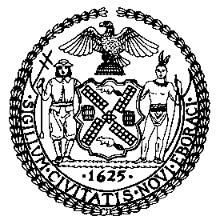

THE COUNCIL OF THE CITY OF NEW YORK

BRIEFING PAPER OF THE HUMAN SERVICES DIVISION
Andrea Vazquez, Legislative Director

COMMITTEE ON GENERAL WELFARE

Hon. Diana Ayala, Chair

February 28, 2022
OVERSIGHT: IMPACT OF THE EXPIRATION OF THE EVICTION MORATORIUMS

Introduction
On February 28, 2022, the Committee on General Welfare, chaired by Deputy Speaker Diana Ayala, will hold an oversight hearing to examine the City’s response to the expiration of the various eviction moratoriums issued by the state and federal governments to protect tenants from losing their housing during the COVID-19 pandemic. Expected to testify are representatives from the Department of Social Services (DSS), advocates, and members of the public.
Federal Eviction Moratoriums
The federal Coronavirus Aid, Relief, and Economic Security (CARES) Act, signed into law on March 27, 2020, imposed a temporary moratorium on all new eviction actions for nonpayment of rent and applied to dwellings with a federally backed mortgage loan. That federal eviction moratorium lasted for only 120 days, and expired on July 24, 2020. By early August, landlords started resuming eviction orders across the country.
In September 2020, the Centers for Disease Control and Prevention (CDC) issued an order under the Public Health Service Act to temporarily halt residential evictions in order to prevent the further spread of COVID-19. The CDC moratorium had a greater scope than the CARES Act and covered all renters who met certain criteria – regardless of whether their residence has a federally backed mortgage – and who submit a signed declaration to their landlords. However, on August 26, 2021, the Supreme Court ruled that the CDC eviction moratorium could not continue unless Congress specifically authorized it, thereby ending the federal moratorium.
New York State’s Eviction Moratorium and Rent Relief Programs
The New York State Tenant Safe Harbor Act, sponsored by State Senator Brad Hoylman and Assemblymember Jeffrey Dinowitz, which was signed into law by the Governor on June 30, 2020, prohibited housing courts from issuing warrants of eviction or judgments of possession against residential tenants who were unable to pay rent due the financial impact of COVD-19. On September 29, 2020, Governor Cuomo signed an Executive Order which broadened and extended the Safe Harbor Act protections through January 1, 2021. Under the Tenant Safe Harbor Act and the Executive Order, tenants who had experienced financial hardship any time after March 7, 2020, including those who were facing an eviction proceeding or who received a judgement or warrant of eviction prior to March 7, 2020, would not be evicted for failing to pay rent. The Tenant Safe Harbor Act was extended several times until it finally expired January 15, 2022. Although protection under the Tenant Safe Harbor Act may have prevented a landlord from evicting a tenant, a court could still allow the landlord to take other legal action to collect unpaid rent from the tenant. The Legal Aid Society has estimated that more than 200,000 New York City households were not covered by the law’s provisions.
On December 28, 2020, then-Governor Andrew M. Cuomo signed the COVID-19 Emergency Eviction and Foreclosure Prevention Act (CEEFPA) of 2020. The Act, sponsored by Senator Brian Kavanagh and Assemblymember Jeffrey Dinowitz, prevents residential evictions, foreclosure proceedings, credit discrimination and negative credit reporting related to the COVID-19 pandemic. The Act placed a moratorium on residential evictions until May 1, 2021, for tenants who had endured COVID-related hardship. Tenants had to submit a hardship declaration, or a document explaining the source of the hardship, to prevent evictions. Landlords could evict tenants that were creating safety or health hazards for other tenants, and those tenants who did not submit hardship declarations. In August 2021, the U.S. Supreme Court prohibited the enforcement of CEEFPA’s hardship declaration eviction protections on the grounds that they violated building owners’ due process rights. In response, Governor Kathy Hochul signed into law an amendment to CEEFPA that created a hearing process for owners to challenge the hardship declarations and extended the use of hardship declarations until January 15, 2022. CEEFPA has not been extended and has since expired.
On July 14, 2020, Governor Andrew Cuomo announced an emergency rental assistance program that provides direct aid for low-income tenants who lost income due to the COVID-19 pandemic. This program was administered by New York State Homes and Community Renewal (HCR) and funded through the Coronavirus Relief Fund, which is part of the CARES Act. More specifically, eligible households were provided with a one-time rental subsidy that was sent directly to the household’s landlord. Households could apply for up to four months of rental assistance. Applicants would not need to repay this assistance.
The program initially included strict eligibility guidelines requiring proof of a pre-pandemic rent burden. During the first round of federal rental assistance made available for New Yorkers, 61% of applicants were ineligible for the program. City residents received 86% of funding distributed through October 2020. The average grant totaled $2,415. On December 17, 2020, HCR announced the re-opening of the COVID Rent Relief Program with expanded eligibility criteria. Households were no longer required to have been rent burdened prior to the pandemic in order to qualify. HCR began accepting applications on December 18, 2020, and stopped receiving applications on February 1, 2021. HCR has not released any data on the second round of the emergency rental assistance program.
Emergency Rental Assistance Program (ERAP)
Across New York State, nearly 600,000 households owe back rent. Recent studies found that one-in-four low-income tenants are behind in their rent, with Black and Latino women facing the highest risk of eviction. To address the growing needs of tenants, in addition to the funding under the Rent Relief Program, New York State also administers the Emergency Rental Assistance Program (ERAP) through its Office of Temporary and Disability Assistance (OTDA). ERAP provides eligible renters in New York State with up to 12 months of rental arrears assistance, up to three months of prospective rental assistance, and up to 12 months of utility arrears assistance, regardless of immigration status. If a household is deemed eligible, payments are provided directly to the landlord/property owner and utility company on their behalf. Residents are eligible if they received unemployment benefits or experienced a reduction in income or an increase in expenses due to the pandemic, after March 13, 2020; and are in rental arrears for rent owned on or after March 13, 2020; and earn less than 80% of the area median income (AMI). Since OTDA began accepting applications on June 1, 2021, more than $680 million in federal funding has been either distributed or obligated via direct payments to landlords.
In November of 2021, Governor Kathy Hochul announced intentions to pause ERAP, as the state waits for additional allotment of federal aid to fund the program, with the majority of the New York State Congressional delegation signing on to a request for $1 billion in federal support to relaunch the program. As of September 2021, Governor Hochul announced new legislation to protect residential tenants and foreclosure protection, including an extension of the moratorium to 2022. Following a lawsuit brought by Legal Aid on behalf of renters, the New York state rent relief portal was reopened and OTDA continued to accept applications for assistance and as a replenishment of federal funding is expected in April.
As of February 8, 2022, 307,957 applications for assistance have been filed with OTDA and 116,968 payments were made. It should be noted that renters cannot be evicted from their homes if they have applied for ERAP, even if their application is yet to be processed. It is additionally estimated that $1.5 billion in payments were issued to landlords through February 8, 2022. In New York City specifically, over 87,000 payments were made with the average amount being $10,220.22.In January 2022, Governor Hochul announced that New York State requested an additional $1.6 billion from the U.S. Treasury Department to help fulfill the unmet need amount tenants and landlords who have applied for ERAP. If the request is granted, the funding would cover approximately 174,000 tenant applications that are not yet funded.
Department of Social Services Prevention Programs
One Shot Deals

The Human Resources Administration’s (HRA) “One Shot Deal” emergency assistance program helps people who cannot meet an expense due to an unexpected situation or event. Emergency assistance is provided for, but not limited to, homelessness, eviction or dispossession, utility disconnection or pending utility shut off, fire disaster, domestic violence, and circumstances that affect the health and safety of the individual or family. The program provides eligible tenants with a one-time rental subsidy from the COVID Rent Relief Program if a tenant is rent burdened, or if they lost, or had income reduced, between April 1 and July 31, 2020.
In April of 2020, the Council passed Local Law 56 of 2020. This legislation protects tenants from COVID-related harassment and discrimination with violations punishable by a civil penalty of $2,000 to $10,000. The City Council won a legal challenge to Local Law 56 by landlords who argued that the bill violated their constitutional rights. The District Court for the Southern District of New York rejected this claim and ruled that the legislation was “reasonable to balance the infringement of contractual rights” due to the public interest needs in the middle of the pandemic.

Homebase
Homebase is an HRA homelessness and shelter prevention network with 23 locations across the five boroughs where assistance is provided to help individuals develop a personalized plan to overcome an immediate housing crisis and achieve housing stability. Homebase services include services to prevent eviction, assistance obtaining public benefits, emergency rental assistance, education and job placement assistance, financial counseling and money management, help relocating and short-term financial assistance.
Households may be eligible for services if they are at imminent risk of entering the shelter system, are low-income, and wish to remain stably housed in their community. This includes those who have not previously experienced housing issues, those who have exited from shelter and require assistance with maintaining housing stability, and those looking to maintain employment and financial stability to ensure that they can remain stably housed.
Homebase staff can work with households whether they are amidst a housing crisis such as eviction or housing court proceedings, or whether they want to prevent a future crisis from happening. Households do not have to be in housing court to seek assistance from Homebase.
CityFHEPS
The City Fighting Homelessness and Eviction Prevention Supplement (CityFHEPS) program assists households in the community who are at risk of homelessness or are referred by the Administration for Children’s Services (ACS), the Three Quarter Housing (TQH) Task Force, the Department of Youth and Community Development (DYCD), or the Department of Correction (DOC) to avert HRA or Department of Homeless Services (DHS) shelter entry. It also helps households who are experiencing street homelessness or residing in a DHS or HRA shelter to obtain permanent housing. All households must meet an income limit—income no greater than 200% of the federal poverty level—and satisfy public assistance requirements. In addition, there are separate eligibility criteria for households at risk of entry to, and currently in, HRA and DHS shelters or experiencing street homelessness.
Right to Counsel
In 2017, the City Council passed Local Law 136, known as the Universal Access to Legal Services (UA) law, which tasks the Office of Civil Justice (OCJ) with providing free legal representation to tenants earning no more than 200% of the federal poverty level and who are facing either eviction in Housing Court or tenancy termination from New York City Housing Authority (NYCHA). Local Law 136 also requires OCJ to provide free limited legal assistance to tenants who earn more than 200% of the federal poverty level. The law mandates that OCJ implement these programs before Fiscal Year (FY) 2022.
To meet the law’s mandate of providing UA to low-income tenants, OCJ is gradually expanding the program throughout the city, adding coverage to individuals in approximately five zip codes each year. In order to choose the order by which zip codes are added to the program, OCJ consulted with New York City Housing Court, legal service providers, and other tenant advocates, and analyzed factors such as “shelter entries from the zip code; prevalence of rent-regulated housing; the volume of eviction proceedings; whether the area is already being served through other legal services programs; and other factors of need.”
As UA was phased in, evictions city wide decreased. Data available on OpenData shows a 30% decrease in evictions from February 2019 to February 2020.
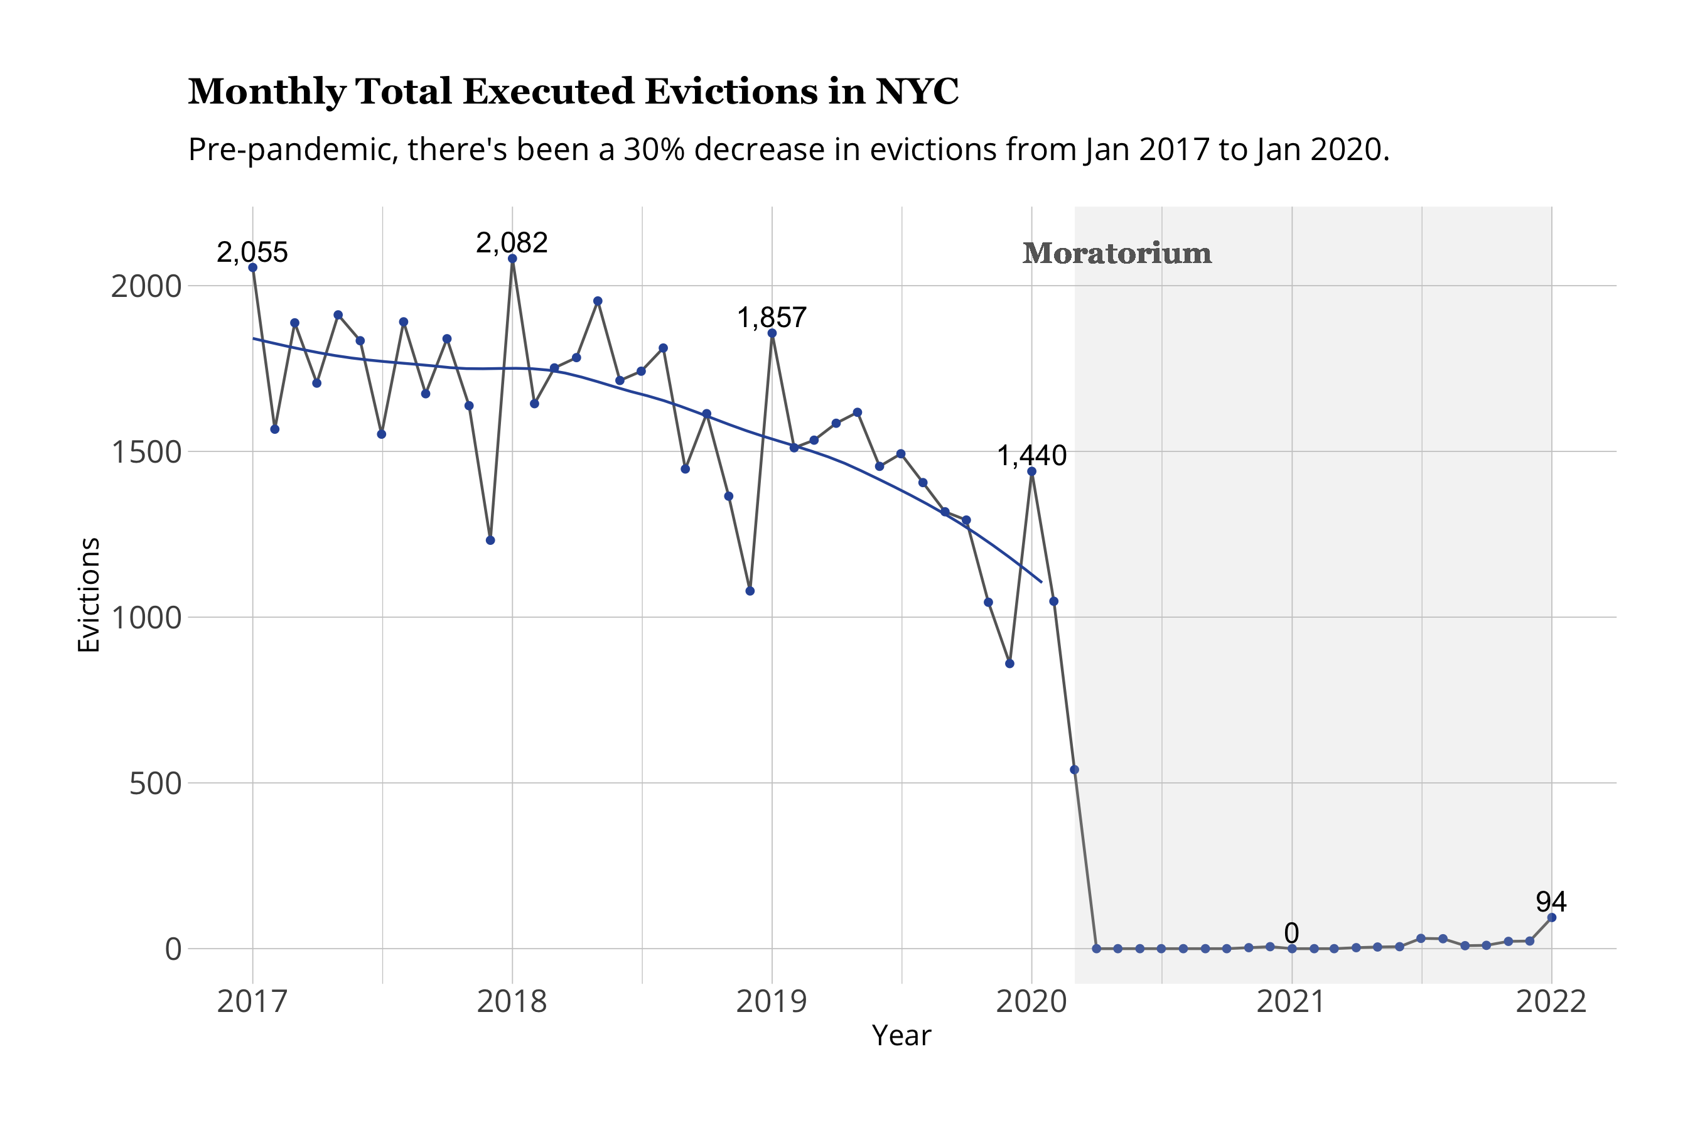
However, the overall impact of UA is hard to pinpoint because of the enactment of concurrent Albany rent reforms. The Housing Stability and Tenant Protection Act of 2019, enacted by the State Legislature in June of 2019, created more legal protections for tenants. According to a study conducted by the Legal Aid Society, evictions dropped by a total of 18.3% between June 2019 to January 2020. That decline was also inconsistent throughout the boroughs; Queens saw a 26.4% decrease in evictions and Manhattan saw a decline of 24.4%, while evictions in the Bronx, Staten Island, and Brooklyn only dropped by 15.2%, 14% and 13%, respectively.
Conclusion
At today’s hearing, the Committee will seek an overview of the City’s plan in response to the end of the state and federal eviction moratoriums to protect tenants from losing their housing and the potential influx of new clients in need of social services assistance.

See section 4022 of Public Law 116–136, available at https://www.congress.gov/bill/116th-congress/house-bill/748/text.
HUD HOME Investment Partnerships Program FAQs, available at https://www.hud.gov/sites/dfiles/CPD/documents/HOME-FAQs-COVID-19.pdf.
Matthew Goldstein, “Landlords jump the gun as eviction moratorium wanes,” The New York Times, July 23, 2020, available at https://www.nytimes.com/2020/07/23/business/evictions-moratorium-cares-act.html.
CDC Order, 85 Fed. Reg. 55292, "Temporary Halt in Residential Evictions to Prevent the Spread of COVID-19,” Sept. 4, 2020, available at https://www.federalregister.gov/documents/2020/09/04/2020-19654/temporary-halt-in-residential-evictions-to-prevent-the-further-spread-of-covid-19.
Id.
Adam Liptak and Glenn Thrush, “Supreme Court Ends Biden’s Eviction Moratorium.” The New York Times, August 26, 2021, available at https://www.nytimes.com/2021/08/26/us/eviction-moratorium-ends.html.
Chapter 127 of the Laws of New York, 2020, https://www.nysenate.gov/legislation/bills/2019/s8192/amendment/b; see also Caroline Spivack, “These are the protections New Yorkers have from eviction,” Curbed New York, Aug. 14, 2020, available at https://ny.curbed.com/2020/3/26/21192343/coronavirus-new-york-eviction-moratorium-covid-19.
Id.
Executive Order No. 202.66, “Continuing Temporary Suspension and Modification of Laws Relating to the Disaster Emergency,” Sept. 29, 2020 https://www.governor.ny.gov/sites/default/files/atoms/files/EO_202_66.pdf
Chapter 127 of the Laws of New York, 2020, https://www.nysenate.gov/legislation/bills/2019/s8192/amendment/b; Executive Order No. 202.66, https://www.governor.ny.gov/sites/default/files/atoms/files/EO_202_66.pdf
NYS Gov. Kathy Hochul, “Governor Hochul Signs New Moratorium on COVID-related Residential and Commercial Evictions into Law, Effective Through January 15, 2022,” Sept. 2 2021, https://www.governor.ny.gov/news/governor-hochul-signs-new-moratorium-covid-related-residential-and-commercial-evictions-law
Caroline Spivack, “Governor Cuomo’s ‘Moratorium’ on Evictions Won’t Really Stop Evictions,” Sept. 30, 2020 https://www.curbed.com/2020/09/nyc-eviction-moratorium-cuomo-tenants-landlords.html
Jane Wester, “New York Courts Extend Freeze on Execution of Residential Evictions Until October,” New York Law Journal, Aug. 12, 2020, https://www.law.com/newyorklawjournal/2020/08/12/new-york-courts-extend-freeze-on-execution-of-residential-evictions-until-october/.
Press Release, Governor Cuomo Signs the COVID-19 Emergency Eviction and Foreclosure Prevention Act of 2020, Dec. 28, 2020, https://www.governor.ny.gov/news/governor-cuomo-signs-covid-19-emergency-eviction-and-foreclosure-prevention-act-2020.
Id.
Id.
Id.
Id.
Greg Baltz, “Data Update: Analysis Of Renters At Risk As Eviction Moratorium Expires,” The Stoop: NYU Furman Center, Jan. 15th 2022, https://furmancenter.org/thestoop/entry/data-update-analysis-of-renters-at-risk-as-eviction-moratorium-expires; Chapter 127 of the Laws of New York, 2020, https://www.nysenate.gov/legislation/bills/2021/s50001
Press Release, Governor Cuomo Announces New COVID Rental Assistance Program, July 14, 2020, available at https://www.governor.ny.gov/news/governor-cuomo-announces-new-covid-rental-assistance-program.
Id.
Id.
Id.
Press Release, Governor Cuomo Announces New COVID Rental Assistance Program, July 14, 2020, available at https://www.governor.ny.gov/news/governor-cuomo-announces-new-covid-rental-assistance-program.
Id.
Office of the NYS Comptroller, “New York State Rent Relief Funding: Spotlight on New York City,” Aug. 2021, https://www.osc.state.ny.us/reports/osdc/new-york-state-rent-relief-funding-spotlight-new-york-city
Id.
Id.
Id.
Press Release, NYS Homes And Community Renewal Announces Expansion of Covid Rent Relief Program Through February 1, 2021, Dec. 17, 2020, available at https://hcr.ny.gov/news/nys-homes-and-community-renewal-announces-expansion-covid-rent-relief-program-through-february.
Id.
Id.
Office of the NYS Comptroller, “New York State Rent Relief Funding: Spotlight on New York City,” Aug. 2021, https://www.osc.state.ny.us/reports/osdc/new-york-state-rent-relief-funding-spotlight-new-york-city
Id.
National Equity Atlas. “Rent Debt in America: Stabilizing Renters is Key to Equitable Recovery,” available at https://nationalequityatlas.org/rent-debt.
Robin Hood Foundation & Center for Poverty & Social Policy at Columbia University, “Monitoring Poverty and Well-Being in NYC,” January 2022 available at https://robinhoodorg-wp-production.s3.amazonaws.com/uploads/2022/01/PT_2022_housing_report_FINAL.pdf
Office of the New York State Comptroller, “New York State Rent Relief Funding,” August 2021 available at https://www.osc.state.ny.us/reports/osdc/new-york-state-rent-relief-funding-spotlight-new-york-city
Id.
Id.
Id.
Cruz David and Elizabeth Kim, “New York to Suspend Rental Assistance Program As Hochul Asks for More Federal Aid” Gothamist, Nov. 12, 2021 available at https://gothamist.com/news/new-york-suspend-rental-assistance-program-hochul-asks-more-federal-aid.
Brand, David, “A Trickle of Tenants at Bronx Housing Court as Eviction Moratorium Ends” CityLimits, Jan. 19, 2022 available at https://citylimits.org/2022/01/19/a-trickle-of-tenants-at-bronx-housing-court-as-eviction-moratorium-ends/
NYS Office of Temporary and Disability Assistance, “New York State Emergency Rental Assistance Program Reports” available at https://otda.ny.gov/programs/emergency-rental-assistance/program-reports.asp.
Vaughn-Holdridge, Natasha “Renters Have Options After End of Eviction Moratorium” Columbia Greene Media, HudsonValley360, Feb 16, 2022 available at https://www.hudsonvalley360.com/news/columbiacounty/renters-have-options-after-end-of-eviction-moratorium/article_1ce6848d-2e4e-5225-b120-94d9a9a7e899.html
Id.
Id.
See One Shot Deal, https://portal.311.nyc.gov/article/?kanumber=KA-01104
Id.
ACCESS HRA FAQ, available at https://a069-access.nyc.gov/accesshra/#/
Local Law 56 for the year 2020, https://legistar.council.nyc.gov/LegislationDetail.aspx?ID=4425102&GUID=4A05D415-0BF2-4980-98A9-C0EABB57E397&Options=ID%7CText%7C&Search=torres.
See Melendez et al v. The City Of New York, Case Number: 1:20-cv-05301.
NYC Human Resources Administration, “Homebase Frequently Asked Questions,” available at https://www1.nyc.gov/site/hra/help/homebase-faqs.page.
Id.
Id.
Id.
Id.
Id.
Portions of this Committee Report are from the NYC Council’s Report “Our Homelessness Crisis: The Case for Change.” For full report see https://council.nyc.gov/data/homeless/.
R.C.N.Y. Title 68 Chapter 10-03.
R.C.N.Y. Title 68 § 10-01 (e).
A household must meet the following requirements with respect to public assistance. The household must apply for any assistance, if it is currently not in receipt of such. In addition, all household members who are eligible for public assistance must be in receipt of it and in compliance with public assistance requirements; R.C.N.Y. Title 68 Chapter 10 City FHEPS.
R.C.N.Y. Title 68 Chapter 10 City FHEPS.
Id.
Id.
NYC Office of Civil Justice 2018 Annual Report and Strategic Plan, NYC Human Resources Administration (the “2018 Report”), available at https://www1.nyc.gov/assets/hra/downloads/pdf/services/civiljustice/OCJ-Annual-Report-2018.pdf
Office of Civil Justice, Universal Access to Legal Services A Report on Year Two of Implementation in New York City, (“The 2019 Report”) Fall 2019, available at https://www1.nyc.gov/assets/hra/downloads/pdf/services/civiljustice/OCJ_UA_Annual_Report_2019.pdf
https://furmancenter.org/files/UAC_Policy_Brief_12_11-18.pdf
Id. at 7.
Data available at https://data.cityofnewyork.us/City-Government/Evictions/6z8x-wfk4. NYC Open Data Portal, Evictions Dataset, Provided by DOI
Oksana Mironova, NYC Right to Counsel: First year results and potential for expansion, Mar. 25, 2019, Community Service Society, https://www.cssny.org/news/entry/nyc-right-to-counsel.
New York Session Laws 2019, Chapter 36.
The Legal Aid Society, Evictions Down 20 Percent Due to Housing Reform, Right to Counsel, Jan. 6, 2020, https://www.legalaidnyc.org/news/evictions-down-20-percent-housing-reform-right-to-counsel/
Gabe Herman, Staying home: NYC evictions down nearly 20 percent after pro-tenant laws enacted, QNS.com, Jan. 7, 2020 available at https://qns.com/story/2020/01/07/staying-home-nyc-evictions-down-nearly-20-after-pro-tenant-laws-enacted/.

