THE COUNCIL OF THE CITY OF NEW YORK
RESOLUTION NO. 1868

Resolution approving with modifications the decision of the City Planning Commission on Application No. N 210409 ZRM, for an amendment of the text of the Zoning Resolution (Preconsidered L.U. No. 921).

By Council Members Salamanca and Moya

WHEREAS, RXR SL Owner, LLC and Terminal Fee Owner, LP, filed an application pursuant to Section 201 of the New York City Charter, for an amendment of the Zoning Resolution of the City of New York, establishing Subarea K within the Special West Chelsea District (Article IX, Chapter 8), and modifying other related Sections, which in conjunction with the related action would facilitate the long-term adaptive reuse of the existing Starrett-Lehigh building, located at 601 W 26th Street, and the Terminal Warehouse building, located at 261 Eleventh Avenue, Manhattan, Community District 4 (ULURP No. N 210409 ZRM) (the “Application”);

WHEREAS, the City Planning Commission filed with the Council on November 5, 2021, its decision dated November 3, 2021 (the “Decision”), on the Application;

WHEREAS, the Application is related to application C 210408 ZMM (Pre. L.U. No. 920), a zoning map amendment to change an M2-3 zoning district to an M2-4 zoning district and expand the Special West Chelsea District;

WHEREAS, the Decision is subject to review and action by the Council pursuant to Section 197-d of the City Charter;

WHEREAS, upon due notice, the Council held a public hearing on the Decision and Application on November 9, 2021;

WHEREAS, the Council has considered the land use implications and other policy issues relating to the Decision and Application; and

WHEREAS, the Council has considered the relevant environmental issues, including the Positive Declaration issued December 11th, 2020 (CEQR No. 21DCP103M). Significant adverse impacts related to hazardous materials and noise would be avoided through the placement of (E) designations (E-625) on selected projected and potential development sites as specified in Chapters 3 and 6, respectively of the Final Environmental Impact Statement (FEIS). The FEIS determined that the proposed actions would have significant adverse impacts with respect to transportation (traffic, transit and pedestrians). The identified significant adverse impacts and proposed mitigation measures under the proposed actions are summarized in Chapter 9, “Mitigation” of the FEIS. The Council has also considered the Technical Memorandum dated November 17, 2021.

RESOLVED:

Having considered the FEIS and Technical Memorandum with respect to the Decision and Application, the Council finds that:

- The FEIS meets the requirements of 6 N.Y.C.R.R. Part 617;

- The environmental impacts disclosed in the FEIS were evaluated in relation to the social, economic, and other considerations associated with the actions that are set forth in this report; and

- The adverse environmental impacts disclosed in the FEIS will be minimized or avoided to the greatest extent

The Decision, together with the FEIS and Technical Memorandum constitute the written statement of facts, and of social, economic and other factors and standards that form the basis of this determination, pursuant to 6 N.Y.C.R.R. §617.11(d).

Pursuant to Sections 197-d and 200 of the City Charter and on the basis of the Decision and Application, and based on the environmental determination and consideration described in the report, N 210409 ZRM, incorporated by reference herein, and the record before the Council, the Council approves the Decision of the City Planning Commission with the following modifications.

Matter underlined is new, to be added;
Matter struck out is to be deleted;
Matter double struck out is old, deleted by the City Council;
Matter double-underlined is new, added by the City Council;
Matter within # # is defined in Section 12-10;
* * * indicates where unchanged text appears in the Zoning Resolution.

ARTICLE I – GENERAL PROVISIONS

Chapter 4 – Sidewalk Cafe Regulations

* * *
14-44
Special Zoning Districts Where Certain Sidewalk Cafes Are Permitted
#Enclosed# or #unenclosed sidewalk cafes# shall be permitted, as indicated, in the following special zoning districts, where allowed by the underlying zoning. #Small sidewalk cafes# however, may be located on #streets# or portions of #streets# within special zoning districts pursuant to the provisions of Section 14-43 (Locations Where Only Small Sidewalk Cafes Are Permitted).

Manhattan | #Enclosed Sidewalk Cafe# | #Unenclosed Sidewalk Cafe#
* * * | * * * | * * *
West Chelsea District | No | Yes⁵

* * *
⁵ #Unenclosed sidewalk cafes# are allowed only on #wide streets# except they are not allowed on the west side of Ninth Avenue between West 15th Street and West 16th Street. #Unenclosed sidewalk cafes# shall also be allowed on West 27th Street between Eleventh Avenue and Joe DiMaggio Highway.

* * *

ARTICLE IX – SPECIAL PURPOSE DISTRICTS

Chapter 8 – Special West Chelsea District

98-00
GENERAL PURPOSES

* * *

98-04
Subareas and High Line Transfer Corridor

In order to carry out the provisions of this Chapter, Subareas A through J K and a #High Line Transfer Corridor# are established within the #Special West Chelsea District#.

* * *

98-10

SPECIAL USE AND PARKING REGULATIONS WITHIN THE SPECIAL WEST CHELSEA DISTRICT

* * *
98-12
Modification of Use Regulations

The #use# regulations of the underlying districts are modified by the provisions of this Section, inclusive.

* * *
98-122
Location within buildings
In Subarea K
[Relocated to Section 98-124 below]
In any C6 District in the #Special West Chelsea District#, the provisions of Section 32-422 (Location of floors occupied by commercial uses) are modified to permit #commercial uses# on the same #story# as a #residential use# or on a #story# higher than that occupied by #residential uses#, provided that the #commercial uses#:
(a) are located in a portion of the #building# that has separate direct access to the #street# with no access to the #residential# portion of the #building# at any #story#; and
(b) are not located directly over any portion of a #building# containing #dwelling units#, except this limitation shall not preclude the location of:
(1) #residential# lobby space below or on the same #story# as #commercial uses#; or
(2) a #commercial use# that fronts on the #High Line# and is located within five feet of the level of the #High Line bed#.

In Subarea K, the provisions of Section 42-10 (USES PERMITTED AS-OF-RIGHT), inclusive, shall be modified as follows:

- The following additional #uses# shall be permitted, provided that the floor space allocated to such #uses# does not exceed 25 percent of the total #floor area# of the #building#:

- from Use Groups 3 and 4, all #uses#, not otherwise permitted by the underlying regulations, other than those with sleeping accommodations;

- from Use Group 6A, food stores, including supermarkets, grocery stores or delicatessen stores, larger than 10,000 square feet;

- from Use Groups 6C, 9A, and 12B, all #uses# not otherwise permitted by the underlying regulations; or

- from Use Group 10A, all #uses#, not otherwise permitted by the underlying regulations, provided that the floor space allocated to such #uses# does not exceed 15 10 percent of the total #floor area# of the #building#.

98-123

Adult establishments
* * *

98-124

Location within buildings

[Relocated from Section 98-122 above]

In any C6 District the #Special West Chelsea District#, the provisions of Section 32-422 (Location of floors occupied by commercial uses) are modified to permit #commercial uses# on the same #story# as a #residential use# or on a #story# higher than that occupied by #residential uses#, provided that the #commercial uses#:

- are located in a portion of the #building# that has separate direct access to the #street# with no access to the #residential# portion of the #building# at any #story#; and

- are not located directly over any portion of a #building# containing #dwelling units#, except this limitation shall not preclude the location of:

- #residential# lobby space below or on the same #story# as #commercial uses#; or

- a #commercial use# that fronts on the #High Line# and is located within five feet of the level of the #High Line bed#.

* * *

98-15
Signs
* * *

98-151

Modification of sign regulations in Subarea K

Within Subarea K, the #sign# regulations of the underlying district shall apply. However, within 15 feet of the intersection of two #streets#, the provisions of Section 42-562 (Restriction on angle and height above curb level) shall not apply.

* * *

98-17
Modification of Parking and Loading Regulations in Subareas H

[Relocated to Section 98-171 below]

#Accessory# off-street parking spaces for existing or new governmental offices may be located on a #zoning lot# other than the same #zoning lot# as the #use# to which such spaces are #accessory#, provided that:

- such spaces are located within Subarea H and in a facility, or portion thereof, that is entirely below #curb level#;

- the portion of such facility beneath the required public plaza area shown on Diagram 3 in Appendix A of this Chapter is sufficiently below #curb level# so that trees may be planted at #curb level# within such public plaza but is in no case less than four feet below #curb level#; and

- no more than 377 spaces are provided within such facility. For purposes of this Section, the governmental offices on #Block# 688, Lots 1001-1002, as of June 23, 2005, may have up to 377 #accessory# off-street parking spaces in such facility.

The underlying provisions of Article III, Chapter 6 and Article IV, Chapter 4 (Accessory Off-street Parking and Loading Regulations) shall apply within the #Special West Chelsea District#, subject to modification by the regulations of this Section, inclusive.

98-171

Parking regulations in Subarea H

[Relocated from Section 98-17 above]

#Accessory# off-street parking spaces for existing or new governmental offices may be located on a #zoning lot# other than the same #zoning lot# as the #use# to which such spaces are #accessory#, provided that:

(a) such spaces are located within Subarea H and in a facility, or portion thereof, that is entirely below #curb level#;

(b) the portion of such facility beneath the required public plaza area shown on Diagram 3 in Appendix A of this Chapter is sufficiently below #curb level# so that trees may be planted at #curb level# within such public plaza but is in no case less than four feet below #curb level#; and

(c) no more than 377 spaces are provided within such facility.

For purposes of this Section, the governmental offices on #Block# 688, Lots 1001-1002, as of June 23, 2005, may have up to 377 #accessory# off-street parking spaces in such facility.

98-172

Waiver of accessory off-street loading berths in Subarea K

In Subarea K, the provisions of Section 44-52 (Required Accessory Off-street Loading Berths) shall not apply to changes of #use#.

* * *

98-20
FLOOR AREA AND LOT COVERAGE REGULATIONS

* * *

98-22

Maximum Floor Area Ratio and Lot Coverage in Subareas

For all #zoning lots#, or portions thereof, located in Subareas A through J K, the maximum #floor area ratios#, #open space ratios# and #lot coverages# of the applicable underlying district shall not apply. In lieu thereof, the maximum #floor area ratio# permitted for #commercial#, #community facility# and #residential uses#, separately or in combination, shall be as specified in the table in this Section. For #residential use#, the maximum #lot coverage# shall be 70 percent for #interior# or #through lots# and no maximum #lot coverage# shall apply to any #corner lot#. For the #conversion# to #dwelling units# of non-#residential floor area# where the total #residential floor area# on the #zoning lot# will exceed the applicable basic maximum #floor area ratio# specified in the table in this Section, such excess #residential floor area# shall only be permitted pursuant to Section 98-26 (Modifications of Inclusionary Housing Program).
MAXIMUM FLOOR AREA RATIO BY SUBAREA

Sub-area | Basic #floor area ratio# (max) | Increase in FAR from #High Line Transfer Corridor# (98-30) | Increase in FAR with #High Line# Improvement Bonuses (98-25) | Inclusionary Housing |  | Permitted #floor area ratio# (maximum)
 |  |  |  | FAR required to be transferred ¹ (minimum) | Increase in FAR for Inclusionary Housing Program (98-26) | Permitted #floor area ratio# (maximum)
A | 6.5 | 2.65 | — ² | 2.65 | 2.85 | 12.0
B | 5.0 | 2.5 | — ² | 1.25 | 1.25 | 7.5
C | 5.0 | 2.5 | NA | 1.25 | 1.25 | 7.5
D⁵ | 5.0 | 2.5 ³ | 2.5 ³ | 1.25 | 1.25 | 7.5
E | 5.0 | 1.0 ³ | 1.0 ^{2,3} | NA | NA | 6.0
F | 5.0 | NA | NA | NA | NA | 5.0
G | 5.0 | 1.0 ³ | 1.0 ³ | NA | NA | 6.0
H | 7.5 | NA | 2.5 | NA | NA | 10.0
I | 5.0 | 2.5 | NA | 1.25 | 1.25 | 7.5
I ⁴ | 5.0 | NA | 2.5 | NA | NA | 7.5
J ⁶ | 5.0 | NA | 2.5 | NA | NA | 7.5
K | 5.0 | NA | NA | NA | NA | 5.0

- Minimum #floor area ratios# required to be transferred pursuant to Section 98-30 (HIGH LINE TRANSFER CORRIDOR), inclusive, before Inclusionary Housing #floor area# bonus can be utilized

- In Subareas A, B, and E, the applicable maximum basic #floor area ratio# of that portion of the #zoning lot# that is within the #High Line Transfer Corridor# may be increased up to a maximum of 1.0, and the applicable maximum permitted #floor area ratio# increased accordingly, by certification of the Chairperson of the City Planning Commission, pursuant to Section 98-35 (High Line Transfer Corridor Bonus)

- For certain zoning lots located in Subareas D, E and G, the provisions of Section 98-25 (High Line Improvement Bonus) may apply in lieu of the provisions of Section 98-30, subject to the provisions of Section 98-241 (In Subareas D, E and G)

- For #zoning lots# over which the #High Line# passes

- For #zoning lots# between West 22nd Street and West 24th Street, the #floor area ratios# shall be 7.5, and no #floor area# increases shall be permitted

- Bonus contribution subject to provisions of Section 98-25 governing first contribution to Affordable Housing Fund

* * *
98-40
SPECIAL YARD, HEIGHT AND SETBACK, AND MINIMUM DISTANCE BETWEEN BUILDINGS REGULATIONS

* * *
98-42
Special Height and Setback Regulations

* * *
98-423
Street wall location, minimum and maximum base heights and maximum building heights

The provisions set forth in paragraph (a) of this Section shall apply to all #buildings or other structures#. Such provisions are modified for certain subareas as set forth in paragraphs (b) through (g) (h) of this Section.

* * *
(g) Subarea J

The provisions set forth in paragraph (a) of this Section shall not apply to any #development# or #enlargement# that utilizes the provisions of Section 98-25. In lieu thereof, the provisions of this paragraph (g) shall apply.

* * *
- Tenth Avenue Zone

The Tenth Avenue Zone shall be that portion of a #zoning lot# within 200 feet of the Tenth Avenue #street line#. Within the Tenth Avenue Zone, any portion of a #building# shall have a maximum #street wall# height of 185 feet before setback and a maximum #building# height of 230 feet, provided that any portion of a #building# located above a height of 90 feet shall be set back not less than 15 feet from the Tenth Avenue #street line#. Any portion of a #building# located above a height of 185 feet shall be set back at least 10 feet from the West 15th and West 16th Street #street lines#, and at least 25 feet from the Tenth Avenue #street line#. Any portion of a #building# above a height of 200 feet shall be set back at least 25 feet from the West 15th and West 16th Street #street lines#, and at least 35 feet from the Tenth Avenue #street lines#, and any portion of a building located above a height of 215 feet shall be set back at least 75 feet from the Tenth Avenue #street line#. Permitted obstructions allowed pursuant to Section 33-42 shall be permitted.

(h) Subarea K

The provisions set forth in paragraph (a) of this Section shall not apply. In lieu thereof, the provisions of the underlying zoning districts shall apply.

MINIMUM AND MAXIMUM BASE HEIGHT AND MAXIMUM BUILDING HEIGHT
BY DISTRICT OR SUBAREA

District or Subarea |  | Minimum Base Height (in feet) | Maximum Base Height (in feet) | Maximum #Building#  Height (in feet)
M1-5 |  | 50 | 95 | 135
Subarea A | within 50 feet of a #wide street# | 60 | 85 | ____¹
Subarea A | between 50 and 100 feet of a #wide street# | 15 | 85 | ____¹
Subarea A | for #zoning lots# with only #narrow street# frontage | 40 | 60 | ____¹
Subarea B |  | 60 | 95 | 135
Subarea C | for #zoning lots# with only #narrow street# frontage | 60 | 110 | 110
Subarea C | for #zoning lots# with Tenth Avenue frontage | 105² | 125² | 125²
Subarea C | for #zoning lots# with Eleventh Avenue frontage | 125² | 145² | 145²
Subarea D |  | 60 | 90 | 250¹
Subarea E |  | 60 | 105³ | 120³
Subarea F |  | 60² | 80² | 80²
Subarea G | for #zoning lots# with only #narrow street# frontage | 60 | 95 | 95
Subarea G | for #zoning lots# with #wide street# frontage | 105² | 120² | 120²
Subarea H |  | 60⁴ | 85⁴ | —⁴
Subarea I | within 300 feet of Tenth Avenue between W. 16th St. & W. 17th St. | 60 | 85 | 120⁵
Subarea I | all other areas | 60 | 105 | 135
Subarea J | Midblock Zone | NA | 110⁶ | 130⁶
Subarea J | Ninth Avenue Zone | NA | 130⁶ | 135⁶
Subarea J | Tenth Avenue Zone | NA | 185⁶ | 230⁶
Subarea K |  | NA⁷ | NA⁷ | NA⁷

- See Section 98-423, paragraph (b)

- See Section 98-423, paragraph (c)

- See Section 98-423, paragraph (d)

- See Section 98-423, paragraph (e)

- See Section 98-423, paragraph (f)

- See Section 98-423, paragraph (g)

- See Section 98-423, paragraph (h)

* * *

Appendix A
Special West Chelsea District and Subareas

[EXISTING MAP]

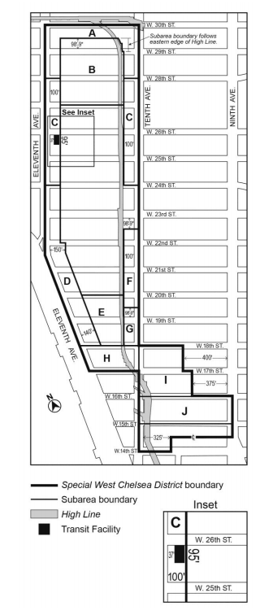
[PROPOSED MAP]

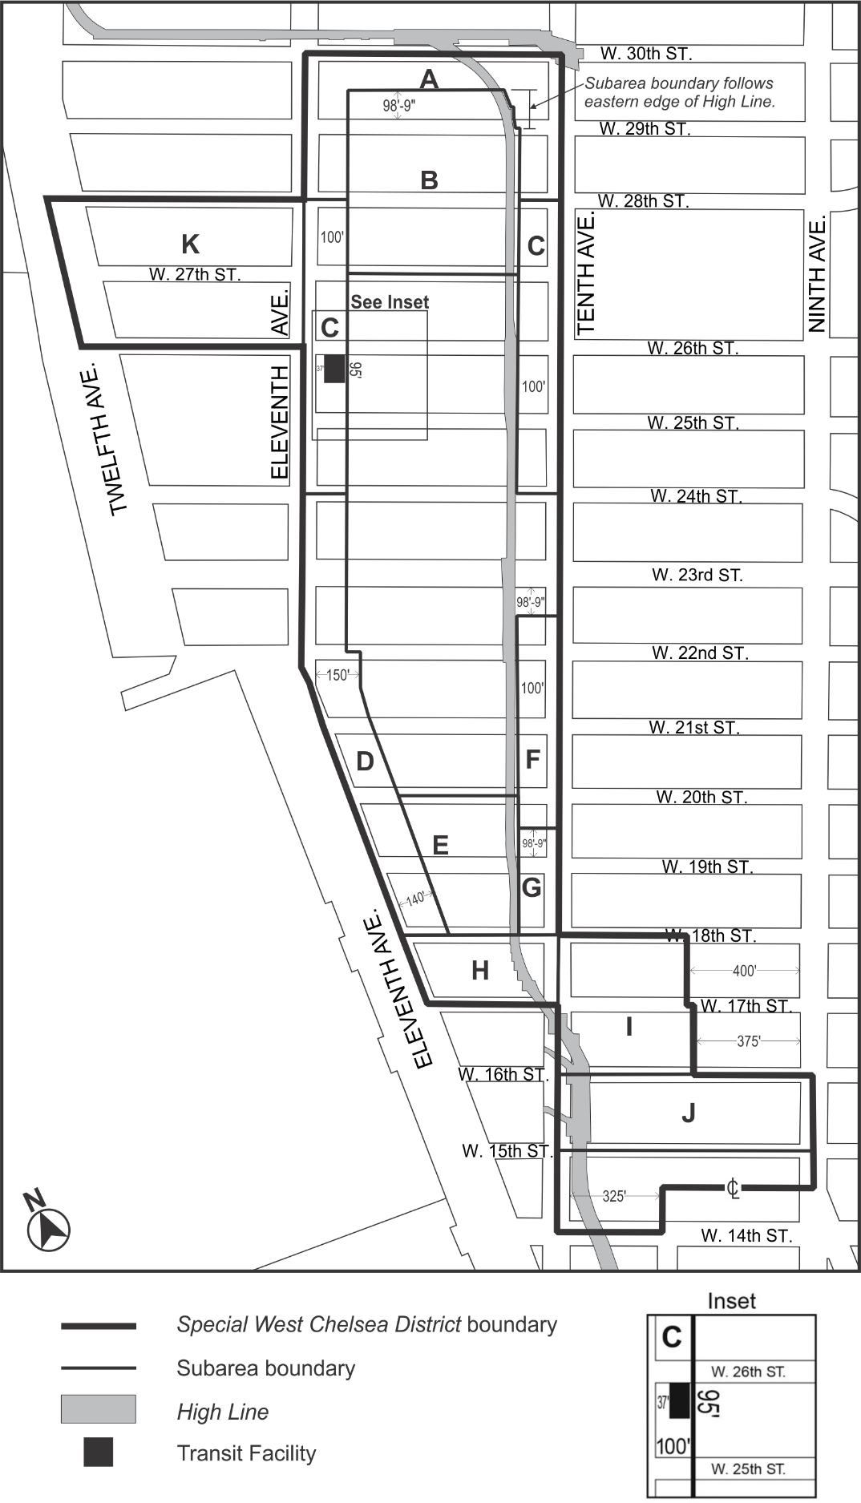
Appendix B
High Line Transfer Corridor Location

[EXISTING MAP]
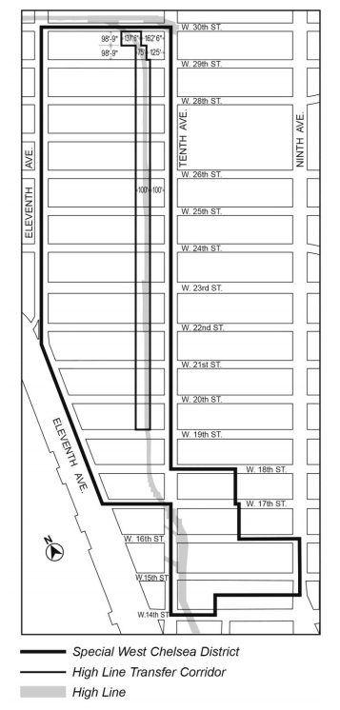
[PROPOSED MAP]

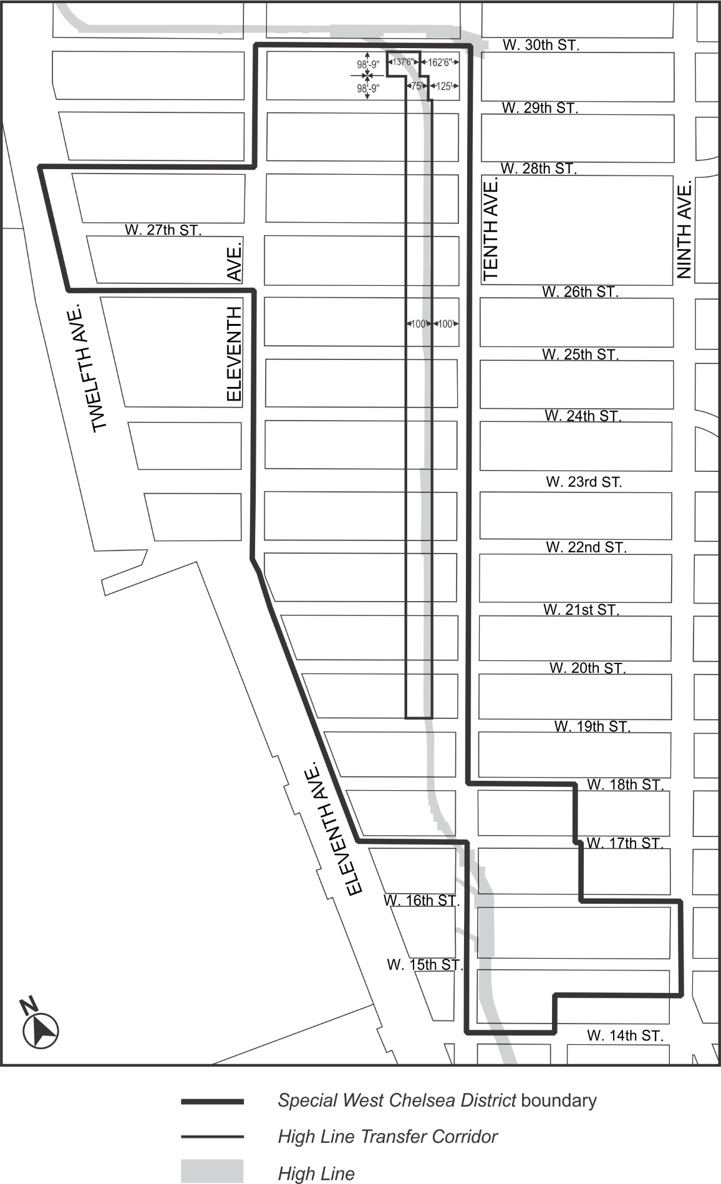

* * *

Adopted.

Office of the City Clerk, }
The City of New York, } ss.:

I hereby certify that the foregoing is a true copy of a Resolution passed by The Council of The City of New York on ______________, 2021, on file in this office.

.....................................................
City Clerk, Clerk of The Council

