THE COUNCIL OF THE CITY OF NEW YORK
RESOLUTION NO. 1764

Resolution approving the decision of the City Planning Commission on Application No. N 130077 ZRM, for an amendment of the Zoning Resolution of the City of New York, creating a new special district as Article XIII, Chapter 3 (Special Southern Roosevelt Island District) for the Cornell NYCTech proposal in Community District 8, Borough of Manhattan (L.U. No. 798).

By Council Members Comrie and Weprin

WHEREAS, the City Planning Commission filed with the Council on March 22, 2013 its decision dated March 20, 2013 (the "Decision"), pursuant to Section 201 of the New York City Charter, regarding an application submitted by Cornell University and the New York City Economic Development Corporation to create a new special district as Article XIII, Chapter 3 (Special Southern Roosevelt Island District) for the Cornell NYCTech proposal, to facilitate the development of a 2.1 million square foot academic and commercial research campus on the southern part of Roosevelt Island. The program for the proposed development is expected to include classroom space as well as office, retail, residential, utility, and hotel use. The project would also allow for 2.5 acres of publicly-accessible open space, (Application No. N 130077 ZRM), Community District 8, Borough of Manhattan (the "Application");

WHEREAS, the Application is related to applications C 130007 MMM (L.U. No. 796), a proposed amendment to the City Map involving the establishment of a 50-foot right-of-way encircling the campus; C 130076 ZMM (L.U. No. 797), a proposed amendment to the Zoning Map, Section Nos. 8d and 9b, changing the zoning designation of certain property from an R7-2 District to a C4-5 District and establishing a Special Southern Roosevelt Island District; and C 130078 PPM (L.U. No. 799), a disposition of city-owned property (Block 1373, Lot 20 and part of Lot 1) by the New York City Department of Citywide Administrative Services (DCAS) to the New York City Land Development Corporation (LDC);

WHEREAS, the Decision is subject to review and action by the Council pursuant to Section 197-d(b)(1) of the City Charter;
WHEREAS, upon due notice, the Council held a public hearing on the Decision and Application on April 30, 2013;

WHEREAS, the Council has considered the land use implications and other policy issues relating to the Decision and Application; and

WHEREAS, the Council has considered the relevant environmental issues and the Final Environmental Impact Statement (“FEIS”) for which a Notice of Completion was issued on March 8, 2013 (CEQR No. 12DME004M);

RESOLVED:

Having considered the FEIS with respect to the Decision and Application, the Council finds that:

- The FEIS meets the requirements of 6 N.Y.C.R.R. Part 617;

- Consistent with social, economic, and other essential considerations, from among the reasonable alternatives thereto, the action is one which minimizes or avoids adverse environmental impacts to the maximum extent practicable; and

- The adverse environmental impacts disclosed in the FEIS will be minimized or avoided to the maximum extent practicable by incorporating as conditions to the approval, in accordance with an environmental commitment letter, dated March 19, 2013, from Cornell and acknowledged and accepted by EDC, those project components related to the environment and mitigation measures that were identified as practicable; and

(4) The Decision together with the FEIS constitute the written statement of facts, and of social, economic and other factors and standards, that form the basis of the decision, pursuant to 6 N.Y.C.R.R. §617.11(d).

Pursuant to Sections 197-d and 200 of the City Charter and on the basis of the Decision and Application, and based on the environmental determination and consideration described in this report, N 130077 ZRM, incorporated by reference herein, the Council approves the Decision.

The Zoning Resolution of the City of New York, effective as of December 15, 1961, and as subsequently amended, is further amended as follows:

Matter in underline is new, to be added;
Matter in strikeout is old, to be deleted;
Matter in # # is defined in Section 12-10;
* * * indicate where unchanged text appears in the Zoning Resolution

* * *

11-12
Establishment of Districts

* * *

Establishment of the Special Southern Hunters Point District

* * *

Establishment of the Special Southern Roosevelt Island District

In order to carry out the special purposes of this Resolution as set forth in Article XIII, Chapter 3, the #Special Southern Roosevelt Island District# is hereby established.

* * *

12-10
Definitions

* * *

Establishment of the Special Southern Hunters Point District

* * *

The “Special Southern Roosevelt Island District” is a Special Purpose District designated with the letters “SRI” in which regulations set forth in Article XIII, Chapter 3, apply. The #Special Southern Roosevelt Island District# appears on #zoning maps# superimposed on other districts and, where indicated, its regulations supplement, modify and supersede those of the districts on which it is superimposed.

* * *

Article XIII – Special Purpose Districts

Chapter 3
Special Southern Roosevelt Island District

* * *
133-00
GENERAL PURPOSES

The #Special Southern Roosevelt Island District# established in this Resolution is designed to promote and protect public health, safety and general welfare. These general goals include, among others, the following specific purposes:

- providing opportunities for the development of an academic and research and development campus in a manner that benefits the surrounding community;

- allowing for a mix of residential, retail, and other commercial uses to support the academic and research and development facilities and complementing the urban fabric of Roosevelt Island;

- establishing a network of publicly accessible open areas that take advantage of the unique location of Roosevelt Island and that integrate the academic campus into the network of open spaces on Roosevelt Island and provide a community amenity;

- strengthening visual and physical connections between the eastern and western shores of Roosevelt Island by establishing publicly accessible connections through the Special District and above grade view corridors;

- encouraging alternative forms of transportation by eliminating required parking and placing a maximum cap on permitted parking;

- providing flexibility of architectural design within limits established to assure adequate access of light and air to the street and surrounding waterfront open areas, and thus to encourage more attractive and innovative building forms; and

- promoting the most desirable use of land in this area and thus conserving the value of land and buildings, and thereby protect the City’s tax revenues.

133-01
Definitions

Definitions specifically applicable to this Chapter are set forth in this Section and may modify definitions set forth in Section 12-10 (DEFINITIONS). Where matter in italics is defined both in Section 12-10 and in this Chapter, the definitions in this Chapter shall govern.

Base Plane

The definition of “base plane” is hereby modified to mean elevation 19.0, which elevation reflects the measurement in feet above Belmont Island Datum, which is 2.265 feet below the mean sea level at Sandy Hook, NJ.

Development Parcel

The “Development Parcel” shall mean all of the property located within the boundaries of the #Loop Road#, as shown on Map 1 in Appendix A of this Chapter. The #Development Parcel# shall be deemed a single #zoning lot# for the purpose of applying all regulations of this Resolution.

Loop Road

The “Loop Road” shall be comprised of the East Loop Road, the North Loop Road, the South Loop Road, and the West Loop Road, as shown on Map 1 in Appendix A of this Chapter. All such roads shall be deemed separate #streets# for the purposes of applying all regulations of this Chapter and shall not generate #floor area#.

133-02
General Provisions

The provisions of this Chapter shall apply within the #Special Southern Roosevelt Island District#. The regulations of all other Chapters of this Resolution are applicable, except as superseded, supplemented or modified by the provisions of this Chapter. In the event of a conflict between the provisions of this Chapter and other regulations of this Resolution, the provisions of this Chapter shall control.

133-03
District Plan and Maps

The regulations of this Chapter are designed to implement the #Special Southern Roosevelt Island# District Plan.

The District Plan includes the following maps:

Map 1 – Special Southern Roosevelt Island District, Development Parcel, and Loop Road

Map 2 – Public Access Areas

The Maps are located in Appendix A of this Chapter and are hereby incorporated and made part of this Resolution. The Maps are incorporated for the purpose of specifying locations where the special regulations and requirements set forth in the text of this Chapter apply.

133-04
Applicability of Article III, Chapter 6 (Accessory Off-Street Parking and Loading Regulations)

The provisions of Article III, Chapter 6 (Accessory Off-Street Parking and Loading Regulations) shall not apply in the #Special Southern Roosevelt Island District#. In lieu thereof, a maximum of 500 #accessory# parking spaces shall be permitted, which may be made available for public use.

However, bicycle parking shall be provided in accordance with the provisions of Section 36-70 (BICYCLE PARKING).

133-05
Applicability of Special Regulations Applying in the Waterfront Area

The provisions of Article VI, Chapter 2 (Special Regulations Applying in the Waterfront Area) shall not apply in the #Special Southern Roosevelt Island District#. In lieu thereof, the area between the shoreline and the western #street line# of the #West Loop Road# and the area between the shoreline and the eastern #street line# of the #East Loop Road# shall be used exclusively for open recreational uses, and shall be accessible to the public at all times.

133-10
SPECIAL USE REGULATIONS

133-11
Additional Uses

Within the #Development Parcel#, the provisions of Section 32-10 (Uses Permitted As-Of-Right) are modified to permit Use Group 17B research, experimental or testing laboratories. Any Use Group 17B #uses# within the #Development Parcel# shall conform with the performance standards of Section 42-20 (Performance Standards), inclusive, applicable to such #use# as in an M1 zoning district.

133-12

Location within buildings

Within the #Development Parcel#, the provisions of Section 32-422 (Location of floors occupied by commercial uses) shall not apply.

133-20

SPECIAL BULK REGULATIONS

Within the #Development Parcel#, the special #bulk# regulations of this Section 133-20, inclusive, shall apply.

133-21
Floor Area Ratio

The #floor area# provisions of Section 23-14 (Minimum Required Open Space, Open Space Ratio, Maximum Lot Coverage and Maximum Floor Area Ratio), shall be modified to permit a maximum #residential floor area ratio# of 3.44 without regard to #height factor#. In addition, the maximum permitted #floor area ratio# for a Use Group 17B research, experimental or testing laboratory shall be 3.40.

133-22
Lot Coverage

The #open space ratio# requirements of Section 23-14 (Minimum Required Open Space, Open Space Ratio, Maximum Lot Coverage and Maximum Floor Area Ratio), and the #lot coverage# requirements of Sections 23-14 (Minimum Required Open Space, Open Space Ratio, Maximum Lot Coverage and Maximum Floor Area Ratio) and 24-11(Maximum Floor Area Ratio and Percentage of Lot Coverage) shall not apply. In lieu thereof, the aggregate #lot coverage# for all #buildings# shall comply with the following:

(a) The maximum #lot coverage# from the #base plane# to a height that is 20 feet above the #base plane# shall be 70 percent.

(b) The maximum #lot coverage# from a height that is more than 20 feet above the #base plane# to a height that is 60 feet above the #base plane# shall be 60 percent.

(c) The maximum #lot coverage# from a height that is more than 60 feet above the #base plane# to a height that is 180 feet above the #base plane# shall be 45 percent.

(d) The maximum #lot coverage# above a height of 180 feet above the #base plane# shall be 25 percent.

The City Planning Commission may authorize an increase in the maximum #lot coverage# as set forth in paragraph (c) of this section to up to 55%, upon finding that such increase is necessary to achieve the programmatic requirements of the development, and will not unduly restrict access of light and air to publicly accessible areas and #streets#.

133-23
Height and Setback

The height and setback regulations of Sections 23-60, 24-50, and 33-40 shall apply except as modified by this Section. All heights shall be measured from the #base plane.#

133-231
Modification of height and setback controls

#Buildings or other structures# may exceed the underlying height and setback regulations for a percentage of the length of each #street line# of the #Loop Road# as follows:

(a) #North Loop Road#: 65 percent

(b) #East Loop Road#: 35 percent

(c) #West Loop Road#: 35 percent

(d) #South Loop Road#: 65 percent

Furthermore, the #street line# length percentage limitations set forth in paragraphs (a) through (d) of this Section may be exceeded by one percentage point for every two percentage points that the #lot coverage# within 50 feet of a #street line# is less than the following percentage:

- #North Loop Road#: 50 percent

- #East Loop Road#: 30 percent

- #South Loop Road#: 50 percent

- #West Loop Road#: 30 percent

All portions of #buildings or other structures# that exceed the underlying height and setback regulations in accordance with this Section shall comply with the height regulations of Section 133-232.

133-232
Height regulations

For the portion of any #building or other structure# exceeding the height and setback controls set forth in Section 133-231, the maximum height of such portion located within 500 feet of the #North Loop Road# shall be 320 feet, exclusive of permitted obstructions allowed by the underlying height and setback regulations, and the maximum height for any such portion on the remainder of the #Development Parcel# shall be 280 feet, exclusive of such permitted obstructions.

133-233
Maximum area of stories above a height of 180 feet

The gross area of any #story# located entirely above a height of 180 feet shall not exceed 15,000 square feet. Where a single #building# has two or more portions located above 180 feet that are entirely separate from one another above such height, each such portion shall not exceed a gross area of 15,000 square feet for any #story# located in whole or part above 180 feet.

133-234
Permitted Obstructions

Sections 23-51 (Permitted Obstructions), 24-62 (Permitted Obstructions) and 33-42 (Permitted Obstructions) shall be modified to allow #accessory# energy generating systems on the roof of a #building#, or any other structures supporting such systems, as permitted obstructions, without limitations.

133-24
Distance Between Buildings

The requirements of Sections 23-70 (Minimum Required Distance Between Two or More Buildings on a Single Zoning Lot) and 23-82 (Building Walls Regulated by Minimum Spacing Requirements) shall not apply, provided that if two or more #buildings# or portions of #buildings# are detached from one another at any level, such #buildings#, or such detached portions of #buildings# shall at no point be less than eight feet apart at or below a height of 180 feet, and shall at no point be less than 60 feet apart above a height of 180 feet.

133-25
Modification of Bulk Regulations

Within the #Special Southern Roosevelt Island District#, the City Planning Commission may, by special permit, allow a modification of the #bulk# regulations of this Chapter and the underlying #bulk# regulations, except #floor area# regulations, provided the Commission finds that:

(a) such modifications are necessary to achieve the programmatic requirements of the academic and research and development campus;

(b) such distribution of #bulk# will result in better site planning and will thus benefit both the residents, occupants or users of the #Special Southern Roosevelt Island District# and the surrounding neighborhood;

(c) such distribution of #bulk# will permit adequate access of light and air to surrounding public access areas, #streets# and properties; and

(d) that such distribution of #bulk# will not unduly increase the #bulk# of #buildings# in the #Special Southern Roosevelt Island District#, to the detriment of the occupants or users of #buildings# in the #Special Southern Roosevelt Island District# or on nearby #blocks#.

133-30
PUBLIC ACCESS AREAS
At least 20 percent of the #lot area# of the #Development Parcel# shall be publicly accessible and shall include, but need not be limited to, a Central Open Area, a North-South Connection, and a Waterfront Connection Corridor, the size and location requirements for which are set forth in Section 133-31. Any supplemental public access areas provided in order to meet the minimum public access #lot area# requirements of this Section shall comply with the requirements of paragraph (d) of Section 133-31. Design and operational standards for such public access areas are set forth in Section 133-32.

133-31
Size and Location of Public Access Areas

- Central Open Area

A Central Open Area shall front upon the #West Loop Road# for a minimum linear distance of 150 feet and be located at least 300 feet south of the #North Loop Road#, and at least 300 feet north of the #South Loop Road#. The Central Open Area shall be at least 30,000 square feet in area, with no portion having a dimension less than 20 feet in all directions counting towards such minimum area.

- North-South Connection

A continuous pedestrian connection shall be provided through the #Development Parcel# from the #North Loop Road#, or from the #West Loop Road# or #East Loop Road# within 200 feet of the #North Loop Road#, to the #South Loop Road#, or to the #West Loop Road# or #East Loop Road# within 200 feet of the #South Loop Road#. Such North-South connection shall have a minimum width of 50 feet throughout its required length. The North-South Connection shall include at least one segment with a minimum length of 300 feet located more than 100 feet from both the #West Loop Road# and #East Loop Road#.

The North-South Connection shall connect to the Central Open Area either directly, or through a supplemental public access area having a minimum width of 30 feet. In the event that the North-South Connection traverses the Central Open Area, the area within the North-South Connection, as determined by its length and minimum required width shall not be included in the 30,000 square foot minimum area of the Central Open Area.

There shall be at least one publicly accessible connection from each of the #East Loop Road# and the #West Loop Road# to the North-South Connection. Such connections shall have a minimum width of 30 feet, and shall be located a minimum of 300 feet south of the #North Loop Road# and a minimum of 300 feet north of the #South Loop Road#. In addition, such connections may be coterminous with the Waterfront Connection Corridor required by paragraph (c) of this Section.

- Waterfront Connection Corridor

A Waterfront Connection Corridor shall be provided through the #Development Parcel# allowing for pedestrian access between the western boundary of the #East Loop Road# and either the eastern boundary of the #West Loop Road# or the eastern boundary of the Central Open Area. Such corridor shall be located in its entirety in the area located 300 feet south of the #North Loop Road# and 300 feet north of the #South Loop Road#. The Waterfront Connection Corridor shall have a minimum width of 30 feet.

- Supplemental Public Access

Supplemental public access areas may be located anywhere within the #Development Parcel#, provided such areas have a minimum dimension of 20 feet in all directions and connect directly to one or more of the #Loop Roads#, the North-South Connection, the Central Open Space, and the Waterfront Connection Corridor.

133-32
Design Requirements for Public Access Areas

- Level of public access areas and limits on coverage

At least 80 percent of publicly accessible areas shall be located at grade level, or within five feet of grade level, as such grade level may change over the #Development Parcel#, and shall be open to the sky. The remainder of such publicly accessible areas may be enclosed, covered by a structure, or located more than five feet above or below grade level, provided that such publicly accessible areas are directly accessible from public access areas that are at grade level or within five feet of grade level, and in all cases have a minimum clear height of 15 feet.

At least 50% of the linear #street# frontage for the Central Open Area required under Section 133-31(a) shall be located at the same elevation as the adjoining sidewalk of the #West Loop Road#. At least 80% of the area of the Central Open Area shall be open to the sky, and the remainder may be open to the sky or covered by a #building or other structure#. A minimum clear height of 30 feet shall be provided in any area of the Central Open Area covered by a #building or other structure#.

The northern and southern access points to the North-South Connection shall be located at the same elevation as the adjoining public sidewalk. The elevation of the North-South Connection may vary over the remainder of its length. At least 70 percent of the area of the North-South Connection shall be open to the sky, and the remainder may be open to the sky or covered by a #building or other structure#. A minimum clear height of 15 feet shall be provided in any area of the North-South Connection covered by a #building or other structure#.

Any portion of the Waterfront Connection Corridor that is covered by a #building# or located within a #building#, shall have a minimum clear height of 30 feet, provided that overhead walkways, structures and lighting occupying in the aggregate no more than 10 percent of the area of the Waterfront Connection Corridor, as determined by the minimum required width, shall be permitted within the required clear height.

- Clear paths

The North-South Connection and the Waterfront Connection Corridor shall each have a clear path of 12 feet throughout their entire required lengths, including those connections required between the North-South Connection and the #East# and #West Loop Roads#. All such clear paths shall be accessible to persons with disabilities.

- Permitted obstructions

Permitted obstructions allowed under paragraph (a) of Section 62-611 may be located within any required public access area, provided that no such permitted obstructions shall be located within a required clear path. Furthermore, kiosks may be up to 500 square feet in area, and open air cafes may occupy not more than five percent of any required public access area.

- Seating

A minimum of one linear foot of seating shall be provided for each 200 square feet of required public access areas. Required seating types may be moveable seating, fixed individual seats, fixed benches with or without backs, and design-feature seating such as seat walls, planter edges or steps. All required seating shall comply with the following standards:

- Seating shall have a minimum depth of 18 inches. Seating with 36 inches or more in depth may count towards two seats, provided there is access to both sides. When required seating is provided on a planter ledge, such ledge must have a minimum depth of 22 inches.

(2) Seating shall have a height not less than 16 inches nor greater than 20 inches above the level of the adjacent walking surface. However, as described in paragraph (5) of this Section, seating steps may have a height not to exceed 30 inches and seating walls may have a height not to exceed 24 inches.

(3) At least 50 percent of the linear feet of fixed seating shall have backs at least 14 inches high and a maximum seat depth of 20 inches. Walls located adjacent to a seating surface shall not count as seat backs. All seat backs must either be contoured in form for comfort or shall be reclined from vertical between 10 to 15 degrees.

(4) Moveable seating shall be credited as 24 inches of linear seating per chair. All moveable seats must have backs and a maximum seat depth of 20 inches. Moveable chairs shall not be chained, fixed, or otherwise secured while the public access area is open to the public.

(5) Seating steps and seating walls may be used for required seating if such seating does not, in aggregate, represent more than 15 percent of the linear feet of all required seating. Seating steps shall not include any steps intended for circulation and must have a height not less than six inches nor greater than 30 inches and a depth not less than 18 inches. Seating walls shall have a height not greater than 18 inches; such seating walls, however, may have a height not to exceed 24 inches if they are located within 10 feet of an edge of a public access area.

Seating shall be provided in the Central Open Area in an amount equal to a minimum of one linear foot for every 100 square feet of the Central Open Area. Such seating shall include at least one moveable chair for every 500 square feet of the Central Open Area, and at least one other seating type. One table shall be provided for every four moveable chairs. At least 15 percent of the required seating shall be located within 20 feet of any #Loop Road#, and at least 10 percent of such required seating shall be located within 20 feet of the North-South Connection or any Supplemental Public Access Area that connects the Central Open Area to the North-South Connection.

Seating shall be provided in the North-South Connection in an amount equal to at least one linear foot for every 150 square feet of the North-South Connection. At least 20 linear feet of such seating shall be located within 20 feet of its northern entrance and an additional 20 linear feet of such seating shall be located within 20 feet of its southern entrance. There shall be at least two types of seating in the North-South Connection.

Seating for open air cafes may be used by members of the public regardless of whether such persons are patrons of a café when not being used for service.

- Planting

At least 20 percent of the required public access areas on the #Development Parcel# shall be comprised of planted areas, including planting beds and lawns.

At least 30 percent of the Central Open Area shall be planted with lawns, planting beds, or a combination thereof.

- Hours

All required public access areas shall be open daily from 6:00 am to 10:00 pm. Signs stating that the North-South Connection is publicly accessible shall be posted at its northern and southern entrances. Signs indicating that the Central Open Space is publicly accessible shall be posted at its entrance from the West Loop Road and the North-South Connection.

133-40
BUILDING PERMITS

The Department of Buildings shall not approve any application for a building permit for a #development# or an #enlargement# unless such application shows the location of the Central Open Area, the North-South Connection and the Waterfront Connection Corridor, and any Supplemental Public Access Areas, for the purposes of demonstrating that the required amount of public access area, as set forth in Sections 133-30 and 133-31, is able to be accommodated on the #Development Parcel#.

133-50
PHASING

The public access areas required pursuant to Section 133-30, inclusive, may be built out in phases on the #Development Parcel# in accordance with this Section.

No temporary or permanent certificate of occupancy from the Department of Buildings may be issued for more than 300,000 square feet of #floor area# #developed# or #enlarged# on the #Development Parcel#, until the Chairperson of the City Planning Commission certifies to the Commissioner of Buildings that at least 25,000 square feet of public access area is substantially complete and open to the public.

No temporary or permanent certificate of occupancy from the Department of Buildings may be issued for more than 500,000 square feet of #floor area# #developed# or #enlarged# on the #Development Parcel#, until the Chairperson of the City Planning Commission certifies to the Commissioner of Buildings that at least 40,000 square feet of public access area is substantially complete and open to the public. The Central Open Area shall be part of the public access area required to be substantially completed and open to the public under this paragraph.

No temporary or permanent certificate of occupancy from the Department of Buildings may be issued for each additional 200,000 square feet of #floor area# #developed# or #enlarged# on the #Development Parcel#, until the Chairperson of the City Planning Commission certifies to the Commissioner of Buildings that an additional 12,000 square feet of public access area is substantially completed and open to the public. A portion of the North-South Connection connecting at least one of the #Loop Roads# and the Central Open Area shall be substantially completed and open to the public prior to obtaining a temporary or permanent certificate of occupancy for more than 750,000 square feet of #floor area# #developed# or #enlarged# on the #Development Parcel#. The Waterfront Connection shall be substantially completed and open to the public prior to obtaining a temporary or permanent certificate of occupancy for more than 900,000 square feet of #floor area# #developed# or #enlarged# on the #Development Parcel#.

Except as set forth above, the open space provided pursuant to this Section may include interim open space areas, provided that no temporary or permanent certificate of occupancy from the Department of Buildings may be issued for more than 1,700,000 square feet of #floor area # #developed# or #enlarged# on the #Development Parcel# until the Chairperson of the City Planning Commission certifies to the Commissioner of Buildings that all of the Central Open Area, the North-South Connection, and the Waterfront Connection are substantially complete and open to the public.

Not more than 20 percent of the #lot area# of the #Development Parcel# shall be required to be improved as public access areas, and the obligation to provide public access areas in accordance with paragraphs (a), (b), (c), and (d) of this Section shall terminate at such time as 20 percent of the #lot area# of the #Development Parcel# has been improved as public access areas and has been opened to the public.

133-60
MODIFICATION OF PUBLIC ACCESS AREAS

Any public access area may be modified, eliminated, or reconfigured over time, provided that such modification, elimination, or reconfiguration does not reduce the amount of public access area required under Section 133-40 (Phasing) for the amount of #floor area# located on the #Development Parcel# at the time of such activity. Any modified or reconfigured public access area shall comply with the applicable provisions of Section 133-30 (PUBLIC ACCESS AREAS), inclusive.

133-70
NO-BUILD VOLUME

A volume shall be established on the #Development Parcel# between a line that is 300 feet south of the #North Loop Road# and a line that is 300 feet north of the #South Loop Road#. Such volume shall extend from the #East Loop Road# to the #West Loop Road# along a line that is within 30 degrees of the line connecting true east and true west. The minimum width of such volume shall be 50 feet, with its lowest level 60 feet above the #base plane#. Such volume shall be open to the sky. No obstructions of any kind shall be permitted within such volume.

APPENDIX A
#Special Southern Roosevelt Island District# Plan

Map 1 – Special Southern Roosevelt Island District, Development Parcel and Loop Road

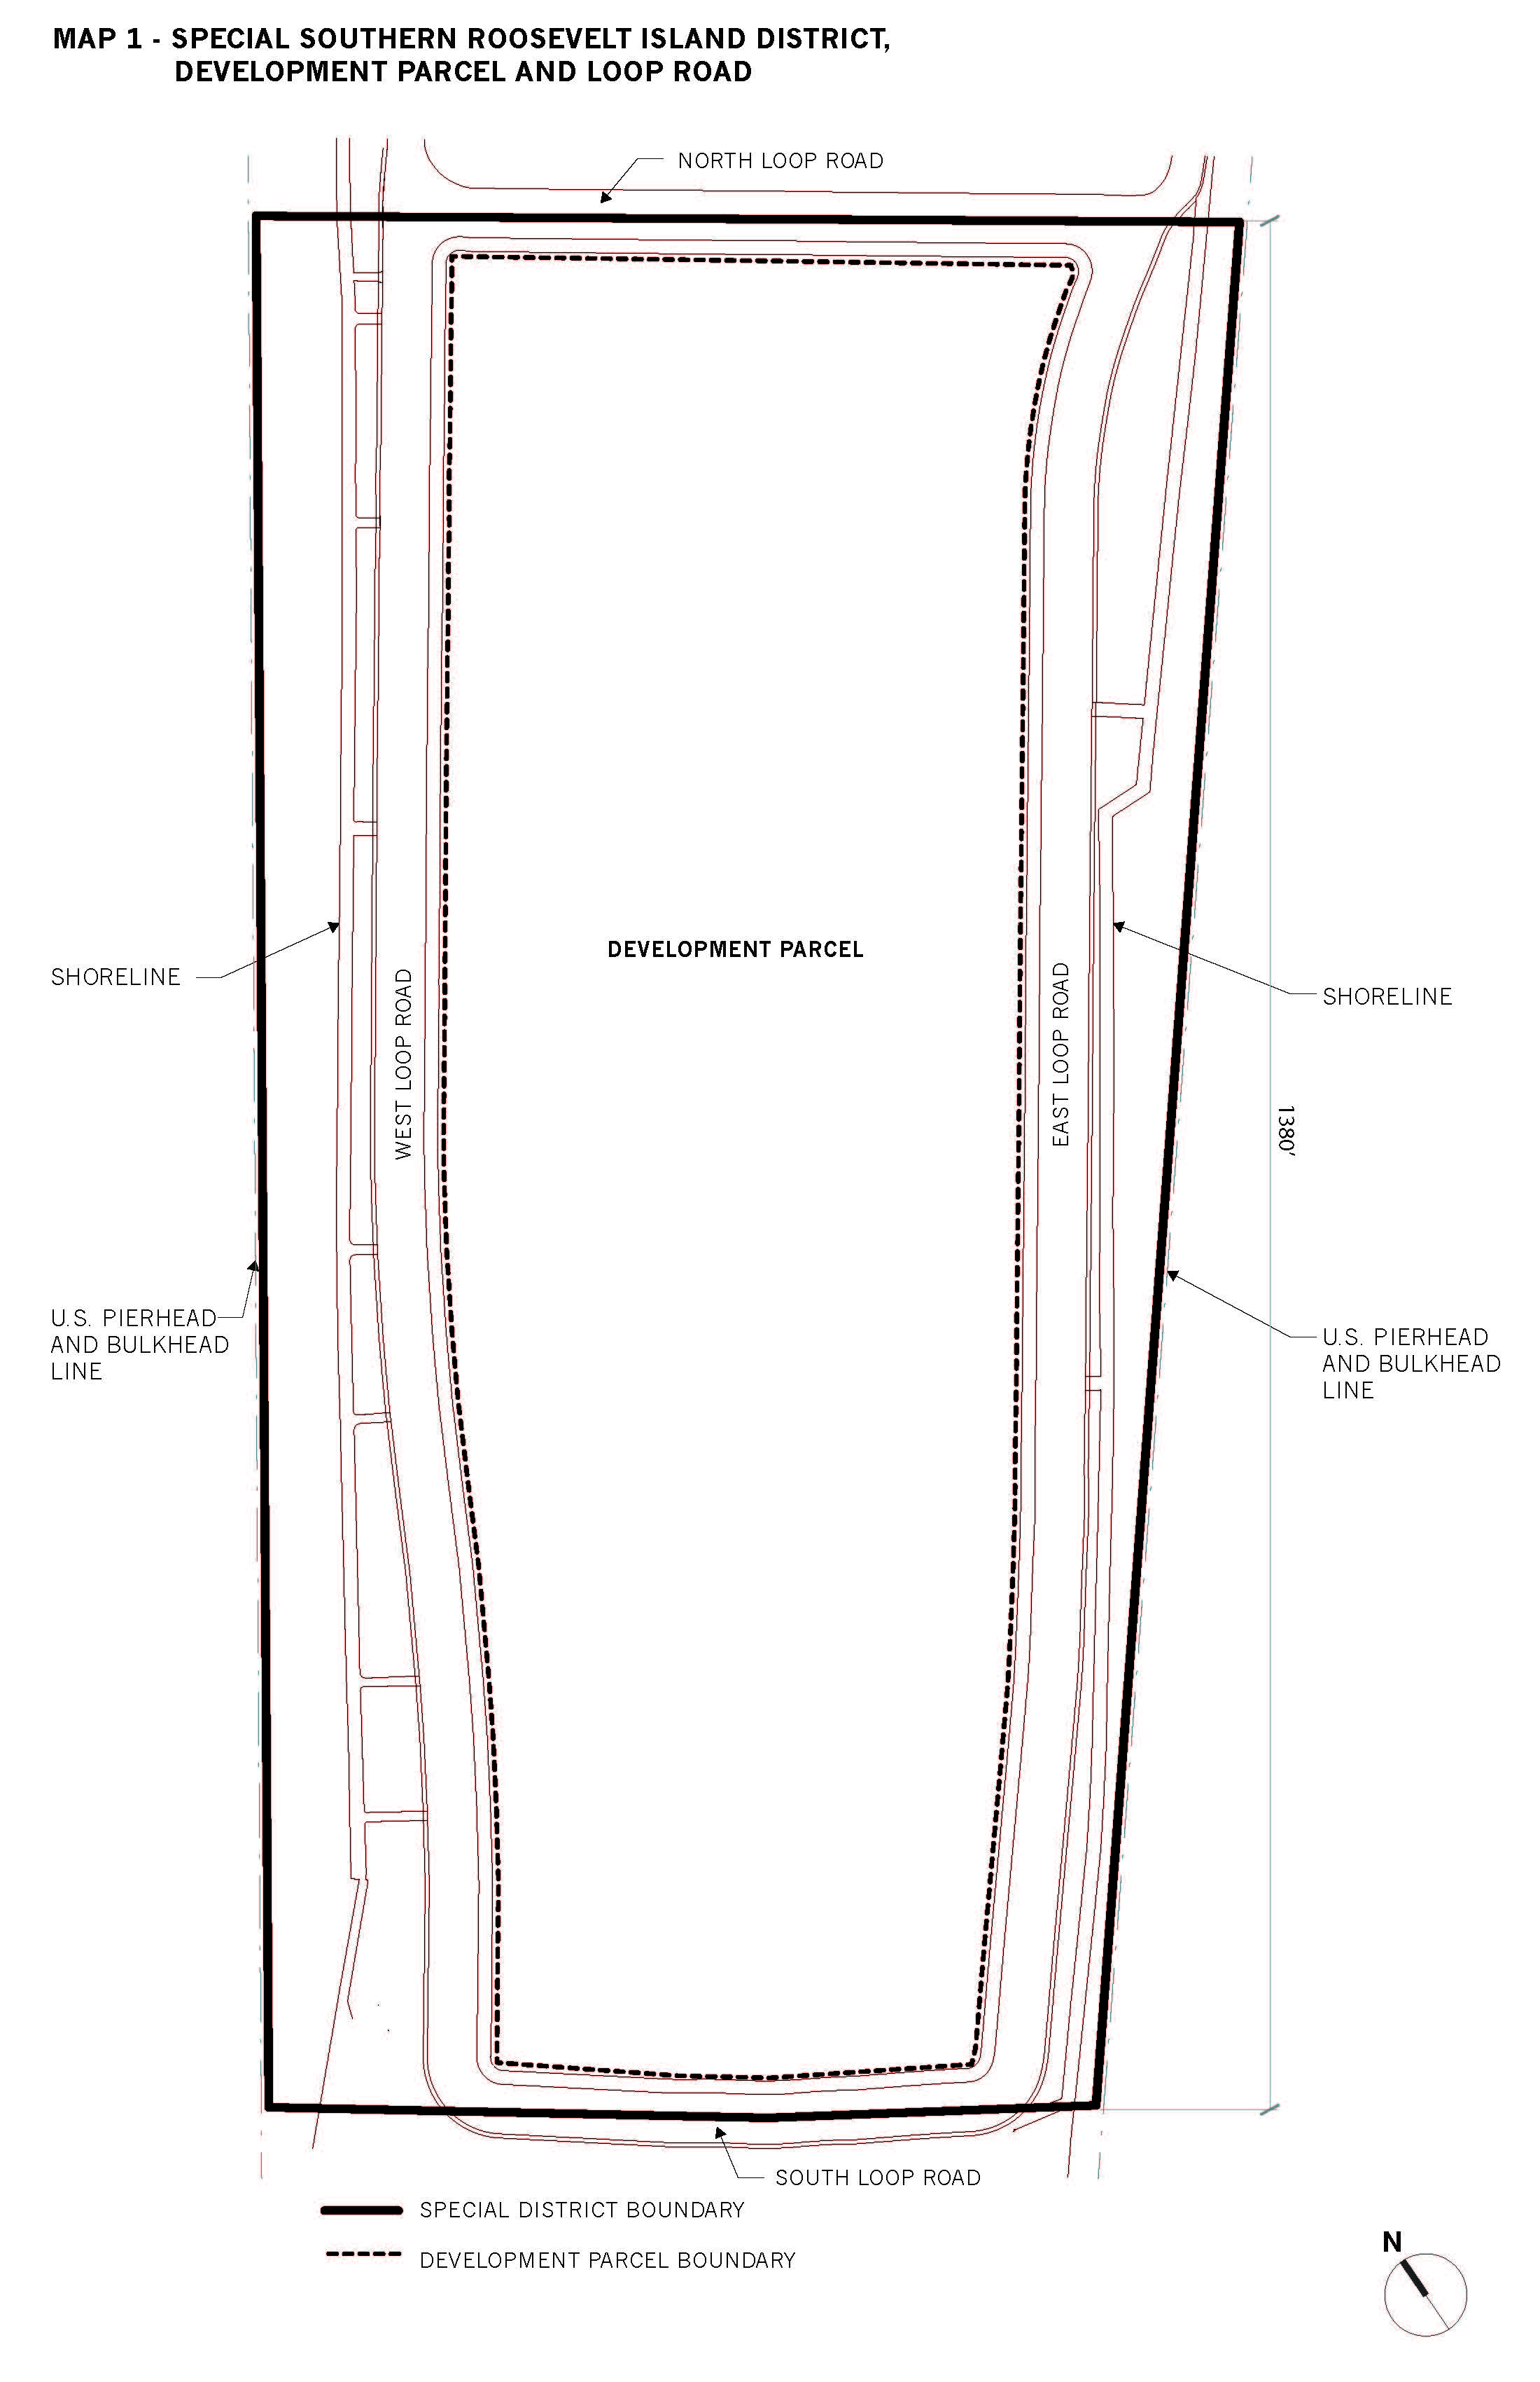
Map 2 – Public Access Areas

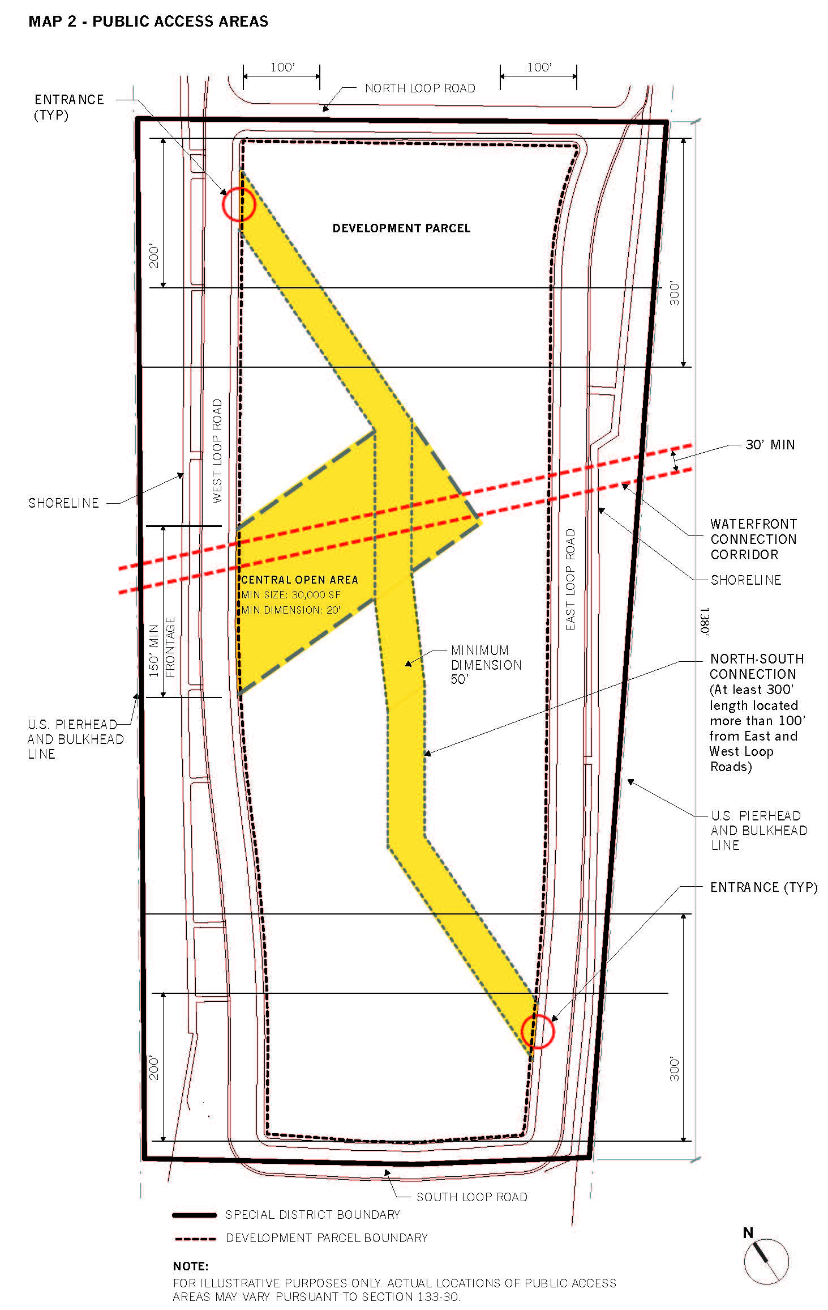

Adopted.
Office of the City Clerk, }
The City of New York, } ss.:

I hereby certify that the foregoing is a true copy of a Resolution passed by The Council of The City of New York on May 8, 2013, on file in this office.

.....…….........................................
City Clerk, Clerk of The Council

