THE COUNCIL OF THE CITY OF NEW YORK
RESOLUTION NO. 1816

Resolution approving the decision of the City Planning Commission on Application No. N 210352 ZRM, for an amendment of the text of the Zoning Resolution (L.U. No. 865).

By Council Members Salamanca and Moya

WHEREAS, New York Blood Center Inc., filed an application pursuant to Section 201 of the New York City Charter, for an amendment of the text of the Zoning Resolution of the City of New York, modifying Article VII, Chapter 4 for the purpose of allowing scientific research facilities in C2-7 Districts and allowing related use and bulk modifications, and modifying APPENDIX F, for the purpose of establishing a Mandatory Inclusionary Housing area, which in conjunction with the related action would facilitate the development of a new, modern headquarters for the New York Blood Center and a commercial life sciences hub located at 310 East 67th Street (Block 1441, Lot 40) in the Upper East Side of Manhattan, Community District 8 (ULURP No. N 210352 ZRM), (the “Application”);

WHEREAS, the City Planning Commission filed with the Council on September 27, 2021, its decision dated September 22, 2021 (the "Decision") on the Application;

WHEREAS, the Application is related to application C 210351 ZMM (L.U. No. 864), a zoning map amendment to change an R8B District to a C2-7 District and to change a C1-9 District to a C2-8 District; and C 210353 ZSM (L.U. No. 866), a zoning special permit pursuant to Section 74-48 of the Zoning Resolution to allow a scientific research and development facility and to allow modification of the height and setback regulations of Section 33-432;

WHEREAS, the Decision is subject to review and action by the Council pursuant to Section 197-d of the City Charter;

WHEREAS, upon due notice, the Council held a public hearing on the Decision and Application on October 20, 2021;

WHEREAS, the Council has considered the land use implications and other policy issues relating to the Decision and Application; and

WHEREAS, the Council has considered the relevant environmental issues, including the Positive Declaration issued November 13th, 2020 (CEQR No. 21DCP080M) and a Final Environmental Impact Statement (FEIS) for which a Notice of Completion was issued on September 10, 2021, in which significant adverse impacts related to hazardous materials, air quality, and noise would be avoided through the placement of (E) designations (E-612) on the project sites. To ensure the implementation of the PCREs the applicant will enter into a Restrictive Declaration at the time of the approval of land use-related actions and prior to issuance of any permits. The proposed project as analyzed in the FEIS identified significant adverse impacts with respect to shadows and construction (noise) and to ensure the implementation of the mitigation measures identified in the FEIS, they are included in the Restrictive Declaration. The Council has also considered the Technical Memorandum dated November 16, 2021 (the “Technical Memorandum”).

RESOLVED:
Having considered the FEIS and Technical Memorandum with respect to the Decision and Application, the Council finds that:

- The FEIS meets the requirements of 6 N.Y.C.R.R. Part 617;

- From among the reasonable alternatives thereto, the action to be approved is one which minimizes or avoids adverse environmental impacts to the maximum extent practicable; and

- The adverse environmental impacts revealed in the FEIS will be minimized or avoided to the maximum extent practicable by incorporating as conditions to the approval those mitigation measures that were identified as practicable.

The Decision, together with the FEIS and Technical Memorandum constitute the written statement of facts, and of social, economic and other factors and standards that form the basis of this determination, pursuant to 6 N.Y.C.R.R. §617.11(d).

Pursuant to Sections 197-d and 201 of the City Charter and on the basis of the Decision and Application, and based on the environmental determination and consideration described in the report, N 210352 ZRM, incorporated by reference herein, and the record before the Council, the Council approves the Decision of the City Planning Commission.

Matter underlined is new, to be added;
Matter struck out is to be deleted;
Matter within # # is defined in Section 12-10;
* * * indicates where unchanged text appears in the Zoning Resolution.

ARTICLE III
COMMERCIAL DISTRICT REGULATIONS

Chapter 2
Use Regulations

* * *

32-30

USES PERMITTED BY SPECIAL PERMIT

32-32
By the City Planning Commission

In the districts indicated, the following #uses# are permitted by special permit of the City Planning Commission, in accordance with standards set forth in Article VII, Chapter 4, or as otherwise indicated in this Section.

* * *

C1 C2 C3 C4 C5 C6 C7 C8
Railroad passenger stations

C2-7 C6
Research and development facility, scientific, in C2-7 Districts within Community District 8 in the Borough of Manhattan, and in C6 Districts

C1 C2 C3 C4 C5 C6 C7 C8
Seaplane bases

* * *

ARTICLE VII
Administration

* * *

Chapter 4
Special Permits by the City Planning Commission

74-40

USE PERMITS

* * *

74-48
Scientific Research and Development Facility

In C2-7 Districts within Community District 8 in the Borough of Manhattan, and in C6 Districts, the City Planning Commission may permit a scientific research and development facility containing as a #commercial use#, where such facility contains laboratories for medical, biotechnological, chemical or genetic research, including space for production, storage and distribution of scientific products generated through research and may modify height and setback regulations for the facility. Such facility shall conform to the performance standards applicable to M1 Districts and occupy a #zoning lot# that either contains a minimum #lot area# of 40,000 square feet or comprises an entire #block#. No #residential use# is to be located anywhere on a #zoning lot# containing such a facility, in conjunction with such facility, may allow the modifications set forth in paragraph (a) of this Section. For a special permit to be granted, applications shall comply with conditions in paragraph (b) and the findings of paragraph (c) of this Section. Additional requirements are set forth in paragraph (d).

- Additional modifications

For such scientific research and development facility, the Commission may modify the following:

  - height and setback regulations; and

  - where such facility is located within C2-7 Districts:

    - #sign# regulations;

    - #floor area ratio# regulations, up to the maximum #floor area ratio# permitted for #community facility uses# for the District; and

    - #yard# regulations.

- Conditions

As a condition for granting a special permit, such facility shall:

  - conform to the performance standards applicable to M1 Districts;

  - occupy a #zoning lot# that either contains a minimum #lot area# of 40,000 square feet or comprises an entire #block#; and

  - occupy a #zoning lot# containing no #residential use#.

- Findings

As a condition for granting a special permit, the Commission shall find that the scientific research and development facility:

(a)(1) will not unduly affect the essential character or impair the future use and development of the surrounding area;

(b)(2) will be located so as to draw a minimum of vehicular traffic to and through local #streets#;

(c)(3) provides fully enclosed storage space for all raw materials, finished products, by-products and waste materials including debris, refuse and garbage; and

(d)(4) that the modification of such height and setback to any applicable #bulk# regulations will not unduly obstruct the access of light and air to adjoining properties or public #streets#.

- with regard to #sign# modifications:

  - a signage plan has been submitted showing the location, size, height, and illumination of all #signs# on the #zoning lot#;

  - the modifications are consistent with the amount and location of commercial life sciences laboratories that the Commission finds appropriate on the #zoning lot#; and

  - #illuminated signs#, if provided:

    - utilize an illumination type, and are located and oriented in a manner so as to minimize any negative effects on nearby residences; and

    - do not alter the essential character of the adjacent area.

- Additional requirements

  - To minimize traffic congestion in the area, the Commission shall require the provision of off-street loading berths conforming to the requirements set forth in Section 36-62 (Required Accessory Off-street Loading Berths) for #commercial uses#.

  - The Commission may also require the provision of #accessory# off-street parking facilities to prevent the creation of traffic congestion caused by the curb parking of vehicles generated by such #use#. The size and location of such parking, bicycle parking, and loading facilities shall comply with the applicable provisions of Section 36-00, inclusive.

  - All applications for the grant of a special permit pursuant to this Section shall be referred to the Commissioner of Health of the City of New York or its successor for a report and recommendations on matters relating to health, safety and general welfare of the public with regard to the proposed facility. If the report is received within 45 days from the date of referral, the Commission shall, in its determination, give due consideration to the report and its recommendations. If such agency does not report within 45 days, the Commission may make a final determination without reference thereto.

In order to promote and protect the public health, safety and general welfare, the City Planning Commission may impose additional conditions and safeguards and more restrictive performance standards where necessary.

* * *

APPENDIX F
Inclusionary Housing Designated Areas and Mandatory Inclusionary Housing Areas

* * *

MANHATTAN

* * *

Manhattan Community District 8

* * *

Map 1 [date of adoption]

[PROPOSED MAP]

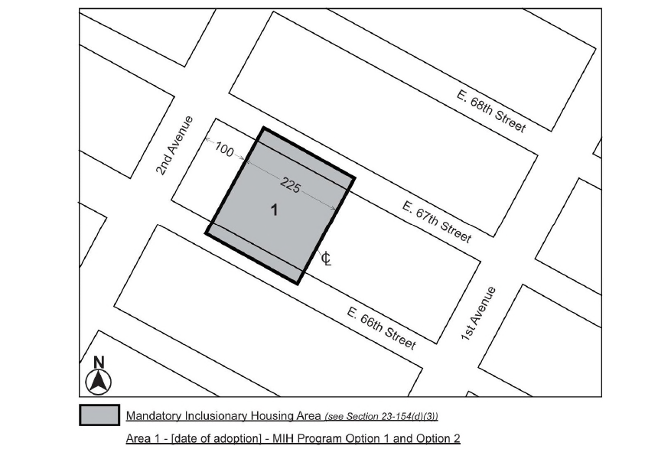

Portion of Community District 8, Manhattan

* * *

Adopted.

Office of the City Clerk,}
The City of New York,} ss.:

I hereby certify that the foregoing is a true copy of a Resolution passed by The Council of The City of New York on _________, 2021, on file in this office.

.....................................................
City Clerk, Clerk of The Council

