THE COUNCIL OF THE CITY OF NEW YORK
RESOLUTION NO. 984

Resolution approving with modifications the decision of the City Planning Commission on Application No. N 240185 ZRK, for an amendment of the text of the Zoning Resolution (L.U. No. 288).

By Council Members Salamanca and Riley

WHEREAS, Grace Housing Development Fund Company, Inc., filed an application pursuant to Section 201 of the New York City Charter, for an amendment of the text of the Zoning Resolution of the City of New York, modifying APPENDIX F for the purpose of establishing a Mandatory Inclusionary Housing area, which in conjunction with the related action would facilitate the development of a new 148,700-square-foot, seven-story mixed-use building, including 132,000-square feet of residential space (153 units), approximately 38 to 54 of which would be permanently income-restricted under Mandatory Inclusionary Housing (MIH) area, 15,900 square feet of ground floor community facility space, and 68 parking spaces in the East New York neighborhood of Brooklyn, Community District 5 (ULURP No. N 240185 ZRK), (the “Application”);

WHEREAS, the City Planning Commission filed with the Council on April 25, 2025, its decision dated April 23, 2025 (the "Decision") on the Application;

WHEREAS, the Application is related to application C 240184 ZMK (L.U. No. 287), a zoning map amendment to change an R5B zoning district to an R6A zoning district;

WHEREAS, the Decision is subject to review and action by the Council pursuant to Section 197-d of the City Charter;

WHEREAS, upon due notice, the Council held a public hearing on the Decision and Application on April 29, 2025;

WHEREAS, the Council has considered the land use implications and other policy issues relating to the Decision and Application; and

WHEREAS, the Council has considered the relevant environmental issues, including the Negative Declaration issued on December 2, 2024 (CEQR No. 23DCP108K), which includes an (E) designation to avoid the potential for significant adverse impacts related to hazardous materials, air quality, and noise (E-802) (the “Negative Declaration”).

RESOLVED:

The Council finds that the action described herein will have no significant impact on the environment as set forth in the (E) Designation (E-802) and Negative Declaration.

Pursuant to Sections 197-d and 200 of the City Charter and on the basis of the Decision and Application, and based on the environmental determination and consideration described in the report, N 240185 ZRK, incorporated by reference herein, and the record before the Council, the Council approves the Decision of the City Planning Commission, with the following modifications.

Matter underlined is new, to be added;
Matter struck out is to be deleted;
Matter double struck out is old, deleted by the City Council;
Matter double-underlined is new, added by the City Council;
Matter within # # is defined in Section 12-10;
* * * indicates where unchanged text appears in the Zoning Resolution.

* * *
APPENDIX F
Mandatory Inclusionary Housing Areas and Former Inclusionary Housing Designated Areas

BROOKLYN
* * *
Brooklyn Community District 5
Map 1 – [date of adoption]
[EXISTING MAP]
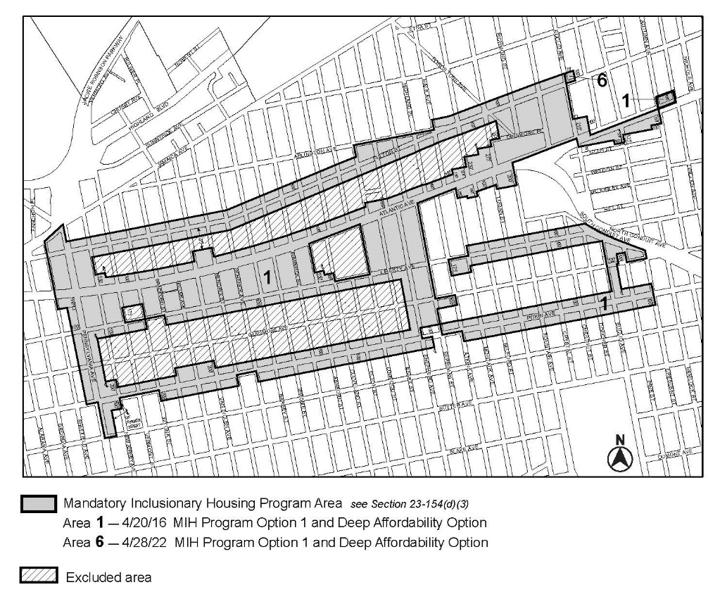

[MAP Approved by CPC]
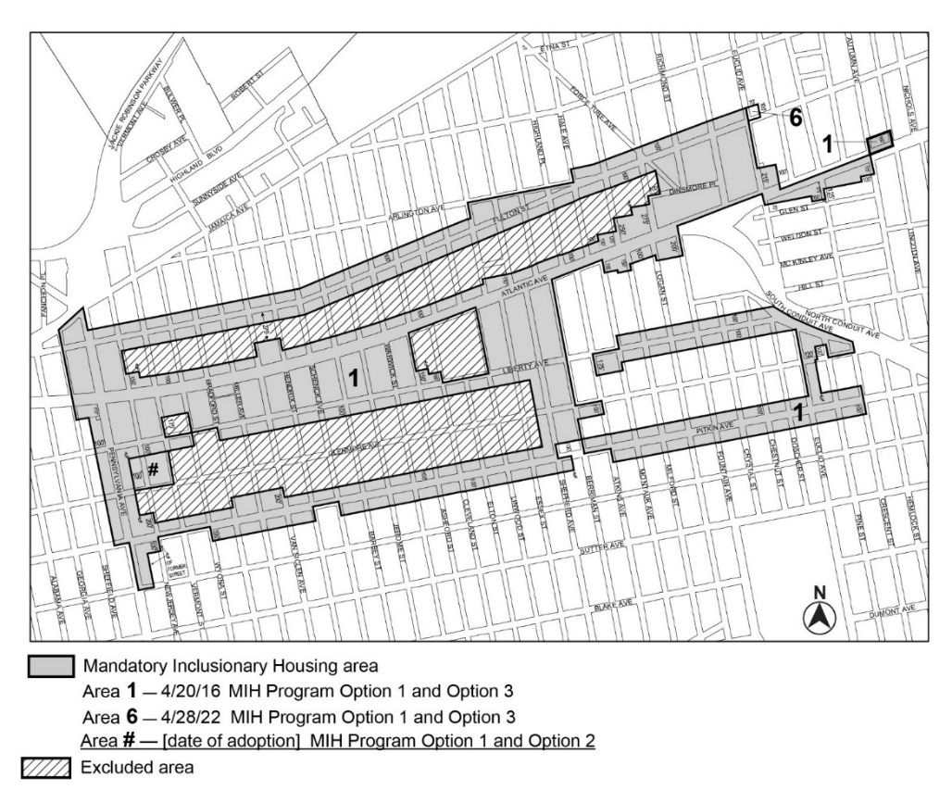

[PROPOSED MAP – Modified by City Council]
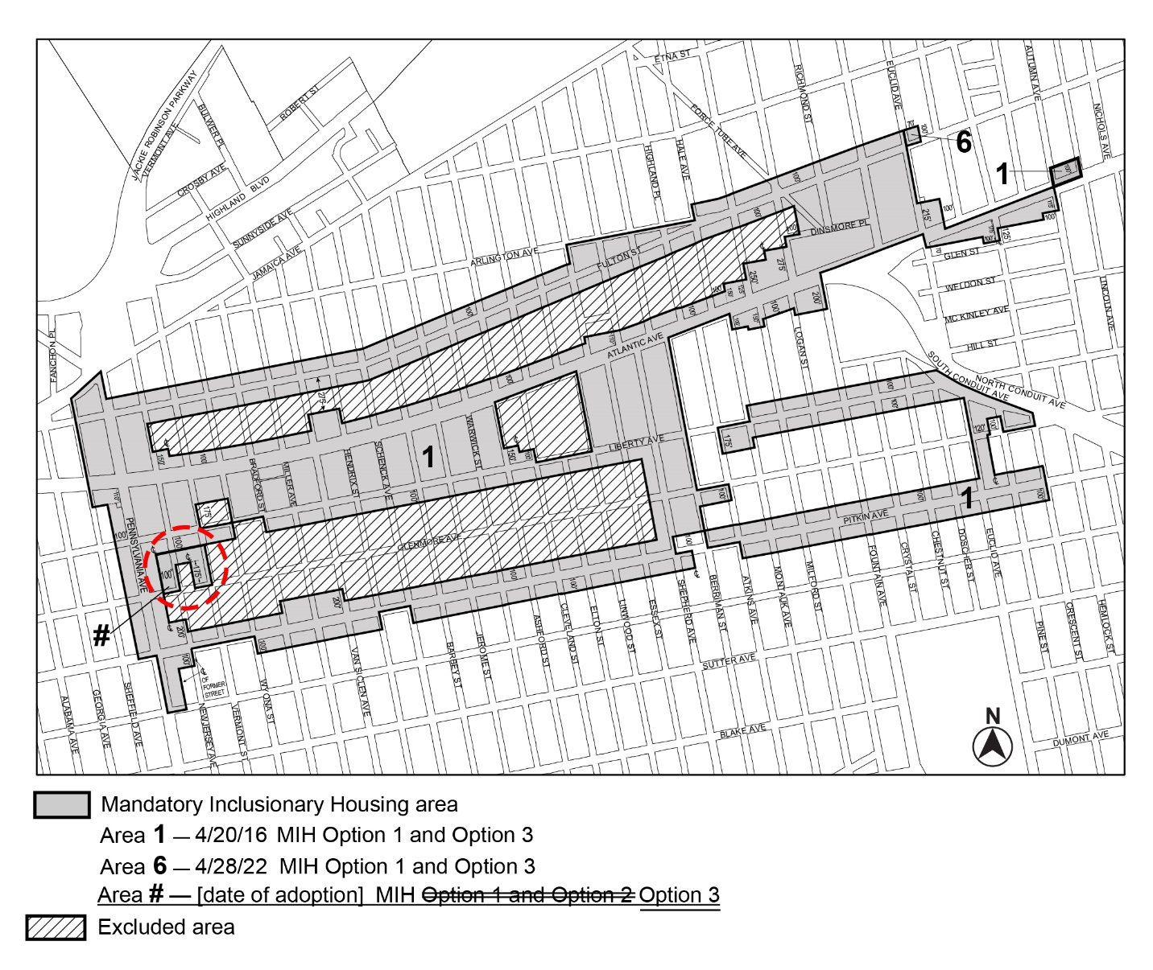
Portion of Community District 5, Brooklyn
* * *
Adopted.

Office of the City Clerk,}
The City of New York,} ss.:

I hereby certify that the foregoing is a true copy of a Resolution passed by The Council of The City of New York on _________, 2025, on file in this office.

.....................................................
City Clerk, Clerk of The Council

