THE COUNCIL OF THE CITY OF NEW YORK
RESOLUTION NO. 282

Resolution approving with modifications the decision of the City Planning Commission on Application No. N 210376 ZRQ, for an amendment of the text of the Zoning Resolution (Preconsidered L.U. No. 84).

By Council Members Salamanca and Riley

WHEREAS, Novel Medicine, P.C., filed an application pursuant to Section 201 of the New York City Charter, for an amendment of the text of the Zoning Resolution of the City of New York, modifying APPENDIX F for the purpose of establishing a Mandatory Inclusionary Housing area, which in conjunction with the related action would facilitate the development of an eight-story residential building located at 66-45 Wetherole Street in the Forest Hills neighborhood of Queens, Community District 6 (ULURP No. N 210376 ZRQ) (the “Application”);

WHEREAS, the City Planning Commission filed with the Council on June 13, 2022, its decision dated June 8, 2022 (the “Decision”), on the Application;

WHEREAS, the Application is related to application C 210375 ZMQ (Pre. L.U. No. 83), a zoning map amendment to change an R4B zoning district to an R6A zoning district;

WHEREAS, the Decision is subject to review and action by the Council pursuant to Section 197-d of the City Charter;

WHEREAS, upon due notice, the Council held a public hearing on the Decision and Application on June 14, 2022;

WHEREAS, the Council has considered the land use implications and other policy issues relating to the Decision and Application; and

WHEREAS, the Council has considered the relevant environmental issues, including the Negative Declaration issued January 31st, 2022 (CEQR No. 21DCP128Q), which includes an (E) designation to avoid the potential for significant adverse impacts related to air quality (E-649) (the “Negative Declaration”).

RESOLVED:

The Council finds that the action described herein will have no significant impact on the environment as set forth in the (E) Designation (E-649) and Negative Declaration.

Pursuant to Sections 197-d and 200 of the City Charter and on the basis of the Decision and Application, and based on the environmental determination and consideration described in the report, N 210376 ZRQ, incorporated by reference herein, and the record before the Council, the Council approves the Decision of the City Planning Commission with the following modifications:
Matter underlined is new, to be added;
Matter struck out is to be deleted;
Matter within # # is defined in Section 12-10;
* * * indicates where unchanged text appears in the Zoning Resolution
Matter double struck out is old, deleted by the City Council;
Matter double-underlined is new, added by the City Council

* * *

APPENDIX F
Inclusionary Housing Designated Areas and Mandatory Inclusionary Housing Areas

* * *

QUEENS

* * *

Queens Community District 6

* * *

Map # – [date of adoption]

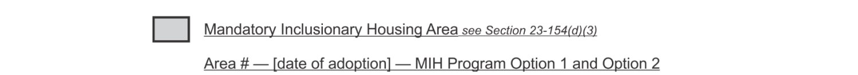

Portion of Community District 6, Queens

* * *

Adopted.
Office of the City Clerk, }
The City of New York, } ss.:
I hereby certify that the foregoing is a true copy of a Resolution passed by The Council of The City of New York on __________, 2022, on file in this office.

.....................................................
City Clerk, Clerk of The Council

