L Staff:


Dylan Casey, Deputy General Counsel

James Lloyd, Project Manager

THE COUNCIL

COMMITTEE REPORT OF THE LAND USE DIVISION

Raju Mann, Director of Land Use

Amy Levitan, Deputy Director of Land Use

COMMITTEE ON LAND USE

Hon. David Greenfield, Chair

September 9, 2015

Int. No. 775: By Council Members Koo, Greenfield, Williams, Gentile, Lancman, Richards, Vallone, Crowley, King, Ferreras-Copeland, and Torres

Title: A Local Law to amend the Administrative Code of the city of New York, in relation to establishing a maximum period of time for the Landmarks Preservation Commission to take action on any item calendared for consideration of landmark status.

Administrative Code: Amends section 25-303 of chapter 3 of title 25 of the Administrative Code of the City of New York.

Int. No. 837: By Council Members Garodnick, Lander, Rosenthal, Koo, Koslowitz, Mendez, and Kallos (by request of the Manhattan Borough President)

Title: A Local Law to amend the Administrative Code of the City of New York, in relation to requiring the Landmarks Preservation Commission to make available a database of all items designated or under consideration for designation.

Administrative Code: Amends section 25-303 of chapter 3 of title 25 of the Administrative Code of the City of New York.

I. Introduction

On Wednesday September 9, 2015, the Committee on Land Use, chaired by Council Member David Greenfield, will hold a hearing on two pieces of legislation relating to the designation of landmarks and operations of the Landmarks Preservation Commission (LPC). In the City of New York, LPC is the agency responsible for designating and regulating “landmarks, portions of landmarks, landmark sites, interior landmarks, scenic landmarks and historic districts.”
Introduction Number 775 (“Int. No. 775”) is a local law that would amend the Administrative Code of the City of New York in relation to establishing a maximum period of time for the Landmarks Preservation Commission to take action on any item calendared for consideration of landmark status. Introduction Number 837 (“Int. No. 837”) is a local law that would amend the Administrative Code of the City of New York in relation to requiring the Landmarks Preservation Commission to make available a database of all items designated or under consideration for designation.

II. Proposed Int. No. 775
A. Background
This proposed legislation, Int. No. 775, would amend the Landmarks Law to implement mandatory timelines for the process for designating landmarks, interior landmarks, scenic landmarks, and historic districts. The bill is intended to help inform landowners and the public about the prospects and timelines for designations of individual landmarks and historic districts. The timelines would cover the period from when an item is calendared for consideration through designation. Currently, LPC can vote to calendar an item as a way of establishing the property or neighborhood as under consideration for designation. The date for the public hearing on the item can be set at the time of calendaring, or at some later date. The practice of calendaring an item prior to a public hearing was established through agency rulemaking, and is not currently required by the Landmarks Law. This bill would codify the practice of calendaring as part of the Landmarks Law, and require properties to be calendared prior to the public hearing. Lastly, Int. No. 775 would also require LPC to act within 18 months on all items that are on the calendar at the time the bill takes effect.
Over the last 15 years, LPC was able to designate individual landmarks within 360 days of the date of calendaring 80 percent of the time. For historic districts, LPC was able to move from calendaring to designation in less than 720 days for 94% of districts. These data were taken from the New York City Open Data Portal.
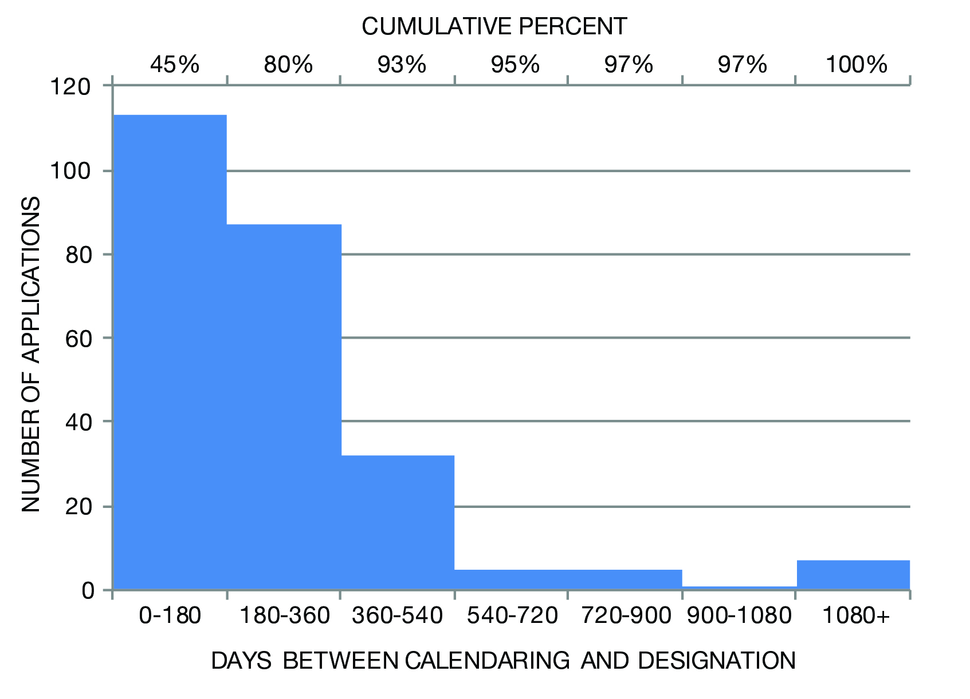
Figure 1: Analysis of Individual Landmarks

When calendaring dates are available for individual landmarks (most designated landmarks after 1998):
- Average time from calendaring to designation: 290 days
- Median time from calendaring to designation: 189 days
- 80% of items were designated within 360 days of calendaring
- 93% of items were designated within 540 days of calendaring
- Very few items took greater than 540 days to be designated.

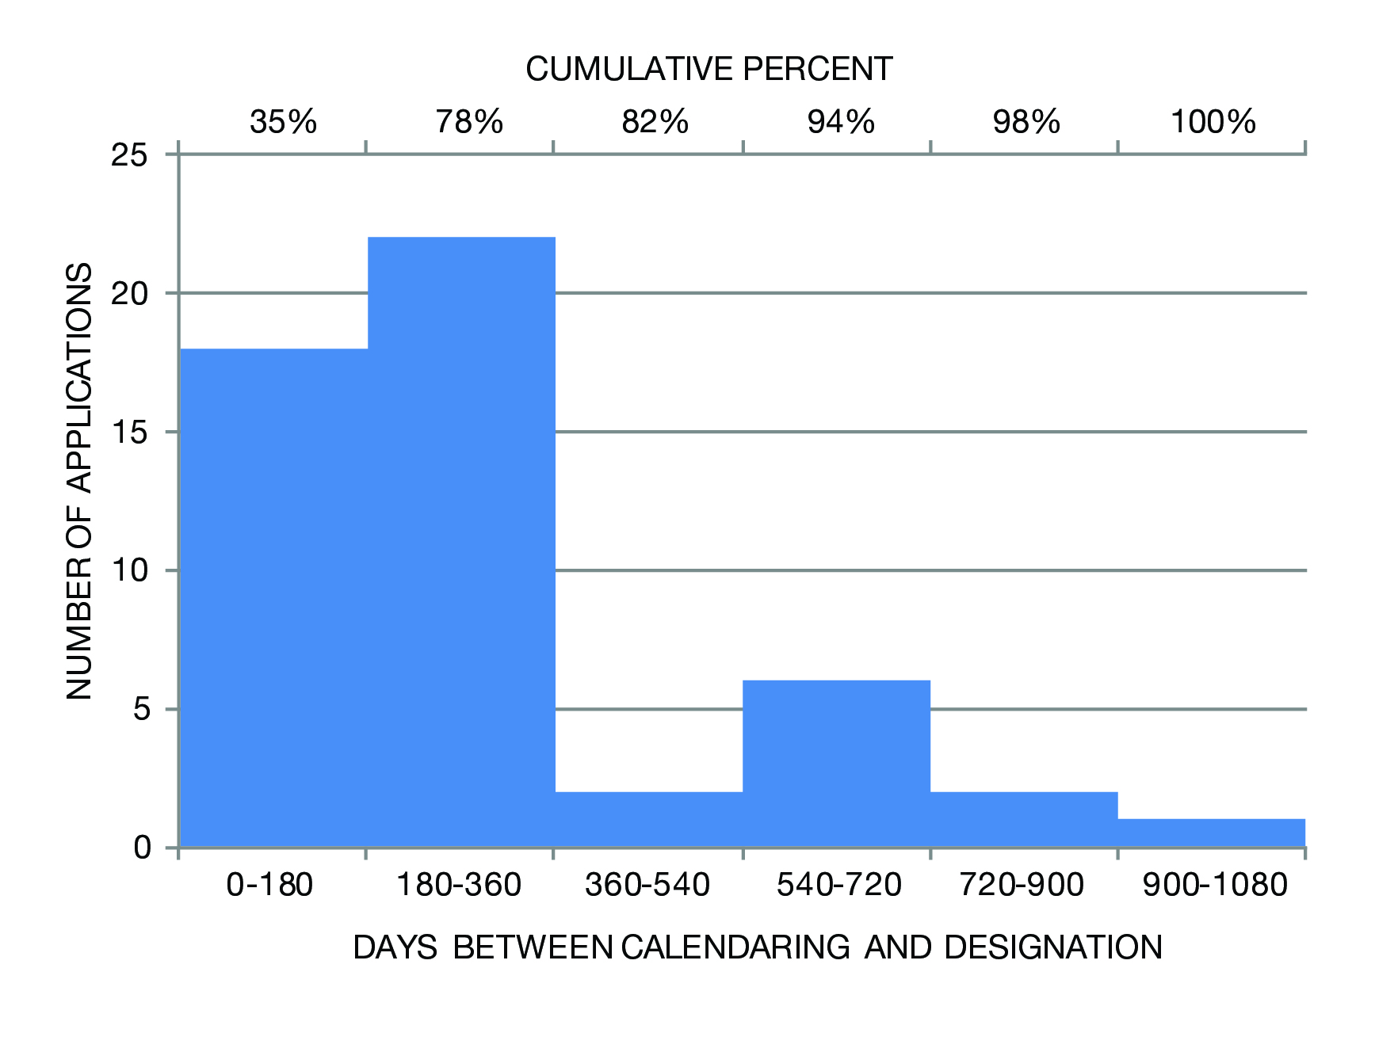
Figure 2: Analysis of Historic Districts

When calendaring dates are available for districts (almost all districts after 1999):
- Average time from calendaring to designation: 286 days
- Median time from calendaring to designation is 224 days
- Most items (78%) were designated within 360 days of calendaring
- 94% of items were designated within 720 days

B. Summary of Proposed Law
Section One of Int. No. 775 would add a new subdivision l to Section 25-303 of chapter 3 of title 25 of the New York City Administrative Code. Chapter 3 governs the Landmarks Preservation Commission and Section 25-303 governs the procedures for the establishment of landmarks, landmark sites, interior landmarks, scenic landmarks and historic districts.
Paragraph (1) of the proposed subdivision l would require LPC to vote to calendar any potential landmark, interior landmark, scenic landmark, or historic district prior to holding a public hearing on that item. The date of the public hearing could be established at the time of calendaring or at a later date.
Paragraph (2) of the proposed subdivision l would establish a timeframe for holding a public hearing and designating landmarks, interior landmarks, and scenic landmarks. It would require LPC to hold a public hearing on any landmark, interior landmark, or scenic landmark within 180 days of the vote to calendar the item. The paragraph would also give LPC 180 days to designate the item following the date of the public hearing. If LPC failed to either hold a public hearing or designate an item within either of the 180 day timeframes, the item would be removed from the calendar and LPC would not be permitted to add the item back to the calendar for a period of 5 years.
Paragraph (3) of the proposed subdivision l would establish a timeframe for holding public hearings and designating historic districts. It would require LPC to hold a public hearing on any historic district within one year of the vote to calendar the district. This paragraph would also give LPC one year to designate the district following the date of the public hearing. If LPC failed to either hold a public hearing or designate a district within either of the one year timeframes, the district would be removed from the calendar and LPC would not be permitted to add the district back to the calendar for a period of 5 years.
Paragraph (4) of the proposed subdivision l would establish a timeframe for designating landmarks, scenic landmarks, interior landmarks, and historic districts that are calendared prior to the effective date of the proposed local law. LPC would have 18 months to designate any such item. If LPC did not designate the item within 18 months, the item would be removed from the calendar and LPC would not be permitted to add the item back to the calendar for a period of 5 years.
Section two of this legislation contains the enactment clause and provides that the local law would take effect on the date of enactment.

III. Proposed Int. No. 837
A. Background
Int. No. 837 would require that LPC make a variety of information accessible to the public via an online database. The database would include all designated landmarks, historic districts, interior landmarks, and scenic landmarks. Additionally, the database would include properties under consideration for designation, to include calendared properties, properties subject to Requests for Evaluation (RFE), and properties being surveyed by the Commission. This database would include the current status of consideration or designation (e.g. under study, inactive, calendared, or designated), the location of each property, the person or organization that submitted an RFE, copies of relevant documents, and scheduled hearing or meeting dates.
This legislation is meant to help inform the expectations of the public and owners of property under consideration. The designation process begins with an initial study or survey of a building or neighborhood by LPC staff. In some cases, this investigation is conducted in response to an RFE, which can be submitted by members of the public. The RFE procedure is not codified in the Landmarks Law, but affords an opportunity to the public to suggest individual buildings or districts that may not otherwise come under consideration by LPC. After submission, LPC sends the individual or organization that submitted the request a letter acknowledging receipt. Following consideration, LPC will then send that person another letter communicating the agency’s determination as to whether or not the request has merit.
While LPC has recently begun releasing data on calendared items and designated items on the NYC Open Data portal, these data do not include properties subject to RFEs or surveys and are only available to those familiar with the portal and able to use sophisticated software.

B. Summary of Proposed Law
Section One of Int. No. 837 would add a new subdivision l to Section 25-303 of chapter 3 of title 25 of the New York City Administrative Code. Chapter 3 governs the Landmarks Preservation Commission and Section 25-303 governs the procedures for the establishment of landmarks, landmark sites, interior landmarks, scenic landmarks and historic districts.
The proposed subdivision l would require LPC to publish a database on its website of all items designated as landmarks, historic districts, interior landmarks, and scenic landmarks. The subdivision would also require the database to include all items under consideration for designation by LPC. Items under consideration, for the purposes of the proposed legislation, would include any properties surveyed by LPC staff, any requests by the public to consider an item for designation, and any item calendared by LPC. The database would include the status of consideration, location of the item, the person or organization who submitted the request, relevant documents, dates of hearings or meetings scheduled, and whether the item is under study, inactive, calendared, or designated.
Section two of this legislation contains the enactment clause and provides that this local law will take effect sixty days after enactment.

Int. No.775

By Council Members Koo, Greenfield, Williams, Gentile, Lancman, Richards, Vallone, Crowley, King, Ferreras-Copeland, and Torres

A LOCAL LAW

To amend the Administrative Code of the City of New York, in relation to establishing a maximum period of time for the Landmarks Preservation Commission to take action on any item calendared for consideration of landmark status.

Be it enacted by the Council as follows:

Section 1. Section 25-303 of chapter 3 of title 25 of the administrative code of the city of New York is amended by adding a new subdivision l to read as follows:
l. (1) The commission shall, upon the adoption of a motion, calendar any item to be considered for designation as a landmark, interior landmark, scenic landmark or historic district prior to holding a public hearing on such item. A motion to calendar must be approved by the majority of the commissioners present in order to be adopted. The date of the public hearing on the proposed designation may be set by the motion to calendar or it may be set at some later time by the chair, acting at his or her discretion.
(2) The commission shall hold a public hearing to consider any landmark, interior landmark, or scenic landmark under consideration for landmark designation within 180 days immediately following the date that the item is calendared by the commission. The commission shall have 180 days immediately following the date the public hearing is held for such item to designate the landmark, interior landmark, scenic landmark. In the event the commission either: (a) disapproves the designation of an item, (b) fails to hold a public hearing on an item within 180 days immediately following the date that the item is calendared by the commission, or (c) fails to designate an item within 180 days immediately following the date the public hearing, the item shall be removed from the calendar of the commission and shall not be calendared again by the commission for possible designation for a period of not less than five years from date of its disapproval or the expiration of a time period set forth in this subdivision.
(3) The commission shall hold a public hearing to consider any historic district under consideration for designation within one year immediately following the date that the item is calendared by the commission. The commission shall have one year immediately following the date the public hearing is held for such item to designate the historic district. In the event the commission either: (a) disapproves the historic district designation, (b) fails to hold a public hearing on a historic district within one year following the date that the item is calendared by the commission, or (c) fails to designate a historic district within one year following the date the public hearing, the historic district shall be removed from the calendar of the commission and shall not be calendared again by the commission for possible historic district designation for a period of not less than five years from date of its disapproval or the expiration of a time period set forth in this subdivision.
(4) For all landmarks, interior landmarks, scenic landmarks, and historic districts that are calendared but not designated by the effective date of the local law that added this subdivision l, the commission shall have 18 months from such date to disapprove or designate any such item. In the event the commission either: (a) disapproves the designation of any such item, or (b) fails to designate any such item within 18 months of the effective date of the local law which added this subdivision l, the item shall be removed from the calendar of the commission and shall not be calendared again by the commission for possible designation for a period of not less than five years from date of its disapproval or the expiration of the time period set forth in this subdivision.
§2. This local law shall take effect immediately

DSC
LS #2381
04/22/15

THIS PAGE INTENTIONALLY LEFT BLANK

Int. No. 837

By Council Member Garodnick, Lander, Rosenthal, Koo, Koslowitz, Mendez and Kallos (by request of the Manhattan Borough President)

A LOCAL LAW

To amend the Administrative Code of the City of New York, in relation to requiring the Landmarks Preservation Commission to make available a database of all items designated or under consideration for designation.

Be it enacted by the Council as follows:
Section 1. Section 25-303 of chapter 3 of title 25 of the administrative code of the city of New York is amended by adding new subdivisions l to read as follows:
l. The commission shall publish online a database of all items designated as landmarks, historic districts, interior landmarks, and scenic landmarks, and all items under consideration for designation. For the purposes of this subdivision, items under consideration for designation shall include any properties or neighborhoods surveyed by the commission, any items for which the public has requested consideration of landmark status, and any item formally calendared for consideration by the commission. Such database shall include information regarding the current status of consideration or designation for each item including, for items under consideration, the location of property under consideration, the person or organization who submitted a request, copies of relevant documents, any scheduled hearings or meeting dates and whether the item is currently under study, inactive, calendared, or designated.
§ 2. This local law shall take effect sixty days after it shall have become a law.

DSC
LS #3597
6/8/15

Section 3020 of the New York City Charter.

