THE COUNCIL OF THE CITY OF NEW YORK
RESOLUTION NO. 783

Resolution approving the decision of the City Planning Commission on Application No. N 220335 ZRX, for an amendment of the text of the Zoning Resolution (L.U. No. 251).

By Council Members Salamanca and Riley

WHEREAS, Housing Options and Geriatric Association Resources, Inc., filed an application pursuant to Section 201 of the New York City Charter, for an amendment of the text of the Zoning Resolution of the City of New York, modifying Appendix F for the purpose of establishing a Mandatory Inclusionary Housing Area, which in conjunction with the related actions would facilitate the development of a new community facility building containing approximately 83 affordable and supportive housing units and community facility space at 893 Eagle Avenue in the Morrisania section of the Bronx, Community District 3 (ULURP No. N 220335 ZRX), (the “Application”);

WHEREAS, the City Planning Commission filed with the Council on July 24, 2023, its decision dated July 24, 2023 (the "Decision") on the Application;

WHEREAS, the Application is related to applications C 220334 ZMX (L.U. No. 250), a zoning map amendment to change an R6 zoning district to an R7-2 zoning district; and C 220336 ZSX (L.U. No. 252), a special permit pursuant to Zoning Resolution (ZR) Section 74-903;

WHEREAS, the Decision is subject to review and action by the Council pursuant to Section 197-d of the City Charter;

WHEREAS, upon due notice, the Council held a public hearing on the Decision and Application on August 10, 2023;

WHEREAS, the Council has considered the land use implications and other policy issues relating to the Decision and Application; and

WHEREAS, the Council has considered the relevant environmental issues, including the Negative Declaration issued February 13th, 2023 (CEQR No. 20DCP076X), which includes an (E) designation for the development site to avoid the potential for significant adverse impacts related to hazardous materials and air quality (E-667) (the “Negative Declaration”).

RESOLVED:

The Council finds that the action described herein will have no significant impact on the environment as set forth in the (E) Designation (E-667) and Negative Declaration.

Pursuant to Sections 197-d and 200 of the City Charter and on the basis of the Decision and Application, and based on the environmental determination and consideration described in the report, N 220335 ZRX, incorporated by reference herein, and the record before the Council, the Council approves the Decision of the City Planning Commission.

Matter underlined is new, to be added;
Matter struck out is to be deleted;
Matter within # # is defined in Section 12-10;
* * * indicates where unchanged text appears in the Zoning Resolution

* * *

APPENDIX F
Inclusionary Housing Designated Areas and Mandatory Inclusionary Housing Areas

* * *

THE BRONX

* * *
The Bronx Community District 3

* * *

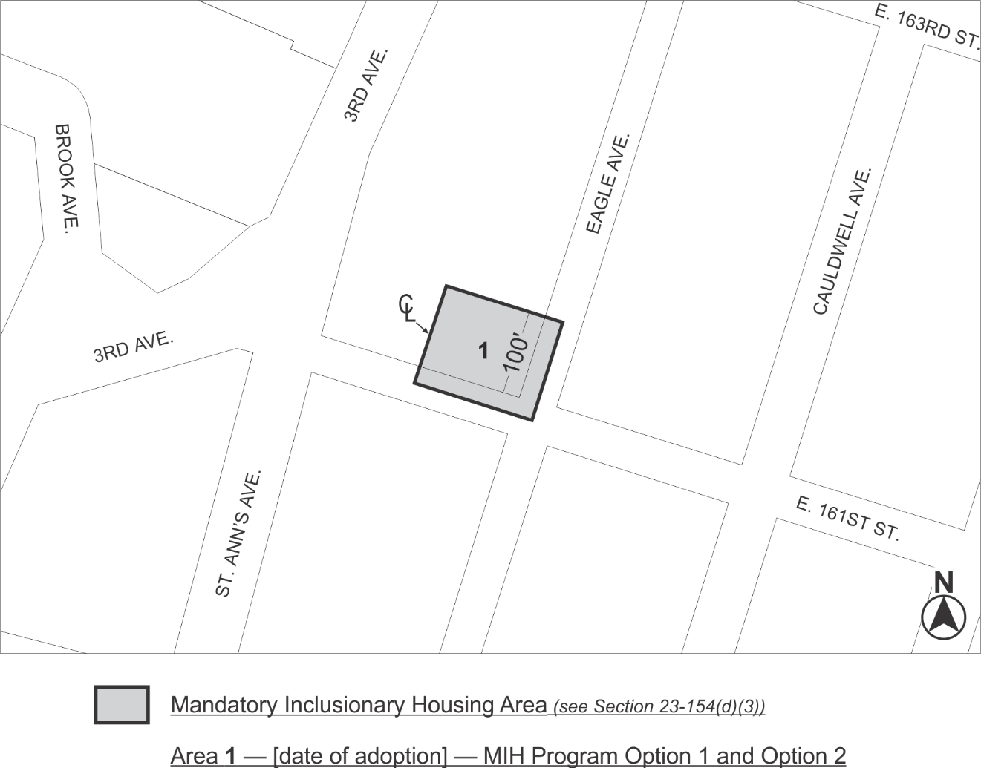

Portion of Community District 3, The Bronx

* * *

Adopted.

Office of the City Clerk,}
The City of New York,} ss.:

I hereby certify that the foregoing is a true copy of a Resolution passed by The Council of The City of New York on _________, 2023, on file in this office.

.....................................................
City Clerk, Clerk of The Council

