THE COUNCIL OF THE CITY OF NEW YORK
RESOLUTION NO. 1771

Resolution approving the decision of the City Planning Commission on Application No. N 210325 ZRM, for an amendment of the text of the Zoning Resolution (L.U. No. 855).

By Council Members Salamanca and Moya

WHEREAS, 495 11 Avenue Owner Realty, LLC, and the New York City Economic Development Corporation, filed an application pursuant to Section 201 of the New York City Charter, for an amendment of the text of the Zoning Resolution of the City of New York, modifying Article IX, Chapter 3 for the purpose establishing a new Subdistrict G within the Special Hudson Yards District, and modifying APPENDIX F, for the purpose of establishing a Mandatory Inclusionary Housing area, which in conjunction with the related actions would facilitate the development of a 57-story mixed-use building with affordable and supportive housing, hotel, office, retail and other uses at 495 Eleventh Avenue in the Clinton/Hell’s Kitchen neighborhood of Manhattan, Community District 4 (ULURP No. C 210325 ZRM) (the "Application");

WHEREAS, the City Planning Commission filed with the Council on September 17, 2021, its decision dated September 1, 2021 (the “Decision”), on the Application;

WHEREAS, the Application is related to applications C 210324 ZMM (L.U. No. 854), a zoning map amendment to rezone from an M1-5 to a C6-4 zoning district and extend the Special Hudson Yards District (SHYD); and C 210326 PCM (L.U. No. 856), a site selection and acquisition to develop an NYPD vehicle storage facility for 55 vehicles;

WHEREAS, the Decision is subject to review and action by the Council pursuant to Section 197-d of the City Charter;

WHEREAS, upon due notice, the Council held a public hearing on the Decision and Application on September 24, 2021;

WHEREAS, the Council has considered the land use implications and other policy issues relating to the Decision and Application; and

WHEREAS, the Council has considered the relevant environmental issues, including the Revised Positive Declaration issued October 1st, 2019, which supersedes the Positive Declaration issued March 23rd, 2018 (CEQR No. 18DME001M) and a Final Environmental Impact Statement (FEIS) for which a Notice of Completion was Issued on August 20, 2021 which identified significant adverse impacts with respect to shadows, transportation (traffic and pedestrians), and construction (traffic and pedestrians); and significant adverse impacts related to hazardous materials and noise would be avoided through the placement of (E) designations (E-610) on the project site. The identified adverse impacts and proposed mitigation measures under the proposed actions are summarized in Chapter 18 “Mitigation” of the FEIS.
RESOLVED:

Having considered the FEIS with respect to the Decision and Application, the Council finds that:

- The FEIS meets the requirements of 6 N.Y.C.R.R. Part 617;

- Consistent with social, economic, and other essential considerations, from among the reasonable alternatives thereto, adopted herein is one which minimizes or avoids environmental impacts to the maximum extent practicable;

- The adverse environmental impacts disclosed in the FEIS will be minimized or avoided to the greatest extent practicable.

The Decision, together with the FEIS constitute the written statement of facts, and of social, economic and other factors and standards that form the basis of this determination, pursuant to 6 N.Y.C.R.R. §617.11(d).

Pursuant to Sections 197-d and 201 of the City Charter and on the basis of the Decision and Application, and based on the environmental determination and consideration described in the report, N 210325 ZRM, incorporated by reference herein, and the record before the Council, the Council approves the Decision of the City Planning Commission.

Matter underlined is new, to be added;
Matter struck out is to be deleted;
Matter within # # is defined in Section 12-10;
* * * indicates where unchanged text appears in the Zoning Resolution.

* * *

ARTICLE IX
SPECIAL PURPOSE DISTRICTS

Chapter 3
Special Hudson Yards District (HY)

* * *

93-04

Subdistricts and Subareas

In order to carry out the provisions of this Chapter, six subdistricts are established, as follows:

Large-Scale Plan Subdistrict A

Farley Corridor Subdistrict B

34th Street Corridor Subdistrict C

Hell’s Kitchen Subdistrict D

South of Port Authority Subdistrict E

Western Rail Yard Subdistrict F

Eleventh Avenue Subdistrict G

In each of these subdistricts, certain special regulations apply which do not apply within the remainder of the #Special Hudson Yards District#. Within certain subdistricts, subareas are established, as follows:

Within the Large-Scale Plan Subdistrict A:

Eastern Rail Yard Subarea A1

Four Corners Subarea A2

Subarea A3

Subarea A4

Subarea A5

Within Farley Corridor Subdistrict B:

Western Blocks Subarea B1

Central Blocks Subarea B2

Farley Post Office Subarea B3

Pennsylvania Station Subarea B4

Within Hell’s Kitchen Subdistrict D:

Subarea D1

Subarea D2

Subarea D3

Subarea D4

Subarea D5

Within these subareas, certain special regulations apply which do not apply within the remainder of the subdistrict.

The subdistricts and subareas are outlined on Map 1 (Special Hudson Yards District, Subdistricts and Subareas) in Appendix A of this Chapter. Additional requirements for specific subdistricts, or portions thereof, are outlined in Appendix B of this Chapter.

* * *
93-052
Applicability of Article I, Chapter 3

#Public parking lots# authorized prior to January 19, 2005, and #accessory# off-street parking facilities for which a special permit has been granted prior to January 19, 2005, may be renewed subject to the terms of such authorization or special permit.

The provisions of Article I, Chapter 3, in their entirety shall be applied to Subdistricts F and G.

The following provisions of Article I, Chapter 3, governing #automated parking facilities#, as defined in Section 13-02, automobile rental establishments, commercial vehicle parking, and off-street loading berths shall apply to Subdistricts A, B, C, D and E, as applicable:

(a) for #automated parking facilities#, the provisions of Section 13-101 (Calculating parking spaces in automated parking facilities), paragraph (b) of Section 13-25 (Reservoir Spaces), and paragraph (b) of Section 13-27 (Minimum and Maximum Size of Parking Facilities);

(b) for automobile rental establishments, the provisions of Section 13-15 (Permitted Parking for automobile Rental Establishments), paragraph (b) of Section 13-221 (Enclosure and screening requirements), Section 13-241 (Location of curb cuts), paragraph (b) of Section 13-242 (Maximum width of curb cuts), paragraph (c) of Section 13-25, and paragraph (c) of Section 13-27;

(c) for commercial vehicle parking, the provisions of Section 13-16 (Permitted Parking for Car Sharing Vehicles and Commercial Vehicles); and (d) for off-street loading berths, the provisions of Section 13-30, inclusive.

Additional provisions of Article I, Chapter 3, shall be applicable as specified in Section 93-80, inclusive.

* * *

93-10

USE REGULATIONS

The #use# regulations of the underlying districts are modified as set forth in this Section, inclusive.

The only permitted change of #use# for the #High Line# shall be to provide publicly accessible open space in accordance with the provisions of Sections 93-71 (Public Access Areas in the Eastern Rail Yard Subarea A1) and 93-75 (Publicly Accessible Open Spaces in Subdistrict F).

* * *

93-13

Special Office Commercial Use Regulations

93-131

Certification for office use

The provisions of this Section shall apply to all #developments# or #enlargements# in the #Hudson Yards Redevelopment Area#, with the exception of Subdistricts F and G.

* * *

93-132
Authorization for office use

The provisions of this Section shall apply to all #developments# or #enlargements# in the #Hudson Yards Redevelopment Area#, with the exception of Subdistricts F and G.

Where the amount of Use Group 6B office #floor area# in a #development# or #enlargement# will result in over 25 million square feet of such #use developed# or #enlarged# after January 19, 2005, within the #Hudson Yards Redevelopment Area#, and such #development# or #enlargement# utilizes increased #floor area# pursuant to Sections 23-154 (Inclusionary Housing), 93-30 (SPECIAL FLOOR AREA REGULATIONS), inclusive, or 96-25 (Floor Area Bonus for New Theater Use), such #development# or #enlargement# shall be permitted only upon authorization of the City Planning Commission that:

(a) such #development# or #enlargement# will not require any significant additions to the supporting services of the neighborhood or that provisions for adequate supporting services have been made;

(b) the #streets# providing access to the #development# or #enlargement# are adequate to handle the traffic generated thereby or provisions have been made to handle such traffic; and

(c) such #development# or #enlargement# is consistent with the goals of the applicable special district.

93-133
Vehicle storage establishments

Within Subdistrict G, Use Group 16C commercial or public utility vehicle storage, open or enclosed, including #accessory# motor fuel pumps shall be permitted as-of-right. The #floor area# of a #building# shall not include floor space used for public utility vehicle storage provided in any #story# located not more than 56 feet above #curb level#.

* * *
93-14
Ground Floor Level Requirements

The following provisions relating to retail continuity and transparency requirements shall apply to all subdistricts in the #Special Hudson Yards District#, except that the provisions of this Section shall not apply in Subdistrict G and along the northern #street# frontage of West 35th through West 39th Streets within 100 feet of Eleventh Avenue, as shown on Map 2 (Mandatory Ground Floor Retail) in Appendix A of this Chapter. However, any #zoning lot# fronting on such #streets# and partially within 100 feet of Eleventh Avenue may, as an alternative, apply the provisions of this Section to the entire West 35th, West 36th, West 37th, West 38th or West 39th Street frontage of the #zoning lot#.

* * *

93-19
Physical Culture or Health Establishments

Within Subdistrict G, #physical culture or health establishments# shall be permitted as-of-right. For the purposes of applying the underlying regulations to such #use#, a #physical culture or health establishment# shall be considered a Use Group 9 #use#.

93-20

FLOOR AREA REGULATIONS

The #floor area# regulations of this Section, inclusive, shall apply to #zoning lots#.

* * *

93-22

Floor Area Regulations in Subdistricts B, C, D, E, and F and G

* * *

(b) Subdistrict F

In Subdistrict F, the #floor area ratio# provisions of Section 93-225 (Floor area regulations in Subdistrict F) shall apply.

(c) Subdistrict G
In Subdistrict G, the #floor area ratio# provisions of Section 93-226 (Floor area regulations in Subdistrict G) shall apply.

* * *
93-226
Floor area regulations in Subdistrict G

In Subdistrict G, the basic maximum permitted #floor area ratio# for #residential#, #community facility#, and #commercial# #uses# on a #zoning lot# shall be as follows:

(a) the maximum #floor area ratio# for #residential uses# shall be 12.0, pursuant to Section 23-154 (Inclusionary Housing);

(b) the maximum #floor area ratio# for #community facility uses# shall be 12.0;

(c) the maximum #floor area ratio# for #commercial# #uses# shall be 12.0; and

(d) the total maximum #floor area ratio# shall be 24.0.

* * *

93-40
HEIGHT AND SETBACK REGULATIONS

In the #Special Hudson Yards District#, height and setback regulations shall be as set forth in this Section, inclusive.

93-41
Rooftop Regulations

(a) Subdistricts A, B, C, D, and E and G

The provisions of Section 33-42 (Permitted Obstructions) shall apply to all #buildings# within Subdistricts A through E and G, except that dormers may penetrate a maximum base height in accordance with the provisions of paragraph (c)(1) of Section 23-621 (Permitted obstructions in certain districts).

(b) Subdistrict F

In Subdistrict F, the provisions of paragraph (f) of Section 33-42 shall apply, except that for towers above a height of 350 feet, rooftop mechanical structures shall comply with the tower top articulation provisions set forth in Section 93-569.

93-42
Height and Setback in Subdistricts A, B, C, D, E, and F and G

In Subareas D4 and D5 of the Hell’s Kitchen Subdistrict D, the underlying height and setback regulations shall apply as set forth in Section 93-542, as modified by Section 93-41 (Rooftop Regulations).

In Subdistricts A, B and C, Subareas D1, D2 and D3 of the Hell’s Kitchen Subdistrict D, and Subdistrict E, the underlying height and setback regulations shall not apply. In lieu thereof, the provisions of Section 93-41 and paragraphs (a) through (d) of this Section shall apply. These regulations are further modified in certain locations as set forth in Section 93-50 (SPECIAL HEIGHT, AND SETBACK AND YARD REGULATIONS). The height of all #buildings or other structures# shall be measured from #curb level#.

In Subdistrict F, the underlying height and setback regulations shall not apply. In lieu thereof, the provisions of Section 93-41 and Section 93-56 (Special Height and Setback Regulations in Subdistrict F) shall apply.

In Subdistrict G, the underlying height and setback regulations and paragraphs (b) through (d) of this Section shall not apply. In lieu thereof, Section 93-57 (Special Height and Setback Regulations in Subdistrict G) shall apply.

* * *

93-50
SPECIAL HEIGHT, AND SETBACK AND YARD REGULATIONS

In Subdistricts A, B and C, and Subareas D1, D2 and D3 of the Hell’s Kitchen Subdistrict D, and Subdistrict E, the height and setback regulations set forth in paragraphs (a) through (d) of Section 93-42 (Height and Setback in Subdistricts A, B, C, D, E, and F and G) shall apply, except that such regulations are modified in certain locations as set forth in this Section. Such modifications include the establishment of #street wall# location regulations, and minimum and maximum base heights, as shown on Map 3 (Mandatory Street Wall Requirements) of Appendix A of this Chapter. Such modifications also include depths of required setbacks, maximum length of #building# walls for towers, and tower #lot coverage#. Special provisions for recesses and sidewalk widenings are as follows:

* * *

In Subdistrict F, the provisions of Section 93-41 (Rooftop Regulations) and Section 93-56 (Special Height and Setback Regulations in Subdistrict F) shall apply.

In Subdistrict G, the provisions of Sections 93-57 (Special Height and Setback Regulations in Subdistrict G) and 93-58 (Special Permit for Modification of Height and Setback Regulations) shall apply.

* * *

93-57
Special Height and Setback Regulations in Subdistrict G

(a) Required setbacks

The required minimum setback for portions of #buildings or other structures# that exceed the maximum base height specified in paragraph (a) of Section 93-42 shall be 10 feet from a #wide street# and 15 feet from a #narrow street#. However, the required minimum setback along West 39th Street shall be five feet.

(b) Tower #lot coverage#

The portion of any #building# or #buildings# located above a height of 150 feet shall be considered a “tower.”

(1) Towers shall occupy a minimum of 20 percent of the #lot area# of the #zoning lot#, except that this requirement shall not apply to the highest 40 feet of such tower or towers.

(2) Towers containing #residences# shall occupy a maximum of 40 percent of the #lot area#.

(3) The aggregate #lot area# of all towers, including #residential# and non-#residential# towers, shall not exceed 65 percent of the #lot area#.

93-578
Special Permit for Modification of Height and Setback Regulations

Within the #Special Hudson Yards District#, except within C1-7A Districts or C2-5 Districts mapped within R8A Districts, for #developments# or #enlargements# on #zoning lots# with at least 20,000 square feet of #lot area# or #developments# or #enlargements# on any size #zoning lot# that occupy the entire #block# front along a #wide street#, the City Planning Commission may modify the regulations set forth in Sections 93-40 (HEIGHT AND SETBACK REGULATIONS), inclusive, and 93-50 (SPECIAL HEIGHT, SETBACK AND YARD REGULATIONS), inclusive, provided the Commission finds that:

(a) such modifications will result in a better distribution of #bulk# on the #zoning lot# and will not adversely affect access to light and air for surrounding public access areas, #streets# and properties;

(b) where the #development# or #enlargement# is subject to the requirements of Sections 93-60 (MANDATORY IMPROVEMENTS), inclusive, or 93-70 (PUBLIC ACCESS REQUIREMENTS FOR SPECIAL SITES), inclusive, such modifications will not impair the quality of such public access areas on the #zoning lot#;

(c) such modifications are consistent with the goal of the special district to provide flexibility of architectural design and encourage more attractive building forms; and

(d) such modifications will result in a #development# or #enlargement# that enhances the streetscape and will be compatible with development in the surrounding area.
The Commission may prescribe additional conditions and safeguards to minimize adverse effects of the #development# or #enlargement# on the character of the surrounding area.

93-59
Special Yard Regulations in Subdistrict G

No rear yard equivalent shall be required in Subdistrict G.

93-60
MANDATORY IMPROVEMENTS

* * *

93-63
Pedestrian Circulation Space

In C2-8 and C6-4 Districts, except within Subdistrict G, all #developments# or #enlargements# on #zoning lots# of 5,000 square feet or larger with more than 70,000 square feet of new #floor area# shall provide pedestrian circulation space in accordance with the provisions of Section 37-50. In addition, for #developments# or #enlargements# that provide subway entranceways constructed after December 21, 2005, one and one-half times the area of such entranceway accessible to the public at #street# level may qualify as pedestrian circulation space, up to a maximum amount of 3,000 square feet.

* * *

93-80
OFF-STREET PARKING REGULATIONS

In Subdistricts A, B, C, D and E, the regulations governing permitted #accessory# off-street parking spaces of Article I, Chapter 3 (Comprehensive Off-street Parking and Loading Regulations in the Manhattan Core), and Article II, Chapter 5; Article III, Chapter 6; and Article IV, Chapter 4 (Accessory Off-street Parking and Loading Regulations) shall not apply, except as set forth in this Section. In lieu thereof, the provisions of this Section, inclusive, shall apply.

In Subdistricts F and G, the regulations of Article I, Chapter 3, shall apply.

* * *

APPENDIX A
Special Hudson Yards District

Map 1 – Special Hudson Yards District, Subdistricts and Subareas

[EXISTING MAP]

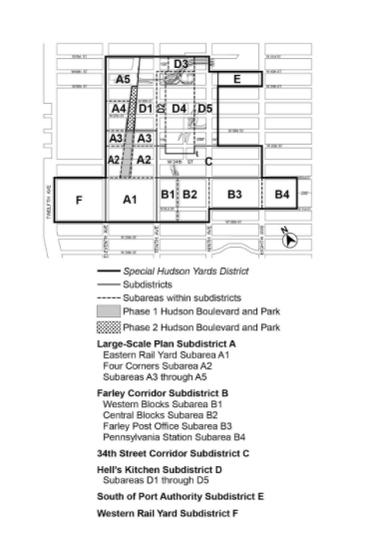
[PROPOSED MAP]

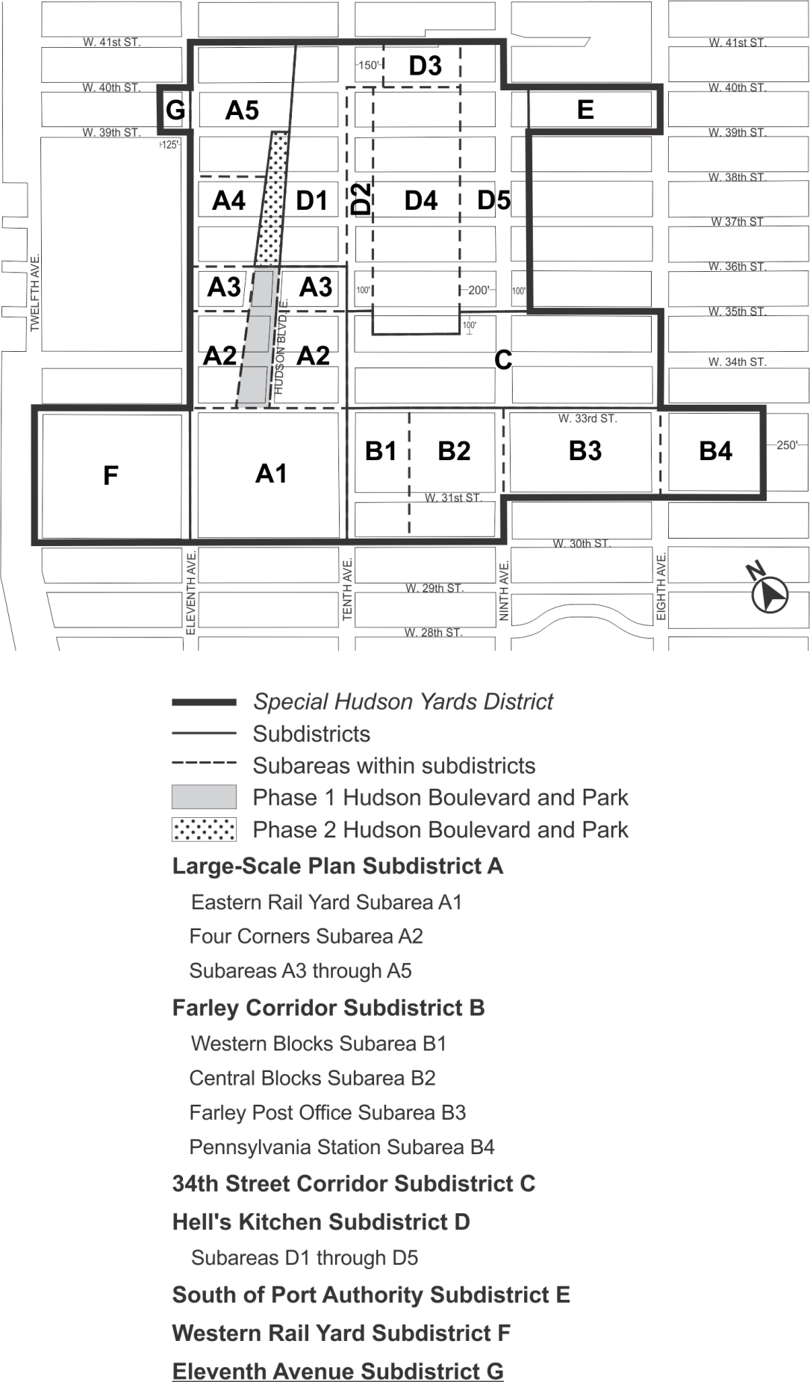

Map 2 – Mandatory Ground Floor Retail

[EXISTING MAP]
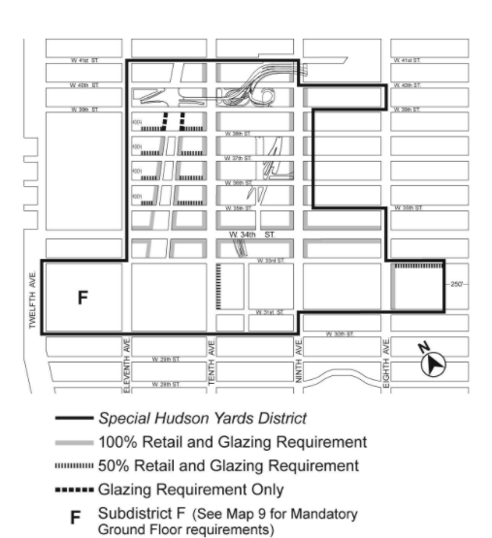

[PROPOSED MAP]
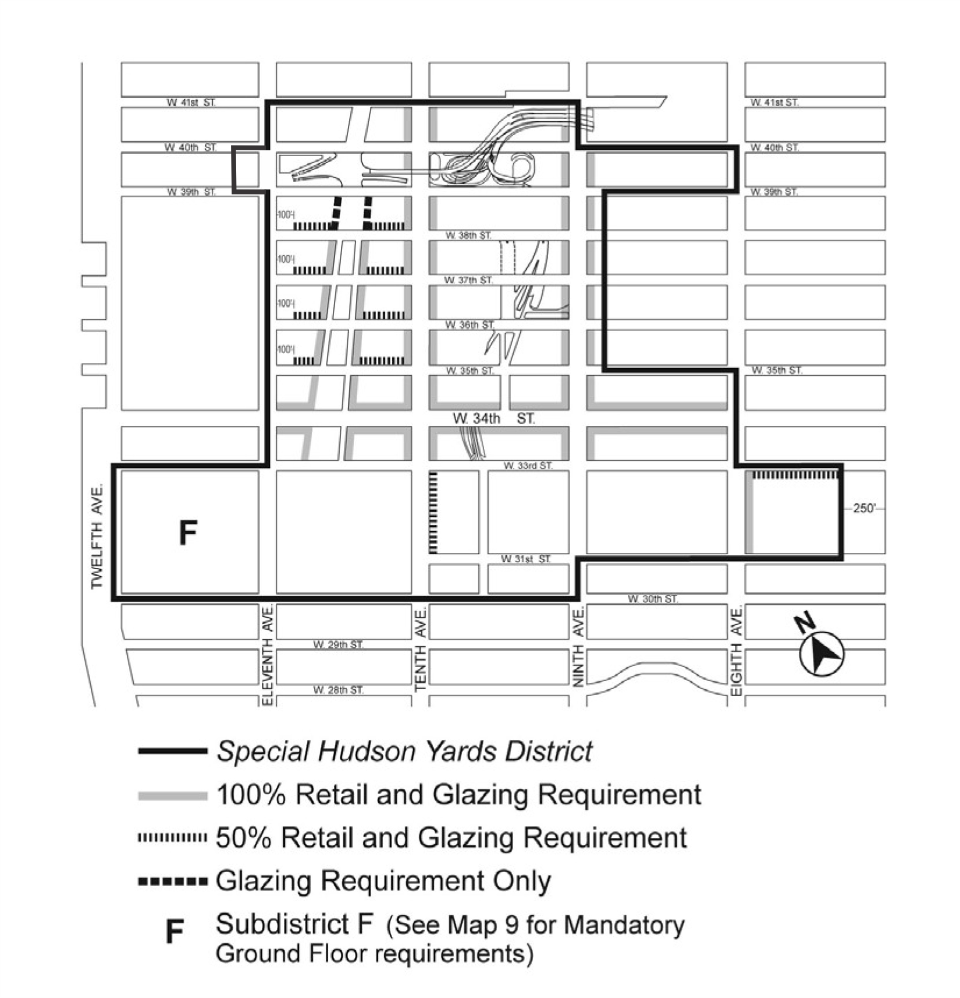

Map 3 – Mandatory Street Wall Requirements

[EXISTING MAP]

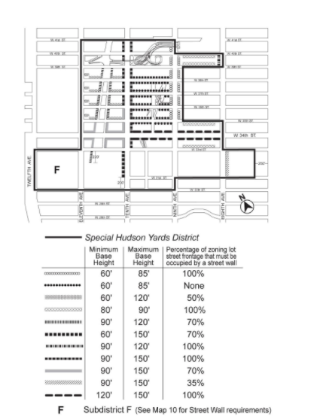

[PROPOSED MAP]

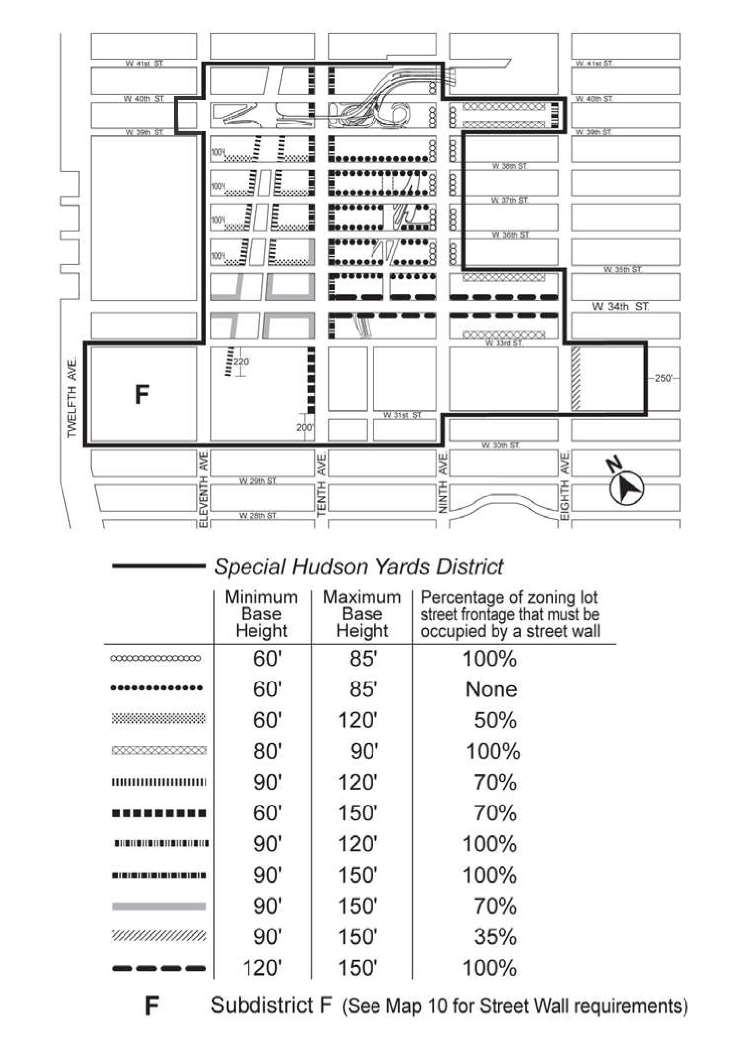

Map 4 – Mandatory Sidewalk Widenings

[EXISTING MAP]

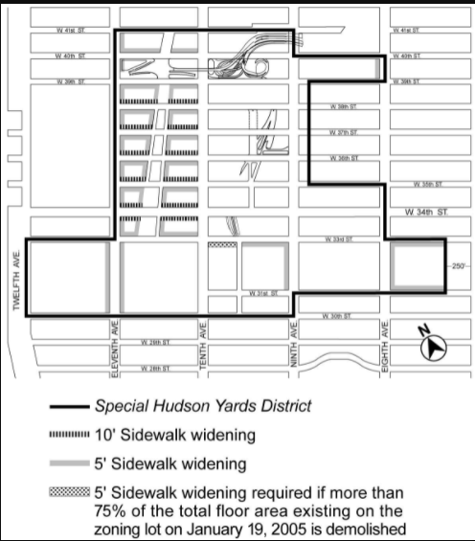

[PROPOSED MAP]

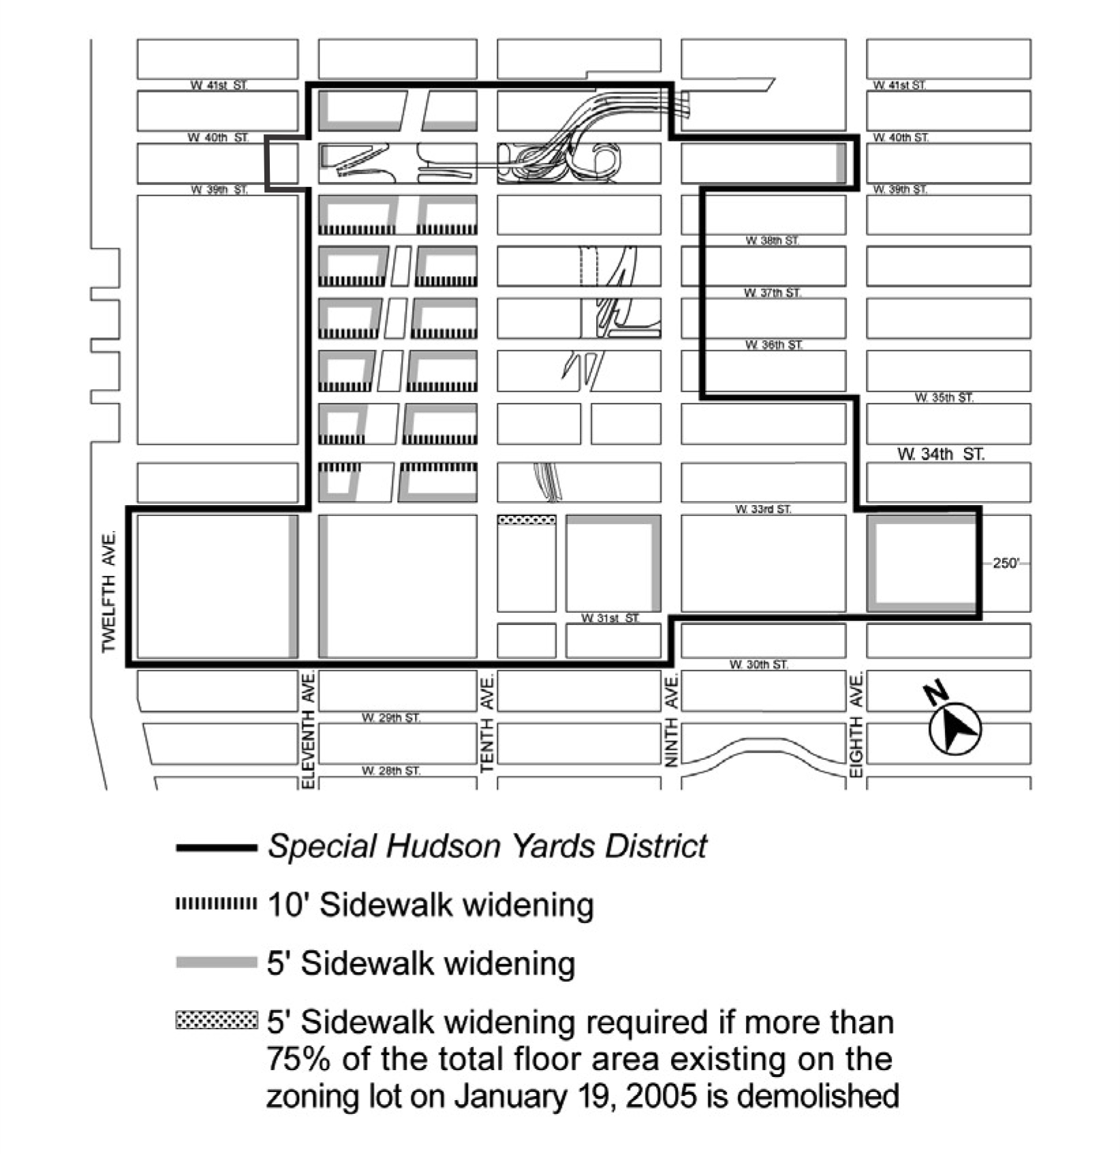

Map 5 – Transit Facilities

[EXISTING MAP]

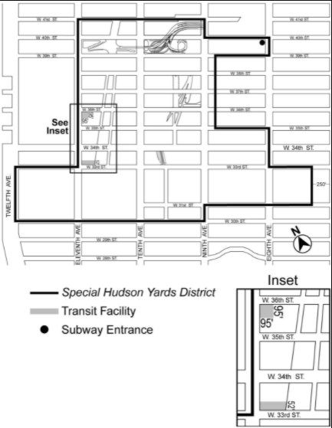

[PROPOSED MAP]

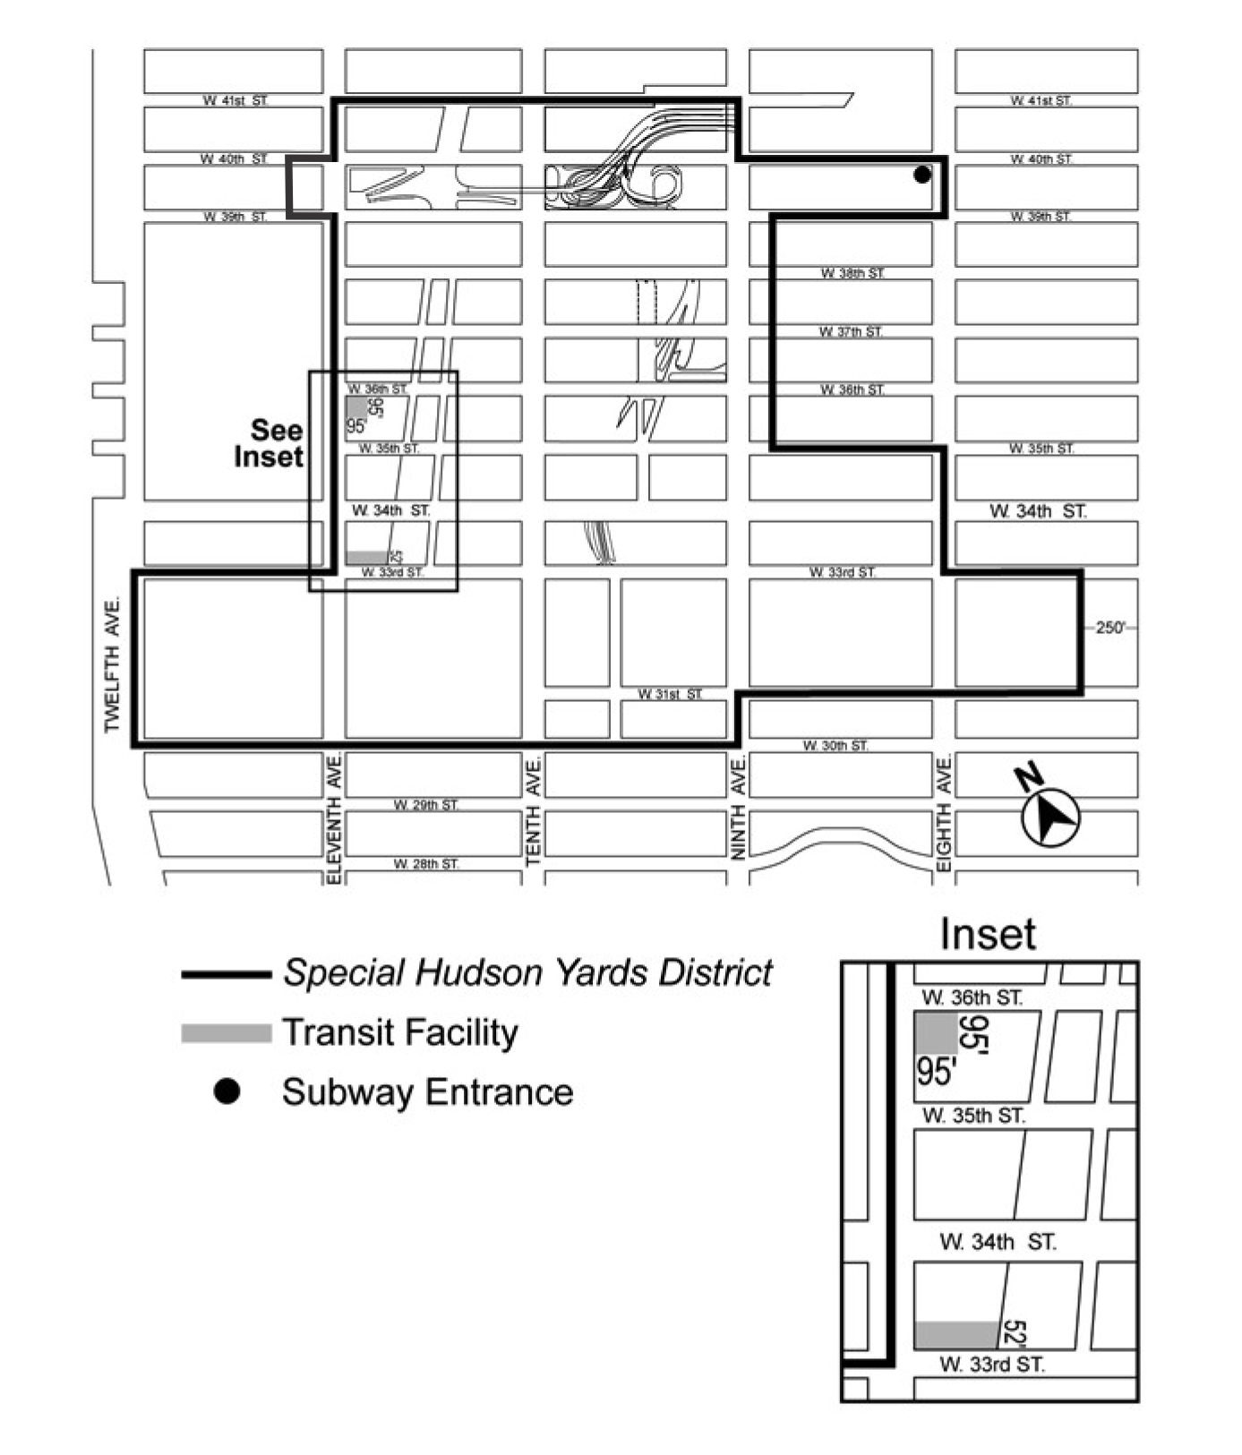

Map 6 – Sites Where Special Parking Regulations Apply

[EXISTING MAP]

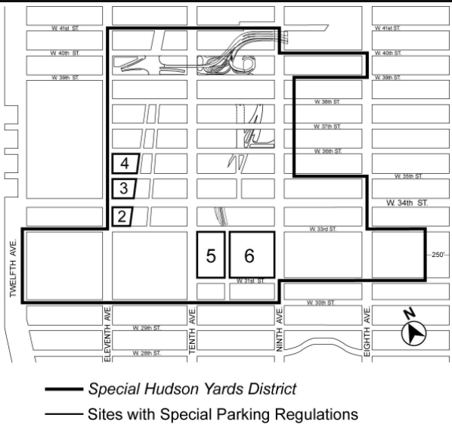

[PROPOSED MAP]
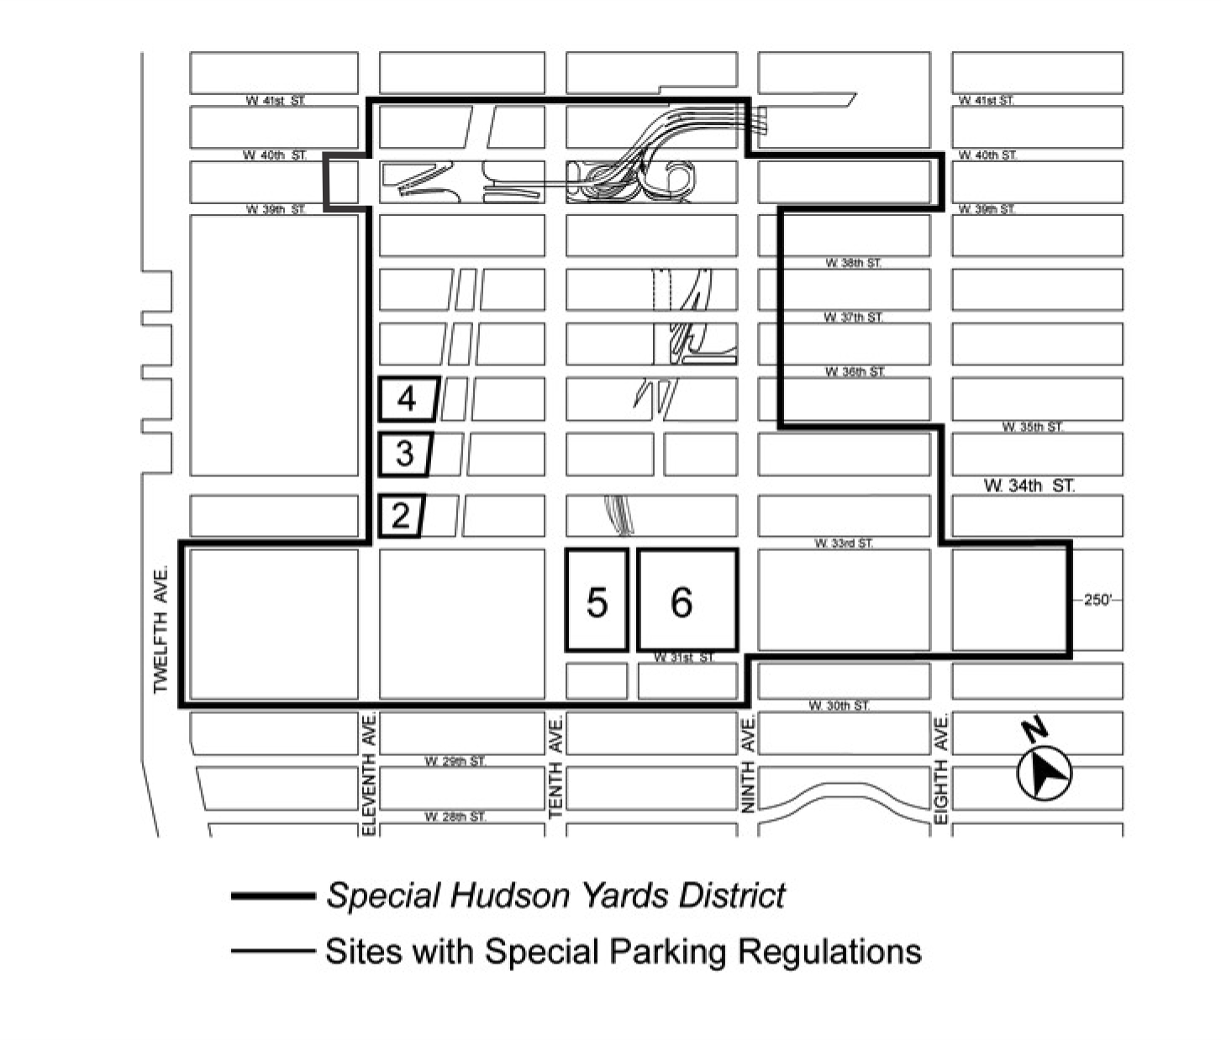

APPENDIX F

Inclusionary Housing Designated Areas and Mandatory Inclusionary Housing Areas

* * *

MANHATTAN

* * *

Manhattan Community District 4

* * *

Map 4 – (12/21/09) [date of adoption]

[EXISTING MAP]

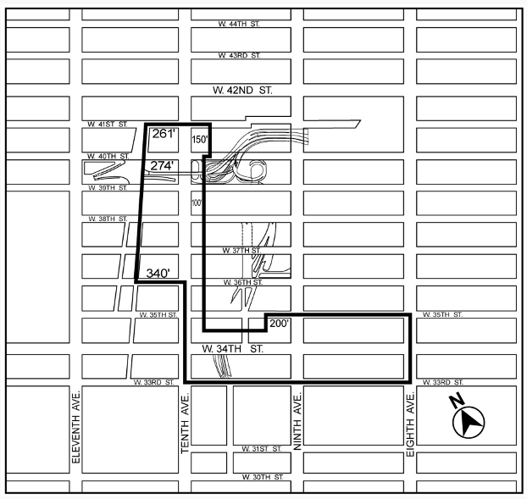

[PROPOSED MAP]
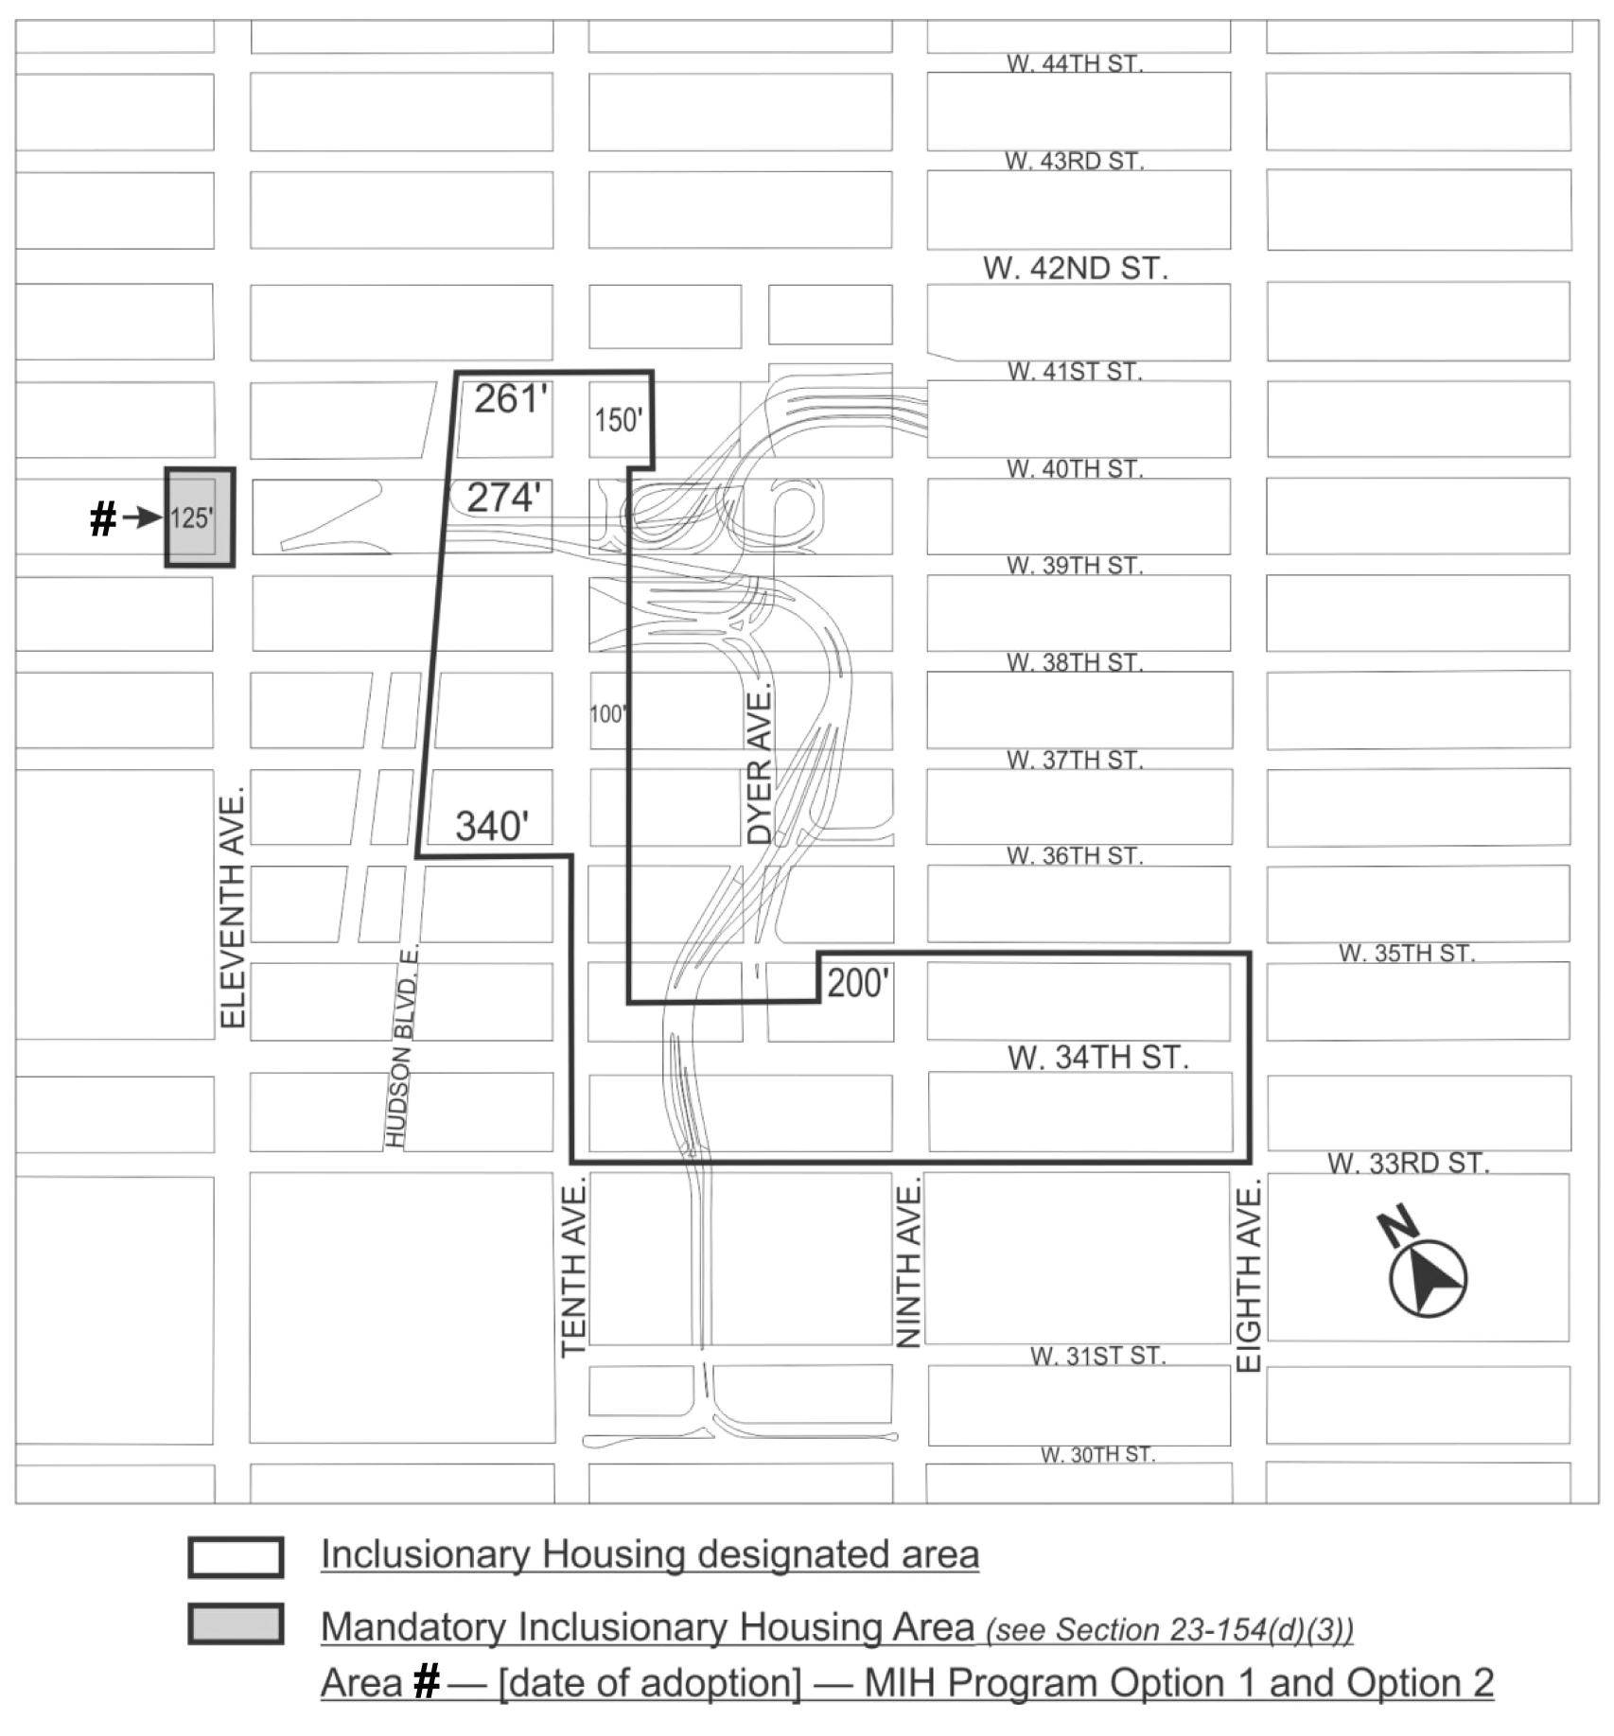

Portion of Community District 4, Manhattan

* * *

Adopted.

Office of the City Clerk, }
The City of New York, } ss.:

I hereby certify that the foregoing is a true copy of a Resolution passed by The Council of The City of New York on October 21, 2021, on file in this office.

.....................................................
City Clerk, Clerk of The Council

