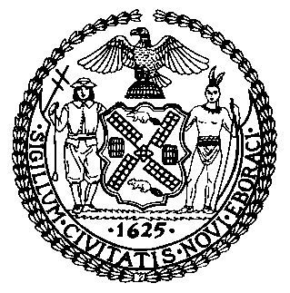 | The Council of the City of New York  Finance Division  Latonia McKinney, Director  Fiscal Impact Statement  Proposed Intro. No: 2321-A  Committee: Housing and Buildings
Title: A Local Law to amend the administrative code of the city of New York, in relation to inspection of building gas piping systems and extension of time to complete work required by inspection | Sponsors: Council Members Cornegy, Yeger, Gennaro, Rosenthal, and Louis
Summary of Legislation: Proposed Intro. No. 2321-A would allow a property owner of a building with gas piping but not active gas service to forgo their gas piping inspection, so long as they provide certification from their utility company and themselves that there is no active gas service in the building. Resumption of gas service would require the property owner to obtain a certificate of approval of gas installation from DOB and comply with the gas piping inspection and certification requirements of local Law 152. This bill would also allow DOB to grant additional time to submit certification, beyond 180 days, if additional tine is needed to ameliorate conditions that must be corrected. Finally, this bill provides a 180 days extension to comply with both the inspection and certification requirements of Local Law 152 for any building owner who requests an extension. Currently, Local Law 152 of 2016 and DOB rules require that building gas piping systems must be inspected ever four years and DOB rules require submission of a certification that all conditions identified in the inspection report have been corrected no later than 120 days, or if more time is needed, no more than 180 days following inspection date.

Effective Date: This local law would take effect 120 days after becoming law, with sections one, two, and three retroactive to and deemed to have been in full force and effect as of January 1, 2020.

Fiscal Year In Which Full Fiscal Impact Anticipated: Fiscal 2023
Fiscal Impact Statement:
 | Effective FY22 | FY Succeeding Effective FY23 | Full Fiscal Impact FY23
Revenues | $0 | $0 | $0
Expenditures | $0 | $0 | $0
Net | $0 | $0 | $0
Impact on Revenues: It is estimated that there would be no impact on revenues resulting from the enactment of this legislation.

Impact on Expenditures: It is anticipated that there would be no impact on expenditures resulting from the enactment of this legislation.
Source of Funds to Cover Estimated Costs: N/A
Source of Information: New York City Council Finance Division
Mayor’s Office of Legislative Affairs

Estimate Prepared by: John Basile, Senior Financial Analyst
Estimate Reviewed by: Chima Obichere, Unit Head
Stephanie Ruiz, Assistant Counsel
Legislative History: This legislation was first introduced to the full Council as Intro. No. 2321 on May 27, 2021 and referred to the Committee on Housing and Buildings (the Committee). A hearing was held by the Committee on September 13, 2021 and the bill was laid over. The legislation was subsequently amended and the amended version, Proposed Intro. No. 2321-A, will be considered by the Committee on October 21, 2021. Upon a successful vote by the Committee, Proposed Intro. No. 2321-A will be submitted to the full Council for a vote on October 21, 2021.
Date Prepared: October 18, 2021

