Transportation Committee Staff:
Kelly E. Taylor, Counsel
Gafar Zaaloff, Policy Analyst
Jonathan Masserano, Policy Analyst
Russell Murphy, Policy Analyst

Waterfronts Committee Staff:
Kristoffer Sartori, Counsel
Patrick Mulvihill, Policy Analyst

Economic Development Committee Staff:
Alex Paulenoff, Counsel
Rachel Harris, Policy Analyst

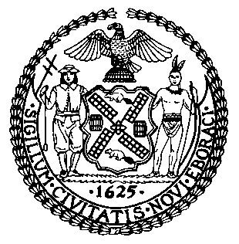

THE COUNCIL OF THE CITY OF NEW YORK

BRIEFING PAPER OF THE HUMAN SERVICES

AND INFRASTRUCTURE DIVISIONS
Matthew Gewolb, Legislative Director

COMMITTEE ON TRANSPORTATION

Hon. Ydanis Rodriguez, Chair

COMMITTEE ON WATERFRONTS

Hon. Deborah Rose, Chair

COMMITTEE ON ECONOMIC DEVELOPEMT

Hon. Daniel R. Garodnick, Chair

September 21, 2015

Oversight – Evaluating the Plan for a Citywide Ferry System

INTRODUCTION

On September 21, 2015, the Committee on Transportation, chaired by Council Member Ydanis Rodriguez, the Committee on Waterfronts, chaired by Council Member Deborah Rose, and the Committee on Economic Development, chaired by Council Member Daniel R. Garodnick, will hold a joint oversight hearing entitled “Evaluating the Plan for a Citywide Ferry System.” The Committee expects to hear testimony from New York City Economic Development Corporation (EDC) and other interested stakeholders.
BACKGROUND
Prior to the construction of bridges and tunnels connecting the five boroughs, ferry service was crucial to connecting and transporting New Yorkers. In more recent decades ferry services more often complement other forms of transportation, relieving growing vehicular and mass transit congestion. Moreover, ferry service has played a crucial role in transporting New Yorkers during emergencies, including in the aftermath of Superstorm Sandy.
Today, ferry service in New York City is provided by both public and private entities. Since 1905, the City has operated the Staten Island Ferry between Staten Island and Lower Manhattan. According to the New York City Department of Transportation (DOT) over 22 million passengers utilize the Staten Island Ferry. In addition to this City-operated ferry service, a host of private companies have long operated ferry service between New York and New Jersey along the Hudson River.
The Council last held oversight hearings on the state of ferry service in New York City in 2012 and 2013. At the 2012 hearing, the EDC highlighted the significant role played by the Council in launching the East River Ferry service. According to one witness at that hearing, the inauguration of the East River Ferry played a role in boosting “local economic development, increasing real estate values and increasing access to the waterfront neighborhoods along the East River.”
2011 Citywide Ferry Study
In 2011, the City released its first ever comprehensive ferry service study. The ferry study was a culmination of proposals put forth by the City Council and the Bloomberg Administration to increase and expand ferry service throughout the City. In the 2011 report, EDC, in conjunction with NYHaborWay, surveyed 43 different locations throughout New York City for possible ferry service. The study, which received technical assistance from DOT, examined the market demand and potential ridership from sites throughout the City, identified possible future service corridors, analyzed the potential for recreational ferry services, reviewed possible funding sources, and investigated the issue of governance.
The 43 sites were selected for ferry commuter analysis based on materials from prior reports, meetings between EDC staff and elected officials, and information gathered from a series of public meetings held by EDC in 2009, which asked City residents to suggest sites to be analyzed. However, of those sites, only 17 were equipped with an existing ferry landing. Because the study only focused on the operating and subsidy costs associated with ferry services, the capital costs necessary to build the dock and barge infrastructure at any one particular site, which could run into the millions of dollars, were not examined.
East River Ferry
Begun as a pilot in 2011, the East River Ferry serves seven stops in Manhattan, Brooklyn, and Queens, with limited seasonal service to Governors Island. Widely considered a success, it met its three-year ridership goal in just 14 months and served over 1.2 million riders in 2014. Average weekday ridership was 3,257 in 2013. NY Waterway operates the service under contract with EDC. Fares are $4 on weekdays and $6 on weekends, with all-day and monthly passes also available.
The East River Ferry experiences seasonal variations in ridership; in the summer months weekend trips, dominated by recreational users, outstrip weekday trips, while in the winter months commuter-heavy weekday trips outpace weekend trips. Ridership in both categories declines during the colder months and rises during the summer. Fares cover 64% of the operating cost, requiring a $2.22 per passenger trip (over $2.5 million a year) subsidy to make up the difference. A comparison of operating subsidies for various transportation modes in New York can be found in Appendix B. As a result of the success of its pilot phase, the East River Ferry was made permanent; the current East River Ferry contract runs through 2019.

Citywide Ferry Study 2013
Building off of the first Citywide Ferry Study and the initial results of the East River Ferry program, EDC conducted an updated and expanded study, the Citywide Ferry Study 2013 (CFS2013). CFS2013 found that East River Ferry service had contributed to a rise in property values near ferry stops (by as much as 8 percent for properties within 1/8 of a mile of stops in Brooklyn and Queens) and contributed to over 600,000 square feet of additional residential and commercial building space in areas near ferry landings. The study concluded that significant potential ridership generated by fast-growing areas of the Brooklyn and Queens waterfront had the potential to support expanded service with only “modest” public subsidy, while more distant locations, while providing accessibility benefits to those communities, would generate higher operating costs requiring greater public subsidy in order to maintain comparable fare rates.
In all, CFS2013 examined 50 potential ferry landing sites and identified the six most promising new routes, including service to LaGuardia Airport. These routes, along with their associated operating subsidy and capital costs, are outlined in Appendix C. The study concluded that an expanded ferry network at a lower uniform fare (in the $3 range) could be revenue neutral while generating significant increased ridership. It also strongly recommended identifying and pursing appropriate “value capture” funding methods to support any increased ferry service.
Planned Citywide Ferry System
On February 3, 2015, Mayor Bill de Blasio announced plans to create a citywide ferry system with fares equivalent to the subway and bus fare. The stated aims of the new service include better connecting residents of neighborhoods with limited transportation service with opportunities throughout the City, spurring development in newly-accessible places (specifically in the outer boroughs), and increasing the resiliency of the City’s transportation network. Like the East River Ferry, the new service will be provided by a private ferry operator overseen by EDC.
In addition to the existing East River Ferry routes, EDC plans five new routes: Astoria, South Brooklyn, and Rockaway routes, which will begin operation in 2017, and Soundview and Lower East Side routes to begin service in 2018. A sixth proposed route that would connect Stapleton and Coney Island with Manhattan has also been discussed as a possible future addition. EDC expects the new ferry system to provide 4.6 million rides per year when fully operational.
In March 2015, EDC issued a Request for Proposals seeking to identify potential operators of the new ferry service. Responses were due in June and EDC expects to select an operator this coming winter. The cost of constructing or renovating the 12 ferry landings that will be necessary for the new service is covered by $55 million in City capital funds. The amount of any City operating funds needed to subsidize the new service will be determined following negotiations with the ferry service operators.
EDC has begun outreach to local communities regarding plans for the new ferry service. Some communities have raised concerns regarding the location and accessibility of planned ferry landings. The plan has also garnered criticism from some transportation advocates, who argue that the limited reach of ferries is not worth the public subsidies required. EDC has also revealed that the new service will not accept MetroCards as a form of fare payment and no free transfer will be available to the bus or subway.
CONCLUSION
Today the Committees look forward to learning more about the plans for the new Citywide Ferry System, including how the Administration is balancing costs and benefits, plans for how to maximize ridership, service, and efficiency, and details on which communities across the City will see benefits of the new service in the immediate and long-term future.
Appendix A –
Current East River Ferry Route Map, as shown on the East River Ferry’s website

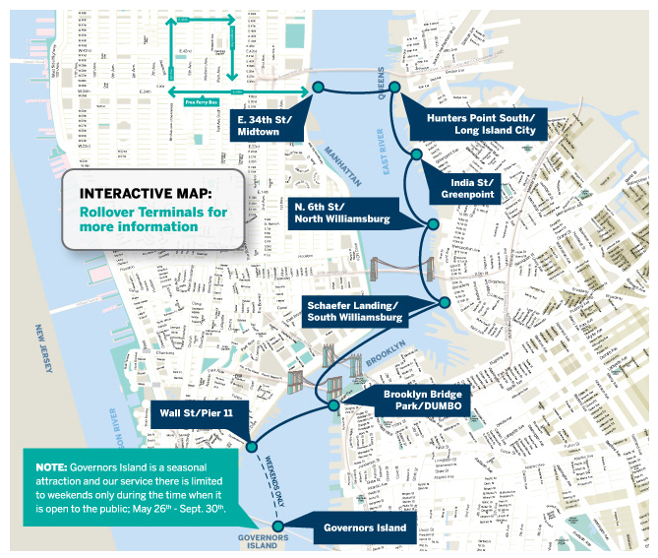
Appendix B – Transit Fares and Subsidies per Passenger Trip

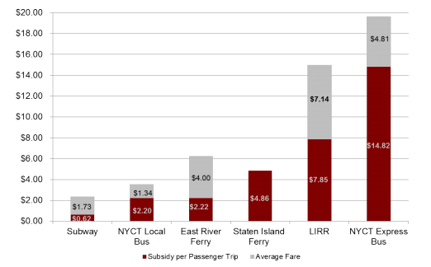
Source: CFS2013
Appendix C – Summary Characteristics of CFS2013 Priority Routes, assuming a $5 fare
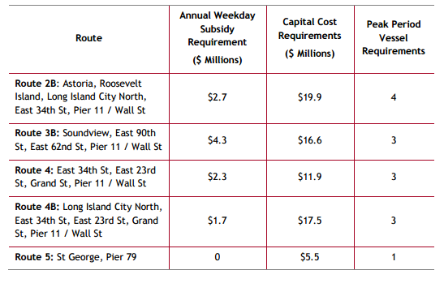
Source: CFS2013

Appendix D – EDC’s Planned Citywide Ferry Routes
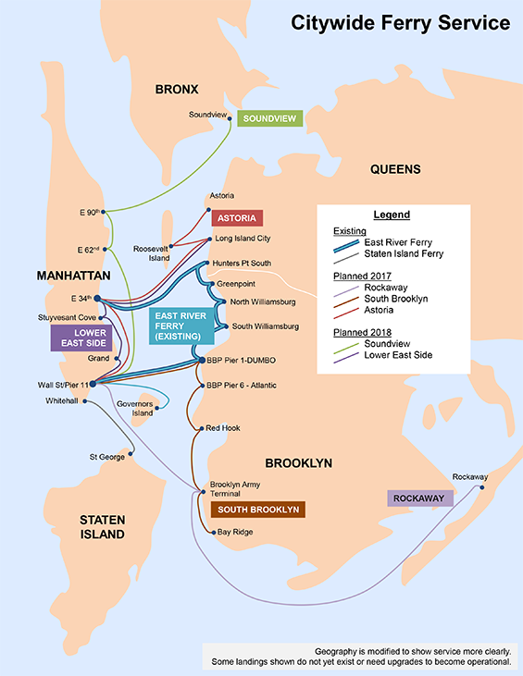
Source: http://www.nycedc.com/project/citywide-ferry-service

Patrick McCandless, Understanding the Challenges of Regional Ferry Service in New York City 11 (2010), available at http://wagner.nyu.edu/files/faculty/publications/RCWP_McCandless.pdf.
Id. at 11-12.
Metropolitan Waterfront Alliance, Maximizing Ferries in New York City’s Emergency Management Planning (Apr. 2013), available at http://waterfrontalliance.org/wp-content/uploads/2015/07/Waterfront_Platform_Ferries_04_2013.pdf.
N.Y.C. Department of Transportation, Ferry Information, http://www.nyc.gov/html/dot/html/ferrybus/ferintro.shtml (last accessed Sept. 17, 2015).
Id.
Testimony of Ronald Lewis, President and CEO of Metropolitan Waterfront Alliance, April 25, 2012.
The NYHarborWay is an initiative of NYC & Company, New York City’s official marketing, tourism, and partnership organization. The NYHarborWay is intended to establish nine harbor destinations as must-see sites for residents and visitors.
N.Y.C. Economic Development Corporation and NYHarborWays, Comprehensive Citywide Ferry Study (Mar. 2012), available at http://www.appleseedinc.com/reports/ComprehensiveCitywideFerryStudy_2011-03-15.pdf.
Id.
See route map in Appendix A.
N.Y.C. Economic Development Corporation, East River Ferry Service, http://www.nycedc.com/project/east-river-ferry-service (last accessed Sept. 17, 2015).
N.Y.C. Economic Development Corporation, Citywide Ferry Study 2013 Final Report 12 (Feb. 2015), available at http://www.nycedc.com/sites/default/files/filemanager/Resources/Studies/2013_Citywide_Ferry_Study/Citywide_Ferry_Study_-_Final_Report.pdf.
NY Waterway, Fare Info & Policies, http://eastriverferry.com/FareInfoPolicies/ (last accessed Sept. 17, 2015).
N.Y.C. Economic Development Corporation, supra note 11 at 13-14.
Id. at 12.
N.Y.C. Economic Development Corporation, Letter to Transportation Committee Chair Ydanis Rodriguez, Jun. 24, 2015, on file with staff.
A preliminary version of the Citywide Ferry Study was issued in 2013, with the final report issued in 2015. Information in this report is based on the final 2015 report unless otherwise noted.
N.Y.C. Economic Development Corporation, supra note 11, at 5.
Id.
Id. at 70.
Id. at 71.
See Appendix D for a map of the planned routes.
N.Y.C. Economic Development Corporation, supra note 15.
Id.
Amy Langfield, Citywide Ferry Plan Will Not Integrate With MTA’s MetroCard for Transfers, DNAinfo, Aug. 23, 2015, http://www.dnainfo.com/new-york/20150821/red-hook/citywide-ferry-plan-will-not-integrate-with-mtas-metrocard-for-transfers.
Matt Flegenheimer, Mayor de Blasio Moves to Expand Ferry Service in New York City, N.Y. Times, Feb. 3, 2015, available at http://www.nytimes.com/2015/02/04/nyregion/mayor-de-blasio-moves-to-expand-ferry-service-in-new-york-city.html?_r=0.
Amy Langfield, supra note 24.

