Governmental Operations Committee Staff
Brad J. Reid, Assistant Deputy Director
Elizabeth Kronk, Legislative Policy Analyst
Emily Forgione, Legislative Policy Analyst
Zachary Harris, Finance Analyst

Data Operations Staff
Alaa Moussawi, Chief Data Scientist
Julia Fredenburg, Data Visualization Specialist
Ben Witte, Data Scientist



THE COUNCIL

COMMITTEE REPORT OF THE GOVERNMENTAL AFFAIRS Division
Jeffrey Baker, Legislative Director
Rachel Cordero, Deputy Director, Governmental Affairs

COMMITTEE ON GOVERNMENTAL OPERATIONS
Hon. Fernando Cabrera, Chair

February 4, 2019

Oversight: City Agency Responsiveness to 311 Service Requests

Int. No. 1002-2018: By Council Members Holden and Yeger

Title: A Local Law to amend the administrative code of the city of New York, in relation to requiring the 311 customer service center to indicate that an agency is unable to respond to a service request or complaint

Administrative Code: Section 23-304

Introduction
On February 4, 2019, the Committee on Governmental Operations, chaired by Council Member Fernando Cabrera will hold an oversight hearing on ‘City Agency Responsiveness to 311 Service Requests,’ and a first hearing on Int. 1002-2018, sponsored by Council Member Robert Holden, in relation to requiring the 311 customer service center to indicate that an agency is unable to respond to a service request or complaint. The committee expects to receive testimony from the 311 Customer Service Center (“311”), the Department of Environmental Protection (“DEP”), the Department of Buildings (“DOB”), the Department of Transportation (“DOT”), the Department of Health and Mental Hygiene (“DOHMH”), the Department of Housing Preservation and Development (“HPD”), the Department of Finance (“DOF”), and the Taxi and Limousine Commission (“TLC”), as well as advocates and members of the public related to the above topics.
This is the second of a two-part hearing on the 311 system. The first hearing was held by the Committee on Governmental Operations and the Committee on Technology, on January 17, 2019 and was focused on 311 Customer Experience and Operations.

Background
311
The 311 Customer Service Center (“311”) was first launched in 2003 as a call center, built on technology from 2002. Since then it has evolved to provide services through text messages, a mobile application, social media and a website. Prior to its establishment by former Mayor Michael Bloomberg, the City relied on approximately 40 agency help lines and a general Mayoral phone line, almost all of which have been folded into the 311 call center. It now registers tens of millions of customer contacts each year – with over 42 million in FY18. Only about half of those contacts originated by telephone, while the rest mostly originated through the website, text messaging, and the mobile app. A customer contact with 311 usually generates either a service request, when the customer is seeking a City agency to take an action, or an informational request, when the customer has a question regarding a City service. There are datasets for both types on the Open Data Portal, both of which are updated daily by 311.
At the joint public hearing of the Governmental Operations and Technology Committees on January 17, 2019, 311 shared the various ways in which it is working with the Department of Information Technology and Telecommunications (DoITT) to enhance customer experiences through a new Customer Relationship Management (CRM) software platform. Currently people can access 311 via phone (by dialing 3-1-1 within the City and 212-NEW-YORK from anywhere in the world), a nyc.gov 311 Online web portal, Facebook, Twitter, sending a text message to 311-NYC (311-692) or via a 311 smartphone application for iPhone and Android. The 311Online website and the mobile app can also be used to look up the status of an individual request by service number, after it has been reported.
Future updates, discussed at the January 17th hearing, will include the creation of user accounts to better track complaints filed with 311. Currently, only the mobile app can track multiple service requests at one time for a customer, and then only if those requests were submitted through the mobile app. Neither the website nor the telephone system allows for similar tracking.
Agency Responsiveness to 311 Complaints
Once a customer makes a complaint or similar request to 311, a “service request” is generated with a unique identifying number, which is shared with the customer and can be used to track the resolution of that case. Of the 42 million 311 contacts, approximately 2.58 million contacts result in a service request being filed. 311 submits the service request, based on complaint type, to the City agency tasked with resolving issues of that type. In an ideal scenario, the service request is clearly described by the user, transcribed by the 311 operator, transmitted between 311 and the appropriate agency, analyzed by the agency liaison and responded to by the appropriate agency. The responding agency should then document a clear resolution, which should be tracked in the 311 service request data and shared with the customer. In practice, this process has significant room for error, and the 311 service request data does not always provide a clear picture of where the process breaks down.
The following table and figure show the top ten City agencies with the most complaints or “service requests” overall, out of the 2.58 million service requests in 2018:
City Agency | Number of Service Requests | Percent of all 2018 311 Service Requests
NYPD | 751,497 | 29.0%
HPD | 594,121 | 23.0%
DSNY | 399,428 | 15.4%
DOT | 289,103 | 11.2%
DEP | 192,468 | 7.4%
DOB | 92,958 | 3.6%
DPR | 84,070 | 3.2%
DOF | 53,339 | 2.1%
DOHMH | 48,390 | 1.9%
TLC | 20,636 | 0.8%

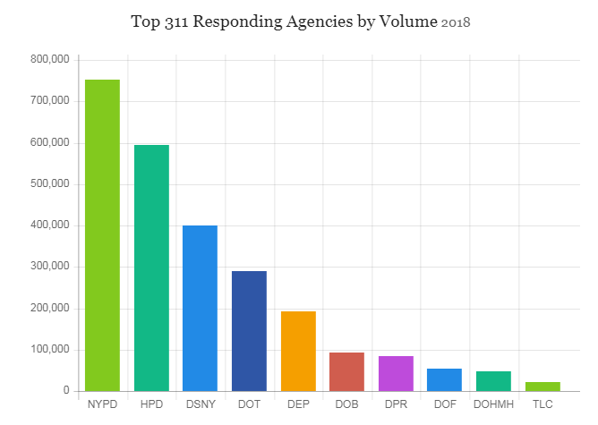

The following table and figure show the top ten complaint types from that same pool of service request data:
Service Request | Responding Agency | Percent of all 2018 311 Service Requests
Noise Complaint (aggregated) | NYPD | 16.9%
Heat and Hot Water Complaint | HPD | 8.6%
Request Large Bulky Item Collection | DSNY | 7.0%
Illegal Parking Complaint | NYPD | 6.3%
Blocked Driveway Complaint | NYPD | 5.3%
Street Condition | DOT | 3.9%
Unsanitary Condition | HPD | 3.2%
Street Light Condition | DOT | 2.9%
Water System | DEP | 2.8%
Plumbing | DOB | 2.3%

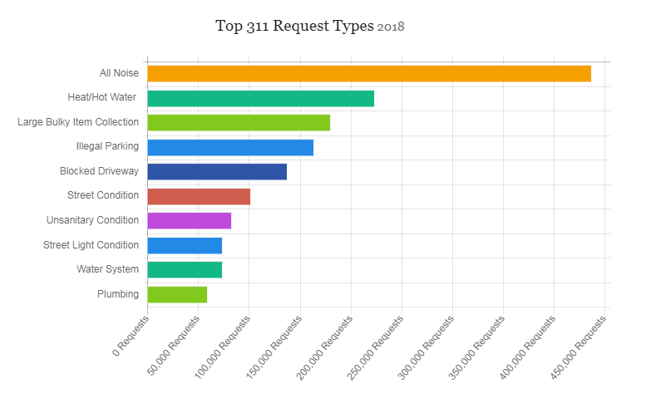
City agencies vary widely in the time it takes for service requests to be completed or reach “resolution.” This variation may be attributed to the variety of complaints, which necessarily require a variety of resolutions, but could also be attributed to City agencies using separate and distinct definitions of “completed” or “resolved,” which is only partially discernable in the data. A review of the 2018 service request data shows that Benefit Card Replacement service requests issued to HRA took less than one minute to resolve on average, while the service requests related to dead or dying trees issued to the Department of Parks and Recreation (“DPR”) took an average of 89 days (or nearly three months) to resolve – the longest mean resolution time in the 2018 data set. The following figure shows the 11 complaint types with the longest resolution times:
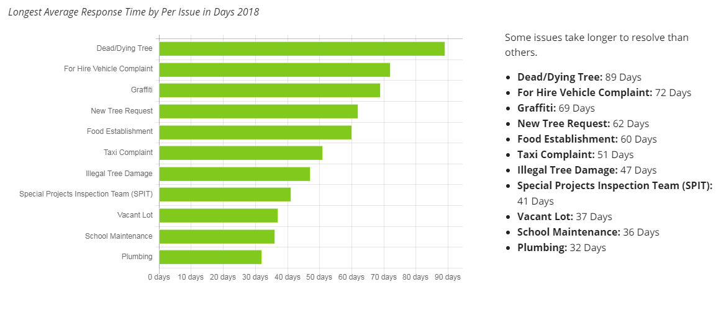

The Committee hopes to hear from the following agencies on specific concerns related to the 311 data on service requests and resolutions.
Department of Environmental Protection (“DEP”). DEP is the City agency tasked with protecting the drinking water New Yorkers access in the City, managing wastewater and storm water, and generally decreasing pollution from air, noise, and hazardous materials. The agency primarily receives complaints related to water quality, construction noise, water and sewer systems, and air quality, to name a few. Of the complaints DEP receives, 42.9% complaints are marked “unobserved” when a DEP employee investigates, and another 15.5% of the complaints result in “no action taken” by the agency.
Department of Health and Mental Hygiene (“DOHMH”). DOHMH is the City agency tasked with promoting the public health through a variety of regulatory measures (i.e. dining establishment licenses and inspections, dog license registrations, etc.), supporting low- to no-cost neighborhood clinics, and research on identified patterns of disease in the city. The agency also engages in programming and outreach related to topics impacting New Yorkers such as tobacco cessation, safe practices for HIV/AIDS, etc. The agency primarily receives complaints related to unsanitary conditions in or near dining establishments (includes rodents, mold, etc.), food poisoning, indoor air quality, and standing water, to name a few. Based on an analysis of publicly available 311 data, 99% of service requests made to the agency in 2018 were closed with resolution descriptions that implied the agency still had work to do.
Department of Transportation (“DOT”). DOT is the City agency charged with the management of the City’s transportation infrastructure. City streets, highways, bridges, waterways, tunnels, and sidewalks fall, for the most part, under the DOT’s purview. The agency primarily receives complaints relating to missing or damaged street signs, curb conditions, broken parking meters, and street conditions (potholes), among others. The 2018 data showed that while 33.9% of cases were designated as ‘fixed,’ 46% of cases had ambiguous designations, making it impossible to check if cases were resolved, transferred to a different agency, or are merely languishing without resolution.
Department of Buildings (“DOB”). DOB is the City agency charged with regulating the use of over one million buildings and the permitting of construction sites. The agency primarily receives complaints relating to construction, plumbing, inappropriate building use, boilers, electrical concerns, among others. With just 16% of cases marked as ‘fixed,’ and 15% marked as ‘violation issued,’ 33% of all complaints were tagged as ‘no action taken.’
Department of Housing Preservation and Development (“HPD”). HPD is the City agency charged with municipal housing preservation and development, which includes enforcing the City’s Housing Maintenance Code. The primary complaints received by the agency are heat and hot water complaints, concerns related to doors, windows, appliances, floorings, stairs, elevator, paint or plaster, interior electrical wiring, among other things. According to the 2018 data, only 5.4% of cases were ‘fixed,’ with another 21.2% of violations resulting in violations being issued. Another 38.2% of complaints resulted in no violation, and in 19.9% of cases, HPD inspectors reported that they ‘did not observe’ the substance of the complaint.
Taxi and Limousine Commission (“TLC”). TLC is the City agency tasked with regulating the taxi and for-hire vehicle industry. The agency primarily receives complaints related to for-hire vehicles and taxis. The data shows that 99% of the cases appear to be ongoing, as the agency does not update cases with any further designation beyond the initial opening of the investigation. This lack of updated resolution descriptions makes it impossible to analyze when or if TLC resolves their complaints.
Department of Finance (“DOF”). DOF is the City agency charged with administering the municipal tax levy, maintaining public records related to property ownership, adjudicating parking tickets, and housing the office of the Sheriff, among other duties related to City revenue management. The agency regularly receives complaints related to property payment issues, parking violation payment issues, and property tax exemption issues, among other service requests. The 2018 data shows that 74% of cases were resolved with descriptions deemed ‘ambiguous,’ making it difficult to determine whether a satisfactory resolution was reached for complainants.
311 Data Limitations
At present, data collected on 311 calls lacks sufficient nuance to allow both the public and agencies to understand if requests are being addressed appropriately and in a timely manner. Data limitations include: (1) inaccurate service request or complaint resolutions by agencies; (2) ambiguous complaint resolutions by agencies; (3) inaccurate response times to service requests or complaint resolutions by agencies; and (4) a small but consistent percentage of cases languish without resolution until batch resolution at a fixed point in time.
Resolution Inaccuracy. Agencies regularly address complaints forwarded to them via 311 without clarifying complaint outcomes. As an example, nearly all complaints forwarded to TLC and DOHMH are closed, but with resolution descriptions that imply an ongoing case. The most common resolution associated with TLC complaints is: “The taxi and limousine commission will contact you within 14 days to confirm your complaint details. Please note your service request number for future reference.” While these complaints may be addressed thoroughly, there is no way to verify resolution in the data.
Ambiguous Resolution. Ambiguous responses many agencies use in place of concrete resolution descriptions are also problematic. Forty-six percent (134,000) of complaints handled by DOT in 2018 resulted in an ambiguous description. Street light condition complaints, the most common complaint type, were consistently resolved with the following response: “Service request status for this request is available on the department of transportation's website. Please click the “learn more” link below.” In the 311 dataset, however, there is no “learn more” link.
Timing Inaccuracy. Certain complaints are more likely to be reported with inaccurate times. For example, 20% of complaints about rodents appeared to be addressed by DOHMH before the complaint was submitted. In other cases, times may be accurately reported, but are misleading. For instance, almost all lead-related complaints are addressed in almost exactly 24 hours, due to the fact that the resolution for a lead complaint is to mail a lead testing kit. However, there is no indication in the data set about the results of lead testing.
Batch Resolutions. Most complaint types follow a pattern wherein a majority of complaints are resolved within a certain number of days. Generally, this is followed by a steep drop, as few complaints need considerably more than the average amount of time to be addressed. Some complaints types, however, show a sudden uptick in complaints resolved - often right around a significant period of time - for example, six months. The data appears to show that agencies batch review open complaint cases that have been open for a period of time, perhaps deemed ‘too long,’ on agency-by-agency basis. For example, the DOT resolves the majority of cases of missing street signs in fewer than 25 days - but 9% of all cases are resolved in just over 175 days.

Legislative Analysis

Int. No. 1002-2018

Int. No. 1002-2018 would require agencies to document when they have received a 311 request or complaint for which the agency is unable to take action to resolve. The documentation of such determination would be submitted by the agency to 311 and used to complete the complaint or service request’s “resolution status.”

Int. No. 1002

By Council Members Holden and Yeger

A Local Law to amend the administrative code of the city of New York, in relation to requiring the 311 customer service center to indicate that an agency is unable to respond to a service request or complaint

Be it enacted by the Council as follows:

Section 1. Chapter 3 of title 23 of the administrative code of the city of New York is amended by adding a new section 23-304 to read as follows:
§ 23-304 Response to service requests and complaints. If an agency that receives a request for service or complaint through the 311 customer service center is unable to take action on such request for service or complaint, the 311 customer service center shall indicate in the description of the action taken on such request for service or complaint in the 311 computer system that the responding agency is currently unable to respond to the request for service or complaint.
§ 2. This local law takes effect immediately.

MHL
LS #6499
06/14/18

APPENDIX
Data Analysis Methodology: Agency Service Request Resolution Categories
In attempting to determine the efficacy of 311 as a service (based on the 2018 dataset of 311 requests), it is necessary to understand the quality of resolutions reached. This proves problematic when looking at the original data, as there are 788 unique resolution descriptions. In order to facilitate analysis, staff examined the 788 unique descriptions and aggregated linguistically similar descriptions under the below 8 resolution description categories:
- Fixed - Action has been taken that in some capacity resolves the issue
- Did_not_observe - The complaint reported was not observed by employees of the investigating agency
- No_action_taken - This occurs when employees of an agency investigate a complaint, and either determine that a complaint was not warranted, or for whatever reason decide not to act beyond the investigation (often the case for NYPD). This can occur for a wide variety of reasons.
- Violations_issued - In response to the complaint, employees of the investigating agency investigated and observed an issue that was in violation of policies. A violation was issued accordingly
- Ongoing - The resolution description either indicates a response will take place in the future, that the issue is under investigation (particularly common for TLC)
- Duplicate - The complaint is marked as a duplicate of a previously made complaint
- Ambiguous - This indicates that the resolution description so completely lacks clarity as to what may have occurred that staff (and members of the public, by extension) are unable to decipher the implications
- Wrong_agency - The complaint was sent to an incorrect agency.
Using these methods of classification, staff was better able to construct complete pictures of the efficacy of 311 as a whole, as well as of each agency. Overall, here are the response rates, based on the nearly 2.58 million complaints lodged in 2018:
Classification | % of Total Resolutions
did_not_observe | 24.8%
fixed | 21.5%
no_action_taken | 18.7%
ambiguous | 17.3%
duplicate | 5.5%
ongoing | 6.2%
violation_issued | 4.8%
wrong_agency | 0.8%
other | 0.4%
‘fixed’ and ‘violations_issued’ combined | 26.3%
‘did_not_observe’ and ‘no_action_taken’ combined | 43.5%

The first nine rows correspond to specific responses, while the final two combine responses where an agency clearly took an action to address the complaint and responses where an agency did not clearly take an action to address the complaint, respectively.

‘311 Customer Service Center: More Calls and a Growing Budget’, IBO Fiscal Brief, April 2008, p. 1-2, found at: http://www.ibo.nyc.ny.us/iboreports/311Apr08.pdf
2018 Mayor’s Management Report, p. 134.
Id.
See 311 Service Requests from 2010 to Present, accessible on NYC OpenData Portal at https://nycopendata.socrata.com/Social-Services/311-Service-Requests-from-2010-to-Present/erm2-nwe9
See Appendix for a detailed description of the methodology used to analyze agency resolution data. Visual representation of analysis available at: https://council.nyc.gov/public-advocate/311-agency/
See pg 8-9 in this report

