Sanitation Committee Staff
Nicole Abene, Counsel
Nadia Johnson, Policy Analyst
Jonathan Seltzer, Finance Analyst

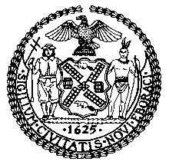

COMMITTEE REPORT OF THE INFRASTRUCTURE DIVISION
Jeff Baker, Legislative Director
Edward Atkin, Deputy Director

COMMITTEE ON SANITATION AND SOLID WASTE MANAGEMENT
Hon. Antonio Reynoso, Chair
April 24, 2018

Oversight – Review of DSNY’s Waste Characterization Study

PRECONSIDERED INT. NO. __: By Council Member Matteo

TITLE: A Local Law to amend the administrative code of the city of New York, in relation to penalties for littering from a vehicle

ADMINISTRATIVE CODE: Amends subdivision 9 of section 16-118

PRECONSIDERED INT. NO. __: By Council Member Matteo

TITLE: A Local Law in relation to a plan to increase enforcement of littering out of vehicles

Introduction
On April 24, 2018, the Committee on Sanitation and Solid Waste Management, chaired by Council Member Antonio Reynoso, will hold an oversight hearing entitled “Review of DSNY’s Waste Characterization Study”. The Committee expects to hear testimony from representatives from the New York City Department of Sanitation (“DSNY”), the New York City Mayor’s Office of Sustainability, and interested members of the public.
- Background
The 2017 NYC Residential, School, and NYCHA Waste Characterization Study is the fourth waste characterization study that DSNY has completed and fulfills the requirement under Local Law 40 of 2010. DSNY also released waste characterization studies in 1990, 2005, and 2013. The study helps assess progress towards the City’s goal to send zero waste to landfills by 2030 (“Zero Waste”).
Residences, schools and NYCHA campuses are all areas the City is targeting to get Zero Waste. A key effort in this mission is the creation and expansion of a citywide organics program. In October 2013, the New York City Council passed Local Law 77 of 2013, which required the DSNY Commissioner to establish a voluntary residential organic waste curbside collection pilot program and a school organic waste collection pilot program. The program has been incrementally rolled out across the city, with all residents having access to compost their food and yard waste through either curbside collection or nearby drop-off locations by the end of 2018.
For schools, recycling initiatives such as designating “Zero Waste Schools,” help to educate children and reduce landfill waste from schools, which generate more than 40,000 tons of refuse per year. A Zero Waste School would divert all of its recyclable and compostable waste within five years. In 2016, DSNY, the Department of Education (DOE), and GrowNYC rolled out over 100 Zero Waste Schools, with the goal of expanding best practices across the city. The 100 Zero Waste Schools aim to be models for waste reuse, reduction, and recycling and organics collection over five years, with best practices and lessons learned then informing the expansion of Zero Waste Schools citywide.
New York City Housing Authority (NYCHA) developments have historically had small and inconvenient recycling bins that have gone unused, or no recycling infrastructure at all. The NYCHA Recycles! program was launched in May 2015 to address compliance challenges with the 1989 NYC Recycling Law as well as to help work towards the Mayor’s Zero Waste initiative as outlined in OneNYC, which calls for every NYC resident to be given the opportunity to recycle, including those living at NYCHA developments. In partnership with DSNY and the Mayor’s Office, the NYCHA Recycles! program ensured that all NYCHA developments had recycling bin infrastructure and separate recyclables for DSNY pick-up by the end of 2016, with each development having a minimum of one bin for metals, plastics, and glass, and one bin for paper and cardboard at each recycling station. NYCHA has continued working with DSNY and GrowNYC to develop a community engagement strategy and promote recycling, and building staff training.

- 2017 Waste Characterization Study
In March 2018, DSNY released the “2017 NYC Residential, School, and NYCHA Waste Characterization Study” (the “2017 Study”). The 2017 Study was conducted from the Spring to Fall of 2017 by Mid-Atlantic Solid Waste Consultants, which assessed 810 samples, sorted under 70 main and 172 sub-categories. The previous waste characterization study was conducted in 2013.
The 2017 Study used the same methodology as the previous study for residential curbside collection, with a few additions. Residential curbside organics collection from neighborhoods with organics collection service was included, which creates a baseline for future studies for assessing organics diversion and contamination. Additionally, for the first time, the 2017 Study includes material from both public schools and NYCHA, creating a baseline for both institutions. For schools, samples were studies from refuse and recycling streams, but did not include organics. For NYCHA, only refuse was sampled. This means it is now possible to assess the composition and contamination profile of NYCHA’s refuse stream and the schools’ refuse and recycling streams, although it is still not possible to asses recycling streams at NYCHA or organics streams at NYCHA or schools.
For residential, schools and NYCHA, the 2017 Study characterizes the materials in the waste stream in terms of whether the materials could have been diverted from landfill or not. There are four main categories of materials. First, “recyclables” includes clean paper and cardboard, and metal, glass, plastic (“MGP”) and cartons. Second, “organics” includes food scraps, food-soiled paper, and yard waste. Third, “other divertable materials” includes textiles, plastic shopping bags, harmful household products, and e-waste. Finally, an “other” category includes materials “for which there are no or very limited options for beneficial use at this time.” These materials include “small scale building material scrap (construction and demolition debris) furniture and household wood products, treated wood and lumber, carpeting, various plastic film, flexible and foam products, multi-material items, disposable diapers, and animal by-products.”
As schools and NYCHA were not included in previous studies, only changes in the residential waste streams’ profile were able to be included in the 2017 Study. The 2017 Study found that residential collections were less than 3.1 million tons per year, down from almost 3.5 million tons in 2005. During the same timeframe, 2.5 million tons of waste were disposed as refuse in 2017, as opposed to 2.8 million tons in 2005. Thus, both the amount of waste generated and the amount of waste collected for the landfill-bound waste stream went down between 2005 and 2017, all while the population of the city grew from 8.2 million to over 8.5 million people.
On a per household basis, the average New York City household discarded 2,280 pounds of “aggregate discards” (or overall waste) per year in 2005, 2,000 pounds in 2013, and 1,990 pounds in 2017. The cause of this steady decline is attributed in part to a reduction in refuse and an increase in paper and MGP recycling. Also during this period, there was an increase in the waste stream of non-bottle rigid plastic waste, food scraps, food soiled paper, harmful household products, and textiles.
The pie charts below show the 2017 composition of aggregate discards for the residential, school, and NYCHA communities. For each of these three sectors, a considerable amount of waste was suitable for either organics or recycling collection, but was instead discarded as refuse. For residential, 68% of the waste collected could have been diverted from landfill, as 34% was suitable for organics collection and another 34% for recycling collection. For schools, 86% of the waste was either organics (51%) or recyclables (35%). For NYCHA, 55% of the waste was either organics (32%) or recyclables (33%). Additionally, under the “other divertable materials” category (textiles, plastic shopping bags, harmful household products, and e-waste), another 9% of refuse could have been diverted from landfill from residences, 2% from schools, and 12% from NYCHA.
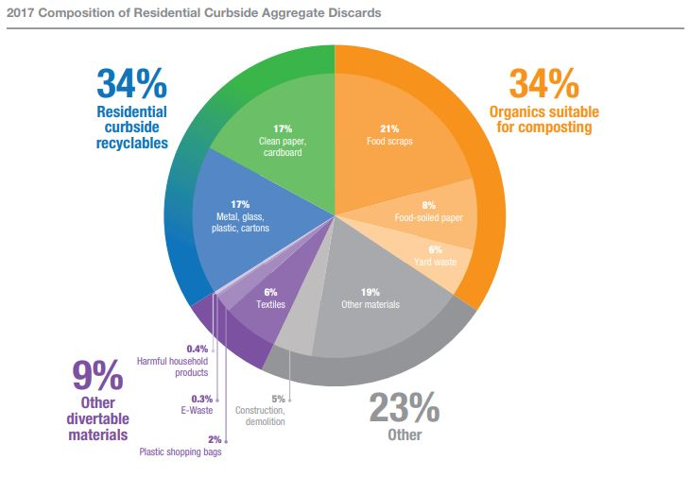
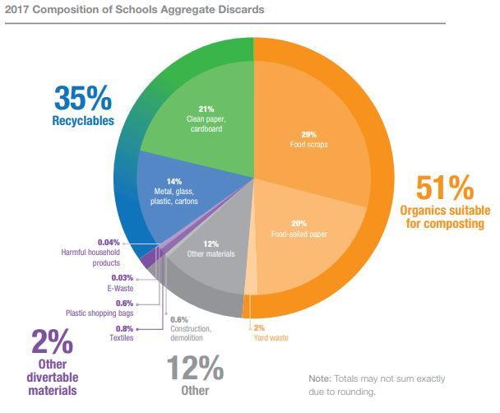
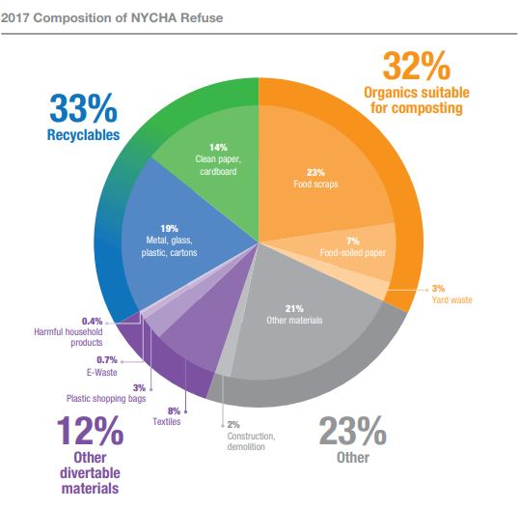
The 2017 Study shows that organics is the biggest area of opportunity for the city to divert waste from landfill. Thus, the City’s new organics program is an imperative tool for reaching the Zero Waste goals. There is also a significant amount of waste from residential, schools, and NYCHA that falls under the category “other,” which currently does not have a clear path to diversion from landfill. Materials in this category made up 23% of the residential waste, 12% of school waste, and 23% of NYCHA’s waste in 2017. The City’s plan to reach zero waste must not only advance existing work to ensure that 100% of materials that have a path to diversion are properly separated from the refuse stream, but it must also create viable paths to diversion for materials that currently do not have one.

- Successful Waste Diversion: San Francisco Case Study
Several other U.S. cities are also working toward stated significant waste reduction goals. It is difficult to compare diversion rates and waste statistics among different cities because of inconsistencies in the methodology and reporting of waste characterization, as well as fundamental differences between U.S. cities. There are some programs that have been successful in other cities, however, that could possibly be explored in New York City.
San Francisco, CA claims an 80% diversion rate. Although there is some debate as to how this diversion rate was calculated, it is widely recognized that San Francisco is a leader in the U.S. in recycling. Because of this, other cities can learn from the strategies that San Francisco has used to divert waste from landfills. San Francisco uses a three-bin system for waste: a green bin for compost, a blue bin for recycling, and a black bin for trash. The recycling bin is single stream – paper, plastic, glass, and metal go into the same blue bin to be sorted later at the recycling facility. It is required that everyone keep their recyclables, compostable material, and trash separate. Single-stream recycling does seem to increase diversion rates, but may also adversely increase contamination rates. This means that some of the materials placed in the single stream recycling bin will still end up in the landfill.
San Francisco has also passed several ordinances to encourage higher diversion rates, including a prohibition on the use of Styrofoam and polystyrene foam in food service, a ban on plastic bags in drugstores and supermarkets, and mandatory recycling and composting for residents and businesses. San Francisco also has a financial incentive for residents to recycle and compost. There is a $35.18 monthly fee for each household for pick-up of residential trash, recycling, and compost. Residents can lower this fee by ordering a smaller trash bin than is standard and sending less material to the landfill by recycling and composting more. San Francisco Department of Environment Director Melanie Nutter also cites education and outreach as effective tools used for their successful waste diversion.

- Legislation
Preconsidered Int. No. ____ A local law to amend the administrative code of the city of New York, in relation to penalties for littering from a vehicle

This bill would raise the fines for littering and spillage out of a vehicle to $200 for a first violation, $350 for any second violation within any 12-month period, and $450 for any third violation within any 12-month period.
Preconsidered Int. No. ____ A Local Law in relation to a plan to increase enforcement of littering out of vehicles

This bill would mandate that the Department of Sanitation create a list of locations where littering out of a vehicle is currently an issue and create a plan to increase enforcement.

- Conclusion
Zero waste is an ambitious and important goal, requiring a focus on both increased waste diversion from landfills and decreased waste generation from city residents and businesses. This Committee is particularly interested in how the City will use the data in the 2017 Waste Characterization Study to inform its strategy to move toward zero waste. The Committee also seeks input, assessments, and ideas from interested members of the public as to how the City can achieve its zero waste goals.

Preconsidered Int. No.
By Council Member Matteo
A LOCAL LAW

To amend the administrative code of the city of New York, in relation to penalties for littering from a vehicle

Be it enacted by the Council as follows:
Section 1. Subdivision 9 of section 16-118 of the administrative code of the city of New York is amended to read as follows:
9. Any person violating the provisions of this section shall be liable for a civil penalty in the following amounts, provided that for the purposes of this subdivision, the term “first violation” means any number of violations issued for a single incident:
a. not less than 50 and not more than 250 dollars for a first violation, except that the civil penalty shall be not less than 250 and not more than 350 dollars for a second violation of subdivision 3, 4 or 6 of this section within any 12 month period, and not less than 350 and not more than 450 dollars for a third or subsequent violation of subdivision 3, 4 or 6 of this section within any 12 month period;
b. notwithstanding paragraph a of this subdivision, for any natural person violating subdivision 6 of this section by means of the act of public urination:
(1) 75 dollars for a first violation, and
(2) not less than 250 and not more than 350 dollars for any second violation within any 12 month period, and
(3) not less than 350 and not more than 450 dollars for any third violation within any 12 month period; and
c. notwithstanding paragraph a of this subdivision, for any natural person violating subdivision 1 of this section:
(1) 75 dollars for a first violation, and
(2) not less than 250 and not more than 350 dollars for any second violation within any 12 month period, and
(3) not less than 350 and not more than 450 dollars for any third violation within any 12 month period[.]; and
d. notwithstanding paragraph a of this subdivision, for any natural person violating subdivision 4 of this section:
(1) 200 dollars for a first violation; and
(2) 350 dollars for any second violation within any 12 month period; and
(3) 450 dollars for any third violation within any 12 month period.
§ 2. This local law takes effect immediately.

NKA
LS 6357
4/6/2018
4:06PM

Preconsidered Int. No.

By Council Member Matteo

A LOCAL LAW

In relation to a plan to increase enforcement of littering out of vehicles

Be it enacted by the Council as follows:

Section 1. The commissioner of sanitation shall develop and submit to the mayor and the speaker of the council by April 1, 2019, a plan to increase enforcement of section 16-118(4) of the administrative code. This plan shall include but not be limited to:
a. a list of locations in the city where litter is commonly thrown from cars, which shall be developed by the commissioner in consultation with council members and community boards;
b. the number of sanitation officers necessary to enforce section 16-118(4) of the administrative code in such locations;
c. the number of violations issued annually for littering out of a vehicle, disaggregated by sanitation district;
d. a description of steps the department of sanitation will take to increase enforcement of section 16-118(4); and
e. a date for implementation of such plan.
§ 2. This local law takes effect immediately.

NKA
LS 6358
4/10/2018
4:10PM

New York City Department of Sanitation, "2017 NYC Residential, School, and NYCHA Waste Characterization Study," (March 2018) http://dsny.wpengine.com/wp-content/uploads/2018/04/2017-Waste-Characterization-Study.pdf
New York City Department of Sanitation, Waste Characterization, available at http://www1.nyc.gov/assets/dsny/site/resources/reports/waste-characterization
New York City Local Law 77 of 2013, available at http://legistar.council.nyc.gov/LegislationDetail.aspx?ID=1450676&GUID=7743FA15-9A38-4854-8877-31C725522D90
New York City Department of Sanitation, "2017 NYC Organics Expansion Maps" (2017), https://www1.nyc.gov/assets/dsny/docs/nyc-organics-collection-areas.pdf
NYC Mayor’s Office of Sustainability, “One New York: The Plan for a Strong and Just City” (April 2015) at 183
Id. at 183
One NYC 2016 Progress Report at 122 and DSNY “Schools” http://www1.nyc.gov/assets/dsny/zerowaste/schools.shtml
NYC Department of Education and NYC Department of Sanitation, "NYC Schools Guide to zero waste," (2016) https://www1.nyc.gov/assets/dsny/docs/zero-waste-schools-guide-zwsg-accessible.pdf
One New York: The Plan for a Strong and Just City at 182
Id.
See “New York City’s Roadmap to 80x50” (September 2016) at 106, available at http://www1.nyc.gov/assets/sustainability/downloads/pdf/publications/New%20York%20City's%20Roadmap%20to%2080%20x%2050_20160926_FOR%20WEB.pdf
NYCHA Final FY 2017 Annual PHA Plan (October 18, 2016) at 305, available at http://www1.nyc.gov/assets/nycha/downloads/pdf/FY2017_final_annual_plan_101816.pdf
NYC Housing Authority, “NYCHA Recycles!” http://www1.nyc.gov/site/nycha/about/nycha-recycles.page
One NYC 2016 Progress Report at 122
New York City Department of Sanitation, "2017 NYC Residential, School, and NYCHA Waste Characterization Study," (March 2018) at 4-5 and 8-9, http://dsny.wpengine.com/wp-content/uploads/2018/04/2017-Waste-Characterization-Study.pdf
Id. at 5
Id. at 12
Id.
Id.
Id.
Id.
Id.
Id.
Id.
Id.
Id.
Id. at 14
Id. at 11
Id. at 40
Id. at 47
Id. at 11, 40, and 47
Id.
Bodamer, David “10 Major U.S. cities With Zero Waste Goals” (July 27, 2015) http://www.waste360.com/waste-reduction/10-major-us-cities-zero-waste-goals
Poirot, Anne “San Francisco’s Race to Zero Waste Has One Last Major Hurdle,” (March 8 2017) https://medium.com/sustainable-food-systems/san-franciscos-race-to-zero-waste-has-one-last-major-hurdle-6c76ca8f2f86 San Francisco calculates the diversion rate including glass, paper, plastic, metal, organic material, and heavy construction material. Construction material is a large portion of the waste that is diverted and some think that this calculation inflates the diversion rate and does not represent the recycling efforts of San Francisco residents. Despite this, San Francisco still has a uniquely high diversion rate.
Richtel, Matt “San Francisco, ‘the Silicon Valley of Recycling’” (March 25, 2016), https://www.nytimes.com/2016/03/29/science/san-francisco-the-silicon-valley-of-recycling.html and Cohen, Steven “Zero Waste in San Francisco and New York: A Tale of Two Cities” (March 28, 2016), https://www.huffingtonpost.com/steven-cohen/zero-waste-in-san-francis_b_9556380.html
San Francisco Ordinance No. 100-09, San Francisco Environment Code, Chapter 18 Sections 1801-12 Mandatory Recycling & Composting Ordinance, 2009 https://sfenvironment.org/sites/default/files/policy/sfe_zw_sf_mandatory_recycling_composting_ord_100-09.pdf
Carr, Robert “Contamination Continues to Hurt Recycling Efforts” (January 27, 2016) http://www.waste360.com/source-separation/contamination-continues-hurt-recycling-efforts and Lacapra, Veronique “With ‘Single-Stream’ Recycling, Convenience Comes At A Cost” https://www.npr.org/2015/03/31/396319000/with-single-stream-recycling-convenience-comes-at-a-cost (“Collins adds that about a quarter of single-stream recycling goes to the dump. For glass, that loss can be as high as 40 percent.”)
SF Environment, “Legislation Related to Zero Waste” https://sfenvironment.org/zero-waste-legislation#recycling-composting-trash
Richtel, Matt “San Francisco, ‘the Silicon Valley of Recycling’” March 25, 2016 https://www.nytimes.com/2016/03/29/science/san-francisco-the-silicon-valley-of-recycling.html?rref=collection%2Fsectioncollection%2Fearth&action=click&contentCollection=earth&region=rank&module=package&version=highlights&contentPlacement=1&pgtype=sectionfront
SF Environment, “Recycling & Composting Requirements for Residents” https://sfenvironment.org/recycling-composting-requirements
SF Environment, “Mayor Lee Announces San Francisco Reaches 80 Percent Landfill Waste Diversion, Leads All Cities in North America” https://sfenvironment.org/news/press-release/mayor-lee-announces-san-francisco-reaches-80-percent-landfill-waste-diversion-leads-all-cities-in-north-america

