Health Committee Staff:
Daniel Hafetz, Counsel
Crystal Gold-Pond, Policy Analyst
Crilhien R. Francisco, Financial Analyst
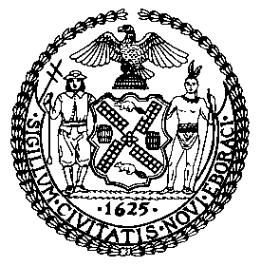

THE COUNCIL OF THE CITY OF NEW YORK

COMMITTEE REPORT OF THE HUMAN SERVICES DIVISION
Robert Newman, Legislative Director
Terzah Nasser, Deputy Director

COMMITTEE ON HEALTH
Hon. Maria del Carmen Arroyo, Chair

September 23, 2013

Int. 1129: By Council Members Arroyo, Barron, Chin, Comrie, Gentile, Gonzalez, Greenfield, Jackson, James, Koo, Mendez, Palma, Rose, Vallone, Vann, Wills, and Rodriguez.

Title: A Local Law to amend the administrative code of the city of New York, in relation to creating a food service establishment inspection ombuds office within the New York city department of health and mental hygiene.

Int. 1132: By Council Members Gentile, Arroyo, Barron, Chin, Fidler, Greenfield, James, Koo, Palma, Rose, Vallone and Rodriguez.

Title: A Local Law to amend the administrative code of the city of New York, in relation to requiring the department of health and mental hygiene to develop and disseminate a food service establishment inspection code of conduct.

Int. 1134: By Council Members Koo, Arroyo, Gentile, Gonzalez, Greenfield, Koslowitz, Palma, Rose, Vacca, Vallone, and Rodriguez.

Title: A Local Law to amend the administrative code of the city of New York in relation to the creation of a Food Service Establishment Advisory Board.

Int. 1141: By Council Members Reyna, Greenfield, Koo, Mendez, Rose and Vallone.

Title: A Local Law in relation to Food Service Establishment Sanitary Inspection Data.

Int. 1146: By Council Members Van Bramer, Arroyo, Greenfield, James, Koo, Rose, Vallone, Wills, and Rodriguez.

Title: A Local Law to amend the administrative code of the city of New York, in relation to requiring the department of health and mental hygiene to develop a consultative inspection program for food service establishments.

I. Introduction
On Monday, September 23, 2013, the New York City Council Committee on Health, chaired by Council Member Maria del Carmen Arroyo, will consider Int. Nos. 1129, 1132, 1134, 1141, and 1146, a package of legislation that would reform the City’s restaurant inspection system. Representatives from the New York City Department of Health and Mental Hygiene (DOHMH), the restaurant industry, food safety experts and other interested members of the community are invited to testify.

II. Background
DOHMH is responsible for permitting, overseeing and inspecting New York City’s 24,000 food service establishments to ensure their compliance with applicable food safety laws, rules and regulations. All restaurants must have a permit to operate and are inspected regularly to ensure compliance with the New York City Health Code.
In 2005, DOHMH created the point and condition system for sanitary health code violations, which is still in use today, with minor alterations. Each violation is classified as either “critical” or “general” and assigned a point value. Depending on the severity level of the violation—referred to as a condition—the point value changes. Critical violation categories include food temperature, food source (e.g., use of unpasteurized milk), food protection (e.g., food item spoiled or cross-contaminated), facility design (e.g., improper sewage disposal system), personal hygiene and other food protection (e.g., eating in food preparation area). General violation categories include vermin/garbage, food source (e.g. canned food product dented), facility maintenance, and improper signage/documentation. Condition levels range from 1-5, with points ranging from 5 to 28 for critical violations and from 2 to 5 for general violations.
Prior to July 2010, a restaurant that received 28 or more points on its inspection was considered to have failed the inspection and would be subject to a follow up “compliance inspection.” Compliance inspections were full inspections and performed in the same manner as the initial inspection. If the restaurant had not corrected the previously cited violations, it would be subject to immediate closure by DOHMH.
In July 2010, DOHMH introduced a restaurant letter grading system in an effort to “1. communicate risks to the public to enable informed public choice about where to dine; 2. improve compliance by food service establishments and 3. reduce, over time, restaurant attributable food-borne illnesses.” They cited the popularity of letter grading in Los Angeles and its success in reducing foodborne illnesses by 20% during the first ten years of implementation.
DOHMH Letter Grading System
DOHMH is required to inspect all restaurants at least annually. At an initial inspection under the letter grading system, an inspector conducts a full sanitary inspection, following the point system developed in 2005. Only those violations that are considered to have a direct bearing on food safety count towards the restaurant’s letter grade. Thus, a restaurant may be fined for violations of regulations such as those regarding artificial trans-fat, smoke-free air laws, calorie menu labeling, and posting of required signage but those violations will not be included when calculating the letter grade.
If, at the initial inspection, a restaurant receives 13 or fewer points, the restaurant will immediately receive an A grade placard. The restaurant must post the letter grade immediately in a conspicuous place on the front window of the restaurant so that it is visible by passersby. A restaurant that receives an A at an initial inspection is considered to have satisfied its annual inspection requirement and will not be inspected again for purposes of letter grading that year. As of January 2011, any restaurant that receives an A on its initial inspection is exempted from any fines for violations.
If, at the initial inspection, a restaurant receives 14 or more points, the inspector will not issue a letter grade but will schedule a re-inspection to occur at least one week later. The restaurant is required to display its current letter grade (if it has one) until the re-inspection occurs. If, at the re-inspection, the restaurant receives 13 or fewer points, it will immediately receive an A grade placard. However, the restaurant will still be subject to fines for any violations it received at the initial inspection, despite the fact that it ultimately received an A grade during re-inspection.
If, at the re-inspection, the restaurant receives more than 14 points, and is not closed by the DOHMH, the restaurant will be issued a “grade pending” card and a letter grade corresponding to the number of points it received. Restaurants who receive between 14 and 27 points will be issued a B grade placard and those who receive greater than 28 points will be issued a C grade placard. Restaurants who get more than 14 points at the re-inspection must immediately post either the “grade pending” placard, if they intended to challenge the inspection results at the Administrative Tribunal, or the grade placard. After adjudication, the restaurant must immediately remove the “grade pending” placard and post the appropriate grade placard.
A restaurant that receives a B letter grade at either an initial or re-inspection will have its inspection cycle begin again five to seven months after the inspection at which it received the B grade. A restaurant that received a C letter grade will have its inspection cycle begin again three to five months later. A restaurant closed by DOHMH on either an initial or re-inspection will begin the cycle again two to four months after re-opening. A new inspection cycle begins with initial inspections for purposes of letter grading. These are not the only inspections that may take place, however. DOHMH reserves the right to conduct additional inspection for purposes of letter grading upon the belief there is “an increased risk to public health,” which may include, but is not limited to, a history of closure, being the subject of a complaint of unsanitary conditions, or being compromised due to an environmental emergency.

Concerns Regarding the Letter Grading System
Since the introduction of letter grading, restaurants raised concerns about the system. While the Administration touted the overwhelming success of the program, and protested that only dirty restaurants had problems with the system, a survey conducted by the Council suggested that approximately two-thirds of surveyed restaurants, including nearly 60% of those restaurants posting “A” grades in their windows, graded the system “1 – Poor” on a scale of 1 to 5. On March 7, 2012, the Council’s Committees on Governmental Operations, Health, Oversight & Investigations, and Small Business, held an oversight hearing during which the concerns raised by restaurants, in meetings and open forums with Council Members since the inception of the program and highlighted in the citywide Council survey, were echoed and amplified. Principal among the issues raised by restaurateurs, advocates and experts during the hearing were the increased fine burden on restaurants since the introduction of the letter grading system; frayed and adversarial relations between DOHMH and restaurants; and inconsistencies across inspections.
The Council survey and hearing testimony made clear that restaurants across all five boroughs, of all sizes, cuisines, and letter grades, had significant concerns with the restaurant inspection process. Further, the Council’s analysis of the restaurant inspection results indicated considerable inspection inconsistency and limited overall improvement of restaurant performance. Taken together, a question arose as to whether the benefits that the letter grading system provided justified the heavy toll taken on restaurants.
Ultimately, in light of its review of restaurant inspection data and issues raised by restaurants, and after extensive conversations with the restaurant industry and DOHMH, the Council determined that eight reform measures would significantly improve the program. Under an agreement reached by the Council and DOHMH that was announced in August 2013, three improvements will be accomplished through rulemaking by DOHMH. These measures include: across the board fine reductions, waiver of fines for restaurants receiving an “A” on initial inspections as a result of adjudication, and waiver of fines and points for violations pertaining to physical layout if such violations were not cited during previous inspections. The remaining five measures would be accomplished by the legislation to be considered today. These include increased data reporting and the creation of an ombuds office, an inspection code of conduct, an advisory board, and a consultative inspection program.
The package of legislation is intended to improve the lines of communication between DOHMH and restaurants, and increase the quality of information provided to restaurants, helping to make the system less adversarial and more cooperative and educational. Further, as restaurants would be better informed about what they might expect during an inspection and better able to prepare accordingly, and as inspectors apply the rules fairly and uniformly, inspection results should become more consistent. The bills are also intended to improve the oversight and performance of the restaurant inspection system by developing better and more thorough performance indicators.

Int. No. 1129
Int. No. 1129 would require DOHMH to establish an office to field complaints, compliments, and comments about individual restaurant inspection issues and the program in general. The office would maintain a telephone hotline and website to receive such feedback. The office would also serve a number of other functions. It would investigate all inspection-related complaints, with the ability to identify egregious inspection errors that should be rectified by the department in lieu of submission to the administrative tribunal. This would include the withdrawal of violations pertaining to physical layout and major fixtures, where a restaurant had never been cited for such a violation during previous inspections; note, however, the restaurant would still be responsible for fixing the cited problem. The office would issue guidance letters on matters pertaining to restaurant inspections, including but not limited to appropriate inspection methods and food handling techniques, either upon request or on the office’s own initiative. Each quarter, the office would compile and analyze the type and number of violations issued by each inspector and would monitor such inspection results for trends and inconsistencies. Finally, the office would make recommendations to the DOHMH Commissioner regarding needed improvements to the restaurant inspection process. The bill would require the office to submit an annual report to the Mayor, the Speaker and the DOHMH Commissioner summarizing its activities for the year.

Int. No. 1132
Int. No. 1132 would require DOHMH to create an inspection code of conduct pamphlet that inspectors would distribute to all restaurant owners/operators immediately prior to the beginning of an initial inspection informing them of their rights regarding restaurant inspections. The code of conduct would also be available on DOHMH’s website. The code of conduct would inform owners and operators that inspectors must: behave in a professional manner and identify themselves in a manner that does not unduly interfere with patrons; be able to communicate with the restaurant owner or operator or use language assistance services; fairly and impartially apply DOHMH laws and rules and have an understanding of all relevant laws and regulations; provide information on how to file a complaint about an inspector and how to contest a violation at the tribunal; be able to answer reasonable questions about the inspection; and upon finding a violation, explain to the owner/operator how to correct such violation.

Int. No. 1134
Int. No. 1134 would require DOHMH to create an advisory board to provide advice to DOHMH on the effect of the inspection program on restaurants, food safety and public health. The board would be comprised of five mayoral appointees and four Council appointees, with the DOHMH Commissioner to serve ex officio. The appointees would include restaurant industry representatives and food safety experts. In addition, DOHMH would be allowed to invite non-member, non-voting participants to assist with the work of the board. The board would meet quarterly, and the agenda for its first four meetings would include the following topics: appropriate point values for violations; inspector training curriculum; the relationship between DOHMH and restaurants; and the impact of letter grading on health and safety, including a discussion of any changes in food-borne illness rates. The bill would require the advisory board to submit an annual report to the Mayor and the Council on the impact of letter grading on health and safety, including food-borne illness rates, and the board’s specific recommendations for improvements to the inspection process.

Int. No. 1141
Int. No. 1141 would build upon the information currently available through the City’s Open Data program to require DOHMH to make public additional data on each restaurant inspection, including: the specific type of inspection conducted (initial, compliance, pre-permit, re-inspection, etc,), each violation cited and corresponding points issued, the total score awarded, the date of adjudication, if any, related to violations issued, and the amount of any fine assessed.

Int. No. 1146
Int. No. 1146 would require DOHMH to establish a program where all restaurants would be able to request an optional, ungraded consultative inspection for educational purposes only. Under this program, consultative inspections would not results in fines or violations, although DOHMH would retain its right require a restaurant to immediately remedy a public health hazard. Inspectors would review the results of the consultative inspection and advise the owner or operator of any potential violations and how to remedy such violations. A special feature of the program would allow new restaurants to request a consultative inspection to be conducted in advance of their (first) initial inspection. DOHMH would establish the fees for consultative inspections through rulemaking – for established restaurants, a rate to cover the cost of the inspection; for new restaurants, a nominal fee to limit abuse of the service.

Appendix 1

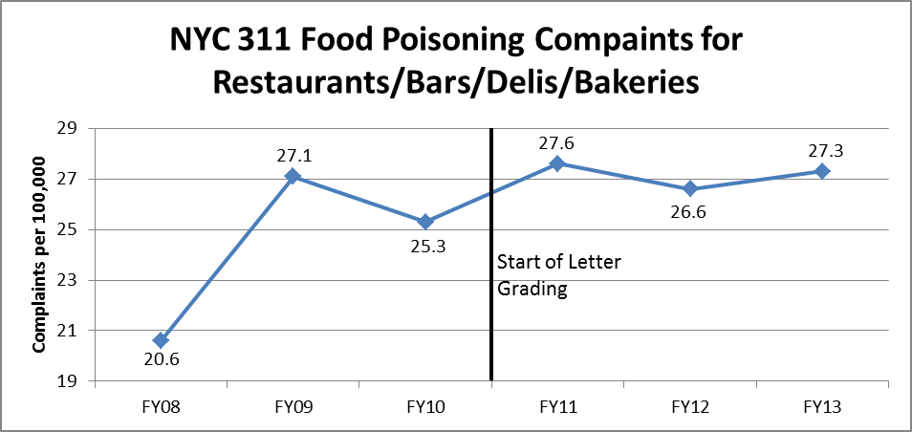
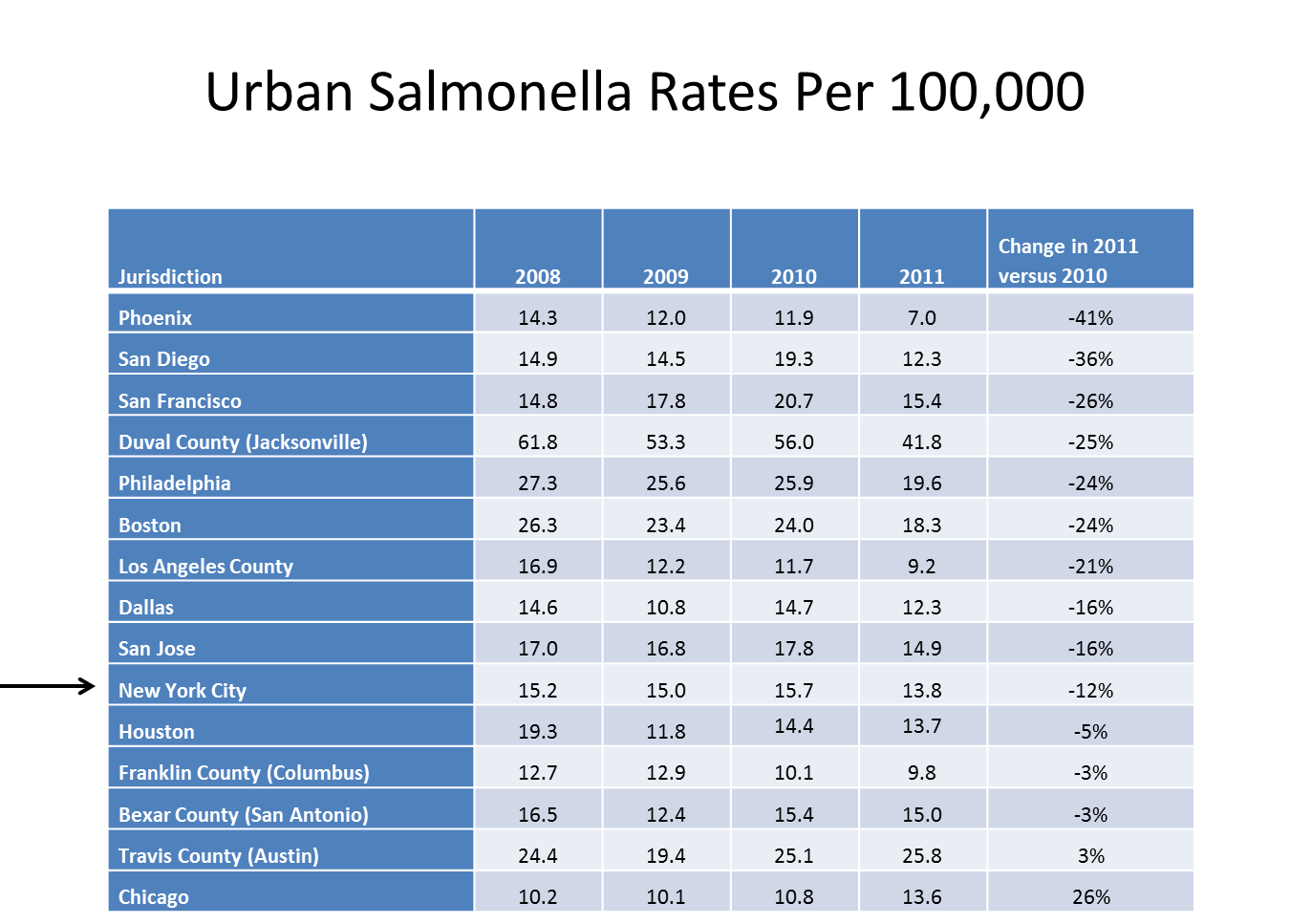

Int. No. 1129

By Council Members Arroyo, Barron, Chin, Comrie, Gentile, Gonzalez, Greenfield, Jackson, James, Koo, Mendez, Palma, Rose, Vallone, Vann, Wills, and Rodriguez

A LOCAL LAW

To amend the administrative code of the city of New York, in relation to creating a food service establishment inspection ombuds office within the New York city department of health and mental hygiene.

Be it enacted by the Council as follows:

Section 1. Chapter 15 of title 17 of the administrative code of the city of New York is amended by adding a new section 17-1505 to read as follows:
§ 17-1505. a. Food service establishment inspections ombuds office; office established. There is hereby established within the food safety program of the department a food service establishment inspections ombuds office.
b. Food service establishment inspections ombuds office; duties and responsibilities. The duties and responsibilities of the food service establishment inspections ombuds office shall include, but not be limited to:
1. establishing a system to receive questions, comments, complaints, and compliments with respect to any food service establishment inspection, including but not limited to, the establishment, operation, and dissemination of a central telephone hotline and website to receive such questions, comments, complaints, and compliments;
2. investigating complaints received pursuant to paragraph 1 of this subdivision and taking any appropriate action regarding such complaints, including but not limited to, withdrawing violations that concern the physical layout and/or major fixtures within a food service establishment when no prior inspection resulted in the issuance of such a violation and neither the physical layout nor the major fixtures have been altered in the intervening time period and identifying egregious inspection errors that ought to be rectified by the department in lieu of submission to the administrative tribunal;
3. issuing guidance letters on matters pertaining to food service establishment inspections, including but not limited to appropriate inspection methods and food handling techniques, either upon request or the department’s own initiative. Any such guidance letter issued by the ombuds office shall be posted on the department’s website upon issuance and, to the greatest extent practicable, distributed to all food service establishment operators;
4. monitoring inspection results for trends and inconsistencies, including but not limited to, via the compilation and analysis on a quarterly basis of the type and number of violations issued by each inspector; and
5. making recommendations to the commissioner regarding improvements to the food service establishment inspection process.
c. Food service establishment inspections ombuds office; departmental resources.
1. The commissioner shall appoint staff as may be necessary within the appropriations therefor to fulfill the mandate of the ombuds office.
2. The department, subject to appropriation, shall ensure that the ombuds office has sufficient funds to fulfill its mandate.
d. Food service establishment inspections ombuds office; annual report. No later than July 1, 2014, and every July 1 thereafter, the ombuds office shall submit to the mayor, commissioner, and speaker of the council an annual report regarding its activities during the previous twelve months. Such report shall include, but not be limited to: (a) the number and nature of each question, comment, complaint, and compliment received by the ombuds office, disaggregated by type of outreach; (b) the resolution of each such complaint; (c) the number of guidance letter requests received and the nature of each such request; (d) the number of guidance letters issued and a copy of each such guidance letter; (e) an analysis of inspection results in accordance with paragraph 4 of subdivision b of this section; and (f) recommendations for improvements to the food service establishment inspection process in accordance with paragraph 5 of subdivision b of this section.
§2. This local law shall take effect ninety days following its enactment.

SAG/SKM/DSS
LS #3460
8/1/13

Int. No. 1132
By Council Members Gentile, Arroyo, Barron, Chin, Fidler, Greenfield, James, Koo, Palma, Rose, Vallone, and Rodriguez

A LOCAL LAW

To amend the administrative code of the city of New York, in relation to requiring the department of health and mental hygiene to develop and disseminate a food service establishment inspection code of conduct.

Be it enacted by the Council as follows:
Section 1. Title 17 of the administrative code of the city of New York is amended by adding a new chapter 15 to read as follows:
CHAPTER 15
FOOD SERVICE ESTABLISHMENTS
§ 17-1501 Definitions. As used in this Chapter the following terms shall have the following meanings:
a. “Covered languages” shall mean Chinese, English, Haitian Creole, Korean, Bengali, Russian and Spanish, and any other language determined by the department.
b. “Critical violations” shall have the meaning it is given in title 24 of the rules of the city of New York.
c. “Food service establishment” shall mean any establishment inspected pursuant to the restaurant grading program established pursuant to subdivision a of section 81.51 of the health code of the city of New York.
d. “Food service establishment inspector” shall mean any individual employed by the department who as part of his or her duties conducts inspections of food service establishments.
e. “General violations” shall have the meaning it is given in title 24 of the rules of the city of New York.
f. “Imminent health hazard or public health hazard” shall have the meaning it is given in article 81 of the health code of the city of New York.
g. “Initial inspection” shall mean the first sanitary inspection within an inspection cycle.
h. “Inspection cycle” shall mean a series of related inspections of food service establishments consisting of at least an initial inspection and including, if triggered by the initial or any subsequent inspections within that cycle, a reinspection and any compliance inspections conducted by the department because of a previous inspection score in that cycle.
i. “Consultative inspection” shall mean an inspection of a food service establishment that is conducted in accordance with section 81.51 of the health code of the city of New York. Any consultative inspection shall be educational and shall not result in fines or a grade.
j. “Notice of violation” shall have the meaning it is given in article 7 of the health code of the city of New York.
k. “Sanitary inspection” shall mean any on-site review by the department of a food service establishment's physical facilities, food handling operations, equipment, sanitary condition, maintenance, and worker hygiene practices. The term may include, but shall not be limited to include, initial, reinspection, compliance and pre-permit inspections.
§ 17–1502 Food Service Establishment Inspection Code of Conduct. a. The commissioner shall develop a food service establishment inspection code of conduct. The inspection code of conduct shall be in the form of a written document, drafted in plain language, which is distributed to all food service establishment inspectors. The inspection code of conduct shall inform owners and/or operators of food service establishments of their rights as they relate to food service establishment inspections.
b. The department shall distribute the inspection code of conduct to all food service establishments. Food service establishment inspectors shall distribute the inspection code of conduct to food service establishment owners or operators prior to the beginning of an initial inspection. The department shall make the inspection code of conduct available on the department’s website in the covered languages.
c. The code of conduct shall include, but not be limited to, the following:
(1) the food service establishment inspector must behave in a professional and courteous manner;
(2) upon arriving for the purposes of performing a sanitary inspection, the food service establishment inspector must immediately identify himself or herself to the staff of the food service establishment, and note the type of inspection, in a manner that does not unreasonably interfere with the dining experience of patrons;
(3) the food service establishment inspector must be as unobtrusive as possible during the inspection, while still conducting the required checks throughout the establishment;
(4) the food service establishment inspector must return any equipment moved, and reassemble any equipment disassembled, by the food service establishment inspector during the course of the inspection to its original location and state of assembly;
(5) the food service establishment inspector must have a sound knowledge of all relevant sanitary code provisions and any other applicable laws and regulations.
(6) the food service establishment inspector must be able to meaningfully communicate with the food service establishment owner or operator, and if necessary, utilize language assistance services to facilitate meaningful communication;
(7) the food service establishment inspector must be able to answer reasonable questions relating to the inspection;
(8) the food service establishment inspector must enforce agency rules in a fair and impartial manner;
(9) the food service establishment inspector must, upon finding a violation, explain to the food service establishment owner or operator how to remedy such violation.
(10) the food service establishment inspector must provide information informing the food service establishment owner or operator how such owner or operator may contest a notice of violation before the relevant local tribunal; and
(11) the food service establishment inspector must provide information on how the food service establishment owner or operator may file a compliment or complaint about an inspector.
d. The commissioner shall regularly, but no less frequently than every two years, review and update the food service establishment inspection code of conduct, as necessary.
e. The code of conduct shall serve as an informational document only and nothing in this subdivision or in such document shall be construed so as to create a cause of action or constitute a defense in any legal, administrative, or other proceeding.
§2. This local law shall take effect ninety days following enactment.

LS # 3454
LCC/JM/SKM/DSS
8/2/13

Int. No. 1134

By Council Members Koo, Arroyo, Gentile, Gonzalez, Greenfield, Koslowitz, Palma, Rose, Vacca, Vallone, and Rodriguez

A LOCAL LAW

In relation to the creation of a Food Service Establishment Advisory Board.

Be it enacted by the Council as follows:

Section 1. Chapter 15 of title 17 of the administrative code of the city of New York is amended by adding a new section 17-1503 to read as follows:
§17-1503 Food Service Establishment Advisory Board. a. There shall be an advisory board to advise the commissioner concerning matters related to the food service establishment sanitary inspection program and its effect on the restaurant industry, food safety and public health.
b. Such advisory board shall consist of ten members as follows:
i. Five members shall be appointed by the mayor, provided that one such member shall represent a food service industry association, one such member shall have advanced specialized training in food safety, one such member shall have advanced specialized training in nutrition, and two such members shall operate food service establishments;
ii. Four members shall be appointed by the speaker of the council, provided that one such member shall represent a food service industry association, one such member shall have advanced specialized training in food safety, one such member shall have advanced specialized training in nutrition, and one such member shall operate a food service establishment;
iii. The commissioner of the department of health and mental hygiene shall serve ex officio.
c.. At the invitation of the department, at-large participants may assist the board.
d. Each member, other than the member serving in an ex officio capacity, shall serve for a term of two years, to commence after the final member of the advisory board is appointed. Any vacancies in the membership of the advisory board shall be filled in the same manner as the original appointment. A person filling such vacancy shall serve for the unexpired portion of the term of the succeeded member.
e. No member of the advisory board shall be removed from office except for cause and upon notice and hearing by the appropriate appointing official.
f. Members of the advisory board shall serve without compensation and shall meet no less often than every three months. At least one meeting each year shall be an open forum at which the public may submit testimony.
g. The agendas for the first four meetings of the advisory board shall include, but not be limited to:
1. a review of current health code violations for which points are assigned, including those violations that do not bear directly on food safety and public health;
2. a review of the current food safety inspector training curriculum;
3. a review of the effect of letter grading on public health and food safety, including information on the top ten most commonly cited violations in the previous year and any change in the incidences of illness from food borne pathogens; and
4. a review of the relationship between the food service industry and the department.
h. On July 1, 2014, and every year thereafter on July first, the advisory board shall submit a report to the mayor and council. Such report shall include, but not be limited to:
1. an assessment of the restaurant inspection program and its effect on the restaurant industry, public health and food safety, including information on the top ten most commonly cited violations in the previous year and any change in the incidences of illness from food borne pathogens; and
2. specific recommendations for changes and/or improvements to the restaurant inspection program and actions, if any, taken by the department in response to such recommendations.
§3. This local law shall take effect immediately.

LS 3459
LCC/SKM
8/19/13
Int. No. 1141

By Council Members Reyna, Greenfield, Koo, Mendez, Rose and Vallone

A LOCAL LAW

In relation to Food Service Establishment Sanitary Inspection Data.

Be it enacted by the Council as follows:

Section 1. Restaurant Inspection Data . For so long as the department operates a letter grading system for sanitary inspection results, as provided in sections 23-03, 23-04 of the rules of the city of New York, and 81.51 of the New York city health code, the following data for each sanitary inspection conducted at a food service establishment shall be collected and reported in accordance with section 23-505 of this code and any rules promulgated thereunder:
a. the inspection type as defined in section 23-01 of the rules of the city of New York;
b. each violation cited and the number of points allocated per violation;
c. total score awarded upon inspection, or, if such inspection result is contested in an administrative tribunal, after adjudication;
d. the date of any such adjudication; and
e. if monetary penalties are assessed, the amount of such penalty.
§3. This local law shall take effect one hundred twenty days after enactment into law except that the commissioner shall take such actions as are necessary for its implementation prior to such effective date.

LS 3976
LCC/SKM
7/24/13
Int. No. 1146
By Council Members Van Bramer, Arroyo, Greenfield, James, Koo, Rose, Vallone, Wills, and Rodriguez

A LOCAL LAW

To amend the administrative code of the city of New York, in relation to requiring the department of health and mental hygiene to develop a consultative inspection program for food service establishments.

Be it enacted by the Council as follows:
Section 1. Chapter 15 of title 17 of the administrative code of the city of New York is amended by section 17-1504 to read as follows:
§ 17–1504 Food Service Establishment Consultative Inspection Program. a. By January 1, 2014, the department shall develop a consultative inspection program for food service establishments.
b. Such consultative inspections shall be optional, and performed for educational and informational purposes only. A consultative inspection shall not result in a notice of violation being issued for general violations, critical violations, imminent health hazards or public health hazards. A consultative inspection shall not impact a food service establishment’s inspection cycle.
c. Upon completion of a consultative inspection, the inspector shall review the results with the owner or operator of the food service establishment, and advise the owner or operator of potential violations and how to remedy such violations.
d. Nothing in this section shall prohibit the department from taking appropriate action if a food service establishment fails to remedy a public health hazard at the time of the consultative inspection.
e. The department may charge a fee which shall be set by rule promulgated by the commissioner.
f. The department may schedule the consultative inspection, as set by rule promulgated by the commissioner, based on factors including but not limited to demand, prioritization according to inspection history, and the inspection cycle of the food service establishment.
g. Within the consultative inspection program for food service establishments, the department shall develop a system for newly licensed food service establishments whereby such establishments may schedule the consultative inspection prior to their first initial inspections for a nominal fee which shall be set by rule promulgated by the commissioner.
§2. This local law shall take effect one hundred twenty days after its enactment into law, provided that the commissioner may promulgate any rules necessary for implementing and carrying out the provisions of this local law prior to its effective date.

LS # 3455
LCC/JM/SKM/DSS
7/24/13

Food service establishment is defined as a “place where food is provided for individual portion service directly to the consumer whether such food is provided free of charge or sold, whether consumption occurs on or off the premises or is provided from a pushcart, stand or vehicle.” 24 R.C.N.Y. Health Code § 81.03(o). Retail food establishments where food is sold and intended to be consumed off-premises, such as grocery stores, are regulated by the New York State Department of Agriculture and Markets. NYS Ag & M, Art. 28.
24 R.C.N.Y. Health Code § 81.05(a).
24 R.C.N.Y. Health Code § 81.05(c).
24 R.C.N.Y. Health Code § 23.01.
NYC DOHMH, “Self Inspection Worksheet for Food Service Establishments,” available at: http://www.nyc.gov/html/doh/downloads/pdf/rii/self-inspection-worksheet.pdf.
Notice of Adoption of Amendments to Article 81 of the New York City Health Code, available at: http://www.nyc.gov/html/doh/downloads/pdf/notice/2010/Article-81.pdf.
Id.
24 R.C.N.Y. Health Code § 23.03(a).
24 R.C.N.Y. Health Code § 23.02.
24 R.C.N.Y. Health Code § 23.03(b).
24 R.C.N.Y. Health Code § 23.07(a).
24 R.C.N.Y. Health Code § 23.07(f).
24 R.C.N.Y. Health Code § 23.03(a).
“Restaurants that Achieve A Grades at the Time of Inspection Are No Longer Subject to Fines for Sanitary Violations” NYC DOHMH, available at http://www.nyc.gov/html/doh/downloads/pdf/rii/restaurant-grading-penalty-relief-faq.pdf.
24 R.C.N.Y. Health Code § 23.03(a).
24 R.C.N.Y. Health Code § 23.07(b).
24 R.C.N.Y. Health Code § 23.03(b).
Supra note 14.
24 R.C.N.Y. Health Code § 23.07(c).
24 R.C.N.Y. Health Code § 23.03(c).
24 R.C.N.Y. Health Code § 23.07(c).
24 R.C.N.Y. Health Code § 23.07(c).
24 R.C.N.Y. Health Code § 23.04(a)(1).
24 R.C.N.Y. Health Code § 23.04(a)(2).
24 R.C.N.Y. Health Code § 23.04(a)(3).
24 R.C.N.Y. Health Code § 23.01.
24 R.C.N.Y. Health Code § 23.04(b).
See, e.g., Transcript, Oversight: Grade Pending: Examining the Department of Health’s Restaurant Inspection Program, Committees on Governmental Operations, Health, Oversight & Investigations, and Small Business, March 7, 2012, at 9, 15, 17, and 21.
See, e.g., DOHMH, “Restaurant Grading in New York City at 18 Months,” http://www.nyc.gov/html/doh/downloads/pdf/rii/restaurant-grading-18-month-report.pdf.;
See, e.g., Michael Grynbaum and Kate Taylor, “Bloomberg Defends Grading System Derided by Restaurateurs,” NY Times, March 6, 2012, available at http://www.nytimes.com/2012/03/07/nyregion/restaurant-grading-system-under-fire-gets-mayors-backing.html (“He denounced critics as “people that complain because they don’t want to keep their restaurants clean.” “They think it’s O.K. to have mice and roaches and dirt and not have people wash their hands before they come back from the bathroom,” the mayor said, his voice rising. “That’s just simply unacceptable, and their complaints are going to fall on deaf ears, I can tell you that. We’re not going to change.””)
See Briefing Paper, Oversight: Grade Pending: Examining the Department of Health’s Restaurant Inspection Program, Committees on Governmental Operations, Health, Oversight & Investigations, and Small Business, March 7, 2012, at 12-20.
See, e.g., Transcript, Oversight: Grade Pending: Examining the Department of Health’s Restaurant Inspection Program, Committees on Governmental Operations, Health, Oversight & Investigations, and Small Business, March 7, 2012, Testimony of Herb Wettenson at 198-199; Jeffrey Chodorow at 243-246; Gary O’Neill at 265-269; Maria Cruz at 328-329; and Stephen Maly at 318-320.
Id.
See generally, Briefing Paper and Transcript, Oversight: Grade Pending: Examining the Department of Health’s Restaurant Inspection Program, Committees on Governmental Operations, Health, Oversight & Investigations, and Small Business, March 7, 2012.
See Briefing Paper, Oversight: Grade Pending: Examining the Department of Health’s Restaurant Inspection Program, Committees on Governmental Operations, Health, Oversight & Investigations, and Small Business, March 7, 2012, at 39-53.
Press Release, “Speaker Quinn Announces Agreement to Reduce Restaurant Fines by Ten Million Dollars Per Year,” New York City Council Press Release 150-2013, August 18, 2013, available at http://council.nyc.gov/html/pr/081813restaurants.shtml.
Id.
For example, in its 18 month letter grading report, DOHMH suggested that letter grading might have been responsible for reducing food borne illness at restaurants. DOHMH reached this conclusion by showing that salmonella rates in New York City had fallen by a larger percentage since the introduction of letter grading than in surrounding states, including Connecticut, New Jersey, and the rest of New York State. However, such an analysis isn't necessarily an apples-to-apples comparison, since New York City is a highly dense urban area while the surrounding states are mostly suburban and rural, and thus the frequency with which people eat out, and what they eat when they do, is likely to vary widely between the two. An analysis of how letter grading has impacted food borne illnesses might also have included 311 complaints about food borne illness at restaurants as well as a salmonella comparison with other large urban areas, both of which show a more mixed result. See Appendix 1.

